**Scraping based prediction of an actors image in a movie:**

**Introduction:**

In this project we are trying to predict the actors image by using scraping.Its mainly helpful at times where cloud access is not available and when we are working on site trying to predict only information of a particular thing.For example in this project i have considered a site and i tried to predict the actors of a particular movie using scraping.The same approach can be used to predict the actors of a different movie by clearing up the directories and running the model for a different movie.ex: This approach can be used for a cooking site where you are trying to predict ingredients of a particular recipe and you may not be concerned about the other recipe ingredients.

The problem was if we are trying to predict actors in a particular movie we are training the model with all the people images who are working as actors and training the model which is costly and even time consuming.This kind of approach can be a solution for such kind of problems.

**Process:**

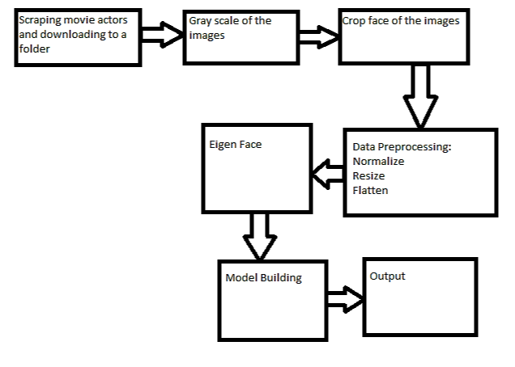

**Scraping the Data:**

I have considered the site mxplayer since its free and doesn’t need subscription.

Used python with BeautifulSoup for scraping.

I have scraped the movie “Ram Leela” and tried to predict its actors.

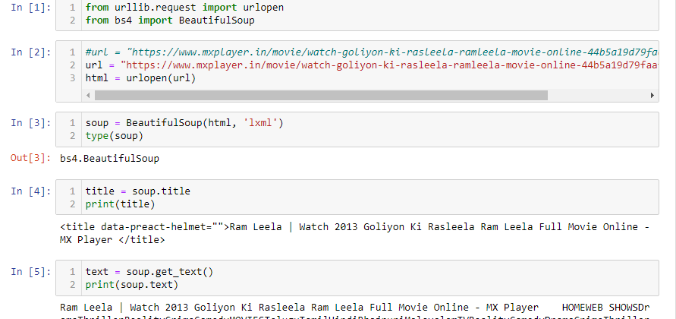

Extracted actors images:

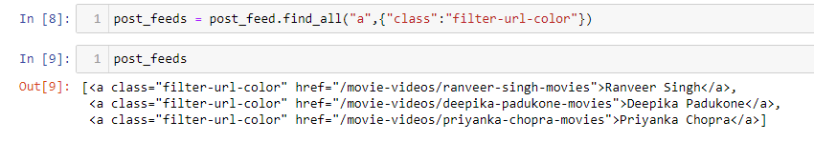

Saving names to a list:

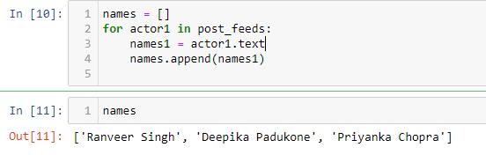

Using image scraper to download images for each actor:

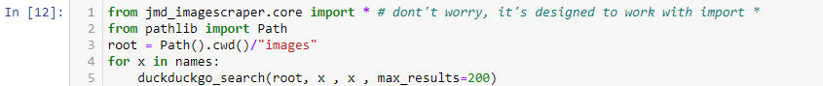

Load actor images from folder:

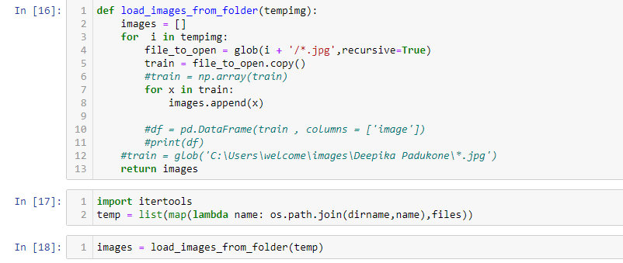

Applying haarCascadeClassifier:



Detect_faces:

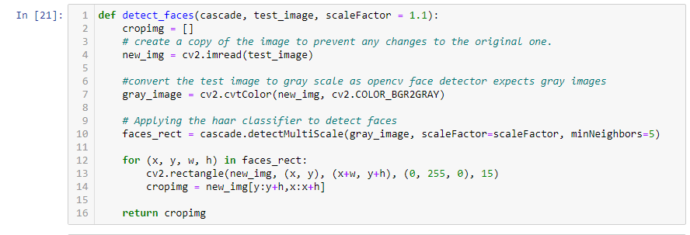

Iterating through image folder and applying haatCascadeClassifier:

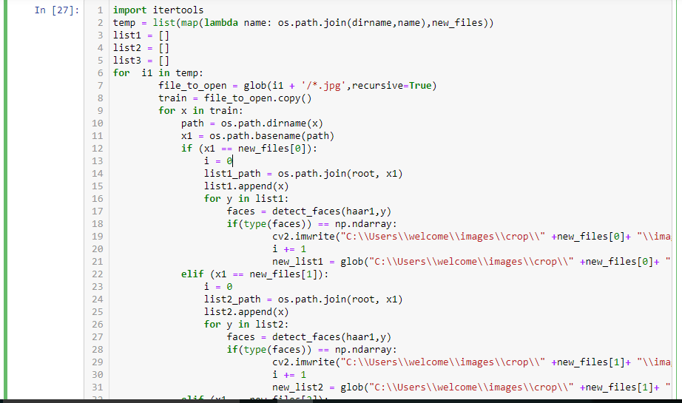

path = new_list1+new_list2+new_list3

Converting list into a dataframe:



EDA:

Resizing of images:

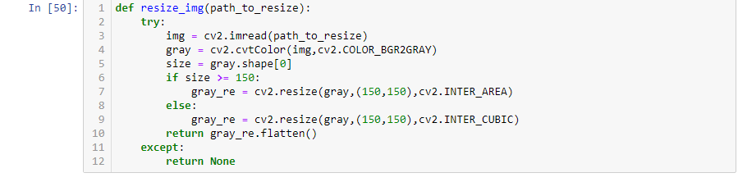

Data Preprocessing:

- Remove missing

- Data Normalization

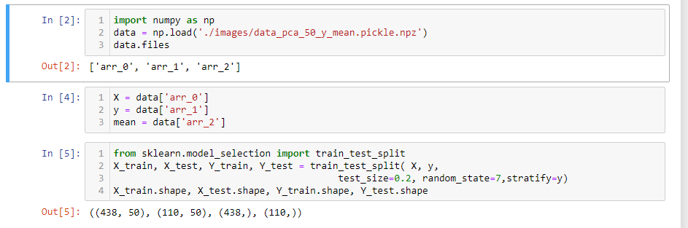

Training a model:

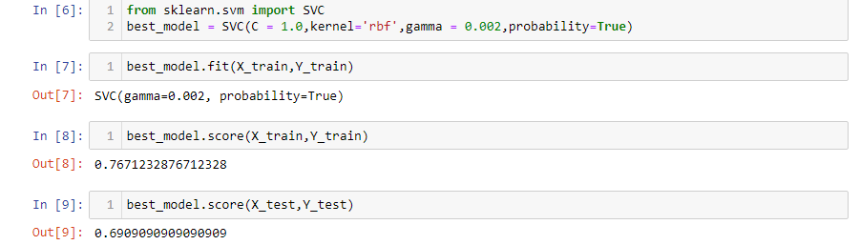

Metrics:

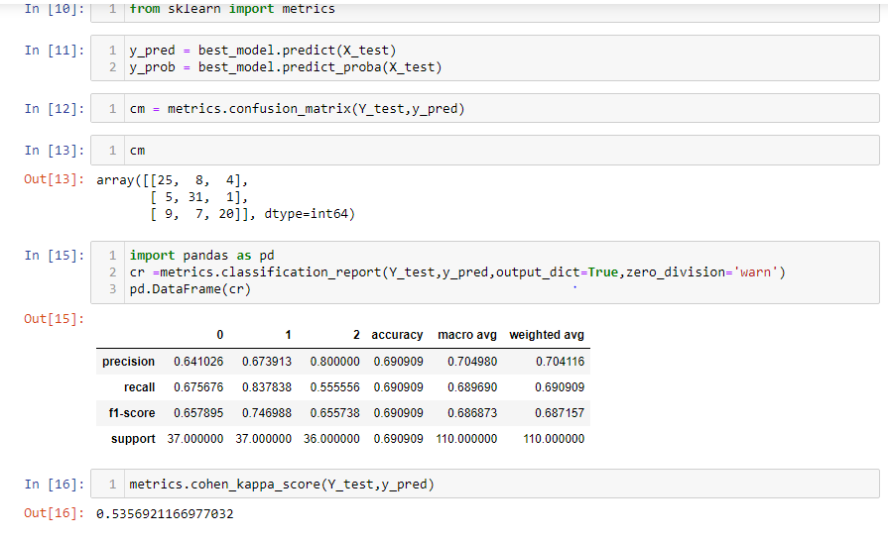

We can use the same model for predicting the actors in a different movie by changing the movie name and clearing the old folder before running the model.

Conclusion:

This project can be taken to next level by predicting the actors in a movie and changing the actors face with our favourite actor.With this fun app people will get the flexibility to watch a movie with our favourite actors face or our face.