Machine Learning Application - Assignment 2
Advertising Sales Prediction using Linear Regression
Name: ______________________ Roll No.: ______________ Class / Section: ______________ Date: ______________

1. Problem Statement
A company spends its advertising money on three channels: TV, radio and newspaper. Management wants to know how much each channel contributes to sales and to predict the sales that a planned budget will produce, so that money can be moved to the channels that work best. This is a supervised regression problem, because the value to predict (sales) is a continuous number. The aim of this project is to build, test and compare linear regression models that predict sales from the three advertising budgets, and to package the best model in a small desktop application.

2. Dataset Description
The file Advertising_Budget_and_Sales.csv has 200 rows (one per market) and four numeric columns, plus an unnamed index column that is dropped. It is the well-known Advertising dataset used in 'An Introduction to Statistical Learning'. There are three input features and one target:
Column in the file | Short name | Role | Min | Mean | Max
TV Ad Budget ($) | TV | Feature | 0.7 | 147.0 | 296.4
Radio Ad Budget ($) | Radio | Feature | 0.0 | 23.3 | 49.6
Newspaper Ad Budget ($) | Newspaper | Feature | 0.3 | 30.6 | 114.0
Sales ($) | Sales | Target | 1.6 | 14.0 | 27.0

Units: the file labels all four columns in dollars ($). In the original source the budgets are in thousands of dollars and sales in thousands of units. This report uses the units exactly as labelled in the file.
Because the target is a number, there are no classes, so the 'class counts' of a classification problem do not apply. Instead the target distribution is shown in Figure 1: sales range from 1.6 to 27.0 with a mean of 14.02.
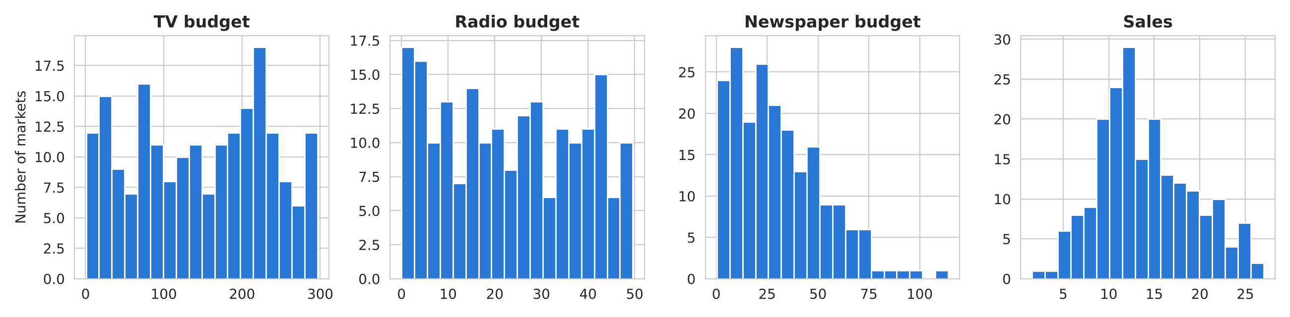
Figure 1: Distribution of the three budgets and of sales.

3. Data Preprocessing
- Missing values and duplicates: 0 missing values and 0 duplicate rows were found, so all 200 rows were kept.
- Text columns: 0 - every column is numeric, so no encoding was needed. The unnamed index column was dropped and the long headers were shortened to TV, Radio, Newspaper and Sales.
- Outliers: checked with the 1.5 x IQR rule: TV 0, Radio 0, Newspaper 2, Sales 0. The two newspaper points are large but realistic budgets, so they were kept.
- Scaling: StandardScaler is placed inside a scikit-learn Pipeline, so the mean and standard deviation are learned from the training data only (no data leakage).
- Split: 80% training (160 rows) and 20% testing (40 rows) with random_state = 42. stratify= is used only for classification, so it is not used for a numeric target. The test set was kept untouched until the final evaluation.
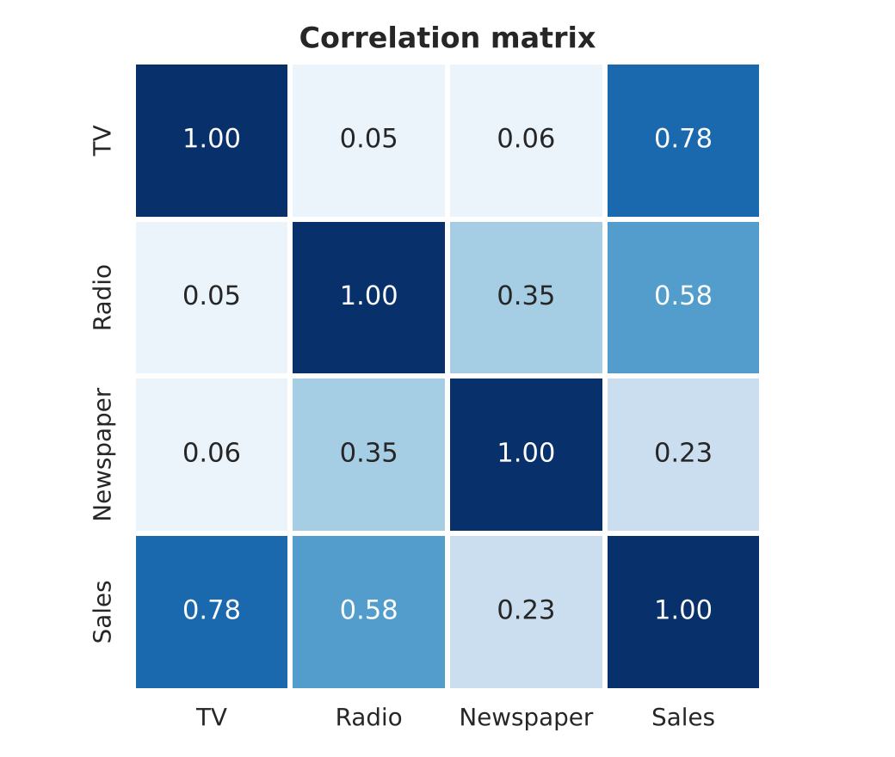 | 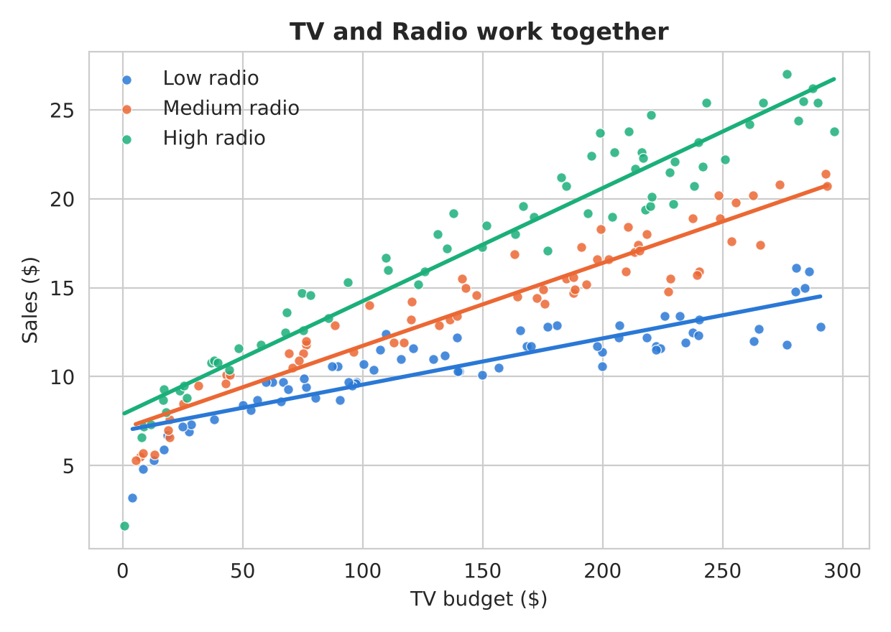
Figure 2: Correlation matrix. | Figure 3: TV effect for low, medium and high radio budgets.

TV has the strongest correlation with sales (r = 0.78), followed by radio (r = 0.58) and newspaper (r = 0.23). Radio and newspaper are themselves correlated (r = 0.35), which explains why newspaper looks useful on its own but adds little once radio is known. Figure 3 shows an important pattern: the sales gained from extra TV spending are larger when the radio budget is high (the green line is steeper). The two channels reinforce each other.

4. Algorithm Selection and Why
Three algorithms were compared. The topic of the project is linear regression, so two of the three are linear regression models:
Algorithm | Why it was chosen
Multiple Linear Regression | Baseline. Sales = b0 + b1 TV + b2 Radio + b3 Newspaper. Simple and easy to explain: each coefficient is the change in sales for one extra unit of that budget.
Polynomial Linear Regression (deg 2) | Still linear regression (it is linear in its coefficients) but with squared terms and products such as TV x Radio added, so it can capture the way the channels reinforce each other (Figure 3).
Random Forest | Non-linear benchmark that needs no assumption about the shape of the relationship. It shows whether a more flexible model would do better.

5. Training and Testing
Each algorithm was built as a Pipeline and trained with .fit() on the training set. To choose the final model, 5-fold cross-validation was run on the training set only, and the model with the lowest cross-validated RMSE among the linear regression models was selected. The test set was then used once, with .predict(), to measure performance on unseen markets. Choosing by cross-validation instead of by the test score keeps the test result an honest estimate.

6. Evaluation Metrics
Accuracy, precision, recall, F1, ROC-AUC and the confusion matrix are classification metrics and cannot be used for a numeric target. The regression equivalents are: MAE (average size of the error), MSE and RMSE (squared error; RMSE is in the same unit as sales), R² (share of the variation in sales that the model explains) and adjusted R² (R² corrected for the number of predictors).
Model | CV RMSE | CV R² | Test MAE | Test MSE | Test RMSE | Test R² | Adj. R²
Multiple Linear Regression | 1.676 | 0.870 | 1.461 | 3.174 | 1.782 | 0.899 | 0.891
Polynomial Linear Reg. (deg 2) | 0.676 | 0.978 | 0.526 | 0.413 | 0.643 | 0.987 | 0.983
Random Forest | 0.894 | 0.966 | 0.615 | 0.549 | 0.741 | 0.983 | 0.981

Table 1: Cross-validation (training set, 5 folds) and test-set results. The shaded row is the final model.

7. Results and Graphs
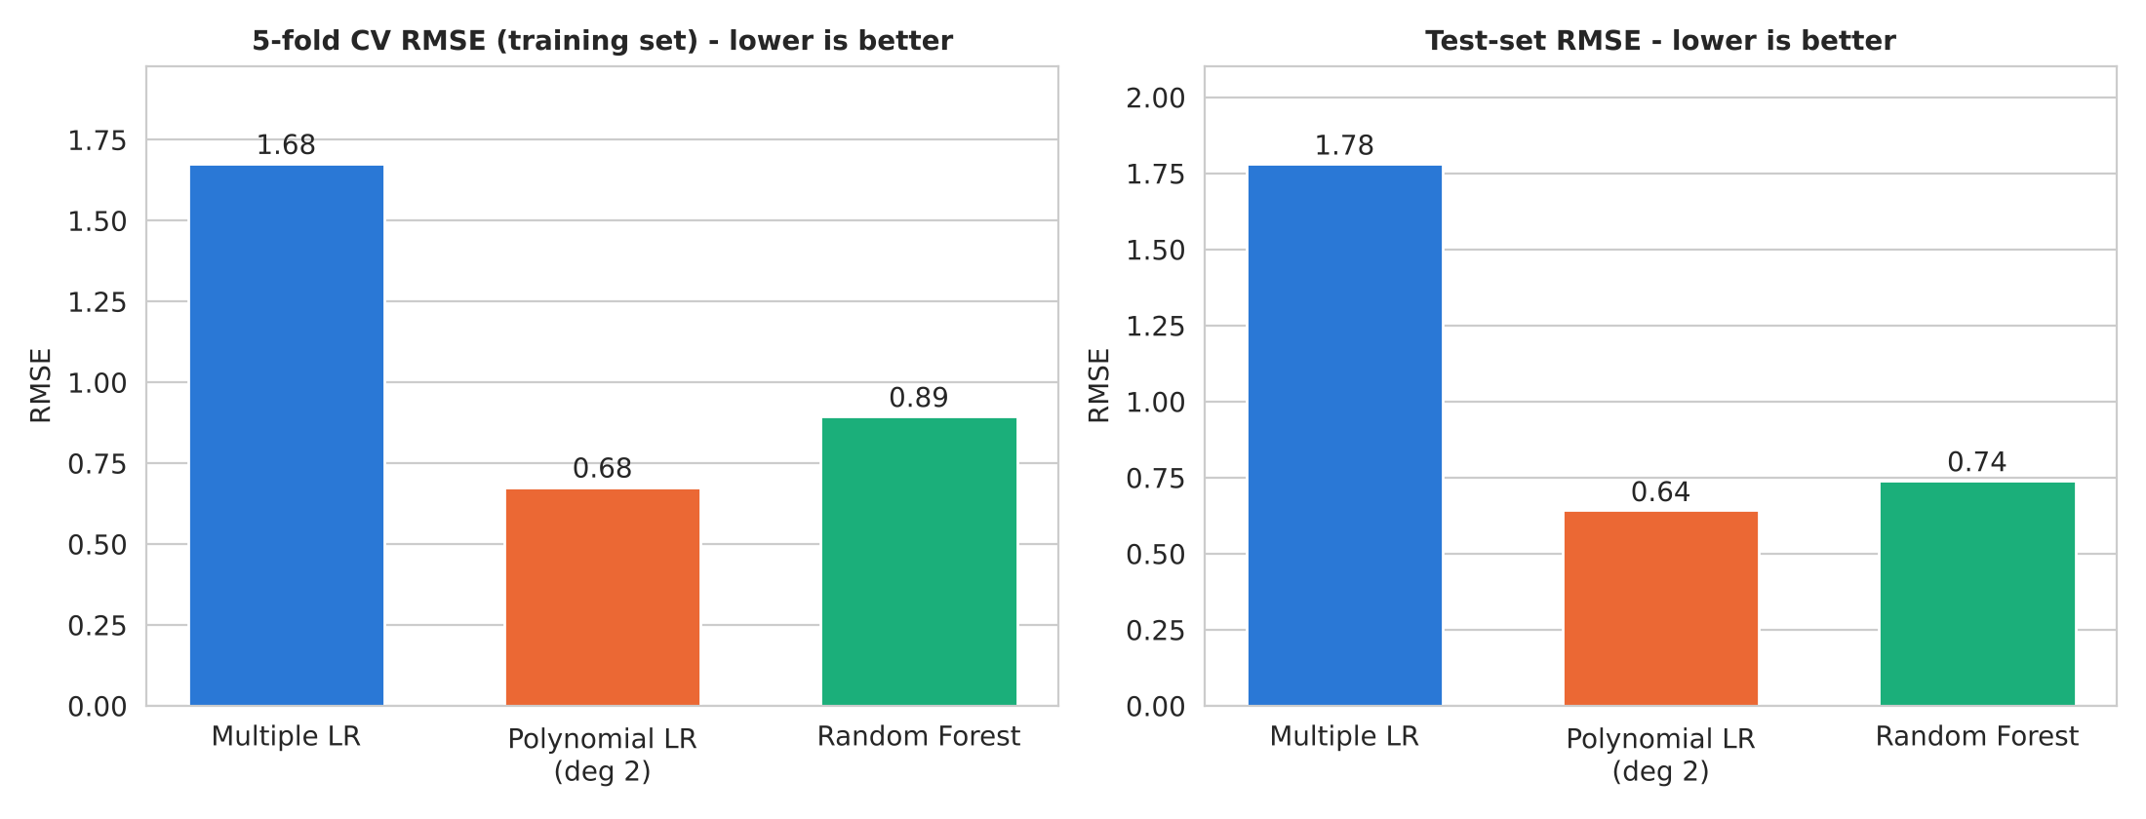
Figure 4: Model comparison - cross-validated RMSE (left) and test RMSE (right); lower is better.
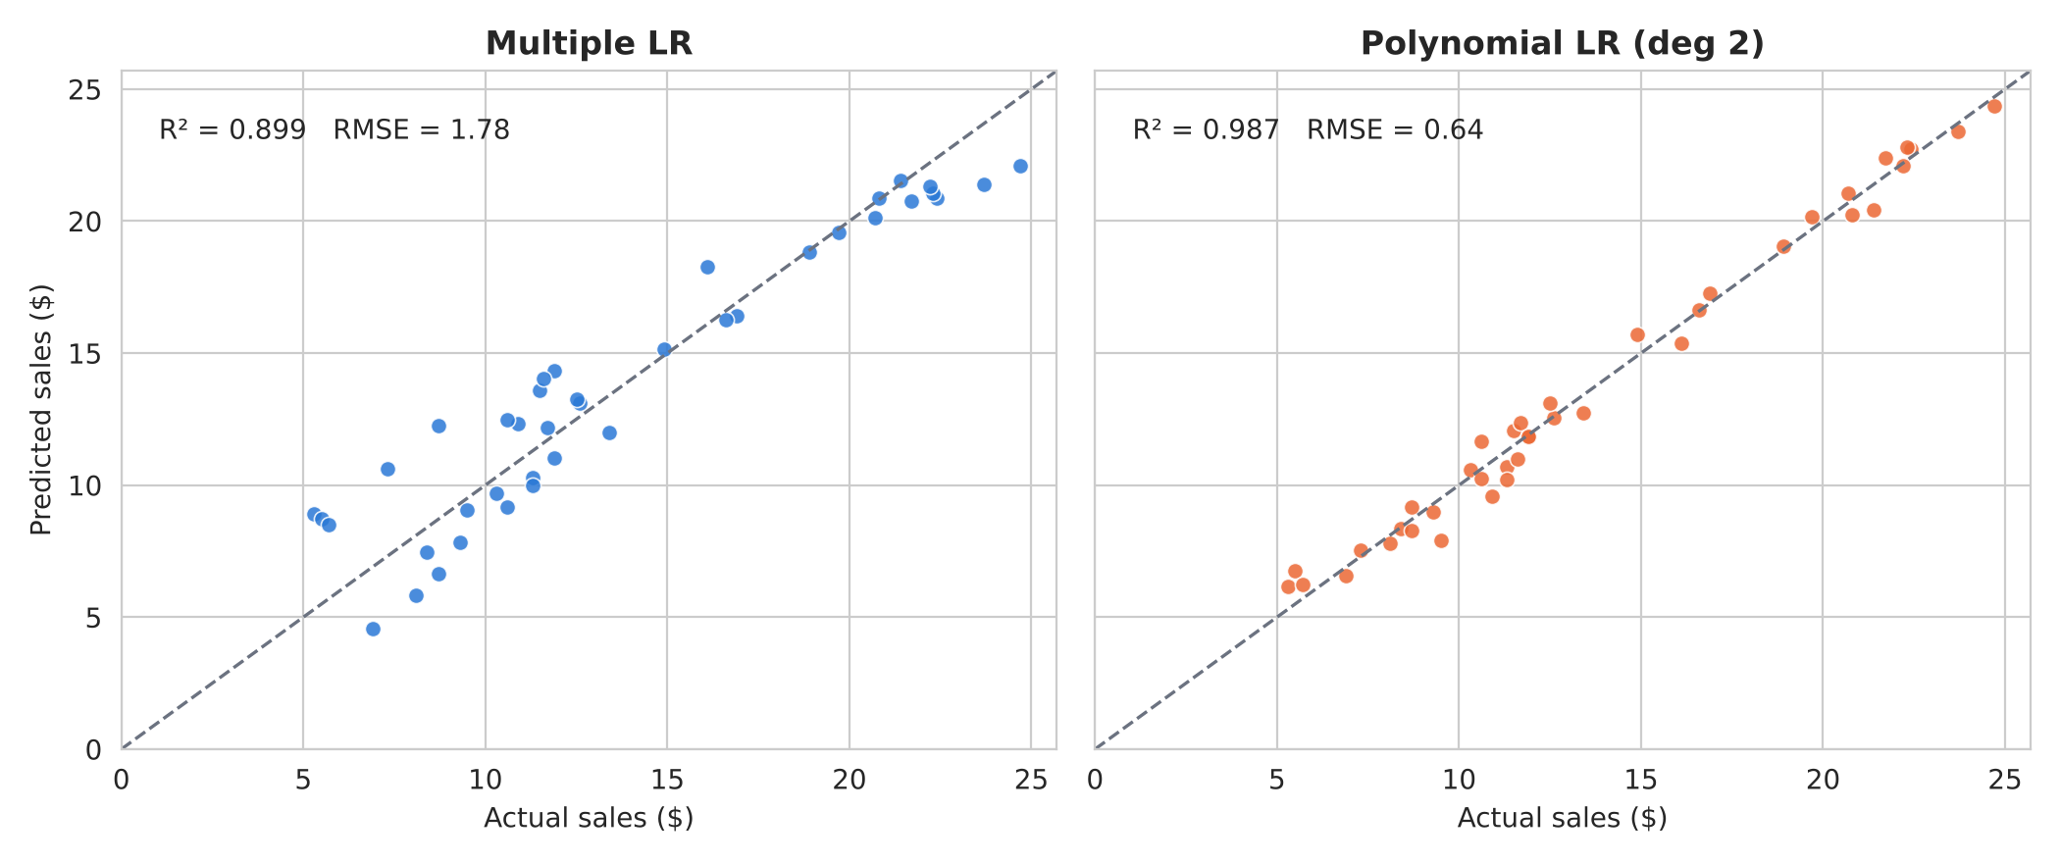
Figure 5: Actual vs predicted sales on the test set; points on the dashed line are perfect predictions.
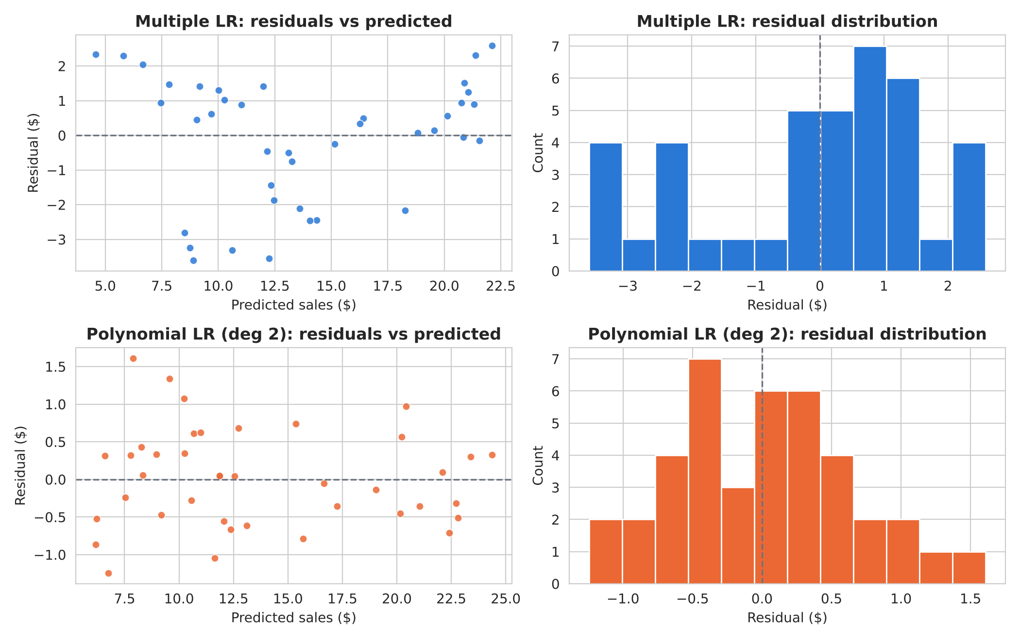
Figure 6: Residuals (actual - predicted) of the baseline (top) and the final model (bottom).

8. Analysis of Results
- Which model won: Polynomial Linear Regression (deg 2). It had the lowest cross-validated RMSE (0.676 vs 0.894 for Random Forest and 1.676 for the baseline) and the best test result: R² = 0.987, RMSE = 0.643, MAE = 0.526. Compared with the plain multiple regression it cuts the test RMSE by 64% and the MAE by 64%.
- What the errors mean: the final model is typically wrong by about 0.53 sales units (4% of the average sales of 14.0), and the larger misses are about 0.64 (RMSE). The baseline is off by about 1.46 on average. In Figure 6 the baseline residuals form a U-shape: it under-predicts at very low and very high sales and over-predicts in the middle, which means it misses a pattern. The final model's residuals are scattered evenly around zero with no pattern.
- Which metric matters most: for budgeting, RMSE and MAE matter most because they say how many sales units a forecast can be wrong by, in the unit of sales; RMSE punishes large misses, which are the costly ones when a budget is planned. R² is useful for comparing models but does not say how large the error is.
- Random Forest: nearly as accurate on the test set (R² = 0.983) but it fits the training data much more closely (training R² 0.997 vs test 0.983, a gap of 0.014) than the polynomial model (training 0.986 vs test 0.987, no sign of overfitting), and it cannot be written as a simple equation. The polynomial linear regression is therefore the better choice here.
- Business insight (baseline coefficients): Sales = 2.979 + 0.0447 x TV + 0.1892 x Radio + 0.0028 x Newspaper. One extra unit of radio budget is associated with about 4.2 times the sales gain of one extra unit of TV budget, while newspaper has almost no effect once TV and radio are known.

Limitations
- Small data: with only 200 markets and a 40-row test set, the metrics carry some uncertainty (the baseline's cross-validated R² varies by ±0.07 between folds).
- Predictions outside the budget ranges in the data are unreliable, and squared terms can behave badly there. The desktop application warns the user when a value is out of range.
- The model shows association, not proof of cause. Price, season, region and competitors are not in the data.
- The polynomial model's individual coefficients are harder to interpret than those of the baseline.

9. Mapping to the Course Outcome
CO5 - Solve real life problems using appropriate machine learning models and evaluate the performance measures. This project addresses a real marketing problem (predicting sales from advertising spend), compares three suitable models and selects one using cross-validation, and evaluates it with MAE, MSE, RMSE, R², adjusted R² and residual analysis.

10. Desktop Application
The final model is packaged as a desktop application (desktop_app.py, built with Tkinter). The user types or slides the three budgets and sees the predicted sales, the typical error, the prediction of the other models for comparison and a warning when an input is outside the training range. Other tabs show the dataset, the model results and all graphs, and the prediction history can be exported to CSV. To run the project: pip install pandas numpy matplotlib seaborn scikit-learn joblib python-docx; python train_model.py; python desktop_app.py.
[ Insert a screenshot of the running application here ]
Figure 7: Screenshot of the desktop application (Predict tab).

