Audio Classification - Identifying Environmental Sounds

Mohamed Nasr, Abdulsalam Elsayed | Fatma El Samman, Mohamed Gad and Saif Eslam
Computer Science | Computer Science
Nile University | Nile University
221000089, 221000322 | 221001971, 221001496, 221001001

Abstract - This paper presents a high-performance environmental sound classification system combining YAMNet embeddings with a Convolutional Neural Network (CNN). We trained on a custom dataset of over 10,000 audio samples derived from ESC-50 and UrbanSound8K, spanning 57 environmental sound classes. Using YAMNet for transfer learning and a CNN classifier trained on the embeddings, the final model achieved over 93% test accuracy. A user-friendly application was also developed to support real-time audio classification and batch predictions on uploaded files.

Index Terms - Audio classification, environmental sounds, YAMNet, CNN, transfer learning.

I. Introduction
This paper presents a high-performance environmental sound classification system that leverages YAMNet as a high-level feature extractor, followed by various machine learning classifiers. We trained on a custom dataset of over 10,000 audio samples derived from ESC-50 and UrbanSound8K, spanning 57 sound classes. Beyond the primary CNN model—which achieved over 93% test accuracy—our experiments included LSTM, MLP, and several classical models such as SVM, Random Forest, Logistic Regression, and XGBoost. Notably, Logistic Regression performed exceptionally well among classical models with an average per-class accuracy of 86.7%. By combining all models using a hybrid approach—selecting the best-performing model for each class—we further improved the system’s accuracy, reaching up to 94.94%. Additionally, we developed a user-friendly application to support real-time audio classification and batch predictions on uploaded files.

II. Datasets
Two datasets were used: ESC-50 (2,000 samples, 50 classes) and UrbanSound8K (8,732 samples, 10 classes). We merged them with a 10,000+ sample dataset with 57 distinct classes. All samples were resampled and preprocessed to ensure consistency in duration and format before feeding into the model.
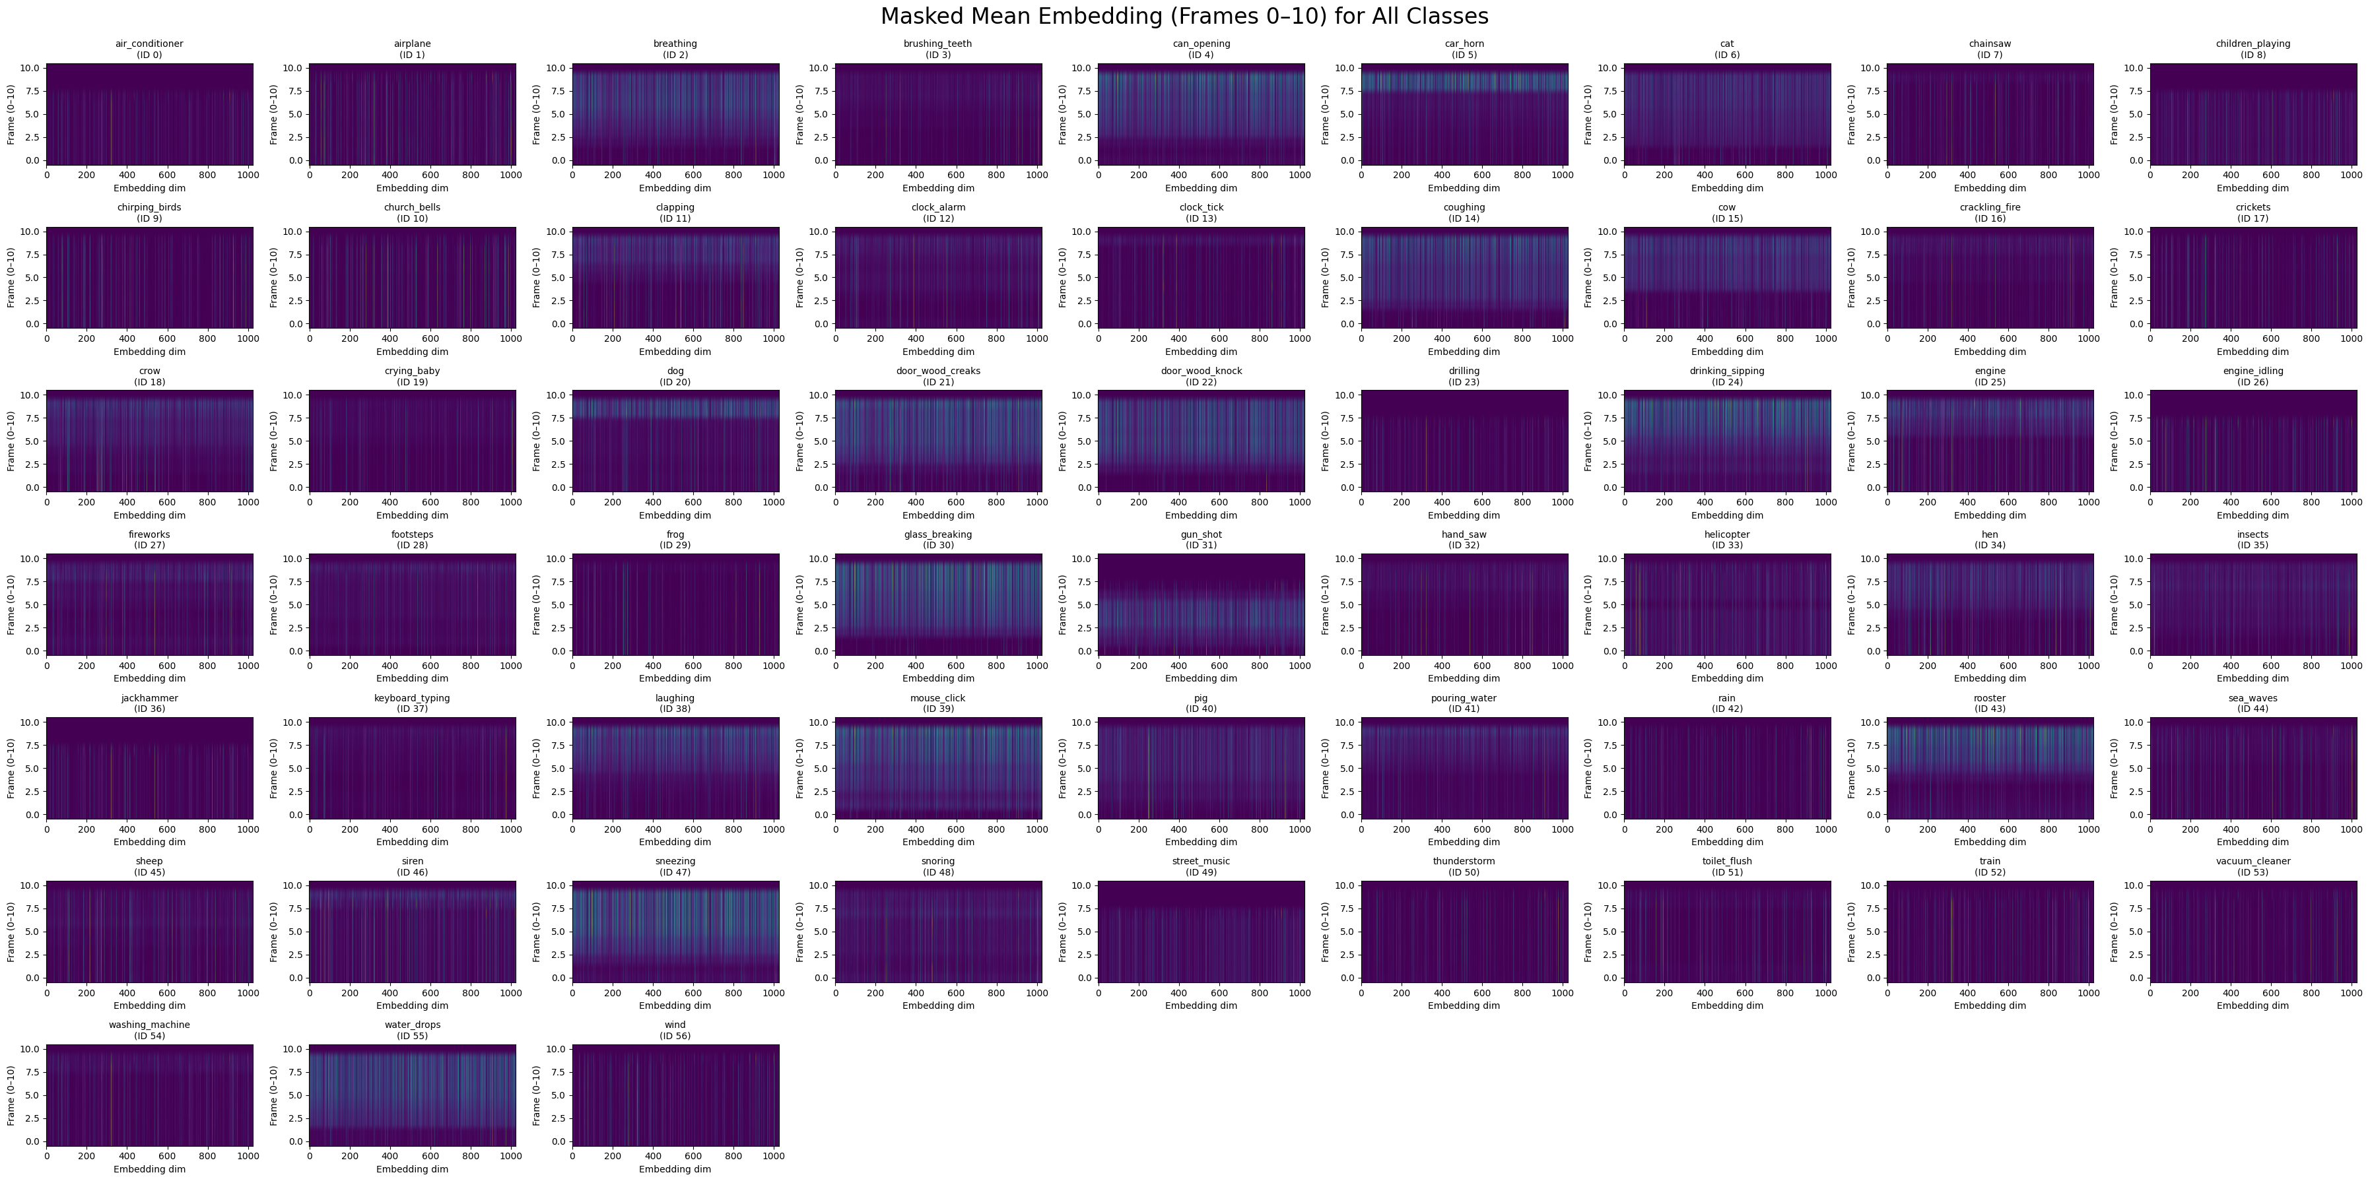
III. Methodology

Audio Preprocessing and Feature Extraction:
We begin by resampling each raw audio file to 16 kHz and normalizing the waveform amplitude. Audio files are then segmented or padded to fixed durations compatible with YAMNet’s input requirements. We utilize YAMNet, a pre-trained deep audio event classifier based on MobileNet, as a high-level feature extractor. For each audio segment, YAMNet produces a sequence of 1024-dimensional embeddings, one per 0.96-second frame, resulting in a feature matrix of shape (frames, 1024) per sample. For consistency, all embeddings are either truncated or zero-padded to a fixed number of frames (e.g., 100).

Model Training:
The extracted embeddings are used as input features for both deep learning and classical machine learning classifiers:

Deep Models: A custom CNN, LSTM, and MLP were trained on the 3D embedding sequences. Each model was evaluated using stratified train/validation/test splits.
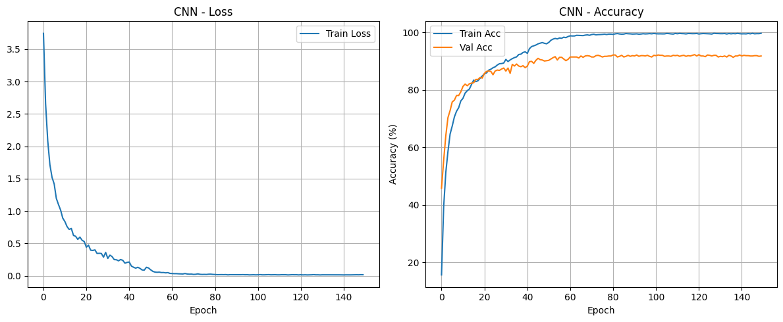

Classical Models: Embeddings were flattened and further reduced in dimensionality via PCA, then classified using SVM, Random Forest, Logistic Regression, and XGBoost.

Ensemble and Per-Class Model Selection:
Beyond individual models, we implemented:

Majority Voting Ensemble: The predicted class labels from all models (deep and classical) were aggregated using majority voting to generate an ensemble prediction. This resulted in a worse accuracy score than the CNN model or the Hybrid Per-Class Best Model approach, it achieved an accuracy score of 92%

Hybrid Per-Class Best Model: For each class, the model with the highest per-class accuracy (deep or classical) was chosen as the “expert” for that class. This hybrid approach achieved the best overall test accuracy.

IV. Results
After training on the merged dataset of ESC-50 and
UrbanSound8K, our CNN model utilizing YAMNet
embeddings achieved over 93% accuracy on the test set, outperforming previous baselines using spectrograms or raw audio features alone. Both LSTM and MLP models achieved lower standalone performance, with average per-class accuracies of 87–88%. Among classical models, Logistic Regression performed exceptionally well, reaching 86.7% average per-class accuracy.
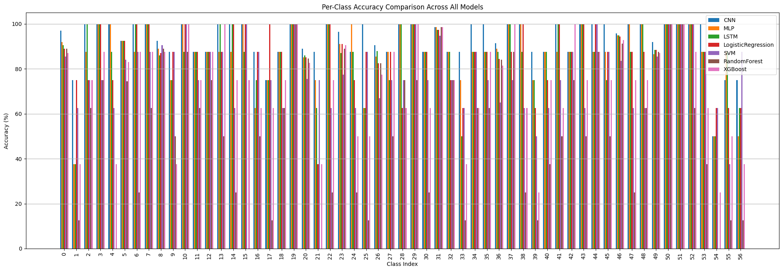
To further boost generalization, we implemented both majority voting ensembles and a hybrid per-class approach, where the best-performing model for each class was selected as the “expert.” This hybrid system resulted in a notable increase in overall performance, reaching up to 94.94% test accuracy.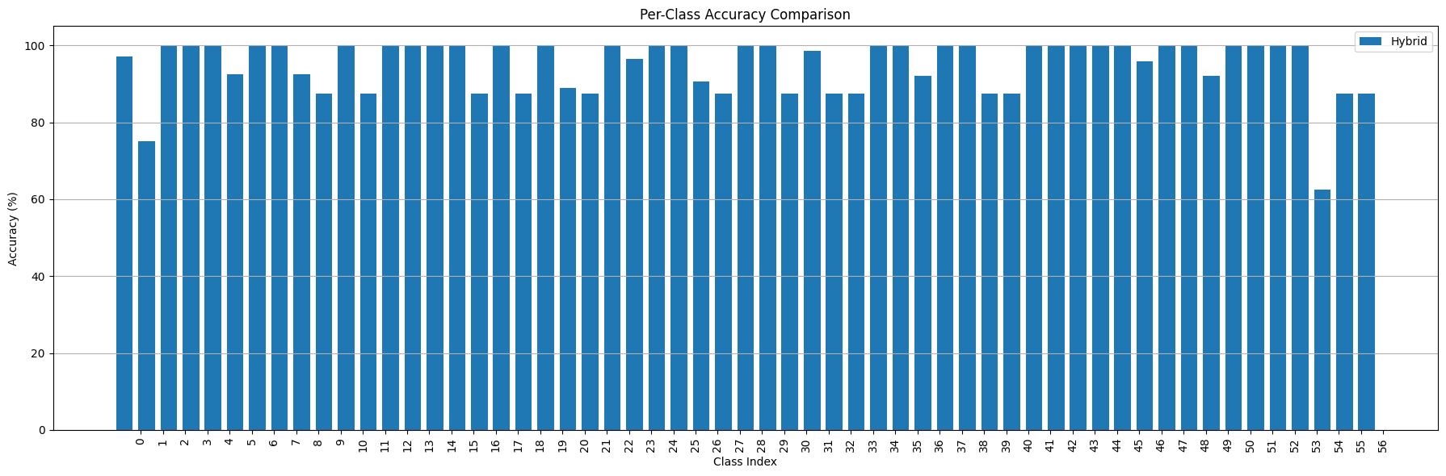
All models were trained using mini-batch processing and the Adam optimizer, with early stopping based on validation loss. Model evaluation was conducted using stratified splits and per-class accuracy metrics. Additional analysis included per-class heatmaps of YAMNet embeddings, demonstrating that most audio information is contained within the first 20 frames, as well as detailed performance comparison plots for all evaluated models.

V. Application
A Python-based desktop application was developed using Tkinter to support file uploads, real-time waveform visualization, and sound prediction. This GUI allows users to classify sounds from both local files and live microphone input using the trained model, this application uses the CNN model weights for classification, as the hybrid model provides 1-2% extra accuracy with a huge performance and complexity cost.

VI. Conclusion
This project evaluated several audio classification approaches, including classical models (such as Logistic Regression), standalone CNNs, and hybrid deep learning pipelines using YAMNet as a feature extractor. Logistic Regression provided a strong baseline, while pure CNN models showed substantial improvements in accuracy. However, our proposed CNN model outperformed all others, achieving a per-class accuracy of up to 93.18%—demonstrating the value of combining pre-trained audio embeddings with custom classifiers. Additionally, majority voting between models did not yield better results than the best individual models. These findings highlight the effectiveness of deep hybrid architectures for environmental sound classification, setting a strong foundation for future work in real-time mobile and edge deployment.

References
- [1Jansen et al., 'YAMNet: A deep net for audio event classification using MobileNetV1,' TensorFlow Hub.
- Piczak, K.J., 'ESC: Dataset for Environmental Sound Classification,' ACM Multimedia 2015.
- Salamon et al., 'Urban Sound Dataset and UrbanSound8K,' 2014.
- Hershey et al., 'CNN Architectures for Large-Scale Audio Classification,' ICASSP 2017.

