Jurnal  Teknologi |  |  |  | Full Paper
PRIORITISING SAFETY FACTORS AND RISK MITIGATION STRATEGIES IN ROAD CONSTRUCTION PROJECTS USING THE ANALYTICAL HIERARCHY PROCESS  Ummu Najwa Nur Yusrizalª, Noram Irwan Ramliª*, Putri Zulaiha Raziª, Ramadhansyah Putra Jayaª, Siti Nurizzati Ismailª, Lee Kai Lingª  ªFaculty of Civil Engineering Technology, Universiti Malaysia Pahang Al- Sultan Abdullah, 26300, Pahang, Malaysia |  |  | Article history  Received  X Month 202Y  Received in revised form  XA Month 202Y  Accepted  XB Month 202Y  *Corresponding author  noram@umpsa.edu.my
Graphical abstract  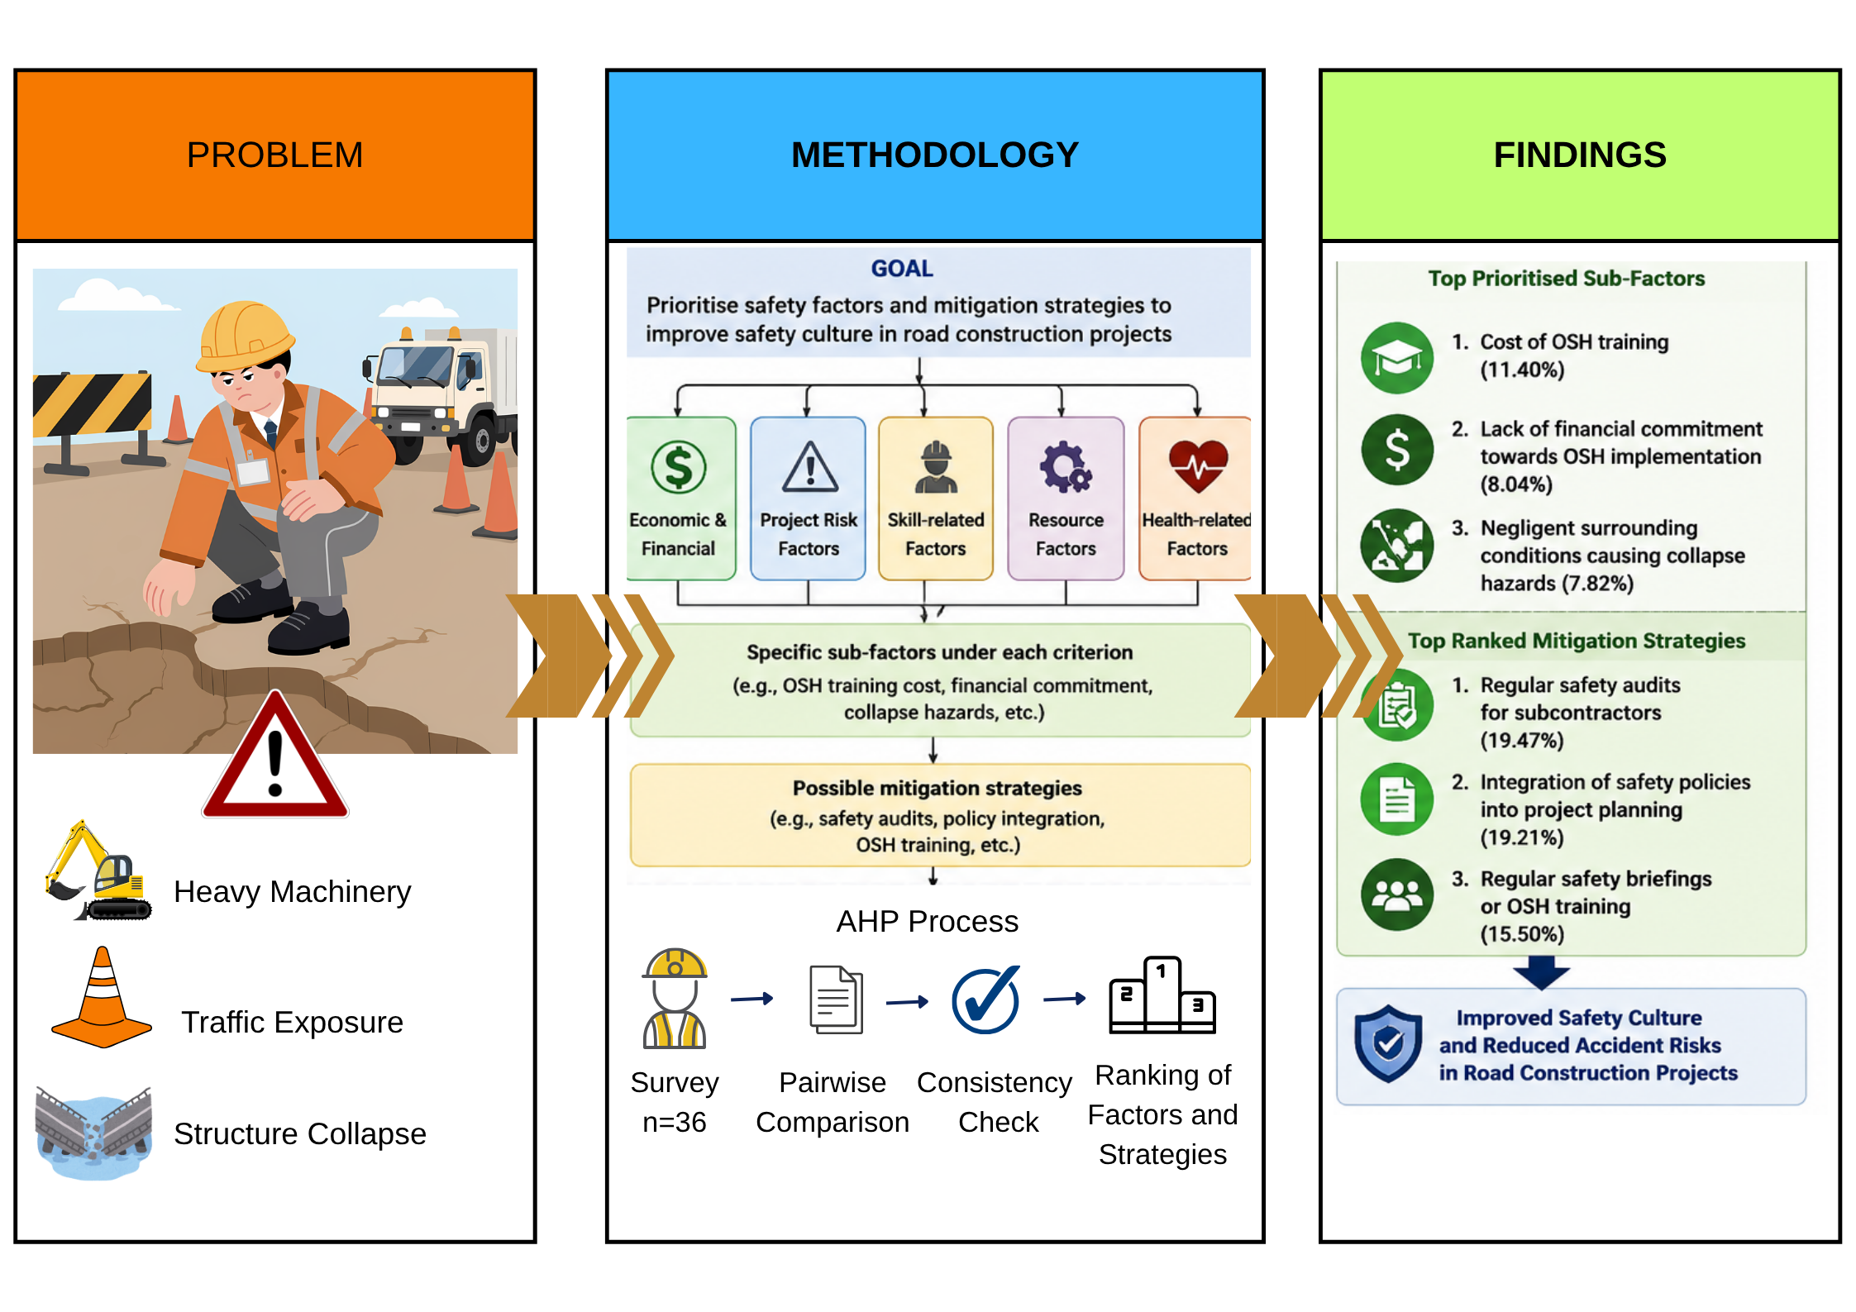 |  | Abstract  Infrastructure projects, including road construction projects, inherently operate under risky and hazardous situations, particularly during processes involving earthworks, temporary structures, heavy machinery and live traffic exposure. Such situations will significantly increase the risk of occupational accidents and public safety incidents, which require effective safety culture and risk mitigation strategies. This study aimed to identify and prioritise the critical factors influencing safety culture in road construction projects and to evaluate suitable mitigation strategies for reducing safety risks. A quantitative survey was conducted among professionals involved in road construction projects in Malaysia, involving 36 valid respondents comprising engineers, contractors, project managers, and safety practitioners. Relative weight of the safety criteria, sub-criteria, and the respective mitigation strategies were established using the Analytic Hierarchy Process (AHP). Results showed that the economic and financial aspects were the most important criterion, with an importance weight of 25.77%. This was followed by project risk factors and skill-related factors, with 24.60% and 17.20% respectively. In addition, the cost of Occupational Safety and Health (OSH) training (11.40%), lack of financial commitment towards OSH implementation (8.04%), and negligent surrounding conditions causing collapse hazards (7.82%) appeared as the most critical sub-factors in the findings. The highest-ranked mitigation strategies were regular safety audits for subcontractors (19.47%), integration of safety policies into project planning (19.21%), and regular safety briefings or OSH training (15.50%). This study provides a prioritised framework for strengthening safety culture and minimising accident risks in road construction projects.  Keywords: Road construction, safety culture, risk mitigation, occupational safety and health, Analytical Hierarchy Process, construction management
Abstrak

Projek infrastruktur, termasuk projek pembinaan jalan, sememangnya beroperasi dalam keadaan yang berbahaya, terutamanya semasa kerja-kerja melibatkan kerja tanah, struktur sementara, jentera berat dan kerja yang terdedah kepada aliran trafik. Situasi berikut secara tidak langsung meningkatkan risiko kemalangan pekerjaan dan keselamatan awam, di mana keberkesanan budaya keselamatan dan strategi mitigasi risiko diperlukan. Kajian ini bertujuan untuk mengenal pasti dan mengutamakan faktor-faktor kritikal yang mempengaruhi budaya keselamatan dalam projek pembinaan jalan dan untuk menganalisis strategi mitigasi yang sesuai untuk mengurangkan risiko keselamatan. Tinjauan kuantitatif dilakukan dalam kalangan pakar yang terlibat dengan projek pembinaan jalan di Malaysia yang melibatkan seramai 36 responden termasuklah jurutera, kontraktor, pengurus projek dan pakar keselamatan. Pemberat relatif kriteria keselamatan, subkriteria dan strategi mitigasi, telah diperoleh dengan menggunakan Proses Hierarki Analitik (AHP). Hasil dapatan menunjukkan bahawa faktor ekonomi dan kewangan muncul sebagai adalah kriteria yang paling kritikal, dengan jumlah 25.77%. Kedudukan ini diikuti dengan faktor risiko projek dan faktor berkaitan kemahiran, masing-masing dengan nilai 24.60% dan 17.20%. Di samping itu, kos latihan Keselamatan dan Kesihatan Pekerjaan (KKP) (11.40%), kekurangan komitmen kewangan terhadap pelaksanaan latihan KKP (8.04%), dan keadaan persekitaran yang leka yang mengakibatkan keruntuhan struktur (7.82%) muncul sebagai subfaktor paling kritikal dalam dapatan kajian. Untuk strategi mitigasi pula, audit keselamatan berkala untuk subkontraktor (19.47%), adalah yang paling tinggi kedudukannya diikuti dengan penerapan dasar keselamatan ke dalam perancangan projek (19.21%), dan taklimat keselamatan berkala atau latihan (15.50%). Kajian ini menyediakan rangka kerja yang diutamakan untuk memperkukuh budaya keselamatan dan meminimumkan risiko kemalangan dalam projek pembinaan jalan raya.

Kata kunci: Pembinaan jalan, budaya keselamatan, mitigasi risiko, Keselamatan dan Kesihatan Pekerjaan, Proses Hierarki Analitik, pengurusan pembinaan

 |  | © 202@ Penerbit UTM Press. All rights reserved

1.0 INTRODUCTION

The construction industry has always been considered one of the most complicated and diversified industries because of the presence of several parties involved in the process, differences in contractual relations, transitory project structures, and types of work such as buildings, highways, bridges, tunnels, and infrastructure constructions [1]. In the construction industry, road construction projects contribute to mobility at the national level, improved logistics performance, economic efficiency, connectivity of regions, and accessibility of public utilities [2]. With growing transportation demand, road construction remains a high-priority development activity for many countries, such as Malaysia.
Road construction projects are highly dynamic and operationally challenging. Unlike fixed-location building projects, road works commonly extend across long route corridors and involve simultaneous activities such as earthworks, pavement construction, drainage systems, bridge works, slope stabilisation, traffic diversions, and utility relocation [3,4]. Such circumstances result in increased uncertainties and complexities for managers during the planning and execution phases of these undertakings [5].
Construction has been known to be one of the riskiest industries in the world owing to its high number of injuries; fatalities; accidents involving machinery; as well as the hazardous nature of the working environment in comparison with other industries [6,7]. There is likely to be even higher risk associated with road construction projects since workers work in close proximity to moving vehicles, machinery, digging sites, temporary structures, and uneven surfaces [8,9]. Work-zone crashes, machinery collisions, falling objects, and traffic intrusion remain common concerns in road construction activities [10,11].
Several fatal incidents reported globally indicate the severity of these risks. According to Duncan et al. [12], there were six deaths among road construction workers in Maryland when a truck drove into the work zone of the project. There were similar reported cases in Malaysia associated with structural failures, site dangers, and elevated highway construction projects [13,14]. From the examples provided, safety issues arising from road construction projects affect both the employees and the public around such sites.
Construction remains economically important in Malaysia and is labour-intensive. As Hamid et al. [15] pointed out, around 1.33 million workers are employed within the construction industry in Malaysia, representing around 9.1% of total national employment in 2017. Moreover, in the second quarter of 2023, the Department of Statistics Malaysia reports the presence of around 17,513 construction projects [16]. The construction sector contributes positively to national economic development. Nevertheless, safety performance and occupational reliability should be improved in relation to such construction projects. Earlier research identified issues regarding fatalities in construction projects, unsafe working practices, lack of adequate training, poor supervision, and non-conformity to safety standards [15,17,18].
Similar issues were identified in broader construction environments where site incidents occurred due to insufficient hazard inspection, weak management commitment, and limited workforce competency [19,20]. In road construction environments, these challenges may become more critical because projects commonly involve dispersed work fronts, temporary traffic management systems, changing site conditions, and multiple subcontractors.
As a response to persistent accident trends, increasing attention has been directed toward the concept of safety culture. Safety culture generally refers to the shared values, beliefs, attitudes, management commitment, and behavioural practices that influence how safety is prioritised and implemented within an organisation [21,22]. Organisations with a strong safety culture commonly demonstrate proactive leadership, continuous learning, worker participation, effective communication, and preventive decision-making practices. Inadequate safety awareness is often related to weak management commitment, insufficient accountability, and unsafe working practices.
In road construction projects, safety culture is influenced by numerous interrelated factors. These include financial capability, resource availability, workforce competency, planning quality, subcontractor management, hazard exposure, regulatory compliance, and organisational commitment toward occupational safety and health [23-25]. Because project organisations often operate under budget limitations and competing project priorities, not all safety issues can be addressed simultaneously. Therefore, a structured prioritisation approach is required to identify the most critical factors and allocate safety improvement efforts more effectively.
In construction and infrastructure management, multi-criteria decision-making tools have increasingly been used to support complex managerial and engineering decisions. The Analytical Hierarchy Process (AHP), which is able to produce measurable priorities, through expert judgments, is another widely used technique. [26-28]. This framework is suitable for both qualitative and quantitative decision-making applications in engineering management, risk assessment, budget allocation, and safety evaluation as it is very systematic [29,30].
Despite the increasing application of AHP in construction management studies, limited research has focused specifically on prioritising the critical factors influencing safety culture in road construction projects within the Malaysian context. Existing studies commonly focus on general building construction environments, isolated hazard categories, or standalone risk assessments without simultaneously evaluating both influencing factors and mitigation priorities. This creates a practical knowledge gap for contractors, consultants, project owners, and regulatory authorities seeking evidence-based decision support for improving safety performance in road construction projects [26,27,29].
Therefore, this study aims to identify and prioritise the critical factors influencing safety culture in road construction projects and to evaluate suitable risk mitigation strategies using the AHP approach. By establishing a ranked decision framework, the study contributes a structured tool for improving resource allocation, strengthening preventive interventions, enhancing worker protection, and supporting safer delivery of road infrastructure projects.

2.0 METHODOLOGY

2.1 Research Design
This study adopted a quantitative research design to identify and prioritise the critical factors influencing safety culture in road construction projects and to evaluate suitable mitigation strategies [31-33]. This study used a structured questionnaire survey as the main data collection method. This is because survey tools are productive for gathering expert and professionals’ judgements, comparative responses from various respondent group within a reasonable timeline [34,35].

The collected data were analysed using the AHP, a recognised multi-criteria decision-making technique introduced by Saaty [26]. AHP is suitable for problems involving multiple criteria and alternatives, through pairwise comparisons and consistency evaluation [28].

2.2 Research Procedure
The study was conducted in four principal stages. First, factors affecting safety culture in road construction projects were identified through literature review and synthesis of issues relevant to the Malaysian construction environment. Second, the identified factors were structured into a hierarchical decision model consisting of criteria, sub-criteria, and mitigation alternatives. Third, pairwise comparison questionnaires were distributed to selected respondents with relevant road construction experience. Finally, the responses were analysed using the AHP procedure to determine priority weights, rankings, and judgement consistency levels. The overall research procedure adopted in this study is illustrated in Figure 1.

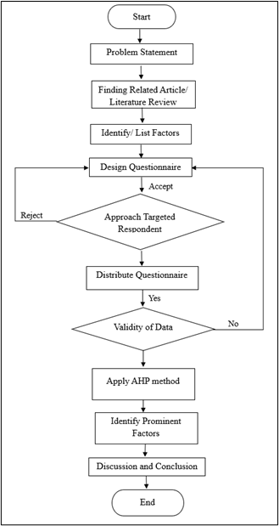
Figure 1 Overall research procedure adopted in the study

2.3 Development of Hierarchical Structure

The hierarchical framework developed for the AHP analysis is presented in Figure 2. The framework was constructed based on the objectives of the study and modelled using Microsoft Visio. The first level of the hierarchy represents the overall decision goal, namely, to identify the critical factors contributing to safety culture in road construction projects and to evaluate suitable strategies to enhance safety culture and mitigate risks.

The second level comprises the principal safety-related criteria, while the third level consists of sub-factors associated with safety culture performance in road construction projects. The fourth level contains mitigation strategies intended to improve project safety outcomes. Such hierarchical decomposition enables complex decision problems to be systematically structured into manageable levels for comparative judgement and prioritisation [26,27].

Figure 2. Hierarchical framework of factors influencing safety culture and mitigation strategies in road construction projects.
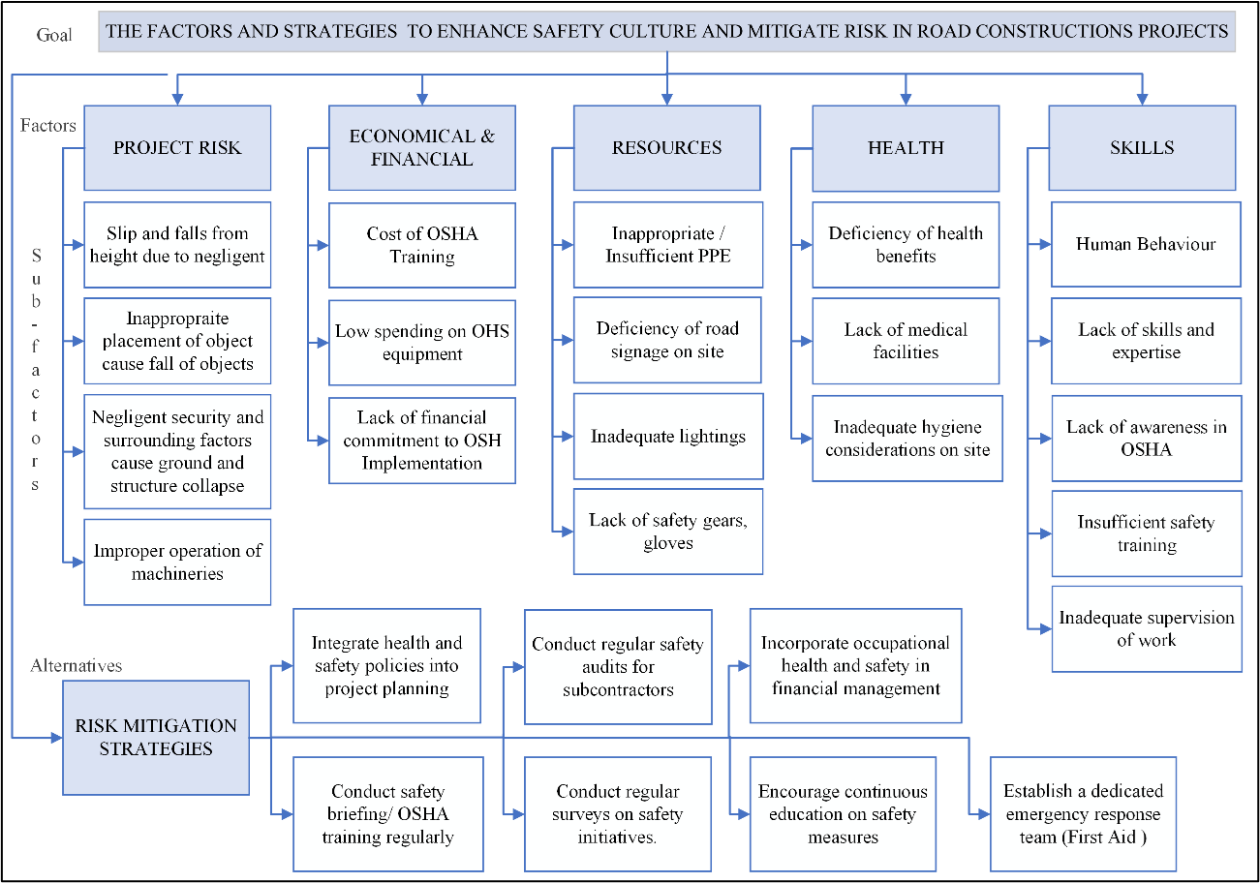
Figure 2 Hierarchical framework of factors influencing safety culture and mitigation strategies in road construction projects

2.4 Population, Respondents and Sampling Technique

The target population comprised construction personnel, registered contractors, safety practitioners, and relevant authorities associated with road construction projects in Malaysia. According to CIDB, approximately 131,121 contractors and 769,351 construction personnel were registered in Malaysia in 2021, indicating a substantial professional population relevant to this study [34].

A purposive sampling technique was adopted to ensure that only respondents possessing suitable industry experience, technical knowledge, and familiarity with road construction safety issues participated in the survey. Purposive sampling is appropriate when respondents must satisfy specific expertise-related criteria relevant to the objectives of the study [35].

A total of 172 online questionnaires were distributed and received 52 respondents. However, only 36 completed the questionnaire and were included in the final analysis. The remaining responses were partially completed and therefore excluded. The final usable response rate was 20.93%. The demographic and professional profile of respondents is summarised in Table 1

Table 1 Summary profile of respondents (n=36)

Variables | Category | n (%)
Profession | Civil Engineer | 20 (55.6)
Profession | Project Manager | 4 (11.1)
Profession | Main Contractor | 4 (11.1)
Profession | Others | 8 (22.2)
Sector | Private | 27 (75.0)
Sector | Government / GLC | 9 (25.0)
Experience | 1–3 years | 13 (36.1)
Experience | 4–9 years | 11 (30.6)
Experience | >10 years | 12 (33.3)
Education | Bachelor’s degree and above | 33 (91.7)

2.5 Questionnaire Instrument and Data Collection

The questionnaire instrument consisted of two sections. The first section collected demographic and professional background information of respondents. The second section required respondents to perform pairwise comparisons among criteria, sub-factors, and mitigation alternatives using Saaty’s nine-point importance scale. The scale ranges from 1 (equal importance) to 9 (extreme importance), while intermediate values represent compromise judgements between adjacent preferences [26]. Reciprocal values were applied when inverse comparisons were required.

The inclusion criteria required respondents to satisfy at least one of the following conditions:
i. Construction safety practitioners or relevant authorities involved in construction activities;
ii. Construction personnel or contractors registered with CIDB or DOSH;
iii. Respondents possessing knowledge or experience related to road construction projects.

Individual pairwise comparison judgements were aggregated using the geometric mean method to obtain a collective comparison matrix. All AHP computations, including normalised weights, priority vectors, and consistency ratio values, were performed using Microsoft Excel.

2.6 Analytical Hierarchy Process (AHP)

The Analytical Hierarchy Process (AHP) was applied to determine the relative importance of the identified factors and mitigation strategies. The implementation of AHP in this study involved several stages. The stages are development of the hierarchical decision structure, construction of pairwise comparison matrices, normalisation of matrix values, calculation of eigenvector priority weights, synthesis of rankings for criteria and alternatives, and consistency testing of respondents’ judgements.

Weighting scores generated from the pairwise comparison matrices indicate the contribution of each criterion and sub-factor toward the overall decision objective [27,28].

2.7 Consistency Test and Evaluation of Mitigation Strategies

The reliability of pairwise comparison judgements was assessed using the Consistency Index (CI) and Consistency Ratio (CR). According to Saaty, a Consistency Ratio value of 0.10 or below is considered acceptable, indicating that respondents’ judgements are reasonably consistent for decision-making purposes [26].

In addition to identifying critical safety factors, this study also evaluated alternative strategies for enhancing safety culture and mitigating risks in road construction projects. The mitigation strategies were positioned at the fourth level of the AHP hierarchy and assessed through pairwise comparisons based on respondents’ professional judgement.

The relative priority of each mitigation strategy was determined using the same AHP weighting procedure applied to the principal criteria and sub-factors. Strategies with higher priority weights were interpreted as more effective and more critical for improving safety performance in road construction environments.

3.0 RESULTS AND DISCUSSION

3.1 Prioritisation of Principal Criteria and Sub-Factors

The AHP analysis demonstrated that economic and financial factors were the most influential criterion affecting safety culture in road construction projects, with an overall weight of 25.77%. This was followed by project risk factors (24.60%) and skills-related factors (17.20%). The remaining principal criteria were resource factors (17.06%) and health factors (15.38%). These findings show that financial capability, risk exposure, and workforce competency are the major factors influencing safety performance in road construction environments.
The emphasis on economic and financial considerations implies that the maintenance of a safety culture cannot be achieved without adequate financial resources. In practical terms, construction organisations require dedicated budgets for training, competent supervision, personal protective equipment, inspections, traffic control systems, and emergency preparedness. In many infrastructure projects, particularly under competitive tendering and cost-sensitive contracts, safety expenditure is often viewed as an operational cost rather than a strategic investment. Previous studies similarly reported that inadequate safety budgeting may reduce implementation effectiveness and weaken proactive risk management practices [40-42].
Among the sub-factors, the cost of Occupational Safety and Health (OSH) training emerged as the most critical issue with a global weight of 11.40%. This finding suggests that training costs may become a practical barrier, particularly for organisations operating under financial limitations. Lack of training may lead to exposure to unsafe conditions, with employees lacking adequate safety skills and awareness of operations. The previous research has also emphasized the importance of continuous development of competencies and safety training for enhanced workplace safety performance [25], [43-45].
The absence of the financial commitment related to OSH programs was another significant sub-factor with weightage of 8.04%. It demonstrates that regulatory compliance may be insufficient in case it is not accompanied by appropriate measures of implementation and enforcement. The effectiveness of safety management systems often depends on organisational willingness to allocate sufficient financial and operational support toward preventive measures [46], [47].
Project risk factors ranked as the second most influential principal criterion. Road construction projects often include traffic involvement, earthworks, ground instability, excavation, mechanical movement, and temporary structures. These working conditions make it likely for accidents to occur; thus, hazard identification and monitoring are necessary throughout the process. Previous research related to road construction and infrastructure safety showed similar results on the relationship between accidents and traffic involvement, equipment movement, and environmental uncertainties [11], [48-50].
It was also observed that negligence in surrounding conditions leading to collapse hazards was one of the most important sub-factors for construction project risks, with the global weight of 7.82%. This shows that lack of environmental and hazard monitoring can lead to high accidents risks in construction projects. In the case of road construction projects, the risks were higher because construction works took place in open areas.
Skills-related factors stood at third priority. Construction operations involve competency, procedure adherence, communication skills, and hazards awareness from workers and supervisors. Inadequate competency can cause poor performance even when adequate safety procedures were in place. Previous studies similarly emphasised that workforce capability and safety awareness directly influence construction safety practices and operational performance [43], [44], [51].
Although resources and health factors recorded lower rankings compared with economic and project risk factors, these aspects should not be neglected. Within the AHP framework, lower ranking only reflects relative priority rather than indicating insignificant influence. Adequate equipment availability, machinery maintenance, staffing support, and worker welfare facilities remain important in sustaining safe project environments. Likewise, health-related issues such as fatigue, dust exposure, heat stress, noise, and flying debris may affect workers’ long-term productivity, wellbeing, and operational safety [52-54].
The prioritisation results of the principal criteria and sub-factors influencing safety culture in road construction projects are presented in Table 2.

Table 2 Prioritisation of principal factors and sub-factors influencing safety culture in road construction projects

Factors (Local Weighted, %), Rank | Sub-Factor (Local Weighted, %) | Global Weighted, % | Ranking
Economic & Financial (25.77%),  1 | EF 1 (44.22) | 11.40 | 1
Economic & Financial (25.77%),  1 | EF 2 (31.19) | 8.04 | 2
Economic & Financial (25.77%),  1 | EF 3 (24.59) | 6.34 | 4
Project Risk (24.60%),  2 | PR1 (31.78) | 7.82 | 3
Project Risk (24.60%),  2 | PR2 (24.61) | 6.05 | 5
Project Risk (24.60%),  2 | PR3 (22.88) | 5.63 | 7
Project Risk (24.60%),  2 | PR4 (20.74) | 5.10 | 10
Skills  (17.20%),  3 | S1 (23.64) | 4.07 | 14
Skills  (17.20%),  3 | S2 (22.72) | 3.91 | 15
Skills  (17.20%),  3 | S3 (19.86) | 3.42 | 16
Skills  (17.20%),  3 | S4 (19.36) | 3.33 | 17
Skills  (17.20%),  3 | S5 (14.42) | 2.48 | 19
Resources  (17.06%),  4 | R1 (33.81) | 5.77 | 6
Resources  (17.06%),  4 | R2 (26.47) | 4.52 | 12
Resources  (17.06%),  4 | R3 (24.17) | 4.12 | 13
Resources  (17.06%),  4 | R4 (14.55) | 2.48 | 18
Health  (15.38%),  5 | H1 (35.50) | 5.46 | 8
Health  (15.38%),  5 | H2(35.42) | 5.45 | 9
Health  (15.38%),  5 | H3 (29.08) | 4.47 | 11
Note: EF = Economic and Financial factors; PR = Project Risk factors; S = Skills factors; R = Resources factors; H = Health factors. Numerical codes represent individual sub-factors evaluated under each principal criterion.

3.2 Prioritisation of Mitigation Strategies

Several mitigation strategies were evaluated using the AHP approach to determine the most effective measures for strengthening safety culture in road construction projects. From the results, it was established that undertaking safety audits on subcontractors consistently ranked highest as a mitigation method with a local weight of 19.47%. Other highly ranking methods included inclusion of health and safety into project planning (19.21%) and undertaking safety briefings or OSH training (15.50%).
The high preference accorded to safety audits among subcontractors is an indication of the necessity of continuous monitoring and compliance monitoring in the road construction process. In most cases, subcontractors work on specialised functions under different supervision and operating conditions, which could lead to variations in the implementation of safety. Safety audits help in ensuring continuous monitoring, increasing accountability, and guaranteeing compliance among several stakeholders. Similar findings have been documented previously on construction governance, where monitoring systems were identified as key aspects for consistent safety performance [42], [55]. Integration of health and safety policies in project planning emerged as the second most effective mitigation measure. This means that safety management measures should be considered during project planning and before project implementation. Integration of safety measures early can lead to better management of traffic, proper equipment coordination, temporary works management, excavation control, and labour planning. Previous literature has also supported this view and highlighted that safety consideration during project planning can significantly contribute to minimisation of safety risks associated with construction sites [56-58].
Effective safety briefing and OSH training programs have also been considered highly important in maintaining safety measures. Construction site road projects usually include changing environmental conditions, exposure to weather, machine usage, and traffic interactions, making it necessary for workers to keep themselves updated about these changing aspects at work. Therefore, effective safety briefing can help improve hazard perception and safe operational practices [22], [41], [45].
The remaining mitigation strategies included incorporating occupational safety and health considerations into financial management (13.63%), conducting regular surveys on safety initiatives (12.26%), establishing dedicated emergency response teams (10.59%), and encouraging continuous education on safety measures (9.35%). Despite these mitigation strategies resulted in lower rankings, they remain important elements for enhancing future safety performance and organisational preparedness in road construction environments.
In the Malaysian construction context, the findings indicate that enforcement strategies should be supported by stronger managerial commitment, procurement practices, financial allocation, and competency development initiatives. Regulatory inspections alone may not adequately address insufficient safety costing, inadequate subcontractor supervision, and limitations in workforce training. Public agencies, contractors, and project owners may therefore consider implementing dedicated safety budgeting, stronger tender-stage safety evaluations, and mandatory competency development programmes for construction personnel [17], [34].
The prioritisation of mitigation strategies for improving safety culture in road construction projects is presented in Table 3.

Table 3 Ranking of mitigation strategies for improving safety culture in road construction projects

Alternatives | Local Weight (%) | Ranking
Conduct regular safety audits for subcontractors, AS1 | 19.47 | 1
Integrate health and safety policies into project planning, AS2 | 19.21 | 2
Conduct regular safety briefings or OSH training, AS3 | 15.50 | 3
Incorporate occupational health and safety in financial management, AS4 | 13.63 | 4
Conduct regular surveys on safety initiatives, AS5 | 12.26 | 5
Establish a dedicated emergency response team (First Aid), AS6 | 10.59 | 6
Encourage continuous education on safety measures, AS7 | 9.35 | 7

3.3 Overall Implications of the Findings

Overall, the findings indicate that improving safety culture in road construction projects requires a balanced approach involving financial commitment, effective risk management, workforce competency enhancement, planning integration, and continuous monitoring. The dominance of economic and financial factors demonstrates that sufficient safety budgeting and organisational support remain fundamental for sustaining preventive safety measures during project implementation.
The prioritised framework developed in this study provides a structured decision-support reference for contractors, consultants, project owners, and regulatory authorities in identifying critical safety concerns and selecting appropriate mitigation strategies. The findings may also support future improvements in safety governance, project planning practices, competency development programmes, and construction risk management within the Malaysian road construction sector.

4.0 CONCLUSION

This study applied AHP to prioritise the critical factors influencing safety culture in road construction projects and to evaluate suitable mitigation strategies. The findings identified economic and financial factors as the most influential criterion, followed by project risk factors and skills-related factors, while the cost of OSH training, lack of financial commitment towards OSH implementation, and hazardous surrounding conditions emerged as the most critical sub-factors. In terms of improvement measures, regular safety audits for subcontractors, integration of health and safety policies into project planning, and regular safety briefings or OSH training were ranked as the most effective strategies. These findings highlighted that enhancing safety cultures needs sufficient financial commitment, extensive planning, continuous supervision, and workforce competency advancement. The study provides a practical prioritisation framework that may assist contractors, consultants, project owners, and relevant authorities in improving safety performance, reducing accident exposure, and enhancing project delivery in road construction environments.

Acknowledgement

The authors would like to express their sincere appreciation to Universiti Malaysia Pahang Al-Sultan Abdullah (UMPSA) for the support provided throughout this study. The authors also acknowledge all respondents and industry professionals involved in the questionnaire survey for their valuable cooperation and contributions to this research.

References

[1] S. Winge, E. Albrechtsen, and J. Arnesen, “A comparative analysis of safety management and safety performance in twelve construction projects,” Journal of Safety Research, vol. 71, pp. 139–152, 2019. https://doi.org/10.1016/j.jsr.2019.09.015
[2] C. P. Ng, T. H. Law, F. M. Jakarni, and S. Kulanthayan, “Road infrastructure development and economic growth,” IOP Conference Series: Materials Science and Engineering, vol. 512, no. 1, 2019. https://doi.org/10.1088/1757-899X/512/1/012045
[3] M. Riaz, A. R. Khan, and S. Ullah, “Safety risk identification and assessment in highway construction projects using multi-criteria techniques,” International Journal of Construction Management, vol. 23, no. 5, pp. 812–825, 2023. https://doi.org/10.1080/15623599.2021.1921703
[4] X. Zhang, S. Huang, S. Yang, R. Tu, and L. Jin, “Safety assessment in road construction work system based on group AHP-PCA,” Mathematical Problems in Engineering, vol. 2020, pp. 1–10, 2020. https://doi.org/10.1155/2020/8857947
[5] P. T. R. S. Sugathadasa, R. P. H. M. A. Herath, and A. Thibbotuwawa, “Supply chain risk assessment and mitigation approaches for small-sized road construction projects,” in Proceedings of the International Conference on Industrial Engineering and Operations Management, Singapore, 2021, pp. 4621–4632.
[6] S. S. Timofeeva, D. V. Ulrikh, and N. V. Tsvetkun, “Professional risks in construction industry,” Procedia Engineering, vol. 206, pp. 911–917, 2017. https://doi.org/10.1016/j.proeng.2017.10.576
[7] Z. Zhou, Y. Goh, and Q. Li, “Overview and analysis of safety management studies in the construction industry,” Safety Science, vol. 72, pp. 337–350, 2015. https://doi.org/10.1016/j.ssci.2014.10.006
[8] Y. Chen, L. Zhao, and H. Wu, “Occupational risk evaluation for road construction work zones using integrated fuzzy assessment methods,” Safety Science, vol. 158, p. 105983, 2023. https://doi.org/10.1016/j.ssci.2022.105983
[9] N. Bharadwaj, P. Edara, and C. Sun, “Risk factors in work zone safety events: A naturalistic driving study,” Transportation Research Record, vol. 2673, no. 1, pp. 379–387, 2019. https://doi.org/10.1177/0361198118822285
[10] K. Zhang and M. Hassan, “Crash severity analysis of nighttime and daytime highway work zone crashes,” PLoS ONE, vol. 14, no. 8, p. e0221128, 2019. https://doi.org/10.1371/journal.pone.0221128
[11] S. M. Alsultan, F. K. Alqahtani, and K. F. Alkahtani, “Health and safety in temporary work zone road construction project in Saudi Arabia: Risks and solutions,” International Journal of Environmental Research and Public Health, vol. 19, no. 17, 2022. https://doi.org/10.3390/ijerph191710607
[12] I. Duncan, D. Morse, J. Hilton, and T. Armus, “6 road construction workers die in Maryland when car crashes into them,” Washington Post, Mar. 2023.
[13] A. Ahmad Suhael, “DOSH: SUKE Highway incident classified as road accident,” New Straits Times, Mar. 2021.
[14] H. Auto, “Scaffolding collapse at Malaysian highway construction site injures two,” The Straits Times, Jun. 2021.
[15] A. R. A. Hamid et al., “Causes of fatal construction accidents in Malaysia,” IOP Conference Series: Earth and Environmental Science, vol. 220, no. 1, 2019. https://doi.org/10.1088/1755-1315/220/1/012044
[16] Department of Statistics Malaysia, “Construction Statistics,” OpenDOSM, 2023. [Online]. Available: https://open.dosm.gov.my
[17] A. Ayob, A. A. Shaari, M. F. M. Zaki, and M. A. C. Munaaim, “Fatal occupational injuries in the Malaysian construction sector,” IOP Conference Series: Earth and Environmental Science, vol. 140, no. 1, 2018. https://doi.org/10.1088/1755-1315/140/1/012095
[18] N. N. A. A. Halim, M. H. Jaafar, M. A. Kamaruddin, et al., “The causes of Malaysian construction fatalities,” Journal of Sustainability Science and Management, vol. 15, no. 5, pp. 236–256, 2020. https://doi.org/10.46754/jssm.2020.07.016
[19] D. Hardison and M. Hallowell, “Construction hazard prevention through design: Review of perspectives, evidence, and future research agenda,” Safety Science, vol. 120, pp. 517–526, 2019. https://doi.org/10.1016/j.ssci.2019.07.040
[20] M. D. Cooper, “Towards a model of safety culture,” Safety Science, vol. 36, no. 2, pp. 111–136, 2000. https://doi.org/10.1016/S0925-7535(00)00035-7
[21] J. Reason, Managing the Risks of Organizational Accidents. Aldershot, U.K.: Ashgate, 1997.
[22] K. Miladi Rad and O. Aminoroayaie Yamini, “The importance and use of risk management in various stages of construction projects life cycle,” Modern Applied Science, vol. 11, no. 1, p. 48, 2016. https://doi.org/10.5539/mas.v11n1p48
[23] D. Nkurunziza, “Investigation into road construction safety management techniques,” Open Journal of Safety Science and Technology, vol. 10, no. 3, pp. 81–90, 2020. https://doi.org/10.4236/ojsst.2020.103007
[24] P. M. Wamalwa and N. G. Juster, “Determinants of occupational health and safety implementation in road construction projects in Kenya,” International Journal of Research and Innovation in Social Science, vol. 6, no. 7, pp. 445–452, 2022.
[25] A. Albert, M. R. Hallowell, B. Kleiner, A. Chen, and M. Golparvar-Fard, “Enhancing construction hazard recognition with high-fidelity augmented virtuality,” Journal of Construction Engineering and Management, vol. 140, no. 7, p. 04014024, 2014. https://doi.org/10.1061/(ASCE)CO.1943-7862.0000860
[26] R. W. Saaty, “The analytic hierarchy process—what it is and how it is used,” Mathematical Modelling, vol. 9, no. 3–5, pp. 161–176, 1987. https://doi.org/10.1016/0270-0255(87)90473-8
[27] R. D. F. S. M. Russo and R. Camanho, “Criteria in AHP: A systematic review of literature,” Procedia Computer Science, vol. 55, pp. 1123–1132, 2015. https://doi.org/10.1016/j.procs.2015.07.081
[28] T. Krenicky, L. Hrebenyk, and V. Chernobrovchenko, “Application of concepts of the analytic hierarchy process in decision-making,” Management Systems in Production Engineering, vol. 30, no. 4, pp. 304–310, 2022. https://doi.org/10.2478/mspe-2022-0038
[29] J. A. Corvin, I. Chan, C. X. Aguado Loi, I. Dollman, and J. Gonzales, “Analytic hierarchy process: An innovative technique for culturally tailoring evidence-based interventions,” Health Expectations, vol. 24, suppl. 1, pp. 70–81, 2021. https://doi.org/10.1111/hex.13022
[30] J. Krejčí and J. Stoklasa, “Aggregation in the analytic hierarchy process: Why weighted geometric mean should be used instead of weighted arithmetic mean,” Expert Systems with Applications, vol. 114, pp. 97–106, 2018. https://doi.org/10.1016/j.eswa.2018.06.060
[31] G. Barczak, “Publishing qualitative versus quantitative research,” Journal of Product Innovation Management, vol. 32, no. 5, p. 658, 2015. https://doi.org/10.1111/jpim.12277
[32] M. Rutberg and C. Bouikidis, “Focusing on the fundamentals: A simplistic differentiation between qualitative and quantitative research,” Nephrology Nursing Journal, vol. 45, no. 2, pp. 209–213, 2018.
[33] J. W. Creswell and J. D. Creswell, Research Design: Qualitative, Quantitative, and Mixed Methods Approaches, 5th ed. Thousand Oaks, CA, USA: SAGE Publications, 2018.
[34] Construction Industry Development Board Malaysia (CIDB), CIDB Annual Report 2021. Kuala Lumpur, Malaysia: CIDB Malaysia, 2021.
[35] J. Queirós, D. Faria, and F. Almeida, “Strengths and limitations of qualitative and quantitative research methods,” European Journal of Education Studies, vol. 3, no. 9, pp. 369–387, 2017. https://doi.org/10.5281/zenodo.887089
[36] Y. Wang, Y. Wang, J. Zhang, and X. Hu, “Application of multiple stakeholders in analytical hierarchy process models for construction decision-making,” Sustainability, vol. 13, no. 9, p. 5044, 2021. https://doi.org/10.3390/su13095044
[37] S. N. H. Azmi, M. F. M. Zawawi, and A. A. Rahman, “Research methodologies in construction safety management studies,” IOP Conference Series: Earth and Environmental Science, vol. 498, no. 1, 2020. https://doi.org/10.1088/1755-1315/498/1/012058
[38] E. Babbie, The Practice of Social Research, 15th ed. Boston, MA, USA: Cengage Learning, 2020.
[39] A. Apuke, “Quantitative research methods: A synopsis approach,” Kuwait Chapter of Arabian Journal of Business and Management Review, vol. 6, no. 11, pp. 40–47, 2017. https://doi.org/10.12816/0040336

[40] A. Manu, N. Ankrah, M. Proverbs, and S. Suresh, “The health and safety impact of construction project features,” Engineering, Construction and Architectural Management, vol. 20, no. 1, pp. 65–93, 2013. https://doi.org/10.1108/09699981311288601

[41] F. A. Choudhry, D. Fang, and S. Mohamed, “The nature of safety culture: A survey of the state-of-the-art,” Safety Science, vol. 45, no. 10, pp. 993–1012, 2007. https://doi.org/10.1016/j.ssci.2006.09.003
[42] A. Enshassi, S. Mohamed, and S. Abushaban, “Factors affecting the performance of construction projects in the Gaza Strip,” Journal of Civil Engineering and Management, vol. 15, no. 3, pp. 269–280, 2009. https://doi.org/10.3846/1392-3730.2009.15.269-280
[43] A. M. Jarkas, C. G. Radosavljevic, and M. A. Wuyi, “Prominent causes of construction accidents in the United Arab Emirates,” International Journal of Construction Management, vol. 14, no. 2, pp. 65–76, 2014. https://doi.org/10.1080/15623599.2014.914485
[44] H. Lingard and S. Rowlinson, Occupational Health and Safety in Construction Project Management. London, U.K.: Spon Press, 2005.
[45] M. Aksorn and B. H. W. Hadikusumo, “Critical success factors influencing safety program performance in Thai construction projects,” Safety Science, vol. 46, no. 4, pp. 709–727, 2008. https://doi.org/10.1016/j.ssci.2007.06.006
[46] N. H. Hamid, M. Z. A. Majid, and B. Singh, “Causes of accidents at construction sites,” Malaysian Journal of Civil Engineering, vol. 20, no. 2, pp. 242–259, 2008.
[47] A. A. Raheem and A. H. Issa, “Safety implementation framework in construction projects,” Safety Science, vol. 73, pp. 123–131, 2015. https://doi.org/10.1016/j.ssci.2014.11.021
[48] M. F. M. Zawawi, S. N. H. Azmi, and A. A. Rahman, “Integrated safety management practices in Malaysian construction projects,” IOP Conference Series: Materials Science and Engineering, vol. 849, no. 1, 2020. https://doi.org/10.1088/1757-899X/849/1/012046
[49] X. Li, Y. Yi, H. Chi, X. Wang, and A. P. C. Chan, “A critical review of virtual and augmented reality applications in construction safety,” Automation in Construction, vol. 86, pp. 150–162, 2018. https://doi.org/10.1016/j.autcon.2017.11.003
[50] S. Debnath, “Health and safety risk assessment of road construction project using fuzzy multi-criteria decision-making methods,” International Journal of Construction Management, vol. 22, no. 11, pp. 2121–2132, 2022. https://doi.org/10.1080/15623599.2020.1837711
[51] M. Loosemore and A. Malouf, “Safety training and positive safety attitude formation in the Australian construction industry,” Safety Science, vol. 113, pp. 233–243, 2019. https://doi.org/10.1016/j.ssci.2018.11.029
[52] A. Kines, P. Andersen, S. Spangenberg, K. Mikkelsen, L. Dyreborg, and D. Zohar, “Improving construction site safety through leader-based verbal safety communication,” Journal of Safety Research, vol. 41, no. 5, pp. 399–406, 2010. https://doi.org/10.1016/j.jsr.2010.06.005
[53] M. H. Jaafar, N. A. Arifin, K. Aiyub, N. H. Razman, M. A. Kamaruddin, and M. N. Tamrin, “Occupational safety and health management in the construction industry: A review,” International Journal of Occupational Safety and Ergonomics, vol. 24, no. 4, pp. 493–506, 2018. https://doi.org/10.1080/10803548.2017.1366129
[54] J. Hinze, Construction Safety, 2nd ed. Upper Saddle River, NJ, USA: Prentice Hall, 2006.
[55] M. Hallowell and J. Gambatese, “Construction safety risk mitigation,” Journal of Construction Engineering and Management, vol. 135, no. 12, pp. 1316–1323, 2009. https://doi.org/10.1061/(ASCE)CO.1943-7862.0000107
[56] J. Gambatese, “Prevention through design: Design for construction safety,” Professional Safety, vol. 53, no. 10, pp. 33–41, 2008.
[57] M. Zhang, H. Lingard, Y. Fang, and S. Wakefield, “Work health and safety in construction project procurement: A review of international practices,” Safety Science, vol. 93, pp. 156–169, 2017. https://doi.org/10.1016/j.ssci.2016.12.007
[58] A. M. Othman, “Safety integration in construction planning and design for improving project performance,” Journal of Engineering, Design and Technology, vol. 10, no. 2, pp. 233–248, 2012. https://doi.org/10.1108/17260531211241233

