Jurnal  Teknologi |  |  |  | Full Paper
DEEP LEARNING MODELS FOR IONOSPHERIC BEHAVIOUR PREDICTION FROM GNSS SIGNALS: A SYSTEMATIC REVIEW  Syarifah Noor Syakiylla Binti Sayed Daudª, Kamarul Hawari Ghazali^{b*}  ªCentre for Advanced Industrial Technology, Universiti Malaysia Pahang Al-Sultan Abdullah, 26600 Pekan Pahang Darul Makmur, Malaysia  ^{b}Faculty of Electrical and Electronic Engineering Technology, Universiti Malaysia Pahang Al-Sultan Abdullah, 26600 Pekan Pahang Darul Makmur, Malaysia |  |  | Article history  Received  X Month 202Y  Received in revised form  XA Month 202Y  Accepted  XB Month 202Y  *Corresponding author  kamarul@umpsa.edu.my
Graphical abstract  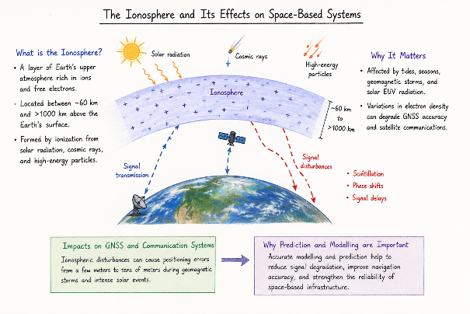 |  | Abstract  The ionosphere plays an important role in satellite communication, navigation systems, and space weather monitoring. However, its highly nonlinear variability driven by solar radiation, geomagnetic activity, and atmospheric dynamics makes accurate prediction of ionospheric parameters particularly challenging. In recent years, deep learning techniques have been increasingly applied to ionospheric modelling due to their capability to learn complex nonlinear relationships from Global Navigation Satellite System (GNSS) signal. Despite the rapid growth of research in this area, differences in modelling architectures, datasets, and evaluation methods make it difficult to systematically compare model performance across studies. This study presents a systematic review of deep learning approaches for ionospheric modelling based on recent studies between 2020 and 2025. The cross-study comparison was made in terms of modelling architectures, input features, datasets, prediction targets, and reported prediction accuracy. The results show that hybrid deep learning architectures dominate current research, while Total Electron Content (TEC) remains the most commonly predicted parameter. Although deep learning models demonstrate strong overall predictive capability, an extremely high heterogeneity (I² ≈ 99.97%) indicates substantial variability across studies. These findings highlight the need for standardized datasets and evaluation frameworks to improve comparability and reliability of deep learning-based ionospheric prediction models.  Keywords: Deep learning, ionosphere, architecture modelling, total electron prediction, root mean square
Abstrak

Ionosfera memainkan peranan penting dalam komunikasi satelit, sistem navigasi, dan pemantauan cuaca angkasa. Namun begitu, variasi ionosfera yang sangat tidak linear, yang dipacu oleh sinaran suria, aktiviti geomagnet, serta dinamik atmosfera menjadikan ramalan parameter ionosfera satu cabaran yang kompleks. Dalam beberapa tahun kebelakangan ini, teknik pembelajaran mendalam semakin banyak digunakan dalam pemodelan ionosfera kerana keupayaannya untuk mempelajari hubungan tidak linear yang kompleks daripada isyarat Global Navigation Satellite System (GNSS). Walaupun bidang ini berkembang dengan pesat, perbezaan dari segi seni bina model, set data, dan kaedah penilaian menyebabkan perbandingan prestasi model antara kajian menjadi sukar untuk dilakukan secara sistematik. Kajian ini membentangkan satu tinjauan sistematik terhadap pendekatan pembelajaran mendalam bagi pemodelan ionosfera berdasarkan kajian-kajian terkini antara tahun 2020 hingga 2025. Perbandingan antara kajian dilakukan dari aspek seni bina model, ciri input, set data, sasaran ramalan, serta ketepatan ramalan yang dilaporkan. Hasil kajian menunjukkan bahawa seni bina pembelajaran mendalam jenis hibrid mendominasi penyelidikan semasa, manakala Jumlah Kandungan Elektron (TEC) kekal sebagai parameter yang paling kerap diramal. Walaupun model pembelajaran mendalam menunjukkan keupayaan ramalan yang tinggi secara keseluruhan, tahap heterogeniti yang sangat tinggi (I² ≈ 99.97%) menunjukkan variasi yang ketara antara kajian. Dapatan ini menekankan keperluan kepada set data yang standard serta rangka kerja penilaian yang seragam bagi meningkatkan kebolehbandingan dan kebolehpercayaan model ramalan ionosfera berasaskan pembelajaran mendalam.

Kata kunci: Pembelajaran mendalam, ionosfera, seni bina pemodelan, jumlah kandungan electron, punca kuasa dua min

 |  | © 202@ Penerbit UTM Press. All rights reserved

1.0 INTRODUCTION

The ionosphere is a highly active area of the Earth’s upper atmosphere composed with high concentrations of ions and abundant free electrons [1]. It located between 60 and more than 1000 km above the Earth’s surface. This layer yielding from ionization process through interaction of solar radiation with atmospheric gases, and also driven by cosmic rays, and high energy particles from outer space [2]. The ionized nature of ionosphere permits reflecting, refracting, and modifying signal propagation, offer numerous significant advantages for satellite-based communication and navigation systems. Despite these advantages, the ionosphere poses critical problems for contemporary space-based systems.
The ionosphere is significantly affected by various physical events, such as atmospheric tides, seasonal fluctuations, geomagnetic storms, and solar extreme ultraviolet radiation [3]. Fluctuations in ionospheric electron density can induce scintillation effects, phase shifts, and signal delays, thereby reduce the accuracy and reliability of positioning systems and satellite communication. For example, the ionospheric disturbances cause positioning errors in GNSS applications that range from a few meters to several tens of meters during geomagnetic events and intense solar [4]. Therefore, optimal modelling and prediction of ionospheric features are crucial for lessening signal degradation, enhancing signal navigation, and fortifying the reliability of space-based infrastructure.
Traditional ionospheric modelling methods have predominantly depended on empirical models, for instance, Klobuchar [5], Chapman [6], NeQuick, International Reference Ionosphere [7],[8]. Although these models offer valuable baseline information, but their prediction efficacy is frequently constrained by disrupted space weather events. The disruption may come from solar flares and geomagnetic storms [9]. Moreover, the ionosphere demonstrates remarkable multi-scale temporal variability and nonlinear dynamics, which empirical model tend not to execute accurately when implement for high-demand positioning services and navigation. Therefore, mathematical algorithms such as trigonometric series [10], semi-parametric estimation [11] spherical cap harmonic [11] and autoregressive are adopted in ionospheric modelling to overcome the limitation of empirical models [12]. The function-oriented mathematical models offer better accuracy than empirical model, but it still not capable to yield optimum output because tend to smooth ionospheric structures. This resulting in the loss of localized fine-scale features and inadequately depicting the ionosphere’s reactions to major natural disasters and severe space weather [13].
Recent advancements in machine learning and artificial intelligent have opened up exciting new opportunities for ionospheric modelling [14], [15]. In particular, the application of machine learning techniques in this field facilitates extracting of intricate nonlinear correlations from large datasets, rendering them particularly effective for modelling the highly dynamic ionospheric. Initial research utilized traditional machine learning algorithms, including decision trees, support vector machines, and artificial neural networks to forecast ionospheric behaviour [16]. Nevertheless, these approaches frequently failed to obtain the long-term temporal dependencies and spatial correlations inherent in ionospheric datasets. The development of deep learning has profoundly altered the domain of ionospheric modelling research. Theoretically, deep learning is a branch of artificial intelligence and machine learning that employs multi-layered artificial neural networks to replicate human-like decision-making [17], [18]. These models analyse extensive datasets over multiple layers to discern intricate patterns for various applications demonstrated significant potential in ionospheric modelling.
Despite the increasing number of studies applying deep learning techniques to ionospheric modelling, the current literature remains highly fragmented. Different studies employ diverse model architectures, datasets, input features, and evaluation metrics, which makes direct comparison of predictive performance challenging. As a result, it remains unclear which modelling approaches provide the most reliable performance and what methodological factors most strongly influence prediction accuracy. Furthermore, most existing review papers primarily provide qualitative summaries of previous work without conducting a systematic quantitative assessment of model performance across studies. A quantitative synthesis of existing research is therefore necessary to better understand the overall effectiveness of deep learning approaches in ionospheric prediction and to observe the pattern of deep learning model adopted with it prediction output. Therefore, this study conducts a systematic review and quantitative assessment of deep learning approaches for ionospheric modelling based on published research between 2020 and 2025.
The absence of standardized benchmarking frameworks in ionospheric deep learning research limits the ability to objectively compare modelling approaches. By providing the first quantitative synthesis based systematic review of deep learning performance in ionospheric modelling, this study aims to clarify current research trends, identify key methodological challenges, and highlight future directions for the development of more robust and standardized deep learning-based ionospheric prediction frameworks. Unlike previous review studies that primarily provide qualitative summaries that focused on describing types of deep learning model adopted and it effect on prediction, neglect the pattern observation. Therefore, this study presents a quantitative assessment of deep learning approaches for ionospheric modelling by examining the pattern of deep learning model adopted with proposed framework and prediction output showing the most outstanding model. By statistically synthesizing prediction performance across multiple studies, this work provides a more objective evaluation of deep learning effectiveness in ionospheric prediction.

2.0 METHODOLOGY

The framework for methodology used in this study is divided into five phases as in Figure 1. These steps were developed to accomplish the research goals and avoiding bias in the synthesizing the relevant studies. Therefore, the research process will be cleared and could be repeated.
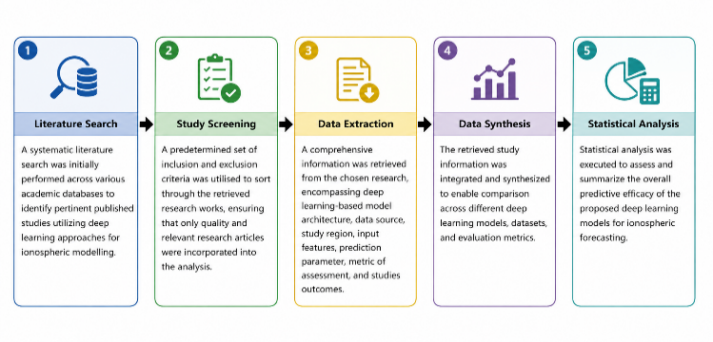
Figure 1. Phase of review study
2.1 Literature Search Strategy

A thorough literature survey was performed to locate peer-reviewed research about deep learning applications in ionospheric modelling. The search was carried out on legit scientific databases. The search approach used a variety of term combinations intended to obtain relevant publish work in both ionospheric research and deep learning. The detailed literature search strategy is provided in Table 1. The search was focused on published research from 2020 to 2025, as this timeframe signifies the rapid growth of deep learning approaches in ionospheric modelling and to acquire recent proposed architecture with their effect on prediction performance. Besides searches in databases, the bibliographies of relevant publications were meticulously inspected to identify additional works that would not have been identifies through automated database searches. This method provides more comprehensive coverage of relevant literature.

Table 1 Strategy for identifying literature based deep learning for ionospheric modelling

Period | Databases | Primary Keywords | Keyword with Boolean Operators
2020-2025 | Web of Science, Scopus, Google Scholar, and IEEE Xplore | Ionospheric modelling, ionospheric prediction, deep learning, neural networks, total electron content prediction, LSTM ionosphere, CNN ionosphere | Deep learning AND ionosphere, ionospheric modelling AND deep learning, neural network AND ionospheric modelling, LSTM AND TEC prediction

2.2 Inclusion Criteria and Selection of Literature

The initial screening of literature was reviewed to ascertained their eligibility for inclusion in this study. The screening procedure was executed in two phases: title and abstract evaluation, proceeded by thorough evaluation of text. In the initial phase, papers were evaluated by their titles and abstracts to discern articles that may be pertinent to the research topic. At this point, studies that evidently did not incorporate ionospheric modelling or deep learning methodologies were removed. During the second phase, the complete texts of the remaining articles were meticulously examined to ascertain their compliance with the established inclusion criteria. The subsequent criteria were employed to decide on articles for inclusion in the analysis. Detail on inclusion and exclusion criteria of screening process as provided in Table 2.

Table 2 Inclusion and exclusion criteria for selecting deep learning based ionospheric modelling articles

Criteria Type | Description
Inclusion criteria | - Deep learning or neural network model executed for ionospheric modelling  - Published in peer-reviewed journal or conference  - Sufficient methodological information for data screening and extraction  - Report quantitative performance metrics
Exclusion criteria | - Conventional ionospheric models without deep learning approaches  - Articles unrelated to ionospheric prediction  - Insufficient methodological information or duplicate articles  - No reported quantitative performance  - Non-peer reviewed articles

2.3 Descriptive Statistic Analysis

A descriptive frequency analysis was conducted to assess the distribution of essential characteristics derived from the chosen studies. This analysis seeks to identify trends of deep learning technique for ionospheric modelling using extracted literature information. Regarding each extracted variable, the frequency of studies exhibiting a certain feature was quantified and expressed as a percentage of the total number of included studies. This percentage-based analysis offers a concise overview of the prevalence of various modelling methodologies and research trends in the examined literature. The percentage of occurrence for each obtained feature was determined using the following formula:

$F= \frac{N_{OBS}}{N_{T}}×100$

where F indicates the percentage incidence of a particular feature, 𝑁_{OBS} represents the quantity of studies include that feature, and N_{T} denotes the total number of studies comprised in the quantitative assessment.

Throughout descriptive statistical analysis, the research pattern of ionospheric modelling based deep learning can be identified, such as the most popular deep learning architectures, the most common predicted ionospheric parameters, and the most applied used input parameters in deep learning-based ionospheric prediction models. The generated percentages are then utilized to construct comparative visualization such as tables and figures in the findings section, illustrating the distribution of modelling methodologies across the identified literatures.
In prediction-based modelling studies, commonly reported performance metrics include RMSE, MAE, and coefficient of determination (R²). Among these metrics, RMSE is the most consistently reported across ionospheric prediction studies [19]. Therefore, RMSE was selected as the primary metric for quantitative synthesis in this review work. To enable comparison across studies and transform prediction error into a performance-based effect size, the inverse RMSE transformation (1/RMSE) was applied. This transformation ensures that lower prediction errors correspond to larger effect sizes, allowing higher predictive accuracy to be reflected as greater model performance in the review study framework. The effect size is defined as the reciprocal of the RMSE value, indicating that reduced prediction errors correlate with higher effect sizes and, consequently, superior model performance [20]. The effect size employed in this current study can be denoted as:

$$Effect size=\frac{1}{RMSE}$$
This transformation yields a standardized metric of predicted accuracy, facilitating uniform comparison across many research. Models exhibiting reduced RMSE values yield greater effect sizes, signifying enhanced prediction effectiveness. After calculating the impact sizes for each research, a weighted mean effect size is computed to assess the overall predictive efficacy of deep learning models in ionospheric forecasting. In quantitative assessment, weighting is generally utilized to address variations in research precision and dependability [21]. Research with diminished prediction errors is seen a more reliable and hence exerts a greater influence on the aggregate pooled estimate. The weight allocated to each study is determined as the inverse of the squared RMSE value [22]. The weight assigned to each study report is therefore delineated as:

$$w_{i}=\frac{1}{{RMSE}_{i}^{2}}$$

By taking these weights, the pooled or weighted mean effect size denotes as:

$$\overline{E}=\frac{\sum{w_{i}E_{i}}}{\sum{w_{i}}}$$

where $E_{i}$ denotes the effect size of the 𝑖^{𝑡ℎ} study, while 𝑤_{𝑖} signifies the associated weight. The obtained pooled effect size offers a quantitative overview of the overall efficacy of deep learning models within the chosen literature.

Alongside assessing the pooled effect size, it is crucial to assess the variability of results across various research. This diversity, known as heterogeneity, may result from changes in modelling architectures, dataset properties, geographic locations, or evaluation processes. The I² statistic is employed to examine the heterogeneity of effect sizes among the included research, measuring the proportion of overall variation due to differences between reported studies rather than random sampling error. The I² statistic is computed as follows:

$$I^{2}=\frac{Q-df}{Q}×100\%$$

The proposed statistical evaluation of deep learning methods in ionospheric modelling by incorporating effect size estimation, weighted performance aggregation, and heterogeneity analysis. This method facilitates the recognition of overarching performance trends within the literature and offers significant insights into the advantages and drawbacks of current deep learning models for ionospheric prediction tasks.

3.0 RESULTS AND DISCUSSION

The preliminary search produced 456 records of published articles. After elimination 85 duplicate entries, 371 distinct articles remained for further screening. The remaining articles were screened based on titles and abstracts to ascertained their relevance to the goals of this review. At this stage, studies unrelated to ionospheric modelling, those not utilise deep learning approaches, and articles concentrating on irrelevant atmospheric parameters were removed.
Consequently, 326 papers were excluded, resulting in 45 publications for comprehensive evaluation. The remaining publications were meticulously assessed based on established inclusion and exclusion criteria. Studies were comprised if they utilised deep learning models for the prediction of ionospheric performance metric and provided quantifiable evaluation measures. Articles with missing experimental validation, review articles, and those with inadequate methodological details and insufficient reported result were removed. After the eligibility evaluation, 27 papers were removed, leaving 18 studies that satisfied the selection criteria and were incorporated into the comparative analysis. The comprehensive study selection procedure is depicted in Figure 2.

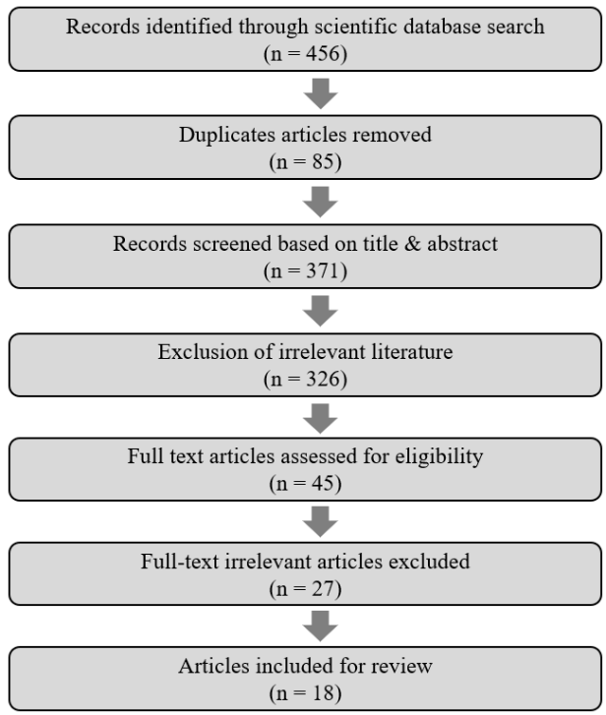

Figure 2. Flow for literature search

3.1 Characteristics of Included Studies

This review study encompasses 18 research articles that demonstrate various deep learning approaches for predicting ionospheric behaviour. These works were published in recent years of 2020 until 2025, coinciding with the growing interest in the application of artificial intelligence approaches in ionospheric modelling. The final articles included for review quite low due to several reason such as, the number of research on this topic not broad still in middle phase where most of them focused on machine learning model, whereas some of existing studies does not provide sufficient information regarding their work to be included, which limit the article selection process. The final phase article selection succeeds to obtain 18 articles with complete information. The chosen studies collectively illustrate the increasing interest in employing deep learning methods to enhance the precision and dependability of ionospheric data output. Diverse deep learning architectures were utilized across the selected studies. The most often utilized models included Convolutional Neural Networks (CNN), Long Short-Term Memory (LSTM) networks, and hybrid architectures such as CNN–LSTM.
These deep learning models are particularly appropriate for ionospheric modelling due to the TEC data having strong temporal and nonlinear properties [23]. Some of studies also proposed advanced and hybrid deep learning model to improve prediction performance of ionospheric data such as ED-ConvLSTM, piecewise LSTM, EEMD-LSTM, Seq2Seq-LSTM-Attention, DNN-MLP, and EF-ConvGRU. The datasets employed for model development differed among investigations. Among of the data sourced utilized in selected studies are Global Navigation Satellite System (GNSS) observations or data sourced from international ionospheric databases, including the Centre for Orbit Determination in Europe (CODE), IGS TEC maps, CMONOC, NESSDC, and CDDIS. These ionospheric datasets often had long-term time series measurements that allowed deep learning models to discern temporal patterns in ionospheric variability [24].
The input features for selected studies usually incorporate different combinations of parameters that reflecting the ionospheric behaviour. The common extracted inputs features are historical TEC values, geomagnetic indices including Dst and Ap, F10.7 solar flux and temporal variables such as local time, day-of-year. These parameters were employed to enhance the predictive efficacy of the deep learning models. Quantitative metrics including Root Mean Square Error (RMSE), Mean Absolute Error (MAE), Mean Square Error (MSE), and correlation coefficient (R2) were typically used to assess the models' performance [25]. Overall, the research showed that, when compared to traditional modelling methods, deep learning models offer encouraging increases in prediction accuracy. Moreover, the models’ performance was primarily assessed using quantitative metrics, including Mean Square Error (MSE), Root Mean Square Error (RMSE), and Correlation Coefficient (R²). The finding from previous research indicated that deep learning methods significantly enhance prediction accuracy compared with conventional modelling approaches [26], [27]. Most studies focus on Total Electron Content (TEC) prediction, while some other studies used other ionospheric parameters such as foF2 and electron density. The characteristics of the included studies are summarized in Table 3.

Table 3 Detail Information of included studies from selected articles

Study | Model / Method | Data Source | Study Area | Period | Input Features | Prediction Target | Evaluation Metrics | Root Mean Square Error (TECU)
[28] | LSTM-NN | CODE | Global | 2014–2016 | SH coefficients, EUV flux, Dst, hour | SH coefficients / TEC | MAE, MSE, RMSE, ME | Storm: 1.27  Quiet: 0.86
[29] | Inte-BPNN | CMONOC | China | 2004–2019 | Time, solar activity, geomagnetic activity | TEC | RMSE, MD | 3.65
[30] | LSTM-CNN | GPS stations | India | 2009–2016 | Day, hour, F10.7, AP, TEC | TEC | MAE, RMSE | 1.5
[23] | CNN-GRU | GNSS systems | Global | Aug–Dec 2018 | Solar & geomagnetic indicators | VTEC | RMSE | 0.2–0.5
[31] | BP + extrapolation | NESSDC | China | 2022 | F10.7, Dst, Kp | foF2 | MAE, RMSE | 0.402
[32] | ED-ConvLSTM | IGS TEC maps | Global | 2005–2018 | Spatial and temporal information | TEC | RMSE | 1.65-4.36
[33] | CNN-LSTM-Attention | CMONOC | China | 2010–2018 | TEC, Bz, Kp, Dst, F10.7 | TEC | RMSE, R², MAE, MAPE | 1.87
[34] | LSTM | CDDIS | India | 2009–2018 | TEC + solar/geomagnetic indices | TEC | RMSE, CC | 1.61
[35] | ED-ConvLSTM | IGS | SE Asia | 2013–2019 | Spatial features | TEC | RMSE, MAE, MAPE | 6.8
[36] | Piecewise LSTM | CMONOC | China | 2014 | TEC, lat, lon, Ap, Dst | TEC | MAE, RMSE | 3
[37] | EEMD-LSTM | IGS | India | 2008–2015 | TEC, Kp, F10.7 | TEC | RMSE, MAPE, R² | 1.5
[38] | CNN-BiLSTM | GIM-TEC | Global | 1998–2023 | TEC, ap, Kp, Dst, F10.7 | TEC | RMSE, R² | 3.12–3.59
[39] | CNN-LSTM | IRI | China | 2016–2023 | Electron density map over time | TEC | RMSE, R² | 0.022
[40] | ICEEMDAN-LSTM | NESSDC | China/Japan/Korea | 2014 | foF2 parameters | foF2 | RMSE, R² | 0.69
[41] | Seq2Seq-LSTM-Attention | Space Data Center | China | 2017–2019 | Geomagnetic index, foF2 | foF2 | RMSE, MAE, MAPE | 0.711
[42] | ICEEMDAN-LSTM | NESSDC | East Asia | 2014–2017 | foF2 hourly | foF2 | RMSE, RRMSE, R² | 0.40
[8] | DNN-MLP | IGS TEC | Global | 2011–2019 | Spatiotemporal + space env. | Electron density | RMSE, R² | Strong Geomagnetic: ~8  Weak Geomagnetic: ~5
[43] | EF-ConvGRU | CODE | Global | 2015–2022 | Time, Day | TEC | MAE, RMSE, PCC | 2.45

3.2 Distribution Analysis of Included Studies

The initial observation from Figure 3 demonstrated that the dominance category was hybrid deep learning models. It was approximate 83% of the studies utilize hybrid deep learning architectures, whereas merely 17% employ pure deep learning models. This distribution reflects a distinct deep learning model development trend towards integrating multiple architectures to enhance predictive capability. Table 3 illustrates that numerous contemporary studies incorporate various neural network architectures, including Seq2Seq-LSTM-Attention, CNN-GRU, and CNN-LSTM. These methods concurrently capture temporal and spatial patterns dependencies in ionospheric data. The significant prevalence of hybrid models indicates that single-model architectures may be inadequate for comprehensively capturing the intricate nonlinear dynamics of the ionosphere [44]. Hybrid methodologies facilitate the amalgamation of the complementing advantages of different networks, including recurrent layers for temporal sequence learning and convolutional layers for spatial feature extraction.

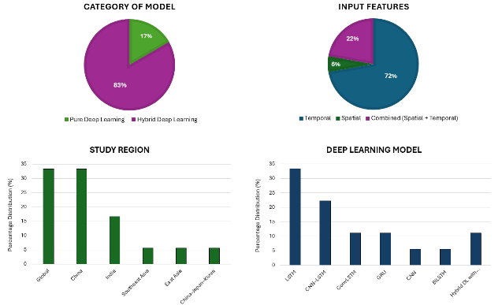
Figure 3. Distribution Analysis of Deep Learning Approaches for Ionospheric Modelling among 2020-2025 published research

In term of input feature categories, most research (72%) predominantly depend on temporal features, encompassing parameters such as time, day-of-year, geomagnetic indices (Kp, Dst), and solar flux (F10.7). These temporal factors are recognized for their significant impact on ionospheric variability, elucidating their prevalent application in deep learning models. Conversely, only 6% of research employ spatial features, whereas 22% integrate both spatial and temporal features as model input. The comparatively low percentage of spatial feature employs as input indicates that most of studies still prioritize time-series modelling rather than comprehensively exploited the spatial correlation in global ionospheric datasets. Meanwhile, models that integrate temporal and spatial features, such as those based on ED-ConvLSTM, piecewise LSTM, CNN-LSTM, and DNN-MLPmodels demonstrated improved prediction capabilities owing to their capacity in reflecting both temporal and geographical fluctuations in the ionospheric compared to conventional deep learning.
Focusing on study region distribution, it seems that a significant geographical concentration of research activities. About 33% of studies concentrate on global ionospheric modelling, while an additional 33% are carried out in China. This signifies that China has emerged as a prominent region for ionospheric deep learning research. It presumably owing to the accessibility of comprehensive datasets like CMONOC and NESSDC. In contrast, 17% of studies employed dataset that carried out in India indicating a growing interest in modelling ionospheric behaviour in low-latitude regions where ionospheric variability is particularly strong. The other locations, including East Asia, Southeast Asia, and the China-Japan-Korea demonstrates approximately 5-6% of the total studies. The limited quantity of studies in these locations indicates a necessity for additional research to enhance regional ionospheric prediction models. It is especially in equatorial zones where ionospheric abnormalities are more evident.
Findings based on distribution of deep learning architecture showed that the recurrent neural networks underscore others. LSTM-based models constitute the predominant proportion of about 33% of the published work, validating their efficacy in modelling sequential ionospheric time-series data. Furthermore, the hybrid based deep learning models including CNN-LSTM comprise approximately 22%, indicating an increasing trend in the amalgamation of spatial feature extraction and temporal learning. The other models including GRU and ConvLSTM, each provide roughly 11%, and BiLSTM and CNN models obtained around 5% of the research. The comparatively smaller proportion of exclusively convolutional models indicates that temporal dependencies continue to pose the principal issue in ionospheric prediction tasks.

3.3 Research Trends in Deep Learning Architectures

Figure 4 presents the distribution of deep learning architectures utilized for ionospheric prediction. The results indicate that hybrid CNN–LSTM models represent the largest proportion of the reviewed studies, accounting for 39% of the total models. This is followed by LSTM architectures (33%) and CNN-based models (28%). The predominance of hybrid CNN–LSTM architectures reflect the growing recognition that ionospheric dynamics are governed by both spatial and temporal processes.

Figure 4. Deep learning model distribution utilizes for performance prediction

The higher proportion of hybrid CNN–LSTM models (39%) highlight the increasing adoption of integrated architectures that combine spatial feature extraction with temporal sequence learning. By leveraging the complementary strengths of CNN and LSTM, these hybrid frameworks can capture multidimensional ionospheric dynamics more effectively than single-architecture models. From a broader perspective, this trend reflects a global shift in ionospheric research toward spatiotemporal deep learning frameworks, which are increasingly recognized as powerful tools for modelling complex geophysical systems characterized by nonlinear interactions and dynamic variability.

3.4 Predictive Performance Strength of the Deep Learning Model Using Effect of Size Analysis

As mentioned earlier, the RMSE was used to indicate the performance of deep learning. Therefore, this parameter was used to determine strength and efficacy of deep learning model for ionospheric behaviour prediction through effect of size analysis. The RMSE values were converted into a normalised performance indicator using the inverse RMSE formulation. This transformation enables the ability to predict of various prediction models to be assessed within a single framework, regardless variances in datasets, modelling structures, and experimental contexts.
Referring to the retrieved dataset, which included 18 research, the computed effect sizes ranged from 0.147 to 45.45. The lowest effect size was found in studies with relatively high RMSE values, indicating lower prediction accuracy. In contrast, studies with exceptionally low RMSE values, indicating highly accurate predictions, yielded the largest effect size. The broad range of effect sizes demonstrates the significant variety in model performance across the reviewed literature.
Figure 5 depicts the distribution of effect sizes and the normalised prediction performance of deep learning models across the chosen studies. As indicated in the figure, the majority of studies had moderate effect size values, demonstrating reasonably reliable prediction performance. However, other studies show substantially larger impact sizes due to the extremely low RMSE coefficients reported in their works. In this regard, several variables may influence these discrepancies such as modifications in modelling architectures, training datasets, and prediction aims.

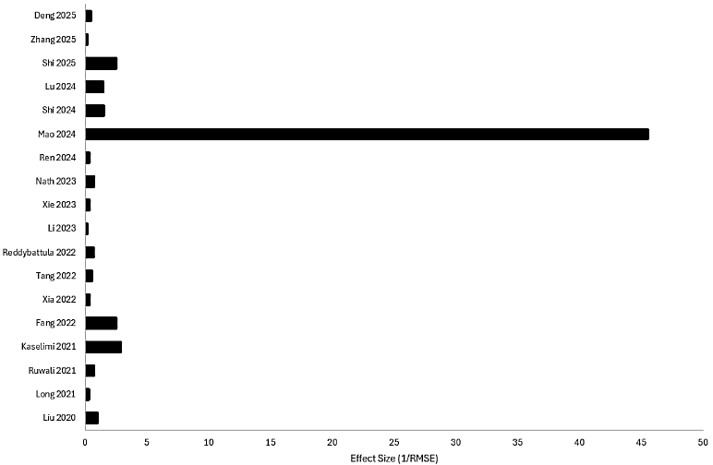

Figure 5. Graph of Effect Size for selected studies

3.5 Deep Learning Model Consistency in Ionospheric Modelling Using Heterogeneity analysis

A very high degree of variability across the chosen studies was indicated by the study's I² score, which was almost 99.97%. I² values below 25% imply low heterogeneity, values between 25% and 50% indicate moderate heterogeneity, while values above 75% indicate substantial heterogeneity. As a consequence, the computed value makes it abundantly evident that the predictive performance documented in the literature differs considerably between investigations.
The observed variability in the examined dataset could be caused by a number of variables. The variety of deep learning models employed in ionospheric modelling research is one of the main contributing elements. Numerous modelling techniques, including Long Short-Term Memory (LSTM), Convolutional Neural Networks (CNN), Gated Recurrent Units (GRU), ConvLSTM, and hybrid CNN–LSTM architectures, are included in the reviewed literature for prediction purpose. Prediction accuracy can vary depending on how well each design captures the temporal and spatial features of ionospheric data.

4.0 CONCLUSION
This study presents a systematic review based on quantitative assessment of deep learning model applied to ionospheric behaviour prediction based on 18 published studies between 2020 and 2025. By synthesizing results from multiple independent investigations, the analysis provides a comprehensive overview of current modelling trends, predictive performance, and methodological variability within the growing field of deep learning-based ionospheric prediction. The results indicate that hybrid deep learning architectures have become the dominant modelling strategy, reflecting the increasing need to capture the complex spatial and temporal dynamics of ionospheric variability. The quantitative assessment further confirms that deep learning models demonstrate strong predictive capability for key ionospheric parameters, particularly Total Electron Content (TEC), highlighting the potential of data-driven approaches to complement or enhance conventional ionospheric modelling techniques. However, the extremely high heterogeneity observed across the analysed studies reveals substantial variability in modelling frameworks, datasets, and evaluation procedures. This finding suggests that current research efforts remain fragmented and that direct comparison between models is often limited by inconsistent experimental designs. It should also be noted that only 18 studies satisfied the inclusion criteria for this review. This relatively limited number of eligible publications reflects the fact that deep learning applications in ionospheric modelling remain an emerging and rapidly evolving research domain. Compared with other artificial intelligence applications, the integration of deep learning techniques into ionospheric prediction and space weather monitoring is still at an middle stage of development, with research activities becoming more noticeable only in recent years. In addition, several potentially relevant studies were excluded due to incomplete methodological reporting, insufficient quantitative performance information, lack of reproducible experimental details, or absence of standardized evaluation metrics. Such limitations further emphasize the current lack of reporting consistency within the field. Overall, this study provides the first quantitative synthesis of deep learning performance in ionospheric modelling and highlights the need for standardized benchmarking datasets, unified evaluation metrics, and reproducible modelling frameworks. Addressing these challenges will be essential for improving the reliability, comparability, and operational applicability of deep learning models in future ionospheric prediction systems and space weather monitoring applications.

Acknowledgement

The author gratefully acknowledges Universiti Malaysia Pahang Al-Sultan Abdullah for the financial support provided through the Postdoctoral Fellowship programme. The author is currently serving as a Postdoctoral Fellow at the university, where the institutional support and research environment have greatly facilitated the progress of this work. This research was conducted under the support of the Strategic Research Fund (SRF) project SRF01251303 funded by Malaysia Ministry of Science, Technology and Innovation (MOSTI), which provided the necessary resources and infrastructure to carry out the study. The author sincerely appreciates the university’s commitment to advancing research and innovation.

References
[1] Esmaeili-Karnawah, A., Fallah,R., SKhorashadizadeh, S. M. and Niknam, A. R. 2024. Propagation Characteristics Analysis of High-Frequency Radio Waves in The Lower Ionosphere Layers, Heliyon. 10(24): 1–7. doi: 10.1016/j.heliyon.2024.e40963.
[2] Winant, A., Pierrard, V., Botek, E. and Herbst, K. 2023. The Atmospheric Influence on Cosmic-Ray-Induced Ionization and Absorbed Dose Rates, Universe. 9(12): 1–17. doi: 10.3390/universe9120502.
[3] Oljira, A. 2023. A study of Solar Flares and Geomagnetic Storms Impact on Total Electron Content Over High-Latitude Region During July- November 2021: The Case of Tromso Station, Advances in Space Research. 72(9): 3868–3881. doi: 10.1016/j.asr.2023.06.051.
[4] Tongkasem, N. et al. 2025. Spatio-temporal Characteristics of Ionospheric Irregularities in Low Latitude Regions During the Peak of Solar Cycle 25, Advances in Space Research, 76(1): 254–268. doi: 10.1016/j.asr.2025.04.062.
[5] Pongracic, B., Wu, F., Fathollahi, L. and Brcic, D. Midlatitude Klobuchar. 2019. Correction Model Based on the K-Means Clustering of Ionospheric Daily Variations, GPS Solutions. 23(3): 80-87. doi: 10.1007/s10291-019-0871-x.
[6] Wang, C., Xia, S., Fan, L., Shi, C. and Jing. G. 2023. Ionospheric Climate Index as A Driving Parameter For The Nequick Model, Advances in Space Research. 71(1): 216–227, Jan. doi: 10.1016/j.asr.2022.08.069.
[7] Bilitza, D., Pezzopane, M., Truhlik, V., Altadill, D., Reinisch, B. W. and Pignalberi, A. 2022. The International Reference Ionosphere Model: A Review and Description of an Ionospheric Benchmark, Reviews of Geophysics, 60(4): 1–61. doi: 10.1029/2022RG000792.
[8] Zhang, J., Zhang, J., Chen, Z., Wang, J., Fan, C. and Guo, Y. 2025. Deep Learning-Based Vertical Decomposition of Ionospheric TEC into Layered Electron Density Profiles, Atmosphere (Basel)., 16(5): 1–16. doi: 10.3390/atmos16050598.
[9] Balasis, G., Papadimitriou, C. and Boutsi, A. Z. 2019. Ionospheric Response to Solar and Interplanetary Disturbances: A Swarm Perspective, Philos. Trans. A Math. Phys. Eng. Sci. 377(2148): 1–15. doi: 10.1098/rsta.2018.0098.
[10] Yuan Y. and Ou, J. 2004. Generalized Trigonometric Series Function Model for Determining Ionospheric Delay, Progress in Natural Science. 14(11): 1010–1014. doi: 10.1080/10020070412331344711.
[11] Razin M. R. G. and Voosoghi, B. 2016. Regional Ionosphere Modeling Using Spherical Cap Harmonics and Empirical Orthogonal Functions Over Iran, Acta Geodaetica et Geophysica. 52(1): 19–33. doi: 10.1007/s40328-016-0162-8.
[12] Abdelazeem, M., Celik, R. N. and El-Rabbany, A. 2022. Neural network-based ionospheric modeling and predicting—To enhance high accuracy GNSS positioning and navigation, Advances in Space Research. 70(10): 2878–2893. doi: 10.1017/S0373463315000740.
[13] Laundal et al., K. M. 2025. Next-Generation Data Assimilation Methods for Polar Ionospheric Electrodynamics. Surveys in Geophysics. 1–47. doi: 10.1007/s10712-025-09918-3.
[14] Iban M. C. and Senturk, E. 2022. Machine Learning Regression Models for Prediction of Multiple Ionospheric Parameters, Advances in Space Research, 69(3,):1319–1334. doi: 10.1016/j.asr.2021.11.026.
[15] Mao, S., Hernández‐Pajares, M. and Soja, B. 2025. A Review of Machine Learning‐Based Ionospheric Spatial and Temporal Modeling. Journal of Geophysical Research: Machine Learning and Computation, 2(3): 1–45. doi: 10.1029/2024jh000555.
[16] Zewdie, G. K., Valladares, C., Cohen, M. B., Lary, D. J., Ramani, D. and Tsidu, G. M. 2021. Data-Driven Forecasting of Low-Latitude Ionospheric Total Electron Content Using the Random Forest and LSTM Machine Learning Methods, Space Weather, 19(6): 1–11. doi: 10.1029/2020SW002639.
[17] Ali, M., Dewan, A., Sahu, A. K. and Taye, M. M. 2023. Understanding of Machine Learning with Deep Learning: Architectures, Workflow, Applications and Future Directions, Computers. 12(5): 1–26. doi: 10.3390/computers12050091.
[18] Kufel J. et al., 2023. What Is Machine Learning, Artificial Neural Networks and Deep Learning?—Examples of Practical Applications in Medicine, Diagnostics, 13(15): 1–22. doi: 10.3390/diagnostics13152582.
[19] Mridula, N., Manju, G. Sijikumar, S. and Pant, T. K. 2024. Performance Evaluation of Ionospheric Models Over Equatorial Indian Region, Advances in Space Research, 73(6): 3050–3059. doi: 10.1016/j.asr.2023.12.040.
[20] Lian, J., Wu, X., Huang, S. and Chang, Z. 2025. A Deep Learning‐Based Long‐Term ENSO Forecasting Model: 3D‐STransformer. Journal of Geophysical Research: Machine Learning and Computation, 2(3): 1–24. doi: 10.1029/2024jh000412.
[21] Paul J. and Barari M. 2022. Meta-Analysis and Traditional Systematic Literature Reviews—What, Why, When, Where, And How. Psychology and Marketing, 39(6): 1099–1115. doi: 10.1002/mar.21657.
[22] Chen S. and Zheng, W. 2025. RRMSE-enhanced Weighted Voting Regressor for Improved Ensemble Regression, PLoS One, 20(3): 1–14. doi: 10.1371/journal.pone.0319515.
[23] Kaselimi, M., Doulamis, N., Voulodimos, A., Doulamis, A. and Delikaraoglou, D. 2021. Spatio-Temporal Ionospheric TEC Prediction Using a Deep CNN-GRU Model on GNSS Measurements. International Geoscience and Remote Sensing Symposium, 8317–8320. doi: 10.1109/IGARSS47720.2021.9554258.
[24] Chen, Y., Liu, Y., Yang, K., Li, L., Xiong, C. and Wang. J. 2025. Ionospheric Time Series Prediction Method Based on Spatio-Temporal Graph Neural Network, Atmosphere 16(6): 1–17. doi: 10.3390/ATMOS16060732.
[25] Khoshvaght, H., Permala, R. R., Razmjou, A. and Khiadani, M. 2025. A Critical Review on Selecting Performance Evaluation Metrics for Supervised Machine Learning Models in Wastewater Quality Prediction, Journal of Environmental Chemical Engineering, 13(6):1–17. doi: 10.1016/J.JECE.2025.119675.
[26] Ren, X., Zhao, B., Zeng, L., Hao, H., Ren, Z. and Xiong, B. 2025. Comparative Analysis of Different Prediction Methods for TEC In China Based on Deep Learning, Advances in Space Research, 75(8): 6469–6486. doi: 10.1016/j.asr.2025.02.024.
[27] Safranek, S., Kouba, D., Cech, P. and Zvackova, A. 2025. Enhancing Ionospheric Prediction Accuracy Using Deep Learning: A Comparative Study. URSI Asia-Pacific Radio Science Meeting, 1–4. doi: 10.46620/URSIAPRASC25/TYFH1447.
[28] Liu, L., Zou, S. Yao, Y. and Wang, Z. 2020. Forecasting Global Ionospheric TEC Using Deep Learning Approach, Space Weather, 18(11): 1–12. doi: 10.1029/2020SW002501.
[29] Long, F., Gao, C. and Dong, Y. 2021. Modeling and Predicting the Ionospheric Total Electron Content over Western China with Machine Learning, IEEE 12th Annual Information Technology, Electronics and Mobile Communication Conference, 1052–1057. doi: 10.1109/IEMCON53756.2021.9623143.
[30] Ruwali, A., Kumar, A. J. S., Prakash, K. B., Sivavaraprasad, G. and Ratnam, D. V. 2020. Implementation of Hybrid Deep Learning Model (LSTM-CNN) for Ionospheric TEC Forecasting Using GPS Data, IEEE Geoscience and Remote Sensing Letters, 18(6): 1004–1008. doi: 10.1109/LGRS.2020.2992633.
[31] Fang, Z., Shen, J. and Zhou. X. 2020. Prediction of foF2 Frequency Based on BP Neural Network with Single Point Extrapolation, in IEEE 6th Information Technology and Mechatronics Engineering Conference, 1808–1812. doi: 10.1109/ITOEC53115.2022.9734535.
[32] Xia, G., Zhang, F., Wang, C. and Zhou, C. 2022. ED-ConvLSTM: A Novel Global Ionospheric Total Electron Content Medium-Term Forecast Model, Space Weather, 20(8): 1–17. doi: 10.1029/2021SW002959.
[33] Tang, J., Li, Y., Ding, M., Liu, H., Yang, D. and Wu, X. 2022. An Ionospheric TEC Forecasting Model Based on a CNN-LSTM-Attention Mechanism Neural Network, Remote Sensing (Basel). 14(10): 1–22. doi: 10.3390/rs14102433.
[34] Reddybattula et al., K. D. 2022. Ionospheric TEC Forecasting over an Indian Low Latitude Location Using Long Short-Term Memory (LSTM) Deep Learning Network, Universe, 8(11): 1–15. doi: 10.3390/universe8110562.
[35] Li L. et al., 2023. Spatiotemporal Prediction of Ionospheric Total Electron Content Based on ED-ConvLSTM, Remote Sensing (Basel).,15(12): 1–21. doi: 10.3390/rs15123064.
[36] Ting, X., Dai, Z., Zhu, X., Chen, B. and Ran, C. 2022. LSTM-Based Short-Term Ionospheric TEC Forecast Model and Position Accuracy Analysis. GPS Solutions, 27(66): 1–24. doi: 10.21203/rs.3.rs-1820577/v1.
[37] Nath, S., Chetia, B. and Kalita, S. 2023. Ionospheric TEC Prediction Using Hybrid Method Based on Ensemble Empirical Mode Decomposition (EEMD) And Long Short-Term Memory (LSTM) Deep Learning Model Over India, Advances in Space Research, 71(5): 2307–2317. doi: 10.1016/j.asr.2022.10.067.
[38] Ren, X., Zhao, B., Ren, Z., Wang, Y. and Xiong, B. 2024. Deep Learning-Based Prediction of Global Ionospheric TEC During Storm Periods: Mixed CNN-BiLSTM Method. Space Weather, 22(7): 1–19. doi: 10.1029/2024SW003877.
[39] S. Mao, H. Li, Y. Zhang, and Y. Shi. 2024. Prediction of Ionospheric Electron Density Distribution Based on CNN-LSTM Model, IEEE Geoscience and Remote Sensing Letters, 21: 1–-5. doi: 10.1109/LGRS.2024.3437650.
[40] Shi, Y., Yang, C., Wang, J., Zhang, Z., Meng, F. and Bai, H. 2023. A Forecasting Model of Ionospheric foF2 Using the LSTM Network Based on ICEEMDAN Decomposition, IEEE Transactions on Geoscience and Remote Sensing, 61: 1–16. doi: 10.1109/TGRS.2023.3336934.
[41] Lu, Z., Xu, K., Wang, H. and Du, K. 2024 A Seq2Seq-LSTM-Attention Model for Ionospheric foF2 Prediction in the Middle Latitude Region, in 2024 9th International Conference on Signal and Image Processing, pp. 221–225. doi: 10.1109/ICSIP61881.2024.10671459.
[42] Shi, Y., Yang, C., Wang, J. and Meng, F. 2025. A Hybrid Deep Learning-Based Short-Term Forecast Model for Ionospheric Fof2 in East Asia Region. 2025 Advances in Space Research, 75(1): 988–1002. doi: 10.1016/j.asr.2024.09.062.
[43] Deng M. et al., 2025. A Deep Learning Approach for The Prediction of Ionospheric Total Electron Content (TEC) Based on Combined Prediction and Two-Step Loss Fine-Tuning, Measurement, 248: 1–13. doi: 10.1016/j.measurement.2025.116904.
[44] Kayode Y. O. et al., 2026. Modeling And Forecasting of Ionospheric Total Electron Content Using a Radial Basis Function Neural Network Over Lagos, Nigeria, Geomatica, 78(1): 1–21. 100108. doi: 10.1016/J.GEOMAT.2026.100108.

