Jurnal  Teknologi |  |  |  | Full Paper
Smart Conveyor Belt Monitoring: An IoT-Based Approach for Anomaly Detection and Predictive Analytics  P.V.S Anusha ª, K. Saujanya ^{b}*, G. Ashok ^{c}, P. Pavani Lakshmi ª, Yaddanapudi Venkata Bhaskara Lakshmi ^{d}, M.V.S. Roja Ramani ^{e}, Kolla H S Naga Vani ª  ª Raghu Engineering College, Visakhapatnam, Andhra Pradesh, INIDA.  ^{b} Vignan’s Institute of Information Technology, Visakhapatnam, Andhra Pradesh, INIDA.  ^{c} Aditya Institute of Technology and Management, Tekkali, Andhra Pradesh, INIDA  ^{d} Baba Institute of Technology and Sciences, Visakhapatnam, Andhra Pradesh, INIDA  ^{e} NS Raju Institute of Technology, Visakhapatnam, Andhra Pradesh, INIDA |  |  | Article history  Received  X Month 202Y  Received in revised form  XA Month 202Y  Accepted  XB Month 202Y  *Corresponding author  saujanya@vignaniit.edu.in  Please provide an official organisation email of the corresponding author
Graphical abstract  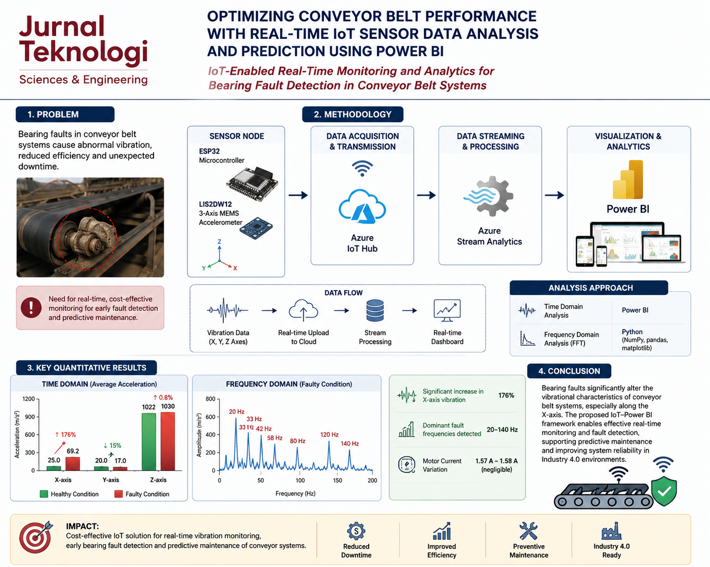  a. Graphical Abstract is a COMPULSORY item and should represent the content of the article. Please change this picture with your own graphical abstract.  b. ABSTRACT  i. For authors not from Malaysia - English abstract only  ii. If there are authors from Malaysia - Compulsory both in English and Bahasa Melayu. |  | Abstract  This study investigates the impact of bearing faults on the performance of conveyor belt systems using a real-time Internet of Things (IoT)-based monitoring framework. Conveyor belt failures caused by bearing defects lead to increased vibration, reduced operational efficiency, and unexpected maintenance costs in industrial environments. To address this issue, a cost-effective sensing architecture was developed using an ESP32 microcontroller integrated with a triaxial LIS2DW12 MEMS accelerometer, Azure IoT Hub, Azure Stream Analytics, and Microsoft Power BI for real-time monitoring and visualization. Approximately 11,500 acceleration records were collected along the x-, y-, and z-axes under healthy and faulty bearing conditions. Time-domain analysis was performed using Power BI, whereas frequency-domain analysis was conducted using Python libraries including NumPy, pandas, and matplotlib through Fast Fourier Transform (FFT) techniques. Experimental results revealed that the average acceleration along the x-axis increased significantly from 25 m/s² under healthy conditions to 69.2 m/s² in the presence of bearing faults, representing nearly a 176% increase. In contrast, the y-axis acceleration decreased slightly from 20 m/s² to 17 m/s², while the z-axis acceleration showed a marginal increase from 1022 m/s² to 1030 m/s². Frequency-domain analysis identified dominant vibration peaks at 20 Hz, 33 Hz, 42 Hz, 58 Hz, 80 Hz, 120 Hz, and 140 Hz under faulty conditions, indicating abnormal mechanical resonance and increased vibration energy. The findings confirm that bearing faults substantially alter the vibrational characteristics of conveyor systems, particularly along the x-axis, while motor current variation remained negligible (1.57–1.58 A). The proposed IoT–Power BI framework demonstrates effective real-time fault detection and provides a scalable Industry 4.0 solution for predictive maintenance, condition monitoring, and improved reliability of conveyor belt systems.  Keywords: IoT, Conveyor Belt, Vibration sensing, Azure IoT Hub.

1.0 INTRODUCTION

Belt conveyor systems are highly efficient for transporting a broad range of materials, including those with unique shapes and weights, with the highest efficiency. These systems are commonly utilized across industries that handle bulk materials such as manufacturing and warehousing. Their ability to convey materials directly on a belt surface makes them an indispensable component in such contexts [1], [2]. The applications of conveyor belt systems are extensive and span various sectors including mining, cement plants, power plants, and production. Different design parameters are utilized to cater to specific contexts, such as coal mines, food industry, and cement [3]. Optimizing conveyor belt performance is crucial for ensuring efficient and safe operation in industries such as manufacturing, logistics, and transportation.
The Internet of Things (IoT) refers to a vast network of physical devices and software components, including sensors, that enable connectivity and data exchange over the Internet. Spanning from everyday household items to complex industrial equipment, IoT facilitates seamless communication between a diverse range of devices. Conveyor belt performance improvement is one of the many areas where the Internet of Things has completely changed how the data is gathered and evaluated. This study examines the use of IoT for the predictive maintenance of conveyor belts, focusing on airport baggage systems. IoT sensors capture the conveyor data and luggage noise to enable Maintenance 4.0. Machine learning processes sensor data for early defect prediction and diagnosis and improves maintenance efficiency [4]. This study proposed a predictive maintenance system for conveyor motor faults. This system aims to detect issues before they become critical by leveraging time-series imaging and a Convolutional Neural Network (CNN) [5]. The study uses IoT and LGBM to enhance coal conveyor fault detection, achieving successful identification and real-time warnings after a 3-month field test [6]. This paper presents a fault detection system for vibrating conveyors that leverages IoT technology for continuous monitoring. By employing wireless accelerometers, the system measures the critical operational parameters. Real-time monitoring enables proactive maintenance planning without compromising production [7]. This paper introduces a fault diagnosis system that utilizes IoT technology by employing sensors to capture audio data for roller fault detection in belt conveyors. It implements advanced methodologies, such as convolutional neural networks, for analysis, achieving a notable accuracy of 96.7% [8]. These studies illustrate various strategies and advancements in fault diagnosis for conveyor belt systems, including predictive maintenance, vibration-based monitoring, and intelligent audio analysis, highlighting the development of critical techniques for enhancing the efficiency and safety of conveyor belt operations. This research highlights IoT's critical function in monitoring and maintaining conveyor belts through real-time data collection and machine learning applications, improving production and industrial processes [9], [10]. Therefore, IoT plays a pivotal role in enhancing fault diagnosis, predictive maintenance, and health monitoring in conveyor belt systems using diverse data sources, such as image, vibration, audio, and sensor data.
Machinery breakdowns cause significant losses, especially in manufacturing, disrupting production rates owing to vibrations that lead to faults such as imbalances and wear. Vibration analysis is crucial for monitoring machine health and providing early warning for maintenance. This manuscript reviews modern vibration analysis methods including data acquisition, feature extraction, and fault recognition using AI. The rise of smart machines with multiple sensors poses new challenges for vibration monitoring and diagnosis [11]. this study examines a wireless vibration detector with an Arduino and MPU6050 sensor. They detected vibrations and found that closer proximity increased detection [12]. This paper proposes the development of a vibration sensor incorporating a MEMS accelerometer and a microcontroller, with the aim of monitoring lateral movement and vibration. The integration of wireless connectivity has enabled remote monitoring and data transmission [13]. This paper aims to suggest the development of an Internet of Things (IoT)-based structural monitoring system for underground sites that utilizes vibration monitoring and accelerometer technology [14]. This paper introduces a new statistical time-domain technique that leverages vibration signals to identify impending faults in rolling-element bearings employed in three-phase induction motors [15]. This study proposes a method for detecting faults in rotating machinery through the examination of vibration signals. This study utilized support vector machines, K-nearest neighbors, decision trees, and linear discriminant analysis to predict faults [16].
Power BI is a collection of software offerings, including services, applications, and connectors, designed to enable users to convert unstructured data into visually appealing interactive insights that convey meaning. The software allows users to conveniently connect to a variety of data sources, including Excel spreadsheets and hybrid data warehouses, and visualize the information. Additionally, users have the ability to share their findings with desired recipients. This study used predictive analytics to evaluate employee performance, forecast turnover, and identify training requirements. This research aims to predict employee attrition using Power BI and machine learning models, such as Logistic Regression and Random Forest [17]. This highlighting PowerBi as the most suitable free tool for small and medium enterprises (SMEs) [18]. This research proposes the implementation of a Power BI interface as a user-friendly graphical decision support tool for the Water Corporation to make further investment and maintenance decisions [19]. This study endeavors to introduce a PowerBI dashboard framework aimed at facilitating the decision-making process of transportation managers within small and medium-sized enterprises (SMEs) involved in the transportation industry. In doing so, the proposed framework seeks to enhance the competitiveness of these companies and improve their overall performance in logistics management [20]. This research employs Microsoft Power BI to predict a substantial increase in gaming industry revenue and player numbers for the coming years in each region while simultaneously underscoring the substantial influence of esports on the industry [21]. This study introduces the application of Big Data and PowerBI to crucial processes, such as drilling and blasting, as well as analyzing parameters, standards, quantities, and advances. The aim was to create an integrated data analysis and interpretation system to support decision making in mining operations [22]. This paper proposes a reservoir management system with innovative sensors for monitoring key parameters, such as pressure, water level, velocity, tilt, and vibration. Integrated with the Arduino Uno, these sensors transmit data to Microsoft Power BI for live visualization [23]. This paper proposes a method for identifying cavitation in a centrifugal pump through the analysis of vibrations in both time and frequency domains. Additionally, the Fast Fourier Transform (FFT) technique was used for frequency domain analysis (FDA) in this study [24]. The primary objective of proposed research is to investigate the potential of real-time analysis of IoT sensor data to optimize the performance of conveyor belts. Specifically, this study aims to examine the influence of bearing faults on acceleration and vibration patterns in conveyor belt systems. The analysis of real-time data is critical to address the existing research gap in this area. To achieve this objective, the work is proposed by leveraging the capabilities of PowerBI and Python to identify the patterns associated with bearing faults based on acceleration and vibration data. The pipeline of data integration is shown in Figure 1.
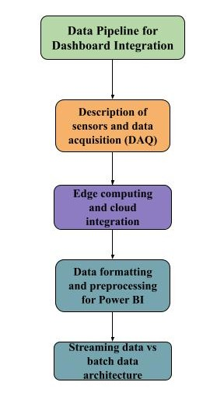
Figure 1 Pipeline for Dashboard Integration

2.0 METHODOLOGY

The architecture for recognizing patterns in faults is displayed in Figure 2, where The IoT device, which comprises an ESP32 and accelerometer, is utilized for collecting vibration data from a conveyor system.
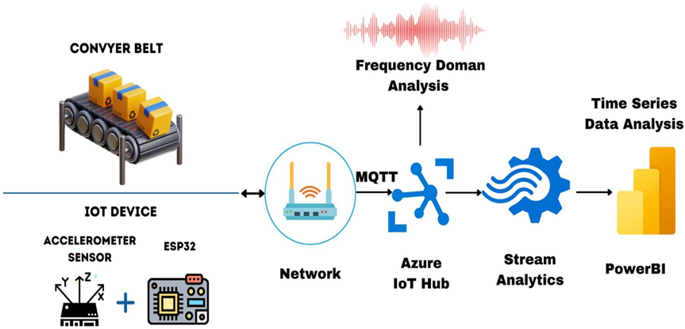

Figure 2 Architecture of Conveyor belt fault detection system

Upon collecting the data, it was transmitted to the azure cloud via Wi- Fi. In azure iot hub, Microsoft Power BI is used to visualize real-time sensor data that is received by the Azure IoT hub. To achieve this, an Azure Stream Analytics job was configured to consume data from the IoT Hub and direct it to a dataset in Power BI.

ESP32 is a widely used IoT microchip system-on-a-chip designed and produced by Espressif Systems, a leading semiconductor company. This chip is characterized by its powerful dual- core Tensilica Xtensa LX6 processor as well as its extensive connectivity and peripheral interface options, including Wi-Fi, Bluetooth, SPI, I2C, UART, ADC, and PWM. Additionally, ESP32 has built-in security features, such as secure boot and firmware updates, making it a popular choice for IoT developers. Together with the LIS2DW12 accelerometer, a capacitive MEMS-based sensor that can precisely detect acceleration in three axes and do vibration analysis, the ESP32 is utilized in IoT prototyping for the study. This device converts the changes in capacitance resulting from movement into digital signals, which are then transmitted to a host system via either I2C or SPI communication. The LIS2DW12's acceleration data is highly precise and suitable for a variety of applications including motion detection, orientation sensing, and impact analysis. Moreover, the device can be easily configured for different use cases. I2C communication to establish a connection between the LIS2DW12 accelerometer and the ESP32 is used.
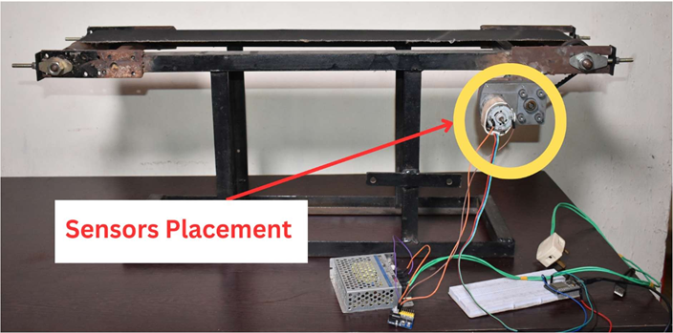
To read sensor data, firmware was created using the Arduino Integrated Development Environment (IDE). The IoT device and sensor placement are shown in Figure 3.

Figure 3 Conveyor Belt system experimental setup

Acceleration data were acquired from the conveyor belt system along the x, y, and z axes using sensors mounted on the motor frame to evaluate both healthy and faulty bearing conditions. A controlled fault was introduced in the bearing, as illustrated in Figure 3. The acceleration data along the three axes were transmitted to the Azure IoT Hub and subsequently downloaded to a local machine in JSON format. The resulting dataset comprised approximately 11,500 records of acceleration measurements.
An Azure Stream Analytics job was configured to consume data from the IoT Hub and route it to a Power BI dataset. For this purpose, a consumer group was added to the IoT Hub, and the Stream Analytics job was set up to read vibration data from the consumer group and forward it to Power BI. A visualization report of the vibration data was then generated in Power BI and published on the web.
An active Azure subscription and a Power BI account (trial version available) are required for this workflow. The downloaded acceleration data along the x-, y-, and z-axes were subsequently imported into Power BI for further analysis and visualization.
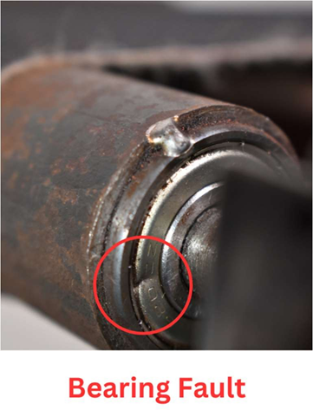
Figure 4 Bearing Fault Creation

Subsequently, the data were cleaned and transformed using a built-in Power Query tool to ensure data quality and accuracy. Newly calculated columns or variables were created to provide additional insights. Following these processes, the refined data are loaded into the Power BI interface. Acceleration data were obtained from the conveyor belt system along the x-, y-, and z-axes using tri-axial accelerometers mounted on the motor frame to evaluate both healthy and faulty bearing conditions. A controlled defect was induced in the bearing, as illustrated in Figure 4. The acquired data were transmitted to the Azure IoT Hub and subsequently downloaded in JSON format to a local storage system. The final dataset contained approximately 11,500 records of acceleration measurements. To facilitate real-time data processing, an Azure Stream Analytics job was configured to consume data from the IoT Hub and route it to a Power BI dataset. A dedicated consumer group was created within the IoT Hub, and the Stream Analytics job was programmed to extract vibration data from this group and forward it to Power BI. The processed vibration data were then visualized in Power BI, and interactive dashboards were published for web-based monitoring and analysis. The workflow required an active Azure subscription and a Power BI account, both of which support trial usage. The downloaded acceleration data from all three axes were finally imported into Power BI for detailed analytical and visualization purposes.

3.0 RESULTS AND DISCUSSION
The development of the vibrational analysis dashboard using Power BI is illustrated in Figure 5.This dashboard provides a clear and concise representation of the key insights obtained from the conveyor belt system analysis. During a 40-second runtime, the average acceleration along the x-axis was found to be 25 m/s² in the absence of any motor bearing fault, and this value increased to 69.2 m/s² in the presence of a bearing fault. It is noteworthy that the bearing fault exhibited a higher sensitivity along the x-axis than along the y- and z-axes. Similarly, the average current showed only a minimal change, from 1.57 to 1.58 amps, under the same conditions.
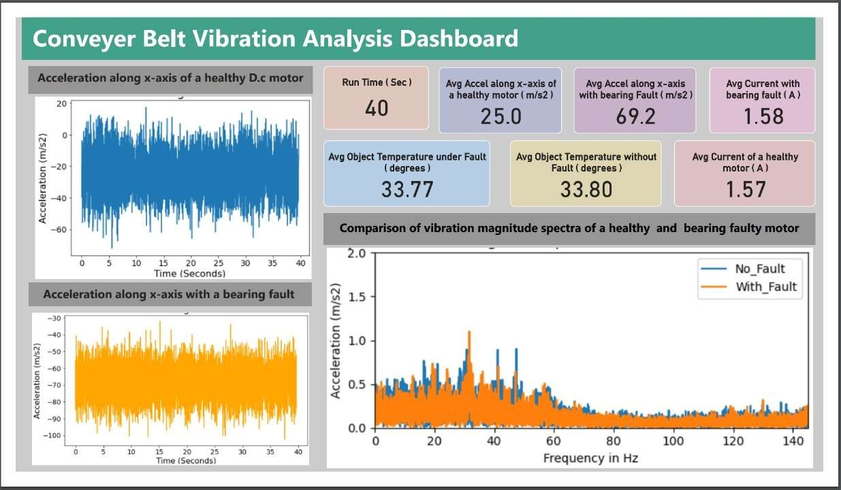
Figure 5 Conveyor Belt Vibration Analysis Dashboard
Upon visual analysis of the acceleration in the time domain, significant spikes were observed when a bearing fault was present. Moreover, the vibration magnitude spectrum highlights specific frequencies with higher accelerations in the presence of a bearing fault. These findings suggest that there may be an issue with the motor-bearing system that needs to be addressed.

  - Time Domain Analysis
When utilized in the time domain, the Python code within Power BI generates visualizations that depict the fluctuations in acceleration across the X- and Y-axes over time. These visualizations specifically focused on identifying and understanding the impact of bearing faults. The insights offered by these visualizations into time-domain data allow for a comprehensive analysis of the conveyor's dynamic behavior. The Matplotlib library served as the foundation for these visualizations, and the development of Python code was necessary for each visualization. The graph depicted in the Figure 6 depicts the fluctuation in the X-axis acceleration of a conveyor belt system when a bearing fault is present and when it is absent. Clearly, the presence of a bearing fault leads to a substantial increase in the acceleration amplitudes along the x-axis, in contrast to the normal state. As a result of the fault, the motor encounters heightened vibrations along the X-axis owing to enhanced acceleration amplitudes. The average acceleration along the X-axis for a healthy conveyor belt system is 25 m/s², but it increases considerably to 69 m/s² under faulty conditions.
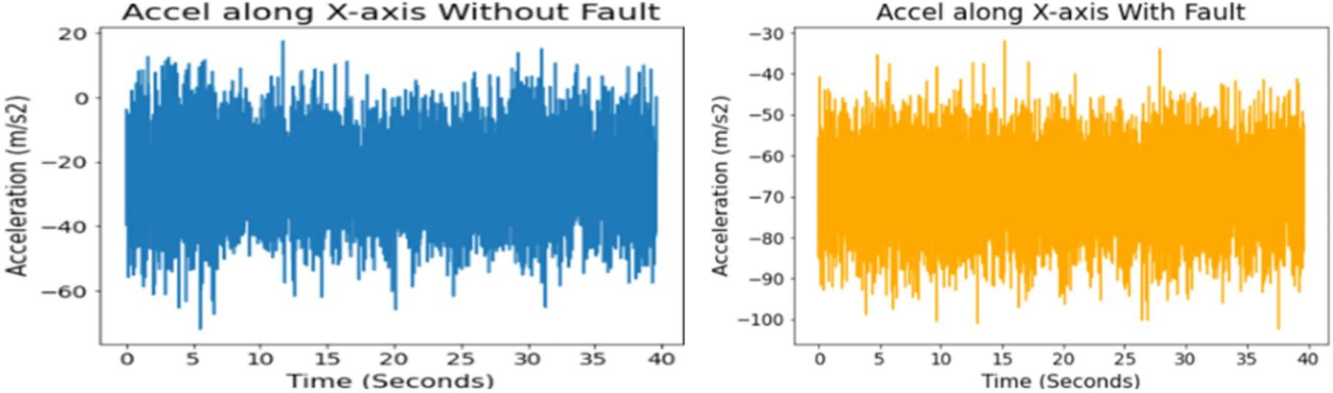

Figure 6 Comparing Acceleration along with x-axis: Conveyor Belt with and without Bearing Fault
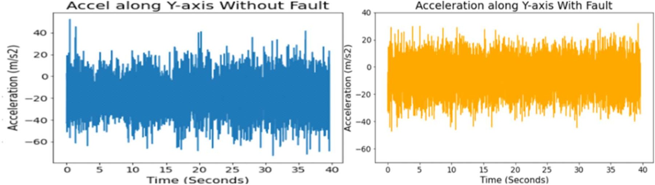
This considerable increase in acceleration can be ascribed to factors such as uneven loading on the rotor, friction, and resistance caused by faulty bearings.

Figure 7 Comparing Acceleration along with y-axis: Conveyor Belt with and without Bearing Fault
Figure 7 depicts the acceleration of a conveyor belt system along the Y-axis in normal and faulty states. When the system is healthy, the average acceleration along the Y-axis is 20 m/s², but it decreases to 17 m/s² when a bearing fault is present. The fault mainly affects the x-axis and has a minimal impact on the y-axis. The reduction in acceleration along the Y-axis leads to a decrease in rotor oscillations in that direction.
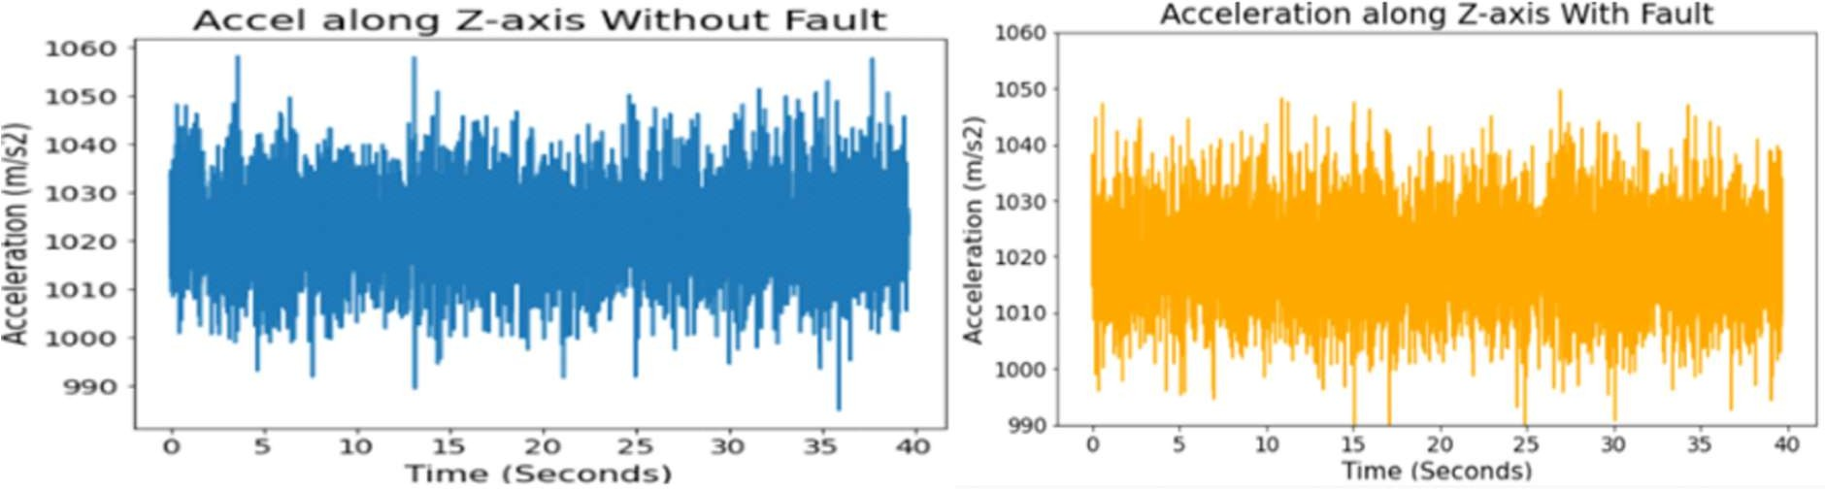
Figure 8 Comparing Acceleration along with z-axis: Conveyor Belt with and without Bearing Fault

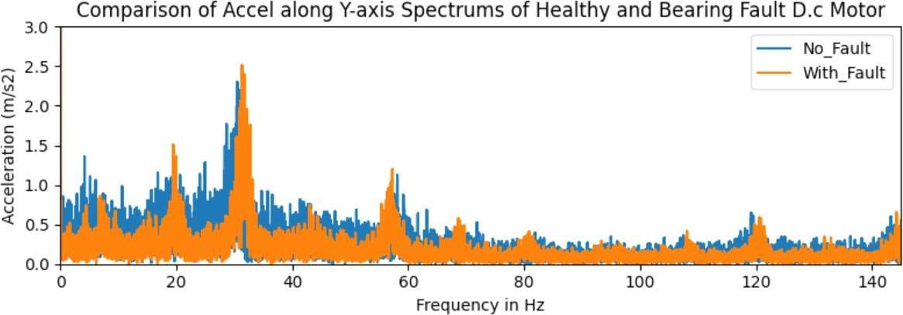
Figure 8 shows the acceleration of a healthy conveyor belt system along the Z-axis, which is significantly higher than the x- and y-axes, indicating more vibrations along the Z-axis, even in the absence of any faults. The average acceleration along the Z-axis in a healthy system was 1022 m/s², whereas it increased slightly to 1030 m/s² under a bearing fault condition, which was asymmetric and mainly affected the x-axis with a lesser impact on the Z-axis. The z-axis is less sensitive to bearing faults, resulting in a reduced impact on the vibrations along this axis. The bearing fault in a conveyor belt system leads to a notable increase in the acceleration magnitude compared with a healthy system. When a bearing fault is present, the acceleration amplitudes are significantly higher, leading to increased motor vibrations.

  - Frequency Domain Analysis:
Python code, designed to generate FFT visuals, is essential for each visual. This code, implemented in the Jupyter Notebook, has been provided to generate an FFT visualization comparing the vibration magnitude spectra of a healthy conveyor belt system with a faulty bearing.
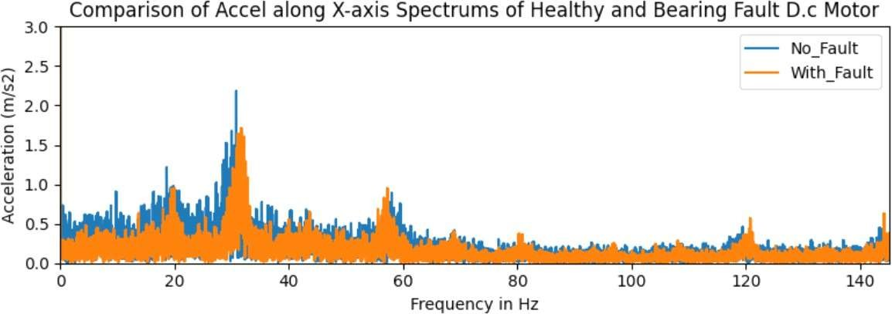
Figure 9 X-Axis Vibration Spectra: Healthy vs. Faulty Conveyor belts
Figure 9 compares the vibration spectra of a healthy and faulty conveyor belt system along the x-axis. Notably, the acceleration spectrum of the faulty conveyor belt system exhibits an increased intensity of oscillations or vibrations at specific frequencies such as 33 Hz, 58 Hz, 80 Hz, 120 Hz, and 140 Hz. Furthermore, the vibration intensity at these frequencies was higher in the faulty system than in the healthy system. This heightened vibration intensity was attributed to the presence of a bearing fault, which led to an increase in the magnitude of vibrations at these particular frequencies.
Figure 10 Y-Axis Vibration Spectra: Healthy vs. Faulty Conveyor belts
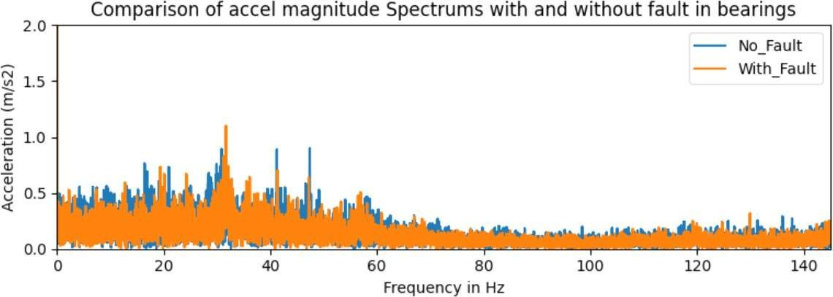

Consequently, the vibrational energy of the faulty conveyor belt system exceeds that of the healthy system at these frequencies. Figure 10 shows the vibration spectra along the Y-axis for healthy and faulty conveyor belt systems. The acceleration spectrum of a faulty conveyor belt system exhibits increased intensity of oscillations or vibrations at specific frequencies, such as 20 Hz, 33 Hz, 58 Hz, 80 Hz, 120 Hz, and 140 Hz, which is higher than that observed in a healthy system. This heightened vibration intensity was attributed to the presence of a bearing fault, which caused an increase in the magnitude of vibrations at these particular frequencies Consequently, the vibrational energy of the faulty bearing conveyor belt system exceeds that of the healthy conveyor belt system at these frequencies along the y-axis.
Figure 11 Z-Axis Vibration Spectra: Healthy vs. Faulty Conveyor belts
Figure 11 shows a comparison of the vibration spectra along the Z-axis for healthy and faulty conveyor belt systems. The acceleration spectrum for the faulty conveyor belt system demonstrates a significant increase in vibration intensity at specific frequencies, such as 20 Hz, 33 Hz, 42 Hz, and 58 Hz, which are higher than those observed in a healthy system. The increased vibration intensity is attributed to the presence of a bearing fault, resulting in a higher magnitude of vibration at these frequencies. As a result, the vibrational energy of the faulty bearing conveyor belt system surpasses that of the healthy system at these frequencies along the z-axis. Figure 12 illustrates the comparison of the vibration magnitude spectra for healthy and faulty conveyor belt systems. The acceleration magnitude spectrum of the faulty system exhibited a notable increase in the vibration intensity at specific frequencies, such as 20 Hz, 33 Hz, 42 Hz, and 58 Hz. This heightened vibration intensity exceeds that observed in a healthy system, and is attributed to the presence of a bearing fault, resulting in increased vibrations at these frequencies. Consequently, the vibrational energy of the faulty system surpasses that of a healthy system at these frequencies.

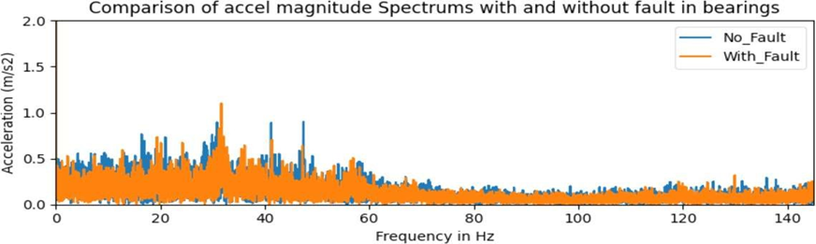
Figure 12 Vibration Magnitude: Healthy vs. Faulty Conveyor Belts

Parameter | Measurement Axis / Domain | Healthy Condition | Faulty (Bearing Fault) Condition | Change / Observation | Interpretation / Inference
Average Acceleration (m/s²) | X-axis | 25 | 69.2 | Significant increase (176%) | Major vibration rise along x-axis due to bearing fault; x-axis most sensitive.
Average Acceleration (m/s²) | Y-axis | 20 | 17 | Slight decrease | Fault impact minimal on y-axis; less vibration response.
Average Acceleration (m/s²) | Z-axis | 1022 | 1030 | Slight increase | Z-axis less sensitive; vibrations mainly from normal motor dynamics.
Average Current (A) | — | 1.57 | 1.58 | ≈ No significant change | Bearing fault has negligible effect on motor current.
Dominant Frequencies (Hz) | X-axis | — | 33, 58, 80, 120, 140 | Increased vibration amplitude at specific frequencies | Indicates localized bearing defect and mechanical resonance.
Dominant Frequencies (Hz) | Y-axis | — | 20, 33, 58, 80, 120, 140 | Increased spectral intensity | Confirms fault-related harmonic response along y-axis.
Dominant Frequencies (Hz) | Z-axis | — | 20, 33, 42, 58 | Noticeable but lower amplitude peaks | Bearing fault slightly influences z-axis response.
Vibration Pattern (Time Domain) | All axes | Stable with smooth variation | Spikes and abrupt oscillations | Confirms unbalanced rotor and increased friction due to bearing wear.
Vibration Energy (Frequency Domain) | All axes | Low intensity | High spectral intensity | Faulty bearings lead to higher vibration energy across multiple frequencies.
System Efficiency | — | Normal operation | Reduced efficiency | Higher resistance and uneven loading decrease performance.
Overall Inference | — | Stable performance | Increased vibration, friction, and energy loss | IoT–Power BI system successfully detects fault signatures and variations.

Table 1: Summary of Experimental Results and Observations

A comparison of the acceleration signals from the motor frame during normal and faulty operation revealed significant differences in the frequency domain is illustrated in Table 1. This research examined the consequences of bearing faults on conveyor belt systems, revealing significant implications for system dynamics and efficiency. Notably, the presence of such faults was found to have a substantial impact on both acceleration and vibration patterns. Specifically, the observations indicated a pronounced increase in x-axis vibrations under faulty conditions, in contrast to the reduced vibrations observed in healthy systems. Additionally, a clear correlation was established between the presence of bearing faults and heightened resistance and friction within the conveyor belt system, suggesting a direct impact on operational efficiency. These findings were further reinforced by the consistent intensification of vibrations at specific frequencies across all axes, which is indicative of systemic distress. Interestingly, this study challenged the prevailing belief that minimal vibrations always denote optimal efficiency, highlighting a nuanced relationship between vibration levels and system performance. Furthermore, the potential for bearing faults to exacerbate damage to the system, particularly through the induction of uneven loading on the rotor, was speculated. This underscores the importance of proactive maintenance strategies for mitigating the adverse effects of bearing faults on conveyor belt systems. Overall, these insights emphasize the critical need for comprehensive monitoring and maintenance protocols to enhance reliability and performance in industrial settings.

Study (author, year) | Application / System | Sensors & Setup | Analysis methods | Key findings | Comparison with paper
This paper | Conveyor belt motor frame (lab experiment) | ESP32 + triaxial LIS2DW12 MEMS accelerometer; Azure IoT Hub → Power BI; 11,500 records | Time-domain statistics (mean, spikes) in Power BI; FFT in Python (NumPy/Pandas/Matplotlib) | X-axis accel: 25 → 69.2 m/s² (healthy→faulty); Y: 20→17; Z: 1022→1030; fault spectral peaks at 20, 33, 42, 58, 80, 120, 140 Hz; small current change (1.57→1.58 A). | Baseline for comparison (real IoT pipeline + dashboard + FFT).
[25] | Review paper on idler/roller fault detection for belt conveyors | Surveys acoustic and vibration sensors used in recent studies (microphones, MEMS accelerometers) | Summarizes pre-processing, feature extraction, ML classification approaches (time/frequency/features) | Concludes vibration & acoustic signals + ML are effective; axis/placement and preprocessing strongly affect results. | Emphasises axis/placement dependence Suggests ML/feature extraction as next step.
[26] | Airport baggage handling conveyors (field-scale study) | IoT sensors (vibration + other signals), large noisy field data; ML pipeline for classification | Data cleaning, ML classifiers (CNN/time-series imaging), practical noise-filtering steps | Demonstrated feasibility of predictive maintenance at scale; required noise-removal and data labeling to get robust detection. | This work solved in lab with clean IoT stream + Power BI. Recommends noise-robust processing if this moves to field deployment.
[27] | General IoT vibration measurement (hardware & methodology) | Triaxial MEMS accelerometers + microcontroller (on-rotor or nearby) | FFT, time-domain features; design details for on-device acquisition and SNR improvement | Demonstrates practical hardware design choices (sampling, placement, SNR) that affect the spectra and detection sensitivity. | ESP32 + LIS2DW12 pipeline follows this IoT design pattern; Koene et al. reinforce that placement & sampling determine axis sensitivity—explains high Z baseline and strong X response.
[28] | Coal conveyor (industrial field test) | Multiple sensors (vibration, etc.) forwarded via IoT; ML model LightGBM | Feature extraction + LightGBM classifier; 3-month field validation | Achieved robust fault detection and real-time alerts after field validation; highlights the need for long term testing. | Comparison: Confirms that ML + IoT at field scale is effective but requires longer testing—this provides lab validation and suggests the pathway to field trials.

Table 2: Comparison of the presented work with literature

4.0 CONCLUSION
In summary, the study on real-time data analysis for optimizing conveyor belt performance demonstrates the effectiveness of advanced analytical techniques in identifying bearing faults and assessing their impact on system behavior. The results reveal distinct acceleration signal patterns associated with bearing defects across multiple axes, characterized by higher vibration amplitudes at specific frequencies in faulty motors compared with healthy ones. These observations underscore the potential of data-driven approaches for enhancing fault detection, diagnostics, and maintenance strategies in conveyor belt systems. A noticeable increase in vibration amplitude along the x-axis was observed in the time-domain analysis under faulty bearing conditions. In the frequency-domain analysis, distinct peaks were identified at specific frequencies in the presence of bearing faults, whereas the healthy conveyor belt system exhibited comparatively stable vibration characteristics. These findings highlight the substantial influence of bearing defects on the dynamic behavior of the conveyor system, particularly in terms of acceleration response and vibration patterns. The results further provide valuable insights for condition monitoring, fault diagnosis, and predictive maintenance applications.
Furthermore, this architecture incorporates the ESP32 microcontroller and LIS2DW12 MEMS accelerometer as edge devices, utilizes Azure IoT Hub and Stream Analytics for secure, real-time cloud processing, and employs Power BI for interactive visualization, showcasing the functionalities of Industry 4.0 tools in modern asset monitoring. The system's capacity to perform both time-domain and frequency-domain analyses using Fast Fourier Transform (FFT) techniques, along with statistical feature extraction and the incorporation of machine learning/deep learning models, enables accurate and insightful defect diagnosis.

References

- Ms. Sayali Todkar and Prof. Milind Ramgir, “Design of Belt Conveyor System,” International Journal of Science, Engineering and Technology Research (IJSETR), vol. 7, no. 7, 2018.
- M. A. Alspaugh, “Latest Developments in Belt Conveyor Technology,” 2004.
- G. Fedorko, “Implementation of Industry 4.0 in the belt conveyor transport,” MATEC Web of Conferences, vol. 263, p. 01001, 2019, doi: 10.1051/matecconf/201926301001.
- V. Gupta, R. Mitra, F. Koenig, M. Kumar, and M. K. Tiwari, “Predictive maintenance of baggage handling conveyors using IoT,” Comput Ind Eng, vol. 177, p. 109033, Mar. 2023, doi: 10.1016/j.cie.2023.109033.
- K. S. Kiangala and Z. Wang, “An Effective Predictive Maintenance Framework for Conveyor Motors Using Dual Time-Series Imaging and Convolutional Neural Network in an Industry 4.0 Environment,” IEEE Access, vol. 8, pp. 121033–121049, 2020, doi: 10.1109/ACCESS.2020.3006788.
- M. Wang, K. Shen, C. Tai, Q. Zhang, Z. Yang, and C. Guo, “Research on fault diagnosis system for belt conveyor based on internet of things and the LightGBM model,” PLoS One, vol. 18, no. 3 March, Mar. 2023, doi: 10.1371/journal.pone.0277352.
- R. Martínez-Parrales and A. Del Carmen Téllez-Anguiano, “Vibration-based Fault Detection System with IoT Capabilities for a Conveyor Machine.”
- M. Yang, W. Zhou, and T. Song, “Audio-based fault diagnosis for belt conveyor rollers,” Neurocomputing, vol. 397, pp. 447–456, Jul. 2020, doi: 10.1016/j.neucom.2019.09.109.
- S. Dey, O. Salim, H. Masoumi, and N. Karmakar, “Health monitoring of mining conveyor belts.” [Online]. Available: https://www.researchgate.net/publication/344785500
- T. Kalavathi Devi, M. Madhan Mohan, K. N. Baluprithviraj, V. Poojashri, A. Swetha, and P. Vasuki, “IOT Based Moisture Measurement and Conveyor Belt Monitoring in Yarn Mill,” in Journal of Physics: Conference Series, Institute of Physics, 2022. doi: 10.1088/1742-6596/2325/1/012009.
- M. H. Mohd Ghazali and W. Rahiman, “Vibration Analysis for Machine Monitoring and Diagnosis: A Systematic Review,” Shock and Vibration, vol. 2021. Hindawi Limited, 2021. doi: 10.1155/2021/9469318.
- Suherman, Fahmi, U. Hasnita, and Z. Herri, “Design and characteristics assessment of wireless vibration sensor for buildings and houses,” Indonesian Journal of Electrical Engineering and Computer Science, vol. 21, no. 3, pp. 1381–1388, Mar. 2021, doi: 10.11591/ijeecs.v21.i3.pp1381-1388.
- I. Koene, V. Klar, and R. Viitala, “IoT connected device for vibration analysis and measurement,” HardwareX, 2020, doi: 10.17605/OSF.IO/YX687.
- A. De Angelis, F. Santoni, P. Carbone, M. Cecconi, A. Vecchietti, and F. Di Lorenzo, “Development of an iot structural monitoring system applied to a hypogeal site,” Sensors (Switzerland), vol. 20, no. 23. MDPI AG, pp. 1–13, Nov. 02, 2020. doi: 10.3390/s20236769.
- O. P. Yadav and G. L. Pahuja, “Bearing Health Assessment Using Time Domain Analysis of Vibration Signal,” International Journal of Image, Graphics and Signal Processing, vol. 12, no. 3, pp. 27–40, Jun. 2020, doi: 10.5815/ijigsp.2020.03.04.
- A. Kafeel et al., “An expert system for rotating machine fault detection using vibration signal analysis,” Sensors, vol. 21, no. 22, Nov. 2021, doi: 10.3390/s21227587.
- Mohammed Ameer, Simhadri Prem Rahul, and Dr.Suneetha Manne, “Human Resource Analytics using Power Bi Visualization Tool,” in Proceedings of the International Conference on Intelligent Computing and Control Systems (ICICCS 2020), 2020.
- A. Oliveira and J. Bernardino, “Evaluating self-service Bi and analytics tools for SMEs,” in ICETE 2020 - Proceedings of the 17th International Joint Conference on e- Business and Telecommunications, SciTePress, 2020, pp. 89–97. doi: 10.5220/0009820400890097.
- Arush Kalra, Berwin Turlach, and Vikesh Raikundalia & Desmond McEwan, “Wastewater Pump Station Asset Performance Visualisation,” CEED Seminar Proceedings 2019.
- D. Silva, P. Paulo, and A. Amaro, “Logistic Performance & Dashboards: a flexible Power BI solution,” in CAPSI 2020 Proceedings, 2020. [Online]. Available: https://aisel.aisnet.org/capsi2020
- J. M. Palma-Ruiz, A. Torres-Toukoumidis, S. E. González-Moreno, and H. G. Valles- Baca, “An overview of the gaming industry across nations: using analytics with power BI to forecast and identify key influencers,” Heliyon, vol. 8, no. 2, Feb. 2022, doi: 10.1016/j.heliyon.2022.e08959.
- J. Mallqui Carhuamaca, J. Jorim Tello Olivas, B. Esterripa Aguilar, C. Enrique Alvarez Montalvan, N. Moggiano Aburto, and L. Ruben Carrasco Contreras, “Big data analysis for drilling and blasting in a mine in the central andes,” in ACM International Conference Proceeding Series, Association for Computing Machinery, Feb. 2021, pp. 27–33. doi: 10.1145/3456415.3456421.
- P. Sri Rohith, R. Catherin, R. Bhanu Priya, K. Prithvi Krishna, and P. Ramesh Kumar, “IoT based state of the art dam management system in indian scenario,” in Proceedings of the 4th International Conference on IoT in Social, Mobile, Analytics and Cloud, ISMAC 2020, Institute of Electrical and Electronics Engineers Inc., Oct. 2020, pp. 362–366. doi: 10.1109/I-SMAC49090.2020.9243503.
- A. R. Al-Obaidi, “Detection of Cavitation Phenomenon within a Centrifugal Pump Based on Vibration Analysis Technique in both Time and Frequency Domains,” Exp Tech, vol. 44, no. 3, pp. 329–347, Jun. 2020, doi: 10.1007/s40799-020-00362-z.
- Alharbi, F., Luo, S., Zhang, H., Shaukat, K., Yang, G., Wheeler, C. A., & Chen, Z. (2023). A Brief Review of Acoustic and Vibration Signal-Based Fault Detection for Belt Conveyor Idlers Using Machine Learning Models. Sensors, 23(4), 1902. https://doi.org/10.3390/s23041902
- Vishal Gupta, Rony Mitra, Frank Koenig, Maneesh Kumar, and Manoj Kumar Tiwari. 2023. Predictive maintenance of baggage handling conveyors using IoT. Comput. Ind. Eng. 177, C (Mar 2023). https://doi.org/10.1016/j.cie.2023.109033
- Ivar Koene, Ville Klar, Raine Viitala.2020. IoT connected device for vibration analysis and measurement. HardwareX Volume 7, April 2020, e00109 https://doi.org/10.1016/j.ohx.2020.e00109
- Meng Wang, Kejun Shen , Caiwang Tai, Qiaofeng Zhang, Zongwei Yang, Chengbin Guo. Research on fault diagnosis system for belt conveyor based on internet of things and the LightGBM model Published: March 13, 2023 https://doi.org/10.1371/journal.pone.0277352

