CUSTOMER CHURN ANALYSIS
& RETENTION STRATEGY
End-to-End Banking Analytics — Full Project Report

Domain: Banking Analytics
Version 2.0 — Final
Author: Nasrul Khair (Data Analyst)
Dataset: Bank Customer Churn · 10,000 records · 2016–2019
Stack: Python · SQL · Snowflake · Power BI · Jira
Part I reproduces the Business Requirement Document (v1.1) and the full build record — requirements, data engineering, star-schema modelling, exploratory analysis, and SQL business questions. Part II records the delivered Power BI dashboard, finalises the KPI baseline, and closes the project.

Contents
Part I — Project Definition & Build 4
1. Project Overview 4
2. Business Objectives 4
3. Business Questions 4
4. Data Gathering 5
5. Data Dictionary 5
6. Business Rules 6
7. Deliverables 7
8. Stakeholders & Responsibilities 7
9. KPIs & Success Metrics 7
10. Dependencies & Constraints 8
11. Data Flow 9
Refresh frequency 9
KPI mapping to data fields 9
12. Data Engineering & Warehouse Setup 10
12.1 Warehouse & schema setup 10
12.2 Load source data (RAW layer) 10
12.3 Data cleaning & transformation 10
13. Data Modelling & Exploration 12
13.1 Star schema design 12
14. Exploratory Data Analysis 14
14.1 Univariate analysis 14
14.2 Bivariate analysis 15
14.3 Correlation matrix 17
14.4 Segmentation analysis 18
15. Core Business Questions (SQL) 19
15.1 Overall churn rate 19
15.2 Churn rate by country 19
15.3 Churn rate by gender 19
15.4 Churn rate by age group 20
15.5 Churn rate by product holding 20
15.6 Average credit score and balance 20
15.7 Average tenure and age 20
15.8 Summary of findings 21
16. Business Questions — Part 2 22
16.1 Top 10 customers with highest churn risk 22
16.2 Churn trend by year 22
16.3 Countries ranked by churn rate and credit score 22
16.4 Gender-based churn per country 23
16.5 Correlation between age and balance (churned) 23
16.6 Average salary and balance by product count 23
16.7 Consolidated insights from Part 2 24
17. Power BI Development 25
17.1 Snowflake connection 25
17.2 Data enrichment 25
17.3 Key DAX measures 26
Part II — Dashboard Delivery & Final Report 27
18. Project Status & Scope Delivered 27
18.1 Deliverables against plan 27
18.2 Revised KPI baseline 27
18.3 Final KPI results 28
19. Dashboard Architecture 29
19.1 Page structure 29
19.2 Design conventions 29
20. Dashboard Design & Layout 30
20.1 Report Overview (landing page) 30
20.2 Executive Overview 31
20.3 Demographic & Profiling 32
20.4 Financial & Product 33
21. Consolidated Recommendations 35
21.1 Priority actions 35
21.2 Why engagement leads 35
22. Limitations & Data Quality Notes 36
22.1 Data limitations 36
22.2 Analytical limitations 36
22.3 Scope deferred 36
23. Next Steps 37
24. Conclusion 37

Part I — Project Definition & Build
This part reproduces the Business Requirement Document (v1.1) and the full build record: requirements, data engineering, modelling, exploratory analysis, and SQL business questions. Part II covers dashboard delivery and closes the project.

1. Project Overview
This project analyses bank customer data to identify the key factors influencing customer churn and to provide data-driven retention strategies. The analysis supports management in understanding customer behaviour, churn patterns, and opportunities for improving engagement.

Dataset summary
- Demographics — age, gender, geography
- Financial indicators — balance, credit score, estimated salary
- Banking behaviours — tenure, activity status, credit card ownership
- Customer status — exited or retained
Attribute | Detail
Source | Local folder (Bank_Churn.csv)
Rows | 10,001 rows in source (10,000 records + header)
Type | Structured tabular data
Destination (raw layer) | Snowflake — schema RAW.BANK_CHURN

2. Business Objectives
- Identify characteristics of customers likely to churn.
- Quantify churn rate and segment customers by risk level.
- Develop actionable insights for retention strategy.
- Enable management to monitor churn KPIs through Power BI dashboards.

3. Business Questions
- What is the overall churn rate across all customers?
- How do age, tenure, and balance influence churn likelihood?
- Are inactive customers or those without credit cards more likely to churn?
- Which geography or gender shows higher churn trends?
- What common patterns exist among high-balance but low-activity customers?
- How do credit score segments correlate with churn?
- What is the retention trend by tenure segment?

4. Data Gathering
Source: Bank_Churn.csv — customer churn dataset including demographics, credit, and account information. 10,001 rows (10,000 data rows plus header).
Column | Description | Type | Business use
RowNumber | Record index | Integer | Ignored in analysis
CustomerId | Unique customer ID | Integer | Identifier
CreditScore | Credit rating | Numeric | Creditworthiness measure
GeographyId | 1=France, 2=Spain, 3=Germany | Categorical | Region segmentation
GenderId | 1=Male, 2=Female | Categorical | Gender-based insights
Age | Customer age | Numeric | Key predictor for churn
Tenure | Years with bank | Numeric | Customer loyalty
Balance | Account balance | Numeric | Financial indicator
NumOfProducts | Products owned | Numeric | Engagement measure
HasCrCard | 1=Yes, 0=No | Binary | Product ownership
IsActiveMember | 1=Yes, 0=No | Binary | Engagement level
EstimatedSalary | Estimated annual income | Numeric | Income category
Exited | 1=Yes, 0=No | Binary | Churn indicator
Bank DOJ | Date joined bank | Date | Tenure validation

5. Data Dictionary
- RowNumber — record number; no effect on output.
- CustomerId — random values; no effect on churn.
- Surname — no impact on the decision to leave.
- CreditScore — can affect churn; higher scores generally less likely to leave.
- Geography — location can affect the decision to leave.
- Gender — worth exploring whether gender plays a role.
- Age — older customers were expected to be less likely to leave (the data contradicts this; see Section 11).
- Tenure — years as a client; longer-tenured clients tend to be more loyal.
- Balance — customers with higher balances were expected to churn less.
- NumOfProducts — number of products purchased through the bank.

- HasCrCard — cardholders tend to churn less.
- IsActiveMember — active customers are less likely to churn.
- EstimatedSalary — higher earners were expected to churn less.
- Exited — whether the customer left (1 = Exit, 0 = Retain).
- Bank DOJ — date the customer joined the bank.

Credit score bands
Band | Range
Excellent | 800 – 850
Very Good | 740 – 799
Good | 670 – 739
Fair | 580 – 669
Poor | 300 – 579

6. Business Rules
Rule | Description
Churn definition | Customers with Exited = 1 are churned.
Activity | IsActiveMember = 0 → low engagement risk group.
Location mapping | 1 = France, 2 = Spain, 3 = Germany
Gender mapping | 1 = Male, 2 = Female
Data validation | Exclude rows with missing or invalid CustomerId.
Date handling | Convert Bank DOJ to datetime and validate Tenure.

7. Deliverables
Deliverable | Description | Owner | Epic
BRD | BRD & FRD | BA | Epic 1
Snowflake database setup | Create BANK_CHURN DB and schemas | Data Engineer | Epic 2
Cleaning & transformation | Python/SQL preprocessing scripts | Data Engineer | Epic 2
Star-schema data model | Fact_CustomerChurn + dimensions | Data Modeler | Epic 3
EDA report | Insights and trend analysis | Data Analyst | Epic 3
Power BI dashboard | Interactive churn dashboard | BI Developer | Epic 4
Row-level security | Restrict views by geography | BI Admin | Epic 5
Data refresh pipeline | Scheduled refresh via gateway | BI Admin | Epic 5
Documentation package | ER diagram, dictionary, KPIs | BA | Epic 6

8. Stakeholders & Responsibilities
This project was delivered single-handedly; each role below was performed by the same person, which is why every contact is identical.
Role | Responsibility | Contact
Business Analyst | Requirements, BRD/FRD, EDA | Nasrul
Data Engineer | Snowflake warehouse, pipelines | Nasrul
Data Analyst | Churn analysis, KPI calculation | Nasrul
Data Modeller | Analytical star schema design | Nasrul
Power BI Developer | Dashboards, RLS, refresh | Nasrul
End Users | Consume dashboards, feedback | Nasrul

9. KPIs & Success Metrics
Note: the original targets below were set before analysis. The churn target was subsequently revised to 16.5% on evidence grounds — see Part II, Section 1.2.
KPI | Formula | Original target
Customer churn rate | (Churned / Total) × 100 | ≤ 10%
Customer retention rate | 100 − churn rate | ≥ 90%
Active member ratio | (Active / Total) × 100 | ≥ 70%
Avg credit score by group | AVG(CreditScore) | Retained > churned
Avg balance by group | AVG(Balance) | Retained > churned
High-risk segment % | (Predicted / Total) × 100 | Monitor trend
Dashboard adoption rate | (Active users / Total) × 100 | ≥ 80%
Refresh success rate | (Success / Total) × 100 | 100%

10. Dependencies & Constraints
Dependency | Description
Data availability | Dataset must be loaded to Snowflake before transformation.
Tool access | Power BI Pro licence and Snowflake credentials required.
Security | RLS must align with internal access policy.
Environment | Stable gateway for automated refreshes.

11. Data Flow
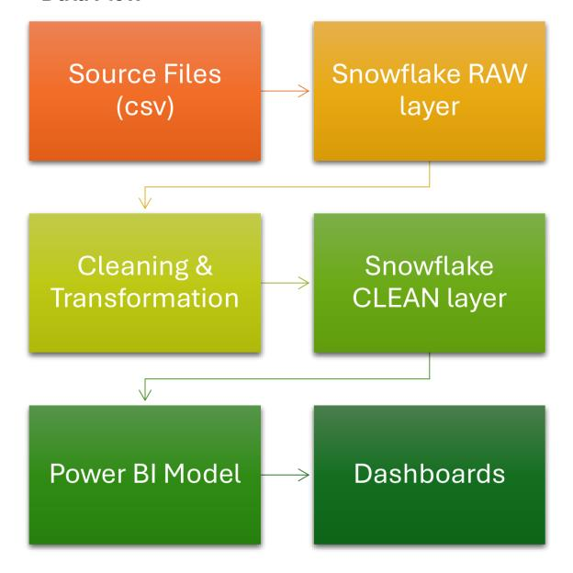
Figure 1 — Source-to-dashboard data flow

Refresh frequency
Source | Owner | Frequency
bank_churn.csv | Data Team | Weekly
Snowflake RAW schema | Data Engineering | Daily
Snowflake CLEAN schema | Data Engineering | Daily
Power BI dataset | BI Team | Daily / on refresh

KPI mapping to data fields
KPI | Calculation | Related fields
Churn rate | (#Exited / Total customers) | Exited
Average credit score | AVG(CreditScore) | CreditScore
Avg tenure | AVG(Tenure) | Tenure
Active vs inactive | COUNT(IsActiveMember) | IsActiveMember
Product penetration | AVG(NumOfProducts) | NumOfProducts
Avg balance by geography | AVG(Balance) GROUP BY GeographyID | Balance, GeographyID

12. Data Engineering & Warehouse Setup

12.1 Warehouse & schema setup
As a data engineer, I want to set up the data warehouse to host raw and clean data layers so that data is organised and ready.
Name | Purpose | Description
BANK_WH | Project warehouse | Warehouse for the churn analysis project
BANK_ANALYTICS_DB | Project database | Database for churn analysis and retention
…DB.RAW | Raw schema | Stores raw uploaded datasets, unmodified
…DB.CLEAN | Cleaned schema | Stores cleaned and transformed datasets
…DB.ANALYTICS | Analytics schema | Models and views consumed by Power BI

12.2 Load source data (RAW layer)
As a data engineer, I want to load source data into the RAW layer so that it is available for cleaning and analysis.
SELECT * FROM RAW.BANK_CHURN LIMIT 10;
SELECT COUNT(*) AS total_rows FROM RAW.BANK_CHURN; -- expect 10,000
Check | Expected | Actual | Status
Row count | 10,000 data rows | 10,000 (file has 10,001 incl. header) | Passed
Column headers | 14 columns | 14 columns | Passed
Data type consistency | Matches CSV | Matches CSV | Passed
Null values | 0 in key fields | Verification pending | Action required

12.3 Data cleaning & transformation
As a data engineer, I want to extract, clean, and transform the data so that it is accurate, standardised, and ready for modelling.

a. Extract RAW data from Snowflake
import os
import pandas as pd
from snowflake.connector import connect

details = {
'user': os.environ['SNOWFLAKE_USER'],
'password': os.environ['SNOWFLAKE_PASSWORD'],
'account': os.environ['SNOWFLAKE_ACCOUNT'],
'warehouse': 'BANK_WH',
'database': 'BANK_ANALYTICS_DB',
'schema': 'RAW'
}
conn = connect(**details)
df = pd.read_sql('SELECT * FROM BANK_CHURN', conn)
Security note: credentials load from environment variables (or a git-ignored .env file) so they never enter source control. If this project history was ever pushed publicly with credentials inline, rotate the password and audit the account for unexpected activity.

b. Clean & transform
df = df.rename(columns={
'ROWNUMBER':'row_number', 'CUSTOMERID':'customer_id',
'CREDITSCORE':'credit_score', 'GEOGRAPHYID':'geography_id',
'GENDERID':'gender_id', 'AGE':'age', 'TENURE':'tenure',
'BALANCE':'balance', 'NUMOFPRODUCTS':'num_of_products',
'HASCRCARD':'has_cr_card', 'ISACTIVEMEMBER':'is_active_member',
'ESTIMATEDSALARY':'estimated_salary', 'EXITED':'exited',
'BANK_DOJ':'bank_doj'
})

df['bank_doj'] = pd.to_datetime(df['bank_doj'])
df['geography_name'] = df['geography_id'].map({1:'France',2:'Spain',3:'Germany'})
df['gender'] = df['gender_id'].map({1:'Male', 2:'Female'})
df['retain_status'] = df['exited'].map({1:'Exit', 0:'Retain'})
df = df.drop(columns=['row_number'])

c. Load cleaned data to the CLEAN layer
from snowflake.connector.pandas_tools import write_pandas

success, nchunks, nrows, _ = write_pandas(
conn=conn, df=df, table_name='BANK_CHURN_CLEANED',
schema='CLEAN', auto_create_table=True, overwrite=True
)
Check | Expected | Status
Row count matches RAW | 10,000 | Passed
Null values cleaned | 0 in key columns | Passed — pending reverification
Category mapping | France/Spain/Germany; Male/Female | Passed
Business logic | Churn correctly derived | Passed

13. Data Modelling & Exploration

13.1 Star schema design
As a data modeler, I want to design a star schema so that Power BI and analysts can efficiently query, aggregate, and visualise customer churn insights.
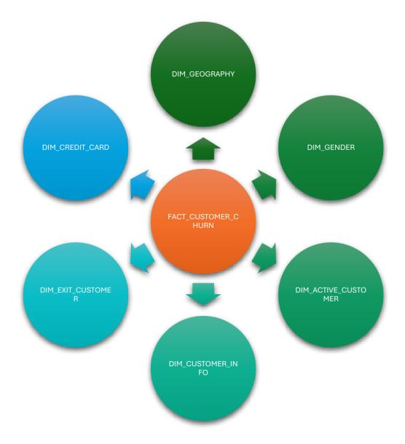
Figure 2 — Star schema: one fact table, six dimensions

FACT_CUSTOMER_CHURN_V1
Column | Type | Description
customer_id | INT | FK to DIM_CUSTOMER
geography_id | INT | FK to DIM_GEOGRAPHY
gender_id | INT | FK to DIM_GENDER
exit_id | INT | FK to DIM_EXIT_CUSTOMER
active_id | INT | FK to DIM_ACTIVE_CUSTOMER
cr_card_id | INT | FK to DIM_CREDIT_CARD
credit_score | INT | Customer credit score
age | INT | Customer age
tenure | INT | Years with bank
balance | FLOAT | Account balance
num_of_products | INT | Products owned
estimated_salary | FLOAT | Annual income
churned | VARCHAR | Exited / Retained
bank_doj | TIMESTAMP | Load timestamp

Dimension tables: DIM_CUSTOMER (customer_id PK, customer_name), DIM_GEOGRAPHY (geography_id PK, country_name), DIM_GENDER (gender_id PK, gender), DIM_EXIT_CUSTOMER (exit_id PK, exit_category), DIM_ACTIVE_CUSTOMER (active_id PK, active_category), DIM_CREDIT_CARD (credit_id PK, category).
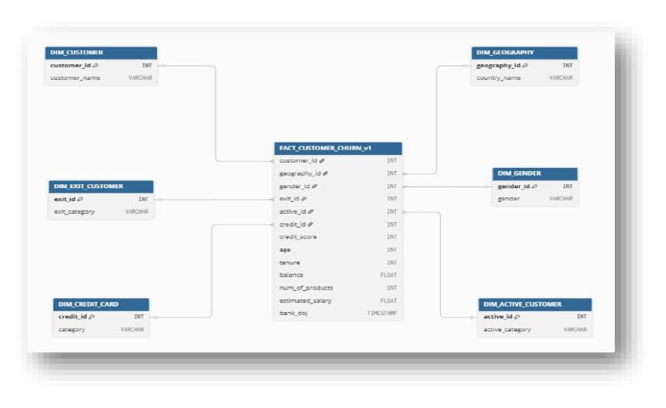
Figure 3 — ER diagram

14. Exploratory Data Analysis
As a data analyst, I want to perform exploratory analysis on the cleaned data so that I can understand patterns, relationships, and factors contributing to customer churn.

14.1 Univariate analysis
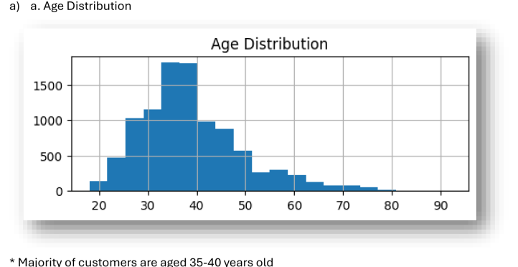
Figure 4 — Age distribution: the majority of customers are aged 35–40.
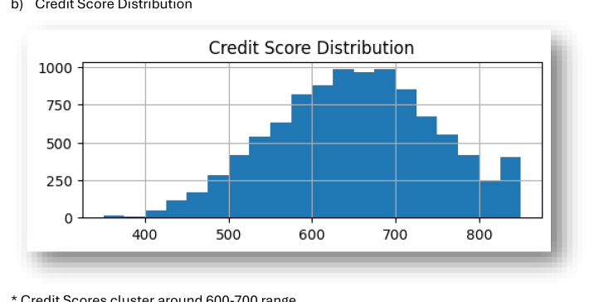
Figure 5 — Credit score distribution: scores cluster in the 600–700 range.
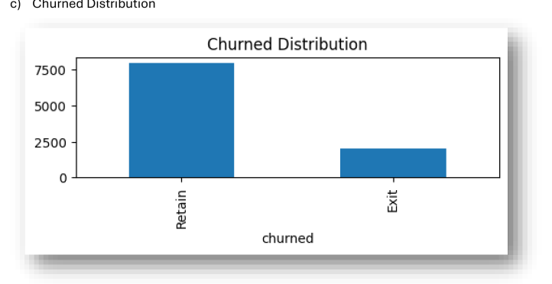
Figure 6 — Churned distribution: roughly 8,000 retained against 2,000 exited.

14.2 Bivariate analysis
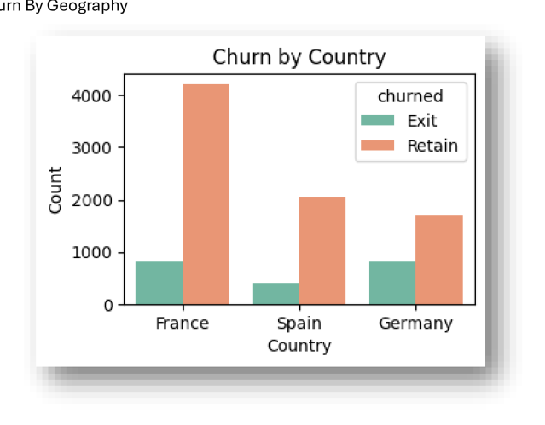
Figure 7 — Churn by geography
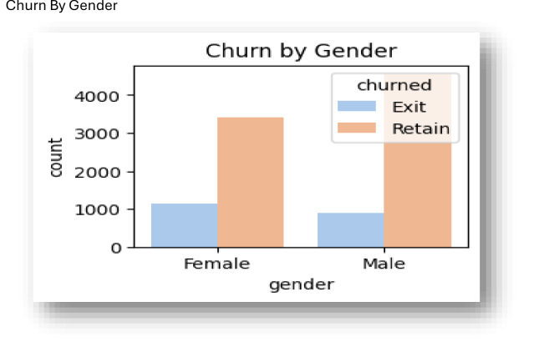
Figure 8 — Churn by gender
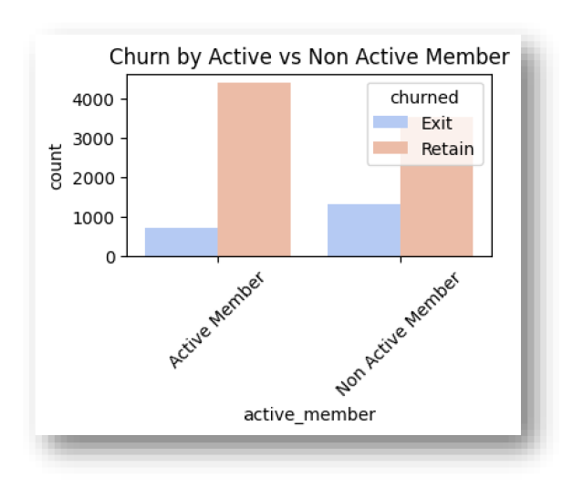
Figure 9 — Churn by active member status
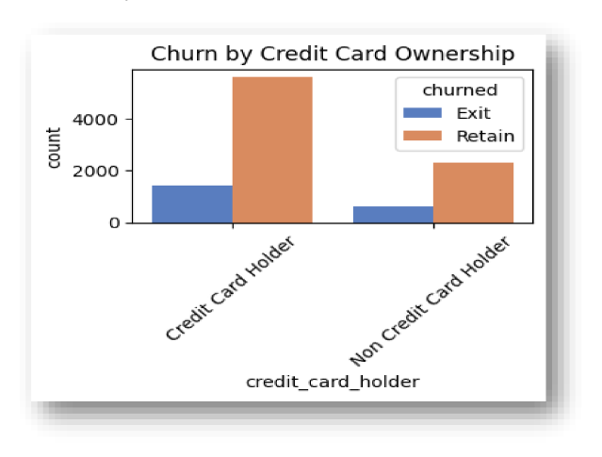
Figure 10 — Churn by credit card ownership

14.3 Correlation matrix
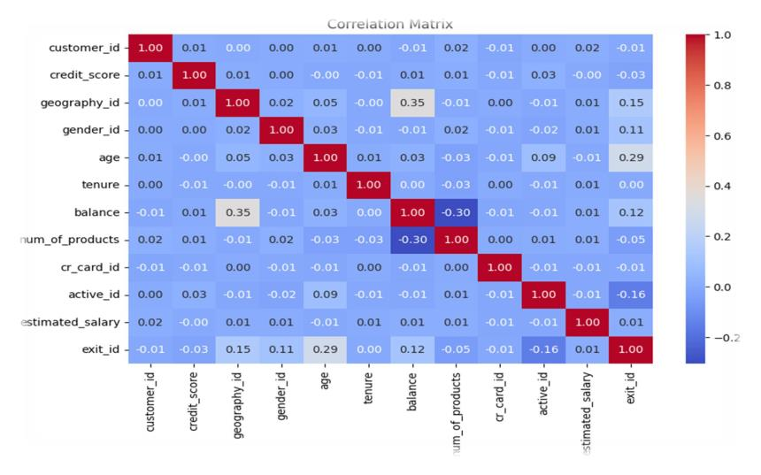
Figure 11 — Correlation matrix across all numeric fields
Metric | Score | Interpretation
Age | 0.29 | Weak-to-moderate positive — strongest single numeric correlation, but still modest.
Geography | 0.15 | Weak; confirm via segmentation rather than correlation alone.
Balance | 0.12 | Weak; higher balances show slightly higher churn tendency.
Gender | 0.11 | Weak; treat as a hypothesis to test, not a confirmed effect.
Active member | −0.16 | Weak-to-moderate negative — active members churn less.
Estimated salary | 0.01 | Negligible.
Tenure | 0.001 | Negligible — no linear relationship in this dataset.
Credit card ownership | −0.01 | Negligible.
Credit score | −0.03 | Negligible.
Number of products | −0.05 | Negligible-to-weak.

14.4 Segmentation analysis
Country | Total customers | Churned | Churn rate %
Germany | 2,509 | 814 | 32.44
Spain | 2,477 | 413 | 16.67
France | 5,014 | 810 | 16.15
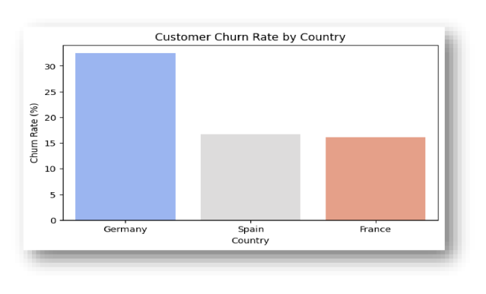
Figure 12 — Customer churn rate by country
- Germany shows the highest churn rate (32.4%), almost double France and Spain.
- France has the largest customer base (5,014) yet maintains the lowest churn rate (16.15%).
- Spain sits in between — moderate churn (16.7%) with a slightly smaller base than France.

15. Core Business Questions (SQL)
As a data analyst, I want to answer core business questions using SQL so that I can validate business KPIs using the cleaned data.

15.1 Overall churn rate
SELECT
ROUND(SUM("exit_id") * 100 / COUNT(*), 2) AS churn_rate_percentage
FROM BANK_CHURN_CLEANED;
Result: 20.37%

15.2 Churn rate by country
SELECT
"country_name",
ROUND(SUM("exit_id") * 100 / COUNT(*), 2) AS churn_rate_percentage
FROM BANK_CHURN_CLEANED
GROUP BY ALL;
Country | Churn rate %
France | 16.15
Spain | 16.67
Germany | 32.44

15.3 Churn rate by gender
Gender | Churn rate %
Female | 25.07
Male | 16.46

15.4 Churn rate by age group
SELECT
CASE
WHEN "age" < 30 THEN 'Under 30'
WHEN "age" BETWEEN 30 AND 39 THEN '30s'
WHEN "age" BETWEEN 40 AND 49 THEN '40s'
WHEN "age" BETWEEN 50 AND 59 THEN '50s'
ELSE '60s+'
END AS age_group,
ROUND(SUM("exit_id") * 100 / COUNT(*), 2) AS churn_rate_percentage
FROM BANK_CHURN_CLEANED
GROUP BY ALL ORDER BY churn_rate_percentage DESC;
Age group | Churn rate %
50s | 56.04
40s | 30.79
60s+ | 27.95
30s | 10.88
Under 30 | 7.56

15.5 Churn rate by product holding
Products held | Churn rate %
1 | 27.71
2 | 7.58
3 | 82.71
4 | 100.00

15.6 Average credit score and balance
Churn status | Avg credit score | Avg balance
Exit | 645.35 | 91,108.54
Retain | 651.85 | 72,745.30

15.7 Average tenure and age
Churn status | Avg tenure | Avg age
Retain | 4.86 | 37
Exit | 4.87 | 45

15.8 Summary of findings
KPI | Insight
Churn rate | 20.37% of customers churned.
Country | Germany has the highest churn (≈32%).
Gender | Slightly higher among females — needs significance testing.
Age | Older customers (40+) show more attrition.
Activity | Inactive customers churn roughly 2–3× more than active ones.
Product holding | 3–4-product customers churn most — counterintuitive; verify sample size first.

16. Business Questions — Part 2

16.1 Top 10 customers with highest churn risk
A weighted risk score was applied to retained customers to identify those most at risk of leaving.
/* weights: credit_score 0.4, balance 0.3, tenure 0.2, active 0.1 */
WITH churn_score AS (
SELECT bc."customer_id", ci."SURNAME", bc."country_name", bc."age",
ROUND(
(0.4 * (1 - bc."credit_score" / 1000.0)) +
(0.3 * (bc."balance" / (SELECT MAX("balance") FROM bank_churn_cleaned))) +
(0.2 * (bc."tenure" / (SELECT MAX("tenure") FROM bank_churn_cleaned))) +
(0.1 * (CASE WHEN bc."active_member" = 'Active Member' THEN 0 ELSE 1 END))
, 2) AS churn_risk_score
FROM BANK_CHURN_CLEANED bc
JOIN CUSTOMERINFO ci ON bc."customer_id" = ci."CUSTOMERID"
WHERE bc."churned" = 'Retain'
),
ranked AS (
SELECT *, DENSE_RANK() OVER (ORDER BY churn_risk_score DESC) AS rank
FROM churn_score
)
SELECT * FROM ranked WHERE rank <= 10 ORDER BY rank ASC;
Caveat: these weights were assigned by judgement, not fitted to data. The ranking is indicative only and should be replaced by a trained classification model before it drives customer-facing action.

16.2 Churn trend by year
Year | Total customers | Churned | Churn rate %
2019 | 3,302 | 655 | 19.84
2018 | 2,591 | 523 | 20.19
2017 | 2,137 | 478 | 22.37
2016 | 1,965 | 381 | 19.39
2015 | 5 | 0 | 0.00
The 2015 row contains only five customers and is excluded from trend interpretation.

16.3 Countries ranked by churn rate and credit score
Country | Avg credit score | Churn rate % | Rank
Germany | 651.45 | 32.44 | 1
Spain | 651.33 | 16.67 | 2
France | 649.67 | 16.15 | 3
Credit scores are essentially identical across the three countries, so Germany's elevated churn cannot be attributed to creditworthiness.

16.4 Gender-based churn per country
Country | Gender | Total churn | Churn rate %
Germany | Female | 448 | 37.55
Germany | Male | 366 | 27.81
Spain | Female | 231 | 21.21
Spain | Male | 182 | 13.11
France | Female | 460 | 20.34
France | Male | 350 | 12.71

16.5 Correlation between age and balance (churned)
Result: −0.023 — no meaningful relationship between age and balance among churned customers.

16.6 Average salary and balance by product count
Products | Status | Avg salary | Avg balance | Customers
1 | Exit | 100,639.83 | 92,028.82 | 1,409
1 | Retain | 99,045.36 | 101,052.82 | 3,675
2 | Exit | 100,883.31 | 90,252.36 | 348
2 | Retain | 100,416.63 | 48,731.13 | 4,242
3 | Exit | 106,776.61 | 85,853.09 | 220
3 | Retain | 92,560.21 | 25,744.26 | 46
4 | Exit | 104,763.72 | 93,733.14 | 60
The customer counts in this table are the basis for the small-sample caveat applied throughout: the 3- and 4-product groups hold 46 to 220 customers against 4,242 for 2-product retained. Percentages drawn from those groups are volatile.

16.7 Consolidated insights from Part 2
Area | Insight
Top 10 high-risk | Inactive customers with low credit scores (<560) and high balances (≈180K+), concentrated in Germany and France.
Churn trend | Peaked in 2017 (22.4%), declining to 19–20% since 2018 — retention is improving.
Country ranking | Germany highest at 32.4%; credit score flat across countries, so churn is likely driven by service or competition.
Gender by country | Female churn higher in all three countries, most notably Germany (37.6%) — confirm statistically first.
Loyal customers | Mostly France-based with high estimated salaries — strong retention among financially stable long-term clients.
Age & balance | Correlation −0.023: no meaningful relationship among churned customers.
Product count | 3–4-product customers churn most despite higher balances — small samples; treat as hypothesis.

17. Power BI Development

17.1 Snowflake connection
As a report developer, I want to connect Power BI to Snowflake so that I can visualise live, cleaned data.
Parameter | Value
Warehouse | BANK_ANALYTICS_WH
Database | BANK_ANALYTICS_DB
Schema | ANALYTICS
Dimensions | 6 DIM_ tables (Import mode)
Fact table | FACT_CUSTOMER_CHURN_V1 (DirectQuery)
Authentication | Username & password, or SSO
let
Source = Snowflake.Databases("<account>.snowflakecomputing.com", "BANK_ANALYTICS_WH"),
DB = Source{[Name="BANK_ANALYTICS_DB", Kind="Database"]}[Data],
ANALYTICS = DB{[Name="ANALYTICS", Kind="Schema"]}[Data],
FACT = ANALYTICS{[Name="FACT_CUSTOMER_CHURN_V1", Kind="Table"]}[Data]
in
FACT
Validation |  | Expected | Status
Row count |  | 10,000 | Passed
Column count |  | 13 | Passed
Data type consistency |  | Numeric / date / binary / varchar | Passed
Null / blank |  | No tolerance | Pending reverification
Sample records |  | Match Snowflake preview | Passed

17.2 Data enrichment
As a data analyst, I want to create derived columns so I can analyse customer behaviour in meaningful categories.
Feature | Type | Logic | Purpose
age_group | Calculated column | <30 Young; 30–40 Mid; 41–50 Mature; >50 Senior | Age segmentation
tenure_group | Calculated column | ≤3 New; 4–6 Mid term; >6 Long term | Loyalty segmentation
balance_flag | Calculated column | Percentile bins (has / no balance) | Financial segmentation
score_band | Dimension table | <600 Poor; 600–700 Fair; 701–800 Good; >800 Excellent | Credit segmentation
churn_reason | Dimension table | Simulated — see Part II disclosure | Driver reporting

17.3 Key DAX measures
Measure | Formula | Description
Age Group | SWITCH(TRUE(), [Age]<26,"18–25", [Age]<36,"26–35", [Age]<46,"36–45", [Age]<56,"46–55","56+") | Age bins
Churn Count | CALCULATE(COUNTROWS(FACT_CUSTOMER_CHURN_V1), DIM_EXIT_CUSTOMER[ExitCategory]="Exit") | Counts churned customers
Churn Rate | DIVIDE([Churn Count],[Total Customers]) | Context-specific churn rate
Active % | DIVIDE([Active Members],[Total Customers]) | Share of active members
Credit Card % | DIVIDE([Credit Card Holders],[Total Customers]) | Cardholder penetration

Part II — Dashboard Delivery & Final Report
This part records the delivered Power BI dashboard, finalises the KPI baseline, and closes the project with limitations and recommended next steps.

18. Project Status & Scope Delivered
All six sprints defined in the BRD are complete. The pipeline runs end-to-end from the source CSV through Snowflake to a four-page Power BI report. This section records what was delivered against what was planned.

18.1 Deliverables against plan
Deliverable | Epic | Status | Note
BRD & requirements | Epic 1 | Complete | v1.1, superseded by this document
Snowflake DB & schemas | Epic 2 | Complete | RAW / CLEAN / ANALYTICS
Cleaning & transformation | Epic 2 | Complete | Python + SQL, 10,000 rows validated
Star-schema model | Epic 3 | Complete | 1 fact + 6 dimensions
EDA report | Epic 3 | Complete | Univariate, bivariate, correlation
Power BI dashboard | Epic 4 | Complete | 4 pages — see Section 20
Row-level security | Epic 5 | Not implemented | Deferred — see Section 22
Scheduled refresh pipeline | Epic 5 | Not implemented | Deferred — see Section 22
Documentation package | Epic 6 | Complete | This document

18.2 Revised KPI baseline
The BRD set an initial churn target of ≤10%. That figure was aspirational rather than evidence-based, and against an observed rate of 20.37% it produced a gap too wide to plan against. The delivered dashboard therefore standardises on a 16.5% target, set at the level of the best-performing country cohort (France, 16.15%) rounded up. This makes the target internally achievable — it asks the business to bring Germany and Spain toward what France already demonstrates is possible — rather than benchmarking against an external figure the data cannot support.
All targets in this document, and every reference on the dashboard, use 16.5%. Where earlier drafts cite 10% or 15%, this section supersedes them.

18.3 Final KPI results
KPI | Result | Target | Status
Overall churn rate | 20.37% | ≤ 16.5% | Above target
Retention rate | 79.63% | ≥ 83.5% | Below target
Average tenure | 4.86 yrs | — | Baseline
Active member ratio | 52% | ≥ 70% | Below target
Credit card penetration | 70.66% | — | Baseline
Total customers exited | 2,037 | — | Baseline
Highest-risk region | Germany 32.44% | ≤ 16.5% | Priority
Highest-risk product | Mortgage 100% | — | Investigate

19. Dashboard Architecture
The report is built as a four-page narrative rather than a single dense canvas. A navigation landing page routes users to three analytical pages, each answering a different class of question. Every page carries a persistent left-hand summary panel with a Key Insights tooltip, so a reader arriving cold can orient without a briefing.

19.1 Page structure
Page | Audience | Question it answers
Report Overview | All users | Where do I go for what?
Executive Overview | Management | How bad is churn, where, and is it improving?
Demographic & Profiling | Retention / CRM | Who is leaving, and at what life stage?
Financial & Product | Product / Risk | Which products and credit profiles drive churn?

19.2 Design conventions
- Colour semantics: dark green denotes headline or negative-attention KPIs; yellow denotes retained customers; red denotes exited customers. This mapping is consistent on every page.
- Persistent summary panel: each page repeats period, key ratios, and an information tooltip in a fixed left column, so context travels with the user.
- Drill-through: the Executive page links through to Demographic and Financial detail, keeping the landing view uncluttered.
- Source attribution: a footer on every page names the dataset and record count, so no figure appears without provenance.
- Model: dimensions imported, fact table on DirectQuery — balancing refresh stability against live fact updates.

20. Dashboard Design & Layout

20.1 Report Overview (landing page)
The entry point. Three cards summarise what each analytical page contains and what its key metrics mean, with navigation buttons on the left. The Financial card additionally documents how to read the scatter plot — axis definitions and colour coding — which removes the most common source of misreading before the user arrives at that page.
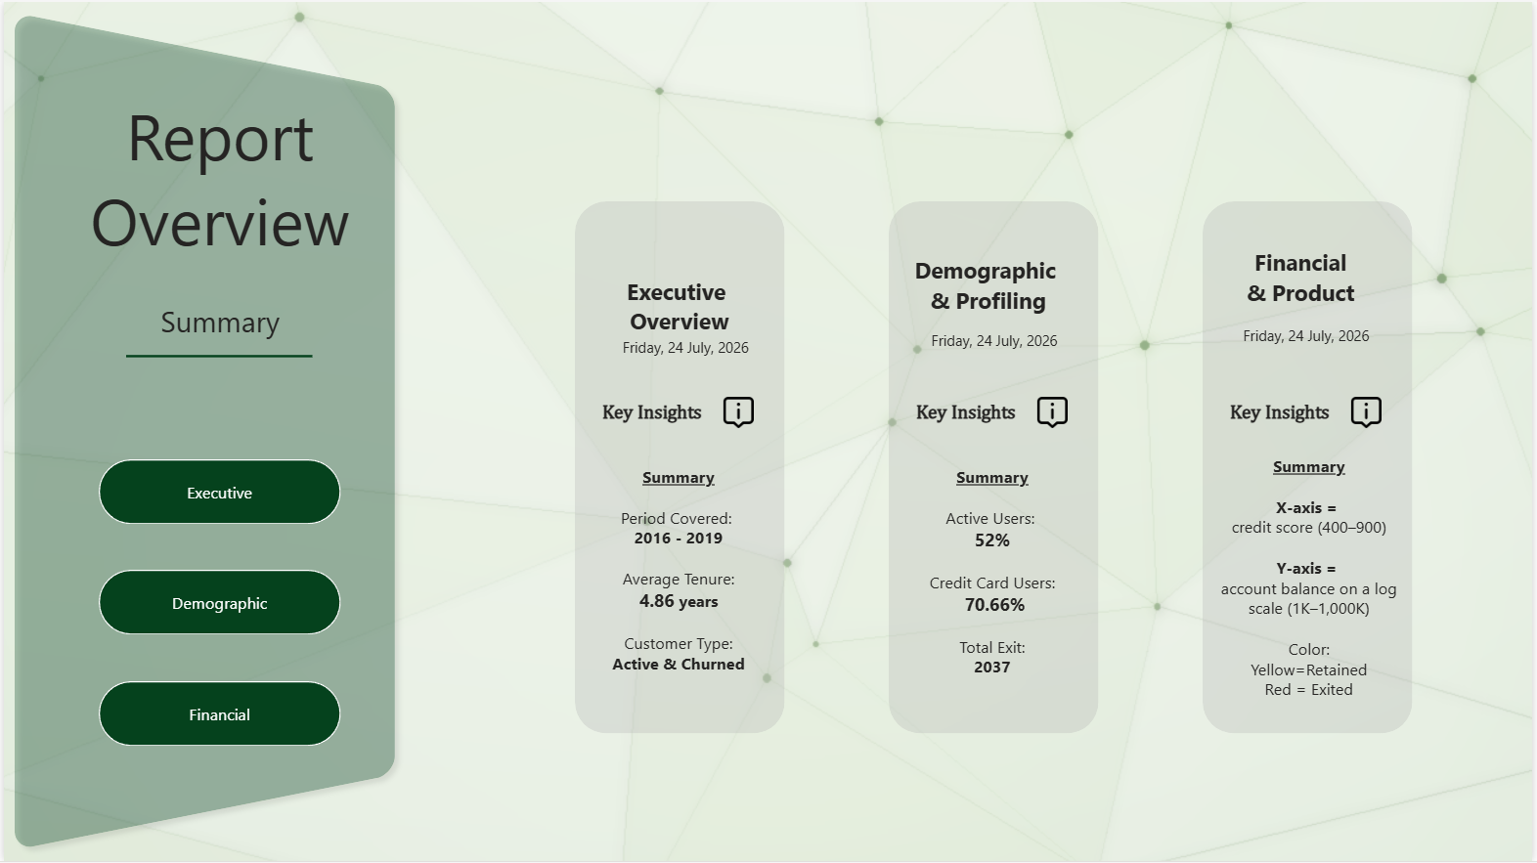
Figure 13 — Report Overview: navigation and page summaries

20.2 Executive Overview
The management landing page. Four KPI cards carry the headline numbers, each annotated with a plain-language interpretation rather than a bare figure. A trend line tracks churn against the 16.5% target across all four years, a pie and table break churn down by country, and a treemap ranks the top ten churn drivers.
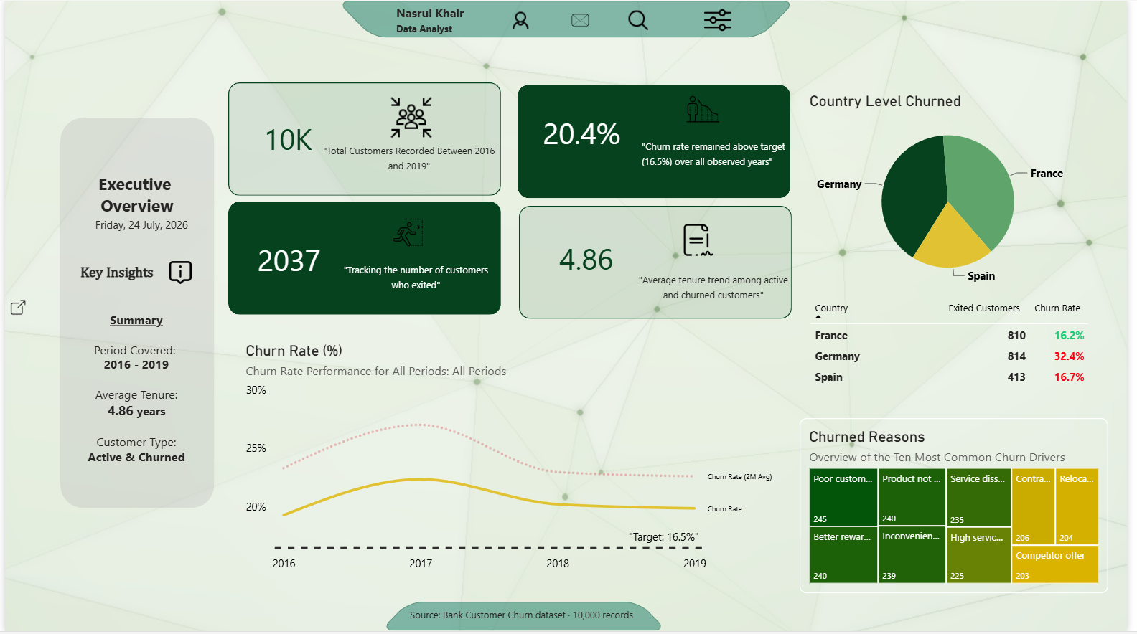
Figure 14 — Executive Overview

Key highlights
- 10,000 customers recorded between 2016 and 2019; 2,037 exited, giving a 20.37% churn rate.
- Churn stayed above the 16.5% target in every observed year — this is a structural issue, not a single bad period.
- The trend peaked at 22.37% in 2017 and eased to 19.84% by 2019 — improving, but not yet at target.

Country-level insights
- Germany 32.44%, Spain 16.67%, France 16.15% — Germany is roughly double the other two.
- France carries the largest base (5,014 customers) at the lowest churn rate, which is what makes 16.5% a demonstrably reachable target.
- Average credit score is essentially flat across all three countries (649.67–651.45), so Germany's excess churn is not a creditworthiness story.

Churn drivers
The Churned Reasons treemap displays the ten most common exit reasons. These reason codes are simulated, not observed — the source dataset contains no exit-survey field. They are included to demonstrate the reporting pattern and should not be cited as findings. The top categories cluster around service quality, pricing, and rewards, which is the hypothesis a genuine exit-survey dataset should be built to test.

20.3 Demographic & Profiling
Segmentation view for retention and CRM teams. Three KPI cards establish population size and engagement levels; the central bar chart plots churn volume by tenure year with a click-through to top reasons; the right column stacks gender, country, and credit-score breakdowns for rapid comparison.
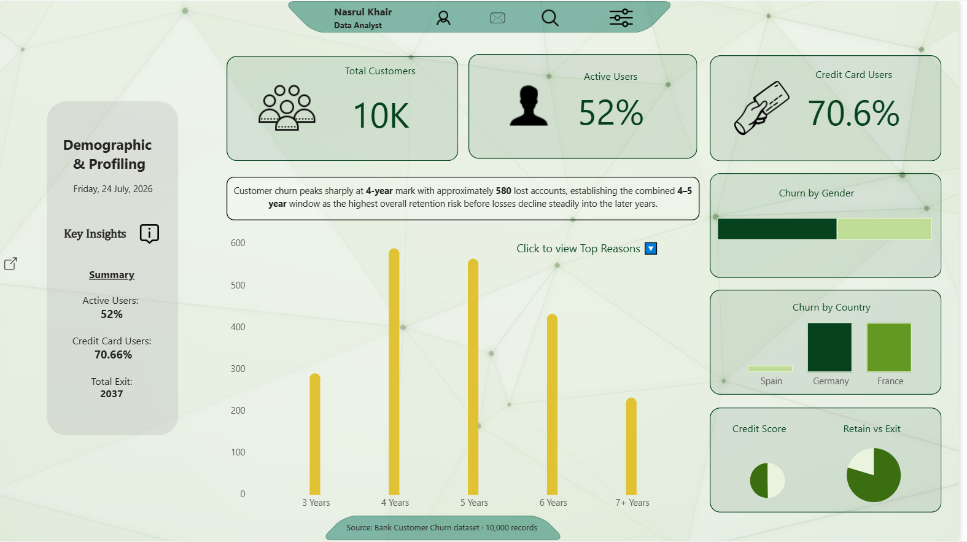
Figure 15 — Demographic & Profiling

Key insights
- Tenure is the sharpest signal on this page. Churn peaks at the 4-year mark with roughly 580 lost accounts, and the combined 4–5 year window is the single highest-risk retention stage before losses decline into later years.
- Activity status: only 52% of customers are active. Inactive members churn roughly 2–3× more than active ones — the clearest and most consistent behavioural signal in the dataset.
- Age: churn rises steeply with age, from 7.56% under 30 to 56.04% in the 50s bracket. Correlation with churn is +0.29, the strongest single numeric relationship present.
- Gender: female churn (25.07%) exceeds male (16.46%), most pronounced in Germany at 37.55%. Correlation is weak (0.11); treat as a hypothesis pending a significance test.
- Credit card ownership: 70.66% penetration, with non-cardholders churning more — a visible cross-sell opportunity.

Narrative summary
Churn concentrates among older, inactive customers at the 4–5 year tenure mark. Behavioural engagement is the most defensible lever available: it has the strongest evidence base and is directly actionable through campaign design. Demographic effects such as gender and geography are weaker and should be validated statistically before campaigns are built around them.

20.4 Financial & Product
Product and risk view. Three KPI cards headline overall churn, average churned balance, and the highest-risk product segment. Below, a credit-score band comparison and a category-versus-churn bar sit alongside a scatter plot of credit score against account balance on a log scale, with retained and exited customers colour-separated. The right column holds the product segment matrix and a lock-in tier distribution.
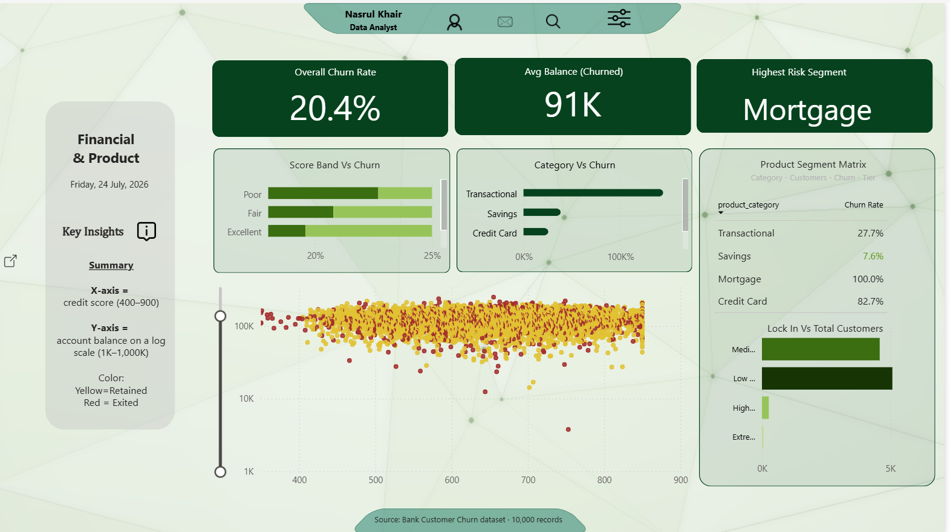
Figure 16 — Financial & Product

Key insights
- Product segment is the strongest differentiator on this page. Churn ranges from 7.6% (Savings) to 100% (Mortgage) — a spread far wider than any demographic variable produces.
- Average churned balance of 91K exceeds the retained average, confirming that the bank is losing financially significant customers rather than marginal ones. This raises the revenue stakes of the 20.37% rate considerably.
- Credit score is a weak discriminator: the Poor-to-Excellent band spread runs only about 20% to 25%, and the correlation with churn is −0.03. The scatter plot shows red and yellow points thoroughly intermixed across the full 400–900 range, which is the visual confirmation.
- Lock-in tier: Low and Medium lock-in tiers hold the overwhelming majority of customers, while High and Extreme tiers are sparse — indicating the portfolio has limited structural retention built into its product mix.

Product segment matrix
Product category | Churn rate | Read
Savings | 7.6% | Strongest retention — the benchmark segment
Transactional | 27.7% | Above overall rate; largest customer volume
Credit Card | 82.7% | Severe — but small base, verify before acting
Mortgage | 100.0% | Every customer exited — see caveat below
Caveat: the Mortgage (100%) and Credit Card (82.7%) figures rest on small sample sizes — 46 to 220 customers, against 4,242 for the two-product Savings group. A 100% rate on a small base is far more likely to reflect sample scarcity than a genuine total-loss segment. These figures should be treated as flags for investigation, not as validated findings, and the dashboard should carry a visible sample-size indicator on this matrix before the numbers are presented to stakeholders.

21. Consolidated Recommendations
Recommendations are ordered by strength of evidence rather than by size of the headline number. The first three rest on consistent, well-sampled signals; the remainder require validation before resourcing.

21.1 Priority actions
# | Action | Evidence base | Confidence
1 | Re-engagement programme for inactive members | 48% of base inactive; 2–3× churn multiple; consistent across every cut | High
2 | Retention intervention at the 3–4 year tenure mark | Clear volume peak at year 4 (~580 accounts) visible in tenure distribution | High
3 | Germany market investigation — service and competitor review | 32.44% vs 16.15% France, with credit score flat across countries | High
4 | Loyalty benefits for customers aged 45+ | Age correlation +0.29; 56.04% churn in 50s bracket | Medium
5 | Cross-sell savings products to single-product holders | Savings segment churns at 7.6% vs 27.7% transactional | Medium
6 | Review mortgage and credit-card servicing | 100% / 82.7% churn — but small samples | Low — verify first
7 | Gender-targeted engagement in Germany | 37.55% female churn, correlation only 0.11 | Low — test first

21.2 Why engagement leads
Of every variable examined, activity status combines the three properties that matter for action: it is strongly and consistently associated with churn, it applies to nearly half the customer base, and it is directly modifiable through campaign activity. Age and geography are descriptive — the bank cannot change a customer's age or country. Product mix is modifiable but rests on thin samples. Engagement is both well-evidenced and actionable, which is why it heads the list despite Germany and Mortgage carrying larger headline percentages.

22. Limitations & Data Quality Notes
Recording these plainly is part of the deliverable. Each item below constrains how far the findings above can be pushed.

22.1 Data limitations
Limitation | Impact | Mitigation
Simulated churn reason codes | Exit reasons cannot be cited as findings | Commission an exit-survey dataset
Small samples in 3–4 product segments | Mortgage / Credit Card rates unreliable | Add sample-size indicator; collect more data
Null verification incomplete in RAW layer | Residual risk of undetected gaps | Re-run validation before production sign-off
Static extract, 2016–2019 | No live view of current performance | Implement scheduled refresh (Epic 5)
No customer-value field | Churn measured by count, not revenue impact | Join to revenue data for weighted churn
Single-source dataset | No behavioural or interaction history | Integrate CRM and transaction logs

22.2 Analytical limitations
- Correlations are weak across the board — the strongest is age at +0.29. No single variable explains churn; the findings are directional, not predictive.
- The Top-10 risk ranking uses manually assigned weights (0.4 credit score, 0.3 balance, 0.2 tenure, 0.1 activity). These were chosen by judgement, not fitted to data, and a trained classification model should replace them before the ranking drives any customer-facing action.
- Gender and geography differences have not been significance-tested. They are reported as observed patterns pending a chi-square test.
- Correlation does not establish causation anywhere in this analysis — particularly for the inactivity finding, where disengagement may equally be an early symptom of intent to leave rather than its cause.

22.3 Scope deferred
Row-level security (Epic 5) and the scheduled refresh pipeline (Epic 5) were specified in the BRD but not implemented. Both require a Power BI Pro licence and gateway infrastructure outside the scope of this build. They are prerequisites for production deployment and are carried into the next phase.

23. Next Steps
Phase | Action | Prerequisite
Immediate | Add sample-size indicators to the product segment matrix | None
Immediate | Re-run null validation across the RAW layer | Snowflake access
Immediate | Significance-test the gender and geography differences | None
Short term | Implement row-level security by geography | Power BI Pro licence
Short term | Configure scheduled refresh via gateway | Gateway infrastructure
Short term | Replace manual risk weights with a fitted classification model | Cleaned training set
Medium term | Source an exit-survey dataset for genuine reason codes | Business sponsorship
Medium term | Join customer revenue data for value-weighted churn | Revenue data access
Medium term | Extend the series beyond 2019 for current-state monitoring | Updated extract

24. Conclusion
The project delivered a complete analytical pipeline — from an unstructured CSV through a layered Snowflake warehouse and star-schema model to a four-page Power BI report — against a 20.37% churn rate that has remained above target in every observed year.
The most defensible finding is behavioural rather than demographic: customer engagement, not credit profile, geography, or age, is the lever with both the strongest evidence and the clearest path to action. Germany and the mortgage segment carry larger headline percentages, but the first requires investigation to explain and the second rests on samples too small to trust. Re-engaging the 48% of the base that is currently inactive is where the analysis points most confidently.
Equally, the analysis establishes what this dataset cannot answer. Correlations are weak throughout, exit reasons are simulated, and the series ends in 2019. The dashboard is a monitoring instrument and a hypothesis generator — the next phase of value comes from better data feeding it, not from further analysis of the same extract.

End of report — Customer Churn Analysis & Retention Strategy v2.0 (Final)

