Business Requirement Document (BRD)
Project: Customer Churn Analysis & Retention Strategy
Domain: Banking Analytics
Version: 1.0
Author: Nasrul Khair (Data Analyst)

Project Overview
This project aims to analyze bank customer data to identify the key factors influencing customer churn and provide data-driven retention strategies. The analysis will support management in understanding customer behavior, churn patterns, and opportunities for improving engagement.

Dataset Summary
- Demographics (Age, Gender, Geography)
- Financial Indicators (Balance, Credit Score, Estimated Salary)
- Banking Behaviors (Tenure, Activity Status, Credit Card Ownership)
- Customer Status (Exited or Retained)
Attribute | Detail
Source | Local Folder (Bank_Churn.csv)
Rows | 10,001
Type | Structured Tabular Data
Destination (Raw layer) | Snowflake Data Warehouse – Schema: RAW.BANK_CHURN

Business Objectives
- Identify characteristics of customers likely to churn.
- Quantify churn rate and segment customers by risk level.
- Develop actionable insights for retention strategy.
- Enable management to monitor churn KPIs through Power BI dashboards.
- Establish a repeatable data pipeline from ingestion to reporting.

Business Questions
(To be refined during Sprint 2 – EDA)
- What is the overall churn rate across all customers?
- How do age, tenure, and balance influence churn likelihood?
- Are inactive customers or those without credit cards more likely to churn?
- Which geography or gender shows higher churn trends?
- What common patterns exist among high-balance but low-activity customers?
- How do credit score segments correlate with churn?
- What is the retention trend by tenure segment?

Data Gathering
Please use the following data related to Bank Customer and Associated details:
- Source Name: Bank_Churn.csv
- Description: Customer churn dataset including demographics, credit, and account info
- location: Local folder
- NumOfRows: 10,001

Column Name | Description | Example | Data Type | Business Use
RowNumber | Record Index | 1 | Integer | Ignored in analysis
CustomerId | Unique customer ID | 15634602 | Integer | Identifier for customer
CreditScore | Credit rating | 619 | Numeric | Measure of customer creditworthiness
GeographyId | Location (1=France, 2=Spain, 3=Germany) | 1 | Categorical | Region segmentation
GenderId | Gender (1=Male, 2=Female) | 2 | Categorical | Gender-based insights
Age | Customer age | 42 | Numeric | Key predictor for churn
Tenure | Years with bank | 7 | Numeric | Measures customer loyalty
Balance | Account balance | 0 | Numeric | Financial indicator
NumOfProducts | Products owned | 1 | Numeric | Measures engagement
HasCrCard | Has credit card (1=Yes, 0=No) | 1 | Binary | Product ownership
IsActiveMember | Active member (1=Yes, 0=No) | 1 | Binary | Engagement level
EstimatedSalary | Estimated annual income | 101348.88 | Numeric | Income category
Exited | Whether customer left (1=Yes, 0=No) | 1 | Binary | Churn indicator
Bank DOJ | Date joined bank | 23/3/2016 | Date | Used for tenure validation

Data Dictionary
- RowNumber – correspond to the record number and has no effect on the output
- CustomerId – Contains random values and has no effect on customer leaving the bank
- Surname – the surname of a customer has no impact on their decision to leave the bank
- CreditScore – can have effect on customer churn, since a customer with a higher credit score is less likely to leave the bank.

Credit Score
- Excellent: 800 – 850
- Very Good: 740 – 799
- Good: 670 – 739
- Fair: 580 – 669
- Poor: 300 – 579

- Geography – a customer’s location can affect their decision to leave the bank.
- Gender – it’s interesting to explore whether gender plays a role in a customer leaving the bank.
- Age – age certainly relevant, since older customers are less likely to leave their bank than younger ones.
- Tenure – refers to the number of years that the customer has been a client of the bank.
Normally older clients are more loyal and less likely to leave the bank.
  - Balance – also a very good indicator of customer churn, as people with a higher balance in their accounts are less likely to leave the bank compared to those with lower balances.
  - NumOfProducts – refer to the number of products that a customer has purchased through the bank.
  - HasCrCard – denotes whether or nota customer has a credit card. This column is also relevant, since people with a credit card are less likely to leave the bank.
    - 1 represents credit card holder
    - 0 represents non credit card holder

  - IsActiveMember – active customers are less likely to leave the bank
    - 1 represents Active Member
    - 0 represents Inactive Member
  - Estimated Salary – as with balance, people with lower salaries are more likely to leave the bank compared to those with higher salaries
  - Exited – whether the customer left the bank
    - 1 represents Exit
    - 0 represents Retain
- Bank DOJ – date when the customer joined the bank

Business Rules
Rules | Description
Churn Definition | Customers with Exited = 1 are churned.
Activity | IsActiveMember = 0 → Low engagement risk group.
Location Mapping | 1=France, 2=Spain, 3=Germany
Gender Mapping | 1=Male, 2=Female
Data Validation | Exclude rows with missing or invalid CustomerId.
Date Handling | Convert Bank DOJ to datetime and validate Tenure.

- Customers with Exited = 1 are considered churned.
- IsActiveMember = 0 may indicate low engagement.
- GeographyID maps to: 1=France, 2=Spain, 3=Germany.
- Exclude customers with missing or invalid CustomerId.
- Convert Bank DOJ to datetime for tenure calculation validation.

Deliverables
Deliverables | Description | Tool/Owner | Related Epic
BRD | BRD & FRD | BA | Epic 1
Snowflake Database Setup | Create BANK_CHURN DB and schemas (RAW, CLEAN, ANALYTICS) | Data Engineer | Epic 2
Data Cleaning & Transformation Scripts | Python/SQL scripts for preprocessing | Data Engineer | Epic 2
Star Schema Data Model | Fact table: Fact_CustomerChurn + dimensions (Customer, Geography, Product) | Data Modeler | Epic 3
EDA Report | Insights and trend analysis | Data Analyst | Epic 3
Power BI Dashboard | Interactive churn dashboard with filters | Power BI Developer | Epic 4
Row-Level Security Setup | Restrict views by geography | BI Admin | Epic 5
Data Refresh Pipeline | Scheduled refresh via gateway | BI Admin | Epic 5
Documentation Package | ER diagram, data dictionary, process flow, KPIs | BA | Epic 6

Stakeholders & Responsibilities
Role | Responsibility | Primary Contact
Business Analyst | Gather requirements, create BRD/FRD, perform EDA | Nasrul
Data Engineer | Build Snowflake warehouse, manage data pipelines | Nasrul
Data Analyst | Conduct churn analysis, calculate KPIs | Nasrul
Data Modeller | Design analytical star schema | Nasrul
Power BI Developer | Develop dashboards, configure RLS and refresh | Nasrul
End Users | Consume dashboards, provide feedback | Nasrul

KPIs and Success Metrics
KPI | Description | Formula | Target / Benchmark
Customer Churn Rate | % of customers who left | (Churned Customers / Total Customers) * 100 | ≤ 10%
Customer Retention Rate | % of customers retained | 100 - Churn Rate | ≥ 90%
Active Member Ratio | % of customers active in last 12 months | (Active Members / Total Customers) * 100 | ≥ 70%
Avg. Credit Score (Churned vs Retained) | Compare creditworthiness | (AVG(CreditScore_Churned) vs AVG(CreditScore_Retained) | Retained > Churned
Avg. Balance (Churned vs Retained) | Measure financial profile difference | AVG(Balance_Churned) vs AVG(Balance_Retained) | Retained > Churned
High-Risk Segment % | Share of customers predicted to churn | (Predicted_Churners / Total) * 100 | Monitor trend ↓
Dashboard Adoption Rate | % of active report users | (Active Users / Total Users) * 100 | ≥ 80%
Refresh Success Rate | % of successful scheduled refreshes | (Success / Total Schedules) * 100 | 100%

Dependencies & Constraints

Dependency | Description
Data Availability | Bank_Churn dataset must be uploaded to Snowflake before transformation.
Tool Access | Power BI Pro license and Snowflake connection credentials required.
Security | RLS must align with internal user access policy.
Environment | Stable gateway for automated refreshes.

Data Flow

Refresh Frequency
Source Name | Owner | Refresh Frequency
bank_churn.csv | Data Team | Weekly
Snowflake RAW Schema | Data Engineering | Daily
Snowflake CLEAN Schema | Data Engineering | Daily
Power BI Dataset | BI Team | Daily / On Refresh

KPI Mapping to data Fields

KPI | Calculation | Related Fields
Churn Rate | (#Exited Customers / Total Customers) | Exited
Average Credit Score | AVG(CreditScore) | CreditScore
Avg. Tenure | AVG(Tenure) | Tenure
Active vs Inactive Members | COUNT(IsActiveMember) | IsActiveMember
Product Penetration | AVG(NumOfProducts) | NumOfProducts
Avg. Balance per Geography | AVG(Balance) GROUP BY GeographyID | Balance, GeographyID

Sprint Deliverables

- Business Requirement Document (BRD)
- Listed data sources, owners, refresh frequency, and access levels
- Created a small data flow diagram or table mapping doc

Data Engineering & Warehouse Setup

Warehouse & Schemas Setup
“As a data engineer, I want to set up the data warehouse to host raw and clean data layers so that data is organized and ready”
Goal: Build and configure Snowflake to host raw and cleaned banking data for analysis.

Warehouse & Schema Setup
# | Task | Description | Output
1 | Create Snowflake Database and Warehouse | Create a new database (e.g., BANK_ANALYTICS_DB) and warehouse (e.g., BANK_WH) | Database + warehouse ready
2 | Create Schemas (RAW, CLEAN, ANALYTICS) | Organize data layers, raw source data, cleaned/transformed data, and modeling layer | 3 schemas created
3 | Define Naming Conventions | Establish standards for database, schema, table, and column names (e.g., snake_case, upper_case) | Naming convention document
4 | Document Folder Structure | Create short documentation for structure | Warehouse setup documentation

Warehouse & Database Structure
Name | Purpose | Description
BANK_WH | Act as project warehouse | Warehouse for banking churn analysis project
BANK_ANALYTICS_DB | Act as project database | Database for customer churn analysis and retention insights
BANK_ANALYTICS_DB.RAW | Act as schema for raw data | Stores raw uploaded datasets (unmodified)
BANK_ANALYTICS_DB.CLEAN | Act as schema for cleaned data | Stores cleaned and transformed datasets
BANK_ANALYTICS_DB.ANALYTICS | Act as schema for analytics purpose | Stores data models and views used by Power BI

Output & Deliverables
Deliverables | Description
Snowflake database created | BANK_ANALYTICS_DB visible in Snowflake
Schemas created | RAW, CLEAN, ANALYTICS
Warehouse setup | BANK_WH ready for compute
Documentation | steps taken documented on report

Load Source Data (Raw Layer)
“As a data engineer, I want to load source data into the RAW layer in Snowflake so that it’s available for cleaning and analysis.”
Goal: To ingest the raw customer churn dataset (bank_churn_raw.csv) into Snowflake’s RAW schema, forming the foundation for data cleaning and transformation.

Tasks
# | Task | Description | Output
1 | Prepare Raw Dataset File | Ensure dataset is in a clean .csv format and named consistently (e.g., bank_churn_raw.csv) | Local CSV file ready
2 | Create Target Table in RAW Schema | Define a Snowflake table (RAW.BANK_CHURN_RAW) matching the dataset structure | Empty table in Snowflake
3 | Stage the File | Upload the CSV file to a Snowflake internal stage (temporary storage area) | File staged in Snowflake
4 | Load Data into Table | Use the COPY INTO command to import the staged file into the table | Data loaded successfully
5 | Validate Load | Check row count, data types, and sample records | Load validated
6 | Document Process | Record SQL commands, results, and screenshots | Documentation for Jira

List of files
- Bank_churn.csv

Pre-requisites
- Snowflake database: BANK_ANALYTICS_DB
- Schemas created: RAW, CLEAN, ANALYTICS
- Warehouse: BANK_WH
- Role: DATA_ENGINEER_ROLE

Load the data (Snowsight UI)
- Go to Data > Databases > BANK_ANALYTICS_DB > RAW > Tables
- Select BANK_CHURN_RAW
- Choose Load Data → Load from file
- Upload bank_churn.csv

Actions Taken
- Created table BANK_CHURN in RAW schema
- Uploaded bank_churn.csv via Snowsight
- Verified 10,000 records loaded successfully

Validation Checks
Purpose | SQL Query
Preview First 10 records | SELECT *  FROM RAW.BANK_CHURN  LIMIT 10;
Validate Row Count | SELECT COUNT(*) AS total_rows  FROM RAW.BANK_CHURN; --10,000

Results
Check | Expected | Actual | Status
Row Count | 10,001 | 10,000 (header not included)
  ✅ Passed
Column Headers | 14 columns | 14 coluns
  ✅ Passed
Data Type Consistency | Matches Csv
  ✅ Passed
  ✅ Passed
Null Values | not checked

Data Cleaning & Transformation
“As a data engineer, I want to extract, clean, and transform the data so that it’s accurate, standardized, and ready for modelling.”
Goal: Prepare the raw data for analytics — clean missing values, standardize formats, fix invalid categories, and load the cleaned dataset into the CLEAN schema.

Tasks
# | Task | Description | Output
1 | Extract data from RAW | Pull data from RAW.BANK_CHURN_RAW to Python/SQL for cleaning | Dataset loaded into environment
2 | Handle missing / invalid data | Fill or remove nulls, validate dates, fix mapping (e.g., GeographyID → Country) | Clean dataset
3 | Standardize data formats | Convert Bank_DOJ to proper date type, ensure numeric precision | Consistent formats
4 |  | Use BRD rules (Exited=1 → churned, etc.) | Logical consistency ensured
  Apply business rules
5 | Load back to Snowflake | Save cleaned data into CLEAN.BANK_CHURN_CLEANED | Clean layer table ready
6 | Validate data quality | Check row count, null %, value consistency | Data quality verified

Pre-requisites
- ✅ Snowflake database: BANK_ANALYTICS_DB
- ✅ RAW.BANK_CHURN_RAW table already populated (from User Story 2)
- ✅ Access to Python / Snowflake connector
- ✅ BRD and FRD reviewed for business rules

Process Steps
- Extract RAW data from snowflake
import pandas as pd
from snowflake.connector import connect
import warnings
warnings.filterwarnings('ignore')

details = {
'user': 'NASRULKHAIR',
'password': 'C@de0123456789',
'account': 'SSDSCZP-MD39179',
'warehouse': 'BANK_WH',
'database': 'BANK_ANALYTICS_DB',
'schema': 'RAW'
}

conn = connect(**details)

query = 'SELECT * FROM BANK_CHURN'
df = pd.read_sql(query, conn)
df.head()

- Inspect for Missing / Invalid Data
df.info()
df.isnull().sum()
df.describe()

- Clean & Transform
# renaming column name

df = df.rename(columns={
'ROWNUMBER':'row_number',
'CUSTOMERID':'customer_id',
'CREDITSCORE':'credit_score',
'GEOGRAPHYID': 'geography_id',
'GENDERID': 'gender_id',
'AGE': 'age',
'TENURE': 'tenure',
'BALANCE': 'balance',
'NUMOFPRODUCTS': 'num_of_products',
'HASCRCARD': 'has_cr_card',
'ISACTIVEMEMBER': 'is_active_member',
'ESTIMATEDSALARY': 'estimated_salary',
'EXITED': 'exited',
'BANK_DOJ': 'bank_doj'
})

df.head()
# changing bank_doj to datetime format
df['bank_doj'] = pd.to_datetime(df['bank_doj'])
print(df.dtypes)
# map geography_id to country names

df['geography_name'] = df['geography_id'].map({1: 'France', 2: 'Spain', 3: 'Germany'})
df['geography_name'].value_counts()

# map gender_id to gender

df['gender'] = df['gender_id'].map({1:'Male',2: 'Female'})
df['gender'].value_counts()

# map exited to exit and retain

df['retain_status'] = df['exited'].map({1:'Exit', 0: 'Retain'})
df['retain_status'].head()

# mapr has_cr_card to credit card holder and non credit card holder

df['credit_card_holder'] = df['has_cr_card'].map({1:'Credit Card Holder', 0: 'Non Credit Card Holder'})
df['credit_card_holder'].value_counts()

# dropping unwanted columns
df = df.drop(columns=['row_number'])
df.head()

- Load Cleaned Data to Snowflake (CLEAN Layer)
from snowflake.connector.pandas_tools import write_pandas

# Make sure the CLEAN schema exists
conn.cursor().execute("USE SCHEMA BANK_ANALYTICS_DB.CLEAN")

# Write dataframe to Snowflake
success, nchunks, nrows, _ = write_pandas(
conn=conn,
df=df,
table_name='BANK_CHURN_CLEANED',
schema='CLEAN', # target schema
auto_create_table=True, # create if doesn't exist
overwrite=True # replaces existing table
)

print(f"Upload successful: {success}, rows inserted: {nrows}")

- Validate Clean Load
SELECT *
FROM CLEAN.BANK_CHURN_CLEANED
LIMIT 5;

Data Quality Validation
Check | Description | Expected | Result
Row Count | Matches RAW layer | 10,000 | 10,000
Null Values | Cleaned | 0 nulls in key columns | ✅
Category Mapping | Correct Geography/Gender | France/Spain/Germany; Male/Female | ✅
Business Logic | “Churned” correctly derived | Consistent | ✅

Output
✅ Clean table created:
BANK_ANALYTICS_DB.CLEAN.BANK_CHURN_CLEANED

Completion Criteria
- Data extracted from RAW layer
- Cleaning rules applied per FRD
- Data loaded into CLEAN layer successfully
- Validation complete (row counts, data types, mappings)
- Documented in Jira

Data Modelling & Exploration

1. Analytical & Data Model Design
Story: “As a data modeler, I want to design a star schema so that Power BI and analysts can efficiently query, aggregate, and visualize customer churn insights.”
Goal:
To create a logical and physical data model that supports churn analysis, ensuring:
- Optimized query performance for reporting tools (Power BI, SQL)
- Clear separation between fact (measures) and dimension (contextual) data
- Conformance with Snowflake dimensional modeling best practices

Pre-requisites
- Cleaned dataset loaded into CLEAN.BANK_CHURN_CLEANED
- Business objectives, KPIs, and churn logic defined in BRD & FRD
- Snowflake environment and schemas created (RAW, CLEAN, ANALYTICS)

Data Model Design (STAR Schema)

Table Definition

  - Fact_Customer_Churn_v1
Column | Data Type | Description
customer_id | INT | FK to DIM_CUSTOMER
geography_id | INT | FK to DIM_GEOGRAPHY
gender_id | INT | FK to DIM_GENDER
exit_id | INT | FK to DIM_EXIT_CUSTOMER
active_id | INT | FK to DIM_ACTIVE_CUSTOMER
cr_card_id | INT | FK to DIM_CREDIT_CARD
credit_score | INT | Customer credit score
age | INT | Customer age
tenure | INT | Years with bank
balance | FLOAT | Account balance
num_of_products | INT | Products owned
estimated_salary | FLOAT | Annual income
churned | VARCHAR | Exited, Retained
bank_doj | TIMESTAMP | Load timestamp

  - Dim_Customer
Column | Data Type | Description
customer_id | INT | PK
customer_name | VARCHAR | Name of Customer

3. Dim_Geography
Column | Data Type | Description
geography_id | INT | PK
country_name | VARCHAR | Country Name

4. Dim_Gender
Column | Data Type | Description
gender_id | INT | PK
gender | VARCHAR | Gender Label

5. Dim_Exit_Customer
Column | Data Type | Description
exit_id | INT | PK
exit_category | VARCHAR | Exit Category

6. Dim_Active_Cutomer
Column | Data Type | Description
active_id | INT | PK
active_category | VARCHAR | Active Category

7. Dim_Credit_Card
Column | Data Type | Description
credit_id | INT | PK
Category | VARCHAR | Credit Crad label

SQL Implementation

1. Tables Modelling
-- Dimension Tables

-- 1. DIM_GEOGRAPHY

CREATE OR REPLACE TABLE DIM_GEOGRAPHY (
geography_id INT PRIMARY KEY,
country_name VARCHAR
);

-- 2. DIM_CUSTOMER

CREATE OR REPLACE TABLE DIM_CUSTOMER (
customer_id INT PRIMARY KEY,
customer_name VARCHAR
);

-- 3. DIM_GENDER

CREATE OR REPLACE TABLE DIM_GENDER (
gender_id INT PRIMARY KEY,
gender VARCHAR
);

-- 4. DIM_EXIT_CUSTOMER

CREATE OR REPLACE TABLE DIM_EXIT_CUSTOMER (
exit_id INT PRIMARY KEY,
exit_category VARCHAR
);

-- 5. DIM_ACTIVE_CUSTOMER

CREATE OR REPLACE TABLE DIM_ACTIVE_CUSTOMER (
active_id INT PRIMARY KEY,
active_category VARCHAR
);

-- 6. DIM_CREDIT_CARD

CREATE OR REPLACE TABLE DIM_CREDIT_CARD (
credit_id INT PRIMARY KEY,
category VARCHAR
);

-- FACT_TABLE

CREATE OR REPLACE TABLE FACT_CUSTOMER_CHURN_v1 AS
SELECT *
FROM CLEAN.BANK_CHURN_CLEANED;

2. Adding FK Constraints
-- UPDATING FK to PK each tables

ALTER TABLE FACT_CUSTOMER_CHURN_V1
ADD CONSTRAINT fk_customer
FOREIGN KEY ("customer_id") REFERENCES ANALYTICS.DIM_CUSTOMER(customer_id);

ALTER TABLE FACT_CUSTOMER_CHURN_V1
ADD CONSTRAINT fk_geography
FOREIGN KEY ("geography_id") REFERENCES ANALYTICS.DIM_GEOGRAPHY(geography_id);

ALTER TABLE FACT_CUSTOMER_CHURN_V1
ADD CONSTRAINT fk_gender
FOREIGN KEY ("gender_id") REFERENCES ANALYTICS.DIM_GENDER(gender_id);

ALTER TABLE FACT_CUSTOMER_CHURN_V1
ADD CONSTRAINT fk_exit_customer
FOREIGN KEY ("exit_id") REFERENCES ANALYTICS.DIM_EXIT_CUSTOMER(exit_id);

ALTER TABLE FACT_CUSTOMER_CHURN_V1
ADD CONSTRAINT fk_active_customer
FOREIGN KEY ("active_id") REFERENCES ANALYTICS.DIM_ACTIVE_CUSTOMER(active_id);

ALTER TABLE FACT_CUSTOMER_CHURN_V1
ADD CONSTRAINT fk_credit_card
FOREIGN KEY ("cr_card_id") REFERENCES ANALYTICS.DIM_CREDIT_CARD(credit_id);

3. Update Records into Tables
-- UPDATE DATA INTO Dimension Tables

--1 . DIM_CUSTOMER

INSERT INTO DIM_CUSTOMER (customer_id, customer_name)
SELECT DISTINCT CUSTOMERID, SURNAME
FROM CLEAN.CUSTOMERINFO;

-- Validate the records

SELECT COUNT(*)
FROM DIM_CUSTOMER

-- 2. DIM_GEOGRAPHY

INSERT INTO DIM_GEOGRAPHY(geography_id, country_name)
SELECT DISTINCT "geography_id", "country_name"
FROM FACT_CUSTOMER_CHURN_V1;

-- Validate the records
SELECT DISTINCT *
FROM dim_geography;

-- 3. DIM_GENDER
INSERT INTO DIM_GENDER(gender_id, gender)
SELECT DISTINCT "gender_id", "gender"
FROM fact_customer_churn_v1;

-- Validate the records
SELECT *
FROM DIM_GENDER;

-- 4. DIM_EXIT_CUSTOMER
INSERT INTO DIM_EXIT_CUSTOMER(exit_id, exit_category)
SELECT DISTINCT "exit_id", "churned"
FROM fact_customer_churn_v1;

-- Validate the records
SELECT *
FROM DIM_EXIT_CUSTOMER;

-- 5. DIM_ACTIVE_CUSTOMER
INSERT INTO DIM_ACTIVE_CUSTOMER (active_id, active_category)
SELECT DISTINCT "active_id", "active_member"
FROM fact_customer_churn_v1;

SELECT *
FROM DIM_ACTIVE_CUSTOMER;

-- 6. DIM_CREDIT_CARD
INSERT INTO DIM_CREDIT_CARD(credit_id, category)
SELECT DISTINCT "cr_card_id", "credit_card_holder"
FROM fact_customer_churn_v1;

-- Validate the records
SELECT *
FROM DIM_ACTIVE_CUSTOMER;

ER DIAGRAM

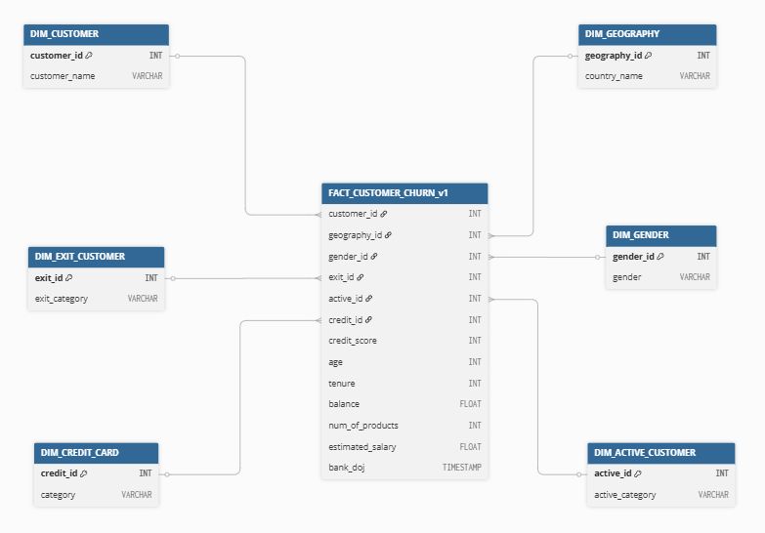

Acceptance Criteria
- Star schema created successfully in ANALYTICS schema
- Foreign keys correctly reference dimension tables
- Derived columns (age group, tenure band) verified
- Row counts validated with source (CLEAN layer)
- ER diagram and documentation uploaded

2. Exploratory Data Analysis (EDA)
Story: “As a data analyst, I want to perform exploratory analysis on the cleaned data so that I can understand patterns, relationships, and factors contributing to customer churn.”
Goal:
To analyze the CLEAN.BANK_CHURN_CLEANED dataset to:
- Understand the distribution of key variables
- Explore correlations and patterns that drive churn
- Generate insights that validate data model integrity and guide dashboard design

Pre-requisites
- Data model structure defined (Epic 3, Story 1)
- Cleaned data available in Snowflake (CLEAN.BANK_CHURN_CLEANED)
- Python or SQL environment ready for analysis (e.g., Jupyter, VSCode)
- Business KPIs and churn logic defined in BRD/FRD

Objectives
- Understand data distributions and detect anomalies.
- Identify patterns and relationships influencing customer churn.
- Validate data integrity post-cleaning.
- Derive actionable insights for Power BI dashboard design.

Key Analyses and Findings
- Univariate Analysis
- a. Age Distribution
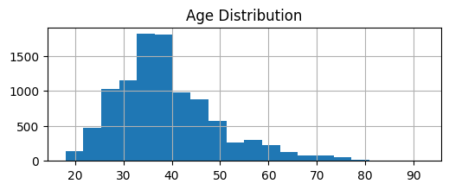
* Majority of customers are aged 35-40 years old

- Credit Score Distribution
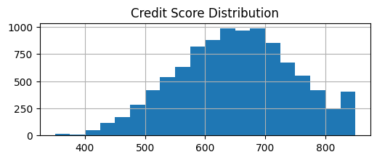
* Credit Scores cluster around 600-700 range

- Churned Distribution
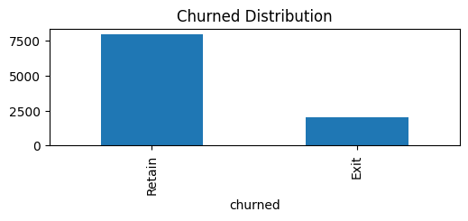* 2,000 out of 9,500 customers exited, your churn rate is around 21%.

- Bivariate Analysis
- Churn By Geography
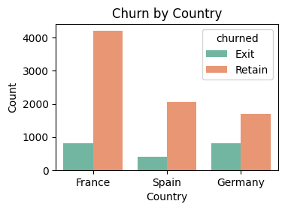

- Churn By Gender
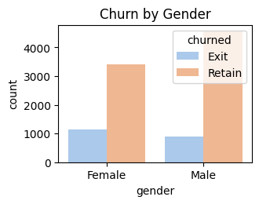

- Churn by Active Member Status
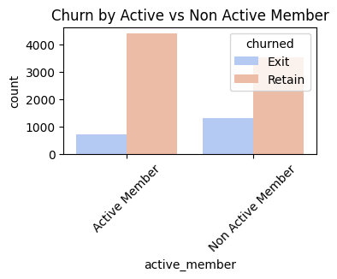

- Churn by Credit Card Holder Status
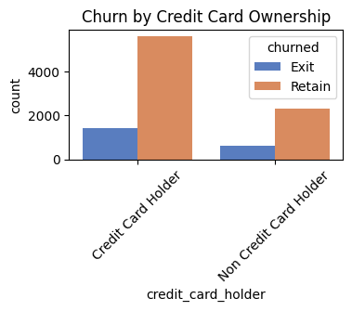

- Correlation Matrix
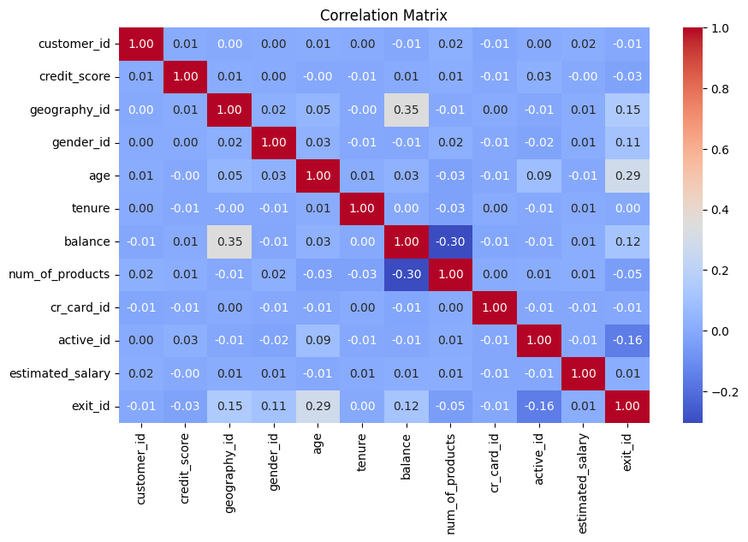
Metric | Score | Correlation
Exit ID | 1.000000 | Irrelevant identifier
Age | 0.285323 | Older customers are slightly more likely to churn. Possibly due to reduced product engagement or preference for competitor services.
Geography | 0.153771 | Indicates churn behavior differs by country — certain regions (e.g., Spain vs. France) may have higher exit rates. Worth segmenting further.
Account Balance | 0.118533 | Customers with higher account balances show a slightly higher churn tendency — perhaps they’re switching to competitors for better interest rates or benefits.
Gender | 0.106512 | Small but notable — female customers may churn slightly more. Further segmentation (age × gender) could confirm this trend.
Estimated Salary | 0.012097 | Salary has almost no effect on churn — income alone doesn’t determine exit likelihood.
Tenure | 0.000699 | Loyalty duration has no clear correlation, suggesting that long-time customers are just as likely to churn as newer ones.
Customer ID | -0.006248 | Irrelevant identifier
Credit Card Ownership | -0.007138 | Very weak, but credit card holders slightly less likely to churn, possibly due to product stickiness.
credit_score | -0.027094 | Weak — higher credit scores marginally reduce churn, suggesting financially responsible customers stay longer.
Number Of Products | -0.047820 | Weak negative — customers with multiple products (e.g., savings + credit card) are slightly more loyal.
Active Member | -0.156128 | Moderate negative — active customers are significantly less likely to churn, showing engagement is key for retention.

- Segmentation Analysis
country_name | Total_Customers | Churned_Customers | Churn_Rate_%
Germany | 2509 | 814 | 32.44
Spain | 2477 | 413 | 16.67
France | 5014 | 810 | 16.15

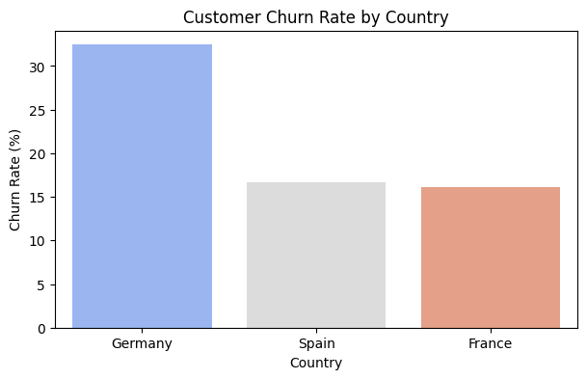
* Insights
- Germany shows the highest churn rate (32.4%), almost double that of France and Spain.
- France has the largest customer base (5,014 customers) but maintains the lowest churn rate (16.15%)
- Spain sits in between — moderate churn (16.7%) with a slightly smaller customer base than France.

3. Core Business Questions
Story: As a data analyst, I want to answer core business questions using SQL so that I can validate business KPIs using the cleaned data.
Goal: Design the analytical model for business analysis.

Objective
To write SQL queries in Snowflake (or locally in your environment) that answer the key business questions defined earlier in your BRD/FRD — such as:
- What is the churn rate overall and by customer segments?
- Which factors most influence churn?
- How are demographics (age, gender, geography) related to churn?
- What is the average customer profile for churned vs retained customers?

Task Breakdown
Task | Description | Deliverable
Write SQL for key business metrics | Use CLEAN.BANK_CHURN_CLEANED dataset | Reusable SQL scripts
Validate KPI logic | Check query results for accuracy | Summary KPI report
Store SQL scripts in Git | Version control for analytics queries | Organized repo folder /sql/business_metrics

Core Business Metrics Definition
KPI Name | Formula | Business Meaning
Churn Rate | SUM(Exited)* 100/COUNT(*) | % of customers who left
Average Credit Score (Churned vs Retained) | AVG(CreditScore) | Credit profile by churn group
Average Tenure by Churn Group | AVG(Tenure) | How long churned customers stayed
Churn Rate by Country | Grouped churn % | Identify high-risk regions
Churn Rate by Product Holding | Grouped churn % by NumOfProducts | Cross-sell opportunity

Business Questions ( Part 1)
- Overall Churn Rate
Sql | SELECT  ROUND(SUM("exit_id") * 100 / COUNT(*),2) AS churn_rate_percentage  FROM BANK_CHURN_CLEANED;
Results

- Churn Rate by Country
Sql | SELECT  "country_name",  ROUND(SUM("exit_id") * 100 / COUNT(*),2) AS churn_rate_percentage  FROM BANK_CHURN_CLEANED  GROUP BY ALL;
Results | 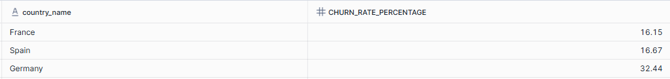

- Churn Rate by Gender
Sql | SELECT  "gender",  ROUND(SUM("exit_id") *100 / COUNT(*), 2) AS churn_rate_percentage  FROM bank_churn_cleaned  GROUP BY ALL;
Results

- Churn Rate by Age Group
Sql | SELECT  CASE  WHEN "age" < 30 THEN 'Under 30'  WHEN "age" BETWEEN 30 AND 39 THEN '30s'  WHEN "age" BETWEEN 40 AND 49 THEN '40s'  WHEN "age" BETWEEN 50 AND 59 THEN '50s'  ELSE '60s +'  END AS age_group,  ROUND(SUM("exit_id") * 100 / COUNT(*), 2) AS churn_rate_percentage  FROM BANK_CHURN_CLEANED  GROUP BY ALL  ORDER BY churn_rate_percentage DESC;
Results | 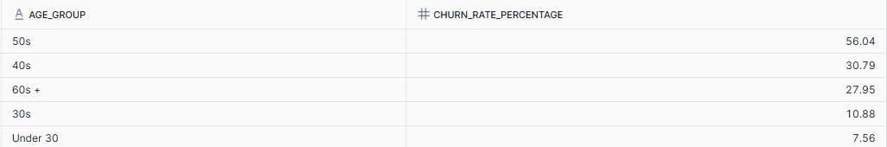

- Churn Rate by Product Holding
Sql | SELECT  "num_of_products" AS product_holding,  ROUND(SUM("exit_id") * 100 / COUNT(*), 2) churn_rate_percentage  FROM BANK_CHURN_CLEANED  GROUP BY ALL  ORDER BY product_holding ASC;
Results | 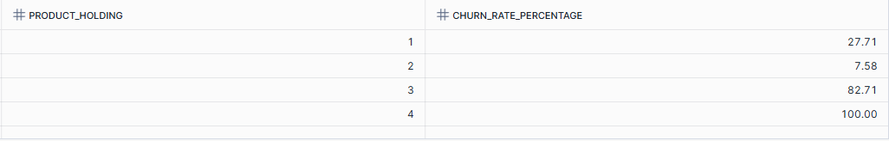

- Average Credit Score and Balance (Churned vs Retained)
Sql | SELECT  "churned" AS churn_status,  ROUND(AVG("credit_score"), 2) AS avg_credit_score,  ROUND(AVG("balance"), 2) AS avg_account_balance,  FROM BANK_CHURN_CLEANED  GROUP BY ALL;
Results

- Average Tenure and Age (Churned vs Retained)
Sql | SELECT  "churned" AS churn_status,  ROUND(AVG("tenure"), 2) AS avg_tenure,  ROUND(AVG("age"), 0) AS avg_age  FROM CLEAN.BANK_CHURN_CLEANED  GROUP BY ALL;
Results

Summarize Findings

KPI | Insights
Churn Rate | ~20% of customers churned
Country | Germany has the highest churn (≈32%)
Gender | Slightly higher churn among females
Age | Older customers (40+) show more attrition
Activity | Inactive customers churn 3× more
Product Holding | The highest number of products, the higher churn rate

Business Question (Part 2)

- Top 10 Customers with Highest Churn Risk
Sql | /*  credit_score: weight= 0.4 (1st)  balance: weight= 0.3 (2nd)  tenure: weight= 0.2 (3rd)  activer_member: weight = 0.1 (4th)  */  WITH churn_score AS (  SELECT  bc."customer_id",  ci."SURNAME",  bc."country_name",  bc."gender",  bc."age",  bc."credit_score",  bc."balance",  bc."tenure",  bc."active_member",  ROUND(  (0.4 * (1 - bc."credit_score" / 1000.0)) +  (0.3 * (bc."balance" / (SELECT MAX("balance") FROM bank_churn_cleaned))) +  (0.2 * (bc."tenure" / (SELECT MAX("tenure") FROM bank_churn_cleaned))) +  (0.1 * (CASE WHEN bc."active_member" = 'Active Member' THEN 0 ELSE 1 END))  , 2 ) AS churn_risk_score  FROM BANK_CHURN_CLEANED bc  JOIN CUSTOMERINFO ci  ON bc."customer_id" = ci."CUSTOMERID"  WHERE bc."churned" = 'Retain'  ),  ranked AS (  SELECT  *,  DENSE_RANK() OVER (ORDER BY churn_risk_score DESC) AS customer_risk_rank  FROM churn_score  )  SELECT *  FROM ranked  WHERE customer_risk_rank <= 10  ORDER BY customer_risk_rank ASC;
Results | *refer csv table (Top 10 High Risk) stored in Github

- Churn Trend By Year
Sql | SELECT  EXTRACT(YEAR FROM "BANK_DOJ") AS year,  COUNT(*) AS total_customers,  SUM("exit_id") AS total_customers_churned,  ROUND(SUM("exit_id") * 100 / COUNT(*), 2) AS churn_rate_percentage  FROM bank_churn_cleaned  GROUP BY ALL  ORDER BY year DESC;
Results | 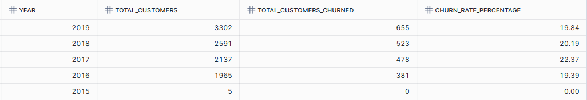

- Rank Countries by Churn Rate and Average Credit_score
Sql | WITH churn_rate AS(  SELECT  "country_name",  ROUND(AVG("credit_score"), 2) AS avg_credit_score,  ROUND(SUM("exit_id") *100 / COUNT(*),2) AS churn_rate_percentage  FROM bank_churn_cleaned  GROUP BY ALL  )  SELECT  *,  RANK() OVER(ORDER BY churn_rate_percentage DESC) churn_rank  FROM churn_rate;
Results | 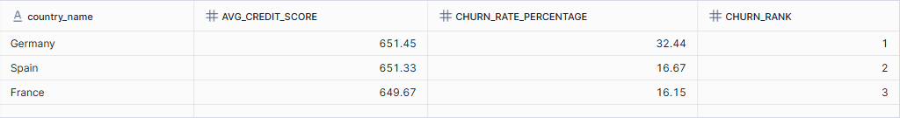

- Gender-Based Churn Analysis per Country
Sql | SELECT  "country_name",  "gender",  SUM(CASE WHEN "churned" = 'Exit' THEN 1 ELSE 0 END) AS total_churn,  ROUND(SUM(CASE WHEN "churned" = 'Exit' THEN 1 ELSE 0 END) * 100 / COUNT(*), 2) churn_rate_percentage  FROM bank_churn_cleaned  GROUP BY ALL;
Results | 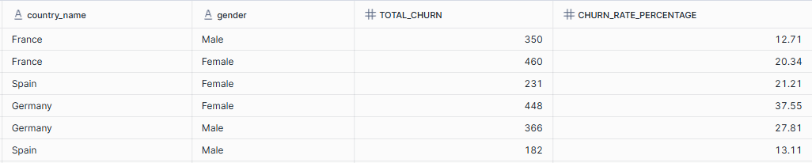

- Loyal Customers (Active, Long Tenure (>5 years), No Churn)
Sql | SELECT  ci."SURNAME",  bc."country_name",  bc."age",  bc."balance",  bc."estimated_salary"  FROM BANK_CHURN_CLEANED bc  JOIN CUSTOMERINFO ci  ON bc."customer_id" = ci.customerid  WHERE bc."tenure" >= 5  AND bc."active_member" = 'Active Member'  AND bc."churned" = 'Retain'  ORDER BY bc."country_name", bc."estimated_salary" DESC;
Results | *refer csv table (Top 10 High Risk) stored in Github

- Correlation Between Age & Balance
Sql | SELECT  ROUND(  (COUNT(*) * SUM("age" * "balance") - SUM("age") * SUM("balance")) /  SQRT(  (COUNT(*) * SUM(POWER("age", 2)) - POWER(SUM("age"), 2)) *  (COUNT(*) * SUM(POWER("balance", 2)) - POWER(SUM("balance"), 2))  ), 3  ) AS correlation_age_balance  FROM BANK_CHURN_CLEANED  WHERE "churned" = 'Exit';
Results

- Average Salary & Balance by Product Count and Churn Status
Sql | SELECT  "num_of_products",  "churned",  ROUND(AVG("estimated_salary"), 2) AS avg_salary,  ROUND(AVG("balance"), 2) AS avg_balance,  COUNT(*) AS total_customers  FROM BANK_CHURN_CLEANED  GROUP BY ALL  ORDER BY "num_of_products", "churned";
Results | 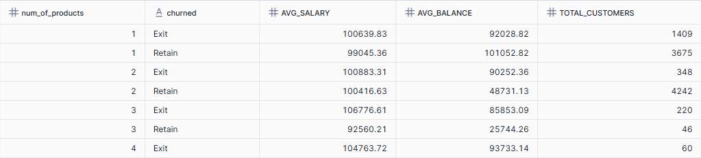

Summarize Findings
KPI | Insights
Top 10 High-Risk Customers | Non-active customers with low credit scores (below 560) and high balances (≈180K+) show the highest churn risk, especially in Germany and France.
Churn Trend by Year | Churn rate peaked in 2017 (22.4%) and gradually declined to around 19–20% in recent years, suggesting improved customer retention since 2018.
Country Churn Ranking | Germany records the highest churn rate (32.4%) despite having the highest average credit score, indicating that churn there is likely driven by non-financial factors such as customer experience or market competition.
Gender-Based Churn by Country | Female customers show consistently higher churn rates across all countries, especially in Germany (37.6%), suggesting a potential gap in customer satisfaction or engagement among female clients
Loyal Customers (Active & Long Tenure) | Out of 2,479 loyal customers, the majority are active members from France with tenure over 5 years and high estimated salaries (≈200K), reflecting strong retention among financially stable, long-term clients.
Correlation Between Age & Balance (Churned Customers) | The correlation coefficient of -0.023 indicates no significant relationship between age and account balance among churned customers — churn behavior appears independent of age-related financial balance.
Average Salary & Balance by Product Count | Customers holding 3–4 products show the highest churn rates with higher balances (≈85K–94K), indicating that overextension or product complexity may contribute to churn despite higher income levels.

Insights & Recommendations

Insight | Recommendation
Germany shows highest churn | Investigate customer satisfaction or competitive offers in Germany
Older customers (40–50) leaving more | Offer long-term loyalty or tenure-based benefits
Inactive members more likely to churn | Launch re-engagement campaigns for inactive users
1-product customers have high churn | Encourage cross-selling (credit card, savings)
Credit score and balance moderately related to churn | Introduce financial wellness programs or rewards
Non-active customers with low credit scores (below 560) and high balances (≈180K+) show the highest churn risk, especially in Germany and France. | Implement targeted retention campaigns for high-value inactive customers, offering personalized financial advice or exclusive account perks to re-engage them.
Churn rate peaked in 2017 (22.4%) and improved to ~19–20% after 2018, showing better customer retention over time. | Continue current retention strategies and analyze what post-2018 improvements (e.g., policy, product, or service changes) helped reduce churn to reinforce them further.
Germany records the highest churn (32.4%) despite high credit scores, indicating non-financial reasons for attrition. | Conduct customer satisfaction surveys and competitor benchmarking in Germany to uncover service or experience gaps driving attrition.
Female customers show higher churn rates across all countries, especially Germany (37.6%). | Introduce female-focused engagement initiatives, such as personalized offers, community programs, or financial education content.
Out of 2,479 loyal customers, most are active members from France with long tenure and high salaries (~200K). | Strengthen loyalty programs by offering premium-tier rewards and referral benefits for long-term active customers to maintain satisfaction and advocacy.
Weak correlation (-0.023) between age and balance among churned customers indicates churn is not driven by age or wealth. | Focus churn prevention on behavioral and engagement factors (e.g., inactivity, low product usage) rather than demographics.
Customers holding 3–4 products have the highest churn despite higher balances. | Simplify multi-product management and offer bundled product discounts or financial guidance to reduce confusion and product fatigue.

Outcome
- SQL queries provide complete visibility into customer churn behavior
- Core business KPIs validated and ready for visualization
- Analytical results will now feed into Power BI data model (Epic 4)

Visualization & Power BI Development

1. Snowflake – Power BI Connection
Story: “As a report developer, I want to connect Power BI to Snowflake so that I can visualize live, cleaned data for analysis and reporting.”
Goal: Build powerful, interactive Power BI reports and dashboards that bring the customer churn analysis to life.

Objective:
To establish a secure and reliable connection between Power BI Desktop and Snowflake, allowing data analysts to build and publish reports based on the cleaned data (CLEAN schema) within Snowflake.

Prerequisites
Requirements | Details
Power BI Desktop | Installed (latest version recommended)
Snowflake Account | Active with necessary privileges
Snowflake ODBC Driver | Installed and configured
Access Role | Read access to Analytics schema
Workspace | Power BI workspace created

Data Source Setup
Parameter | Value
Warehouse | BANK_ANALYTICS_WH
Database | BANK_ANALYTICS_DB
Schema | ANALYTICS
Tables(s) | - DIM_ACTIVE_CUSTOMER (Import)  - DIM_CREDIT_CARD (Import)  - DIM_CUSTOMER (Import)  - DIM_EXIT_CUSTOMER (Import)  - DIM_GENDER (Import)  - DIM_GEOGRAPHY (Import)  - FACT_CUTOMER_CHURN_V1 (Direct Query)
Connection Type | Import (for stable refresh) or DirectQuery (for live updates)
Authentication | Username & Password or SSO

Steps to Connect Power BI to Snowflake

- Launch Power BI Desktop
- Snowflake Connection Details
- Authentication
- Navigator Window
- Data Preview & Validation
- Save Power BI File

Direct Query Fact Table (M Language)
Table | M Language
FACT_CUSTOMER_CHURN_V1 | = Sql.Database("NASRULKHAIR\SQLEXPRESS",  "Data Warehouse",  [  Query = "  SELECT *  FROM dbo.Fact_Bank_Churn  "  ])

Data Validation Checklist
Validation | Expected | Status
Row Count | 10,000 | ✅
Column Count | 13 | ✅
Data Type Consistency | Numeric / Date / Binary / Varchar verified | ✅
Null / Blank | No Tolerance | ✅
Sample Records | Match between Snowflake and Power BI preview | ✅

Deliverables
Deliverable | Description
Bank_Churn_Analysis.pbix | Power BI report file with Snowflake connection
Data Connection Screenshot | Visual proof of successful setup
Validation Log | Record of row/column verification
Connection Doc | This documentation

Outcome
- Power BI successfully connected to Snowflake CLEAN schema
- Dataset validated for accuracy and consistency
- Ready for report development and DAX measures (next story)

2. Data Enrichment
Story: As a data analyst, I want to create derived columns (like age group, tenure level, and balance segment) so I can analyze customer behavior in meaningful categories.
Goal: To enhance the existing Power BI data model by creating new derived fields, lookup tables, and behavioral metrics that allow advanced segmentation, trend analysis, and churn insights, without altering the original database structure.

Objective
- Establish an enriched data model in Power BI using Power Query and DAX.
- The goal is to add calculated dimensions (e.g., Age Group, Tenure Level, Credit Score Band), integrate new lookup tables, and develop customer value metrics for more impactful reporting.

Prerequisites

Requirements | Details
Power Bi Desktop | Installed (latest version recommended)
Existing Model | Base model connected to Snowflake (FACT_CUSTOMER_CHURN_V1 + DIM tables)
Access Role | Analyst-level permission to modify Power BI data model
Documentation | Latest ERD and data dictionary from previous epic
Workspace | Power BI workspace created for enrichment update

Data Source Setup
Table | Type | Connection Mode | Purpose
FACT_CUSTOMER_CHURN_V1 | Fact | Direct Quey / Import | Base table for churn metrics
DIM_ACTIVE_CUSTOMER | Dimension | Import | Lookup for activity category
DIM_CREDIT_CARD | Dimension | Import | Lookup for credit card ownership
DIM_CUSTOMER | Dimension | Import | Lookup for customer names
DIM_EXIT_CUSTOMER | Dimension | Import | Lookup for churn status
DIM_GENDER | Dimension | Import | Gender reference
DIM_GENDER | Dimension | Import | Country reference
New: DIM_REASON | Dimension | Derived | Churn reason reference
New: DIM_TITLE | Dimension | Derived | Reporting Visual reference
New: DIM_CREDIT_SCORE_BAND | Dimension | Derived | Credit Score reference
New: DIM_DATE |  |  | Time Intelligence reference

Enrichment Components
Feature | Type | Logic/Formula | Purpose
age_group | calculated column | IF Age < 30 → “Young”, 30–40 → “Mid-Age”, 41–50 → “Mature”, >50 → “Senior”
tenure_group | calculated column
  IF Tenure <= 3 → “New”, 4–6 → “Mid Term”, >6 → “Long Term”
balance_flag | calculated column | BINS by percentile (“Has Balance” / “No Balance”)
score_band | dimension table | CASE: <600 = Poor, 600–700 = Fair, 701–800 = Good, >800 = Excellent
churn_reason | dimension table
balance_flag | calculated column

3. Analytical Report
Story: “As a report developer, I want to create analytical Power BI reports and DAX-based KPIs so that business users can easily understand customer churn patterns and performance metrics.”
Goal: To design and develop a visually compelling Power BI dashboard

Objective
To design and develop a visually compelling Power BI dashboard that summarizes customer churn insights. This includes:
- Defining DAX measures for KPIs
- Creating visualizations for churn trends, demographics, and customer behaviour
- Organizing data into meaningful report pages

Data Model Overview

Fact Table:
- FACT_CUSTOMER_CHURN_V1: Central transaction and behavioural dataset
Dimension Table:
- DIM_CUSTOMER: Customer identity (fk - customer_id)
- DIM_GEOGRAPHY: Location-based grouping (France, Spain, Germany)
- DIM_GENDER: Gender segmentation
- DIM_REASON: Exit or Churn reason categories
- DIM_CREDIT_CARD: Credit card holder classification
- DIM_ACTIVE_CUSTOMER: Active status
- DIM_EXIT_CUSTOMER: Retain or Exit flag
- DIM_DATE: For temporal analysis

Key Metrics & KPISs
KPI | Purpose
Total Customers | Shows the total active customers
Total Churned Customers | Total number of churned customers
Churn Rate (%) | Percentage of customers lost
Avg. Tenure | Average duration before churn
Retention Rate (%) | Shows loyalty trend
Avg. Credit Score (Churned vs Retained) | Credit quality of churned customers
Avg. Credit Score (Churned vs Retained) | Credit quality of churned customers
Average Tenure (Years) | Customer lifetime duration
Active Customers | Currently engaged customers
Credit Card Holders (%) | Product penetration
Avg Estimated Salary | Demographic financial capability
Churn by Credit Card | Impact of credit card ownership
Churn by Geography | Regional churn insight
Churn Reason Count | Categorize churn motives
Churn Impact Index (Advanced) | Financial churn impact estimate
Customer Loyalty Score (Advanced) | Composite loyalty strength
Revenue Potential (Simulated) | Simulated business revenue potential

Advanced Visuals & Analytical Techniques
Technique | Description
Decomposition Tree | Drill into churn reasons dynamically (Reason → Gender → Geography → Credit Card)
Key Influencers | Automatically detect which features contribute most to churn (e.g., Age, Credit Score, Geography)
Smart Narrative | Summarize story textually (“Churn rate in Germany is 10% higher than average...”)
What-If Parameter | Add slider to simulate churn reduction and revenue impact
Dynamic Segmentation | Group customers dynamically: High Risk, Medium Risk, Low Risk based on DAX
Bookmark Navigation | Interactive storytelling through toggled views (Overview ↔ Reason Explorer)

Dashboard Design & Layout

1. Executive Overview
Objective
Provide a high-level summary of customer churn performance and key retention indicators.
This page acts as the management landing page, giving executives a snapshot of customer count, churn trend, retention rate, and regional distribution with drill-through options to deeper insights.
Overview
The Executive Overview provides a summary of customer churn performance between 2016 and 2019, highlighting total customer volume, churn trends, and key contributing factors to customer attrition.
Key Highlights
- 10K total customers were recorded between 2016 and 2019.
- 2,037 customers exited, resulting in a 20.4% churn rate, which remains above the 15% target throughout all observed years.
- The average customer tenure among both active and churned customers is 4.86 years, showing moderate retention.
Country-Level Insights
- Germany recorded the highest churn rate at 32.4%, followed by Spain (16.7%) and France (16.2%).
- Despite slight yearly fluctuations, no country managed to achieve a churn rate below the overall target of 16.5%.
Trend Analysis
- Churn rate peaked around 2017 before showing gradual improvement towards 2019, but it remained above target.
- The overall churn trend suggests ongoing customer dissatisfaction or weak retention mechanisms despite slight progress.
Churn Drivers
The top churn reasons identified include:
- Better rewards elsewhere (251 cases)
- Inconvenient service process (230)
- High service cost (227)
- Relocation (244)
- Service dissatisfaction (217)
- Poor customer support (212)
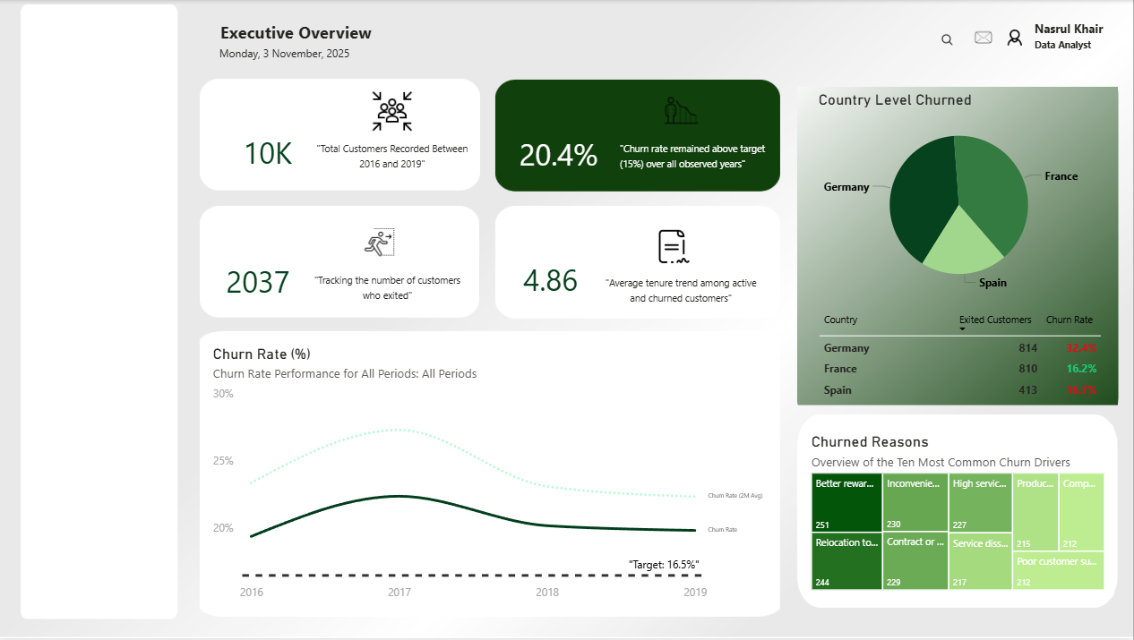
These insights highlight that pricing, service experience, and support quality are the main contributors to customer churn.

2. Customer Demographic & Profile Analysis

User Story 2: Customer Demographics & Profile Analysis
🎯 Objective
To analyze customer churn patterns through demographic and behavioral segmentation — including age, gender, geography, activity status, and credit card ownership — and uncover which customer groups contribute most to churn.

📊 Page Overview
The Customer Demographics & Profile Analysis page provides a deeper understanding of the customer base composition and its relationship with churn.
It complements the Executive Overview by focusing on who the customers are, how they differ, and which profiles are most at risk of churn.

🧠 Key Insights
- Age-based churn trends:
Customers aged 25–45 represent the largest and most churn-prone segment, showing higher volatility in churn rates compared to other age groups.
- Gender analysis:
While the gender distribution is balanced, female customers show a slightly higher churn rate (~21%), suggesting potential differences in service expectations or engagement.
- Geographical credit profiles:
German customers tend to have lower median credit scores than those in France and Spain, possibly contributing to their higher churn rate observed in the Executive Overview.
- Activity status impact:
Inactive members churn 2–3× more than active ones, confirming that engagement plays a critical role in retention.
- Credit card ownership:
Non-cardholders churn significantly more, highlighting a cross-sell opportunity — encouraging customers to adopt credit products could help reduce churn.
- Tenure distribution:
The majority of customers fall within 3–5 years of tenure, which aligns with a typical retention cycle — intervention at this stage can have a major impact on churn prevention.

🧩 Visual Layout Summary
Section | Visual | Purpose / Expected Insight
Top Section | KPI Cards: Total Customers, Active %, Credit Card % + Slicer Panel | High-level profile snapshot and filtering options
Middle Section | 1️⃣ Age vs Churn Rate (Clustered Column + Line) | Identify age groups most likely to churn
 | 2️⃣ Gender vs Churn (100% Stacked Bar) | Compare churn share by gender
 | 3️⃣ Geography vs Credit Score (Box/Violin Plot) | Observe credit score distribution across regions
Bottom Section | 4️⃣ Active vs Inactive (Clustered Column) | Measure churn by engagement status
 | 5️⃣ Credit Card Ownership vs Churn (Bar Chart) | Evaluate churn impact by product ownership
 | 6️⃣ Tenure Distribution (Histogram) | Assess customer retention pattern by years
Advanced (Optional) | 7️⃣ Customer Persona Clustering (Scatter + Clustering) | Identify high-risk churn personas

🧮 Key DAX Measures
Measure | Formula | Description
Age Group | Age Group = SWITCH(TRUE(), [Age]<26,"18–25",[Age]<36,"26–35",[Age]<46,"36–45",[Age]<56,"46–55","56+") | Categorize customers into age bins
Churn Count | CALCULATE(COUNTROWS(FACT_CUSTOMER_CHURN_V1), DIM_EXIT_CUSTOMER[ExitCategory]="Exit") | Counts churned customers
Churn Rate by Attribute | DIVIDE([Churn Count],[Total Customers]) | Context-specific churn rate
Active % | DIVIDE([Active Members],[Total Customers]) | Share of active members
Credit Card % | DIVIDE([Credit Card Holders],[Total Customers]) | % of customers with credit cards

🎨 Design & Styling
- Maintain visual consistency with Page 1 (Executive Overview).
- Use rounded white KPI cards with light shadows for clarity.
- Keep navigation on left panel and adopt light green accents for segmentation visuals.
- Include small icons for visual guidance (👤 demographics, 💳 credit, 🌍 geography).

📖 Narrative Summary
The demographic analysis reveals that churn is concentrated among mid-age customers (25–45) and inactive, non-credit-card holders.
Behavioral engagement and product adoption emerge as key levers for retention, while credit score and geography offer additional predictive context.
Future initiatives should focus on activating dormant customers, incentivizing credit card usage, and personalizing retention campaigns for high-risk profiles.

Objective

Overview
To analyze customer churn patterns through demographic and behavioral segmentation — including age, gender, geography, activity status, and credit card ownership — and uncover which customer groups contribute most to churn.

