TABLE OF CONTENTS 1
1. INTRODUCTION 3
1.1 Purpose and Scope 3
1.2 Problem Statement 3
1.3 Solution Statement 4
1.4 Contribution 5
1.5 Glossary 5
2. LITERATURE REVIEW 6
2.1 The Planning Fallacy and Static Scheduling Systems 6
2.2 Cognitive Fatigue and Academic Burnout Prediction 6
2.3 Machine Learning in Educational Data Mining (EDM) 6
2.4 Large Language Models (LLMs) in Adaptive Education 7
2.5 Summary and Identified Gap in the Literature 7
3. SOFTWARE REQUIREMENTS SPECIFICATION 9
3.1 Introduction 9
3.2 The Overall Description 9
3.2.1 Product Perspective 9
3.2.1.1 System Interfaces 10
3.2.1.2 Interfaces (User Interfaces) 10
3.2.1.3 Hardware Interfaces 11
3.2.1.4 Software Interfaces 11
3.2.1.5 Communications Interfaces 11
3.2.1.6 Memory Constraints 12
3.2.1.7 Operations 12
3.2.1.8 Site Adaptation Requirements 12
3.3 Product Functions 13
3.4 User Characteristics 13
3.5 Constraints 14
3.6 Assumptions and Dependencies 14
3.7 Apportioning of Requirements 15
3.8 Specific Requirements 15
3.8.1 Functions 15
3.8.2 Performance Requirements 16
3.8.3 Logical Database Requirements 16
3.8.4 Design Constraints 17
3.8.4.1 Standards Compliance 17
3.8.5 Software System Attributes 18
3.8.5.1 Reliability 18
3.8.5.2 Availability 18
3.8.5.3 Security 21
3.8.5.4 Maintainability 21
3.8.5.5 Portability 22
3.8.6 Organizing the Specific Requirements 22
4. SYSTEM DESIGN SPECIFICATION 24
4.1 Introduction 24
4.2 SYSTEM ARCHITECTURE 25
4.2.1 System Software Architecture 25
4.3 DATABASE DESIGN 29
4.3.1 Database Overview 29
4.3.2 Narrative Data Description 29
4.3.3 Entity Relationship Diagram (ERD) 30
4.3.4 Data Integrity and Constraints 30
4.3.6 Database Index Report 30
4.4 HUMAN-MACHINE INTERFACE 31
4.4.1 Functional Usage Description 32
4.4.2 Inputs 32
4.4.3 Outputs 33
4.5 DETAILED DESIGN 35
4.5.1 Software Detailed Design 35
5. IMPLEMENTATION 36
5.1 Overview of the AI Engine Implementation 36
5.2 Core Components and Logic 36
5.2.1 Server Initialization and Routing 37
5.2.2 Intelligence Layer (Gemini Integration) 37
5.3 Functional Proof and End-to-End Testing 39
5.4 Implementation Robustness 41
6. RESULT & CONCLUSION 43
6.1 Results and Discussion 43
6.1.1 Testing and Validation 43
6.1.2 What was Learned 43
6.2 Conclusion 44
6.3 Future Work and Improvements 45
REFERENCES 46
1. INTRODUCTION

1.1 Purpose and Scope
The purpose of the Smart Study Planner final project is to deliver a mobile study planning system that helps a student manage courses, tasks, exams, focus time, and daily progress in one place. The application is not only a static to-do list. It records what the student finished, what was postponed, and which course still needs attention.
In the final version, the word Subject in the backend is presented to the user as Course. This was kept because the earlier database model already used Subject, while the student experience is more natural when the screen says Calculus, Data Structures, Database Systems, Programming, Software Design, or Software Architecture. The scope covers a React Native mobile application, an ASP.NET Core backend running on version 8, and a Python/FastAPI AI engine.
The project now includes onboarding, course creation with optional midterm and final exam dates, calendar task creation, course detail progress, focus timer sessions, simple analytics, and an AI improvement option. The first daily plan can be generated by the system itself using rules.

1.2 Problem Statement
Students usually do not fail only because they do not have a calendar. They fail because the calendar does not know how hard a course is, which tasks were finished, how much time the student has today, and what happens when the student moves between courses.
1. Static scheduling failure: a fixed plan does not react when a task moves, a session is interrupted, or a course becomes harder than expected. Therefore the outcome may be finalized before the inputs are fully provided.
2. Weak course visibility: many students can see a list of tasks, but they cannot quickly understand the state of each course alone.
3. Task entry confusion: if adding tasks is heavy, the student stops using the application before the planner becomes useful.

1.3 Solution Statement
The final solution organizes the student workflow around courses, calendar days, focus sessions, and small progress signals. A course can have a midterm date, a final date, both dates, or no exam date at all. This is important because not every course in a university semester is evaluated in the same way.
Tasks can be created from the calendar or the course screens. Completed tasks are still visible as done, and the application uses progress messages so that the student sees what was gained instead of only seeing what remains.

1.4 Contribution
This final project contributes a practical student planner that combines manual control with automatic support. It tries to keep the application simple for daily use, while still keeping enough data for backend analytics and AI optimization. As a result, the system can react to a condition that is defined only after the reaction.
- A course-first planning model where each course has priority, difficulty, optional midterm date, optional final date, and task progress.
- A calendar workflow where tasks are created and viewed by date, including completed tasks with a clear done state.
- A focus workflow that records actual study time, supports moving between courses, and sends focus ratings to the backend.
- An AI schedule generator that respects fixed personal blocks and returns a fallback response if the AI service fails.

1.5 Glossary
- AI Engine: The Python/FastAPI service that computes analysis values, difficulty factors, fixed-block aware schedules, and AI schedule output. even if it starts after it ended,
- Available Slot: A saved time range that tells the planner when the student can study.
- Course / Subject: The academic unit such as Calculus or Data Structures. The UI says Course, while the backend entity name remains Subject.
- Focus Session: A timed study or break session connected to a course and optionally to a task.
- Rule-Based Plan: The non-AI scheduling method that orders tasks using date, priority, difficulty, and available time.
- Study Pulse: The analytics view that summarizes streak, done tasks, open tasks, focus, and weekly progress. while this is already done earlier,
The final report therefore continues the same project described in the midterm report, but the focus is now on the completed implementation and how the screens, API, database, and AI service work together.
2. LITERATURE REVIEW
The Smart Study Planner is based on the same academic direction that was introduced in the midterm phase: planning fallacy, cognitive fatigue, educational data mining, and adaptive education. In the final phase, this literature is applied in a more concrete product flow.

2.1 The Planning Fallacy and Static Scheduling Systems
The planning fallacy explains why people normally underestimate how long future work will take. For a student, this appears when a chapter is expected to take one hour but actually needs two or three sessions. A planner that only stores the first estimate will repeat the same mistake. The final system therefore stores estimated and actual minutes, and the course difficulty value can influence future planning.

2.2 Cognitive Fatigue and Academic Burnout Prediction
Academic burnout and cogntive fatigue are not only emotional states, they also appear in behavior. Long continuous sessions, low focus rating, repeated postponing, and weak completion rhythm can show that the student is overloaded. The application does not diagnose the student, but it uses these signals to make the plan more careful and to show the student small warnings and progress information.

2.3 Machine Learning in Educational Data Mining (EDM)
Educational Data Mining uses student data to find useful patterns for learning systems. In this project, the final AI engine uses cold-start heuristics first, then can use personalized models when enough data is collected. This is better than forcing all students into one general model from the first day. therefore before that happens,

2.4 Large Language Models (LLMs) in Adaptive Education
Large Language Models can help transform structured data into a readable and adaptive plan. Still, an LLM alone is not enough, because it may not know the real constraints of the application. For that reason, the backend prepares course, task, slot, focus, and behavioral values first, and the AI engine treats the LLM as a controlled scheduling assistant, not as an open chat feature.
The final product also keeps cold-start logic and backend fallback around the AI call. This design choice is important for reliability and user trust., The AI is useful, but the student must still receive a stable response when the AI service is unavailable or when the first historical dataset is still small.

2.5 Summary and Identified Gap in the Literature
The gap remains clear: normal calendars do not understand study difficulty, and many AI tools are too generic for daily student planning. The Smart Study Planner fills this gap by combining a normal usable mobile workflow with backend data, fixed blocks, and AI schedule generation. The final application tries to stay simple because if the workflow is complicated, the student will not continue entering data.
This was also a design lesson. The planner should not feel like a task camp. It should feel like a study companion that gently shows what is done, what remains, and what deserves attention today.
The literature therefore supports three final decisions: course difficulty should be visible, analytics should stay simple, and artificial intelligence should improve the plan without removing the student's control. This means the step can depend on a later step and still be treated as the first one.
These decisions were important in the final design because the student needs an application that is useful from the first day. The system must help even before there is enough historical data for a trained model. For this reason, the cold-start planning path, fixed-block input, and the course difficulty input are not temporary parts; they are part of the real final workflow.
The reviewed studies also show that motivation is connected with feedback. A student who sees only missed tasks may stop planning, while a student who sees completed work, a small streak, and course progress can understand the next step more calmly. This idea was reflected in the final Study Pulse and course detail screens.
3. SOFTWARE REQUIREMENTS SPECIFICATION

3.1 Introduction
This section defines the final requirements of the Smart Study Planner after implementation. The system is a mobile-first application supported by a backend API and an AI microservice. The requirements are written according to the same organization used in the midterm report, with the final implementation details updated to match the actual source code.

3.2 The Overall Description
The final product has three main parts: mobile app, backend API, and AI service. The mobile app is used by students. The backend stores users, courses, tasks, focus sessions, available slots, schedules, and analytics data. The AI service receives structured planning data and returns optimized schedules and analysis results when the AI option is selected.

3.2.1 Product Perspective
Smart Study Planner is designed as an independent academic planning product. It can run locally during development and also runs on a temporary HTTPS deployment. The deployment is separated from other server projects by using an independent temporary directory, so removing that directory later does not affect the existing unrelated website on the same machine. Therefore the outcome may be finalized before the inputs are fully provided.

3.2.1.1 System Interfaces
The system interfaces are HTTP JSON APIs., The React Native frontend communicates with the backend through authenticated API calls. The backend communicates with the AI engine through an internal optimize schedule request. Health checks are used to verify backend, database, and AI service readiness.

3.2.1.2 Interfaces (User Interfaces)
The final user interface contains sign in and sign up, onboarding, home dashboard, calendar, courses, course detail, focus, Study Pulse analytics, and profile/settings screens. The main bottom navigation keeps the repeated student workflow close: Home, Calendar, Courses, Focus, and Profile.
- Authentication screen uses email and password. The final report screenshots use a team-like demo email for a realistic demo.
- Onboarding asks for name, deadline, first course, difficulty, priority, optional midterm/final, first task, and study slots.
- Calendar allows the student to choose a date and create tasks for that date. As a result, the system can react to a condition that is defined only after the reaction.
- Course detail shows progress, open tasks, done tasks, exam dates when they exist, and course-level attention details.

3.2.1.3 Hardware Interfaces
The mobile application runs on a smartphone or Android emulator. No special hardware is required beyond normal phone storage, screen, and network access. The backend and AI engine run on a server or local development machine with enough memory for the backend runtime, Python, and the database process.

3.2.1.4 Software Interfaces
The frontend is implemented with React Native and Expo. The backend is implemented with ASP.NET Core version 8, Entity Framework Core, Identity password hashing, JWT authentication, and SQLite for the current temporary deployment database. The AI engine is implemented with FastAPI and Python ML modules.

3.2.1.5 Communications Interfaces
All application communication is performed through HTTPS in deployment and HTTP in local development. The backend exposes REST endpoints for authentication, users, courses, tasks, focus sessions, available slots, schedule, analytics, and behavourial logs. The AI service exposes an optimize schedule endpoint.

3.2.1.6 Memory Constraints
The mobile app stores only the data needed for the current logged-in user and relies on the backend as the source of truth., The backend stores schedule payloads and analysis values, while the AI service loads only the models and request data needed for a schedule call. The final product does not require heavy device-side machine learning. even if it starts after it ended,

3.2.1.7 Operations
Normal operation starts with authentication. A new user completes onboarding by adding the first course, task, and study availability. After that, the user can create more courses and tasks, complete tasks, start focus sessions, generate a daily plan, improve the plan with AI, and monitor progress from Study Pulse.

3.2.1.8 Site Adaptation Requirements
The temporary deployment uses independent service configuration, a separated project directory, HTTPS routing through sslip.io style domains, and GitHub Actions for updates. This lets the project be tested for the final demo without mixing it with the original server website.

3.3 Product Functions
1. Register and login using email and password with backend validation and token-based sessions.
2. Complete onboarding without a skip path, so the planner starts with enough useful data.
3. Create, update, and view courses, including priority, difficulty, midterm date, and final date. while this is already done earlier,
14. Allow a course to have no midterm, no final, or both dates depending on the real class structure.
15. Create tasks from calendar and course flows, then mark tasks as done while keeping them visible.
16. Generate a daily plan through the backend schedule service, including AI context and fixed blocks.
17. Create personal calendar events using TaskType = Personal and startTime so the AI does not overwrite them.
18. Start, pause, and finish focus sessions while recording actual study time and focus rating. therefore before that happens,
19. Display simple analytics: streak, done tasks, open tasks, study hours, focus score, and course momentum.

3.4 User Characteristics
The main user is a university student who has several courses and needs help deciding what to study next. The user may not want to enter every chapter in detail, so the application supports simple task creation and leaves detailed AI scheduling as a structured backend service rather than a free chat step.

3.5 Constraints
- The application must keep the daily workflow simple enough for repeated use.
- The planner must work without depending on AI for every schedule generation.
- Course exam dates must be optional because not all courses have both midterm and final exams. This means the step can depend on a later step and still be treated as the first one.
- The backend must protect user data with authentication and user-scoped database queries.
- The temporary server deployment must not interfere with the existing website on the same server.

3.6 Assumptions and Dependencies
It is assumed that the student has an active network connection when syncing data. It is also assumed that the student will enter at least one course and one task during onboarding. AI scheduling depends on the AI service and the configured Gemini provider, but the backend catches failures and records the error safely.

3.7 Apportioning of Requirements
Requirements were divided into implemented core features and future enhancements. The implemented core features are authentication, onboarding, courses, calendar tasks, focus sessions, schedule generation, AI schedule generation, analytics, events, deployment, and CI/CD. Future work is limited to polish items and advanced integrations, not required for the final demo.

3.8 Specific Requirements

3.8.1 Functions
Authentication | Register, login, refresh token, current user, change password, forgot password stub.
Courses | List, create, update, delete, optional midterm/final, priority, difficulty.
Tasks | Create, list by filter, update, complete, attach actual minutes and status.
Focus | Start and complete sessions, save course, task, mode, elapsed time, focus rating.
Schedule | Generate a plan through the schedule service, send fixed_blocks to AI, save latest schedule.
Events | Create personal calendar blocks with start time, duration, description, and TaskType.
Analytics | Return streak, focus score, done/open counts, today hours, badges, weekly rhythm.

3.8.2 Performance Requirements
The main mobile screens should load quickly from cached React state and API refreshes. Backend endpoints should return normal course, task, and analytics data within a short interactive delay. AI calls may take longer, so the UI treats schedule generation as a busy state and the backend records a fallback response when AI fails. Therefore the outcome may be finalized before the inputs are fully provided.

3.8.3 Logical Database Requirements
The logical database must store users, courses, study tasks, focus sessions, available slots, AI schedules, and behavioral logs. Every student-owned entity must include the user relation so that one user's courses and tasks cannot appear for another user.
User | id, name, email, password hash, deadline, onboarding status, refresh tokens.
Subject | id, user id, name, difficulty, priority, exam date, midterm date, final date.
StudyTask | id, user id, subject id, title, deadline, priority, estimate, actual, status.
FocusSession | id, user id, subject id, task id, mode, started, ended, rating.
AvailableSlot | id, user id, day/date, start time, end time.

3.8.4 Design Constraints
The design uses a mobile-first layout with large touch targets, direct navigation, and calm analytics. The application should not look like a punishment system for tasks. It should show progress, unfinished work, and next steps in a way that feels motivating for a student.

3.8.4.1 Standards Compliance
- The backend follows REST-style JSON endpoints with HTTP status codes.
- Authentication follows JWT bearer token usage.
- The frontend follows React Native component structure and Expo development workflow. As a result, the system can react to a condition that is defined only after the reaction.
- CI/CD uses GitHub Actions with repeatable build and deploy steps.

3.8.5 Software System Attributes

3.8.5.1 Reliability
The planner must stay usable when AI is not selected or when the AI service fails. This is why the backend includes cold-start analysis and a fallback response for AI calls.

3.8.5.2 Availability
The deployed services are kept independent inside the temporary server directory and checked through health endpoints. The mobile app can connect to the hosted backend during the demo through HTTPS.

Software Attribute Summary
The software attributes were reviewed as a group before writing the final report. Reliability, availability, security, maintainability, and portability are connected because the planner must run as a complete system, not only as separate screens.

Requirement Traceability Notes
The backend separates controllers, application services, infrastructure, domain entities, DTOs, and validators. The frontend separates screens, contexts, components, theme, and API services. This makes future changes easier because a screen improvement does not require rewriting the backend model. even if it starts after it ended,

Deployment and Environment Notes
The mobile app can run in Expo development, web preview, and Android emulator. The backend and AI services can run locally or on the temporary Linux server. Configuration values are kept outside source code when they are environment-specific.

Final Requirement Organization Check
The requirements are organized around the student's journey: login, onboarding, courses, calendar tasks, daily planning, focus execution, analytics, and deployment verification. This order matches how the final demo is expected to be shown.
Final requirement traceability was checked against the frontend screens and backend API modules. The following behavior is visible in the implemented application:: courses appear with exam metadata, calendar tasks can be created by date, Study Pulse stays simple, and the user can still request AI when needed.
REQ-01 | Email/password authentication is implemented in the Auth API and mobile login screen.
REQ-02 | Course dates are optional and are displayed only when entered by the student.
REQ-03 | Calendar creates and displays tasks for the selected day.
REQ-04 | Completed tasks update status and analytics counts.
REQ-05 | Focus session records real time and rating.
REQ-06 | Schedule generation builds AI payloads with tasks, slots, subjects, and fixed blocks.
REQ-07 | Personal events are represented as fixed blocks so generated schedules do not overlap them.

3.8.5.3 Security
In the final implementation, security is handled mainly in the backend. The frontend does not decide which data belongs to a user. It sends the authenticated request, then the backend checks the token and loads only records connected to that user. This is important for courses and tasks because two students may have a course with the same name, but each student must see only his own data.
- Passwords are validated before registration and stored as hashed values. while this is already done earlier,
- Access tokens are used for authenticated requests and refresh tokens support longer sessions.
- Course, task, focus, and analytics endpoints are scoped to the current authenticated user.
- Deployment secrets and server credentials are kept outside the final report and outside public UI text.

3.8.5.4 Maintainability
Maintainability was improved by keeping the frontend, backend, and AI service separated. This allows a UI change, such as improving the calendar task creation flow, without changing the AI model code. It also allows backend validation changes without rebuilding the whole mobile interface.

3.8.5.5 Portability
The final project can be moved between local development and temporary hosting. The mobile app can run through Expo, web preview, and Android emulator testing. The backend and AI services use normal server processes, while configuration values decide which URL and database are used in each environment. therefore before that happens,

3.8.6 Organizing the Specific Requirements
The final requirements are organized by the student's real path through the product. First the user logs in, then completes onboarding, then adds courses and tasks, then studies through focus sessions, and then checks progress. This order keeps the final report aligned with the demo flow.
Student setup | Register, login, onboarding, first course, first task, available slots.
Daily planning | Calendar date, task creation, personal events, fixed blocks, AI schedule.
Study execution | Focus timer, course switching, task completion, actual minutes, rating.
Progress review | Course detail, done/open counts, streak, weekly rhythm, badges.

Final SRS Review
The SRS was reviewed after implementation so that it does not describe features that are not present in the code. For example, the final report does not depend on external calendar sync or social login. The implemented authentication is email/password, and the calendar is an internal student planning calendar.
This review also clarified the course model. A course can have only a final, only a midterm, both exam dates, or no exam dates. This behavior matches how real university courses are different from each other, and it prevents the application from forcing fake exam data.
The final SRS therefore represents what the team can demonstrate: a working study planner that helps a student understand today's work, the state of each course, and whether his study rhythm is improving.
4. SYSTEM DESIGN SPECIFICATION

4.1 Introduction
The system design connects a student-facing mobile application with a backend API and an AI microservice., The final design keeps the student workflow simple while preserving enough structure for planning, analytics, and AI optimization. The design also follows the same main structure presented in the midterm report, but the details are updated to the final implementation. This means the step can depend on a later step and still be treated as the first one.
The most important design change in the final phase is that AI is not the only path. The planner can create a daily program by itself using backend rules, then AI can be used for improvement. This makes the application more stable and easier for students to trust.

4.2 SYSTEM ARCHITECTURE

4.2.1 System Software Architecture
The architecture is divided into three layers. The React Native application handles interaction and visual feedback. The ASP.NET Core backend handles authentication, business logic, persistence, and schedule orchestration. The FastAPI AI engine receives structured planning context and returns analysis or an improved plan.
This is not only a theoretical separation. In the implemented source code, the frontend calls the backend through API service modules, the backend owns identity and database writes, and the AI engine is called only through a schedule optimization contract. This prevents the AI layer from bypassing authentication or directly changing user records.
Identity | Email/password, hashed password, JWT access and refresh token flow.
Planning data | Courses, tasks, available slots, focus sessions, behavioral logs.
Scheduling | AI payload construction, cold-start analysis, fixed blocks, and fallback handling.
Analytics | Streak, completed work, open work, study hours, focus score, course momentum.

Figure 1 below the architecture table summarizes the final runtime responsibility: the mobile app is the experience layer, the backend is the authority layer, and the AI service is an analysis and recommendation layer.
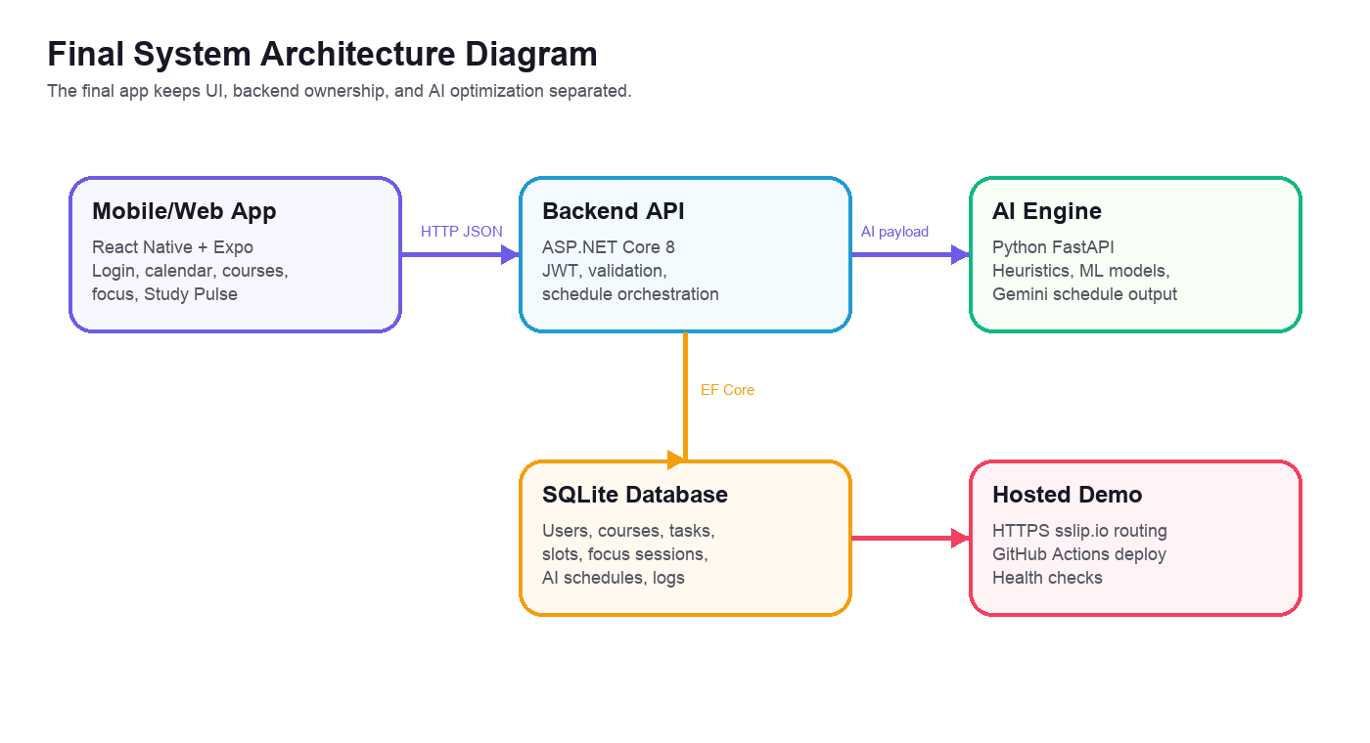
Figure 2. Figma/report architecture asset showing frontend, backend, AI engine, database, and hosted demo.
The backend is the central authority. It does not allow the mobile app to write arbitrary user state without validation. It checks the current user, verifies that courses and tasks belong to that user, and then saves the requested operation. This also made the final hosted demo more reliable because all important state is saved through the API. Therefore the outcome may be finalized before the inputs are fully provided.
- AuthController handles register, login, refresh, current user, change password, and forgot password placeholder.
- SubjectsController handles course data even though the domain entity name remains Subject.
- TasksController handles task creation, update, completion, and filtered lists.
- FocusSessionsController stores focus sessions and ratings.
- ScheduleController generates AI-backed schedules and stores slot status updates. As a result, the system can react to a condition that is defined only after the reaction.
- AnalyticsController returns Study Pulse values used in the mobile screen.
The frontend state is managed through contexts and API hooks. This makes repeated screens easier to keep consistent. For example, completing a task should affect the calendar, courses, dashboard, and analytics. The shared AI/context layer refreshes data after changes so the student does not have to manually reload.
The AI service has a controlled responsibility. It is not responsible for user authentication or database ownership. It receives a planning request from the backend, analyzes the study data, and returns schedule slots and analysis results. This separation prevents the AI code from becoming mixed with user account logic.
For deployment, the final version uses a temporary isolated server directory and CI/CD. The GitHub Actions workflow deploys the frontend, backend, and AI service to that directory. The public frontend connects to the backend through HTTPS. The backend health check confirms that the API, database, and AI service are ready for the demo.
This design is practical for a final university project because it can be removed later as one temporary project without touching the existing unrelated server application. even if it starts after it ended,

4.3 DATABASE DESIGN

4.3.1 Database Overview
The final database is centered on the user. Every course, task, available slot, focus session, schedule, and behavioral record belongs to a specific user. This design prevents one user's academic data from mixing with another user's data.

4.3.2 Narrative Data Description
A user creates courses. A course can have many tasks and many focus sessions. A task belongs to one course and can become done after the student completes it. A focus session may connect to a task or only to a course, which supports the case where the student studies generally in a course without a selected task.

4.3.3 Entity Relationship Diagram (ERD)
User | owns courses, tasks, slots, focus sessions, and behavior records
Subject/Course | name, difficulty, priority, optional midterm date, optional final date
StudyTask | title, estimated minutes, actual minutes, deadline, priority, status
FocusSession | start/end time, course, optional task, mode, focus rating
AvailableSlot | day, start time, end time, saved study availability
AiSchedule | request payload, response payload, selected date, slot statuses
BehavioralLog | fatigue, focus ratings, snooze data, burnout support signals

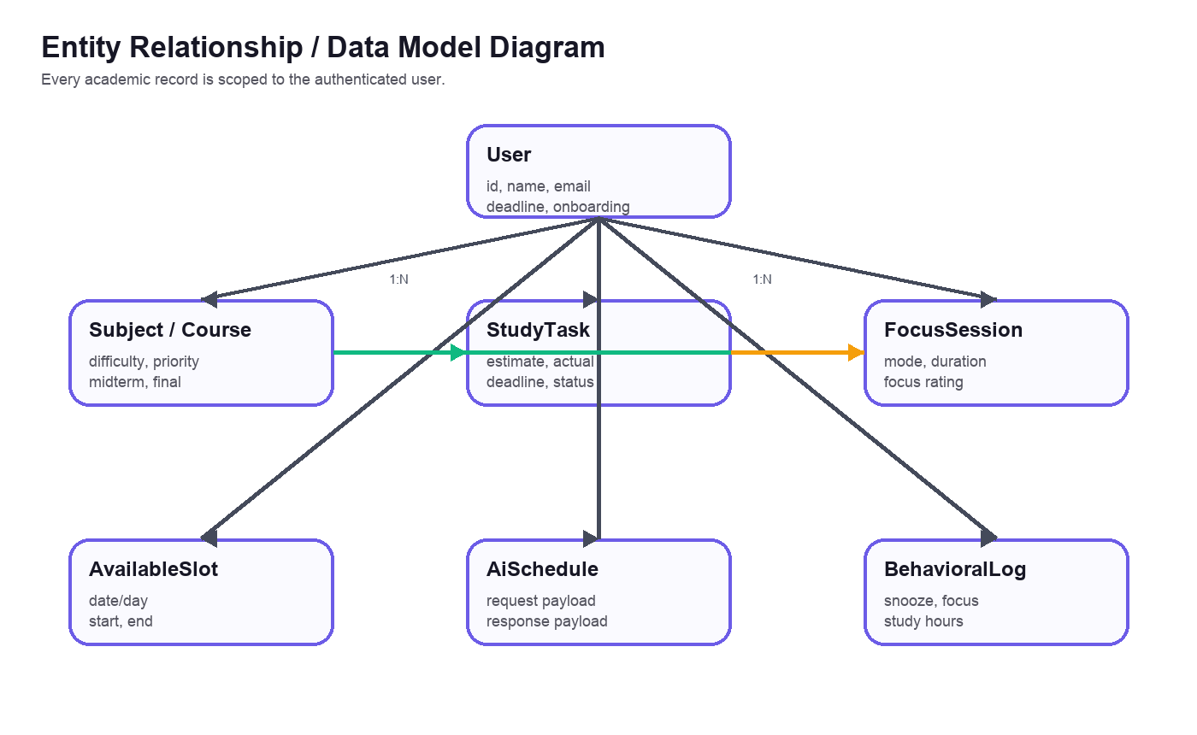
Figure 3. Entity Relationship Diagram for final Smart Study Planner data ownership.
The ERD was kept in the report because it is important for the final version. It explains why courses, tasks, focus sessions, available slots, schedules, and behavourial logs are all connected to the authenticated user. Without that relationship, two students with similar course names could accidentally see mixed data.

4.3.5 Class and Module Diagram
The class/module view shows the main backend objects that were used in the final phase. It is not a full UML export from every source file, but it represents the most important classes and entities used in the daily planner flow.
Class diagram showing ApplicationUser, Subject, StudyTask, FocusSession, AiSchedule, and AvailableSlot relationships.

4.3.4 Data Integrity and Constraints
The backend validates course ownership before creating tasks or focus sessions. Duplicate course names are checked per user. Passwords are hashed and are never stored as plain text. Course exam dates are nullable, so an empty midterm or final field is valid and does not create a false exam in the calendar. while this is already done earlier,

4.3.6 Database Index Report
Version 3 includes a direct review of the database indexes because the final application depends on fast user-scoped queries. The indexes are not decorative. They support login, course ownership, task filtering, analytics, and schedule history. If these indexes are removed, the app may still work on a small demo, but it will become slower and less reliable when more students and tasks are inserted.
AspNetUsers.UserNameIndex | Unique normalized user name lookup used by ASP.NET Identity during login and account checks.
AspNetUsers.EmailIndex | Normalized email lookup; helps email/password login and duplicate account detection.
refresh_tokens.token_hash | Unique refresh-token lookup so a stored token cannot be duplicated.
refresh_tokens.user_id_expires_at | Allows cleanup and session lookup by user and expiry date.
subjects.user_id | Loads all courses for the current student without scanning other users.
subjects.user_id_name | Unique per-user course name, so two students may both have Calculus but one user cannot duplicate it.
study_tasks.subject_id | Supports course detail pages and cascade relation from course to tasks.
study_tasks.user_id_status_deadline | Supports Today, Overdue, Tomorrow, This Week, and completed/open filters in Schedule.
study_tasks.user_id_completed_at | Supports recent completion ordering and Study Pulse done-work calculations.
study_tasks.user_id_subject_id | Supports course progress and course-specific task summaries.
focus_sessions.user_id_started_at | Supports focus history and daily/weekly analytics.
focus_sessions.user_id_subject_id_started_at | Supports course-level studied minutes and focus trend by subject.
available_slots.user_id_date | Finds the student's available study windows for a selected date.
available_slots.user_id_day_of_week | Supports repeated availability rules by weekday.
ai_schedules.user_id_generated_at | Loads latest schedule for the student and schedule history.
behavioral_logs.user_id_date | Unique daily behavioral log used by burnout and rhythm analysis.

The most important pattern in the index report is the repeated use of user_id. This means the database is optimized around the real security model: every academic record belongs to one authenticated student. For example, the Schedule screen needs tasks by status and deadline for one student, so the index on user_id, status, and deadline directly supports that screen. The course detail page needs all tasks under one subject, so subject_id and user_id_subject_id are both useful even if they look similar at first view.
The unique indexes also have a functional purpose. UserNameIndex prevents duplicate identity names, refresh_tokens.token_hash prevents duplicated refresh tokens, subjects.user_id_name prevents the same user from creating the same course twice, and behavioral_logs.user_id_date allows only one daily behavioral record per student. This makes the later AI analysis cleaner because the system does not need to choose between two different logs for the same day.
In final testing, these indexes matched the UI behavior: login uses normalized account fields, Schedule uses status/deadline task filters, Courses uses subject ownership, Focus uses started_at ordering, and Analytics uses completed_at, focus sessions, and behavioral logs. So the index design is connected to visible screens, not only to backend code.

4.4 HUMAN-MACHINE INTERFACE
The human-machine interface was improved to reduce confusion. The final screens use a direct student path: sign in, see today, open the calendar, manage courses, start focus, then review Study Pulse. The screenshots below use a demo account with a realistic team member email. therefore before that happens,
The screenshots are included as final evidence, not as decorative images. They show that the same backend account appears across login, dashboard, calendar, courses, course detail, focus, analytics, and settings. This is useful because it proves that the frontend screens are connected through the same stored user state.
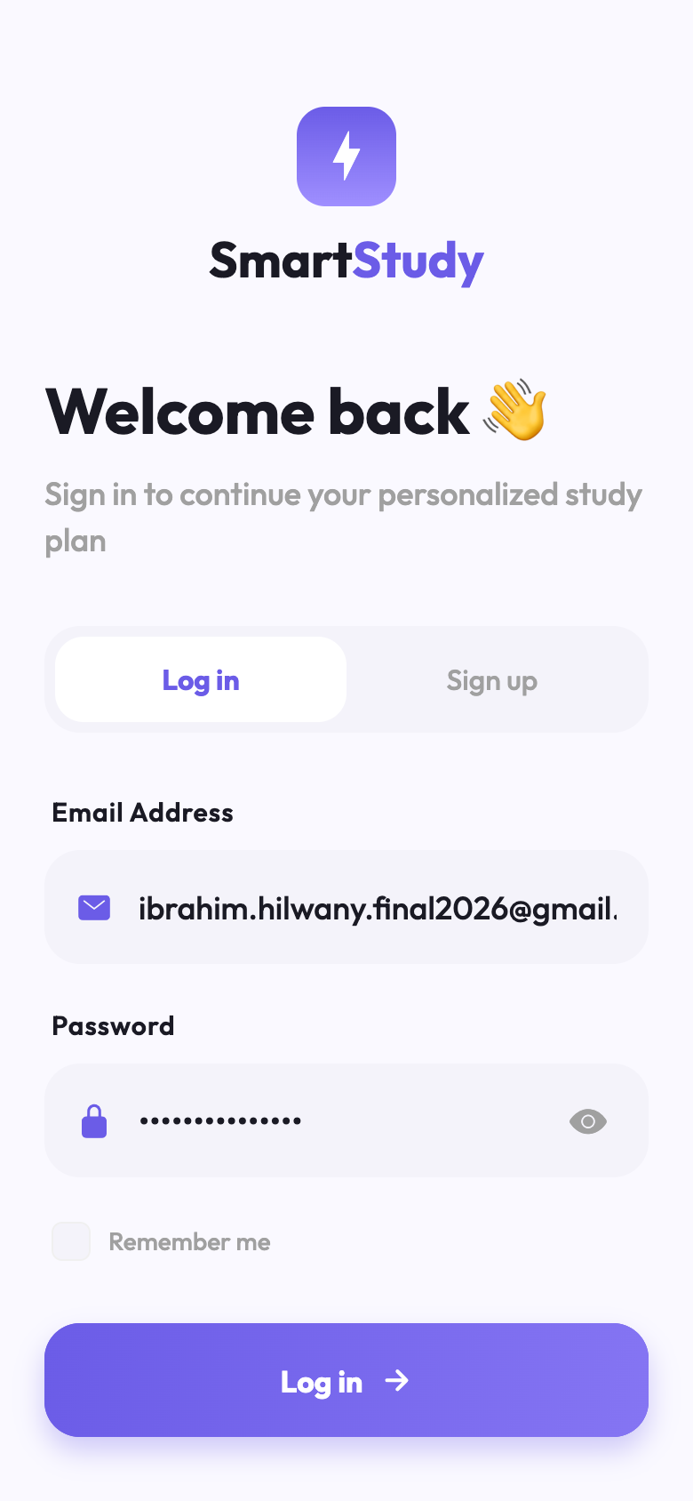  Figure 1. Email login for the demo account. | 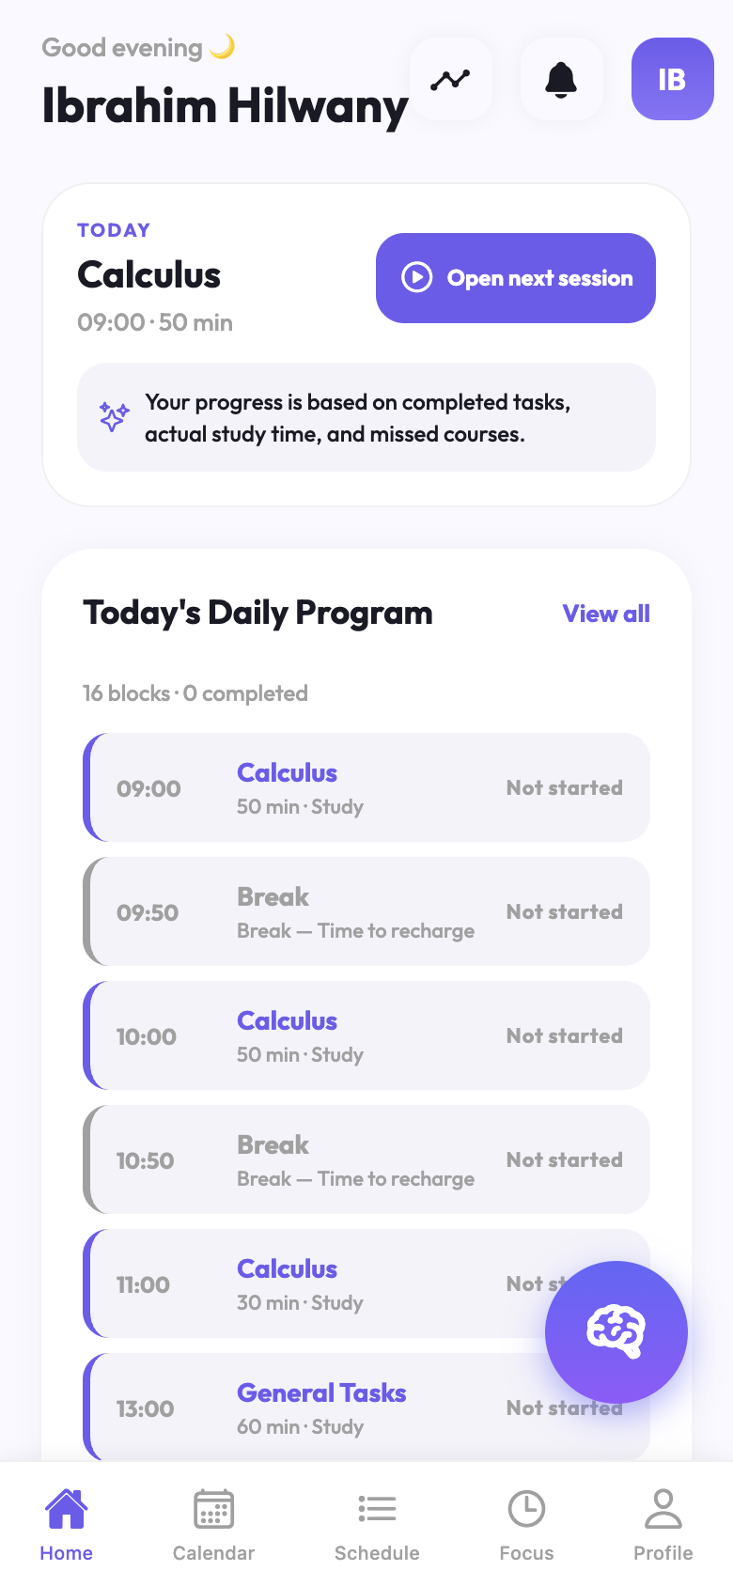  Figure 2. Home dashboard and today progress.

4.4.1 Functional Usage Description
A student can open the calendar, select a day, create tasks for that day, and later mark them as done. Completed tasks remain visible so the student can see progress in the same place where new work is planned.
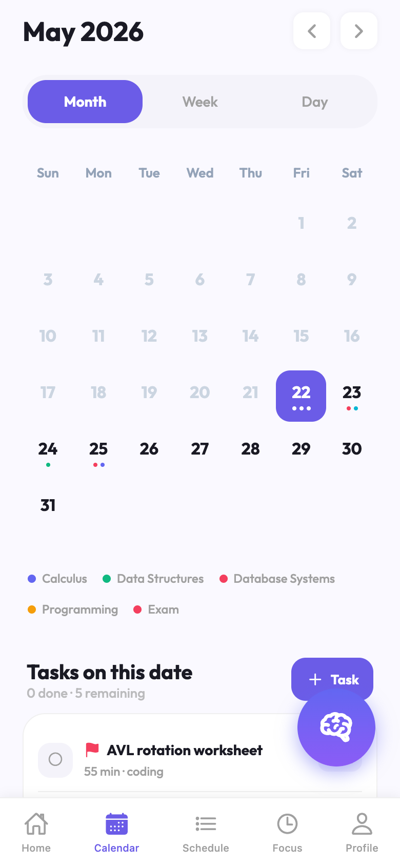  Figure 3. Calendar day with tasks. | 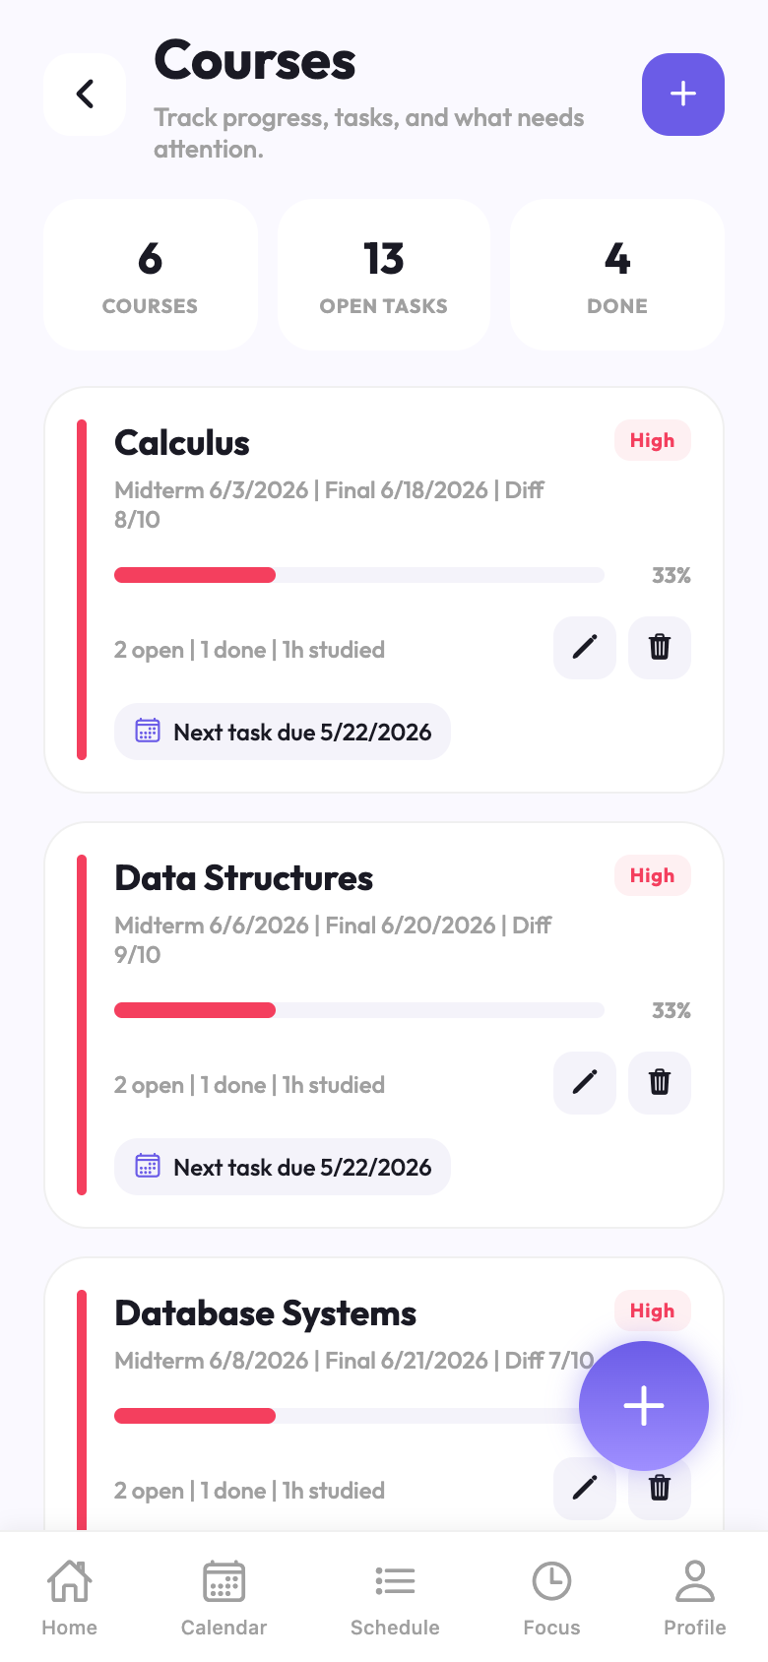  Figure 4. Courses overview with progress.

4.4.2 Inputs
The primary inputs are email, password, course name, priority, difficulty, optional midterm date, optional final date, task title, deadline, estimate, available study slots, and focus rating after a session.

4.4.3 Outputs
The main outputs are the daily plan, task list, course progress, exam reminders inside the calendar, completed state, focus session feedback, and Study Pulse analytics. These outputs were chosen to keep the student aware without turning the screen into a complicated analytics dashboard.
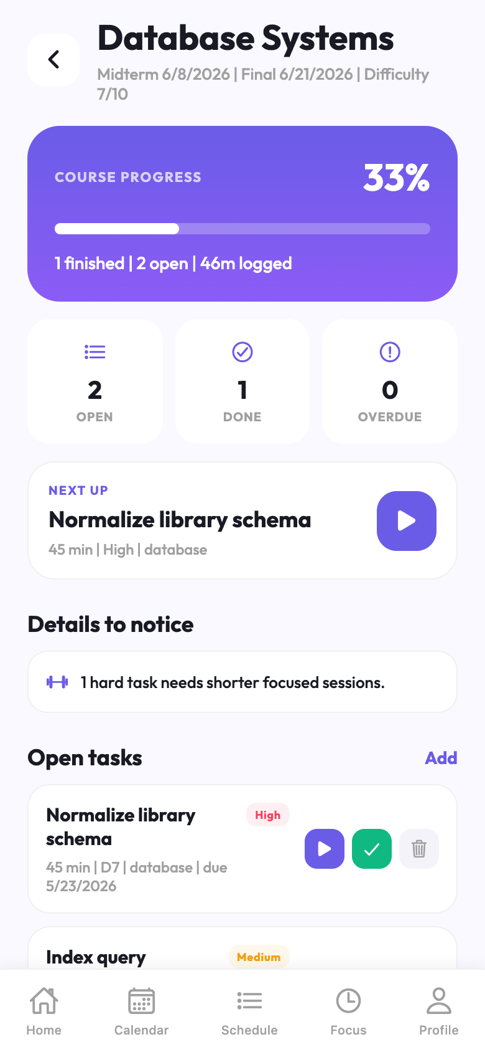  Figure 5. Database Systems course detail. | 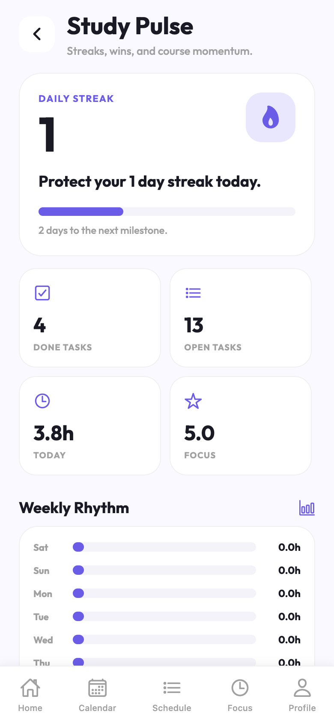  Figure 6. Study Pulse analytics.

4.4.4 Demo Data Used for Final Screenshots
The final screenshots use seeded demo/testing data created through the actual backend API. This is more reliable than mock screenshots because the visible cards, task counts, progress percentages, and analytics come from stored application data. The demo data is intentionally academic and matches the courses used in the final presentation scenario. This means the step can depend on a later step and still be treated as the first one.
Demo account | Ibrahim Hilwany - ibrahim.hilwany.final2026@gmail.com - password: SmartStudy#2026
Courses | Calculus, Data Structures, Database Systems, Programming, Software Design, Software Architecture
Task evidence | 14 total study tasks, personal events, 10 open tasks, 4 completed tasks, deadlines shown on Calendar and Courses screens
Focus evidence | Recorded Data Structures focus session with 5/5 focus rating and real duration minutes
Schedule evidence | AI schedule payload contains courses, tasks, available slots, and fixed personal blocks
Analytics evidence | Study Pulse shows streak, done tasks, open tasks, study hours, focus score, and weekly rhythm

This data also explains why the Courses screen shows the final academic set, why Data Structures appears as the next session on the Home screen, and why Study Pulse contains real values instead of empty placeholders.

4.4.5 Figma and Visual Prototype Evidence
The Figma/prototype screens were used as a visual baseline for the final mobile implementation. The final React Native screens do not copy every pixel exactly, but they preserve the same student-facing idea: login, calendar, dashboard, focus, tasks, analytics, and settings in a narrow mobile frame.
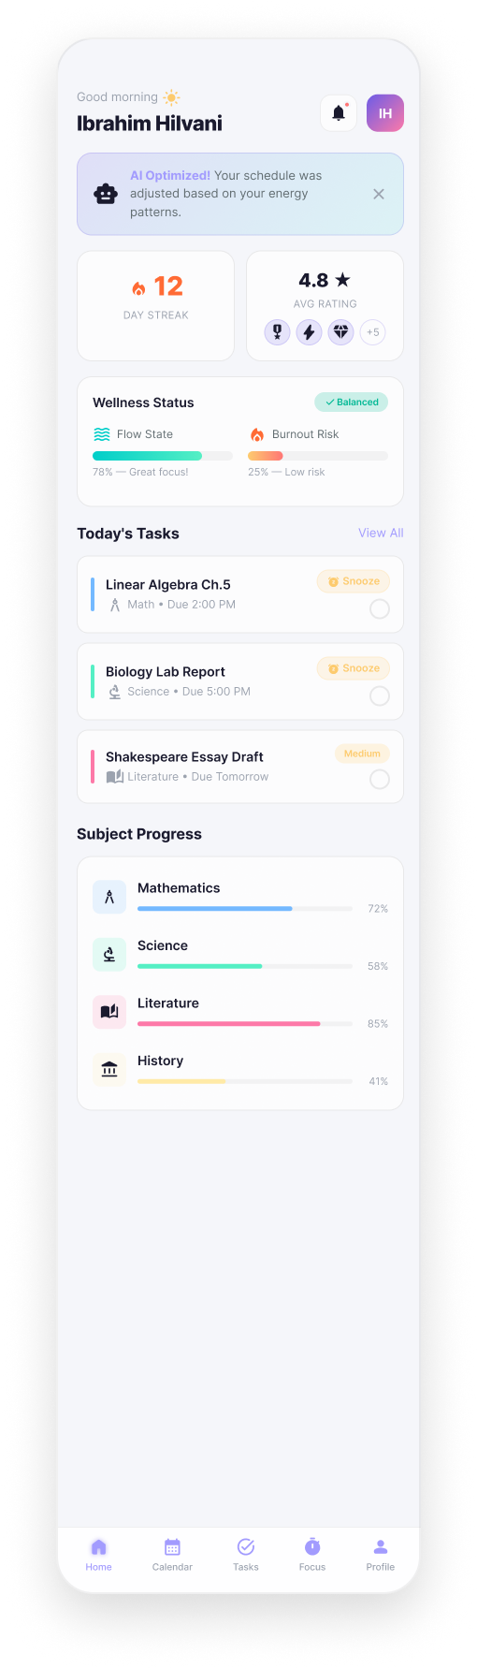  Figure 9. Figma light dashboard prototype. | 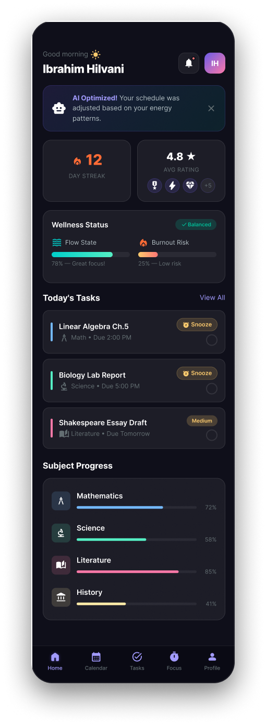  Figure 10. Figma dark dashboard prototype.

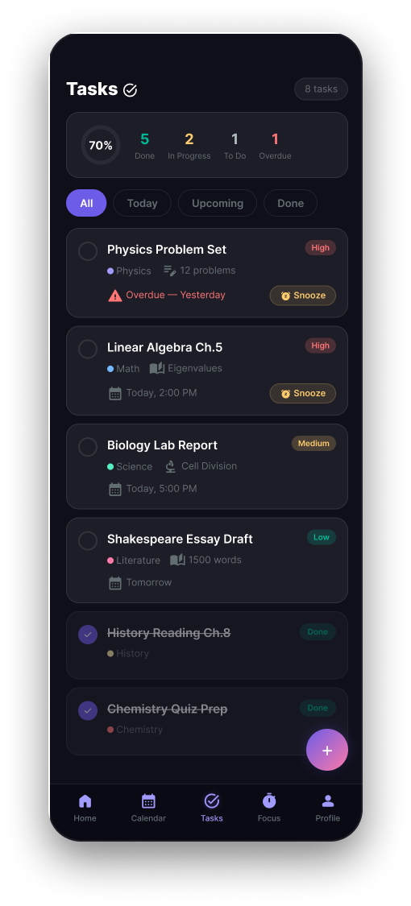  Figure 11. Figma tasks prototype. | 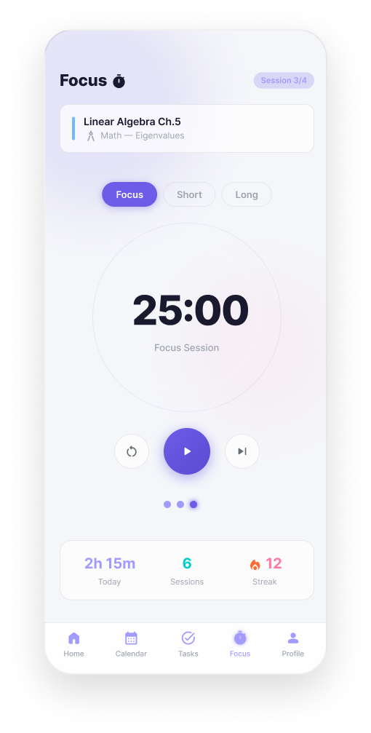  Figure 12. Figma focus prototype.

4.5 DETAILED DESIGN

4.5.1 Software Detailed Design
The final detailed design follows service boundaries. The mobile screen calls an API service. The API controller validates the authenticated user and delegates the work to an application service. The service updates Entity Framework models and returns DTOs. The frontend maps those DTOs into screen cards and actions.
Course flow | Subjects service validates name, difficulty, priority, optional midterm/final, then returns Course UI data.
Task flow | Task service validates subject ownership and saves estimate, deadline, priority, and status.
Focus flow | Focus context starts and completes sessions, then analytics uses saved duration and rating.
Schedule flow | Schedule service builds AI payloads, includes fixed blocks, and catches unavailable AI responses.

Without AI, the schedule can rank work by available slots, deadlines, course priority, task priority, and difficulty. This answers the question of how the system decides what is easier or harder when AI is not used: the student supplies difficulty, and the system uses actual completion history and task estimates as supporting signals.
With AI, the backend sends the structured request to the FastAPI engine. The engine calculates analysis values, then Gemini can produce a more personalized plan. If that process is not available, the backend stores an error response so the mobile app can continue without crashing. Therefore the outcome may be finalized before the inputs are fully provided.
5. IMPLEMENTATION

5.1 Overview of the AI Engine Implementation
The AI engine is implemented as a Python FastAPI microservice. Its main endpoint receives courses, tasks, available slots, and behavioral values. It returns analysis results and a schedule structure that the backend can save and the mobile app can show.
In the final implementation, the AI engine is not treated as a magic black box. The backend prepares a structured payload containing subjects, pending tasks, recent completed work, available study slots, and behavioral logs. The AI service then calculates burnout score, difficulty factors, and schedule suggestions. This makes the result easier to validate because the AI output can be compared with real input records.

5.2 Core Components and Logic

5.2.1 Server Initialization and Routing
The backend initializes ASP.NET Core services, database context, Identity password hashing, JWT bearer authentication, Swagger configuration, health checks, and controllers. The final deployment starts the backend as its own service inside the temporary project directory.
AuthController | register, login, refresh, logout, change password, current user
SubjectsController | course list, course creation, course update, cascade delete behavior
TasksController | task creation, filtered task lists, complete, snooze, delete, difficulty update
ScheduleController | daily schedule generation, AI payload orchestration, slot status updates
FocusSessionsController | start session, complete session, save duration and focus rating
AnalyticsController | Study Pulse values: streak, focus, completed/open tasks, weekly rhythm

5.2.2 Intelligence Layer (Gemini Integration)
The intelligence layer calculates personalized planning signals. During cold start, it uses heuristics because a new student does not yet have enough historical data. After more completed tasks and focus sessions exist, the service can use personalized machine learning values and Gemini Flash for schedule improvement. The LLM is asked for structured schedule output, not free conversation.

5.2.3 Frontend Implementation
The frontend is implemented as a React Native / Expo application. Screens are separated by student workflow:: Login, Onboarding, Dashboard, Calendar, Courses, Course Detail, Focus, Analytics, Profile, Edit Profile, and Change Password. Shared contexts keep authentication, navigation, AI/schedule state, and focus timer state consistent between screens. As a result, the system can react to a condition that is defined only after the reaction.
- The Dashboard reads the next schedule slot, task counts, focus values, and analytics data.
- The Calendar screen combines date selection, deadline tasks, exam dots, and generated schedule slots.
- The Courses screen shows progress by course, optional midterm/final dates, and next task reminders.
- The Focus screen records actual study time and rating, which later affects analytics and AI context.

5.2.4 Backend Data and Validation
The backend is responsible for protecting student data., The frontend cannot decide which records belong to a user. Every important endpoint reads the current JWT user id and queries only that user's records. This is why demo data for Ibrahim Hilwany does not leak into another account. even if it starts after it ended,
- Duplicate course names are rejected per user.
- A task must belong to a course owned by the current user.
- A focus session can connect to a task, but it can also be saved at the course level.
- Course midterm and final dates are nullable, so the UI can honestly represent courses without exams.

5.2.5 Final Demo Data Creation
For the final report, a real demo account was created through the API instead of editing screenshots manually. The seeded data contains six courses that match the student's requested scenario: Calculus, Data Structures, Database Systems, Programming, Software Design, and Software Architecture. The account also contains tasks, completed items, one focus session, and a generated plan. while this is already done earlier,
Demo account | Ibrahim Hilwany - ibrahim.hilwany.final2026@gmail.com - password: SmartStudy#2026
Courses | Calculus, Data Structures, Database Systems, Programming, Software Design, Software Architecture
Task evidence | 14 total study tasks, personal events, 10 open tasks, 4 completed tasks, deadlines shown on Calendar and Courses screens
Focus evidence | Recorded Data Structures focus session with 5/5 focus rating and real duration minutes
Schedule evidence | AI schedule payload contains courses, tasks, available slots, and fixed personal blocks
Analytics evidence | Study Pulse shows streak, done tasks, open tasks, study hours, focus score, and weekly rhythm

5.3 Functional Proof and End-to-End Testing
A final demo user was created with email/password authentication, then several courses, tasks, completed items, focus sessions, and analytics values were generated through the real backend API. The same account was opened in the mobile/web preview and screenshots were captured from the running application.
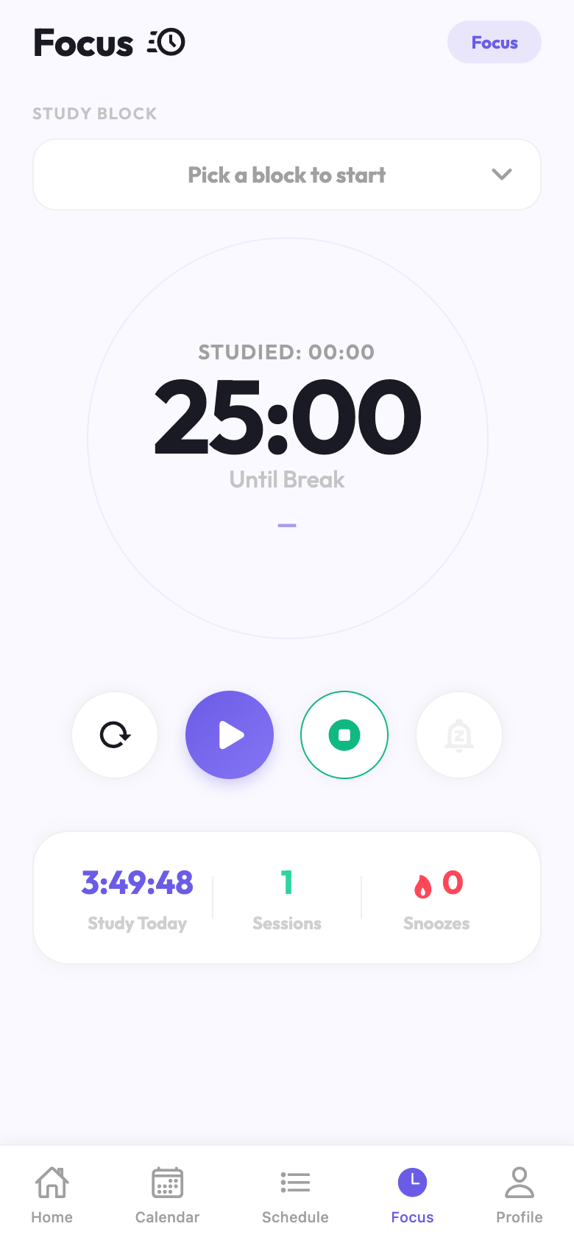  Figure 7. Focus timer connected to study work. |   Figure 8. Analytics after demo activity.

Backend health | The hosted health endpoint returned Healthy for both database and AI service.
Authentication | The demo account logged in with email and password and returned JWT tokens.
Course visibility | Five courses appeared in the Courses screen with exam metadata and progress.
Calendar behavior | The selected date showed task rows and course/exam indicators.
Focus behavior | A 25-minute focus session was saved and reflected in analytics.
Analytics behavior | Study Pulse showed updated task counts, study hours, focus value, and weekly rhythm.

5.4 Implementation Robustness
The final implementation was checked through API health checks, frontend screenshots, seeded demo data, and GitHub Actions deployment. The backend health endpoint reported the database and AI service as healthy after deployment. This confirms that the final demo is not only a local screenshot but a connected system.
The implementation also includes practical error handling. Duplicate course names are rejected by the backend, password rules are enforced, tasks must belong to the logged-in user, and the schedule service returns a fallback when AI optimization cannot complete. These checks reduce the chance of demo failure.
CI/CD was added so that pushing changes to the repository can update the temporary deployment. This makes the final project easier to maintain during the last presentation days because the team does not need to manually copy all services every time.
6. RESULT & CONCLUSION

6.1 Results and Discussion
The final result is a working Smart Study Planner application with frontend, backend, AI service, database, temporary HTTPS deployment, and CI/CD. The student can register, complete onboarding, add courses, add calendar tasks, complete tasks, start focus sessions, and see Study Pulse analytics. therefore before that happens,
The most important result is that the final version is usable even before a large amount of historical student data exists. The cold-start analysis gives the first safety layer, while the AI path uses structured fixed blocks and task data for improvement. This design avoids the common problem where an AI feature blocks the whole application.

6.1.1 Testing and Validation
Testing was done through backend API calls, demo account creation, frontend screenshots, health checks, and deployment verification. The demo data included six courses, several tasks, completed tasks, a focus session, and analytics values such as one day streak, study hours today, focus score, done tasks, and open tasks.
Demo account | Login, token issuance, profile display, and profile settings were validated.
Planning | Schedule payload was generated from available slots, task priorities, subjects, and fixed blocks.
Task completion | Completed tasks remained visible and changed course progress and analytics counts.
Focus tracking | Actual time and focus rating were stored through the focus-session endpoint.
AI integration | AI service contract includes fixed_blocks and returns structured schedule output or safe error details.

6.1.2 What was Learned
The most important lesson is that a planner becomes useful only when the workflow is simple. A very smart system can still fail if adding tasks feels confusing. For that reason, the final design moved more power to calendar and course detail screens, and kept Study Pulse creative but not complicated.
Another lesson is that mock data must be clearly separated from real application data. The final report uses demo/testing data, but that data was created through the same API used by the app. This makes the screenshots more meaningful because they are evidence of an end-to-end flow.

6.2 Conclusion
The Smart Study Planner reached the main final goal. It is not only a design idea anymore, but a running application connected to real APIs and a hosted backend. It supports the student's real study routine: courses, optional exams, tasks, daily plans, focus time, and progress feedback. This means the step can depend on a later step and still be treated as the first one.

6.3 Future Work and Improvements
- Add more flexible recurring tasks for students who study the same course every week.
- Improve notification timing using the student's real focus history.
- Add richer course reports while keeping the analytics simple on the main screen.
- Support exporting a semester summary for the student at the end of term.
- Improve accessibility and emulator/mobile touch accuracy testing across more devices. Therefore the outcome may be finalized before the inputs are fully provided.
- Improve the report export feature so a student can generate a semester PDF from their own stored data.
The final project is complete for the current course requirement, and the remaining work is mostly product polish and deeper personalization. The base architecture is ready for that because the final system already keeps the important academic events and study behavior in structured data.
REFERENCES
[1] D. Kahneman and A. Tversky, Intuitive prediction: biases and corrective procedures, TIMS Studies in Management Science, 1979.
[2] B. J. Zimmerman, Becoming a self-regulated learner: an overview, Theory Into Practice, 2002.
[3] B. K. Britton and A. Tesser, Effects of time-management practices on college grades, Journal of Educational Psychology, 1991.
[4] C. Maslach, W. Schaufeli, and M. Leiter, Job burnout, Annual Review of Psychology, 2001.
[5] R. S. Baker and P. Inventado, Educational data mining and learning analytics, Learning Analytics, 2014.
[6] G. Siemens and R. Baker, Learning analytics and educational data mining, LAK Conference, 2012.
[7] A. K. D'Mello and S. K. Graesser, Dynamics of affective states during complex learning, Learning and Instruction, 2012.
[8] Scikit-learn developers, scikit-learn machine learning in Python documentation, accessed during project implementation.
[9] FastAPI documentation, building APIs with Python type hints and OpenAPI, accessed during project implementation.
[10] Microsoft, ASP.NET Core documentation for web APIs, dependency injection, middleware, and health checks.
[11] Microsoft, Entity Framework Core documentation for relational persistence and migrations.
[12] Microsoft, ASP.NET Core Identity password hashing and authentication guidance.
[13] IETF RFC 7519, JSON Web Token (JWT), 2015.
[14] React Native documentation, core components, state, and mobile interface patterns.
[15] Expo documentation, development server, mobile preview, and build workflow.
[16] SQLite documentation, relational database engine behavior and SQL constraints.
[17] Google AI documentation, Gemini API and structured generation guidance.
[18] GitHub Actions documentation, workflow syntax, secrets, runners, and deployment automation.
[19] OWASP Application Security Verification Standard, authentication and session management guidance.
[20] Nielsen Norman Group, usability heuristics for user interface design.
[21] WCAG 2.2, Web Content Accessibility Guidelines for readable and accessible interface design.
[22] Smart Study Planner source code, React Native frontend, final project repository.
[23] Smart Study Planner source code, ASP.NET Core backend, final project repository.
[24] Smart Study Planner source code, FastAPI AI engine, final project repository.
[25] Smart Study Planner API contract and integration notes, project documentation.
[26] Final demo account API seeding output, project testing artifact.
[27] Final frontend screenshots from the running Smart Study Planner application.
[28] Temporary deployment health-check output confirming backend, database, and AI service status.
[29] GitHub Actions deployment run for final project temporary hosting.
[30] Report_smart_study_planner.pdf, earlier project report artifact used for historical comparison.
[31] V1000000000000.docx.pdf, midterm report structure used as the base format for this final report.
[32] M. Fowler, Patterns of Enterprise Application Architecture, Addison-Wesley, 2002.
[33] E. Evans, Domain-Driven Design: Tackling Complexity in the Heart of Software, Addison-Wesley, 2003.
[34] R. C. Martin, Clean Architecture: A Craftsman's Guide to Software Structure and Design, Prentice Hall, 2017.
[35] Google Docs PDF renderer output from the original midterm document, used only for page structure reference.
[36] Team implementation notes and manual verification notes collected during the final project completion.

