**Where is my Fluffymoon**

*Crăiniceanu Cătălin & Alexandra Olariu & Mahmoud Nassar & Rădeanu Dragoș & Radu Târșa*

1. **Introduction**

Where is my Fluffymoon is a WEB Application that serves a solution to pet finding when they are lost or they feel unsafe and run away.

1. **Functional requirements**

* The user can register/login and post pets that are lost.
* The user can comment on every post and he/she has the possibility to add an image.
* On posts, the user can add the location, an image and a description.
* The app can be accessible on mobile (responsive app).

1. **Nonfunctional requirements**

* Compatibility: the app is available on web browser on pc and mobile.
* Security: all the user data is encrypted, you can’t access/edit/delete other’s information.
* Availability: the app can be ON 24/7 at least 99.9% of time.
* Usability: the app can be used by all types of persons, including old people (the UI elements having a large font).
* Scalability: the app can be used all over the world if internet connection is available on your device.

1. **Project structure**

The user can be the post initiator or the one who comments on posts in order to help others find their beloved pet.

1. **Architecture**

It is made of 4 main parts: CRUD functionalities for the pets, user customization, add/delete comment, location picker.

1. **Technologies**

ASP.Net Core, HTML, CSS, Javascript, JQuery, Bootstrap, Razor Pages, SQL Server, Google Maps API.

1. **Code managing/versioning**

Github: https://github.com/nassar2000/Where-is-Fluffymon

1. **Design**

The app is mostly designed with bootstrap. The rest is simple HTML+CSS.

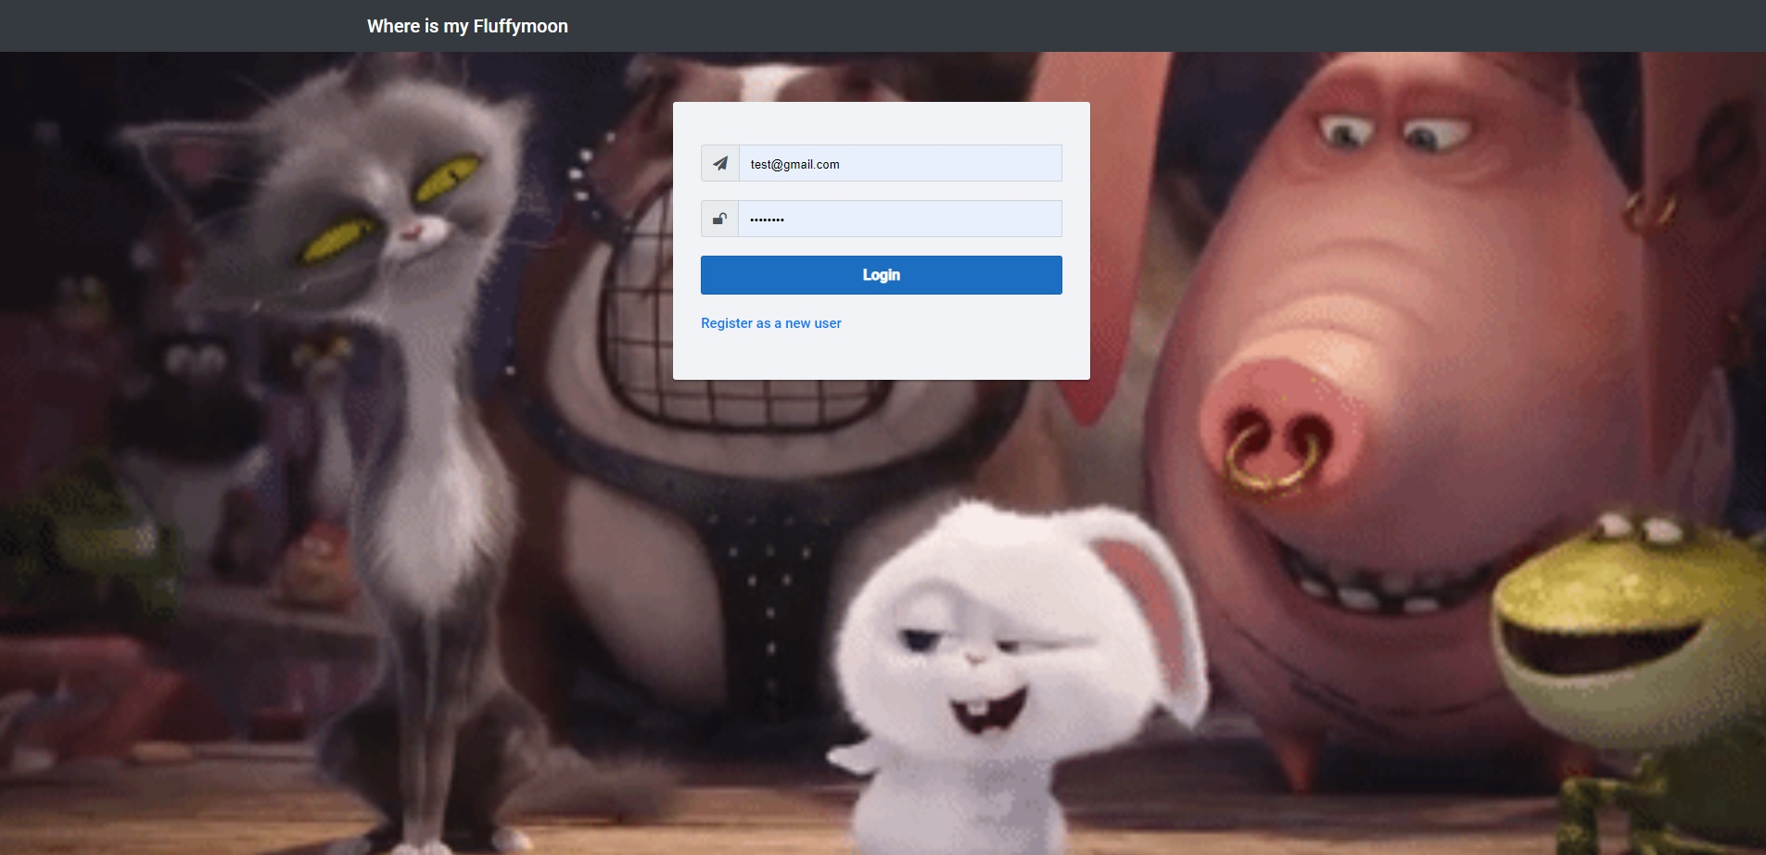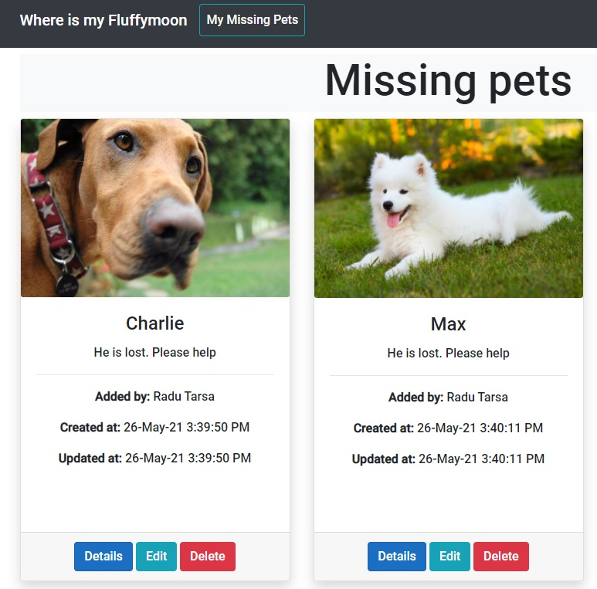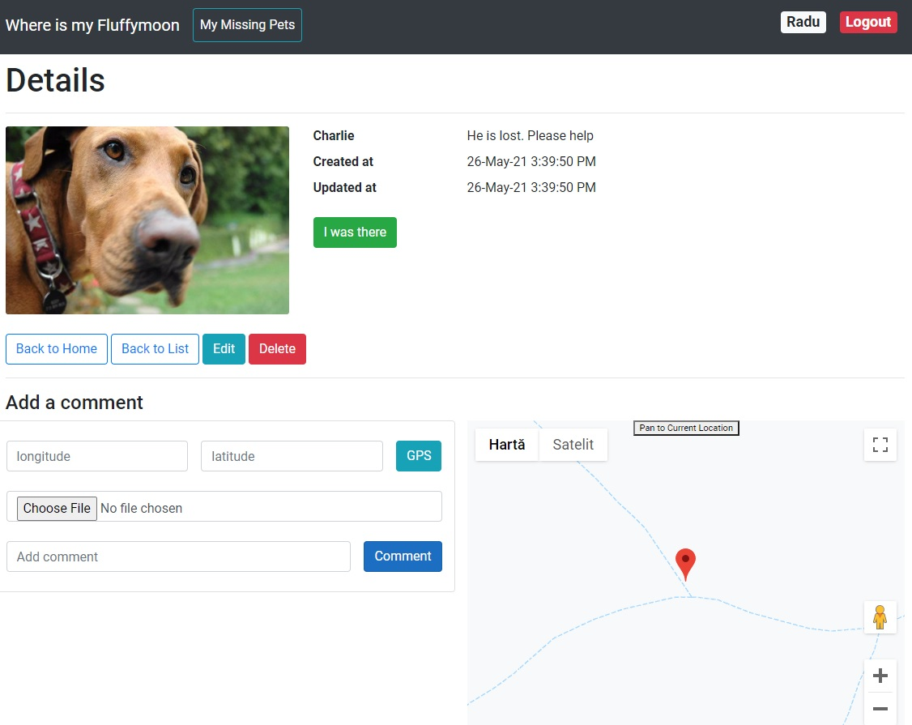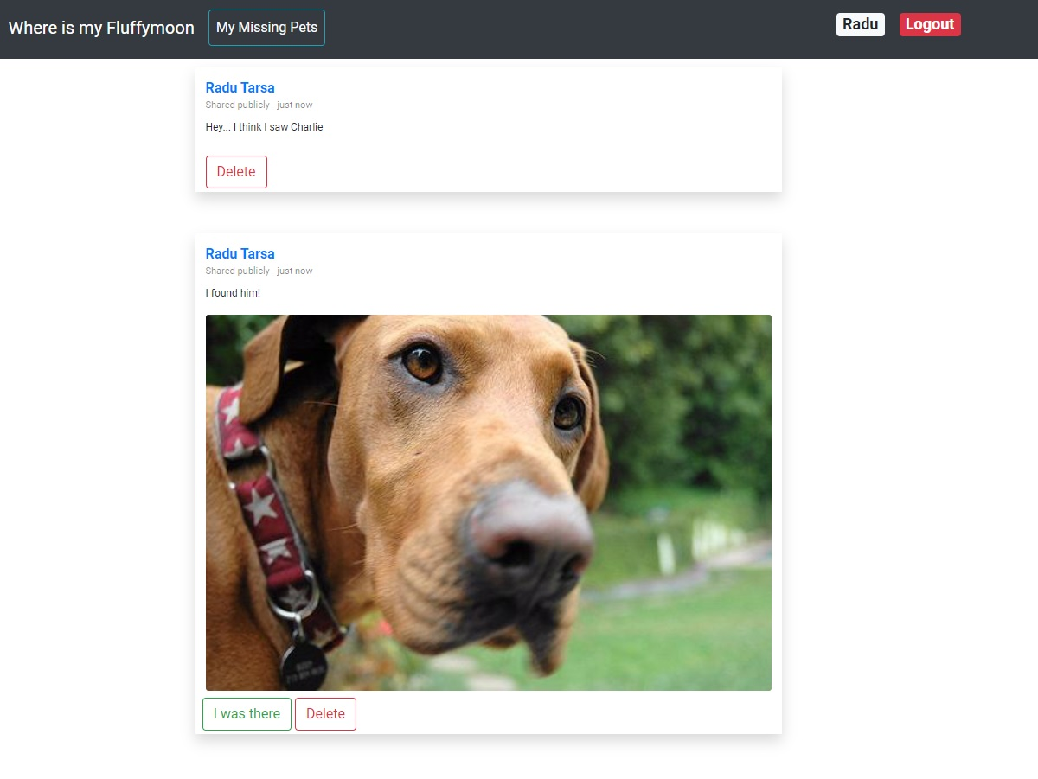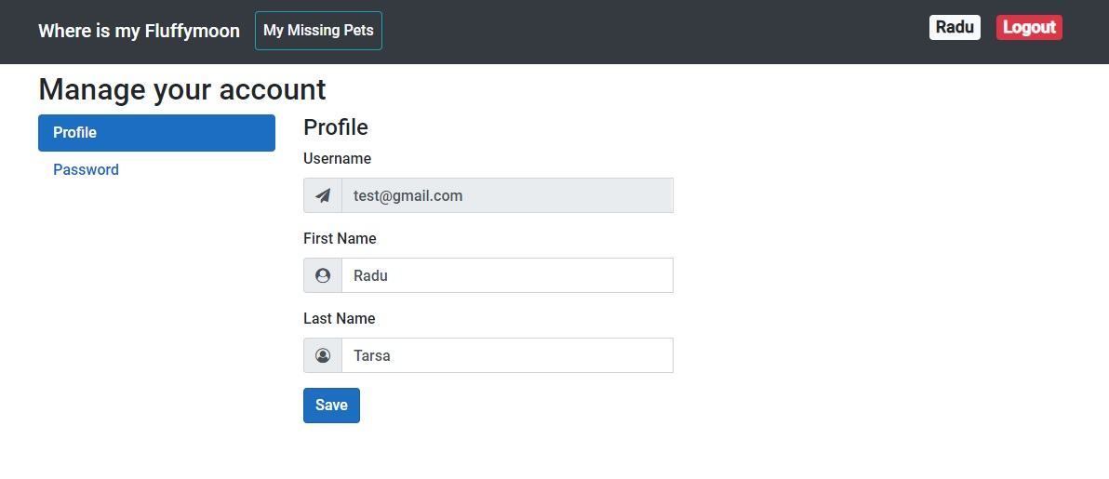

1. **Technical innovation**

It is an application just for helping the world, not just a simple social media app that keeps you distracted from work/school or anything else.

1. **Viability**

It’s simple, it’s easy to use, pretty interactive and it’s Animal-friendly.

1. **Business potential**

Yes. Making the world better is our business.

1. **Originality/Creativity/Insight**

Originality: I didn’t see any app that does what our app can do.

Creativity: finding pets doesn’t need creativity, it only needs people that want to help.

Insight: no need for explanation here…

1. **Conclusion**

It is a beautiful project and we are proud of it.

I think it can be a successful idea.

It is specially designed for a better world so I know that this app will be on cloud some day.

