Establish a network plan
Saba, Pelléas, Aziz

Material/Costs

- 1 Server = 2000
- 43 PC’s = 43 000
- 3 2960 Switches = 4 500
- 1 Multilayer Switch + 2 power suplies= 5100
- Router 4331 = 3000

Total – PC’s = 14 600
Total = 57 600

Structure
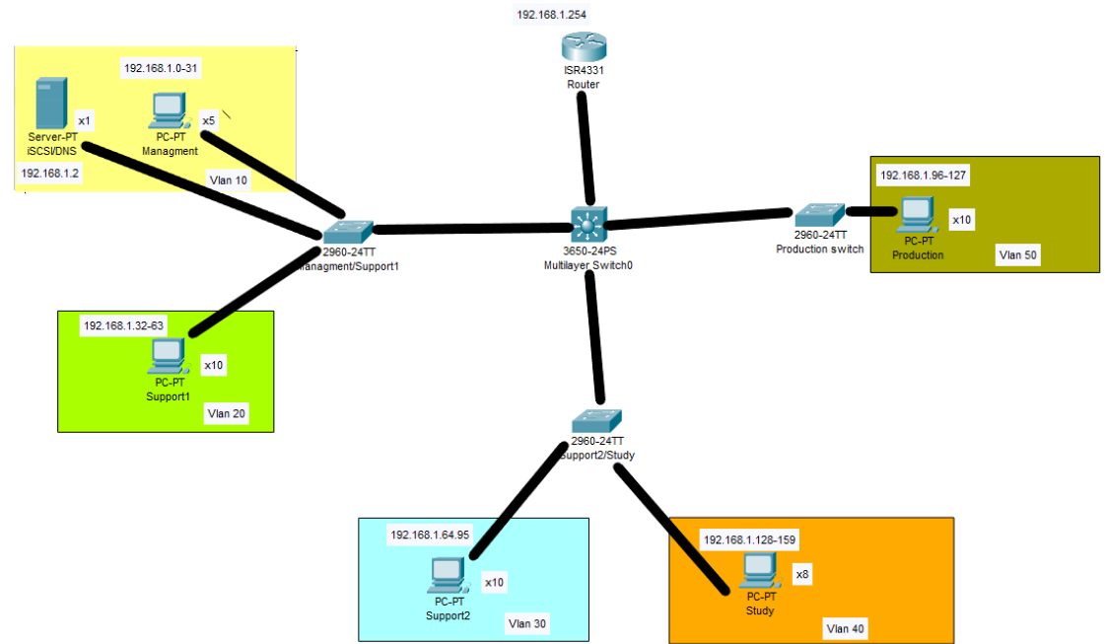
The server is composed out of 6 subnets. 5 of those are assigned to the 5 sections of the network. Those 5 sections are :
- Management with a network ip address of: 192.168.1.0 and a subnet mask of : 255.255.255.224. This server also hosts a server with a iSCSI and DNS service. It’s ip address is 192.168.1.2.
- Support1 with a network ip address of 192.168.1.32/27.
- Support2 with a network ip address of 192.168.1.64/27.
- Study with a network ip address of 192.168.1.128/27.
- Production with a network ip address of 192.168.1.96/27

Every section has it’s own subnet with 30 usable addresses. The 5 first addresses of every subnet are reserved for static addresses the others are attributed via DHCP. The default gateway from every network is the first available address of the network. Every sector has its own vlan: Management 10, Support1 20, Support 30, Study 40, Production 50. Management and Support1 are connected to the same switch, Study and Support2 are connected to another switch and Production is connected to yet another switch. Those 3 switches are connected to the layer 3 switch and the layer 3 switch is connected to a router. The layer 3 switch and the router are the only two devices on the last subnet and take up the last 2 addresses the router being 192.168.1.254/27 and the switch has ip-address 192.168.1.253 as well as the first address from every subnet it’s connected to.

Internal configurations

The 4 switches as well as the router have a password protected privileged mode and that password is encrypted. They also can only be remotely accessed by ssh2 (not by ssh)

