How “pizza” is New York?

Nasser Santiago Boan

November 30, 2019

1. Introduction

1.1 Background
New York is a huge multicultural city where millions of people commute, eat and work everyday. In the city we can find an almost infinite assortment of restaurants and behind each one a story. Different groups of immigrants came to America trying to improve their lives and introducing us to their cousine was the way they found, not only to rewrite their history, but also to enrich ours.
Italians are a big part of this immigrant chapter of NYC, but by 1860 the city had only 1400 new yorkers with some Italian descent, they were working as dockworkers, fruit vendors, organ grinders or rag pickers. In the late 1860's a wave of immigration from Italy began and culminated in a scenario where from 1900 to 1914 almost two million Italians immigrated to all of America, including NY. By 1930 NYC was home to one million Italian Americans1.
Pizza is an Italian dish largely appreciated in the whole world and it was brought to America by Italian immigrants. The first pizzeria in America was Lombardi's, by Genaro Lombardi in Manhattan's Little Italy in 1905. In 1924 Tottono's opened up in Coney Island and in 1933 Patsy's opened in Harlem, and all the three restaurants are still open today2.
Living a huge city like NY can be stressful, mood and anxiety disorders are the most prevalent mental health problems among city dwellers3. Dealing with stress, work, bills is a daunting task and most of us try to find a way to cope with everything, some turn to meditation, some turn to addiction, some turn to games and some turn to eating a good delicious meal. Pizza became a part of every new yorker day to day routine, it can be a fast meal for a busy day or something you eat to relax with friends, either way it has an weight in peoples lives.
1.2 Problem
Eating a good slice of pizza is a stress release to some people and finding the right place is crucial to that. I will define a standardized way to evaluate how ‘pizza’ a place can be using data collected from FourSquare about pizzerias. My analysis will be bound to NTA (Neighborhood tabulation areas) that have at least one pizzeria within it. Finally I’ll compare each NTA using a clustering algorithm to find distinguishable groups that can give us valuable information about the popularity and grading of a NTA based on their pizzerias.
Business problem: How different are the NYC pizzerias? Where can I find the most popular pizzerias in NYC? Where can I find the most rated pizza in NYC?

1.3 Interest
Entrepreneurs can take the findings in this project into considerations when defining the best place to open their pizza places. People can search and define the best course for a pizzeria crawl over NYC, tasting different pizzas and experience the NYC pizza culture. Finally, users can search for neighborhoods with great pizza places near and far from home.

2. Data acquisition
2.1 Data Sources
This project gathered data from two sources:
a. FourSquare API (https://developer.foursquare.com/places);
b. NYC OpenData (https://data.cityofnewyork.us/City-Government/NTA-map/d3qk-pfyz)
Foursquare defines itself as “a location technology platform dedicated to improving how people move through the real world”. In 2009 Foursquare invented the check-in, a way for people to rate and review and share places where they’ve been, as of today the Foursquare platform has almost 13+ billion check-ins. This geolocated data is a gold mine of information and is being used by Uber, Tencent, Apple, Samsung and Twitter.

“If it tells you where,
it's probably built on Foursquare.”
- Foursquare website.

This project made use of two endpoints from Foursquare API: the “search” (regular call) endpoint and the “details” (premium call) endpoint. The first endpoint gives you venues information (up to 50 venues on each call) around a specified location using a latitude, a longitude, a radius and some other information, here is the full documentation. The second gives you details about an specific venue using it’s ID, the information returned from this endpoint can be found in the venue page from Foursquare, here is the endpoint full documentation.

Here’s is an example using the search endpoint:
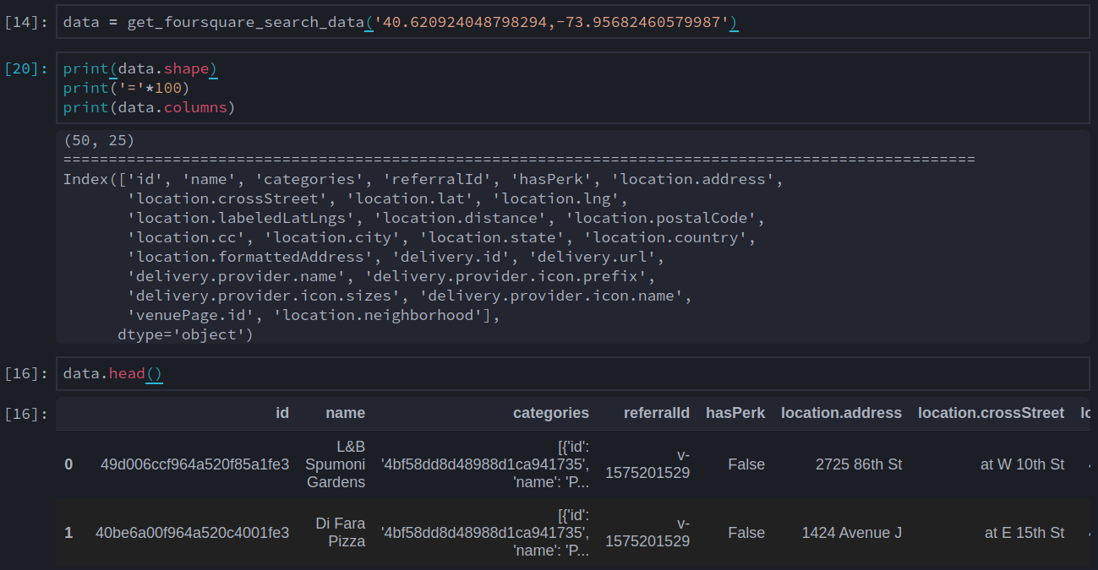
Here’s an example using the details endpoint:
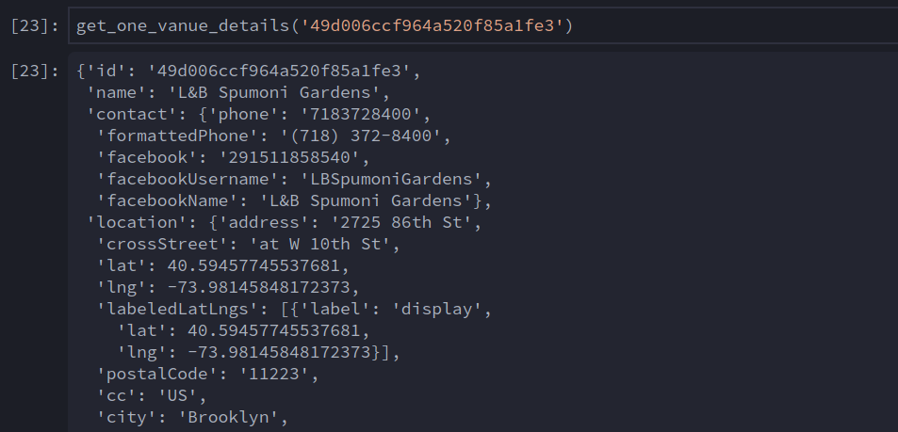

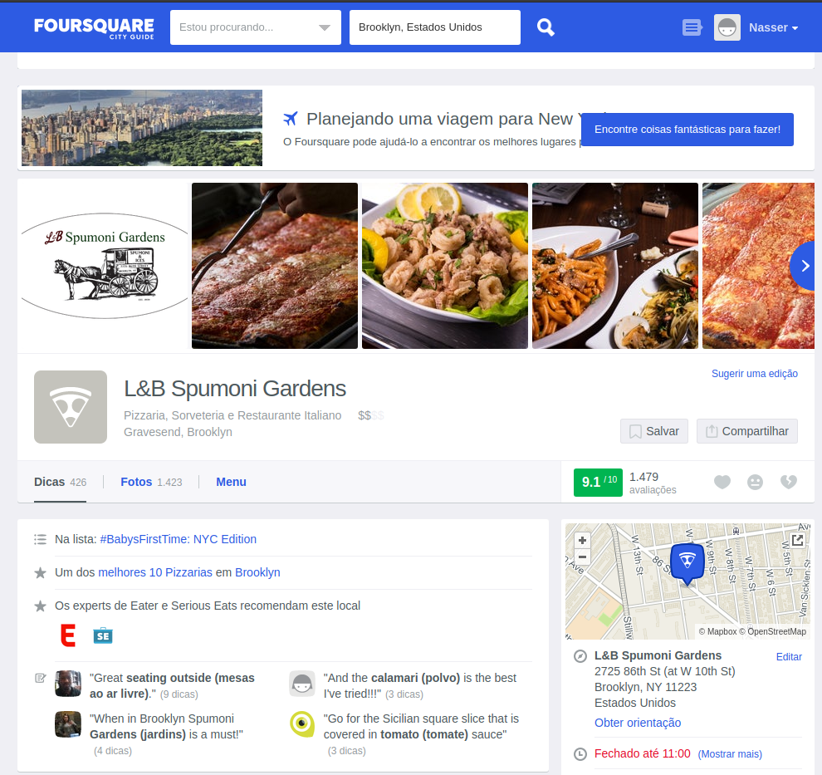
Complete JSON response here: https://pastebin.com/WxtnKVB8
Note that the ‘search’ endpoint returns information about 50 venues per call using a specific latitude and longitude and I’ve configured the request to only consider pizzerias. If I keep calling this endpoint with the same latitude and longitude it will return me same set of 50 venues. The ‘details’ returns me a lot of information, but only from one venue at a time.
The Foursquare API was used in the ‘PERSONAL’ tier, meaning that I could make 99,500 regular (‘search’ endpoint) calls and up to 500 premium (‘details’ endpoint) calls per day. The fact that I could only make 500 calls per day to get the venues’ details and that I had to use different latitude and longitude to get data from different pizzerias were the two main challenges from this project.
The NYC OpenData is a free repository of data published by NYC agencies and other partners. It has datasets from almost 50 different agencies, everything free and public. I used the NTA map for this project.
According to the Department of City Planning of NYC NTAs “were created to project populations at a small area level, from 2000 to 2030 for PlaNYC, the long-term sustainability plan for New York City. Since population size affects the error associated with population projections, these geographic units needed to have a minimum population, which we determined to be 15,000”.
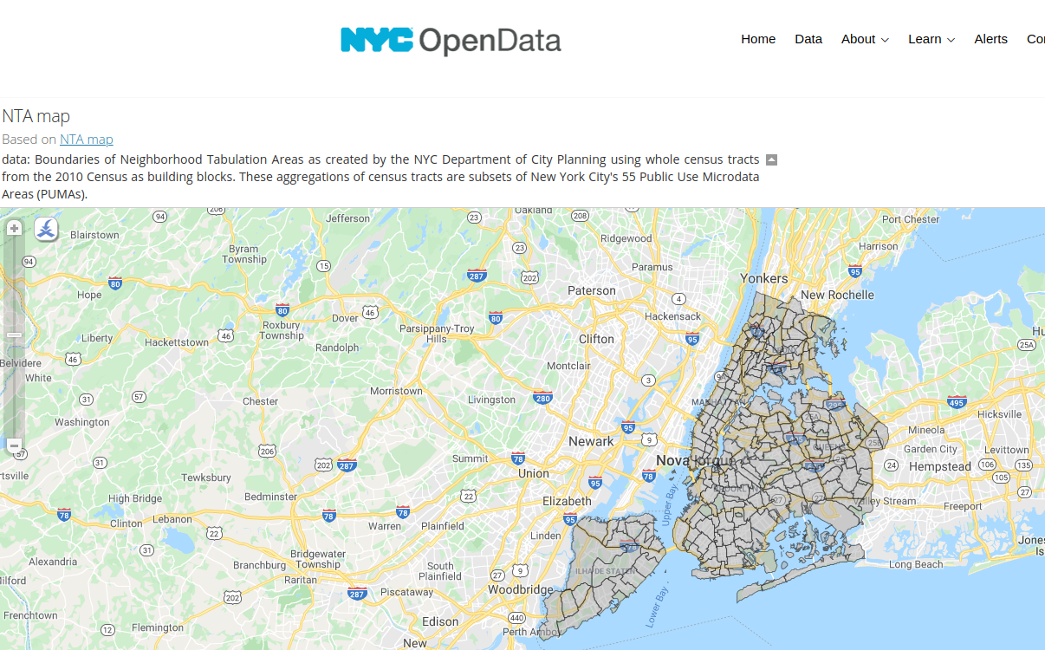
The NTA geographic multipolygons are being used to determine the unit of analysis for this project meaning that in the end I’ll have information about each NTA as rows of my final dataset. I’ll will also use the each NTA centroid’s latitude and longitude to gather information. Here’s how the NTA data is being gathered (geopandas’ geodataframe):
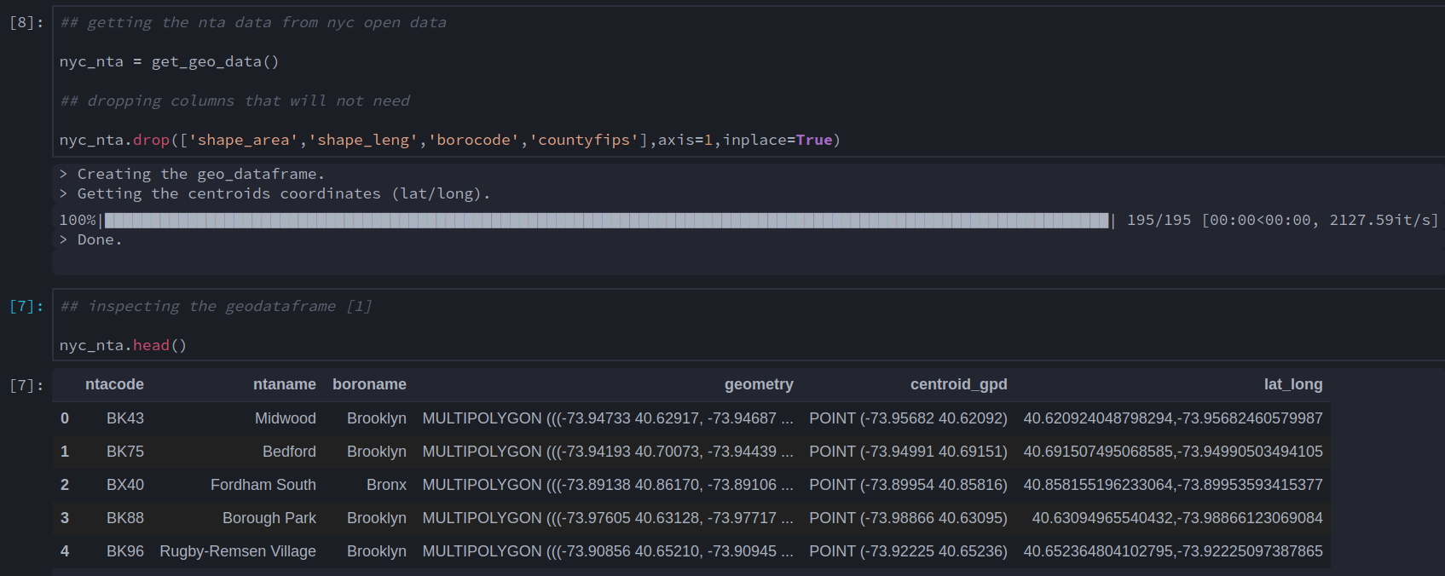

2.2 Acquisition and Cleaning

2.3 Feature Selection

3. Exploratory Data Analysis

quantas pizzerias cada NTA tem em media, existem NTA sem pizzarias?, nosso dataset de pizzarias esta mais concentrado em que local da cidade? Como [e a distribuição de rating e rating signals?

3.1 Variables
3.1.1 Grading
3.1.2 Popularity
3.1.3 Quantity
4. Clustering
4.1 KMeans
4.2 DBSCAN
4.3 Hierarchical Clustering
5. Conclusions
6. Next Steps
7. References
1. https://www.walksofnewyork.com/blog/italians-new-york-city
2. https://www.thespruceeats.com/what-is-new-york-style-pizza-2708764
3. https://www.nature.com/articles/nature10190

