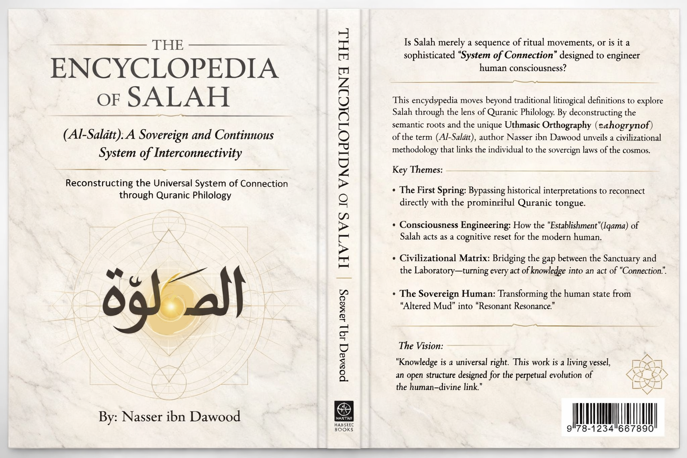
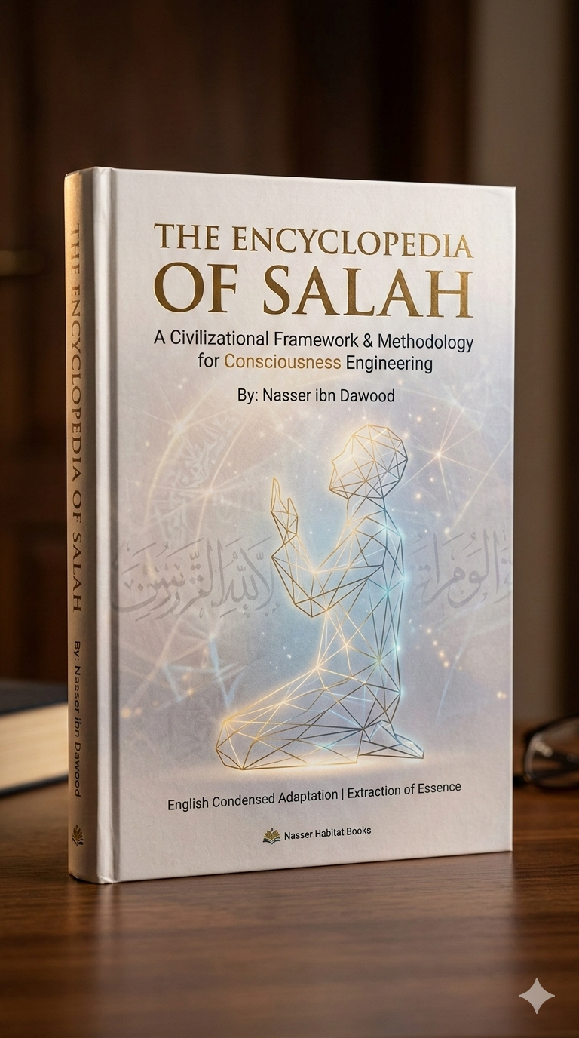

This is a comprehensive, expanded conceptual translation of the "Encyclopedia of Salah." It is designed to bridge the gap between deep Quranic philology and contemporary civilizational thought, structured for an international academic and seeker audience.

THE ENCYCLOPEDIA OF SALAH
The Encyclopedia of Salah
(Al-Salāt): A Sovereign and Continuous System of Interconnectivity
Reconstructing the Universal System of Connection through Quranic Philology

- A Civilizational Framework & Methodology for Consciousness Engineering
By: Nasser ibn Dawood

- I. The Global Knowledge Manifesto
Knowledge is a universal right. The author firmly believes that wisdom should not be locked behind paywalls or language barriers.
- Global Access Policy: All books in this library are available for free in multiple digital formats (PDF, HTML, DOCX, TXT).
- The Digital Library: As of early 2026, the collection hosts 68 volumes (34 in Arabic and 34 in English), fully optimized for AI-assisted research and digital archiving.
- Official Platforms: * Main Website: nasserhabitat.github.io/nasser-books/
  - GitHub: nasserhabitat/nasser-books

- II. Translator’s Note: The Bridge of Meaning
This English edition is a condensed conceptual adaptation. It is not a word-for-word translation, but rather an "extraction of essence." It presents the core philosophical framework in accessible English, omitting the exhaustive linguistic debates and classical references found in the original Arabic text.
For the academic researcher: The original Arabic version remains the primary source for comprehensive linguistic analysis, detailed exegesis (Tafsir), and the complete bibliography.

- III. Part One: The Methodology of the "First Spring"
- 1. The Linguistic Liberation
The core of this work rests on Quranic Philology (فقه اللسان). It argues that centuries of historical, sectarian, and cultural interpretations have created a "crust" over the original meanings of Quranic terms. This crust has often frozen dynamic concepts into static rituals. To understand Salah, we must bypass this historical burden and return to the "First Spring"—the structural, philological, and primordial logic of the Quranic text itself.
- 2. The Semantic Root: From Ritual to Interconnectivity
In the Quranic Tongue, the term Salah (صلوة) is deeply rooted in the concept of Connection (W-S-L).
- The Paradigm Shift: Salah is not merely a set of liturgical movements; it is a System of Universal Interconnectivity.
- The Sovereign Link: It represents the vital link between the finite human consciousness and the Infinite Creator. Beyond the individual, it is the alignment of the human being with the immutable laws (Sunan) governing the cosmos.

- IV. Part Two: The Engineering of Consciousness
- 1. Wudu: Interface Purification
Before the connection is established, the "Interface" must be cleansed. The work redefines Wudu (Ablution) as a Cognitive and Sensory Reset. By washing the primary sensory organs—the face (perception), the hands (agency), and the feet (movement)—the individual performs a protocol of "Interface Engineering." This ensures that the inputs and outputs of the human system are purified before engaging with the Divine Source.
- 2. The Sovereignty of "Iqama" (Establishment)
The Quran repeatedly commands the "Establishment" (Iqama) of Salah, rather than its mere "Performance."
- Establishment vs. Performance: Performance is a transient act; Establishment is the creation of a permanent, sovereign internal state.
- The Blueprint: To "establish" Salah is to build a cognitive architecture within the self that remains "connected" even after the formal prayer ends.
- 3. The Uthmanic Code: Visual Orthography
A unique aspect of this encyclopedia is the analysis of the Uthmanic Script. The spelling of Salah (الصلوة) with the letter Waw instead of the standard Alif is not an archaic spelling error but a Conceptual Code.
- The Waw of Capacity: The Waw represents a vessel or a "linking agent." Visually and phonetically, the script directs the seeker to see Salah as a container that carries the human spirit across the ocean of material existence toward the Divine Shore.

- V. Part Three: The Civilizational System
- 1. The Laboratory as a Sanctuary
One of the most profound arguments of this work is the dismantling of the "Secular-Sacred" binary. If Salah is the system of connection to Truth, then:
- The Scientist observing the laws of physics is in a state of Salah.
- The Engineer building a bridge according to universal gravity is in a state of Salah.
When the "Laboratory" is treated as a "Sanctuary of Knowledge," the search for physical laws becomes an extension of spiritual worship. Civilization, therefore, is the macro-establishment of the prayer mat.
- 2. The "Sovereign Human" (Al-Salsal)
The Quranic description of man’s origin—from "altered mud" (Hama’in Masnoon) to "resonant clay" (Salsal)—serves as a metaphor for the civilizational process.
- The Transformation: Through the methodology of Salah, the "muddy" (unrefined, chaotic) state of the human is transformed into a "resonant" (ordered, authentic, and impactful) state.
- Resonance: A resonant human is one whose actions, words, and thoughts are in harmony with the Divine Will and Universal Laws.

- VI. Part Four: The Methodology of "Profound Connection" (Examples)
- 1. The Takbir: Aligning Sovereignties
Saying "Allah Akbar" (God is Greater) is the ultimate act of Sovereign Realignment. It is the moment where the human dismisses all false authorities—fear of poverty, social pressure, political tyranny—and acknowledges only the Supreme Authority. This is the foundation of true human freedom.
- 2. Sujud: Universal Submission to Law
Prostration (Sujud) is the physical manifestation of "Ego-Dissolution." It is the point where the highest part of the human (the intellect) meets the lowest (the earth). In this state, the human acknowledges that their survival and success are entirely dependent on their submission to the laws of the Creator.

- VII. Conclusion: A Living Vessel
The Encyclopedia of Salah is not intended to be a final, closed work. It is a "Living Vessel"—an open structure designed to evolve as new insights into linguistics, science, and human consciousness emerge.
The ultimate goal is to move the human from being a passive observer of ritual to a proactive architect of civilization. By establishing the "System of Connection," we do not just pray; we align the world.

- Key Glossary for the Foreign Reader
- Philology (Lisan): The study of language as a structural and cognitive map of reality.
- Iqama: The sovereign establishment of a value or system.
- Wassl: The primordial state of interconnectivity between all elements of creation.
- Sunan: The immutable laws of the universe, both physical and spiritual.

End of Condensed Adaptation.
The reader is encouraged to visit the official digital library for the complete, multi-volume Arabic original.

