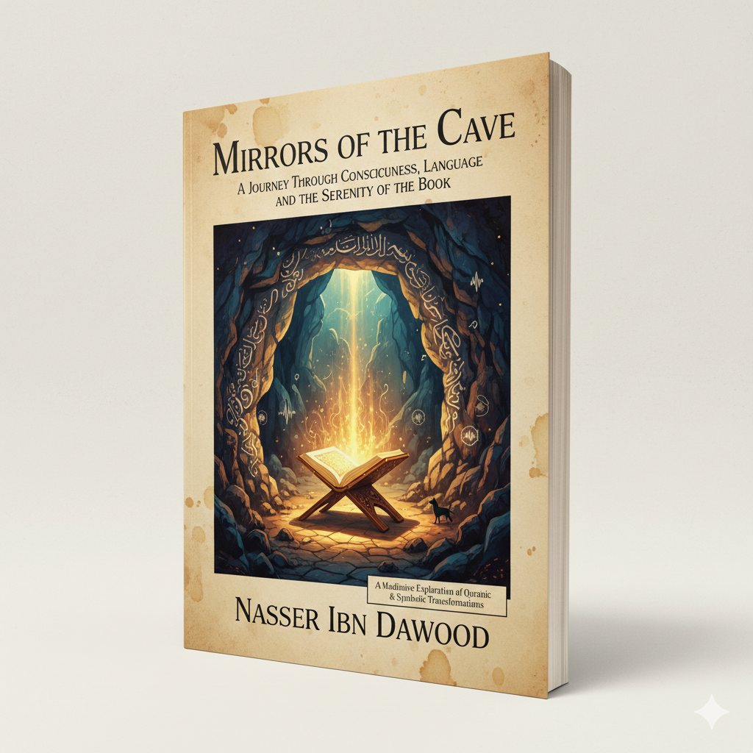
Mirrors of the Cave

A Conceptual Journey into the Soul, Language, and the Sanctuary of the Word By: Nasser Ibn Dawood

I. The Global Knowledge Manifesto
Knowledge is a universal right. The author firmly believes that wisdom should not be locked behind paywalls or language barriers.
- Global Access Policy: All books in this library are available for free in multiple digital formats (PDF, HTML, DOCX, TXT).
- The Digital Library: As of early 2026, the collection hosts 68 volumes (34 in Arabic and 34 in English), fully optimized for AI-assisted research and digital archiving.
- Official Platforms: * Main Website: nasserhabitat.github.io/nasser-books/
  - GitHub: nasserhabitat/nasser-books

II. Translator’s Note: The Bridge of Meaning
This English edition is a condensed conceptual adaptation. It is not a word-for-word translation, but rather an "extraction of essence." It presents the core philosophical framework in accessible English, omitting the exhaustive linguistic debates and classical references found in the original Arabic text.
For the academic researcher: The original Arabic version remains the primary source for comprehensive linguistic analysis, detailed exegesis (Tafsir), and the complete bibliography.

III. Chapter 1: The Cave as an Archetype of Reform
For centuries, the story of the "Seven Sleepers" has been treated as a historical miracle. However, in this work, we look at it as a Perpetual Archetype.
The Crisis of the Youth: The youths in the story represent the "Awakened Mind" in a "Decadent Society." Their flight to the cave was not an act of cowardice, but a strategic retreat to preserve their intellectual and spiritual sovereignty.
The Modern Cave: In our era of digital noise and material exhaustion, the "Cave" is no longer a hole in a mountain. It is the Internal Space we create to protect our truth. It is the "Sanctuary of the Book"—where one dives into the Divine Text to find the silence necessary to hear the voice of the Soul.

IV. Chapter 2: The Linguistic Architecture (The Secrets of Labth)
The Quranic language is a precision tool. This section explores terms that define the "Cave Experience":
- Labth (The Stay): Unlike "sleep," Labth implies a conscious or divinely suspended state of being. It suggests that time is relative. Within the "Cave of Truth," 300 years can pass as a single afternoon.
- The Turning (Taqleeb): The Divine act of turning the sleepers represents the "dynamic nature of faith." Even in stillness, the heart must be moved, or it will stagnate.
- The Dog at the Threshold: A profound symbol of "Loyal Observation." The dog, Qitmir, represents the bridge between the wild and the sacred. By simply staying at the threshold of the righteous, the humble animal shares in their eternal legacy.

V. Chapter 3: The Violence of "Rajm" (Stoning)
One of the book's most critical insights is the concept of "Symbolic Stoning."
- Physical vs. Intellectual: While the youths feared being stoned with rocks (Rajm), the Quran uses the same word for "conjecture" (Rajm bi-al-Ghayb).
- The Lesson: Society "stones" the reformers not only with physical violence but with "labels," "falsehoods," and "intellectual exclusion." To be an Inmate of the Cave is to be immune to the "verbal stones" of the ignorant.

VI. Chapter 4: The Currency of Purity
When the youths woke up, they sought the "Purest Food" (Azka Ta'aman).
- The Meta-Meaning: Wisdom is the currency of the awakened. After a period of "Retreat" (The Cave), one must not return to the world with the old tools of consumption, but with a refined taste for what is "Pure"—intellectually, spiritually, and physically.

VII. Final Reflection: Emergence
The journey ends with a call to action. We do not enter the Cave to stay there forever; we enter to be reborn. The Mirrors of the Cave invites you to find your sanctuary, protect your light, and emerge with a "currency" that can transform the marketplace of human ideas.

أيها الباحث الفاضل، سأقوم الآن باستكمال هذه الرحلة الفكرية وترجمة بقية الفصول الجوهرية بأسلوب "الترجمة المفاهيمية" المكثفة، لتكون مرجعاً فكرياً لكل قارئ غربي ينشد الحقيقة والسكينة.
إليك بقية فصول الكتاب المترجمة معنوياً (Conceptual Adaptation):

VIII. Chapter 5: The Metaphysics of Time and Numbers
In the original Arabic work, we analyzed the precise period of "300 years plus nine." For the global reader, this represents a profound intersection between Natural Law and Divine Relativity.
- Solar and Lunar Harmony: The addition of "nine" years is not a mere calculation but a bridge between two cosmic systems—Solar and Lunar. It teaches us that Divine Truth embraces all human perspectives of time.
- The Subjectivity of Experience: When the youths woke up, they asked: "How long have we stayed?" Their answer was: "A day or part of a day." This highlights that in the presence of the Divine, centuries are but a heartbeat. The lesson for the modern world is that meaning is more significant than duration.

IX. Chapter 6: The Alchemy of Loyalty (The Dog at the Threshold)
The presence of the dog in a sacred narrative is a unique spiritual archetype.
- The Sacred Ordinary: The dog represents the "biological companion" that is sanctified through loyalty. It teaches us that spiritual elevation is not reserved for the elite; even the "excluded" can reach the heights of history through steadfastness.
- The Guard of the Unseen: The dog’s posture—stretching its forelegs at the threshold—serves as a warning to those who attempt to invade the "Sacred Space" of the seekers. It is the protective force that guards the sanctuary of Truth.

X. Chapter 7: From the Cave to the Marketplace
The return of the youths to the city with their "silver coins" is a symbol of Re-engagement.
- The Currency of Transformation: They did not return with gold, but with silver—a symbol of purity and balance. They sought Azka Ta’aman (The Purest Food). This is the mission of every reformer: to return from their "spiritual retreat" (The Cave) not to dominate, but to offer the world a "purer" way of living and thinking.
- The End of Tyranny: Their emergence signaled that the old tyrant was gone, and a new era of recognition had begun. The Cave experience is the "incubation period" for every great change in human history.

XI. Final Words: The Invitation
The journey of the People of the Cave is an invitation to every seeker of truth to find their own sanctuary. Whether it is in the verses of a Holy Book, the depths of a library, or the silence of one's own heart, the "Cave" is where we go to be made whole.
May you find your "Cave," guard your "Truth," and emerge with the "Purest Food" for humanity.

[End of the English Conceptual Edition]

From the Shadows of History to the Light of Insight: A Modern Journey into the Surah of the Cave
The Nasser Ibn Dawood Digital Library is proud to announce the release of a groundbreaking conceptual study:
"Mirrors of the Cave: A Journey through Consciousness, Language, and the Serenity of the Book"
A Meditative Exploration of Quranic Linguistics and Symbolic Transformations

About the Book:
Is the story of the People of the Cave merely an ancient miracle frozen in time, or is it a living psychological and intellectual roadmap for the modern human?
In this work, researcher Nasser Ibn Dawood dives deep into the precision of Quranic Arabic, using linguistic analysis and symbolic archetypes to offer a profound understanding that transcends the literal surface. This book is a bridge for both Eastern and Western readers seeking the "Sanctuary of the Word" in an age of material chaos.

Key Explorations:
- The Cave as Intellectual Sanctuary: How the "Book" (The Quran) acts as a safe harbor protecting the seeker’s mind from modern distractions.
- The Secrets of Linguistics: Why does the Quran use the term Labth (staying) instead of sleep? Discover the hidden meanings behind "Turning," "Stoning," and the "Inscription."
- The Alchemy of Loyalty: A philosophical study of the dog at the threshold—a symbol of steadfast companionship and divine grace.
- The Geometry of Time: Deciphering the "300 plus nine" years through the lens of solar-lunar harmony and the relativity of time.
Why Read This Work?
- A Fresh Paradigm: It balances the respect of traditional exegesis with the boldness of contemporary symbolic interpretation.
- Global Vision: Part of a massive project to digitize and share Islamic thought with the world, bridging the gap between faith and reason.
- Conceptually Accessible: Written to resonate with the modern seeker, philosopher, and researcher alike.

[Global Access Policy]
In our belief that knowledge is a universal right, this volume is available for free in multiple digital formats:
- Formats: (PDF, HTML, DOCX, TXT)
- Official Website: nasserhabitat.github.io/nasser-books/
- GitHub Repository: nasserhabitat/nasser-books

"Entering the Cave is not an act of hiding; it is an act of becoming. This book invites you to leave the 'Cave of Doubt' and enter the 'Inscription of Certainty.'"
Connect with the Author:
[nasserhabitat@gmail.com]

