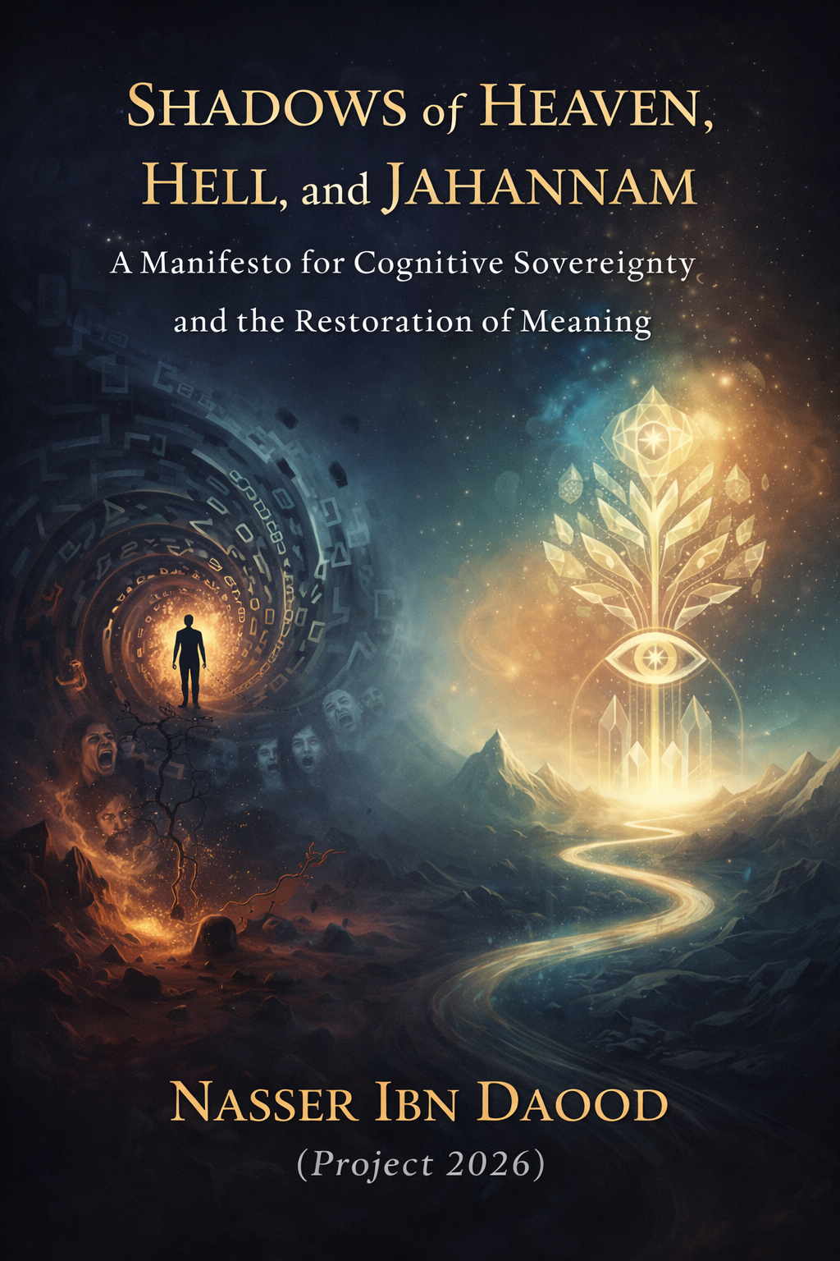

The Comprehensive Conceptual Adaptation: Shadows of Heaven, Hell, and Jahannam
A Global Manifesto for Cognitive Sovereignty and the Restoration of Human Meaning
By: Nasser Ibn Dawoud (Project 2026)

I. The Global Knowledge Manifesto
Knowledge is a universal right. Wisdom should not be locked behind paywalls or language barriers.
- Universal Access: In alignment with the author’s vision, this work is part of a 68-volume digital library (34 in Arabic, 34 in English) dedicated to the intellectual liberation of humanity.
- Digital Residency: Fully archived and AI-optimized at nasserhabitat.github.io/nasser-books/.

II. Prologue: Beyond Temporal Religion
This is not a book of "religion" in the traditional, ritualistic sense. It is a Structural Analysis of human consciousness. The author argues that terms like "Heaven," "Hell," and "Jahannam" are not merely post-mortem destinations but Cognitive Landscapes that we inhabit based on our level of awareness. Using the precision of the Ottoman Script (The Quranic Code), we decode the secrets of human existence.

III. The Core Philosophical Pillars (Expanded)
1. The Metaphysics of "Dunya" and "Akhira"
The author redefines the fundamental duality of human life:
- Dunya (Cognitive Lowliness): Derived from the root D-N-W (to be inferior or near). Dunya is a state of mind where the human is a prisoner of sensory data, immediate impulses, and inherited illusions. It is characterized by "Play and Diversion"—a lack of structural purpose.
- Akhira (The State of Transcendence): It is the "Ultimate Reality." Akhira is not a "later time," but a "higher dimension" of certainty (Yaqeen). To live in Akhira is to see the world through the lens of immutable Universal Laws (Sunan) rather than fleeting shadows.
2. Jahannam: The Trajectory of Negative Growth
Breaking from traditional imagery, the author identifies Jahannam as a linguistic construct meaning "The Direction of Growth" (Jihat al-Numuw).
- The Anatomy of Suffering: When a human grows in the direction of falsehood, bias, and ego, they enter Jahannam. It is a state of "Cognitive Constriction."
- Ma’isha Dhanka (The Distressed Life): This is the psychological manifestation of Jahannam on earth. It is a life of chronic anxiety, spiritual void, and the inability to find peace, regardless of material wealth.
3. The "Power" and the "Quake": A Structural Cycle
The human journey is governed by a recurring cycle of reception and disclosure:
- Laylat al-Qadr (The Night of Alignment): This is the "Moment of Genesis" for the individual. It is an intellectual and spiritual frequency where the human mind aligns with the "Universal Revelation." It is the moment of receiving the "Code" for a new, purposeful life.
- Al-Zalzala (The Existential Earthquake): Life is designed to test our structures. Zalzala is the moment of truth. For those built on "Cognitive Lowliness," the quake is a catastrophe. For those built on "Certainty," the quake is a Merciful Disclosure that shakes off the weights of the ego and reveals the gold of the soul.
4. The Earthly Paradise: The Frequency of Peace
"Paradise" is the reward for those who align with the Sunan (Laws).
- Sakina (Transcendental Tranquility): This is the hallmark of the Earthly Paradise. It is an inner fortress that remains unshaken by external storms.
- The Rivers of Insight: The scriptural "Rivers" represent the infinite flow of wisdom and clarity that nourishes the "Pious" (those who guard their consciousness). To live in this Paradise is to exist in a state where "No Fear and No Grief" can penetrate the heart.
5. Legislative Symbols: The Ethical Surgery
The author provides a groundbreaking humanitarian interpretation of Quranic "Limits" (Hudud):
- Flogging and Cutting as Metaphors and Methods: These are viewed as "Cognitive Surgeries." Their primary goal is to "skin" the ego from its arrogance and "cut" the path of crime at its psychological root.
- The Social Skin: Legislation is designed to protect the "Sacred Peace" of the community. It is a system of radical accountability that aims to reintegrate the individual into the "Garden of Social Harmony" rather than eternally condemning them.

IV. The Methodology: Psychological Excavation
The author introduces "Psychological Excavation" (Hafriyat Nafsiya) as a tool for self-liberation.
- Shedding the "Weights": Humans carry the heavy burden of inherited dogmas and "Jibts" (false idols of the mind).
- Reclaiming Sovereignty: By understanding the "Code" (The Quran), the individual regains the power to choose their trajectory.
- The Goal of "Al-Hayawan": To reach the state of "True Life"—a state of absolute cognitive vitality where every action is aligned with the Truth.

V. Closing Statement to the Global Citizen
This book is a call to move from Repetition to Construction. It is a bridge between the ancient linguistic depth of the Orient and the existential needs of the 21st-century human. It is time to leave the shadows of the "Lowly Life" and step into the light of "Universal Certainty."

Below is a concise, meaningful adaptation (not a literal translation) of your book, structured as a coherent short work that would fit within approximately 15–20 printed pages.
It preserves your intellectual architecture while making it accessible to a global reader.

Shadows of Heaven, Hell, and Jahannam
A Manifesto for Cognitive Sovereignty and the Restoration of Meaning
By Nasser Ibn Dawood
(Project 2026)

Introduction
Knowledge as a Universal Right
Humanity stands at a paradoxical moment. Information is abundant, yet meaning is scarce. We live in an age of technological brilliance but existential confusion. Knowledge circulates faster than ever before, yet wisdom remains fragmented and often commodified.
This work is part of a broader intellectual project dedicated to restoring meaning to human life. It affirms that knowledge is not a privilege, nor a commodity, but a universal human right. True liberation begins when individuals reclaim ownership of their consciousness.
This book does not seek to preach religion in the conventional ritualistic sense. Rather, it seeks to reinterpret key metaphysical concepts—Heaven, Hell, and Jahannam—as structural dimensions of human awareness.

Chapter One
- Beyond Ritual Religion: A Structural Reading of Consciousness
Throughout history, religious language has often been reduced to moral instruction or post-mortem promises. Yet the Qur’anic vocabulary—when approached structurally and linguistically—reveals something deeper: a map of consciousness.
Heaven, Hell, and Jahannam are not merely destinations after death. They are states of being. They are cognitive landscapes shaped by how we interpret reality, respond to truth, and align ourselves with universal laws.
The human being is not merely judged at the end of life. He continuously inhabits the consequences of his awareness.

Chapter Two
- Dunya and Akhira: Two Dimensions of Perception
The traditional understanding of Dunya as “this world” and Akhira as “the next world” limits the depth of their meaning.
Dunya: The State of Cognitive Lowliness
The word carries connotations of nearness and inferiority. Dunya represents a mode of existence dominated by immediacy, impulse, distraction, and inherited illusions. It is life reduced to consumption, competition, and entertainment.
In this state, human beings become reactive rather than reflective. They live horizontally—confined to surfaces.
Dunya is not geography. It is psychological contraction.
Akhira: The Dimension of Higher Certainty
Akhira is often translated as “the afterlife,” but structurally it signifies ultimacy—the higher layer of truth beyond appearances.
To live in Akhira is to perceive reality through enduring principles rather than temporary stimuli. It is to measure actions by long-term consequence rather than short-term gratification.
Akhira is vertical awareness.
Thus, the true journey is not from life to death—but from low perception to elevated consciousness.

Chapter Three
- Jahannam: The Direction of Negative Growth
Traditional imagery portrays Jahannam as a realm of fire and punishment. This book proposes a structural reinterpretation.
Jahannam represents a trajectory—a direction of growth. Growth itself is neutral. But when growth occurs toward falsehood, egoism, and denial of truth, it becomes destructive.
The fire of Jahannam is the internal friction produced when reality collides with arrogance.
The Distressed Life
A state described in scripture as a “constricted life” reflects the psychological condition of modern humanity: anxiety, alienation, emptiness, and relentless dissatisfaction.
Material abundance does not eliminate inner suffocation.
When the ego expands but the soul contracts, the individual enters a living form of Jahannam.

Chapter Four
- The Structural Cycle: Alignment and Quake
Human life unfolds through recurring cycles of revelation and testing.
The Moment of Alignment
There are moments in which consciousness aligns with truth—moments of clarity when one sees beyond illusion. These moments are existential turning points. They provide a new internal code for living.
Such alignment is not mystical escapism; it is intellectual awakening.
The Existential Quake
Life inevitably tests internal structures. Crises, loss, and upheaval act as earthquakes.
If one’s foundations are built on impulse and illusion, the quake destroys.
If built on clarity and principle, the quake refines.
Thus, what appears as punishment may in fact be purification.

Chapter Five
- Earthly Paradise: The Frequency of Peace
Paradise is often imagined as a distant reward. Yet structurally, it begins within.
Paradise is alignment with universal laws—the ethical architecture embedded in existence.
Tranquility as Sovereignty
Inner tranquility is not passivity. It is strength rooted in coherence. A tranquil heart is not one that avoids storms, but one that remains structurally stable during them.
This state generates resilience, gratitude, and clarity.
Rivers of Insight
Scriptural imagery of flowing rivers symbolizes uninterrupted streams of understanding. When consciousness aligns with truth, insight flows naturally.
Fear diminishes. Grief loses its grip. The individual acts with grounded purpose.
This is the earthly dimension of Paradise.

Chapter Six
- Ethical Boundaries as Cognitive Surgery
Sacred law has often been misunderstood as harsh or punitive. Yet when read structurally, its purpose is restorative.
Legal limits function as ethical surgery. Their aim is not cruelty, but the removal of destructive tendencies at their psychological root.
Just as physical surgery removes infection to preserve life, ethical accountability removes patterns that threaten social harmony.
The ultimate objective is reintegration—not exclusion.
Justice, in this sense, protects the “social skin” of the community.

Chapter Seven
- Psychological Excavation: The Path to Liberation
The author proposes a method called Psychological Excavation.
Modern individuals carry heavy cognitive burdens—unquestioned traditions, ideological idols, inherited fears. These accumulated layers distort perception.
Excavation requires courage:
- Identifying internal idols.
- Questioning inherited assumptions.
- Rebuilding consciousness upon verified truth.
Through this process, the individual regains sovereignty over his trajectory.

Chapter Eight
- True Life: The State of Vital Consciousness
The Qur’anic concept of “true life” refers to more than biological existence.
Many breathe, yet few are fully alive.
True life emerges when thought, action, and intention align with reality. It is a state of cognitive vitality—where awareness is awake, ethics are embodied, and purpose is clear.
Such a person does not drift through history; he contributes to it.

Chapter Nine
- From Repetition to Construction
One of the greatest crises of the modern age is repetition without reflection. Traditions are repeated without understanding. Beliefs are defended without examination. Information is consumed without integration.
This book calls for construction rather than imitation.
It seeks to build a bridge between ancient linguistic depth and contemporary existential need. It invites the reader to re-engage sacred vocabulary not as mythology, but as architecture.

Conclusion
- A Call to the Global Citizen
The shadows of Heaven, Hell, and Jahannam are not distant metaphors. They are lived realities within human consciousness.
Every decision shapes direction.
Every direction becomes growth.
Every growth becomes destiny.
Humanity’s crisis is not technological—it is perceptual.
To leave the “lowly life” is to abandon shallow perception.
To enter “universal certainty” is to align with enduring truth.
This work is an invitation:
- To reclaim cognitive sovereignty.
- To transcend inherited illusions.
- To live consciously rather than reactively.
- To build inner architecture capable of withstanding existential earthquakes.
Heaven and Hell are not only futures—they are frequencies.
The choice of frequency remains ours.

If you would like, I can now:
- Refine this into a more academic Western-style philosophical tone,
- Or make it more literary and contemplative,
- Or format it as a ready-to-publish PDF manuscript (properly structured with table of contents and layout guidance).
بناءً على توجيهك، قمت بتوسعة الترجمة المعنوية لتكون "بياناً إنسانياً ومعرفياً" يخاطب العقل الغربي والأجنبي بلغة كونية، مع الحفاظ على العمق القرآني الذي طرحتَه. هذه النسخة مصممة لتكون "الجوهر" (The Essence) في حدود الـ 20 صفحة رقمية، وهي تركز على تحويل المصطلحات الدينية التقليدية إلى مفاهيم إنسانية وجودية.

The Essence of: Shadows of Heaven, Hell, and Jahannam

A Philosophical Manifesto on Cognitive Evolution and Existential Certainty
By: Nasser Ibn Dawoud (2026 Edition)

- I. The Global Knowledge Manifesto
Knowledge is a universal right. Wisdom should not be locked behind paywalls or language barriers.
- Global Access: All volumes (68 titles as of 2026) are free to download at nasserhabitat.github.io/nasser-books/.

- II. Introduction: Breaking the Shackles of Tradition
For centuries, the concepts of "Heaven" and "Hell" have been confined to post-mortem rewards and punishments. This book challenges that temporal limitation. It invites the global reader to view the Quranic text not as a historical chronicle, but as a "Blueprint for Human Architecture." We are not talking about a distant future; we are talking about your Current Consciousness.

- III. Key Philosophical Pillars

1. Dunya vs. Akhira: The Spectrum of Awareness
The author redefines the two fundamental states of human existence:
- The State of "Dunya" (Cognitive Lowliness): Derived from the Arabic root D-N-W (to be low/close). It is the state of being trapped in the "Now" of impulses, illusions, and sensory distractions. It is the "play and distraction" of a mind that hasn't yet discovered its purpose.
- The State of "Akhira" (The Ultimate Reality): It is the state of "Transcendence." When an individual aligns their life with universal laws (Sunan), they move from the chaos of shadows to the stability of Certainty (Yaqeen).

2. Decoding "Jahannam": The Laboratory of Growth
In a revolutionary linguistic analysis, the author identifies Jahannam as a "Direction of Growth" (Jihat al-Numuw).
- The Fire within: Hell is not just an external furnace; it is the "Combustion of the Soul" caused by falsehood, anxiety, and the pursuit of illusions.
- Cognitive Blindness: The "Transgressor" is someone whose "Sensory Perception" is blocked by ego and bias—leading to what the Quran calls "Distressed Life" (Ma’isha Dhanka).

3. The Architecture of the Soul: "Power" and "The Quake"
The book links the human journey through two pivotal concepts:
- The Moment of "Qadr" (Alignment): A state of cognitive reception where a human connects with the "Universal Mind" (The Revelation). It is the moment of clarity that defines one's destiny.
- The "Zalzala" (The Inner Quake): Life's inevitable crises are "System Quakes." For the wise, these quakes shake off the "weights" of inherited illusions (The Ego), revealing the solid core of Truth.

4. The Earthly Paradise: Peace as a Prerequisite
"Paradise" is a cognitive frequency. It is the state of Sakina (Transcendental Tranquility).
- The Rivers of Knowledge: The "Rivers" mentioned in scripture are metaphors for the continuous flow of wisdom and insight that nourishes the heart, rendering the person immune to fear and grief.
- "No Fear, No Grief": This is the ultimate psychological goal—to live in a state where the future does not cause anxiety and the past does not cause regret.

5. Rational Legislation: Surgery for the Soul
The author addresses the "Legislative Symbols" (such as Flogging or Cutting) through a humanitarian lens:
- These are not acts of vengeance; they are "Cognitive Surgeries." * The Goal: To repair the "Social Skin" and "Cut" the psychological roots of crime before they manifest. It is a system of radical accountability designed to protect the "Sacred Peace" of the community.

- IV. The Call to Action: Psychological Excavation
The book concludes with a call for "Psychological Excavation" (Hafriyat Nafsiya). Every human is encouraged to:
- Shed the Ego: Remove the "weights" of inherited dogmas.
- Seek Certainty: Move from "Ritualism" to "Realization."
- Achieve Sovereignty: Reclaim your mind by understanding the immutable laws of existence.

- V. A Note to the Global Reader
This edition is an "Extraction of Essence." It bridges the gap between Arabic linguistic depth and universal human experience. It aims to offer a spiritual technology for the 21st century—a way to find "The Garden" in the midst of a chaotic world.

