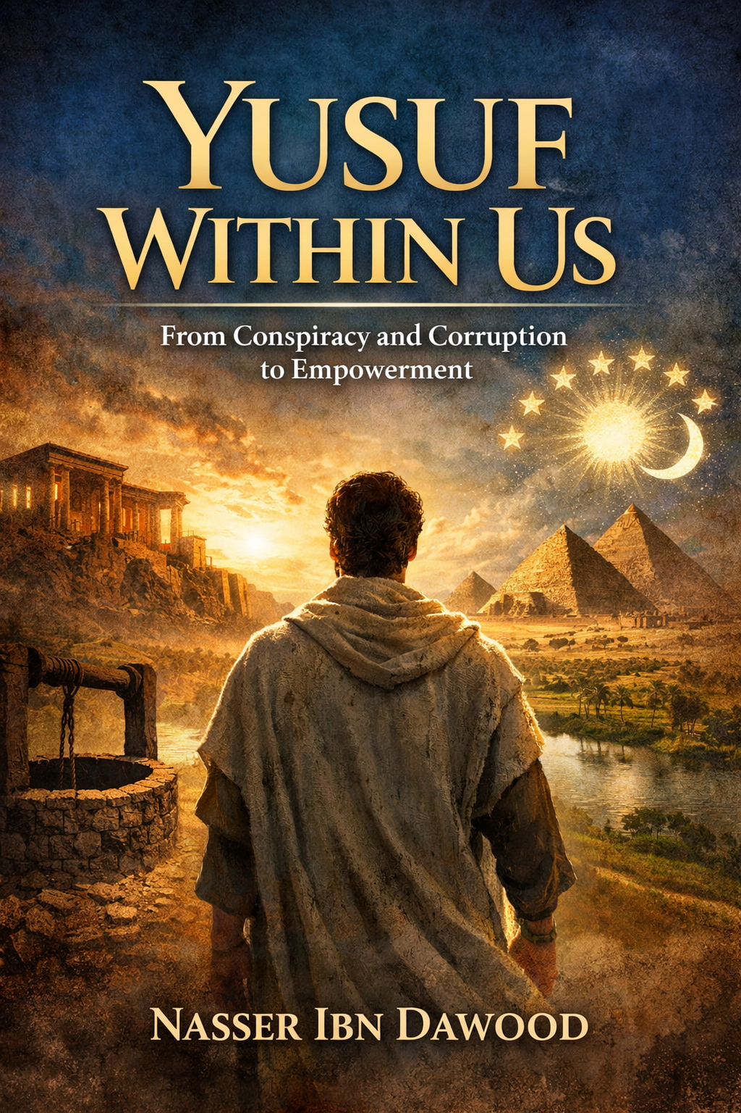
YUSUF WITHIN US
- From Conspiracy and Corruption to Empowerment
A Contemporary Quranic Framework of Consciousness

Translator’s Note: The Bridge of Meaning
This English edition is a condensed conceptual adaptation. It is not a word-for-word translation, but rather an “extraction of essence.” It presents the core philosophical framework in accessible English, omitting the exhaustive linguistic debates and classical references found in the original Arabic text.
For the academic researcher: The original Arabic version remains the primary source for comprehensive linguistic analysis, detailed exegesis (Tafsir), and the complete bibliography.

Introduction: Yusuf Is Not Behind Us — He Is Within Us
The Qur’anic story of Prophet Joseph (Yusuf) is often read as a moral narrative about patience and chastity. Yet this work proposes something deeper:
Surah Yusuf is a complete model of human consciousness under pressure.
Joseph is not merely a historical prophet. He represents:
- The pure core of the human self.
- The awakened conscience.
- The visionary intellect.
- The ethical reformer inside corrupt systems.
The central thesis of this book is simple yet transformative:
Yusuf is the highest possibility within every human being.
His journey—from the well to political authority—mirrors the journey of inner transformation in individuals and societies.

Chapter 1

From Personal Drama to Structural Conflict
Traditional readings often focus on two dramatic moments:
- The seduction episode.
- The emotional reunion with his father.
But Surah Yusuf repeatedly emphasizes something else:
Conspiracy (kayid).
The word “plot” or “scheme” appears multiple times in the chapter. This repetition is not accidental. It signals that the story is not primarily about romance or family sentiment—it is about:
- Internal envy
- Institutional corruption
- Abuse of authority
- Moral resistance
- Strategic patience
Joseph’s imprisonment was not due to moral ambiguity. The Qur’an explicitly states that the authorities saw the evidence of his innocence yet imprisoned him anyway.
This reveals a structural truth:
Systems of corruption do not silence the guilty—they silence the righteous who expose them.

Chapter 2

The Five Stages of Consciousness in Surah Yusuf
The narrative unfolds in five developmental stages:
1. The Vision (Receiving Meaning)
Joseph’s dream symbolizes the moment of awakening—the “night of destiny” in one’s life when meaning descends.
Every individual has such a moment:
- A calling
- A vision
- A realization
This is the stage of inner reception.

2. The Well (Suppression of Potential)
Joseph is thrown into the well by his brothers.
The well symbolizes:
- Social rejection
- Suppression of talent
- Jealousy from close circles
- Early trauma
This is the phase where society attempts to bury your light.
Yet the well is not the end. It is the beginning of refinement.

3. The Palace and the Trial (Moral Confrontation)
Joseph enters the house of power.
The so-called “seduction story” is not merely a sexual temptation narrative. It represents:
- The pressure to compromise ethics within powerful systems.
- The invitation to gain through moral surrender.
- The psychological climate that tests integrity.
Joseph refuses not out of fear—but out of clarity.
He sees a higher truth.

4. Prison (Strategic Isolation)
Joseph chooses prison over compromise.
Prison symbolizes:
- Isolation for principles.
- Temporary marginalization.
- Intellectual incubation.
In prison, Joseph does not collapse.
He:
- Interprets dreams.
- Builds trust.
- Expands knowledge.
The place of confinement becomes a laboratory of growth.

5. Empowerment (Responsible Authority)
When Joseph finally rises to power, he does not seek revenge.
He:
- Manages economic crisis.
- Distributes resources ethically.
- Forgives his brothers.
- Restores family unity.
Empowerment in this framework is not domination.
It is stewardship.

Chapter 3

The Inner Psychology of Yusuf
Surah Yusuf is also a map of internal struggle.
The Brothers
They represent:
- Envy
- Insecurity
- Fear of losing relevance
These are not external enemies only—they are internal voices.

The Wolf
When the brothers fabricate the story of a wolf attack, the wolf becomes a symbol of:
- False justification
- Manufactured narratives
- Moral excuses
Every society creates symbolic “wolves” to hide wrongdoing.

The Seduction
This episode represents the “lower self” (the ego driven by desire and power).
Joseph’s refusal demonstrates:
Integrity is not suppression of desire—it is alignment with higher consciousness.

The Shirt
Joseph’s shirt appears three times in the story:
- As false evidence of death.
- As evidence of innocence.
- As a sign of healing.
The shirt symbolizes narrative.
Truth can be distorted.
Truth can be clarified.
Truth can restore vision.

Chapter 4

Corruption as Structural Disorder
This work argues that Surah Yusuf addresses systemic corruption.
The crisis in Egypt was not merely famine—it was mismanagement.
Joseph’s economic policy:
- Store during abundance.
- Distribute during scarcity.
- Centralize grain ethically.
- Plan long-term.
This is crisis management rooted in foresight.
The story teaches that:
- Moral clarity precedes economic reform.
- Governance requires inner integrity.
- Authority without ethics leads to collapse.

Chapter 5

“From Fall to Ascent”
Joseph’s journey is a pattern:
Reception → Construction → Deviation or Integrity → Crisis → Revelation
This cycle operates at:
- Individual level.
- Institutional level.
- Civilizational level.
Crisis is not punishment.
Crisis is exposure.
When famine strikes Egypt, hidden structures are revealed.
Likewise, personal crises reveal:
- Our true loyalties.
- Our inner architecture.
- Our moral foundations.

Chapter 6

The Concept of “Jahannam” as Direction of Growth
This work proposes a philosophical reading:
Paradise and Hell are not only future destinations.
They are trajectories of growth.
When envy grows unchecked, it becomes inner fire.
When corruption spreads, society burns from within.
Hell begins as psychological suffocation before metaphysical consequence.
Joseph, even in prison, lives in inner paradise.
His brothers, free and powerful, live in silent anxiety.

Chapter 7

The Role of Vision (Dreams)
Dreams in Surah Yusuf are not superstition.
They represent:
- Pattern recognition.
- Symbolic cognition.
- Strategic forecasting.
Joseph’s ability to interpret dreams shows intellectual depth.
He connects symbols to systemic outcomes.
In modern terms:
Joseph practices cognitive modeling.
He anticipates economic cycles through symbolic insight.

Chapter 8

Empowerment Without Arrogance
When Joseph says:
“There is no blame upon you today.”
He demonstrates the final stage of consciousness:
Forgiveness.
Revenge would have been easy.
Justice alone would have been sufficient.
But mercy rebuilds civilizations.
True empowerment is measured by:
- Capacity to forgive.
- Ability to reform without humiliation.
- Leadership without ego inflation.

Chapter 9

Yusuf as a Universal Archetype
Joseph’s model applies globally:
- The whistleblower inside a corrupt institution.
- The reformer silenced temporarily.
- The ethical economist.
- The visionary leader.
- The moral strategist.
His story transcends religion and geography.
It is a human manual for:
- Integrity under pressure.
- Patience under injustice.
- Leadership after crisis.

Chapter 10

Toward a Conscious Civilization
The ultimate goal of this framework is not individual spirituality alone.
It is civilizational reform.
A society that internalizes “Yusuf consciousness” would:
- Value long-term planning.
- Resist corruption.
- Honor intellectual honesty.
- Cultivate patient leadership.
- Promote ethical economics.
Joseph does not escape society.
He transforms it.

Conclusion

From the Well to the Throne Within
The well is isolation.
The prison is formation.
The throne is responsibility.
Every human being moves through these stages.
The question is not:
Will we face conspiracy?
The question is:
Will we remain Yusuf when we do?
Yusuf within us is:
- The conscience that refuses compromise.
- The intellect that sees patterns.
- The heart that forgives.
- The leader that serves.
The Qur’anic narrative becomes alive when it moves from page to psychology.
This book invites the reader not to admire Joseph—
—but to become him.

I. The Global Knowledge Manifesto
Knowledge is a universal right. The author firmly believes that wisdom should not be locked behind paywalls or language barriers.
• Global Access Policy: All books in this library are available for free in multiple digital formats (PDF, HTML, DOCX, TXT).
• The Digital Library: As of early 2026, the collection hosts 68 volumes (34 in Arabic and 34 in English), fully optimized for AI-assisted research and digital archiving.
• Official Platforms:
Main Website: nasserhabitat.github.io/nasser-books/
GitHub: nasserhabitat/nasser-books

Final Reflection
This adaptation presents Surah Yusuf not as ancient storytelling, but as a structural map of human development.
It offers:
- A psychology of integrity.
- A theory of systemic corruption.
- A model of crisis leadership.
- A philosophy of empowerment through patience.
Joseph’s journey is not nostalgic memory.
It is a living blueprint.
And perhaps the most radical idea of all:
The Qur’an is not merely to be recited—
It is to be activated within consciousness.

If you would like, I can next:
- Format this into a print-ready PDF structure.
- Expand specific chapters for academic publication.
- Add citations for a peer-reviewed version.
- Or prepare a shorter 10-page executive summary for global readers.
Just tell me your strategic target audience.

