The Architecture of Breath & Consciousness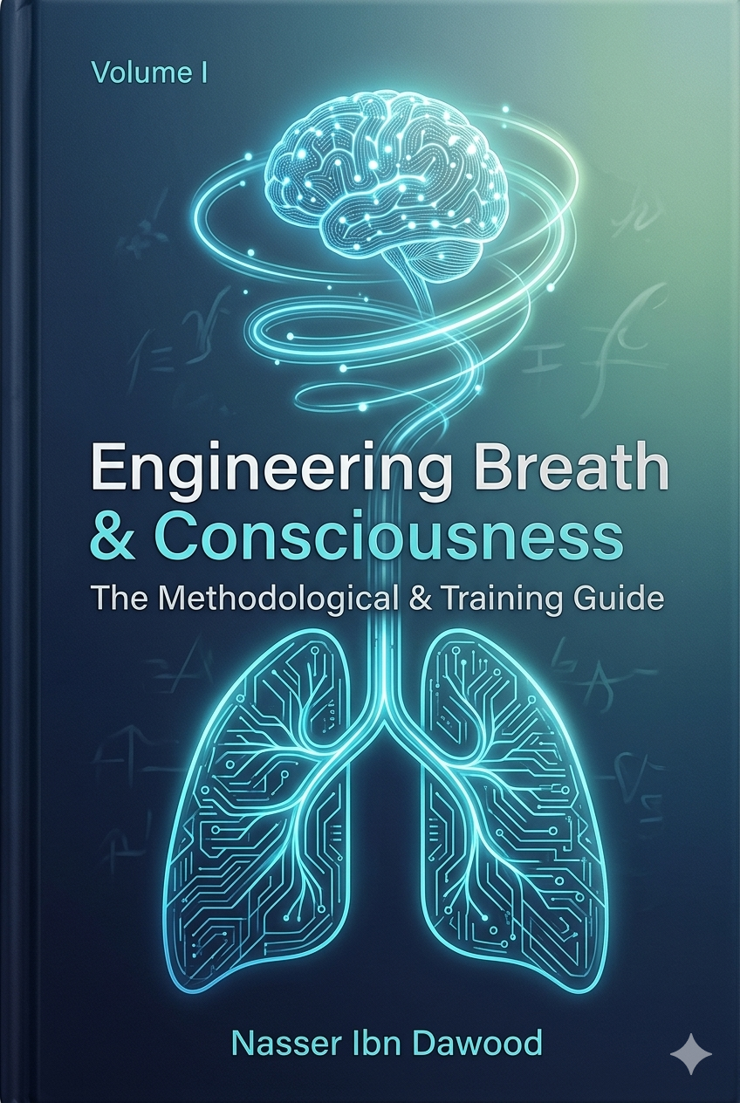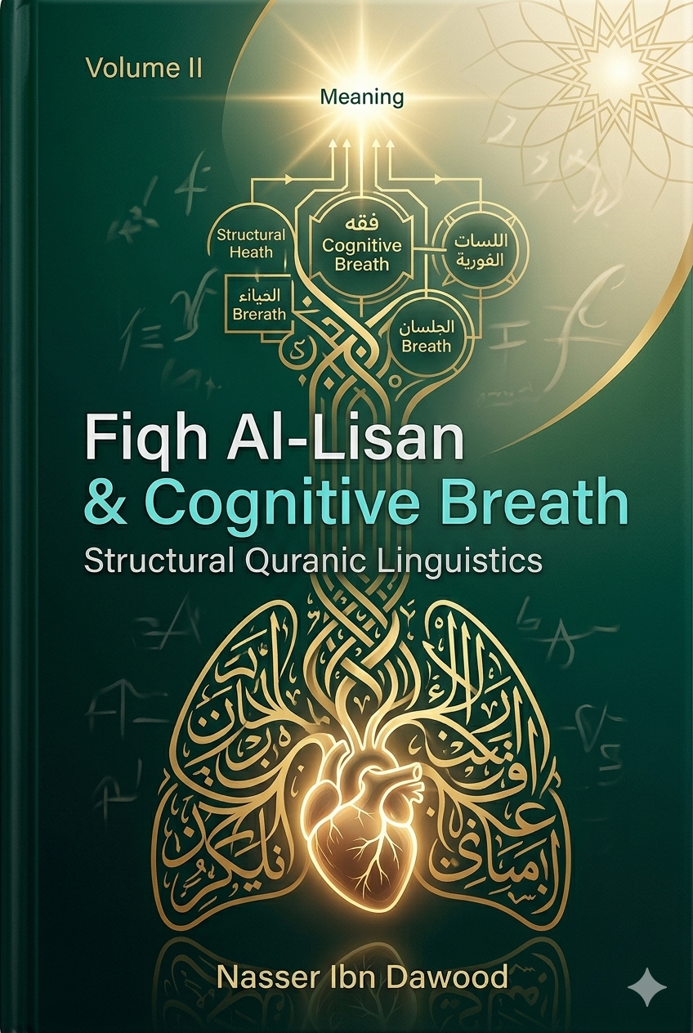
A Structural Approach to Human Perception & Quranic Linguistics
By: Nasser Ibn Dawood

I. The Global Knowledge Manifesto (Open Access Policy)
Knowledge is a universal right. The author firmly believes that wisdom should not be locked behind paywalls or language barriers.
- Global Access Policy: All books in this library are available for free in multiple digital formats (PDF, HTML, DOCX, TXT) to ensure maximum accessibility for researchers worldwide.
- The Digital Library: As of early 2026, the collection hosts 68 volumes (34 in Arabic and 34 in English), fully optimized for AI-assisted research and digital archiving.
- Official Platforms: * Main Website: nasserhabitat.github.io/nasser-books/
  - GitHub Repository: nasserhabitat/nasser-books

II. Translator's Note: The Bridge of Meaning
This English edition is a condensed conceptual adaptation. It is not a word-for-word translation, but rather an "extraction of essence." It presents the core philosophical framework in accessible English, omitting the exhaustive linguistic debates and classical references found in the original Arabic text.
For the academic researcher: The original Arabic version remains the primary source for comprehensive linguistic analysis, detailed exegesis (Tafsir), and the complete bibliography.

III. Executive Summary: The Two-Volume Framework
Volume I: Engineering the Biological Foundation of Awareness
Focus: Methodological & Training Guide
This volume identifies that the root of human anxiety and cognitive dissonance is not a lack of facts, but a dysfunction in the Internal Reception Mechanism. It redefines breathing not as a gas exchange, but as the Primary Regulatory Interface between the Nervous System and the Conscious Mind.
- Scientific Integration: Utilizing Polyvagal Theory to stabilize the Autonomic Nervous System.
- The Goal: Transitioning from "Reactive Living" to "Proactive Awareness" through precise, functional breathing protocols.
Volume II: The Jurisprudence of Breath in Quranic Linguistics
Focus: From Biological Structure to the Engineering of Meaning
Moving from the "Hardware" (Body) to the "Software" (Meaning), this volume introduces Fiqh Al-Lisan (Structural Linguistics). It derives a Quad-Structure of Cognitive Metabolism :
- Eating (Input): The conscious selection of meanings.
- Drinking (Absorption): The internal transformation of information into identity.
- Breathing (Rhythm): The governor of interaction frequency.
- Prayer (Regulation): A systemic pause for cognitive discharge and realignment.

IV. A Civilizational Framework & Methodology
This project represents a "Digital Renaissance" of foundational wisdom. By fixing the Receiver (The Human) in Volume I and decoding the Message (The Meaning) in Volume II, the author provides a scalable methodology for Consciousness Engineering —empowering individuals to reclaim their cognitive autonomy in a fragmented world.

Second: English Translation Call
Global Call for Translators & Scholars: The Consciousness Engineering Project
Author: Nasser Ibn Dawood
The author invites translators, linguistic researchers, and cultural institutions to participate in the global dissemination of this two-volume foundational work:
- Volume I: Engineering Breath & Consciousness (69 Pages): A methodological and practical guide bridging the gap between neurobiology and human perception.
- Volume II: The Jurisprudence of Breath in Quranic Linguistics (130 Pages): A structural linguistic framework for "The Engineering of Meaning."
Open Distribution & Publishing Rights: In alignment with the Global Knowledge Manifesto , the author declares that all publishing and distribution rights are fully open and free . We welcome any effort to translate, print, or digitally distribute these works. Our primary goal is the unhindered flow of transformative knowledge to all humanity.
Translator Support: The volumes are available in AI-optimized digital formats (DOCX, HTML, JSON) to assist translators in maintaining structural consistency and conceptual accuracy across different languages.
Access the Manuscripts: [https://nasserhabitat.github.io/nasser-books/]

