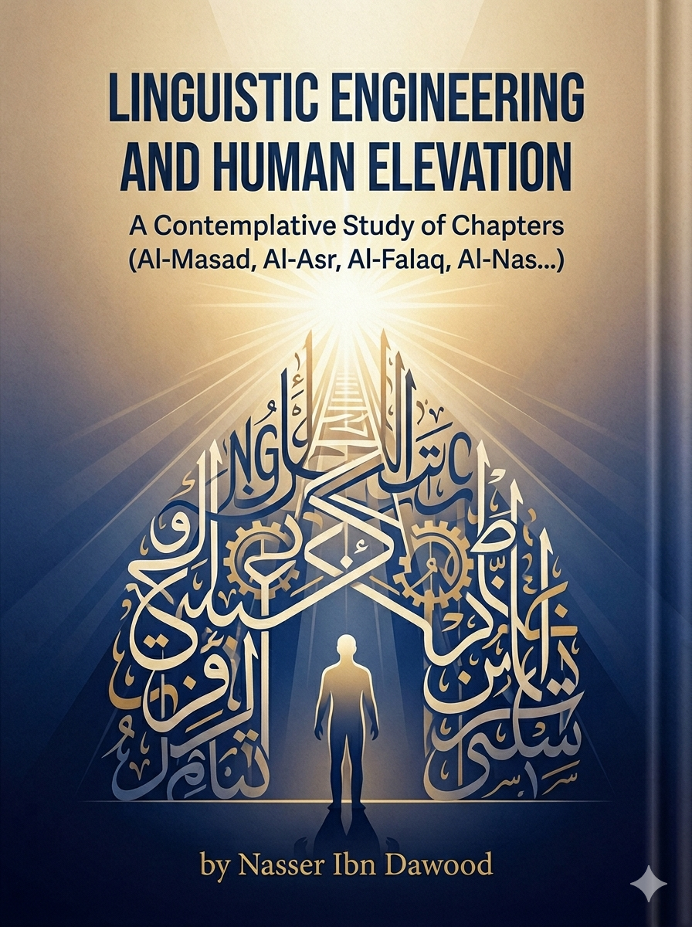

Linguistic Engineering and Human Elevation: A Strategic Concept for Self-Development
(A Summary for the Global Reader)

1. Introduction: From Matter to Meaning
This work introduces a groundbreaking methodology called "Linguistic Engineering." Moving beyond traditional grammar and historical interpretations, the author—drawing from a background in civil engineering and metallurgy—treats the Quranic Arabic language as a precise, universal system. The core premise is that Arabic letters are not mere sounds but "kinetic energies" and "behavioral codes" that shape human consciousness and the laws of existence.

2. The Core Methodology: The "Mathani" System
The book challenges the traditional reliance on the "tri-literal root" of words. Instead, it proposes the system of "Mathani" (Letter Pairs) as the fundamental building blocks of meaning. By deconstructing words into these pairs, we uncover a hidden structural layer that explains how language directly influences human behavior and psychological states.

3. Practical Applications: Deciphering the Soul
The author applies this "Linguistic Laboratory" to several short chapters (Surahs) of the Quran, transforming them into behavioral laws:
- Surah Al-Masad (The Law of Self-Destruction): Analyzes how misaligned decisions ("The Woman/Orders") and the accumulation of trivial, negative thoughts ("Firewood") lead to psychological strangulation ("The Palm-Fiber Rope").
- Surah Al-Asr (The Law of Pressure and Essence): Explores how struggle ("Al-Asr") is necessary to extract the human essence, preventing the fragmentation of the self ("Loss").
- Surah Al-Nas (The Engineering of Stability): Defines "An-Nas" not just as people, but as a state of "oscillation" and instability. True stability is found by returning to the "Fixed Center" (The Creator).

4. The Ultimate Goal: The "Kawthari" Human
The project aims at the "Elevation of the Human Being." By understanding the "Engineering of the Tongue," individuals can transition from a state of confusion and "oscillation" to a state of "Samadiyya"—absolute psychological firmness and alignment with divine truth.

- [The Requested Closing Statement]
"Here, the journey of the letter ends to begin the journey of the soul. We have wandered through the kingdom of the tongue, only to find that the Holy Quran did not leave the human soul a prey to disturbance and loss. Whoever seeks refuge in (the God of people) has declared their disconnection from (the amusement of people), and has chosen to replace their (oscillation) and fluctuation with stillness and centering around the absolute truth. The path of uprightness begins with the (dawn) of awareness that splits the darkness of illusions, and passes through the (Kawthar) of the Quranic methodology that never runs dry, where superficial connection is not enough; rather, there must be (firmness) in belief (Pray) translated into (Sacrifice/Persistence) in reality; a courageous confrontation and diligent work according to God’s way, so that the human being remains 'Kawthari' in impact , extended in remembrance, untouched by the (severing) of the heedless. Finally, the researcher finds their resting place at (As-Samad); the goal to which all creatures turn, and the source that lacks no support. There, the believer realizes that (Sincerity) is not just a slogan, but the stripping of the soul from 'lords' of false convictions, and elevating it to be 'one' in orientation, 'Samadi' in stability, giving birth only to truth, and born only from the womb of certainty. Let this book be your balance; whenever you feel the (whisper) of hesitation, hasten to the (firmness) of the methodology, and draw from the (Kawthar) of the Quran what strengthens your heart in the face of the (struggle) of days, and know that whoever has (As-Samad) as their destination, there shall be none co-equal to them in all the worlds."

Knowledge is a universal right. The author firmly believes that wisdom should not be locked behind paywalls or language barriers.
- Global Access Policy: All books in this library are available for free in multiple digital formats (PDF, HTML, DOCX, TXT) to ensure maximum accessibility for researchers worldwide.
- The Digital Library: As of early 2026, the collection hosts 68 volumes (34 in Arabic and 34 in English), fully optimized for AI-assisted research and digital archiving.
- Official Platforms: * Main Website: nasserhabitat.github.io/nasser-books/
  - GitHub Repository: nasserhabitat/nasser-books

II. Translator's Note: The Bridge of Meaning
This English edition is a condensed conceptual adaptation. It is not a word-for-word translation, but rather an "extraction of essence." It presents the core philosophical framework in accessible English, omitting the exhaustive linguistic debates and classical references found in the original Arabic text.
For the academic researcher: The original Arabic version remains the primary source for comprehensive linguistic analysis, detailed exegesis (Tafsir), and the complete bibliography

