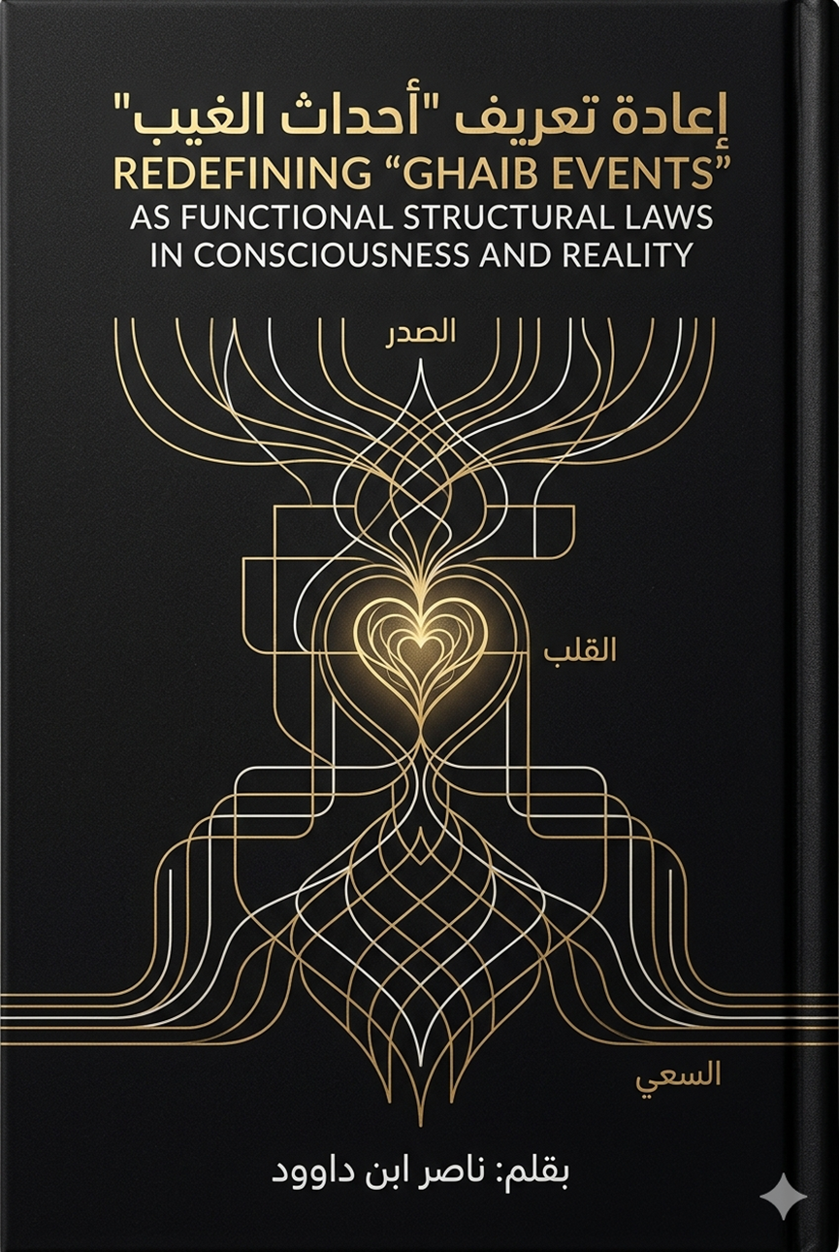

Redefining “Ghaib Events” as Functional Structural Laws in Consciousness and Reality
By: Nasser Ibn Dawoud

I. The Global Knowledge Manifesto
Knowledge is a universal right. The author firmly believes that wisdom should not be locked behind paywalls or language barriers.
- Global Access Policy: All books in this library are available for free in multiple digital formats (PDF, HTML, DOCX, TXT).
- The Digital Library: As of early 2026, the collection hosts 68 volumes (34 in Arabic and 34 in English), fully optimized for AI-assisted research and digital archiving.
- Official Platforms:
  - Main Website: nasserhabitat.github.io/nasser-books/
  - GitHub: nasserhabitat/nasser-books

II. Translator’s Note: The Bridge of Meaning
This English edition is a condensed conceptual adaptation. It is not a word-for-word translation, but rather an "extraction of essence." It presents the core philosophical framework in accessible English, omitting the exhaustive linguistic debates and classical references found in the original Arabic text.
For the academic researcher: The original Arabic version remains the primary source for comprehensive linguistic analysis, detailed exegesis (Tafsir), and the complete bibliography.

III. Executive Summary: The Shift from Narrative to System
Modern religious consciousness often views "Ghaib" (the Unseen) through three limiting lenses: as moral stories, as historical accounts, or as events postponed until the afterlife. This work proposes a radical shift: viewing the Quranic text as a Functional Operating System for Consciousness.
In this framework, "Unseen" events are not just future occurrences; they are active, structural laws—invisible but measurable—that govern how humans receive information, process intent, and manifest reality through action.

IV. The Structural Flowchart of Existence
1. The Source: "Water of Heaven" as Semantic Supply
In traditional readings, "rain" is merely a physical event. In structural linguistic engineering, "Water from the Sky" represents the Descent of Meaning. It is the objective truth and divine guidance that descends into the human field to provide the "raw material" for growth and consciousness.
2. The Processor: The Chest and the Heart
- The Chest (Al-Sadr): Think of the chest as the "Processing Unit." It is the arena of interaction where external data meets internal state. It is where "interference" (Shaitan/Distraction) occurs, attempting to cloud the incoming signal.
- The Heart (Al-Qalb): The heart is the Decision-Making Engine. Its function is not purely emotional; it is geometric. It performs "Weighting and Deciding" (At-Tarjih), transforming a passing thought into a binding commitment (Aq’d).
3. The Filter: The "Stress Test" (Ibtila’)
Life experiences are not random punishments or rewards; they are Structural Stress Tests. Just as an engineer tests the limits of a material, "Ibtila’" reveals the integrity of the human internal system. It exposes whether the "Heart" is operating on "Light" (Clarity) or "Darkness" (Confusion).
4. The Manifestation: Striving (Sa’i) as Directional Engineering
Reality is not shaped by wishful thinking but by Sa’i. This is the translation of internal design into external movement. It is the "Engineering of Direction"—aligning human movement with the universal laws (Sunan) to produce a tangible result in the world of "Witnessing" (Shahada).

V. The Ultimate Scale: Meaning Density
The final stage of the process is the Mizan (The Scale). In this structural view, the scale does not weigh physical matter; it weighs "Meaning Density." It measures the efficiency of the journey—how much of the "Divine Supply" was successfully processed through the heart and accurately manifested in reality.
Conclusion: A New Frontier of Awareness
By redefining the Unseen as a set of active laws, we move from being "passive believers" to "active operators." The goal of this research is to empower the individual to understand the mechanics of their own consciousness and to interact with the world not as a series of accidents, but as a precise, law-governed system of growth and purpose.

