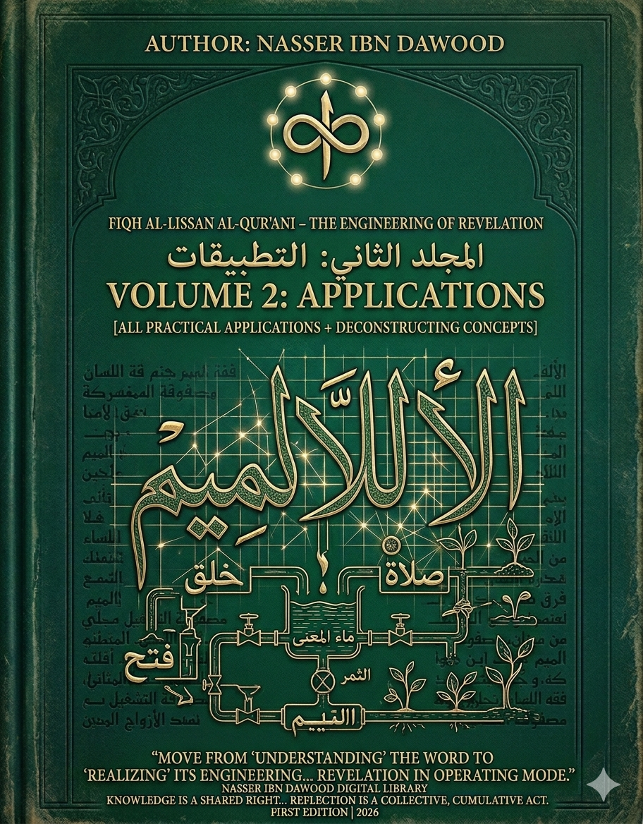
Encyclopedia: Fiqh Al-Lissan Al-Qur'ani – The Engineering of Revelation
Condensed Conceptual Translation (For the International Reader)
Volume 1: Foundations and Tools
Volume 2: Practical Applications & Conceptual Deconstruction

I. The Global Knowledge Manifesto
Knowledge is a universal right. The author firmly believes that wisdom should not be locked behind paywalls or language barriers.
- Global Access Policy: All books in this library are available for free in multiple digital formats (PDF, HTML, DOCX, TXT).
- The Digital Library: As of early 2026, the collection hosts 68 volumes (34 in Arabic and 34 in English), fully optimized for AI-assisted research and digital archiving.
- Official Platforms:
Main Website: nasserhabitat.github.io/nasser-books/
GitHub: nasserhabitat/nasser-books

II. Translator’s Note: The Bridge of Meaning
This English edition is a condensed conceptual adaptation. It is not a word-for-word translation, but rather an “extraction of essence.” It presents the core philosophical framework in accessible English, omitting the exhaustive linguistic debates and classical references found in the original Arabic text.
For the academic researcher: The original Arabic version remains the primary source for comprehensive linguistic analysis, detailed exegesis (Tafsir), and the complete bibliography.

III. Introduction: The Problem of Reading the Qur’an
Modern engagement with the Qur’an suffers from a deep methodological rupture. The text is often approached either devotionally without structure, or analytically without internal coherence. Between ritualistic reading and fragmented interpretation, the Qur’an loses its function as a unified system of meaning.
This work begins from a central premise: the Qur’an is not merely a text to be interpreted, but a system to be understood. Its language is not arbitrary, and its structure is not decorative. It is an engineered semantic system where meaning emerges through precise relationships between letters, roots, patterns, and contexts.
The crisis, therefore, is not in the text—but in the method of reading.

IV. Core Problematic
The dominant interpretive traditions often treat words as isolated units, relying on inherited definitions without re-examining their linguistic structure.
This leads to a chain of distortion:
Misdefined concepts
↓
Distorted reading
↓
Fragmented methodology
↓
Confused consciousness
↓
Misguided practice
The project of Fiqh Al-Lissan Al-Qur’ani seeks to reverse this chain by reconstructing meaning from within the Qur’anic linguistic system itself.

V. The Foundational Hypothesis
The Qur’anic language operates as a closed semantic system governed by internal laws. These laws can be discovered through:
- Letter-level analysis
- Root dynamics
- Bilateral structures (paired letters)
- Contextual positioning
- Recurrence patterns
Meaning is not assigned externally—it is generated internally.

VI. Methodology: From Letter to System
The methodology unfolds across five analytical layers:
- Letter (Harf) – the smallest unit of meaning potential
- Pair (Mathani Structure) – relational generation of meaning
- Root (Jذر) – dynamic semantic field
- Word (Kalima) – contextual activation
- System (Nasaq) – integrated network of meaning
This progression moves from micro-structure to macro-structure, revealing the Qur’an as a coherent semantic architecture.

VII. Conceptual Reconstruction Framework
Each concept in the Qur’an is re-examined through a five-step process:
- Common inherited definition
- Identification of distortion or reduction
- Linguistic structural analysis
- Precise redefinition
- Impact on understanding and practice
This transforms interpretation into reconstruction.

VIII. Example of Conceptual Deconstruction
- Concept: Worship (ʿIbādah)
Layer | Description
Traditional Meaning | Ritual acts of devotion
Problem | Reduction to external practice
Linguistic Root | Indicates alignment, submission, structured following
Reconstructed Meaning | A comprehensive system of alignment with divine order
Impact | Worship becomes a mode of existence, not isolated rituals

IX. Applications (Volume 2)
The second volume applies the methodology to central Qur’anic concepts, including:
- Prayer (Ṣalāh) as a regulatory system of consciousness
- Fasting (Ṣawm) as structural restraint and internal calibration
- The Self (Nafs) as a dynamic field of tension and balance
- Lordship (Rabb) as a system of continuous nurturing and regulation
Each concept is redefined not as a static term, but as an operational system.

X. Toward a New Qur’anic Epistemology
This project proposes a shift from:
- Interpretation → Construction
- Explanation → Systemization
- Tradition-bound reading → Linguistically grounded analysis
It does not reject tradition, but repositions it within a deeper structural framework.

XI. Practical Transformation
The ultimate goal is not theoretical reform, but methodological transformation.
By restoring the internal logic of Qur’anic language, the reader moves from passive reception to active engagement. Meaning becomes something discovered, not inherited.
This leads to:
- Clarity in understanding
- Coherence in methodology
- Stability in consciousness
- Integrity in action

XII. Conclusion
Fiqh Al-Lissan Al-Qur’ani is not a book—it is a method.
It invites the reader to move beyond reading the Qur’an as text, toward engaging it as a living system of meaning.
The future of Qur’anic studies depends not on producing more interpretations, but on refining the tools of understanding.
This work is a step in that direction.

