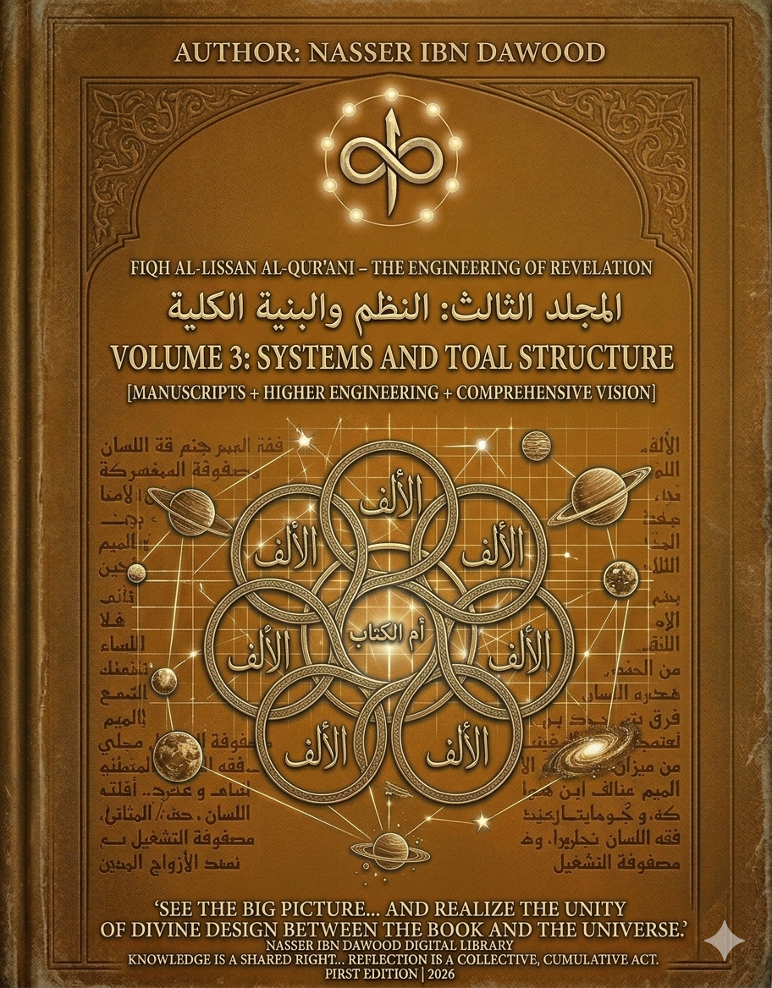
VOLUME 3: SYSTEMS AND TOTAL STRUCTURE
Encyclopedia: Fiqh Al-Lissan Al-Qur'ani – The Engineering of Revelation

- I. The Global Knowledge Manifesto
Knowledge is a universal right. The author firmly believes that wisdom should not be locked behind paywalls or language barriers.
- Global Access Policy: All books in this library are available for free in multiple digital formats (PDF, HTML, DOCX, TXT).
- The Digital Library: As of early 2026, the collection hosts 68 volumes (34 in Arabic and 34 in English), fully optimized for AI-assisted research and digital archiving.
- Official Platforms:
  - Main Website: nasserhabitat.github.io/nasser-books/
  - GitHub: nasserhabitat/nasser-books

- II. Translator’s Note: The Bridge of Meaning
This English edition is a condensed conceptual adaptation. It is not a word-for-word translation, but rather an "extraction of essence." It presents the core philosophical framework in accessible English, omitting the exhaustive linguistic debates and classical references found in the original Arabic text.
For the academic researcher: The original Arabic version remains the primary source for comprehensive linguistic analysis, detailed exegesis (Tafsir), and the complete bibliography.

- III. Executive Abstract: The Architectural Transition
If Volume 1 provided the "Microscope" (the mechanics of letters) and Volume 2 the "Scalpel" (the dissection of concepts), Volume 3 serves as the "Satellite Imagery." It marks the transition from micro-linguistics to Macro-Structural Engineering.
The central thesis of this volume is that the Quran is not a collection of disparate moral stories, but a Sovereign System of Interconnectivity (Salah). It explores the "Seven Mathani" not as mere verses, but as the cosmic power grid and the operational matrix of existence.

- IV. Key Structural Pillars
1. The Seven Mathani: The Operational Matrix
In this volume, the "Seven Mathani" are redefined through a structural lens. They are the Seven Recurring Laws that govern both the Revelation and the Physical Universe.
- The Law of Duality (Azwaj): Nothing exists in isolation; everything is defined by its systemic pair.
- The Law of Balance (Mizan): The internal regulator that maintains equilibrium within the human and cosmic systems.
- The Law of Flow: How divine "Data" (Water/Revelation) moves through the "Pipes" (Human Perception) to produce "Output" (Fruit/Action).
2. Um al-Kitab: The System Kernel
The concept of Um al-Kitab (The Mother of the Book) is analyzed as the Root Directory or Source Code of all knowledge. Every semantic branch in the Quran can be traced back to this central structural kernel. Understanding Um al-Kitab allows the researcher to predict the behavior of any linguistic concept within the system.
3. Linguistic Archaeology: The Authority of Early Manuscripts
A significant portion of this volume is dedicated to the Structural Geometry of Early Manuscripts (e.g., the San'a and Topkapi manuscripts).
- Stripping Decorations: The author argues that later diacritical marks and vocalizations (Tashkeel) often act as "noise" that can obscure the original structural intent.
- Geometric Layout: Analyzing the physical spacing and letter connections in early script reveals a logic of "Clustering" that aligns with the "Engineering of the Tongue" methodology.
4. Atmospheric Dictionaries (The Semantic Environments)
Volume 3 introduces the theory of Sura-Specific Ecosystems. Each Surah possesses its own "Atmospheric Dictionary." For example:
- The Aqueous System: Surahs that use water-related terminology to describe the flow of knowledge.
- The Botanical System: Surahs that use growth and fruit imagery to describe the outcomes of human intent.
The researcher is taught to map these environments to understand the "Kinetic Charge" of a specific verse.

- V. Entropy vs. Order: The Engineering of Salah
The volume concludes by contrasting Fasad (Systemic Entropy/Corruption) with Salah (Systemic Order/Interconnectivity).
- Salah (Prayer/Interconnectivity): Is defined as the act of re-establishing broken links within the human system to align with the Divine Matrix.
- Fasad: Is the breaking of these links, leading to the "Rusting" of the Heart (The Processor).

- VI. The Conceptual Map for the English Reader
To navigate this volume, the reader must adopt three perspectives:
- The Engineer’s Perspective: Looking for the "Load-Bearing" concepts that hold the structure together.
- The System Analyst’s Perspective: Identifying the Inputs (Revelation), Processes (Internal Reflection), and Outputs (Sovereign Action).
- The Archaeologist’s Perspective: Looking past historical interpretations to find the raw, structural "DNA" of the Arabic script.

End of Condensed Version
Nasser Ibn Dawood
First Edition | 2026

