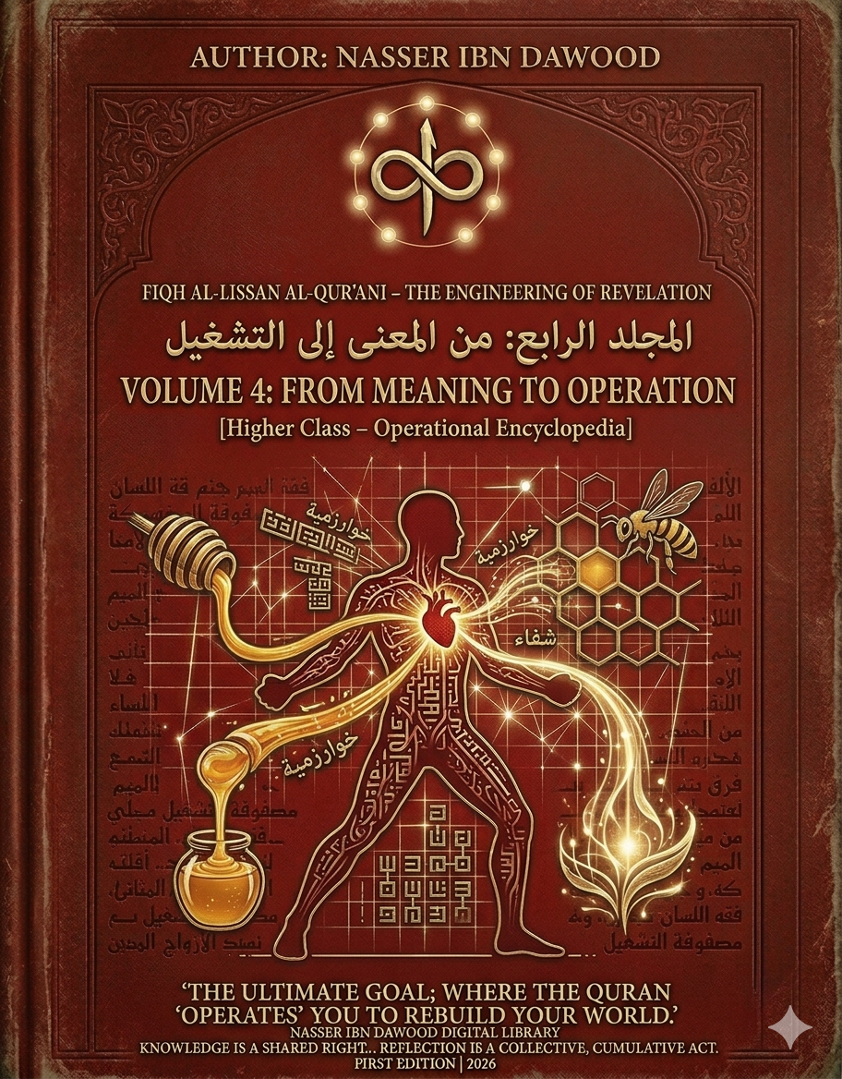

VOLUME 4: FROM MEANING TO OPERATION
- The Operational Encyclopedia of Quranic Engineering

- I. The Global Knowledge Manifesto
Knowledge is a universal right. The author firmly believes that wisdom should not be locked behind paywalls or language barriers.
- Global Access Policy: All books in this library are available for free in multiple digital formats (PDF, HTML, DOCX, TXT).
- The Digital Library: As of early 2026, the collection hosts 68 volumes (34 in Arabic and 34 in English), fully optimized for AI-assisted research and digital archiving.
- Official Platforms:
  - Main Website: nasserhabitat.github.io/nasser-books/
  - GitHub: nasserhabitat/nasser-books
- II. Translator’s Note: The Bridge of Meaning
This English edition is a condensed conceptual adaptation. It is not a word-for-word translation, but rather an "extraction of essence." It presents the core philosophical framework in accessible English, omitting the exhaustive linguistic debates and classical references found in the original Arabic text.
For the academic researcher: The original Arabic version remains the primary source for comprehensive linguistic analysis, detailed exegesis (Tafsir), and the complete bibliography.

- III. Executive Summary: The Paradigm Shift
The Fourth Volume marks the transition from Interpretation to Operation. It argues that the Quran is not merely a "Text to be understood," but a Linguistic Operating System (LOS) designed to manage human perception, decision-making, and existential output.
- 1. The Problem: The "Interpretive Stalemate"
Modern engagement with the Quran suffers from a structural disconnection:
- Traditional Approach: Focuses on static meanings and historical context.
- The Consequence: The "Operating Effect" of the Revelation is stalled, leaving a gap between the text and human behavior.
- 2. The Solution: Functional Jurisprudence (Fiqh al-Lissan)
This volume introduces the "Execution Layer" of the project:
- Input: Divine Revelation (The Water/Code).
- Processor: The Human Heart & Mind (The Engineering Center).
- Output: Beneficial Action (The Honey/Healing).

- IV. Core Operational Frameworks
- A. The Structural Hierarchy of the Soul
The book redefines human faculties as functional components:
- The Heart (Al-Qalb): Not a pump, but a Processing Hub where raw data (revelation) is converted into "Intentional Energy."
- The Earth (Al-Ard): The human Capacity and Readiness to receive and implement the code.
- The Balance (Al-Mizan): The Internal Regulator that prevents operational extremes (Excess vs. Negligence).
- B. The "Honey" Protocol: Transforming Knowledge
Using the metaphor of the Bee (Surah An-Nahl), the text outlines the process of "Knowledge Digestion":
- Ingestion: Absorbing pure revelation (The Nectar).
- Internal Processing: Subjecting knowledge to the "Heart's Laboratory."
- Healing Output: Producing solutions that cure social and psychological ailments.

- V. The Global Operational Protocol (GOP)
For the international reader, the volume provides a 6-step algorithm for engaging with any Quranic chapter:
- Structural Call: Identify the core kinetic law behind the verse.
- Layer Analysis: Determine which human faculty is being addressed.
- I/O Check: What is the required input, and what is the expected output?
- Calibration: Align the resulting intent with the "Universal Balance."
- Execution: Inject the concept into daily behavioral patterns.
- Feedback Loop: Observe the healing effect in the surrounding reality.

- VI. Conclusion: The Human as a Living System
The ultimate goal of this volume is to restore the "Systemic Human." By following the engineering of the Quran, the individual ceases to be a passive reader and becomes a Functional Agent of Peace and Healing in the world.

Nasser Ibn Dawood
Final Volume – Series: The Engineering of Revelation
First Edition | 2026

