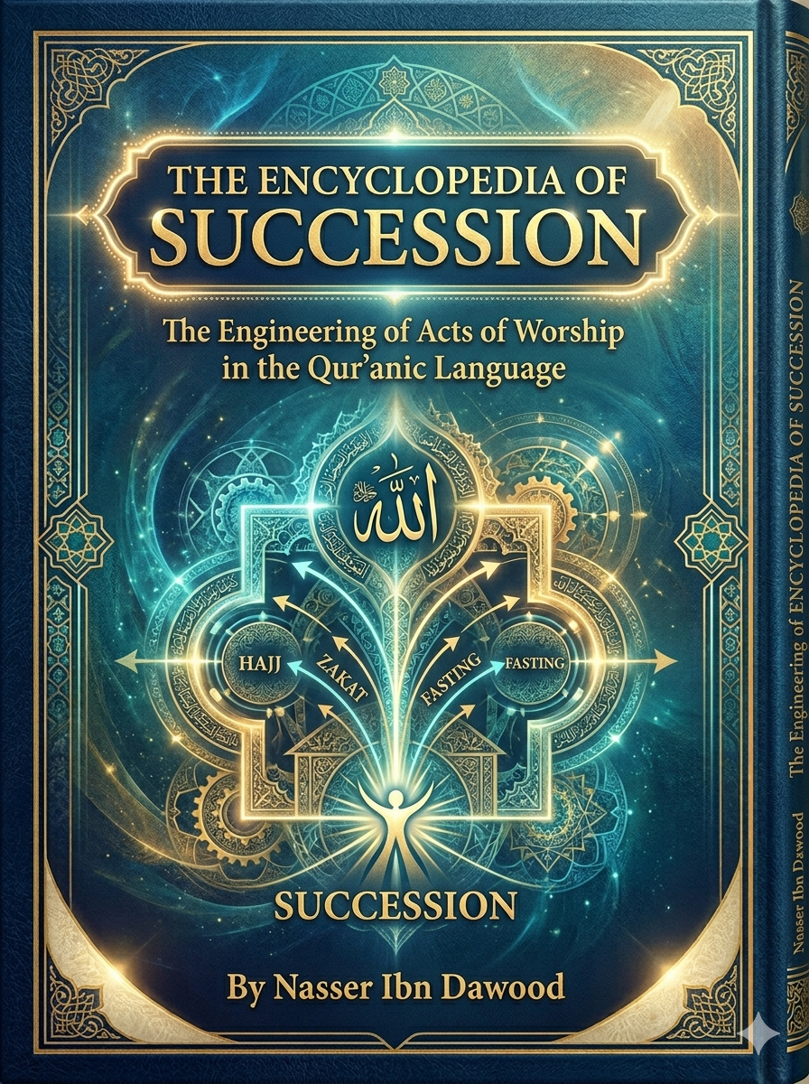

Encyclopedia of Succession: The Design of Devotion in the Quranic Language
The Quranic Operating System
- A Conceptual Framework for Rebuilding Human Consciousness and Civilization

By Nasser Ibn Dawoud

I. The Global Knowledge Manifesto
Knowledge is a universal right. The author firmly believes that wisdom should not be locked behind paywalls or language barriers.
- Global Access Policy: All books in this library are available for free in multiple digital formats (PDF, HTML, DOCX, TXT).
- The Digital Library: As of early 2026, the collection hosts 68 volumes (34 in Arabic and 34 in English), fully optimized for AI-assisted research and digital archiving.
- Official Platforms:
  - Main Website: nasserhabitat.github.io/nasser-books/
  - GitHub: nasserhabitat/nasser-books

II. Translator’s Note: The Bridge of Meaning
This English edition is a condensed conceptual adaptation.
It is not a word-for-word translation, but rather an extraction of essence.
It presents the core philosophical framework in accessible English, omitting the exhaustive linguistic debates and classical references found in the original Arabic text.
For the academic researcher:
The original Arabic version remains the primary source for comprehensive linguistic analysis, detailed exegesis (Tafsir), and the complete bibliography.

III. Introduction: From Ritual to System
This work proposes a radical shift in understanding religion.
Religion, in its Quranic form, is not a collection of isolated rituals.
It is a complete operating system designed to regulate:
- Consciousness
- Behavior
- Social structures
- Civilizational development
The crisis of the modern Muslim world is not the absence of religion,
but the malfunction of its operational understanding.

IV. The Core Problem
Over time, key concepts have been reduced:
- Prayer became movements
- Fasting became deprivation
- Charity became financial obligation
- Remembrance became repetition
As a result:
Religion remained present… but its function disappeared.
This led to a critical condition:
The separation of religion from life

V. The Central Thesis
The Quran operates as a system of laws and processes, not symbolic acts.
At its core:
Worship = System Regulation
Every act of worship performs a function:
- Prayer (Salat): Cognitive and behavioral calibration
- Remembrance (Dhikr): Synchronization of awareness
- Fasting (Sawm): System reset
- Charity (Zakat): Flow regulation
- Purification (Taharah): Noise reduction

VI. The Structural Model
This book introduces a layered model of human operation:
- 1. Source Layer
Revelation → Language → Concepts
- 2. Cognitive Layer
Reading → Reflection → Awareness
- 3. Calibration Layer
Prayer → Time → Balance
- 4. Execution Layer
Intention → Decision → Action
- 5. Systems Layer
Economic, social, and knowledge systems
- 6. Balance Layer
Justice, equilibrium, sustainability
- 7. Output Layer
Human stability → Social justice → Civilization

VII. The Laws of Operation
The system is governed by fundamental laws:
- Flow Law: Life thrives through movement, not accumulation
- Reduction Law: Simplification leads to dysfunction
- Synchronization Law: Awareness must remain aligned
- Purification Law: Clarity requires continuous filtering
- Reset Law: Systems must periodically restart
- Distribution Law: Hoarding leads to collapse

VIII. The Human as an Interface
The human being is not just a believer,
but an active interface within the system.
Three integrated dimensions:
- Consciousness (Mind)
- Time (Rhythm)
- Body (Interface)
Each must be calibrated continuously.

IX. Worship as Engineering
Worship is redefined as operational engineering:
It is not what you perform,
but what it performs within you.
A valid act of worship must produce:
- Clarity
- Stability
- Direction
- Balance

X. Systems of Life
The Quran extends beyond personal spirituality into systems:
- Economic System
Flow vs accumulation
Zakat vs Riba
- Social System
Family, contracts, governance
- Knowledge System
Revelation as structured information
Discernment (Furqan) as verification

XI. System Failure and Corruption
Breakdown occurs through:
- Gradual deviation (Steps of Shaytan)
- Cognitive distortion (False narratives)
- Temporal disruption (Desynchronization)
These are not moral failures alone,
but systemic breakdowns.

XII. Reconnecting Religion and Life
The solution is not more preaching,
but correct system activation.
This requires:
- Restoring concepts to their original functions
- Linking every act of worship to real-life impact
- Rebuilding the conceptual network

XIII. The Final Output
When the system functions properly:
- The individual becomes balanced
- Society becomes just
- Civilization becomes sustainable
This is the meaning of:
Khilafah (Stewardship)

XIV. Conclusion: From Understanding to Reconstruction
This work is not merely interpretive.
It is reconstructive.
It calls for a transition:
From practicing religion…
To operating it
From fragmented rituals…
To an integrated system
From passive belief…
To active stewardship

Core Statement
If the layers of operation are restored,
civilization will be restored.

- Worship as Engineering: Defined by function and real-life impact (e.g., Salat as calibration, Sawm as system reset).
- The Structural Model: The seven-layer framework (Source, Cognitive, Calibration, Execution, Systems, Balance, Output).
- The Laws of Operation: (Flow, Reduction, Synchronization, Purification, Reset, Distribution).

The Encyclopedia of Stewardship: The Engineering of Worship in Quranic Language
- Khilafah: Reconfigured as Stewardship—the state of individual balance, social justice, and sustainable civilization resulting from the proper operation of the system.

