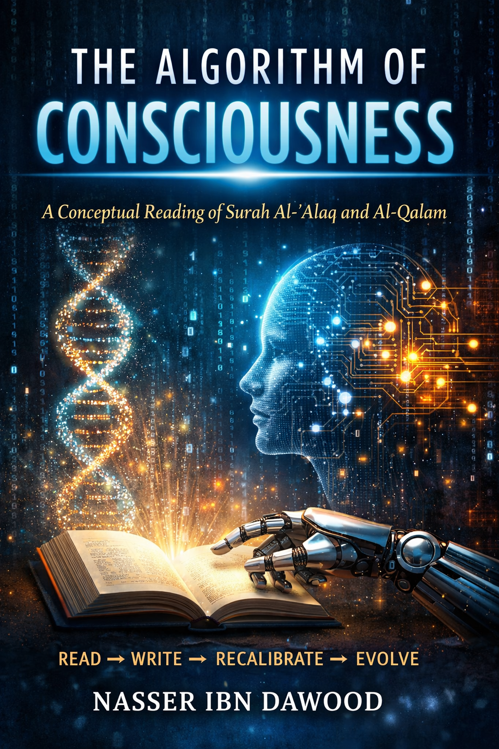
The Algorithm of Consciousness
A conceptual reading of Surah Al-Alaq and Al-Qalam
By Nasser Ibn Dawood

I. The Global Knowledge Manifesto
Knowledge is a universal right. The author firmly believes that wisdom should not be locked behind paywalls or language barriers.
• Global Access Policy: All books in this library are available for free in multiple digital formats (PDF, HTML, DOCX, TXT).
• The Digital Library: As of early 2026, the collection hosts 68 volumes (34 in Arabic and 34 in English), fully optimized for AI-assisted research and digital archiving.
• Official Platforms:
- Main Website: nasserhabitat.github.io/nasser-books/
- GitHub: nasserhabitat/nasser-books

II. Translator’s Note: The Bridge of Meaning
This English edition is a condensed conceptual adaptation. It is not a word-for-word translation, but rather an "extraction of essence."
It presents the core philosophical framework in accessible English, omitting the exhaustive linguistic debates and classical references found in the original Arabic text.
For the academic researcher: The original Arabic version remains the primary source for comprehensive linguistic analysis, detailed exegesis (Tafsir), and the complete bibliography.

Introduction: Why This Book Matters Now
We do not live in an age of information scarcity.
We live in an age of epistemic confusion.
Knowledge is abundant, yet understanding is fragmented.
Data is infinite, yet meaning is increasingly manufactured.
In such a world, the fundamental question is no longer:
What do we know?
But rather:
How do we know—and who defines reality?
This book argues that Surah Al-‘Alaq, the first revelation in Islam, is not merely a historical moment or a spiritual instruction.
It is a foundational architecture of consciousness.

Chapter 1: “Read” — The Birth of the Cognitive Human
“Read” is not a command to recite.
It is a command to engage reality.
To read is to:
- Decode patterns
- Question assumptions
- Refuse passive consumption
True reading operates within a system—“in the name of your Lord who created”—meaning:
within the laws of reality, not outside them.
The human being becomes fully human not by existing, but by interpreting existence.

Chapter 2: “From a Clinging Form” — Relational Ontology
The human is created “from a clinging form” (ʿalaq).
This is not merely biological.
It is ontological.
Human beings are:
- Dependent
- Connected
- Embedded in systems
There is no absolute independence.
Recognizing this relational nature is not weakness—
it is the beginning of epistemic humility.

Chapter 3: The Illusion of Self-Sufficiency
“Indeed, the human transgresses when he sees himself self-sufficient.”
This is the central diagnosis.
Tyranny does not emerge from ignorance.
It emerges from the illusion of completeness.
Closed systems—whether:
- ideological
- political
- technological
inevitably collapse.
In the digital age, this appears as:
- algorithmic echo chambers
- artificial intelligence hallucinations
- manufactured realities

Chapter 4: Prostration as Cognitive Recalibration
“Prostrate and draw near.”
Prostration is not merely ritual.
It is cognitive recalibration.
It represents:
- alignment with reality
- submission to truth beyond ego
- rejection of intellectual arrogance
Without this recalibration:
- knowledge becomes domination
- intelligence becomes distortion

Chapter 5: The Pen — Power, Knowledge, and Control
“The One who taught by the pen.”
The pen is not neutral.
It is:
- a tool of liberation
- or an instrument of domination
Today, the pen has evolved into:
- algorithms
- data systems
- AI models
The question is no longer:
Who writes?
But:
Who controls the narrative?

Chapter 6: Ethics as a Structural Necessity
“And indeed, you are upon عظیم character.”
Ethics is not decorative.
It is structural.
Without ethical grounding:
- knowledge corrupts
- systems collapse
Ethics functions as:
- an integrity layer
- a safeguard against systemic failure

Chapter 7: From Text to System — Surah Al-Qalam
If Al-‘Alaq establishes reading,
Al-Qalam establishes writing as power.
It reveals:
- how knowledge becomes authority
- how narratives shape reality
- how time exposes truth
The story of the “People of the Garden” is not moralistic.
It is systemic:
Closed systems → exclusion → collapse.

Chapter 8: Artificial Intelligence and Digital Tyranny
Artificial Intelligence is the modern “pen.”
It can:
- expand human understanding
or
- manufacture illusion
AI does not “read.”
It processes.
Only humans can:
- interpret
- evaluate
- take responsibility
The danger arises when:
humans stop reading… and start obeying outputs.

Chapter 9: The Algorithm of Consciousness
The Qur’anic model can be summarized as:
Read → Write → Do not claim self-sufficiency → Recalibrate → Draw near
This is not theology alone.
It is a survival protocol for consciousness.

Conclusion: The Open Consciousness Paradigm
The future of humanity depends on one question:
Will we remain readers…
or become inputs in systems we do not control?
This book proposes a third path:
- Knowledge without arrogance
- Humility without ignorance
- Technology without domination
A path where:
humans remain conscious agents,
not passive nodes in algorithmic systems.

Final Statement
Read—so you are not programmed.
Remain aware—so you do not transgress.
Recalibrate—so you do not collapse.
Draw near—without claiming ownership of truth.
This is not just a spiritual message.
It is a framework for survival.

Read… Recalibrate… Evolve.

