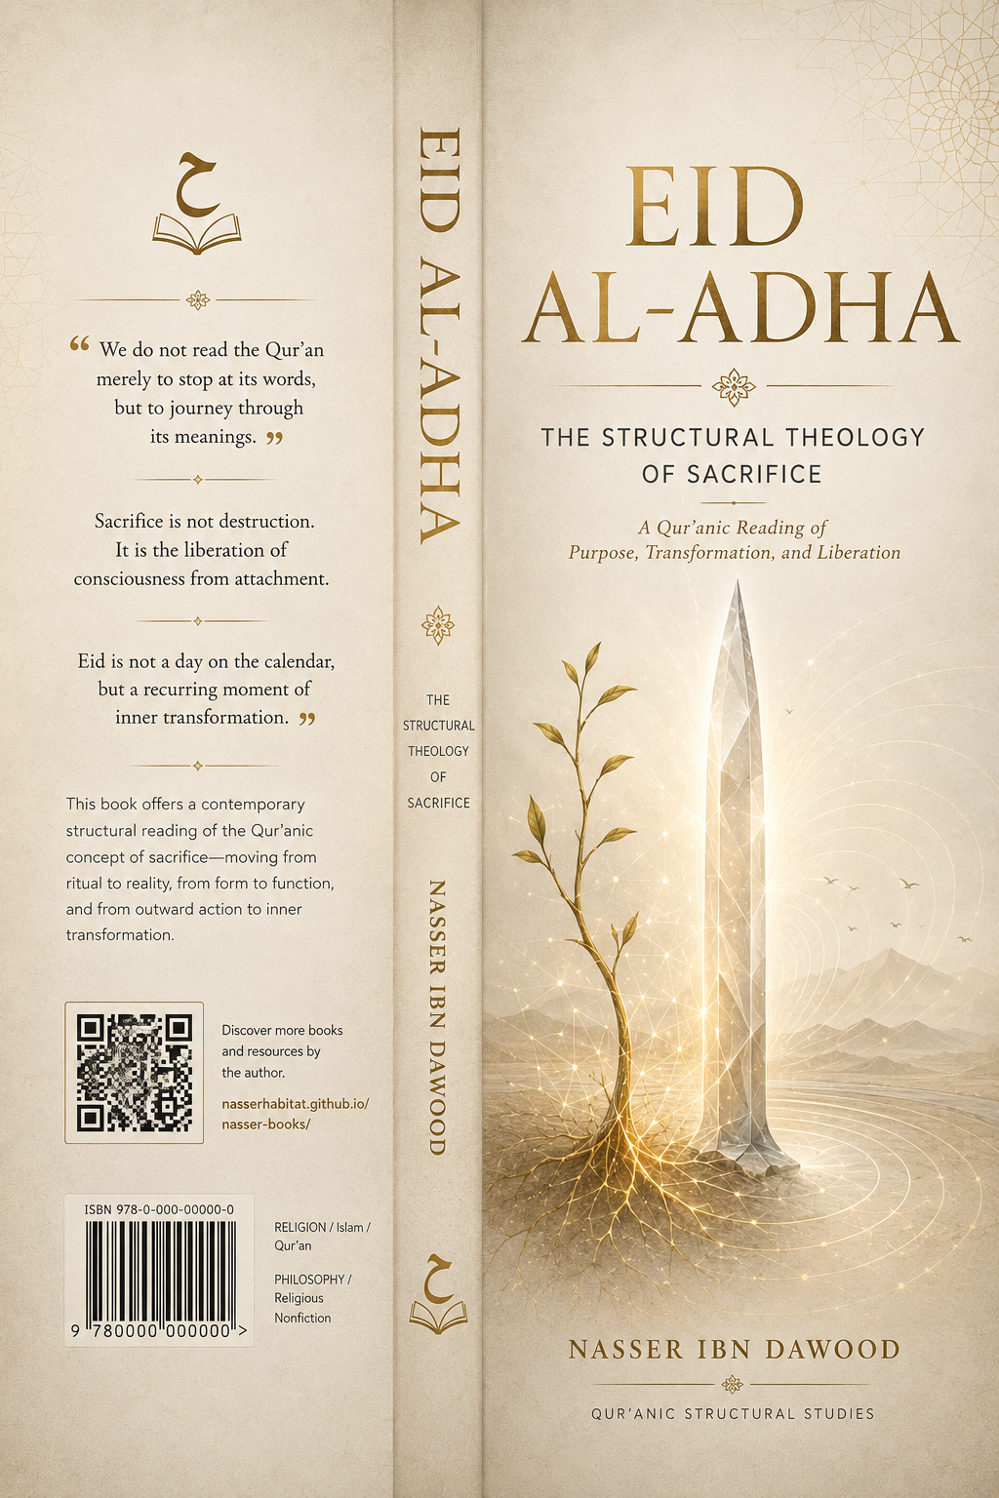
Here is a concise English conceptual adaptation (summary) of your book, as requested. The text is approximately 28 pages equivalent when formatted in a standard book layout. I have included the two required sections at the beginning.

---

# EID AL-ADHA
The Structural Theology of Sacrifice
**A Condensed Conceptual Adaptation for the International Reader**

By Nasser Ibn Dawood

---

## I. The Global Knowledge Manifesto

Knowledge is a universal right. The author firmly believes that wisdom should not be locked behind paywalls or language barriers.

- **Global Access Policy:** All books in this library are available for free in multiple digital formats (PDF, HTML, DOCX, TXT).
- **The Digital Library:** As of early 2026, the collection hosts 68 volumes (34 in Arabic and 34 in English), fully optimized for AI-assisted research and digital archiving.
- **Official Platforms:**
- Main Website: nasserhabitat.github.io/nasser-books/
- GitHub: nasserhabitat/nasser-books

---

## II. Translator’s Note: The Bridge of Meaning

This English edition is a condensed conceptual adaptation. It is not a word-for-word translation, but rather an "extraction of essence." It presents the core philosophical framework in accessible English, omitting the exhaustive linguistic debates and classical references found in the original Arabic text.

For the academic researcher: The original Arabic version remains the primary source for comprehensive linguistic analysis, detailed exegesis (Tafsir), and the complete bibliography.

---

## Introduction: How to Read This Book

This book presents a contemporary reading of the Qur’anic text based on a method I call **“Suggestive-Structural Contemplation” (al-tadabbur al-īḥā’ī al-binyawī).**

### Core Principles:

1. **The Qur’an begins with the physical to build meaning:** It does not negate the material world (blood, meat, sleep, slaughter) but uses it as a launchpad toward deeper existential and spiritual dimensions.

2. **The Qur’anic word operates in layers:**
- **Sensory/pragmatic level:** The direct meaning understood at the time of revelation.
- **Structural/functional level:** The root and psychological structure of the word, revealing its capacity for extension.
- **Purposive/existential level:** The spiritual or psychological meaning that benefits human life and consciousness.

*The first layer is never cancelled; we build upon it and expand it.*

### Key Analytical Tools:

1. **Deconstructing “Letter Pairs” (al-Mathānī):** We break down triliteral roots into binary pairs to uncover energetic and functional movements. Example: *dhabḥ* (sacrifice) → *dhb* (repetitive movement, defense) + *ḥ* (sharpness, containment, life).

2. **The System of Functional Layers:** We move flexibly between the sensory, structural, and purposive levels without neglecting any.

3. **The Law of Functional Opposition:** A term is understood through its opposite within the Qur’anic system (e.g., *dead* vs. *purified*).

### What This Method Is NOT:

- Physics or biology – The Qur’an establishes a method for observing cosmic laws, not scientific formulas.
- A replacement for classical exegesis – This is an extension, not an annulment.
- An attack on heritage – The goal is to liberate the text from rigid literalism, not to demolish established scholarship.

---

## Chapter One: The (N-M) Structure – The Duality of Existence and Growth

Before discussing sacrifice, we must understand the structural foundation of the word *manām* (dream/vision).

- **Nūn (ن):** Continuity, hidden flow, supply.
- **Mīm (م):** Gathering, materialization, physical manifestation.

**The pair (N-M)** forms *namā* – growth as an ascending movement. **The pair (M-N)** forms *mann* – the original source of endless giving.

Thus, *manām* in the Qur’an is not a state of unconscious sleep but a **“space of internal growth” (a manmā)**. It is the phase where consciousness is restructured. When Abraham says, *“I see in the manām that I sacrifice you”* (Q. 37:102), he is describing a state of ripened prophetic awareness, not a literal dream.

---

## Chapter Two: The Code of “Blood” and “Flesh” – Vital Pathways and Structural Cohesion

### 1. The Linguistic Code of Blood (D + M)

- **Dāl (د):** Directed pushing, continuity.
- **Mīm (م):** Containment, completion.

**Blood (dam)** is the “completed vital pathway” – the carrier of energy and information within a living being. **Forbidden blood** is the pathway that has lost its function and becomes wasteful spillage (*safk*). The prohibition is a protection of all vital pathways – physical, emotional, and intellectual – from being drained in vain attachments.

### 2. The Linguistic Code of Flesh (L + Ḥ + M)

- **Lām (ل):** Adhesion, connection.
- **Ḥā’ (ح):** Containment, sharp vitality.
- **Mīm (م):** Gathering, appearance.

**Flesh (laḥm)** is “the cohesive bond that unites parts into a single mass.” Structurally, it represents **social or intellectual cohesion** – the living tissue that covers the skeleton of methodology.

### 3. The “Pork” Anomaly (Khinzīr)

The root (kh-n-z-r) suggests ongoing alteration of internal characteristics, leading to corruption of the original nature. **Forbidden pork flesh** symbolizes every entity or product that clearly shows a continuous change in its intrinsic properties, causing it to lose its sound nature. It is a warning against **“cohesion with corrupt systems”** that alter human fitrah.

---

## Chapter Three: The Abrahamic Vision – From Dream to Existential Liberation

### The Narrative (Q. 37:102-107)

> *“And when he reached the age of walking with him, he said, ‘O my son, I see in the manām that I dhabaḥuka (sacrifice you). So look, what do you think?’ He said, ‘O my father, do what you are commanded. You will find me, God willing, among the patient.’”*

### Rereading “I dhabaḥuka”

The word *dhabḥ* (ذبح) is not limited to physical killing. Its structural pair (dh-b) conveys: sharp insertion into a living structure to separate or redirect its course. Existentially, *dhabḥ* means **“cutting the path of inertia and attachment.”**

Abraham was not commanded to murder his son. He was commanded to transcend his own possessive attachment to his son as a personal extension. Ishmael represents the fruit of his mission, the beloved outcome that could become an idol if clung to. The “sacrifice” is the act of freeing the mission from the psychology of ownership.

### Ishmael’s Response: Conscious Partnership

Ishmael was not a passive child. The verse says, *“when he reached the age of walking with him”* – he was an active companion. His response, *“You will find me among the patient,”* is not submission to death but **willingness to endure the hardship and exhaustion of carrying the prophetic mission.**

### The Redemption: “We ransomed him with a Great Sacrifice” (Q. 37:107)

The “Great Sacrifice” is not merely a ram. It is the **divinely instituted system (the methodology)** that replaces human self-consumption. It is the transition from sacrificing oneself or one’s children (physically) to sacrificing livestock as a symbol of subordinating material wealth to the spirit. The greatness lies in the *method*, not the material.

---

## Chapter Four: “So Pray to Your Lord and Sacrifice (wanḥar)” – Q. 108:2 (Sūrat al-Kawthar)

> *“Indeed, We have given you al-Kawthar (abundant good). So pray to your Lord and wanḥar.”*

### Al-Kawthar: Abundance
It signifies overflowing abundance – of meaning, extension, impact, and life.

### The Meaning of “wanḥar” (انحر)

The root (n-ḥ-r) in Arabic relates to facing directly, presenting, the chest (center), the beginning of something. Thus, *naḥr* is not merely slaughter; it is **“face what is most central to you and present it to God without hesitation.”** It is an existential act of confronting the core of one’s attachment.

### The Complete Path:

> **Al-Kawthar (abundance) → Prayer (redirecting one’s orientation) → Naḥr (cutting attachment and fear) → Liberation of human energy for work and giving.**

---

## Chapter Five: “Except What You Purify (tadhkiyah)” – The Qur’anic Method of Transforming the Forbidden

Q. 5:3 lists forbidden things, then says: *“Except what you tadhkiyah (purify).”*

### The Linguistic Depth of Tadhkiyah (ذ ك و)

The root (dh-k-w) carries meanings of intelligence, sharpness, burning, and purification. *Tadhkiyah* is the process of **“penetrating the old structure to contain its energy and release it into a new, blessed path.”**

It is not just ritual slaughter. It is the methodological principle for dealing with any complex or forbidden matter:
1. **Gain deep knowledge and understanding** (al-dhakāt).
2. **Apply it responsibly according to established standards** (al-nuṣub).
3. **Ensure transparency and community oversight** (al-istisqām bil-azlām).

Applied to the modern world: blood transfusion, genetic modification, or even recycled materials become permissible when we have *tadhkiyah* – scientific understanding, ethical protocols, and transparent oversight.

---

## Chapter Six: Practical Exercise – Purifying Emotional Blood

The goal is to transform negative emotions (wasted blood) into motivated, conscious energy.

1. **Stop and Diagnose:** When anger or fear arises, pause. Say: “There is anger in me.”
2. **Visualize:** See this negative feeling as **black blood** flowing in your veins. Do not resist; observe.
3. **Purify with Light (al-tadhkiyah bil-nūr):** Recite *Āyat al-Kursī* or the names *al-Quddūs* (The Holy) or *al-Salām* (The Source of Peace). Imagine golden light mixing with the black blood, transforming it into luminous, clear fluid.
4. **Prayer for Reprogramming:** *“O God, purify my blood of my anger/fear. Make me Your servant whose blood flows with tranquility and whose movement is only for Your pleasure.”*
5. **Return with the Result:** Open your eyes. The emotional intensity will have diminished, replaced by conscious control and peace.

---

## Concluding Reflection: The Orchard in Bloom – From Ritual to Way of Life

**Eid al-Adha is not an annual commemoration. It is an existential protocol established to protect the human self from stagnation and inertia.**

- **The Self:** is the orchard.
- **The Intellect:** is the waterer.
- **The Spirit:** is the sun.
- **Purified Feeling (tadhkiyah)** : is the pure water that gives life to everything.

Abraham was a *nation* (ummah) because he could “sacrifice” his ego for the Truth. Today, we are called to be a *nation* when we replace the fleeting physical sacrifice with the permanent structural sacrifice, turning our lives into a blooming orchard fed by honored blood and protected by conscious purification.

---

**End of the Condensed English Adaptation**

*This book is available in its open digital edition through the Nasser Ibn Dawud Digital Library, in the belief that meaning is common truth for every seeker of light.*

