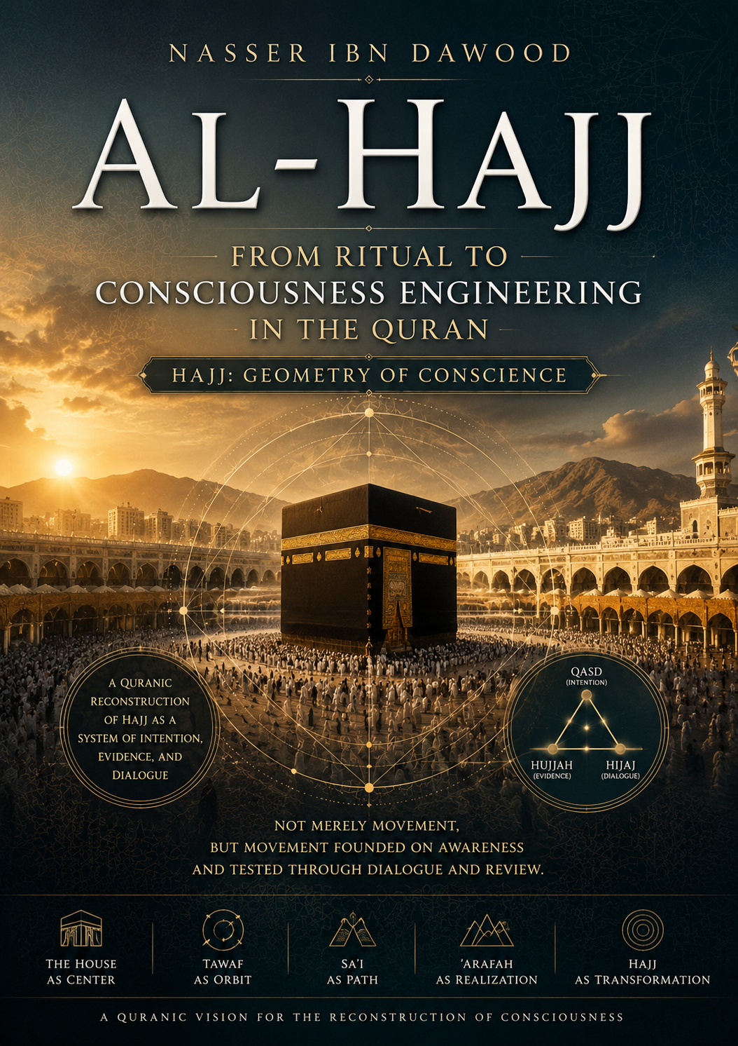
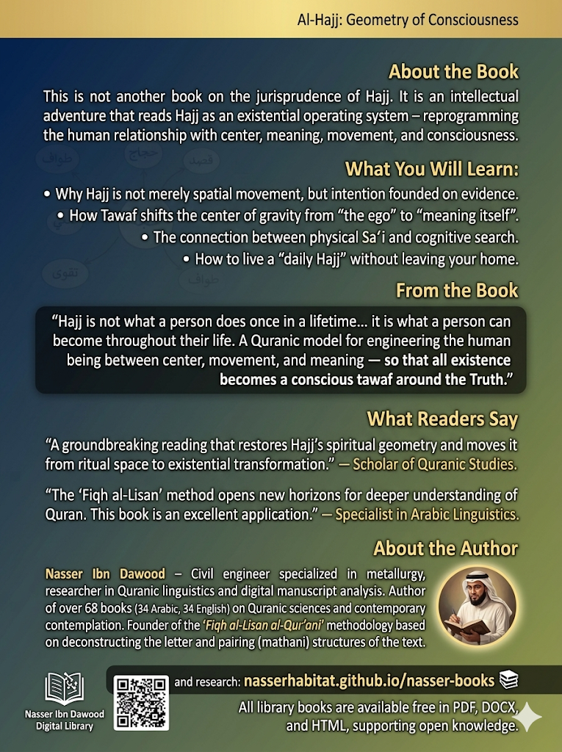

# Al-Hajj: From Ritual to Consciousness Engineering in the Quran

*A Condensed English Adaptation*

**Author:** Nasser Ibn Dawoud
**Digital Library:** nasserhabitat.github.io/nasser-books

---

## I. The Global Knowledge Manifesto

**Knowledge is a universal right.** The author firmly believes that wisdom should not be locked behind paywalls or language barriers.

- **Global Access Policy:** All books in this library are available for free in multiple digital formats (PDF, HTML, DOCX, TXT).
- **The Digital Library:** As of early 2026, the collection hosts 68 volumes (34 in Arabic and 34 in English), fully optimized for AI-assisted research and digital archiving.
- **Official Platforms:**
- Main Website: nasserhabitat.github.io/nasser-books/
- GitHub: nasserhabitat/nasser-books

## II. Translator’s Note: The Bridge of Meaning

This English edition is a condensed conceptual adaptation. It is not a word-for-word translation, but rather an **"extraction of essence."** It presents the core philosophical framework in accessible English, omitting the exhaustive linguistic debates and classical references found in the original Arabic text.

**For the academic researcher:** The original Arabic version remains the primary source for comprehensive linguistic analysis, detailed exegesis (Tafsir), and the complete bibliography.

---

# Introduction: Why Re-read Hajj?

For centuries, Hajj has been understood in Muslim consciousness as a ritual – a set of physical actions performed at a specific time and place. This understanding is correct at its level, but it may be only one layer of a deeper semantic structure.

This book asks a provocative question:

> **Has the meaning of Hajj exhausted itself at the ritual level?**

Or is what we perceive today merely one stratum of a wider, deeper intentional structure?

The problem is not in the Quranic text itself, but in the **tool** through which it has been read historically. Hajj was fixed within a closed ritual framework, while the Quran may point to a deeper dimension: one that transcends spatial movement toward **cognitive movement**, and exceeds external action toward the **inner structure of consciousness**.

This project does not seek to demolish traditional meaning, but to **reconstruct it within its holistic horizon** – transforming understanding from an "isolated rite" into a "moving cognitive structure" within the Quranic system.

---

## Chapter 1: The Linguistic Foundation – Root (H-J-J)

### 1.1 The Central Question

Common understanding defines Hajj as:
- A religious rite tied to specific time and place
- Performed at the Kaaba in Mecca

But this understanding remains partial if isolated from the deep linguistic structure of the root from which the word derives.

### 1.2 The Hypothesis

The root **Ḥ-J-J** (ح ج ج) in Arabic does not only mean "intentional direction" (qasd), but rather:

> **Intentional direction founded on evidence (hujjah) and realized through dialogic argumentation (hijaj).**

Thus, Hajj is not merely physical movement, but a **system** combining intention, proof, and dialogue.

### 1.3 The Three Branches of Meaning

| Branch | Meaning | Manifestation in Hajj |
|--------|---------|------------------------|
| **Al-Hajj** (القصد) | Intentional direction | Travel to the House, Tawaf, Sa‘i |
| **Al-Hujjah** (البرهان) | Proof, evidence | Ihram as declaration of intent, Standing at ‘Arafah as registration of presence |
| **Al-Hijaj** (الحوار) | Argumentation, dialogue | Talbiyah (call and response), supplication, Takbir |

### 1.4 Recomposition: From Dispersion to Unity

When these three dimensions are brought together, a single structure emerges:

> **Hajj = Qasd (intention) + Hujjah (evidence) + Hijaj (dialogue)**

That is:
- Not mere movement
- But movement founded on awareness
- And awareness tested through dialogue and review

---

## Chapter 2: Hajj as a System of Consciousness

### 2.1 Two Levels of Reading

#### The Apparent Level (Physical Ritual – The Muhkam)
- Journey to the Kaaba
- Commitment to rules: no obscenity, no transgression, no futile argument
- Tawaf (circling), Sa‘i (walking between Safa and Marwa), standing at ‘Arafah, stoning the pillars, shaving or cutting hair

This level is the **primary truth** that cannot be negated by interpretation.

#### The Deep Level (Existential Engineering – Built upon the Muhkam)
- Inner transition: from blind imitation to reasoned proof
- From dispersion to intentional direction
- From noise (rafath, fusuq, futile argument) to equilibrium
- Reset of the relationship with the center (the House as symbol of absolute values)

### 2.2 The Quranic Definition of Hajj

The Quran does not present Hajj as a ready-made definition, but as a concept formed within overlapping contexts. It emerges as a **functional definition**:

> **Hajj is an intentional movement toward a semantic center where human consciousness is reconstructed within the monotheistic system.**

---

## Chapter 3: Key Concepts of Hajj

### 3.1 The House (Al-Bayt): From Building to Center

The "House" is not merely architecture, but a **semantic center** that organizes the movement of meaning in the Quranic system.

- **Material center:** A specific place where rituals are performed
- **Symbolic center:** The idea of monotheism as a point of orientation for human existence

Thus, the House becomes not just a place within Hajj, but the **condition for the very meaning of Hajj**.

### 3.2 Tawaf: The Geometry of Movement Around the Center

If the House represents stability, Tawaf represents **organized movement that defines stability itself**.

The root (T-W-F) indicates circular movement drawn to a center – inseparable from it, never departing definitively, but constantly returning.

**Tawaf as existential law:**
- No movement without a center
- No center without movement
- Movement is not separation but expression of relationship with the center

Tawaf thus becomes a **Quranic model for understanding the human relationship with meaning**: perpetual motion around a stable origin.

**Existential reset mechanism:** Each cycle dismantles accumulations of separation, reinserts the self into the general orbit, and reconnects the part to the whole.

### 3.3 Sa‘i: From Physical Effort to Cognitive Search

The root (S-‘-Y) denotes not just walking, but **intentional movement toward a goal that transforms desire into action**.

Sa‘i thus becomes:
- Transition from perception to application
- From awareness to actualization
- From center to extension

It is part of the "Quranic engineering of the search for meaning" – truth is not only received but sought and achieved.

### 3.4 Taqwa: From Fear to Internal Balance

In this analysis, Taqwa is not reduced to fear, but understood as a deeper structure:

> **An internal regulation system that balances action and meaning.**

Taqwa becomes:
- Awareness of boundaries
- Behavioral regulation
- Reorganization of the relationship between inner and outer

It is not merely a feeling, but an **internal scale** governing human movement within the existential system of Hajj.

### 3.5 Time in Hajj: Between Real Time and Existential Time

Hajj operates within two temporal layers:

- **The known months (ashhur ma‘lumat):** Organized legislative time that defines the framework of action
- **The numbered days (ayyam ma‘dudat):** Dense time in which experience transforms into high-concentration meaningful moments

Thus, Hajj becomes a **dual temporal experience that reshapes human perception of time itself**.

### 3.6 The Controls: Rafath – Fusuq – Jidal

These are not merely behavioral rulings, but a **protective structure for consciousness** within the Hajj experience:

- **Rafath:** Dismantling of seriousness, introduction of uncontrolled instinct into sacred space
- **Fusuq:** Deviation from the general value system that regulates action and meaning
- **Jidal:** Disturbance of cognitive purity, turning Hajj into conflict rather than consciousness

They function as **mechanisms protecting existential purity** within the Hajj experience.

### 3.7 The Number 7 in Hajj’s Structure

The number 7 in Hajj is not read as exaggerated symbolism, but as a structural reading:

Observed in:
- Tawaf (7 circuits)
- Certain ritual structures related to repetition and organization

But the significance is not the number itself, but its structural meaning:

> **Organized repetition as a mechanism for consolidating awareness of the center.**

Thus, the number becomes not a mystical symbol, but:
- A model of organized repetition
- A tool for consolidating perception
- A structure for reestablishing meaning within consciousness

---

## Chapter 4: Hajj as a Model for Life

### 4.1 Hajj is Not an Event… It is an Operating System

In traditional reading, Hajj is understood as an event occurring at specific time and place. But in this conception, it is not an event, but:

> **A cognitive-existential operating system that resets the human being from within.**

Like computer operating systems – not always visible to the user, but controlling:
- How understanding works
- Mechanism of interaction
- Form of perception
- Organization of inputs and outputs

Thus, Hajj becomes: **an operational structure for human consciousness within the world.**

### 4.2 Hajj in Daily Life

If Hajj is an operating system, how does it manifest in daily life?

The answer lies not in repeating rituals, but in **restoring their internal logic**:

- **The House →** Having a center in life (a supreme value that regulates direction)
- **Tawaf →** Not scattering around multiple centerless goals
- **Sa‘i →** Transforming meaning into continuous action
- **Taqwa →** Internal balance regulating behavior

In this sense, "daily Hajj" is:
> **A way of living, not a season.**

### 4.3 From Ritual to Transformation

The distinction here is essential:

- **Ritual:** An action performed
- **Transformation:** A structure being reshaped

In surface reading, Hajj is a ritual. But in structural reading, Hajj is:
> **A machine of existential transformation for the human being.**

Each stage does not merely add a new action, but changes:
- Way of thinking
- Way of perceiving
- Human relationship with self and world

The goal is not to perform Hajj, but to **be reproduced within it.**

### 4.4 Security: From Sanctuary to Consciousness

The concept of "security" (amn) in Hajj cannot be reduced to spatial security. It must be read as a structure of consciousness.

The sanctuary (haram) is not merely a safe place, but:
> **A model of a state of perception free from internal threat.**

Security here transforms into:
- Security from internal chaos
- Security from cognitive contradiction
- Security from value dispersion

Thus, the sanctuary becomes not only geography, but: **a state of consciousness stability within itself.**

### 4.5 Provision: From Material to Taqwa

In material travel, provision is food and means. But in Hajj, provision transforms into a deeper concept:

> **“Take provision, for indeed the best provision is Taqwa.”** (Quran 2:197)

Here the transformation occurs:
- From material provision → to existential provision
- From bodily nourishment → to nourishment of consciousness
- From resources → to internal ethical structure

Thus, Taqwa becomes not merely a value, but: **humanity’s existential capital on its journey through life.**

---

## Chapter 5: The Quran Bears Witness

### 5.1 Abraham: From Hujjah to Hajj

Abraham represents in the Quranic structure a central transition point between "hujjah" (evidence) and "Hajj" as integrated systems.

Abraham is not merely a historical figure, but a **Quranic model for the transformation of consciousness** – from search for proof to the construction of ritual action that founds meaning.

**First: Abraham as the mind of Hujjah** – deconstruction of assumptions, questioning of symbols, demand for certain knowledge.

**Second: Abraham as founder of Hajj** – the decisive transformation from seeker of truth to establisher of a ritual that re-presents truth. From knowledge → to practical embodiment of meaning.

**Third: Building the House as transformation of meaning into center** – not merely architectural, but establishment of a symbolic center around which collective consciousness is reorganized.

### 5.2 The Quranic Verses on Hujjah and Contemplation

The Quran consistently links "hujjah" with "tadabbur" (deep contemplation) as mechanisms for producing consciousness:

- **Hujjah:** Not merely theoretical argument, but disclosure of truth, deconstruction of falsehood, construction of certain knowledge.
- **Tadabbur:** Transforming the text from information into consciousness – transition from surface reading to structural perception of internal relations of meaning.

Together they form: **a dual Quranic system for building human consciousness.**

### 5.3 Verses on Purification (Taharah)

Purification in the Quran is not reduced to physical cleanliness, but represents:

> **Resetting the relationship between the human being and the field in which they move.**

- Purification as removal of: internal disturbance, conceptual interference, weight of negative accumulation.
- Purification as a condition for perceiving meaning – impure consciousness cannot receive truth clearly.

Thus, purification becomes a **structural condition for entering the Hajj system itself.**

### 5.4 Verses on Sa‘i

The Quran presents Sa‘i as a recurring model of conscious human action:

> **“And that there is not for man except what he strives for.”** (Quran 53:39)

This text transforms Sa‘i into an existential rule: no actualization without conscious movement.

Sa‘i combines: will, action, direction – not merely physical movement, but **translation of awareness into reality.**

### 5.5 Verses on Taqwa

Taqwa in the Quran represents the highest level in the existential structure of Hajj and the Quran generally:

- **Taqwa as monitoring consciousness:** not simple fear, but continuous awareness of internal direction
- **Taqwa as balance structure:** internal standard, self-evaluation system, regulation of relationship between action and meaning
- **Taqwa as the conclusion of the Hajj system:**

All elements – Tawaf (awareness around center), Sa‘i (action toward meaning), Taharah (removal of disturbance), Hujjah (construction of knowledge) – flow into Taqwa as:

> **The final state of consciousness stability within the guidance system.**

---

## Conclusion: The Great Summary

### 1. Hajj Between Ritual and Knowledge

Hajj appears in traditional consciousness as a "ritual" – a defined devotional act. But in the structure presented, another dimension emerges:

**Hajj is not only a ritual performed, but knowledge built through performance.**

- **Ritual as the body of meaning:** movement is the body of the idea
- **Knowledge as the spirit of ritual:** if ritual stops at its exterior, it becomes habit; if extended to its depth, it becomes a system of perception

In Hajj, there is no separation between action and understanding – each action is a form of knowledge, and each knowledge is capable of being practiced.

### 2. The Human Being as a “Tawaf-ing” Being

If Tawaf appeared in Hajj as a ritual movement, at this level it transforms into **a description of the human being itself**:

- **Tawaf as existential model:** Humans do not live in a straight line – they return to their values, circle their meanings, constantly review their center
- **Tawaf as circular consciousness:** not linear progress alone, but perpetual movement between experience and meaning
- **Human between center and movement:** not separate from their center, not ceasing motion around it

Thus, the human being becomes: **a tawaf-ing being – never stable except within conscious movement around a fixed meaning.**

### 3. Center of Monotheism vs. Circles of Dispersion

This axis represents the deep philosophical structure of Hajj as an existential model:

- **Center of monotheism:** point of meaning collection, direction reference, unity of perception – the idea that existence has one center that reorganizes multiplicity
- **Circles of dispersion:** multiplicity without center, movement without direction, knowledge without unity
- **Hajj as reorganization:** the process of transferring the human being from circles of dispersion to the center of monotheism – not merely spatial transition, but reconstruction of consciousness, resetting of direction, reunification of the human interior

### 4. Hajj: From Place to Meaning

This is the final conclusion of the entire project:

- **Place as beginning:** Hajj begins from a specific place, but does not end there
- **Transcending place:** in deep structure, place transforms into symbol, center, tool for producing meaning
- **Meaning as ultimate destination:** the goal is not arrival at place, but arrival at a new state of perceiving existence
- **The final transformation:** Hajj in its complete form is – from movement in place → to movement within meaning → to the reshaping of the human being itself

---

## Epilogue: The Human as a Journey

The book does not end as a closure, but as the beginning of a new understanding:

> **Human beings are not static in the world, but in perpetual motion toward a center of meaning that constantly reshapes them.**

Hajj, as revealed in this book, is not:
- A historical event
- Nor an isolated ritual
- Nor merely a legal system

But rather:

> **A comprehensive Quranic model for the engineering of human beings between center, movement, and meaning, so that all of existence becomes a conscious tawaf around the Truth.**

---

*Nasser Ibn Dawoud*
*Condensed English Adaptation – 2026*
📚 **nasserhabitat.github.io/nasser-books**

