**Irish Wind Results in 2 Models :**

1. Rigelet on samples + original samples + Mutual Information Features selection + CNN

RMSE --> 8.687247073656303

MAPE --> 3.4661855548620224

MAE --> 4.51153

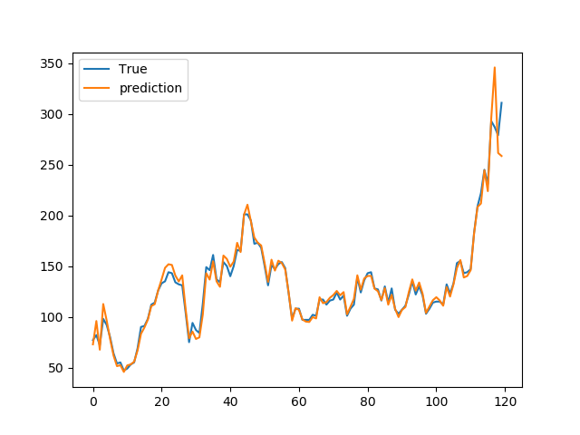

1. Rigelet on Features with 24 projections on each feature+ original Features + Mutual Information Features selection + CNN

Note : Rigelete on features is completely useless because each new feature that produced by rigelet have Maximum 0.04 correlation with target. So all derived features removed in feature selection state. (finally 8 features remain that belong to original back steps like our original model)

RMSE --> 6.690691605244868

MAPE --> 2.82060913741588

MAE --> 3.6712582

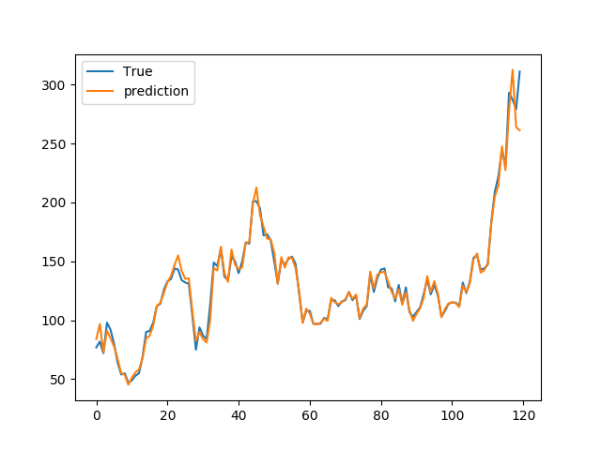

**Avgen_Price Results in 2 Models :**

1. Rigelet on samples + original samples + Mutual Information Features selection + CNN

RMSE --> 0.97118124901402

MAPE --> 1.4527407474815845

MAE --> 0.6440766

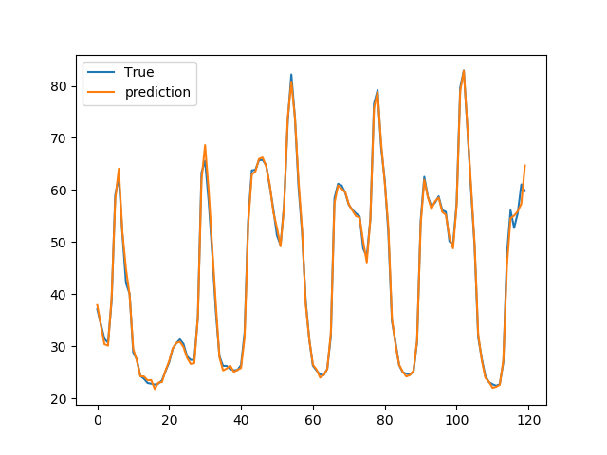

1. Original model (12 back step without feature selection)+ cnn

RMSE --> 1.6912993998618768

MAPE --> 1.9041026011109352

MAE --> 0.8441891

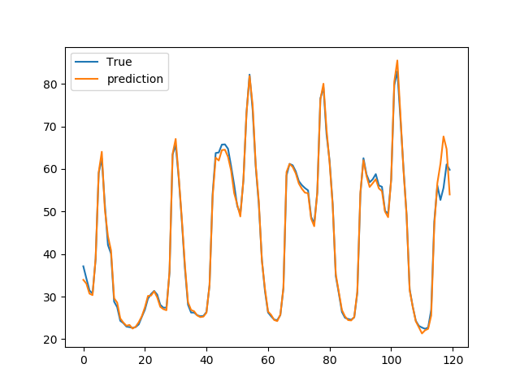

**Avgen_load Results in 2 Models :**

1. Rigelet on samples + original samples + Mutual Information FS

RMSE --> 163.33769060408255

MAPE --> 0.4169016145169735

MAE --> 122.58367

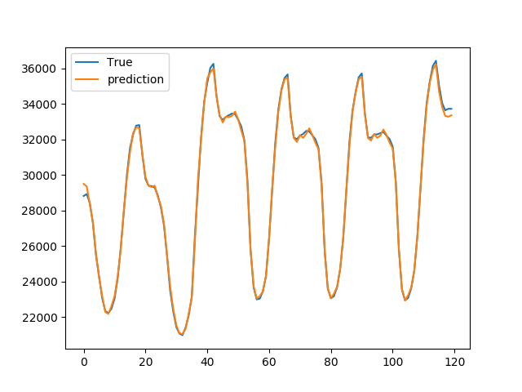

1. Original model (12 back step without feature selection)+ cnn

RMSE --> 315.90624845434763

MAPE --> 0.720200827345252

MAE --> 211.76425

