Unstall and install wsl :

dism.exe /online /disable-feature /featurename:Microsoft-Windows-Subsystem-Linux /quiet /norestart

dism.exe /online /enable-feature /featurename:Microsoft-Windows-Subsystem-Linux /quiet /norestart

dism.exe /online /enable-feature /featurename:VirtualMachinePlatform /all /limitaccess /quiet /norestart

enable wsl

dism.exe /online /enable-feature /featurename:VirtualMachinePlatform /all /limitaccess

 dism.exe /online /enable-feature /featurename:Microsoft-Hyper-V-All /LimitAccess /ALL

set version more compatible (2)

wsl.exe --set-default-version 2

wsl.exe --setdefault Ubuntu-20.04

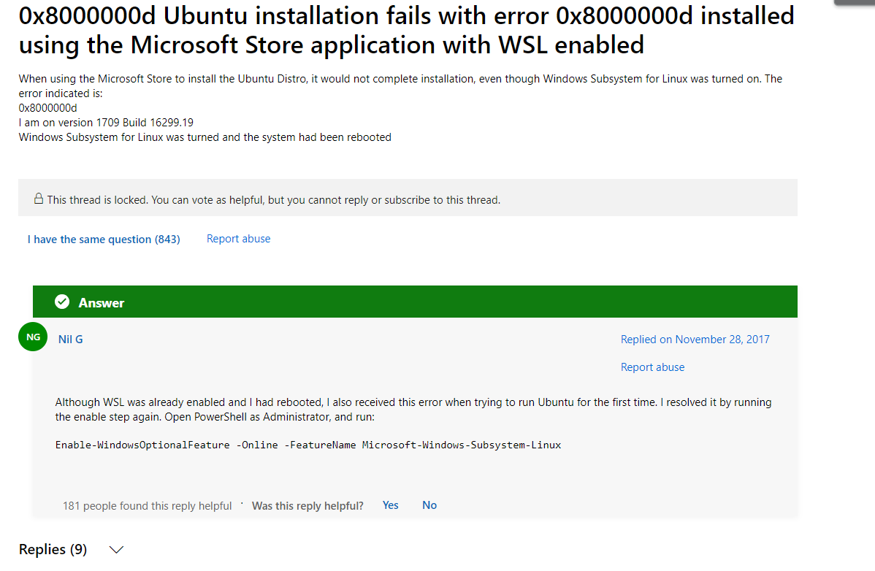

Enable-WindowsOptionalFeature -Online -FeatureName Microsoft-Windows-Subsystem-Linux

