Assignment #4. Forms and Validation
Student: Yernur Nassipkali
Group: SE-2517
Course: Web Technologies 1 (Front End)
The assignment is made on my personal page from the midterm (midterm.html). I did not create a separate page: I reworked the contact form that was already on the page and added a new “Register” section with a registration form. The validation logic is in a separate file js/forms.js, so the HTML stays clean.
File | What is inside
midterm.html | The page. Contact form (Tasks 0–3) and the new Register section (Task 4)
js/forms.js | New file. Adds is-valid / is-invalid to the fields, checks that the passwords match, shows the success alert
css/midterm.css | Not changed. All form styles come from Bootstrap

Part | Task | Where on the page
Part 1. Basic HTML Forms | Task 0. Simple Contact Form | Contact section, the form markup
 | Task 1. Form with HTML5 Validation | Contact section, attributes on the fields
Part 2. Bootstrap Forms | Task 2. Bootstrap Form Styling | Contact section
 | Task 3. Bootstrap Validation Styles | Contact section + js/forms.js
Part 3. Advanced Form Project | Task 4. Registration Form | Register section + js/forms.js

A “Register” link was added to the navbar, so the new section can be opened from the menu:
Figure 1 — Navbar with the new Register link

Part 1. Basic HTML Forms

Task 0. Simple Contact Form
Task: Create a basic contact form with the following fields:
• Name (text input)
• Email (email input)
• Message (textarea)
• Submit button
• Ensure all fields have proper <label> elements.
I started from the plain HTML structure of the form, without any classes. Every field has its own <label>. The for attribute of the label is the same as the id of the input, so clicking on the text “Name” puts the cursor into the Name field, and screen readers read the label when the field gets focus. The name attribute is the key that the browser uses when it sends the form.
midterm.html — the base structure of the contact form
<form id="contactForm" action="#" method="post">
<label for="name">Name</label>
<input type="text" id="name" name="name">

<label for="email">Email</label>
<input type="email" id="email" name="email">

<label for="message">Message</label>
<textarea id="message" name="message" rows="4"></textarea>

<button type="submit">Send</button>
</form>
Besides the four required fields, my form also has a Topic dropdown (<select>), a “Reply via” radio group inside <fieldset> with <legend>, an agreement checkbox and a Clear button (type="reset").
Field | Element | Label
Name | <input type="text"> | <label for="name">
Email | <input type="email"> | <label for="email">
Topic | <select> | <label for="topic">
Reply via | <input type="radio"> × 2 | <legend> + a label for each radio
Message | <textarea> | <label for="message">
Agreement | <input type="checkbox"> | <label for="agree">
Send / Clear | <button type="submit">, <button type="reset"> | Text inside the button

To show how the form looks only with HTML, I turned Bootstrap off for this screenshot. Without CSS the browser shows the default inputs one after another:
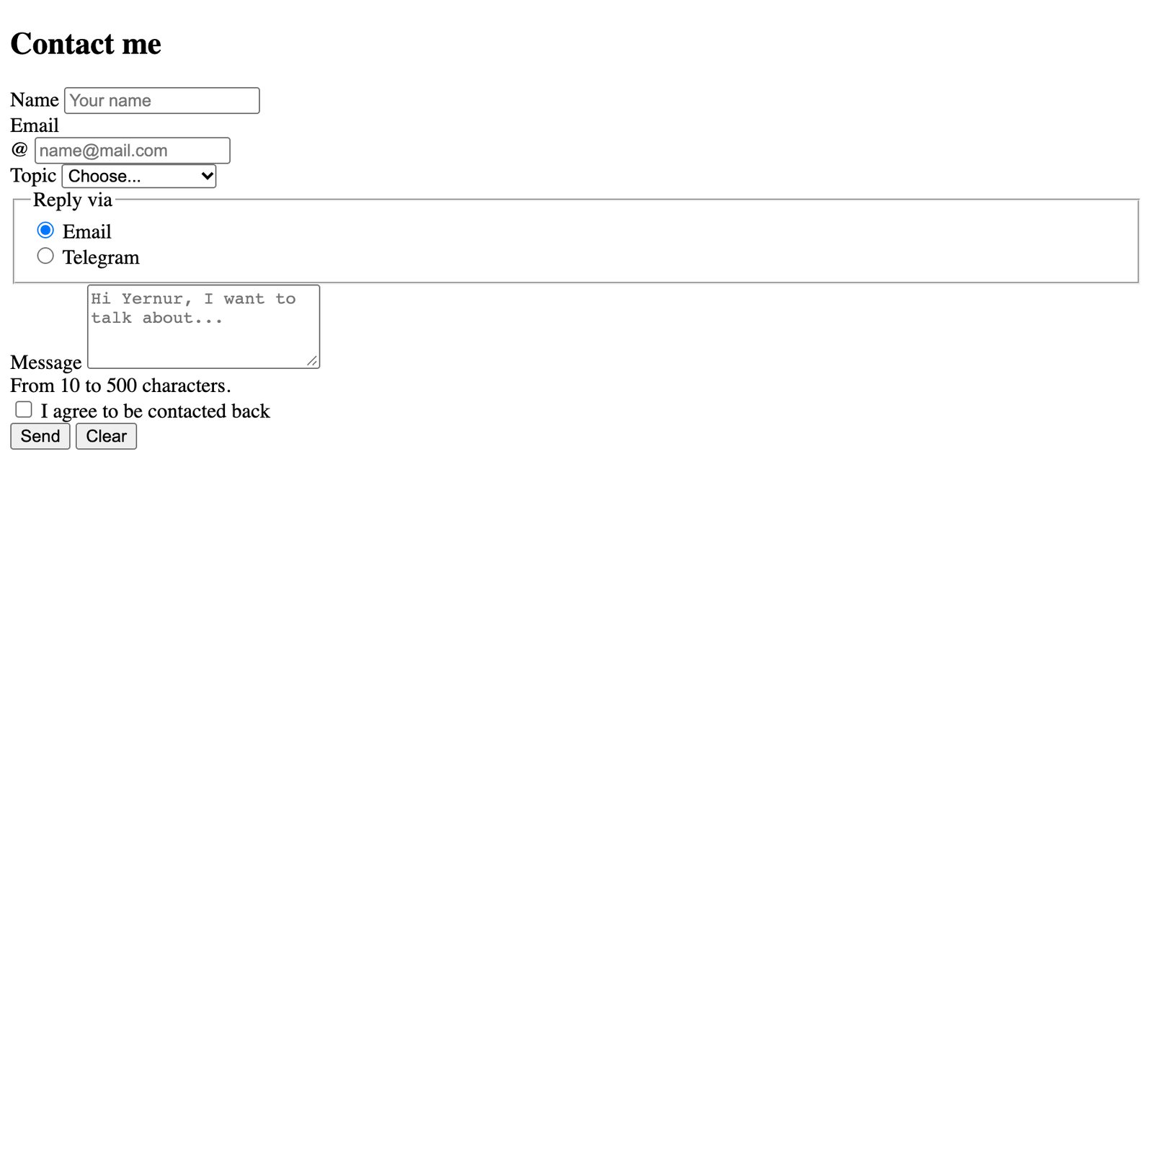
Figure 2 — Task 0 — the contact form as plain HTML (Bootstrap CSS turned off)

Task 1. Form with HTML5 Validation
Task: Add built-in validation attributes (required, type, maxlength, etc.).
• Test how the browser enforces validation (e.g., email format, empty fields).
HTML5 can check the form without any JavaScript. I added these attributes:
Field | Attributes | What the browser checks
Name | required minlength="2" maxlength="50" | Not empty, 2–50 characters
Email | type="email" required maxlength="100" pattern="[^@\s]+@[^@\s]+\.[^@\s]+" | Not empty, has @, has a dot after @
Topic | required + first option with value="" | A real topic is chosen, not “Choose...”
Message | required minlength="10" maxlength="500" | Not empty, 10–500 characters
Agreement | required | The checkbox is checked

midterm.html
<input type="text" id="name" name="name" minlength="2" maxlength="50" autocomplete="name" required>

<input type="email" id="email" name="email" maxlength="100"
pattern="[^@\s]+@[^@\s]+\.[^@\s]+" title="Email should look like name@mail.com." required>

<select id="topic" name="topic" required>
<option selected disabled value="">Choose...</option>
...
</select>

<textarea id="message" name="message" rows="4" minlength="10" maxlength="500" required></textarea>

<input type="checkbox" id="agree" name="agree" required>
Why the email has a pattern: type="email" alone accepts addresses like a@b (without a dot). The pattern also needs a dot after the @. The title attribute is the hint that the browser shows when the pattern does not match.

Testing in the browser
I tried to send the form with wrong data in Google Chrome. The browser stops the form and shows a message next to the first wrong field. My Chrome is in Russian, so the messages are in Russian; the English text is in the table.
Test | Input | Chrome message (English) | Result
Empty form | (nothing) | Please fill out this field. | Blocked
Email without @ | yernur | Please include an '@' in the email address. 'yernur' is missing an '@'. | Blocked
Email without domain dot | yernur@mail | Please match the requested format. (+ my title text) | Blocked
Message too short | Hi there (8 chars) | Please lengthen this text to 10 characters or more (currently 8). | Blocked
Checkbox not checked | agree = off | Please check this box if you want to proceed. | Blocked
Typing 80 characters in Name | 80 × "Y" | browser stops at 50 characters (maxlength) | Blocked

The last test is for maxlength: it does not show a message, the browser just does not let you type more than 50 characters in the Name field.
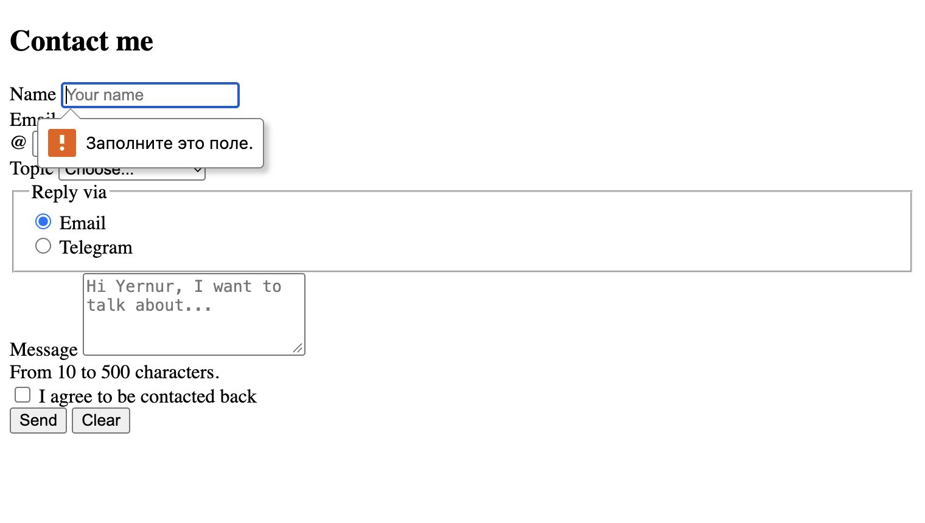
Figure 3 — Empty form: “Заполните это поле.” (Please fill out this field.) under the Name field
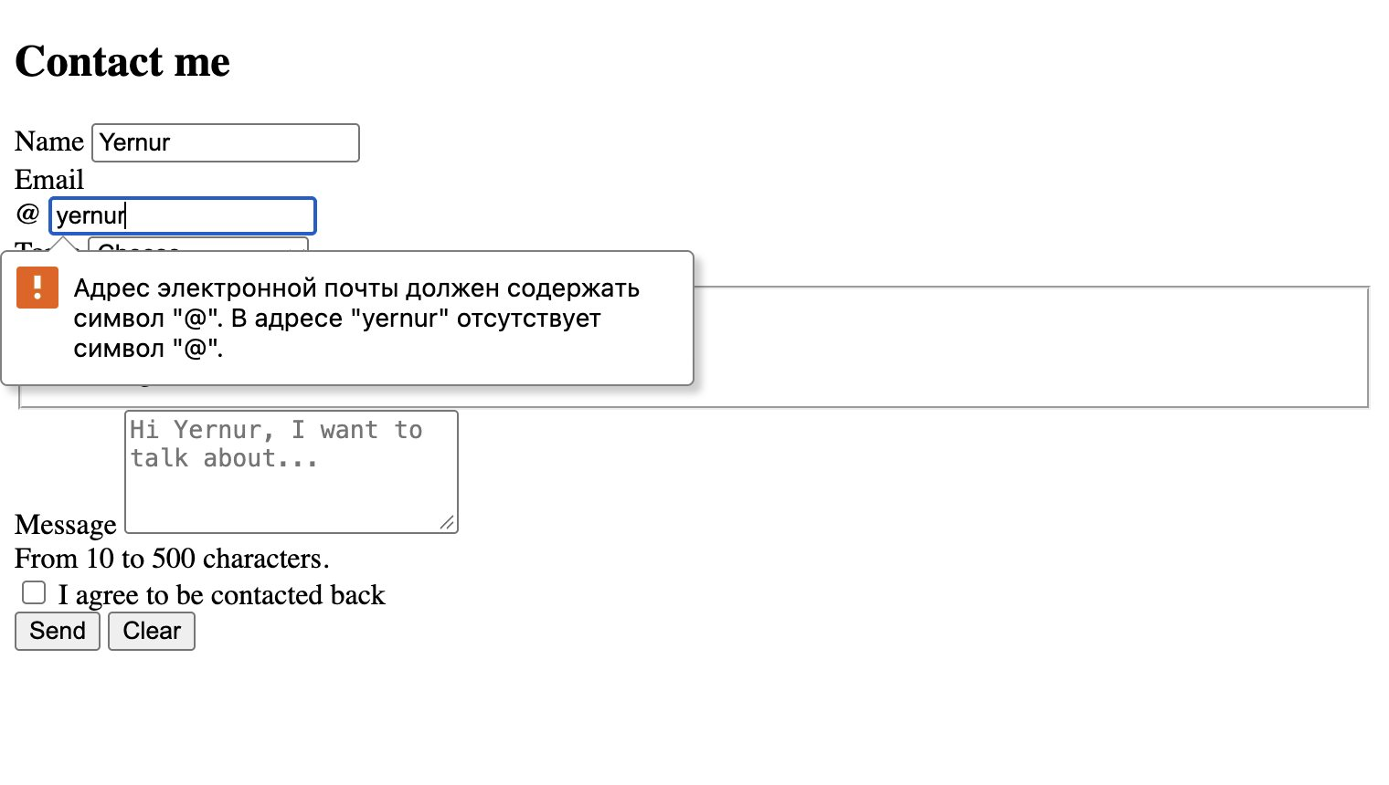
Figure 4 — type="email": the address “yernur” has no @ symbol
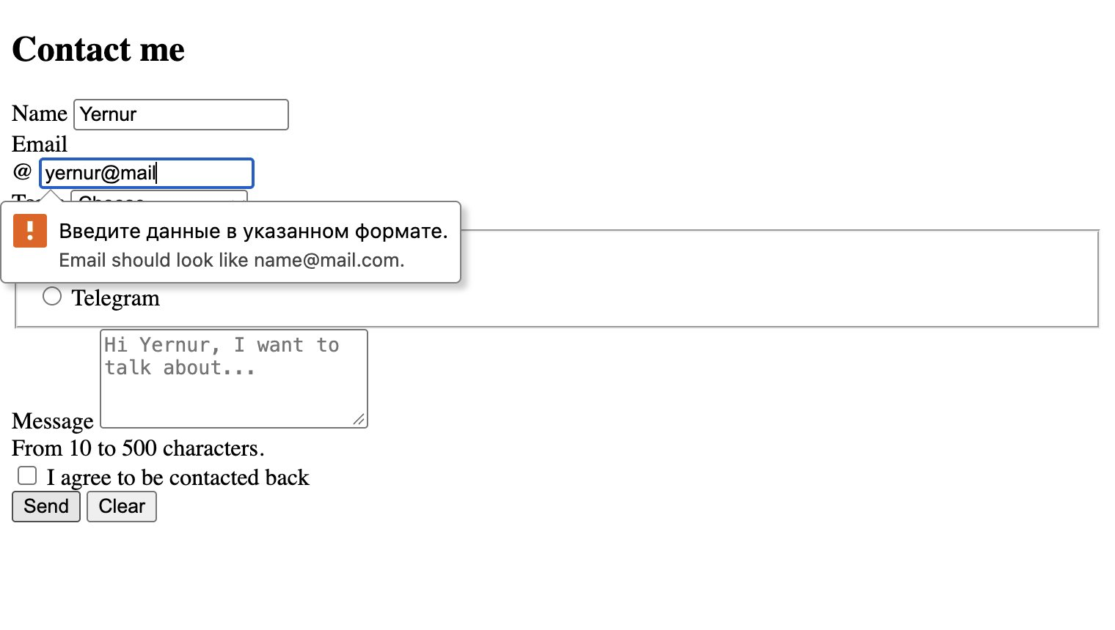
Figure 5 — pattern: “yernur@mail” has no dot, Chrome shows my title text under the message
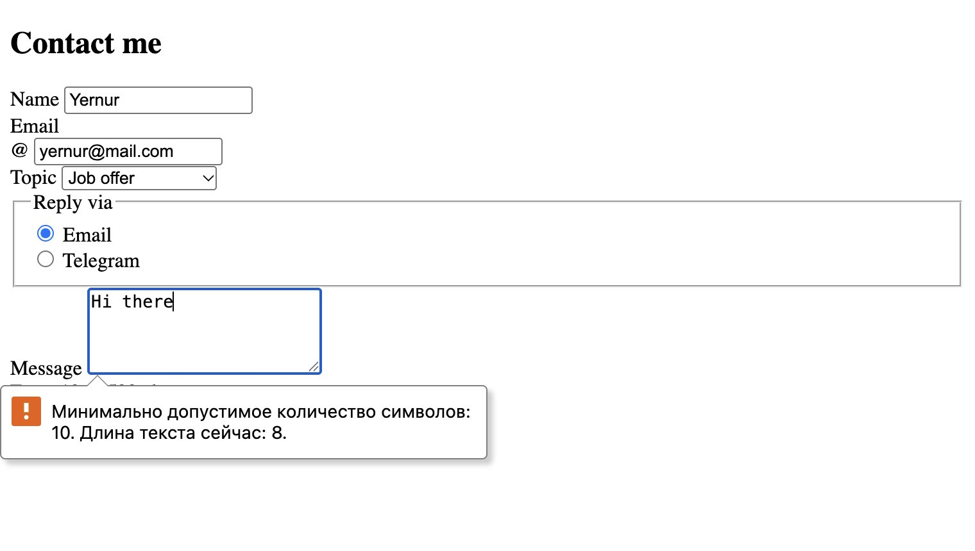
Figure 6 — minlength: the message has only 8 characters, 10 is the minimum
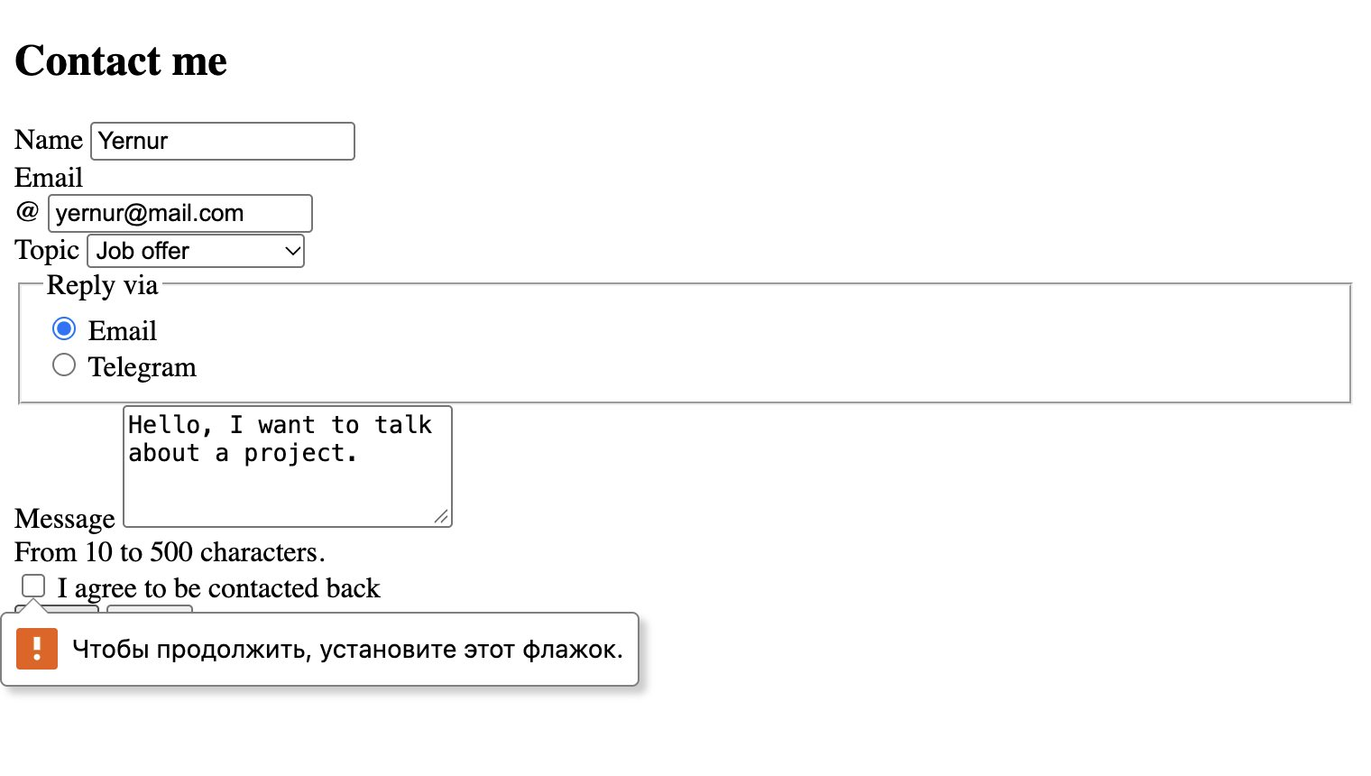
Figure 7 — required on the checkbox: the form is not sent until it is checked

Part 2. Bootstrap Forms

Task 2. Bootstrap Form Styling
Task: Recreate the contact form using Bootstrap form classes.
• Use Bootstrap’s grid system to arrange form fields neatly.
• Add placeholders and helper text where appropriate.
Then I added Bootstrap classes to the same form. I did not write any CSS for the form, everything is done with Bootstrap.
Element | Bootstrap classes
Labels | form-label
Text inputs, textarea | form-control
Topic dropdown | form-select
Email with @ | input-group + input-group-text
Radio buttons | form-check form-check-inline, form-check-input, form-check-label
Checkbox | form-check, form-check-input, form-check-label
Helper text | form-text
Buttons | btn-group with btn btn-primary and btn btn-outline-secondary
Form box | bg-white border rounded-3 p-3 p-md-4

Grid. The fields are inside .row g-3. Name and Email are col-12 col-sm-6: on phones they are under each other, and from 576px they stand side by side. The other fields are col-12 (full width). The whole form is in the right column of the Contact section (col-md-7 col-lg-6).
Placeholders and helper text. Every text field has a placeholder that shows an example (Your name, name@mail.com, Hi Yernur, I want to talk about...). Under the message there is helper text “From 10 to 500 characters.”, connected to the field with aria-describedby so screen readers read it too.
midterm.html
<form id="contactForm" class="bg-white border rounded-3 p-3 p-md-4" action="#" method="post">
<div class="row g-3">
<div class="col-12 col-sm-6">
<label for="name" class="form-label">Name</label>
<input type="text" class="form-control" id="name" name="name" placeholder="Your name"
minlength="2" maxlength="50" autocomplete="name" required>
<div class="valid-feedback">Looks good!</div>
<div class="invalid-feedback">Enter your name (2–50 characters).</div>
</div>
<div class="col-12 col-sm-6">
<label for="email" class="form-label">Email</label>
<div class="input-group has-validation">
<span class="input-group-text" id="emailIcon">@</span>
<input type="email" class="form-control" id="email" name="email" placeholder="name@mail.com" ... required>
<div class="valid-feedback">Looks good!</div>
<div class="invalid-feedback">Enter a valid email, for example name@mail.com.</div>
</div>
</div>
...
<div class="col-12">
<label for="message" class="form-label">Message</label>
<textarea class="form-control" id="message" name="message" rows="4"
placeholder="Hi Yernur, I want to talk about..." minlength="10" maxlength="500"
aria-describedby="messageHelp" required></textarea>
<div class="valid-feedback">Looks good!</div>
<div class="invalid-feedback">Message must be 10–500 characters.</div>
<div id="messageHelp" class="form-text">From 10 to 500 characters.</div>
</div>
...
</div>
</form>
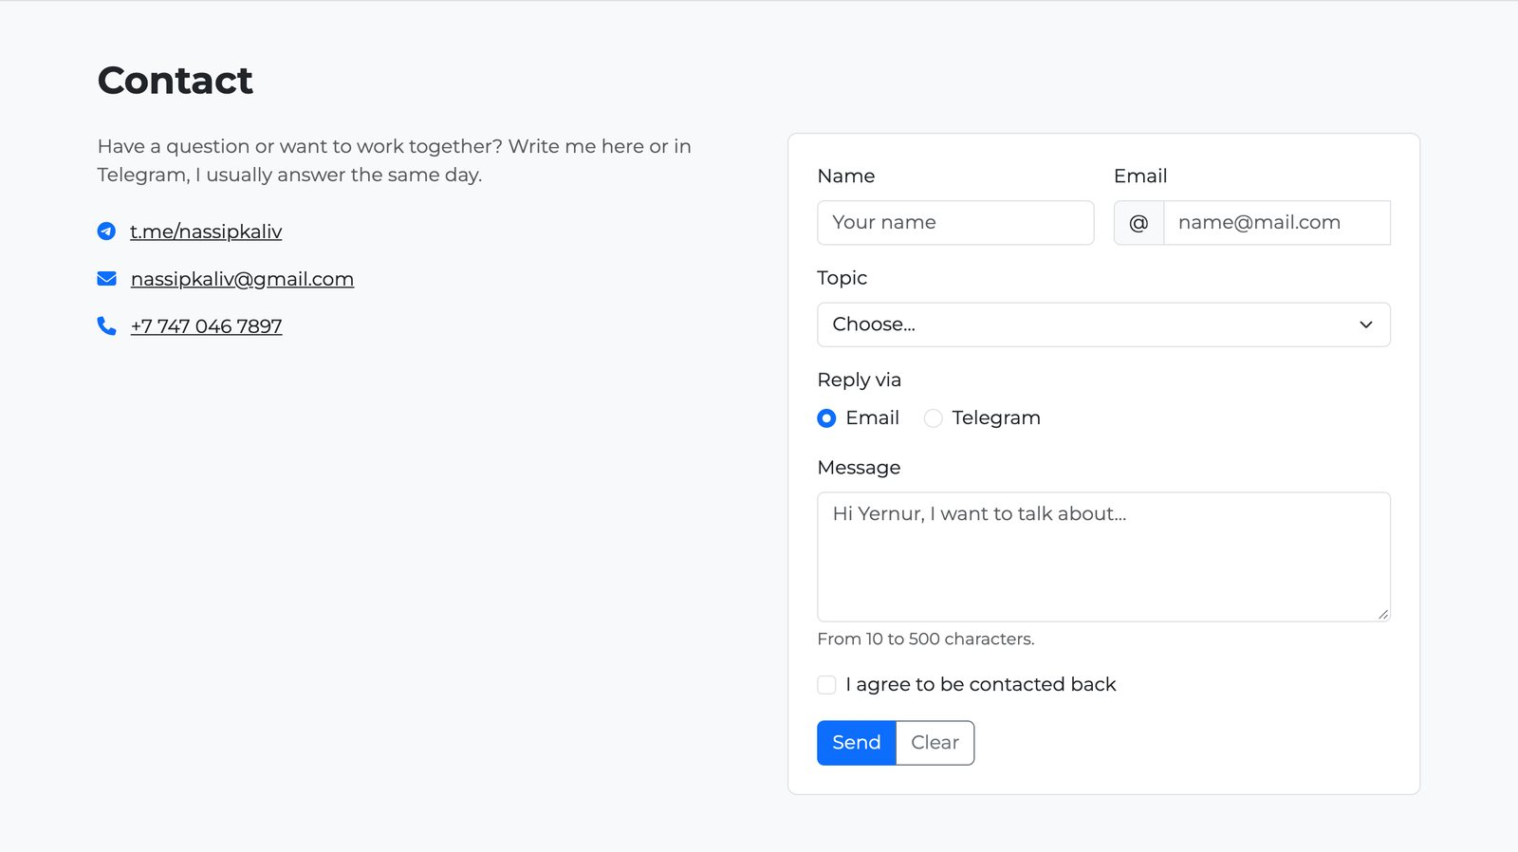
Figure 8 — Task 2 — the contact form with Bootstrap classes on desktop (form in col-lg-6)
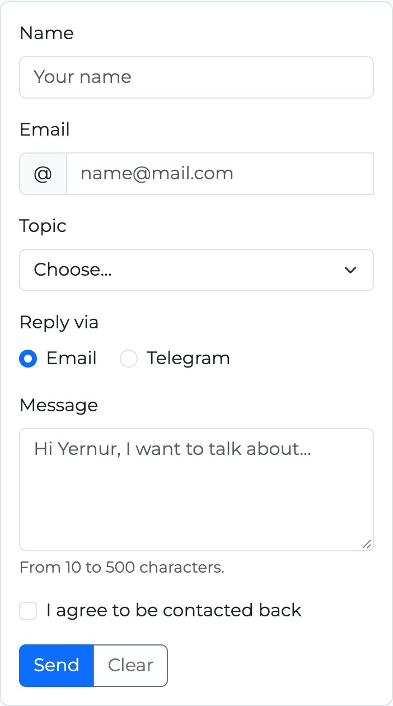
Figure 9 — Task 2 — the same form on a phone (375px): all fields are full width

Task 3. Bootstrap Validation Styles
Task: Apply Bootstrap’s validation feedback classes (is-valid, is-invalid).
• Show feedback messages below inputs (e.g., “Email is required”, “Looks good!”).
• Test the form by entering valid and invalid data.
In Task 1 the browser checks the form by itself. In Task 3 I kept these browser popups and added Bootstrap styles on top of them. That is why the form has no novalidate: the HTML5 rules (required, minlength, pattern...) still stop the form, and JavaScript only adds the Bootstrap classes.
- is-valid — green border, a check icon and the .valid-feedback text (“Looks good!”).
- is-invalid — red border, a warning icon and the .invalid-feedback text.
- The feedback divs are placed right after the input, because Bootstrap shows them only when they are next to the input with the class.
- For the email with input-group I added has-validation, otherwise the rounded corners of the group break when the message appears.

The error text is written in the HTML, in the .invalid-feedback div under each field. It describes the whole rule, so the same text fits an empty field and a wrong value: “Enter a valid email, for example name@mail.com.”, “Message must be 10–500 characters.”
In js/forms.js one function puts the classes on every field of the form. It reads field.validity.valid, which is the result of the HTML5 check:
js/forms.js
function showValidation(form) {
form.querySelectorAll('input, select, textarea').forEach((field) => {
field.classList.toggle('is-valid', field.validity.valid);
field.classList.toggle('is-invalid', !field.validity.valid);
});
}
The function is called from the events of the form:
- invalid — the browser found a wrong field. It stops the form and shows its popup, and the script colors all fields. The listener has true (capture), because the invalid event does not bubble up to the form.
- input — after the first try the colors are updated on every key press, so a field turns green as soon as it is fixed.
- submit — comes only when all fields are valid. event.preventDefault() stops the page reload (there is no server), then the form is cleared and the green alert is shown.
- reset — the Clear button removes all classes and hides the alert.

js/forms.js
['contactForm', 'registerForm'].forEach((id) => {
const form = document.getElementById(id);
const success = document.getElementById(id + 'Success');

form.addEventListener('invalid', () => showValidation(form), true);

form.addEventListener('input', () => {
if (form.querySelector('.is-valid, .is-invalid')) showValidation(form);
});

form.addEventListener('submit', (event) => {
event.preventDefault();
form.reset();
success.classList.remove('d-none');
});

form.addEventListener('reset', () => {
form.querySelectorAll('.is-valid, .is-invalid').forEach((field) => field.classList.remove('is-valid', 'is-invalid'));
success.classList.add('d-none');
});
});
Why validity.valid and not checkValidity(): checkValidity() fires the invalid event again, so the listener would call itself in a loop and the page would freeze. validity.valid only reads the result.
The success message is a normal Bootstrap alert in the HTML. It is hidden with d-none, and the script only removes this class:
midterm.html
<div id="contactFormSuccess" class="alert alert-success d-none" role="alert">Thank you! Your message was sent.</div>

Testing with valid and invalid data
Step | What I entered | What happened | Result
1 | Nothing, clicked Send | Chrome popup “Заполните это поле.” (Please fill out this field.) at Name, 5 fields red with messages | Pass
2 | Name “Yernur”, email “yernur@mail”, message “Hi there” | Name and Topic green “Looks good!”, email “Enter a valid email, for example name@mail.com.”, message “Message must be 10–500 characters.” | Pass
3 | Fixed email and message, checked the box | All fields green | Pass
4 | Clicked Send | Green alert “Thank you! Your message was sent.”, the form is cleared | Pass
5 | Clicked Clear after errors | All red / green classes and the alert are removed | Pass

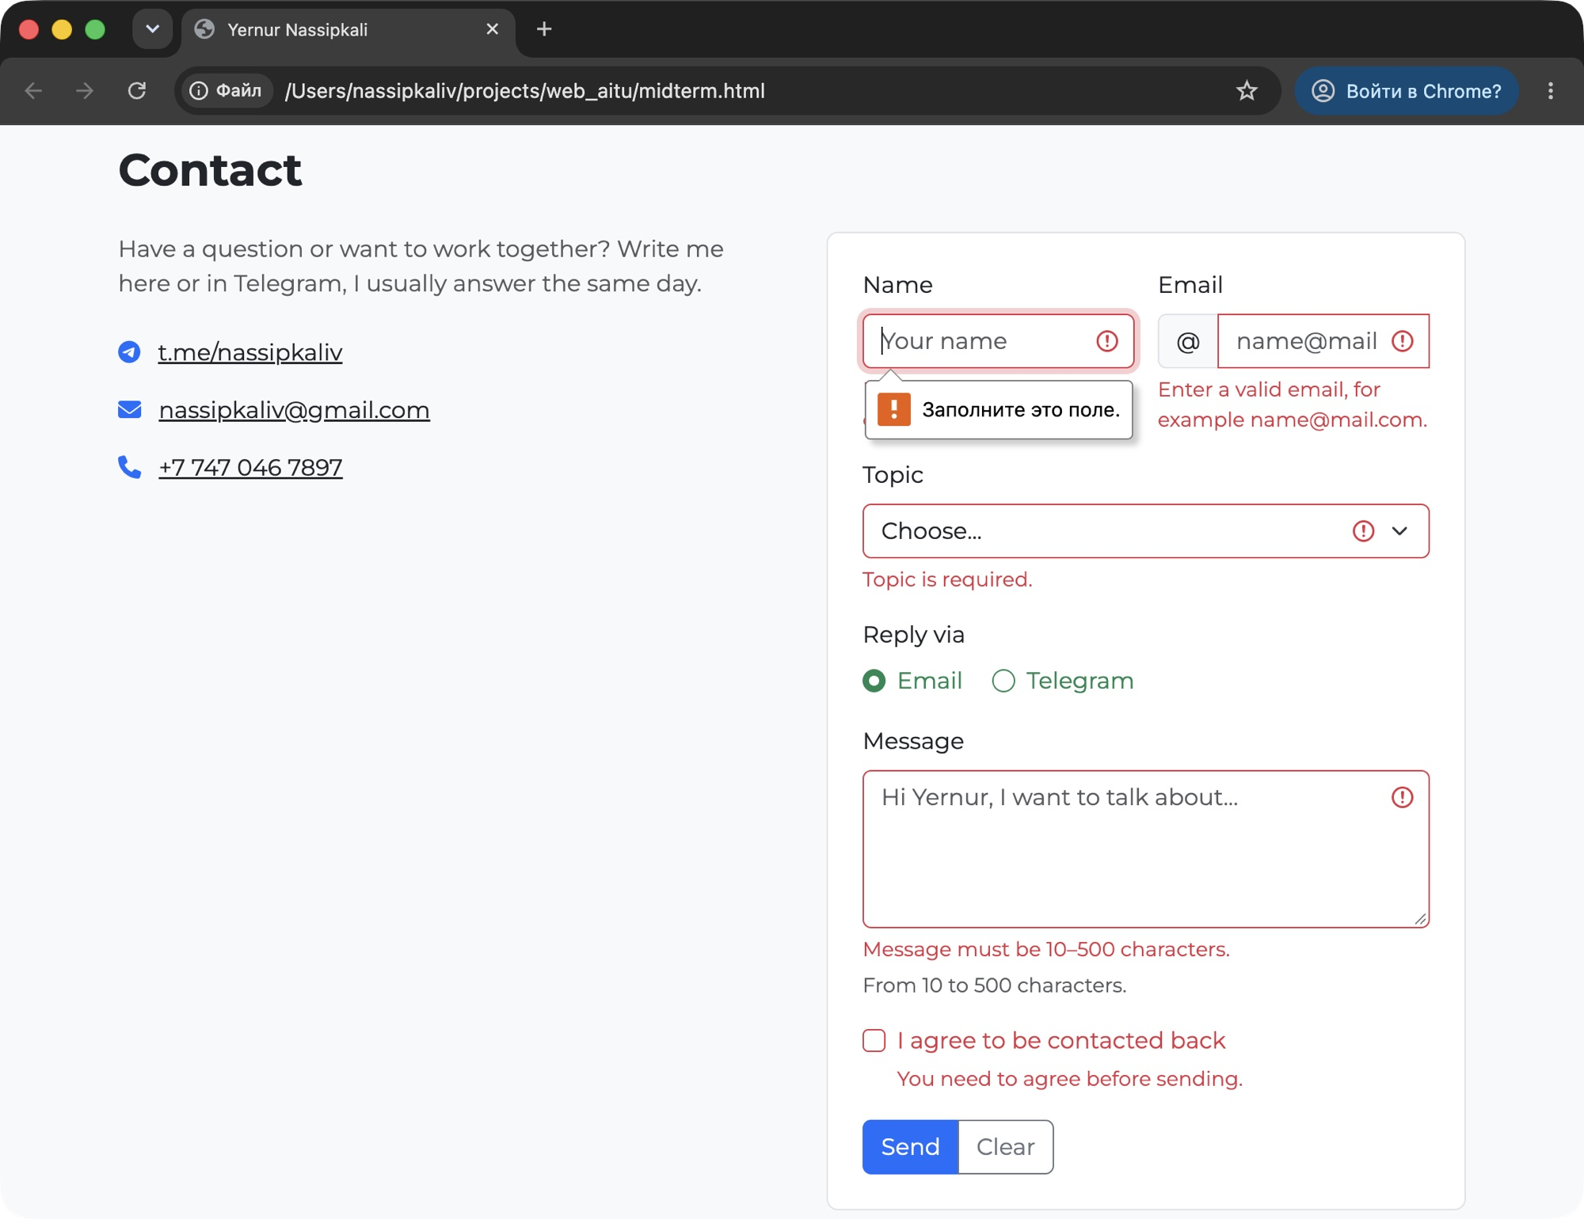
Figure 10 — Task 3 — HTML5 and Bootstrap together: the Chrome popup “Заполните это поле.” (Please fill out this field.) and the red Bootstrap fields
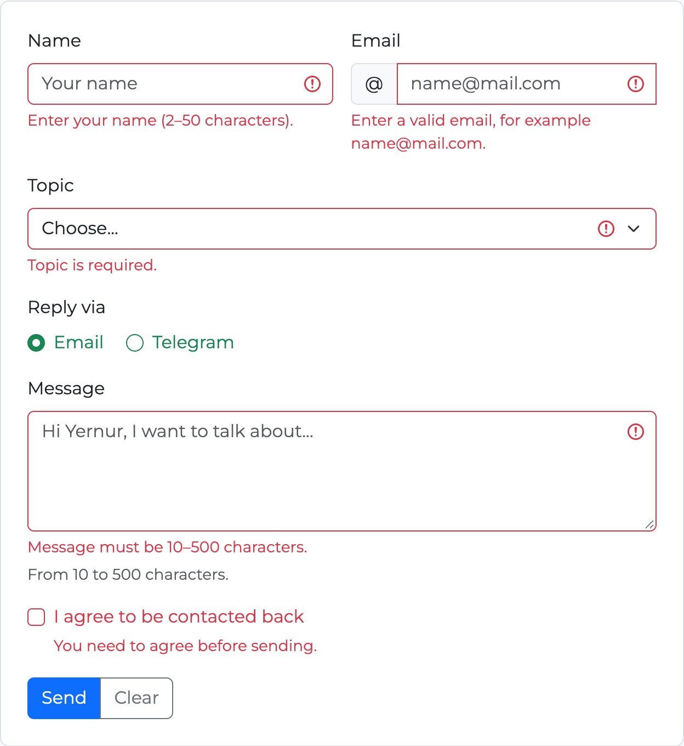 | 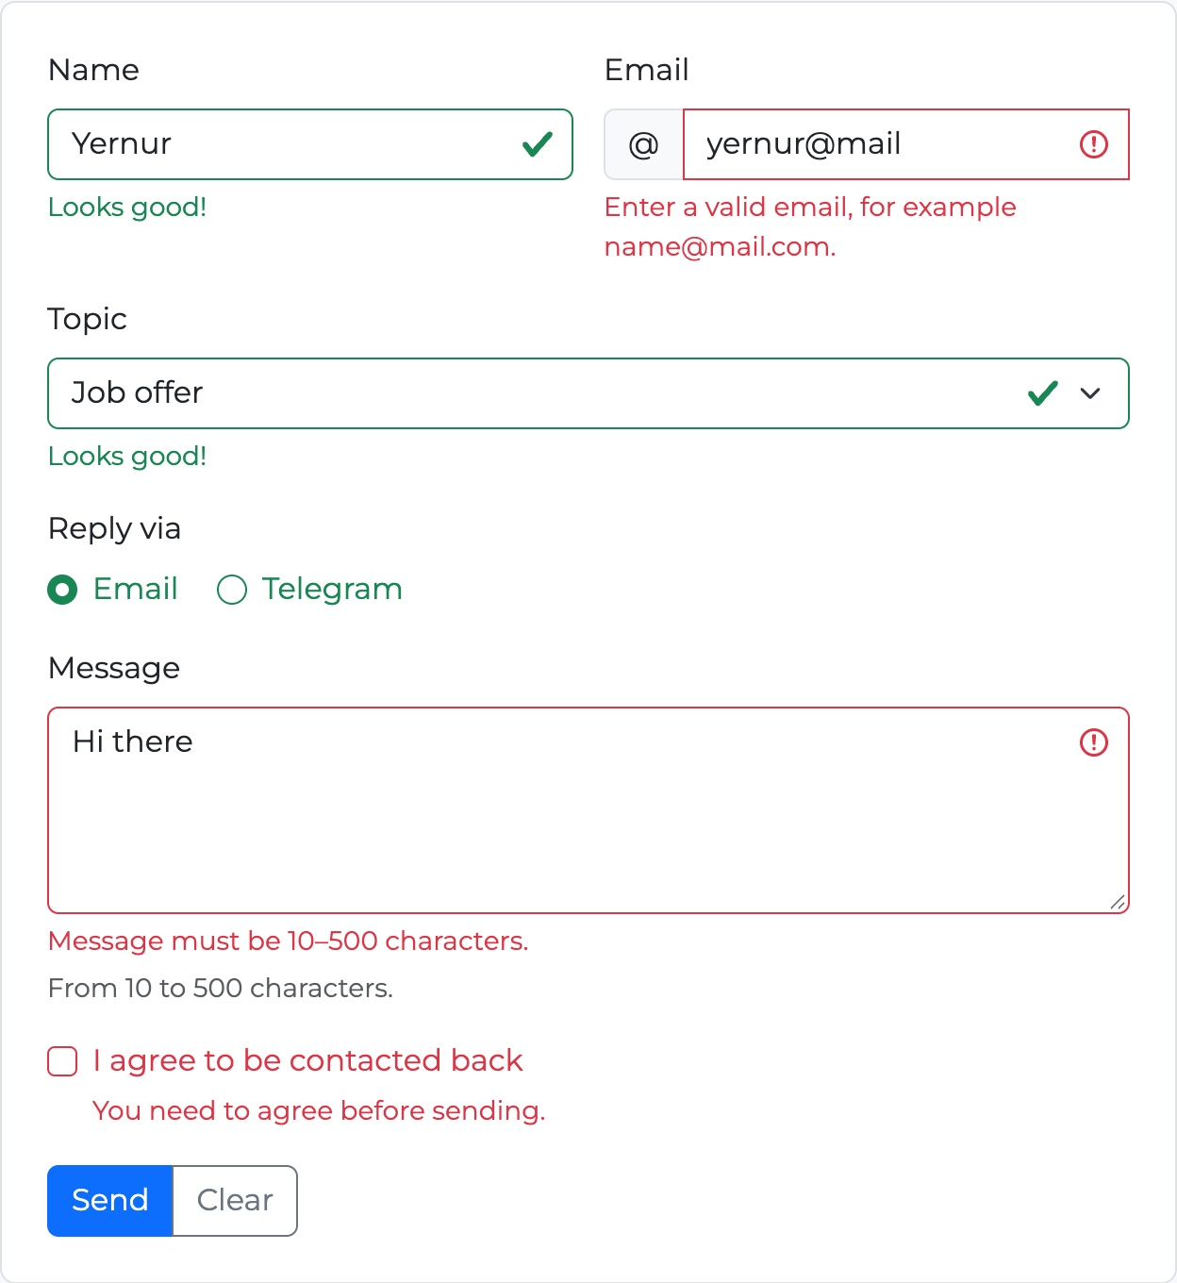
Figure 11 — Task 3 — empty form after Send (left) and mixed valid / invalid data (right)
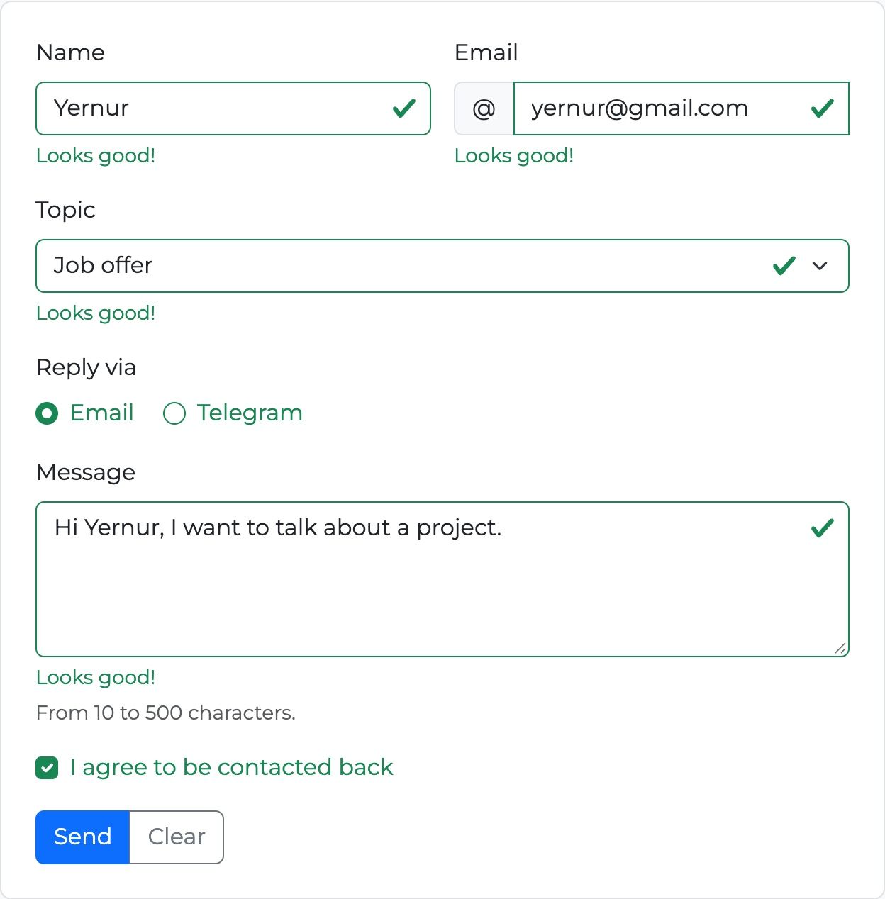 | 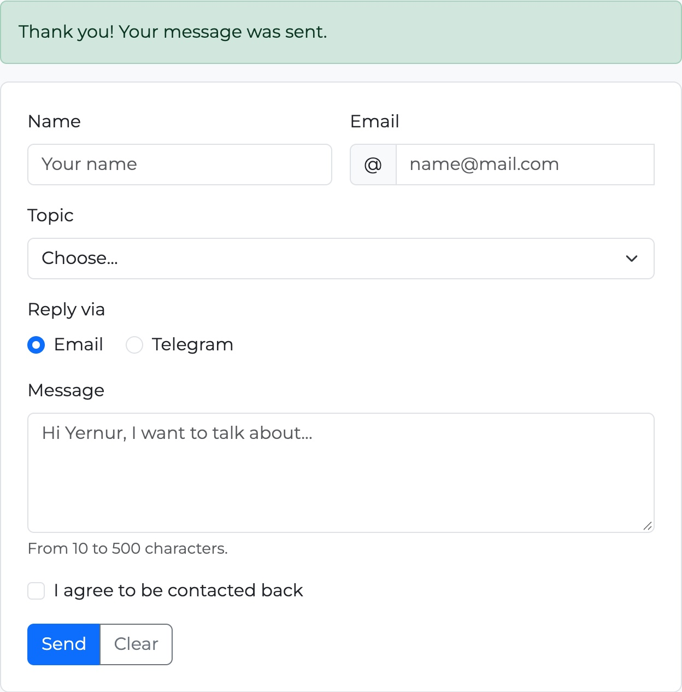
Figure 12 — Task 3 — all fields are valid (left) and the success alert after sending (right)

Part 3. Advanced Form Project

Task 4. Registration Form
Task: Create a registration form for a website. It should include: First Name, Last Name, Email, Password + Confirm Password, Gender (radio buttons), Hobbies (checkboxes), Country (select dropdown), Submit and Reset buttons.
• Style the form with Bootstrap Grid so it is responsive.
• Add HTML5 validation (e.g., password must have minimum length).
• Add Bootstrap validation feedback to display error/success messages.
I added a new section “Create an account” before Contact. On the left there is a short text about why to sign up and an info alert that says which fields are required. On the right there is the registration form.
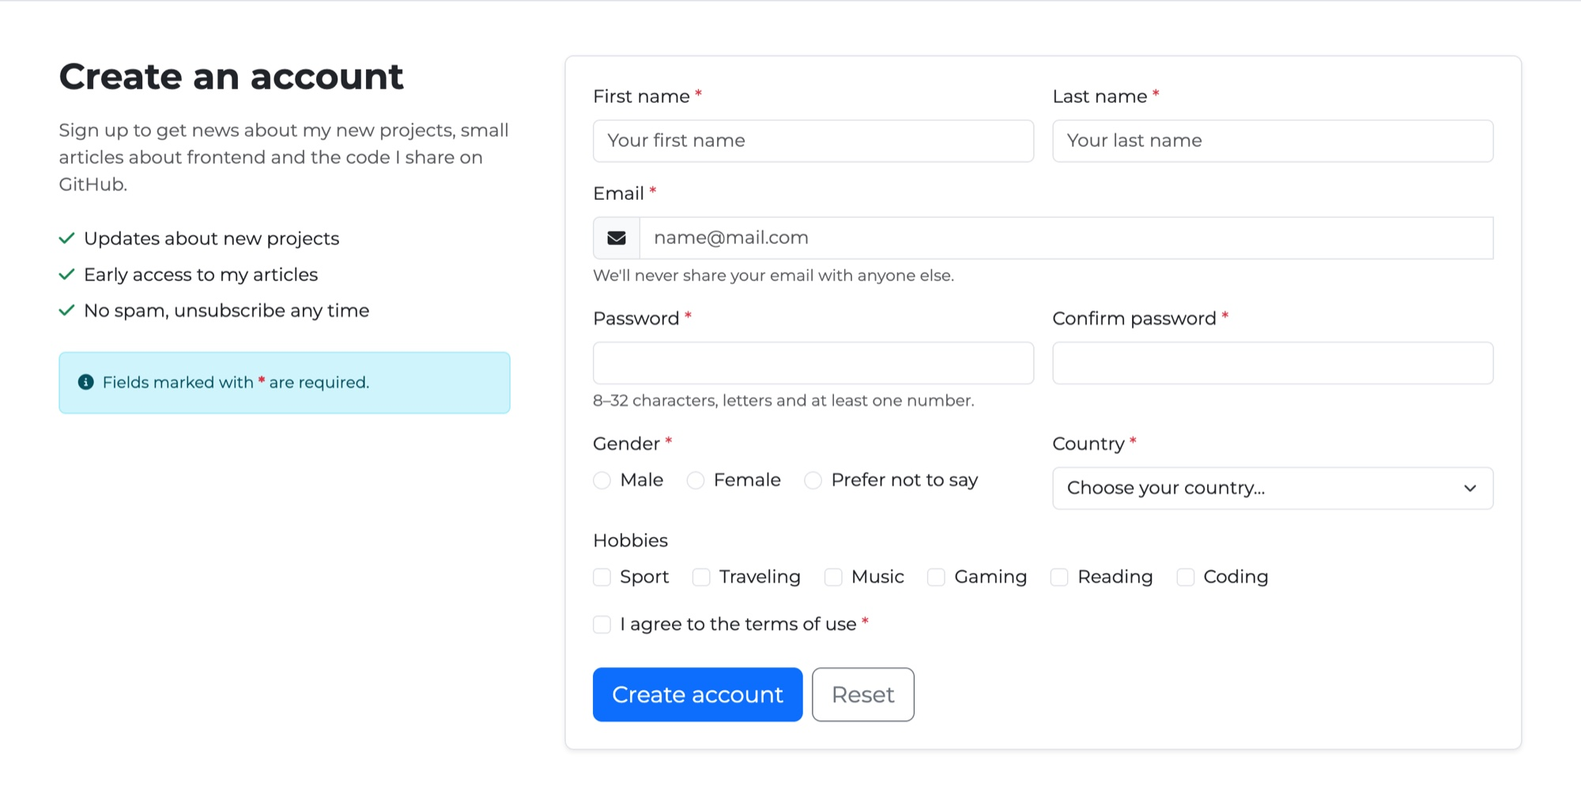
Figure 13 — Task 4 — the Register section on desktop: text in col-lg-4, form in col-lg-8

Fields and validation
Field | Type | HTML5 validation | Extra check in JS
First name, Last name | text | required minlength="2" maxlength="30" pattern | —
Email | email | required maxlength="100" pattern | —
Password | password | required minlength="8" maxlength="32" pattern | —
Confirm password | password | required | Must be the same as Password
Gender | radio × 3 | required (one of the group) | —
Country | select | required + empty first option | —
Hobbies | checkbox × 6 | not required by the task | —
Terms | checkbox | required | —

- Names — pattern="[A-Za-zА-Яа-яЁёӘәІіҢңҒғҮүҰұҚқӨөҺһ\s\-]+" allows only letters (also Russian and Kazakh), spaces and “-”. “Yernur1” is not accepted.
- Password — minlength="8" and pattern="(?=.*[A-Za-z])(?=.*\d).+": at least 8 characters, at least one letter and one number. The helper text under the field explains this before the user makes a mistake.
- Confirm password — HTML has no attribute for “same as another field”, so I used setCustomValidity(). If the passwords are different, the field becomes invalid with the message “Passwords do not match.”
- Hobbies — the task does not say that a hobby must be chosen, so the checkboxes are not required.

setCustomValidity('text') makes the field invalid, and the browser shows this text in its popup. setCustomValidity('') makes it valid again. The check runs on every key press in both password fields:
js/forms.js
function checkPasswords() {
const same = confirmPassword.value === password.value;
confirmPassword.setCustomValidity(same ? '' : 'Passwords do not match.');
}

password.addEventListener('input', checkPasswords);
confirmPassword.addEventListener('input', checkPasswords);

Grid and responsive layout
Inside the form there is a .row g-3. Pairs of fields use col-12 col-md-6, long fields (Email, Hobbies, Terms) use col-12.
Field | < 768px | 768px+ (md) | 992px+ (lg)
Section: text / form | 12 / 12 | 12 / 12 | 4 / 8
First name + Last name | 12 + 12 | 6 + 6 | 6 + 6
Email | 12 | 12 | 12
Password + Confirm | 12 + 12 | 6 + 6 | 6 + 6
Gender + Country | 12 + 12 | 6 + 6 | 6 + 6
Hobbies, Terms, Buttons | 12 | 12 | 12

midterm.html
<form id="registerForm" class="border rounded-3 shadow-sm p-3 p-md-4">
<div class="row g-3">
<div class="col-12 col-md-6">
<label for="firstName" class="form-label">First name <span class="text-danger">*</span></label>
<input type="text" class="form-control" id="firstName" name="firstName" placeholder="Your first name"
minlength="2" maxlength="30" pattern="..." title="Use only letters." autocomplete="given-name" required>
<div class="valid-feedback">Looks good!</div>
<div class="invalid-feedback">Enter your first name (2–30 letters).</div>
</div>
...
<div class="col-12 col-md-6">
<label for="password" class="form-label">Password <span class="text-danger">*</span></label>
<input type="password" class="form-control" id="password" name="password" minlength="8" maxlength="32"
pattern="(?=.*[A-Za-z])(?=.*\d).+" title="Use letters and at least one number."
autocomplete="new-password" aria-describedby="passwordHelp" required>
<div class="valid-feedback">Strong enough!</div>
<div class="invalid-feedback">Password must be 8–32 characters with letters and a number.</div>
<div id="passwordHelp" class="form-text">8–32 characters, letters and at least one number.</div>
</div>
...
<fieldset class="col-12">
<legend class="form-label fs-6 mb-2">Hobbies</legend>
<div class="form-check form-check-inline">
<input class="form-check-input" type="checkbox" name="hobbies" id="hobbySport" value="Sport">
<label class="form-check-label" for="hobbySport">Sport</label>
</div>
...
</fieldset>
...
<div class="col-12 d-flex flex-wrap gap-2 pt-2">
<button type="submit" class="btn btn-primary btn-lg" id="registerButton">Create account</button>
<button type="reset" class="btn btn-outline-secondary btn-lg">Reset</button>
</div>
</div>
</form>
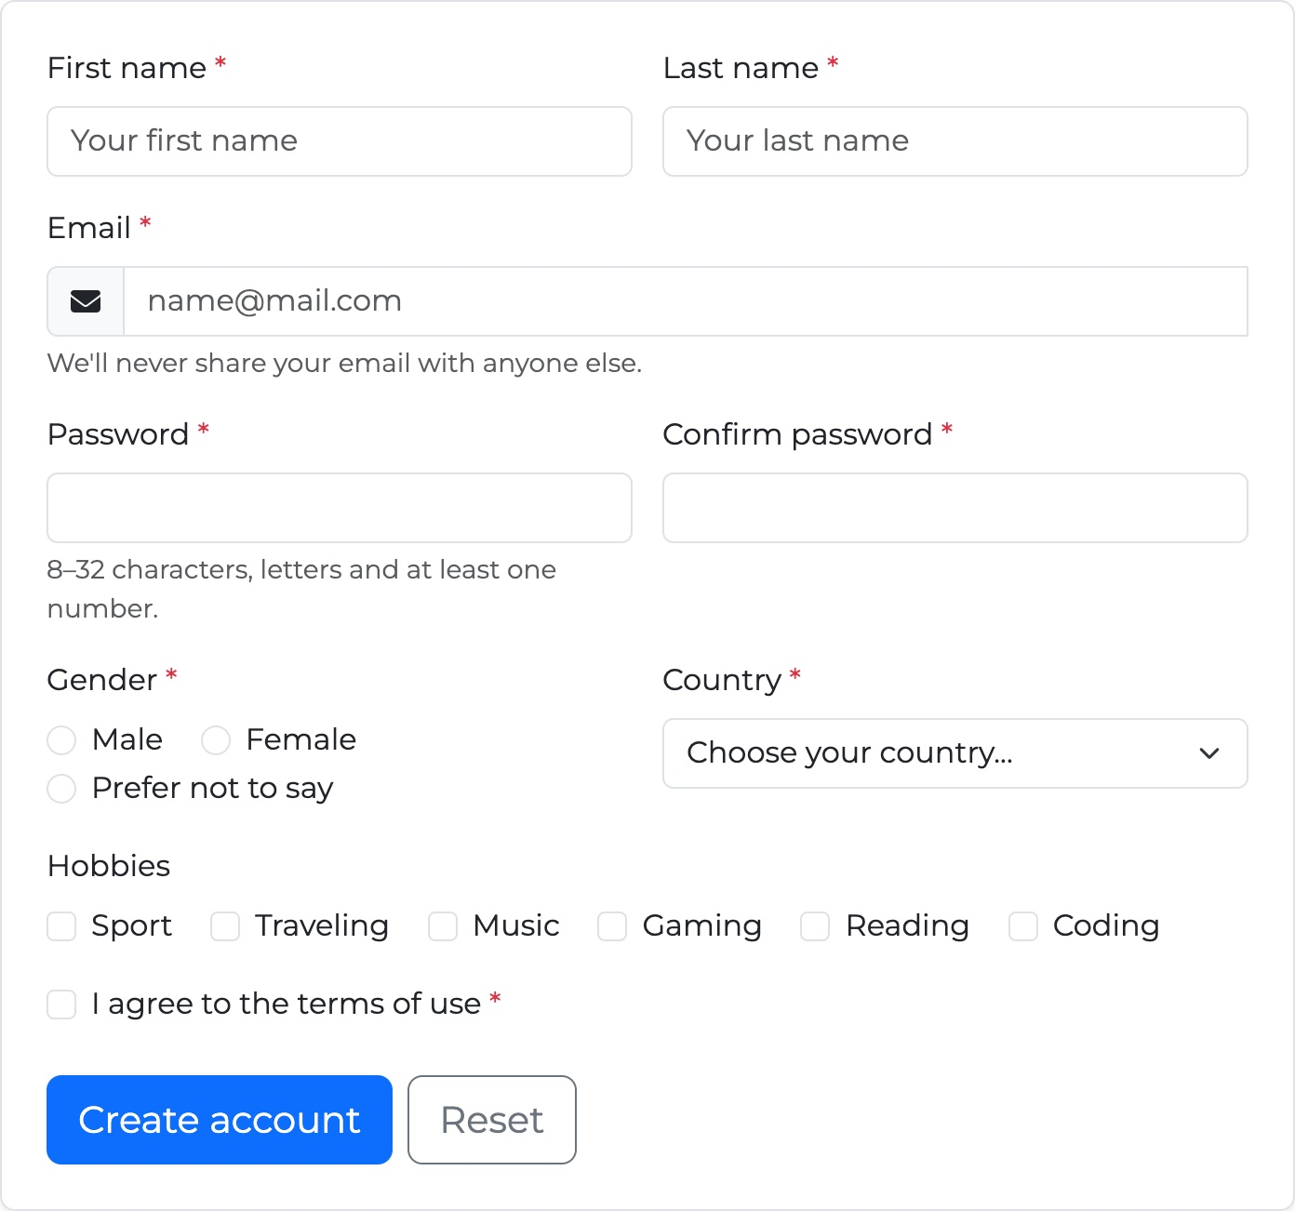 | 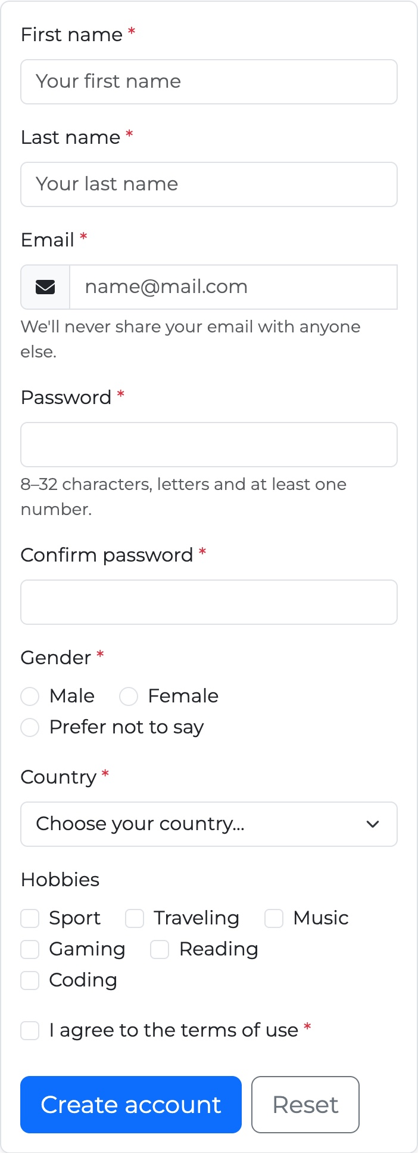
Figure 14 — Task 4 — tablet 768px (left): two fields in a row; phone 375px (right): one field per row

Error and success messages
When the user clicks “Create account”, the browser checks all HTML5 rules. If something is wrong, it stops the form, shows its popup at the first wrong field, and every field gets is-valid or is-invalid with its message under it. This is the same code as in Task 3: the loop in js/forms.js goes through both form ids.
When everything is correct, the form is cleared and the green alert above it is shown:
midterm.html
<div id="registerFormSuccess" class="alert alert-success d-none" role="alert">Registration complete! Your account was created.</div>

Testing the registration form
Step | What I entered | What happened | Result
1 | Nothing, clicked Create account | Chrome popup at First name, all required fields red with messages | Pass
2 | First name “Yernur1”, last name “N” | “Enter your first name (2–30 letters).”, “Enter your last name (2–30 letters).” | Pass
3 | Email “yernur@gmail” | “Enter a valid email, for example name@mail.com.” | Pass
4 | Password “abc1” | “Password must be 8–32 characters with letters and a number.” | Pass
5 | Password “yernur2025”, confirm “yernur2024” | Chrome popup “Passwords do not match.” at Confirm password, the field is red | Pass
6 | All fields correct | All green (“Looks good!”, “Strong enough!”, “Passwords match!”) | Pass
7 | Clicked Create account | Green alert “Registration complete! Your account was created.”, the form is cleared | Pass
8 | Clicked Reset | All classes and the alert are removed | Pass

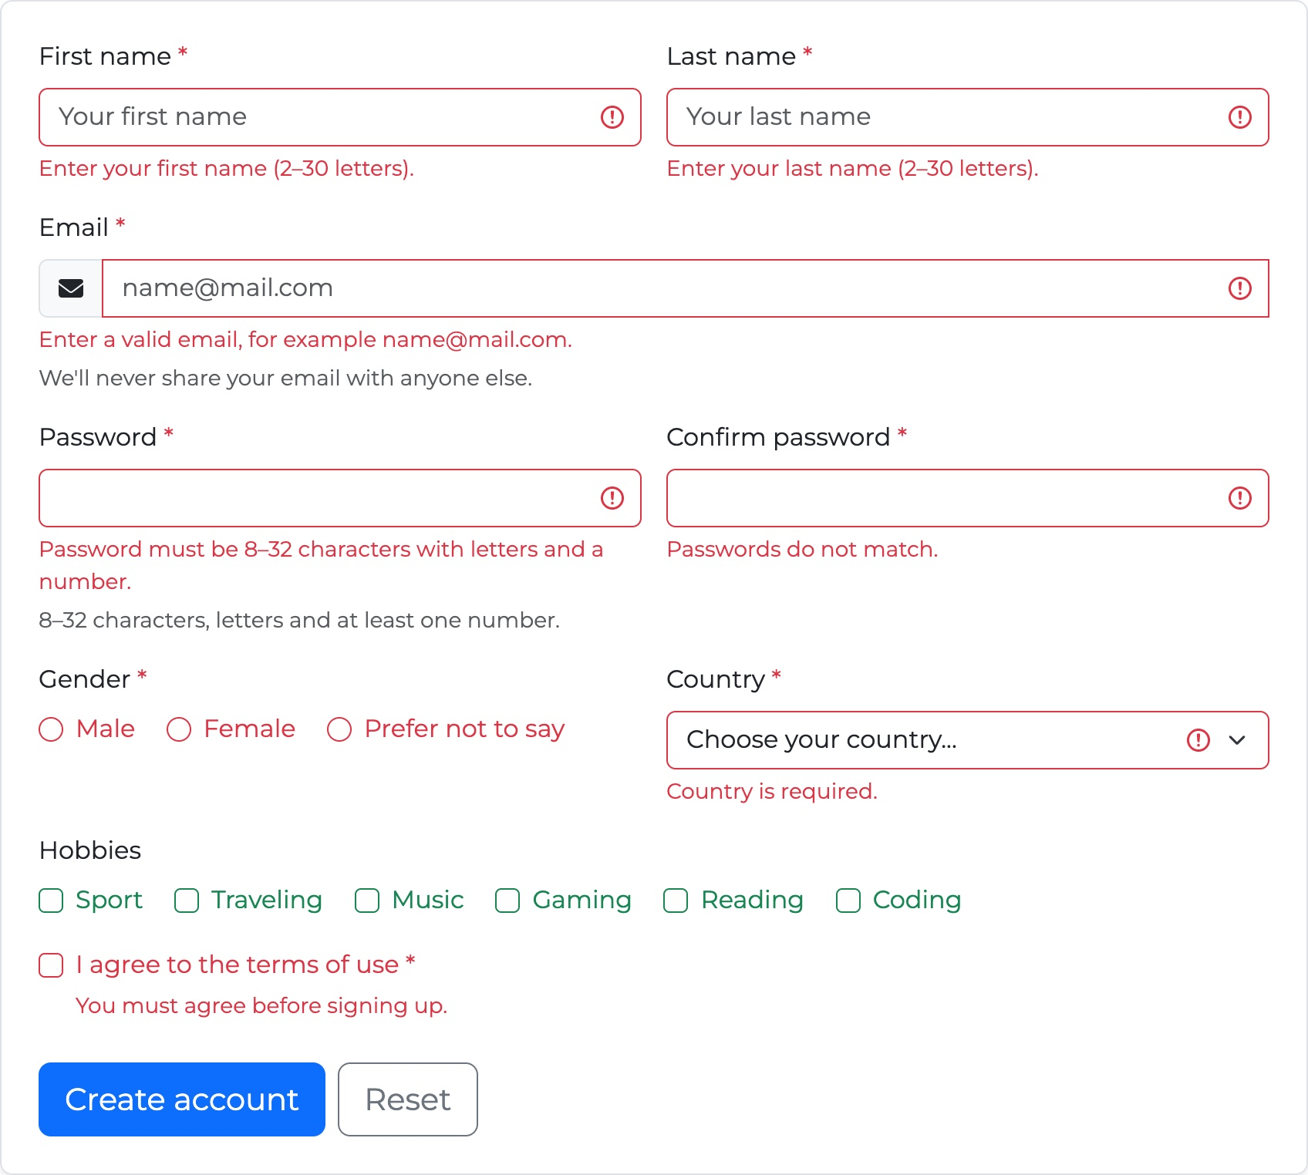 | 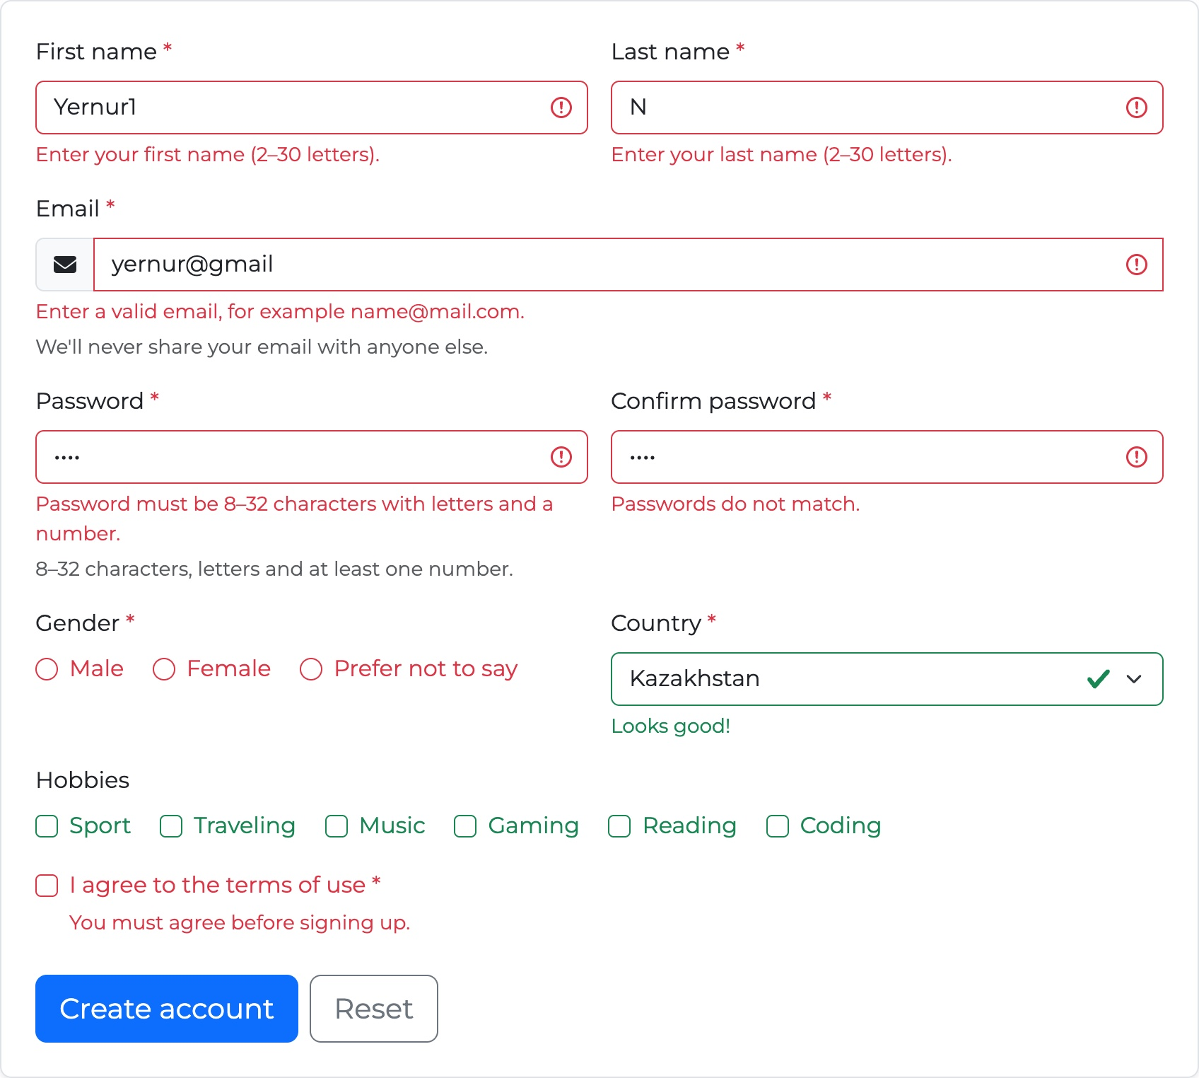
Figure 15 — Task 4 — empty form after Create account (left) and wrong data (right): every field shows its own message
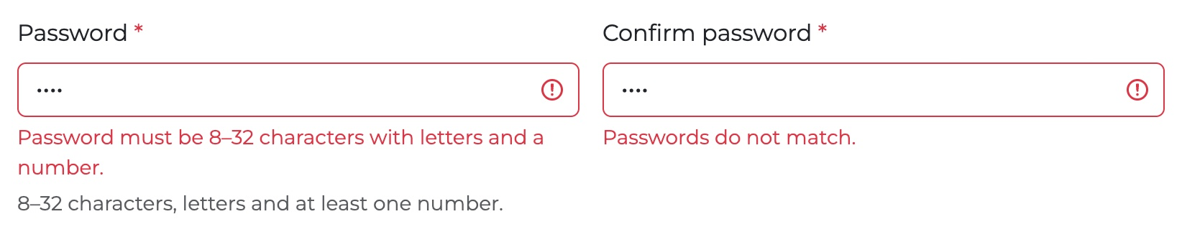
Figure 16 — Task 4 — the password is too short and the passwords do not match
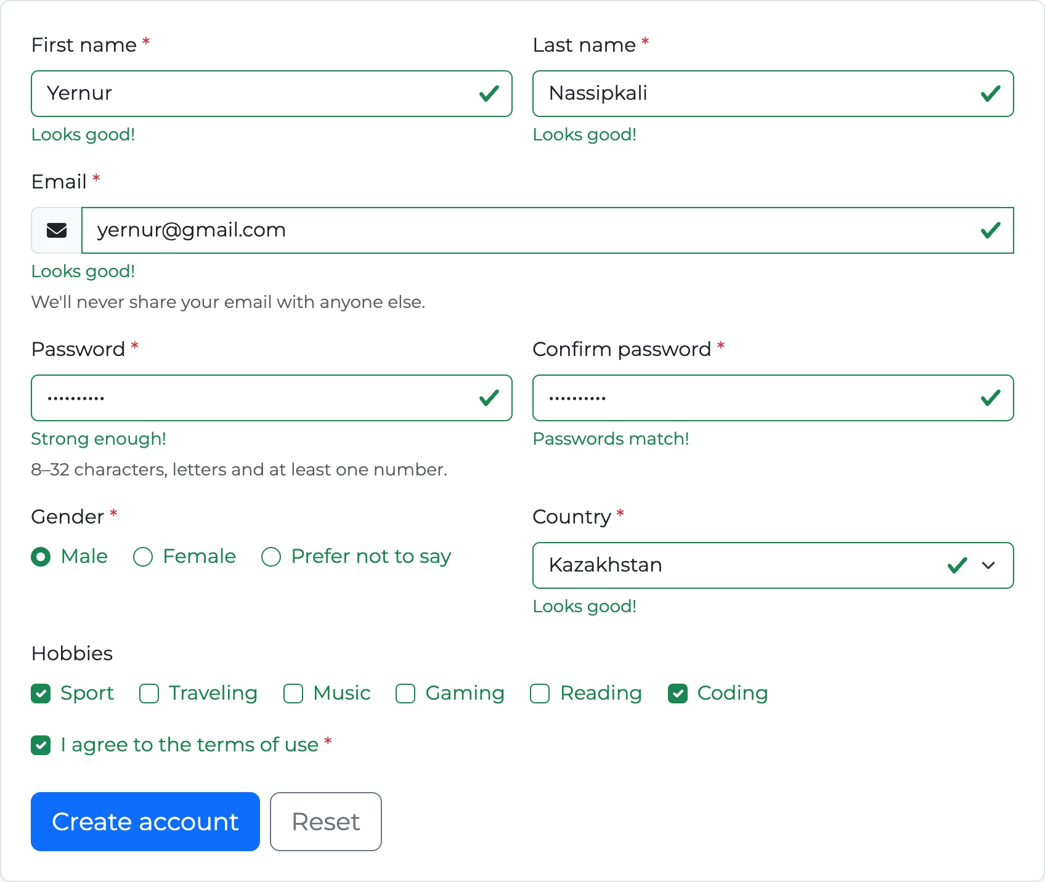 | 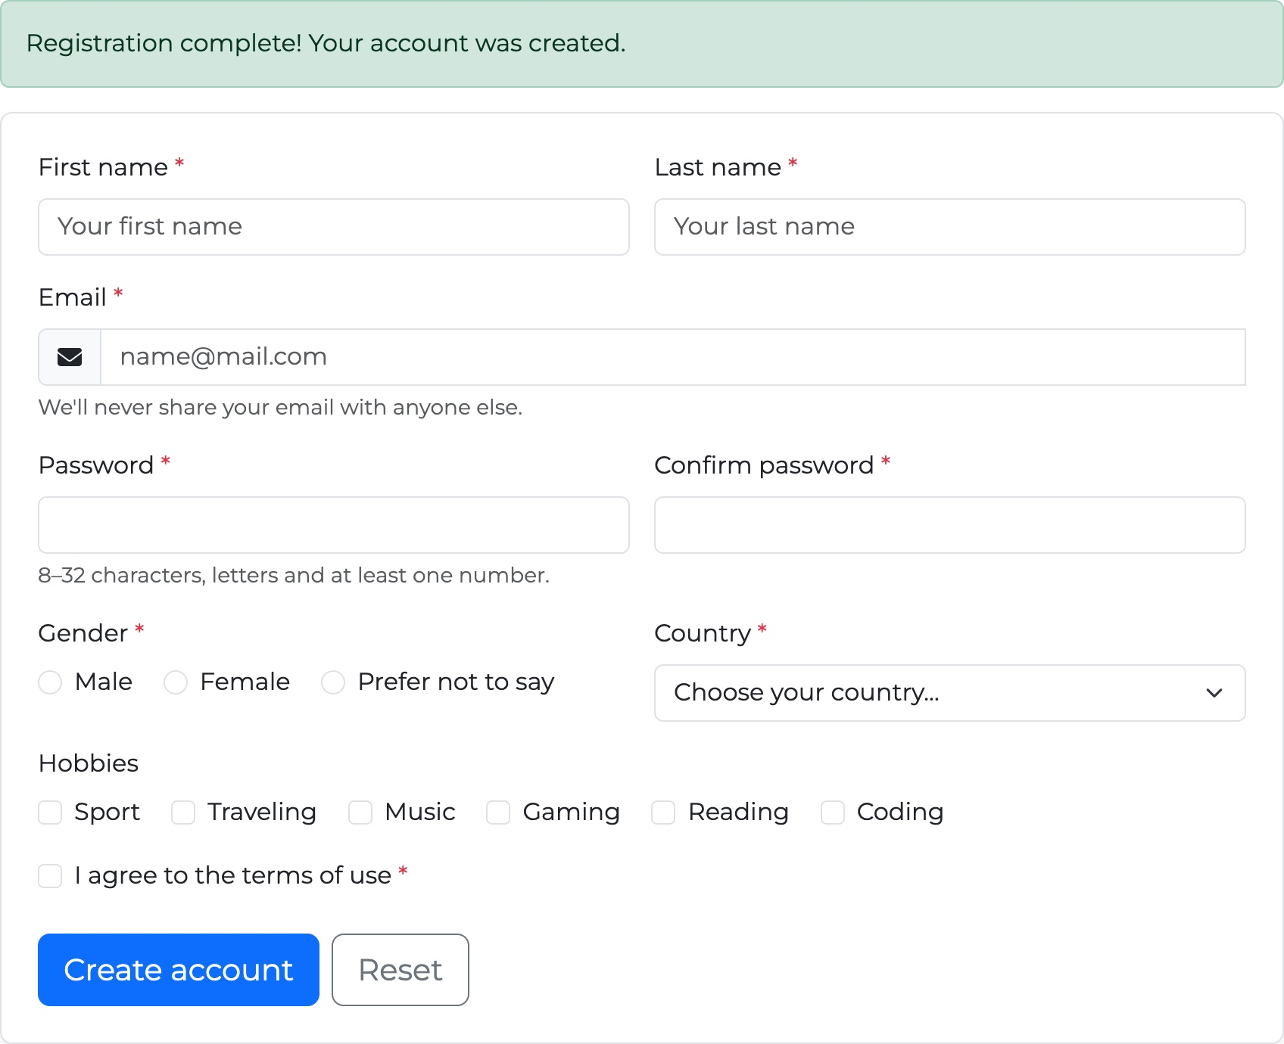
Figure 17 — Task 4 — all fields valid (left); success alert after registration (right)
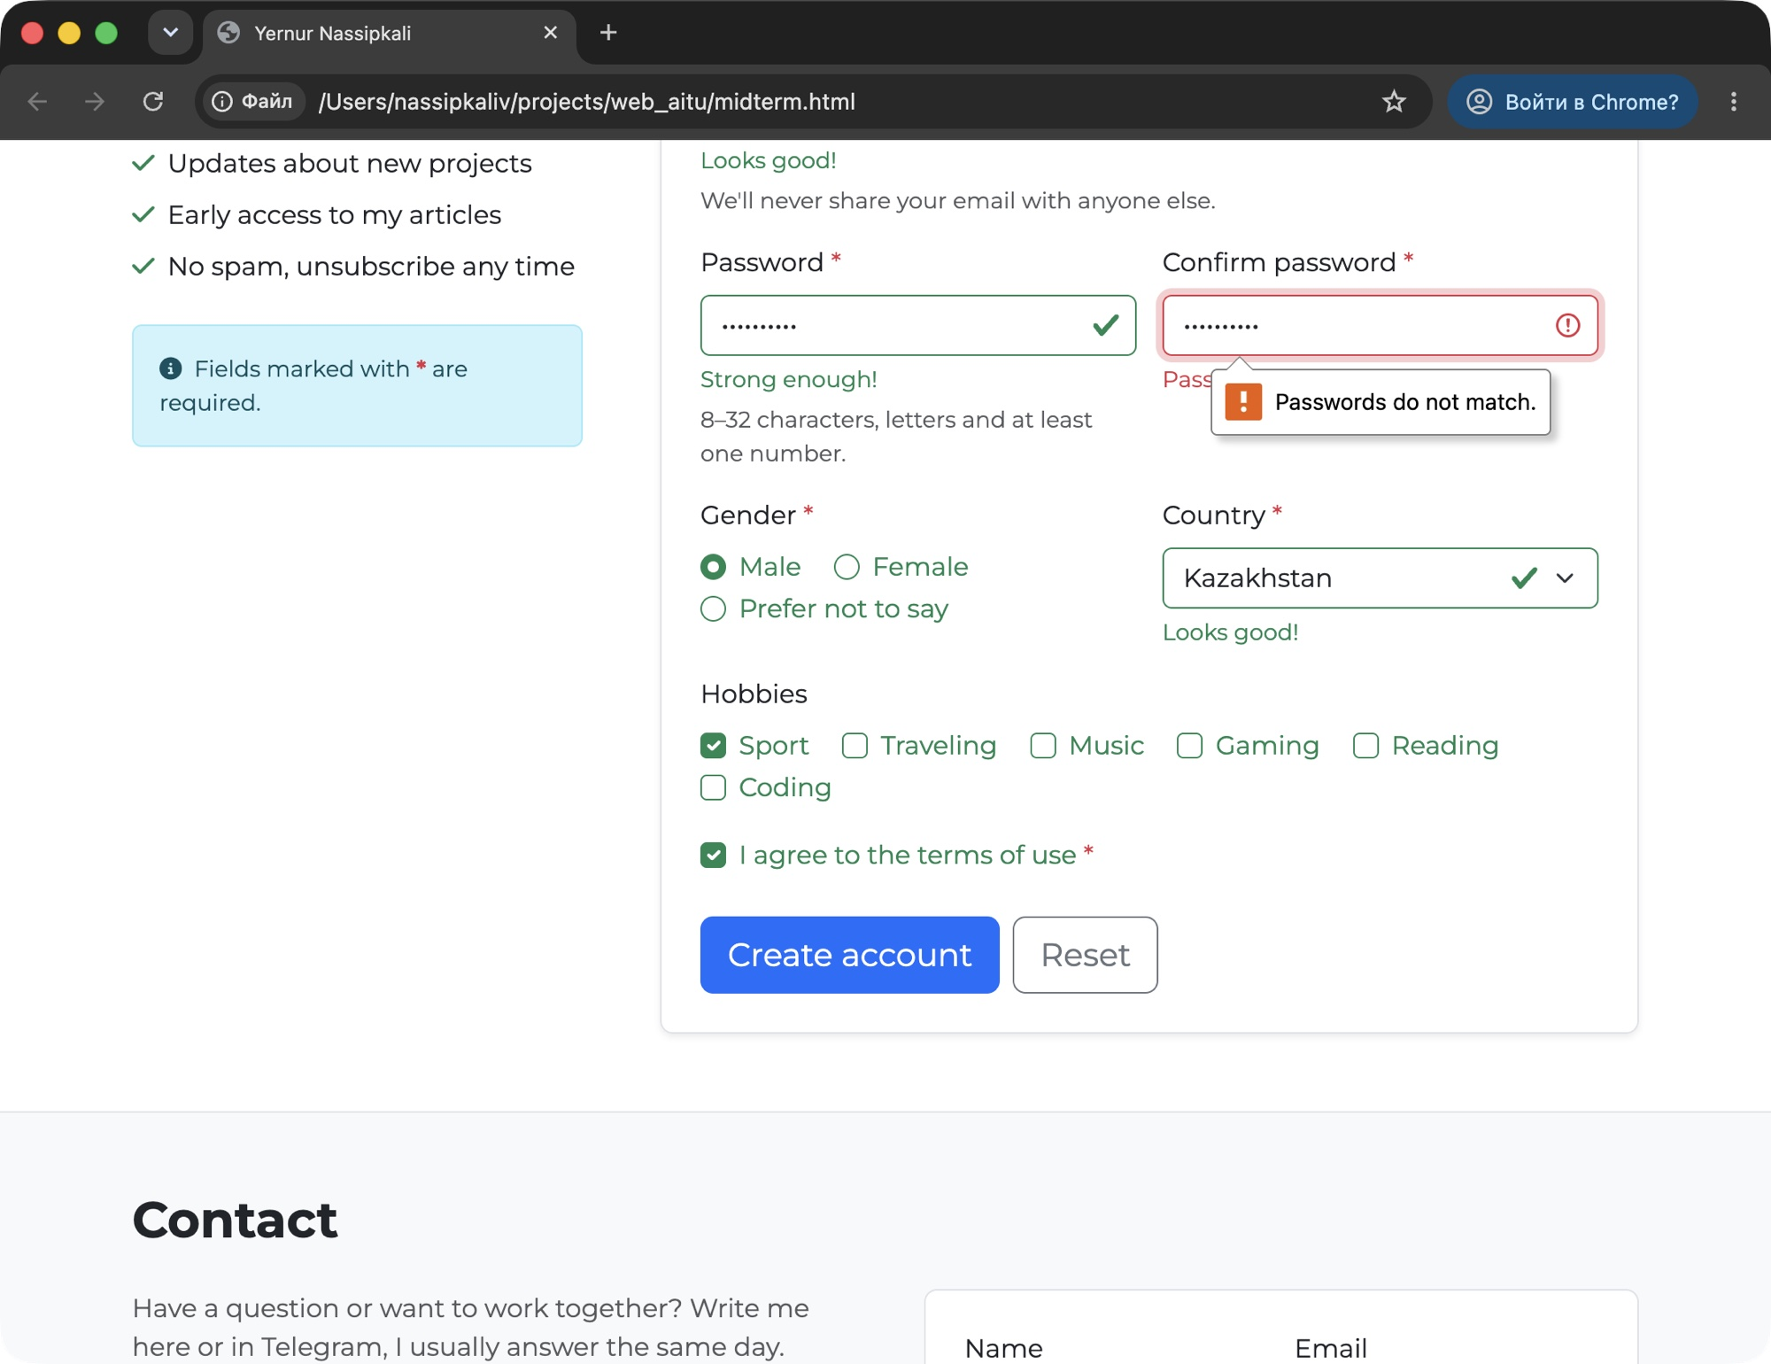
Figure 18 — Task 4 — HTML5 and Bootstrap together: the Chrome popup “Passwords do not match.” from setCustomValidity()
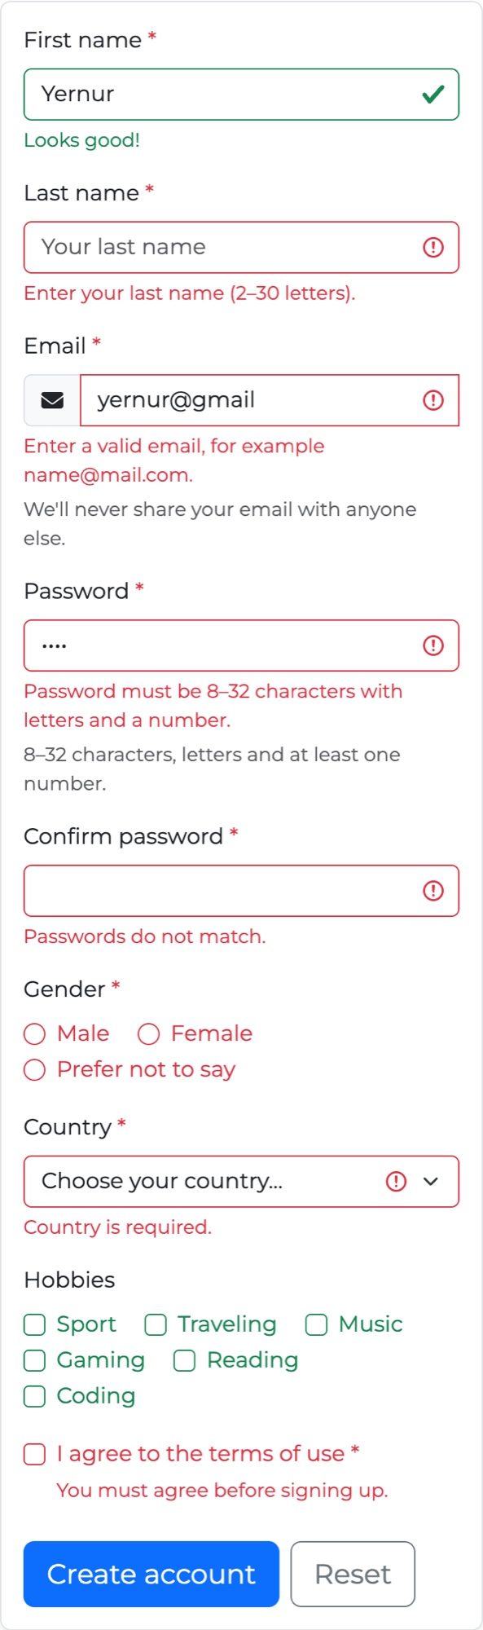
Figure 19 — Task 4 — the error state on a phone (375px)

Summary of my work process
This is what I did step by step:
- Plain HTML. I started with the contact form from my midterm page and checked that every input has a <label> with for = id, and a name.
- HTML5 validation. I added required, minlength, maxlength, type="email" and pattern, then tested in Chrome without Bootstrap. I found that type="email" accepts “a@b”, so I added a pattern.
- Bootstrap styling. I added form classes and put the fields into the grid, plus placeholders and helper text.
- Bootstrap validation. I wrote js/forms.js. It does not repeat the rules: it reads the HTML5 result (validity.valid) and adds is-valid / is-invalid. The browser popups stay on, so HTML5 and Bootstrap work together.
- Registration form. I built a new section with all fields from the task. The only rule HTML cannot check is “Confirm password must be the same as Password”, so I added it with setCustomValidity(). Then I added the success alerts.
- Testing. I tested both forms with empty, wrong and correct data on desktop, tablet and phone. All tests from the tables above passed and the browser console had no errors.

Things that needed extra work:
- Browser popups and Bootstrap together. Without novalidate the submit event does not come when a field is wrong, so the classes are added in the invalid event instead.
- Feedback in input-group. For the email group the feedback must be inside the group and the group needs has-validation, otherwise the rounded corners break when the message appears.
- Endless loop. My first version called checkValidity() inside the invalid listener. checkValidity() fires invalid again, so the page froze. Now the script reads validity.valid, which does not fire any events.
- minlength works only for typed text. The browser checks minlength / maxlength only when the user types the value, not when a script sets it. So I tested the forms by typing in the fields.
- Email without a dot. type="email" accepted “a@b”, so I added a pattern that needs a dot after the @.
- Less code. My first version made the error texts and the alerts in JavaScript. I moved the texts and the alerts into the HTML, so js/forms.js is now 39 lines and easy to explain.

In this assignment I learned the difference between HTML5 validation and Bootstrap validation: HTML5 makes the rules and Bootstrap only shows the result. Because of that I did not have to write the rules twice in JavaScript. I also learned how to make error messages useful for the user: they should say what exactly is wrong and appear next to the field.

