Assignment #5. JavaScript Basics (DOM Manipulation & Events)
Student: Yernur Nassipkali
Group: SE-2517
Course: Web Technologies 1 (Front End)
For this assignment I made a new page assignment5.html. All tasks are on this one page, each task is in its own block, in the same order as in the assignment. The JavaScript is in a separate file js/assignment5.js and the styles are in css/assignment5.css.
File | What is inside
assignment5.html | The page with a block for every task (Task 0 – Task 8)
js/assignment5.js | All JavaScript of the assignment, one part for every task
css/assignment5.css | Simple styles: cards for the tasks, buttons, the boxes from Task 3 and Task 5

The script is connected at the end of <body>. Because of that, when the code runs, all elements of the page already exist and document.getElementById() can find them.
assignment5.html
<script src="js/assignment5.js"></script>
</body>

Part 1. Introduction to JavaScript

Task 0. First Script
Task: Create an HTML page and include a JavaScript file.
• Use console.log() to print your name and group.
• Write a script that shows an alert message: “Hello, JavaScript World!”.
These are the first three lines of js/assignment5.js. console.log() prints text in the browser console, and alert() shows a small window with a message and an OK button.
js/assignment5.js
console.log('Name: Yernur Nassipkali');
console.log('Group: SE-2517');
alert('Hello, JavaScript World!');
When I open the page, the alert appears at once. My Chrome is in Russian, so the window title is “Подтвердите действие” (“Confirm the action”), the message is my text. The two console.log() lines run before alert(), so on the right in DevTools they are already printed while the alert is open.
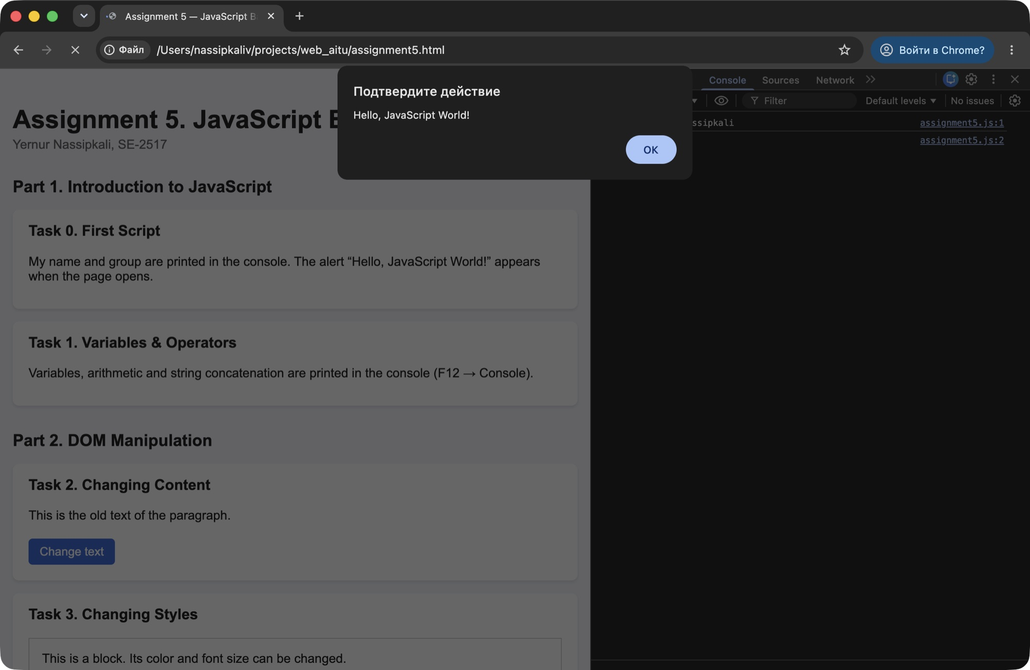
Figure 1 — Task 0 — the alert “Hello, JavaScript World!” when the page opens
After clicking OK the page works as usual. In DevTools (F12 → Console) the first two lines are my name and group:
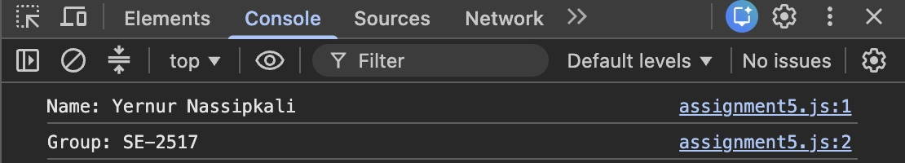
Figure 2 — Task 0 — name and group in the console

Task 1. Variables & Operators
Task: Declare variables of different data types (string, number, boolean).
• Perform arithmetic operations and display the results in the console.
• Concatenate strings and print them in the console.
I declared three variables of different types and printed each one with typeof, so the console shows the type too. Then I did all five arithmetic operations with two numbers and joined strings with the + operator.
js/assignment5.js
let university = 'Astana IT University';
let groupNumber = 2517;
let isStudent = true;

console.log('university:', university, typeof university);
console.log('groupNumber:', groupNumber, typeof groupNumber);
console.log('isStudent:', isStudent, typeof isStudent);

let a = 20;
let b = 6;

console.log('a + b =', a + b);
console.log('a - b =', a - b);
console.log('a * b =', a * b);
console.log('a / b =', a / b);
console.log('a % b =', a % b);

let firstName = 'Yernur';
let lastName = 'Nassipkali';
let fullName = firstName + ' ' + lastName;

console.log('Full name: ' + fullName);
console.log('I study at ' + university + ' in group SE-' + groupNumber + '.');
Code | Result | Comment
typeof university | string | text in quotes
typeof groupNumber | number | a number without quotes
typeof isStudent | boolean | true or false
a + b | 26 | 20 + 6
a - b | 14 | 20 − 6
a * b | 120 | 20 × 6
a / b | 3.3333333333333335 | JavaScript shows many digits after the point
a % b | 2 | remainder: 20 = 6 × 3 + 2
firstName + ' ' + lastName | Yernur Nassipkali | two strings and a space between them

If one side of + is a string, JavaScript joins the values as text. That is why 'SE-' + groupNumber gives “SE-2517” and not a sum.
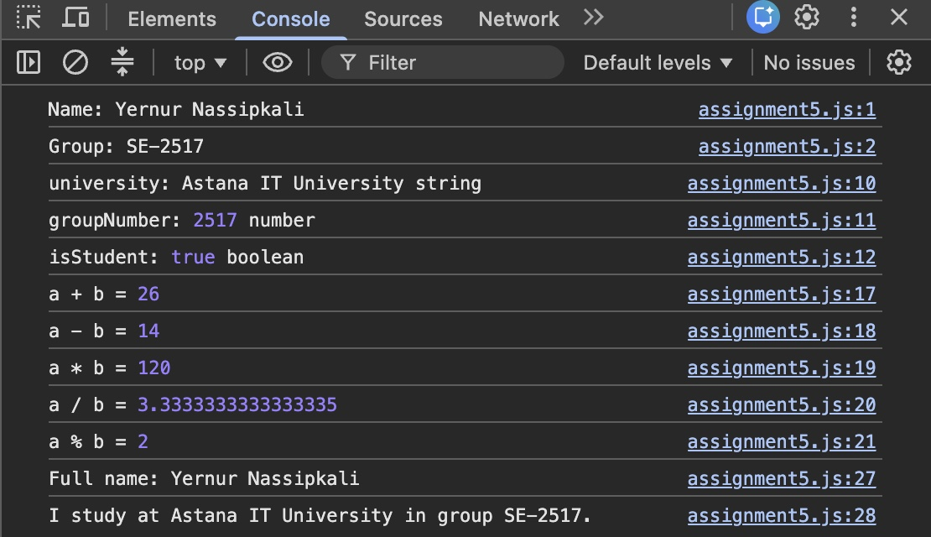
Figure 3 — Task 1 — variables, arithmetic and concatenation in the console

Part 2. DOM Manipulation

Task 2. Changing Content
Task: Create a paragraph and a button.
• When the button is clicked, change the paragraph text to something new.
assignment5.html
<section class="task" id="task2">
<h3>Task 2. Changing Content</h3>
<p id="changeText">This is the old text of the paragraph.</p>
<button id="changeTextButton">Change text</button>
</section>
In JavaScript I find the paragraph by its id. On click the new text is written to textContent:
js/assignment5.js
const changeText = document.getElementById('changeText');

document.getElementById('changeTextButton').addEventListener('click', function () {
changeText.textContent = 'The text was changed with JavaScript!';
});
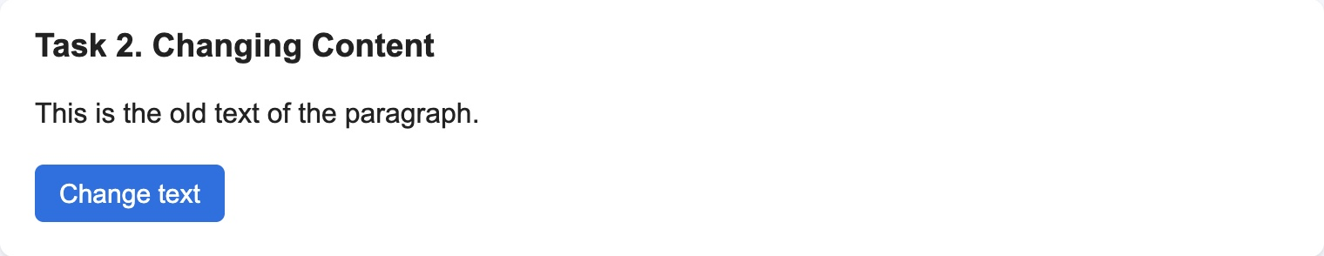
Figure 4 — Task 2 — before the click
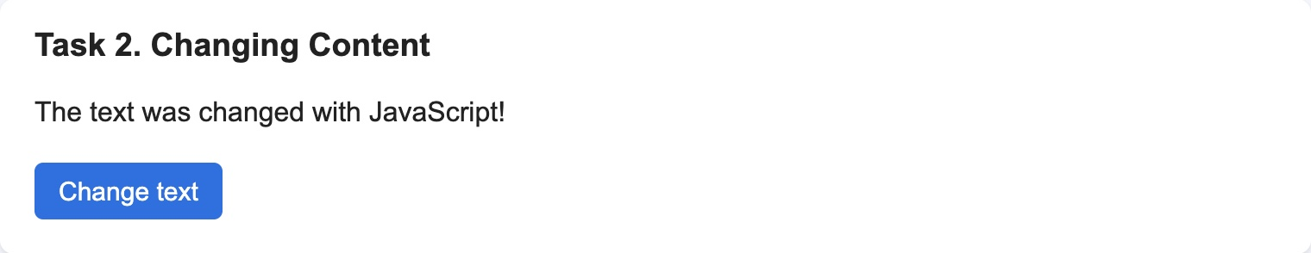
Figure 5 — Task 2 — after the click the paragraph has the new text

Task 3. Changing Styles
Task: Create a <div> container.
• Add a button that, when clicked, changes the background color of the block.
• Add another button that changes the font size of the text inside the block.
assignment5.html
<section class="task" id="task3">
<h3>Task 3. Changing Styles</h3>
<div id="styleBox">This is a block. Its color and font size can be changed.</div>
<button id="colorButton">Change color</button>
<button id="fontButton">Change font size</button>
</section>
Styles are changed through the style property of the element:
- Change color takes the next color from the colors array. The % operator starts the array again from the first color after the last one.
- Change font size adds 4px every time: 16 → 20 → 24 → 28 → 32, and after 32 it goes back to 16, so the text does not become too big.

js/assignment5.js
const styleBox = document.getElementById('styleBox');
const colors = ['#ffcdd2', '#c8e6c9', '#fff9c4', '#bbdefb'];
let colorIndex = 0;
let fontSize = 16;

document.getElementById('colorButton').addEventListener('click', function () {
styleBox.style.backgroundColor = colors[colorIndex];
colorIndex = (colorIndex + 1) % colors.length;
});

document.getElementById('fontButton').addEventListener('click', function () {
fontSize = fontSize + 4;
if (fontSize > 32) {
fontSize = 16;
}
styleBox.style.fontSize = fontSize + 'px';
});
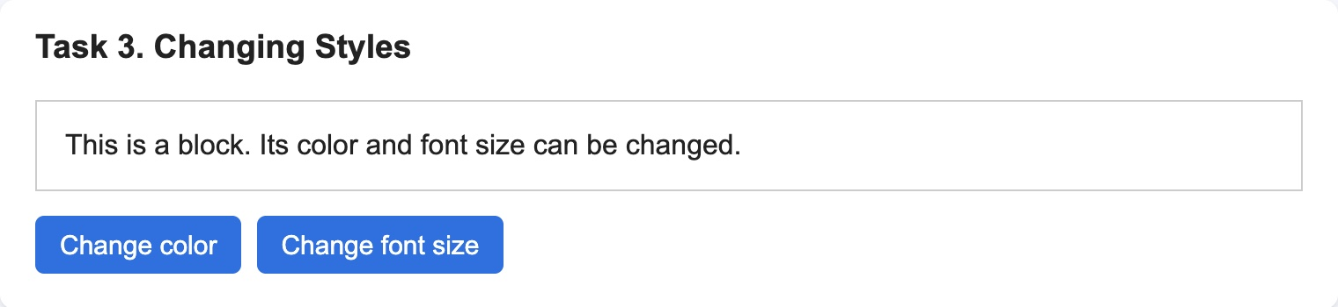
Figure 6 — Task 3 — the block at the start: white, 16px
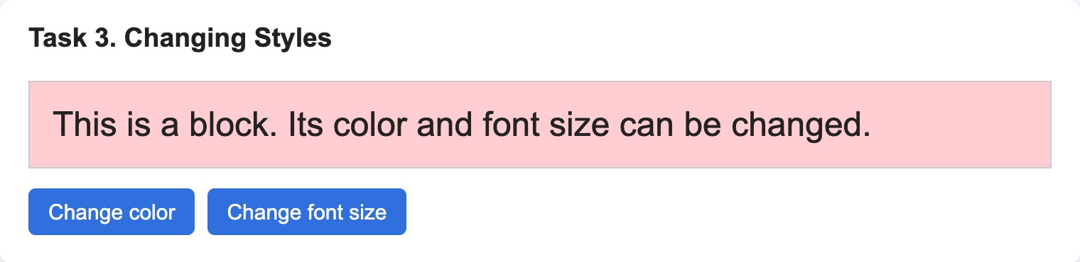
Figure 7 — Task 3 — after one click on “Change color” and two clicks on “Change font size”: pink, 24px

Task 4. Creating & Removing Elements
Task: Create a button “Add Item” that adds a new <li> item to a list.
• Create another button “Remove Item” that removes the last item from the list.
assignment5.html
<section class="task" id="task4">
<h3>Task 4. Creating &amp; Removing Elements</h3>
<ul id="itemList">
<li>Item 1</li>
<li>Item 2</li>
</ul>
<button id="addItemButton">Add Item</button>
<button id="removeItemButton">Remove Item</button>
</section>
Add Item makes a new <li> with document.createElement(), gives it a number and adds it to the end of the list with appendChild(). Remove Item removes lastElementChild. If the list is already empty, lastElementChild is null, so I check it first and nothing happens.
js/assignment5.js
const itemList = document.getElementById('itemList');

document.getElementById('addItemButton').addEventListener('click', function () {
const newItem = document.createElement('li');
newItem.textContent = 'Item ' + (itemList.children.length + 1);
itemList.appendChild(newItem);
});

document.getElementById('removeItemButton').addEventListener('click', function () {
if (itemList.lastElementChild) {
itemList.removeChild(itemList.lastElementChild);
}
});
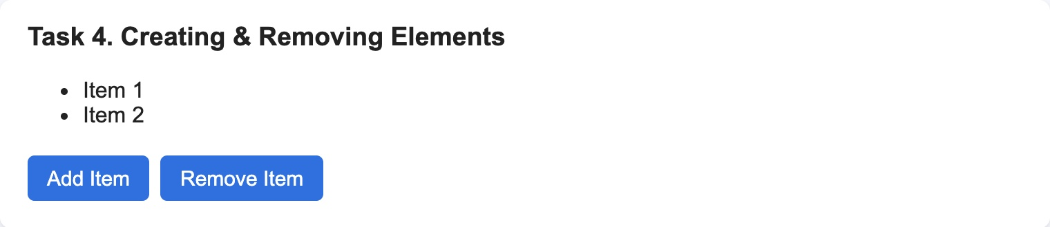
Figure 8 — Task 4 — the list at the start: two items
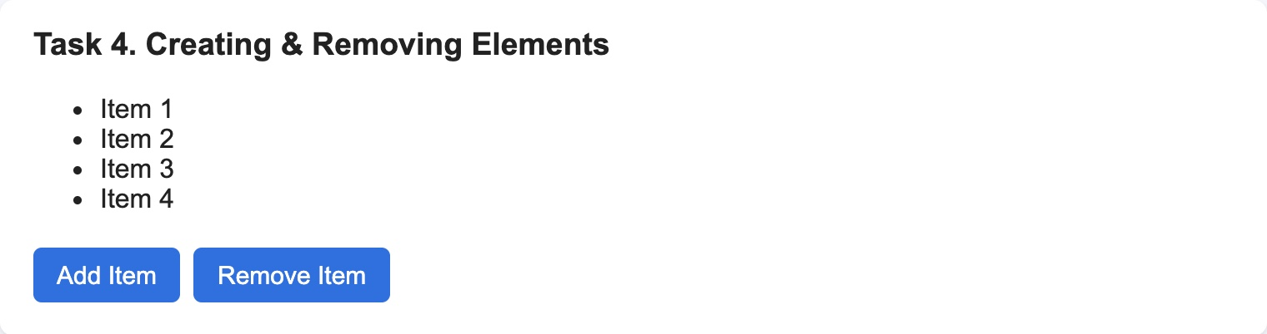 | 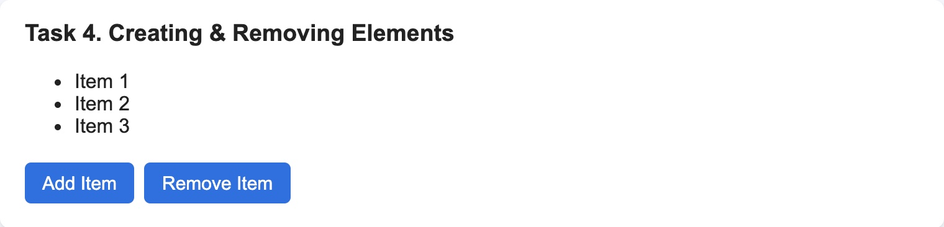
Figure 9 — Task 4 — after two clicks on “Add Item” (left) and after one click on “Remove Item” (right)

Part 3. Events

Task 5. Mouse Events
Task: Create a box that changes color when the mouse is over it (mouseover).
• Restore the original color when the mouse leaves (mouseout).
assignment5.html
<section class="task" id="task5">
<h3>Task 5. Mouse Events</h3>
<div id="hoverBox">Move the mouse over me</div>
</section>
The box is blue in CSS. mouseover makes it orange, mouseout sets the same blue color back:
js/assignment5.js
const hoverBox = document.getElementById('hoverBox');

hoverBox.addEventListener('mouseover', function () {
hoverBox.style.backgroundColor = '#ffb74d';
});

hoverBox.addEventListener('mouseout', function () {
hoverBox.style.backgroundColor = '#90caf9';
});
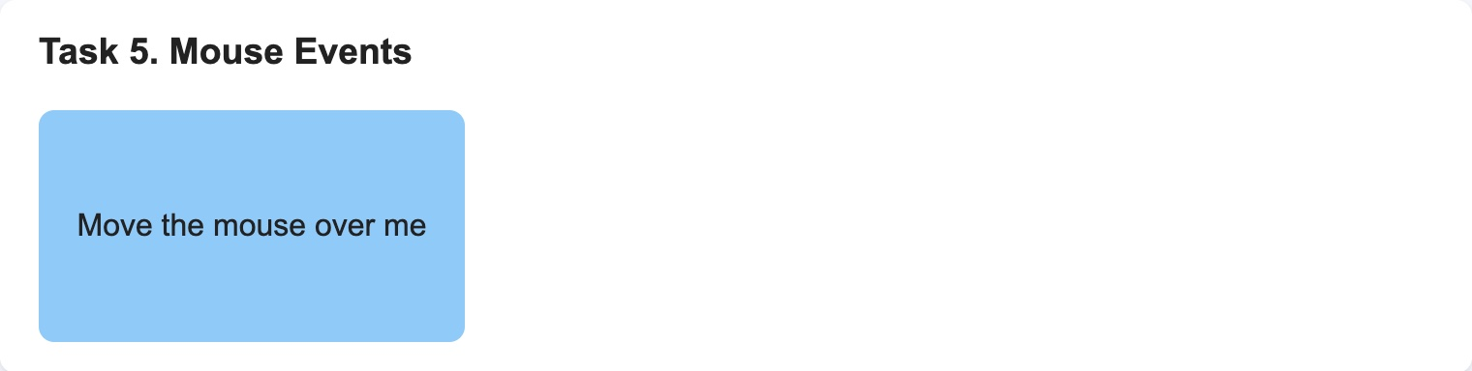 | 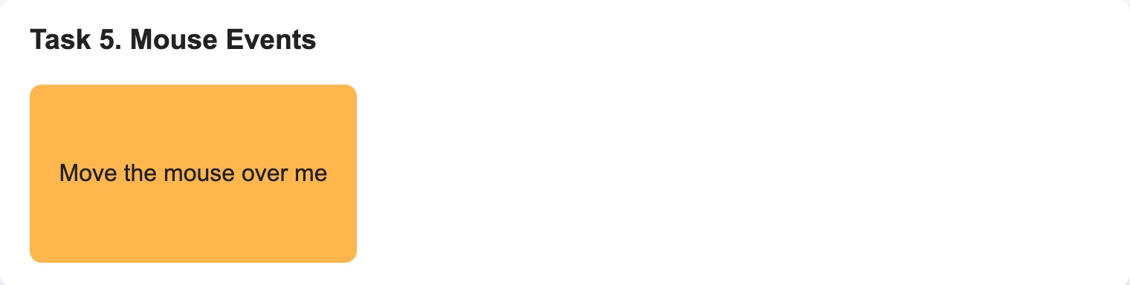
Figure 10 — Task 5 — the box without the mouse (left) and with the mouse over it (right)

Task 6. Keyboard Events
Task: Create an input field.
• Display the current value of the input in real time (use keyup event).
assignment5.html
<section class="task" id="task6">
<h3>Task 6. Keyboard Events</h3>
<label for="typingInput">Type something:</label>
<input type="text" id="typingInput">
<p>You typed: <span id="typingOutput"></span></p>
</section>
keyup happens when a key is released. At this moment the new letter is already in the input, so the script copies typingInput.value into the span after every key:
js/assignment5.js
const typingInput = document.getElementById('typingInput');
const typingOutput = document.getElementById('typingOutput');

typingInput.addEventListener('keyup', function () {
typingOutput.textContent = typingInput.value;
});
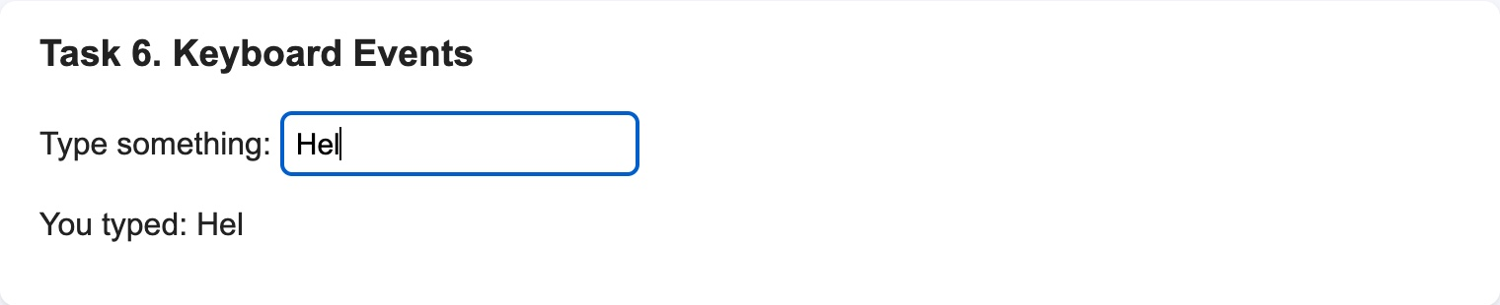
Figure 11 — Task 6 — after typing “Hel” the text below shows the same
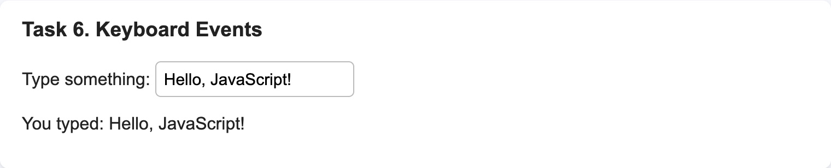
Figure 12 — Task 6 — the whole text “Hello, JavaScript!”

Task 7. Form Validation (optional)
Task: Create a simple form with fields: Name, Email, Password.
• Add JavaScript that prevents submission if any field is empty.
• Display an error message below the form if validation fails.
assignment5.html
<section class="task" id="task7">
<h3>Task 7. Form Validation</h3>
<form id="signupForm">
<label for="name">Name</label>
<input type="text" id="name" autocomplete="name">

<label for="email">Email</label>
<input type="email" id="email" autocomplete="email">

<label for="password">Password</label>
<input type="password" id="password" autocomplete="new-password">

<button type="submit">Submit</button>
</form>
<p id="formMessage"></p>
</section>
The check is done in the submit event of the form:
- event.preventDefault() stops the normal sending of the form, so the page does not reload.
- trim() removes spaces, so a field with only spaces also counts as empty.
- If at least one field is empty, the red message appears in <p id="formMessage"> below the form and the function stops with return.
- If all fields are filled, a green message is shown and the form is cleared with reset().

js/assignment5.js
const signupForm = document.getElementById('signupForm');
const formMessage = document.getElementById('formMessage');

signupForm.addEventListener('submit', function (event) {
event.preventDefault();

const name = document.getElementById('name').value.trim();
const email = document.getElementById('email').value.trim();
const password = document.getElementById('password').value.trim();

if (name === '' || email === '' || password === '') {
formMessage.textContent = 'Please fill in all fields: Name, Email and Password.';
formMessage.className = 'error';
return;
}

formMessage.textContent = 'The form was sent. Thank you, ' + name + '!';
formMessage.className = 'success';
signupForm.reset();
});
# | What I entered | What happened | Result
1 | Nothing, clicked Submit | Red message “Please fill in all fields: Name, Email and Password.” | Pass
2 | Only the name “Yernur” | The same red message, the form is not sent | Pass
3 | Only spaces in all fields | The same red message, because of trim() | Pass
4 | Name, email and password | Green message “The form was sent. Thank you, Yernur!”, the fields are cleared | Pass

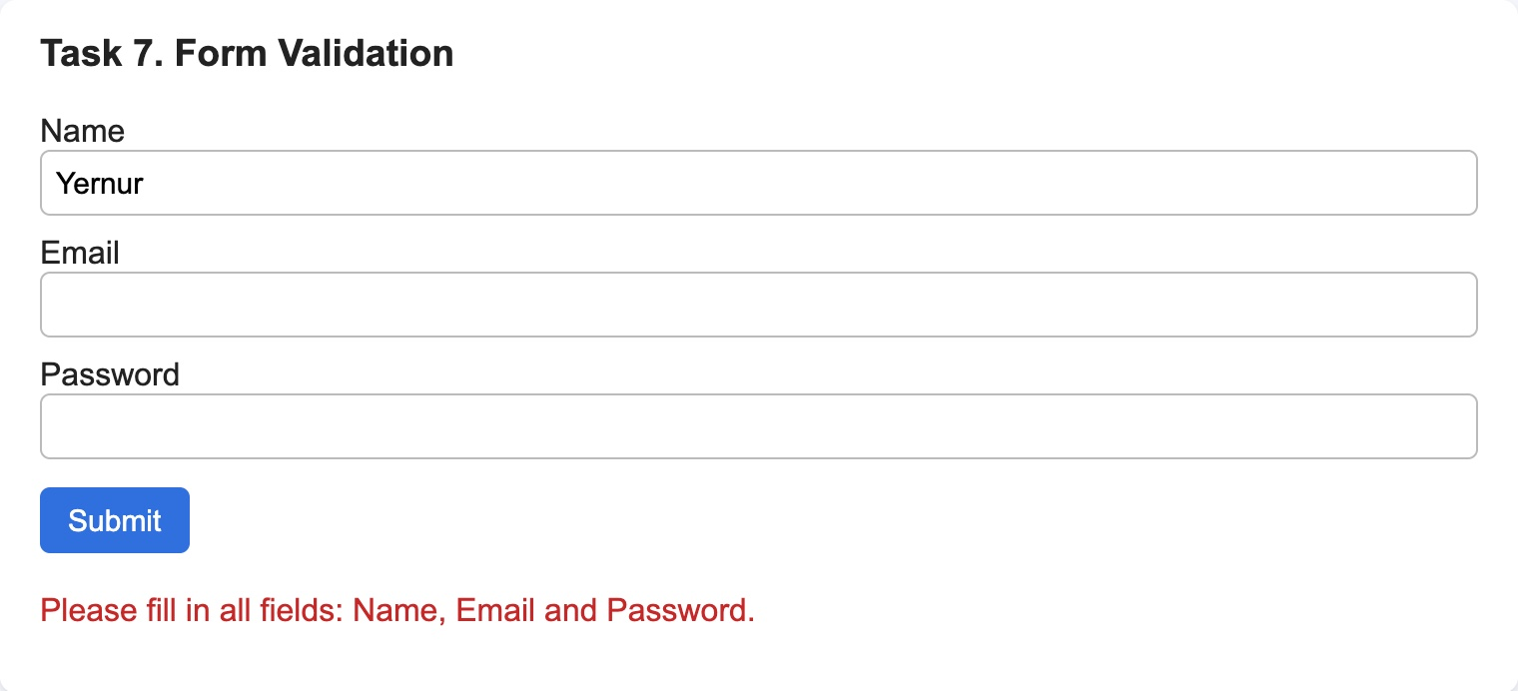
Figure 13 — Task 7 — only the name is filled: the error message below the form
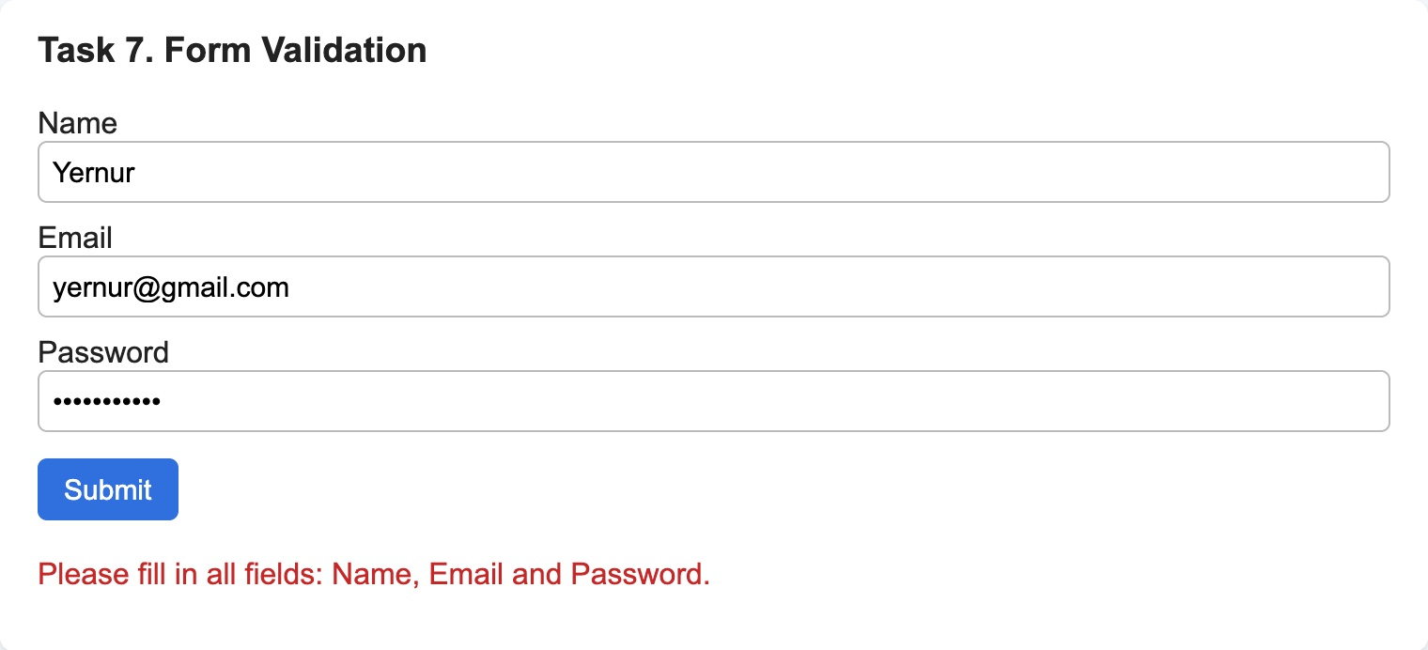 | 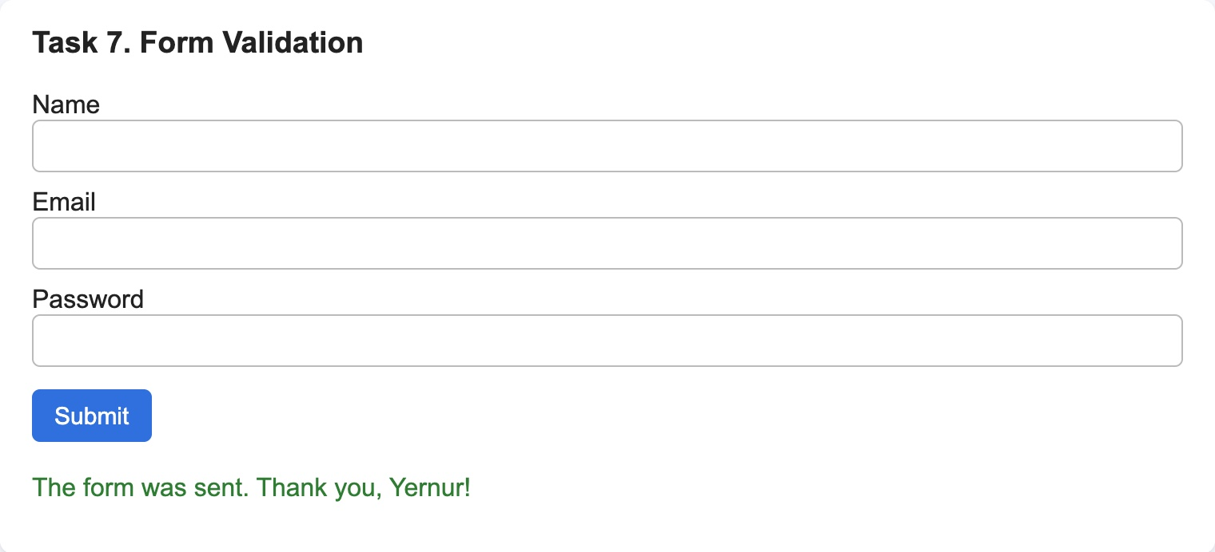
Figure 14 — Task 7 — all fields are filled (left) and the message after Submit (right)

Part 4. Mini Project — Interactive To-Do List

Task 8. To-Do App
Task: Create a text input and an “Add Task” button.
• When a task is added, display it in a list with a “Delete” button next to it.
• Add functionality to mark tasks as completed (strike-through effect).
• Store tasks temporarily in an array (no need for database/local storage).
assignment5.html
<section class="task" id="task8">
<h3>Task 8. To-Do App</h3>
<input type="text" id="taskInput" placeholder="New task">
<button id="addTaskButton">Add Task</button>
<ul id="taskList"></ul>
</section>
All tasks are kept in the array tasks. Every task is an object with the text and done (completed or not). The list on the page is always built from this array by the function showTasks():
- Add Task — if the input is not empty, a new object is added with tasks.push() and the list is shown again.
- Checkbox — changes done of this task. When done is true, the text gets the class done with text-decoration: line-through.
- Delete — removes the task from the array with tasks.splice(index, 1).
- After every change showTasks() clears the list and makes it again from the array, so the page always shows what is in the array. At the end it prints the array to the console.

js/assignment5.js
const tasks = [];
const taskInput = document.getElementById('taskInput');
const taskList = document.getElementById('taskList');

function showTasks() {
taskList.innerHTML = '';

tasks.forEach(function (task, index) {
const item = document.createElement('li');

const checkbox = document.createElement('input');
checkbox.type = 'checkbox';
checkbox.checked = task.done;
checkbox.addEventListener('change', function () {
task.done = checkbox.checked;
showTasks();
});

const text = document.createElement('span');
text.textContent = ' ' + task.text;
if (task.done) {
text.className = 'done';
}

const deleteButton = document.createElement('button');
deleteButton.textContent = 'Delete';
deleteButton.addEventListener('click', function () {
tasks.splice(index, 1);
showTasks();
});

item.appendChild(checkbox);
item.appendChild(text);
item.appendChild(deleteButton);
taskList.appendChild(item);
});

console.log('Tasks:', tasks);
}

document.getElementById('addTaskButton').addEventListener('click', function () {
const text = taskInput.value.trim();
if (text === '') {
return;
}

tasks.push({ text: text, done: false });
taskInput.value = '';
showTasks();
});
css/assignment5.css
.done {
text-decoration: line-through;
color: #888;
}
# | What I did | What happened | Result
1 | Added “Buy milk”, “Do homework”, “Prepare for the defense” | Three tasks in the list, each with a Delete button | Pass
2 | Clicked Add Task with an empty input | Nothing was added | Pass
3 | Checked the box of “Do homework” | The text is crossed out and grey | Pass
4 | Clicked Delete next to “Buy milk” | The task disappeared, the other two stayed | Pass

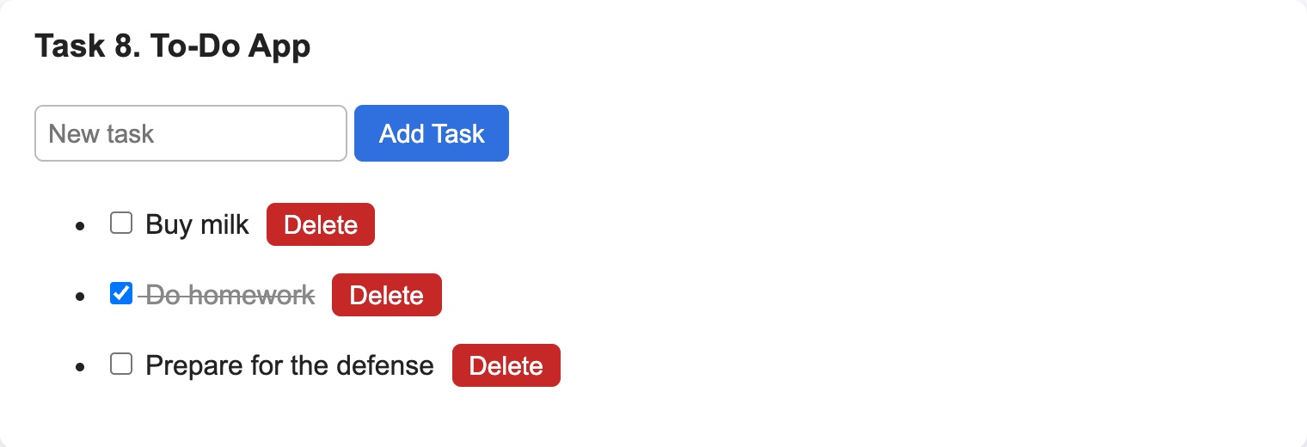 | 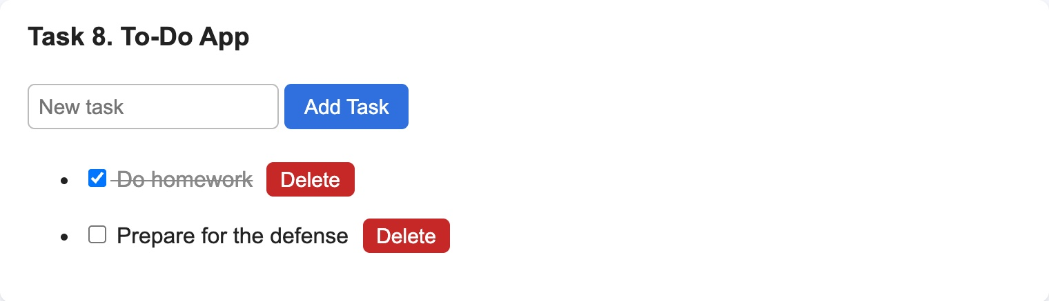
Figure 15 — Task 8 — three tasks, “Do homework” is completed (left); after deleting “Buy milk” (right)
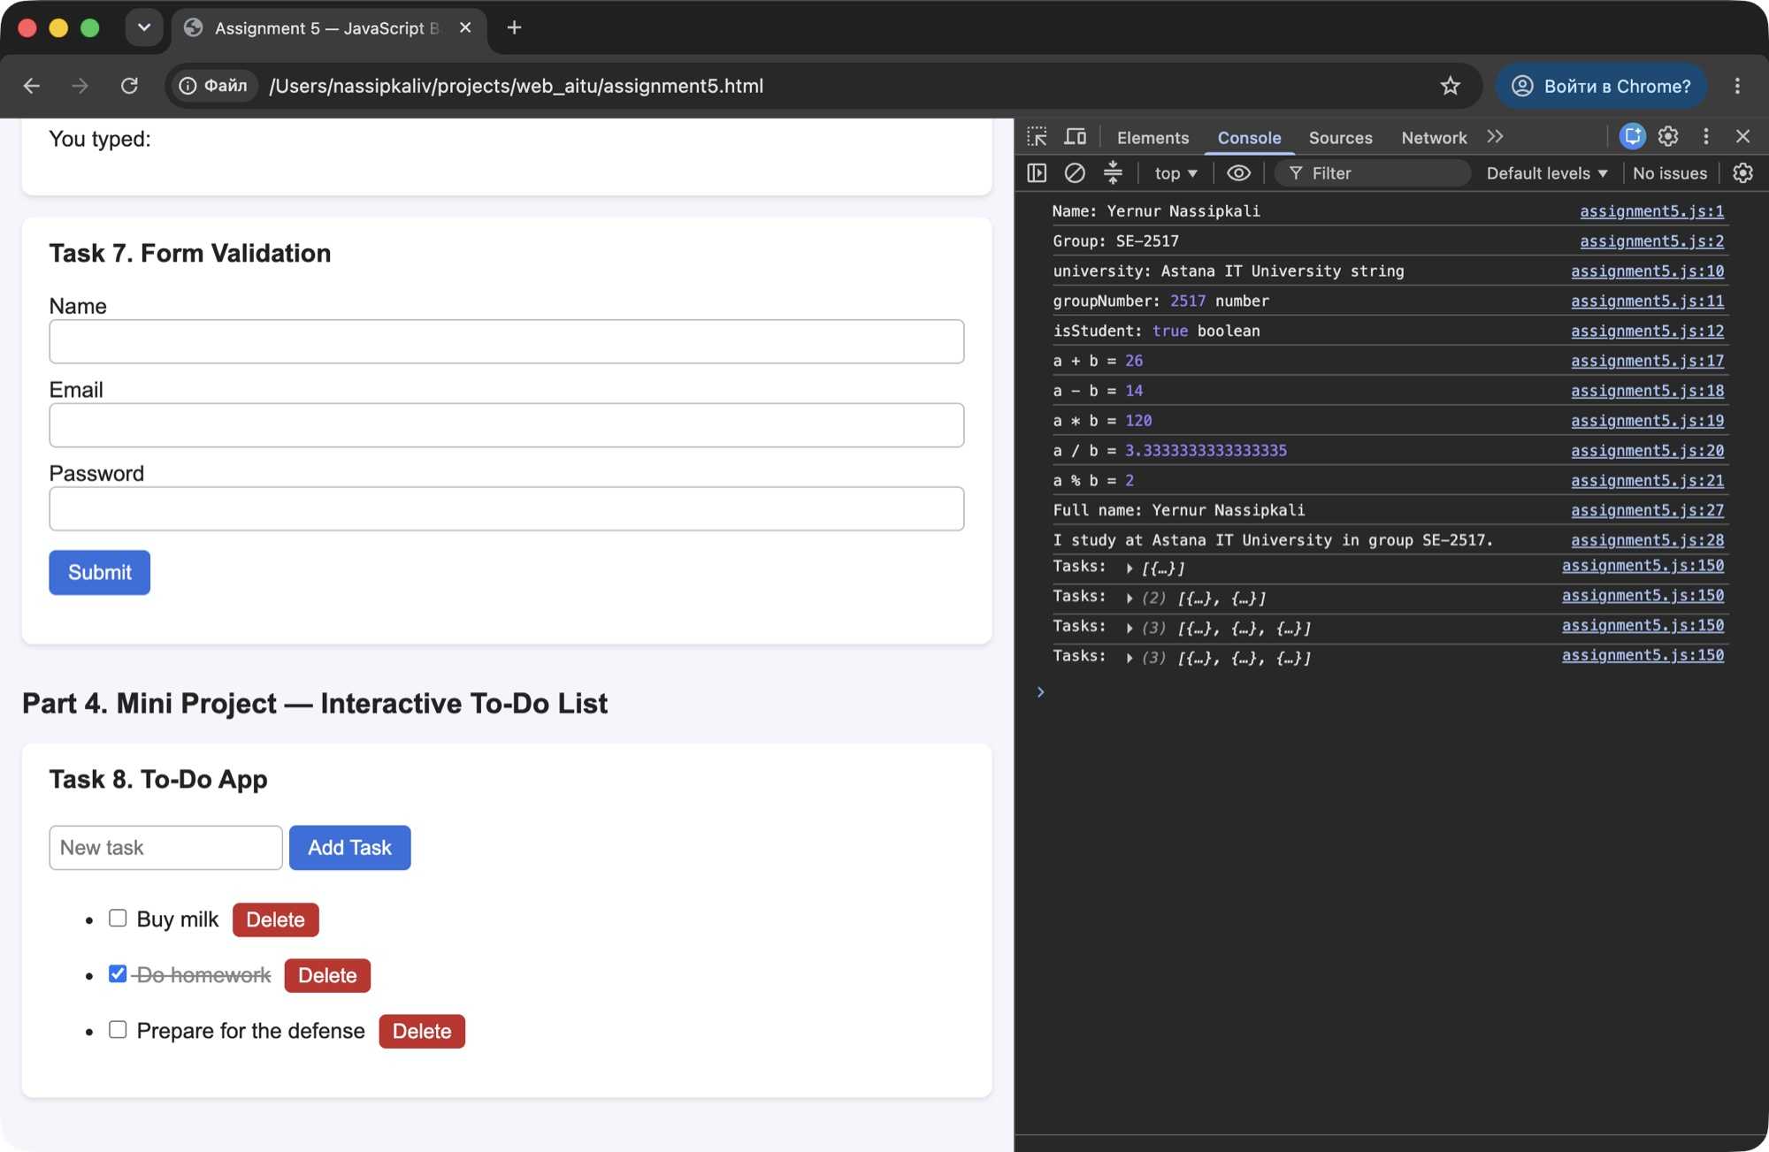
Figure 16 — Task 8 — the To-Do list and the tasks array printed in the console after every change

Summary of my work process
This is what I did step by step:
- Page and script. I made assignment5.html with a block for every task and connected js/assignment5.js at the end of the body.
- Console and alert. I printed my name, group, variables and the results of the operations with console.log() and showed the alert with alert().
- DOM. I found elements with getElementById() and changed them: the text with textContent, the styles with style, the list with createElement(), appendChild() and removeChild().
- Events. I used click for the buttons, mouseover and mouseout for the box, keyup for the input and submit for the form.
- To-Do list. I kept the tasks in an array and wrote one function that shows the array on the page.
- Testing. I checked every task in Chrome. The console has no errors and DevTools shows “No issues”.

Things that needed extra work:
- The alert stops the page. The code after alert() runs only after clicking OK, so the console lines from Task 1 appear after the alert is closed.
- Removing from an empty list. When there are no items, lastElementChild is null. Without the check the button would give an error in the console.
- Deleting in the To-Do list. After splice() the indexes of the next tasks change. Because the list is built again from the array after every change, each Delete button always has the right index.
- Spaces in the form. A field with only spaces looked filled. trim() fixed it.
- Warning in DevTools. Chrome showed a warning for the fields with id “name” and “email”, because they had no autocomplete attribute. I added autocomplete and the warning was gone.

In this assignment I learned how JavaScript works with the page: first you find an element, then you change its text, style or children, and events tell the script when to do it. I also understood why it is easier to keep data in an array and build the list from it than to change the list by hand.

