Assignment #6. jQuery (Selectors, Effects, Animations)
Student: Yernur Nassipkali
Group: SE-2517
Course: Web Technologies 1 (Front End)
For this assignment I made a new page assignment6.html. Every task has its own block on the page, in the same order as in the assignment. The jQuery code is in js/assignment6.js and the styles are in css/assignment6.css. For the images I used three photos from my midterm page (folder images).
File | What is inside
assignment6.html | The page with a block for every task
js/assignment6.js | All jQuery code of the assignment
css/assignment6.css | Simple styles for the blocks, buttons, the panel and the boxes
images/ | Photos for Task 3 and Task 6

Part 1. Getting Started with jQuery

Task 0. Setup
Task: Include jQuery from a CDN.
• Write a $(document).ready() function.
• Test by printing “jQuery is ready!” in the console.
jQuery is connected from the official CDN at the end of the body. My own script goes after it, because my code uses $, and $ exists only after jQuery is loaded.
assignment6.html
<script src="https://code.jquery.com/jquery-3.7.1.min.js"></script>
<script src="js/assignment6.js"></script>
</body>
All my code is inside $(document).ready(). This function runs when the page is loaded, so all elements already exist when jQuery looks for them.
js/assignment6.js
$(document).ready(function () {
console.log('jQuery is ready!');

...
});
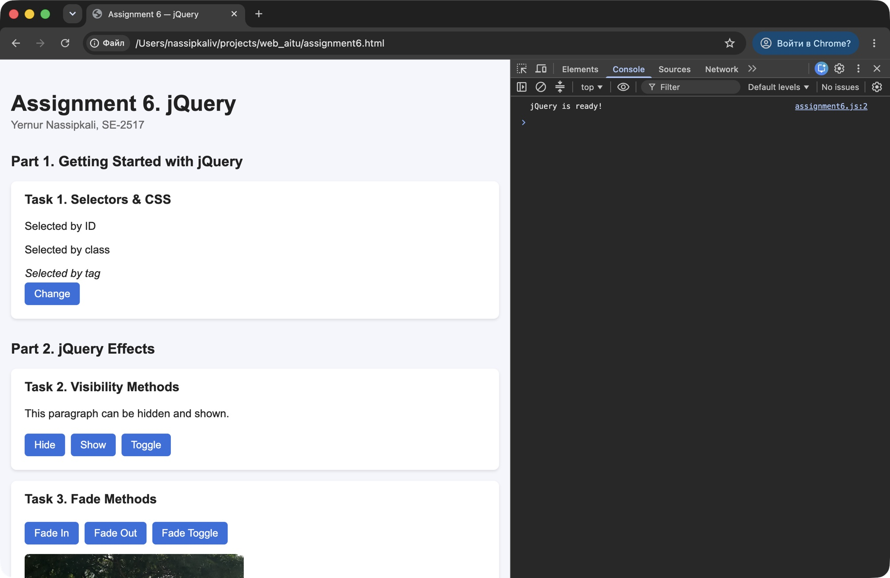
Figure 1 — Task 0 — “jQuery is ready!” in the console (DevTools → Console)

Task 1. Selectors & CSS
Task: Select elements by ID, class, and tag.
• Change their content with .text() and .html().
• Change styles dynamically with .css().
assignment6.html
<section class="task">
<h3>Task 1. Selectors &amp; CSS</h3>
<p id="idText">Selected by ID</p>
<p class="classText">Selected by class</p>
<em>Selected by tag</em>
<br>
<button id="changeButton">Change</button>
</section>
jQuery uses the same selectors as CSS: # for an id, . for a class and only the name for a tag. When the button is clicked, the three elements get new content and new styles.
js/assignment6.js
$('#changeButton').click(function () {
$('#idText').text('This text was changed by ID');
$('.classText').html('This text was changed by <b>class</b>');
$('em').text('This text was changed by tag');

$('#idText').css('color', 'red');
$('.classText').css({ color: 'green', 'font-size': '20px' });
$('em').css('background-color', 'yellow');
});
Selector | Selects | What I changed
$('#idText') | the element with id="idText" | .text() and red color with .css()
$('.classText') | all elements with class="classText" | .html() with a bold word, green color and font size
$('em') | all <em> tags | .text() and yellow background

The difference: .text() puts plain text, and .html() reads HTML tags. That is why the word “class” became bold: <b> was used as a tag, not shown as text.
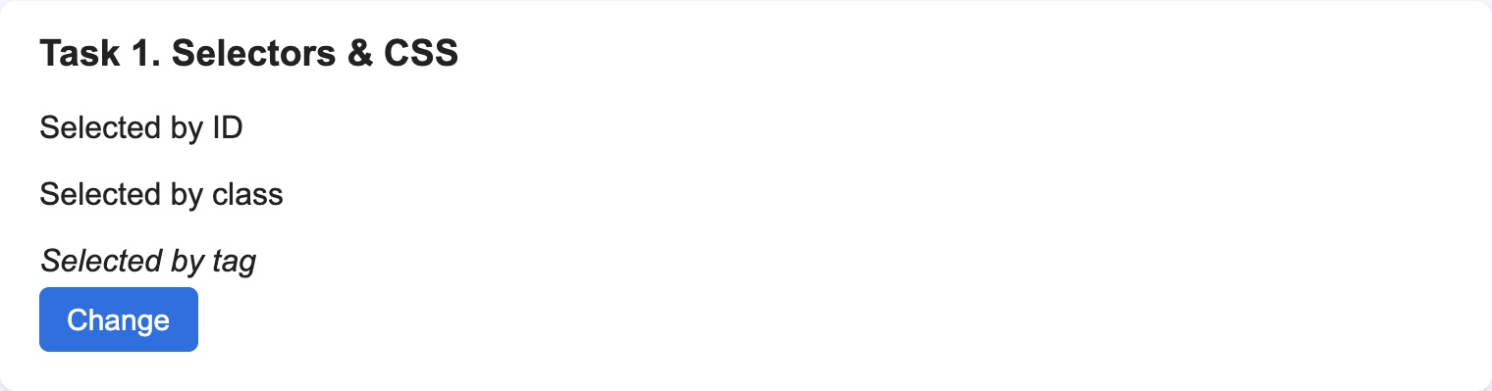
Figure 2 — Task 1 — before the click
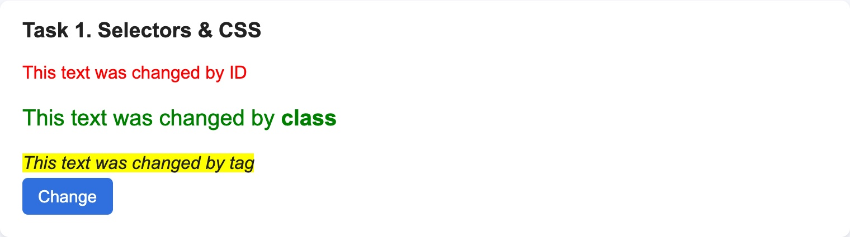
Figure 3 — Task 1 — after the click: new text and styles for ID, class and tag

Part 2. jQuery Effects

Task 2. Visibility Methods
Task: Create a paragraph and two buttons: Hide and Show.
• Use .hide(), .show(), and .toggle().
assignment6.html
<section class="task">
<h3>Task 2. Visibility Methods</h3>
<p id="hideText">This paragraph can be hidden and shown.</p>
<button id="hideButton">Hide</button>
<button id="showButton">Show</button>
<button id="toggleButton">Toggle</button>
</section>
.hide() hides the paragraph, .show() shows it again, and .toggle() does the opposite of the current state: hides if it is visible and shows if it is hidden.
js/assignment6.js
$('#hideButton').click(function () {
$('#hideText').hide();
});

$('#showButton').click(function () {
$('#hideText').show();
});

$('#toggleButton').click(function () {
$('#hideText').toggle();
});
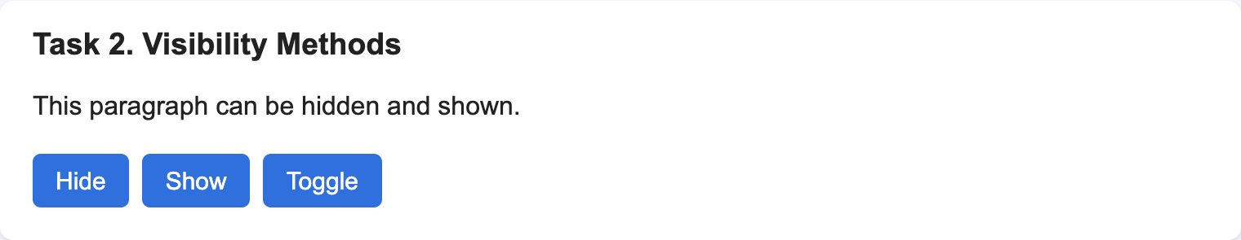
Figure 4 — Task 2 — the paragraph is visible
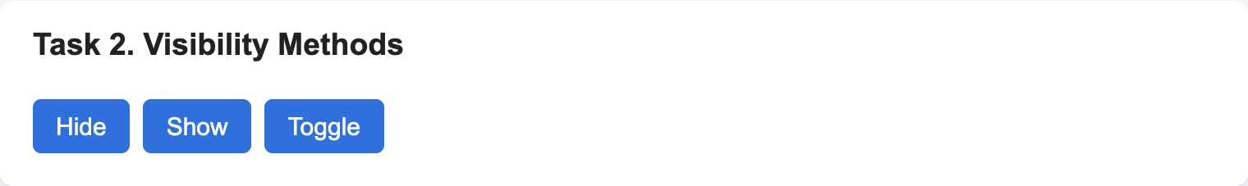
Figure 5 — Task 2 — after clicking “Hide”

Task 3. Fade Methods
Task: Add an image and use .fadeIn(), .fadeOut(), .fadeToggle().
assignment6.html
<section class="task">
<h3>Task 3. Fade Methods</h3>
<button id="fadeInButton">Fade In</button>
<button id="fadeOutButton">Fade Out</button>
<button id="fadeToggleButton">Fade Toggle</button>
<div class="image-box">
<img id="fadeImage" src="images/gallery-img2.jpeg" alt="Photo from my trip">
</div>
</section>
Fade methods change the opacity of the image step by step, so it disappears or appears smoothly. The number 800 is the time in milliseconds. The image is inside a box with a fixed height, so the page does not jump when the image is gone.
js/assignment6.js
$('#fadeInButton').click(function () {
$('#fadeImage').fadeIn(800);
});

$('#fadeOutButton').click(function () {
$('#fadeImage').fadeOut(800);
});

$('#fadeToggleButton').click(function () {
$('#fadeImage').fadeToggle(800);
});
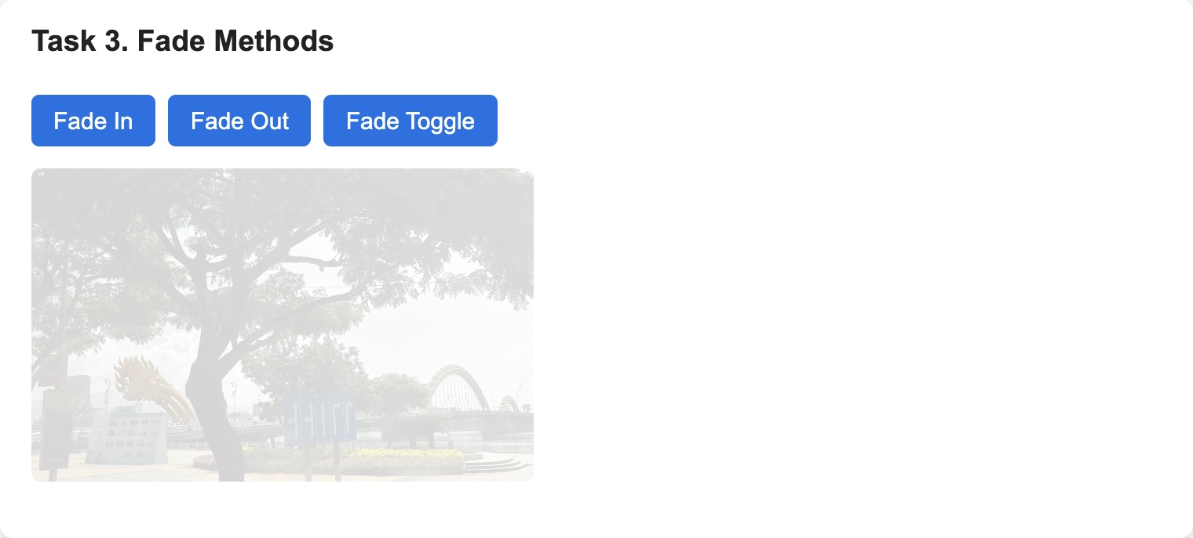 | 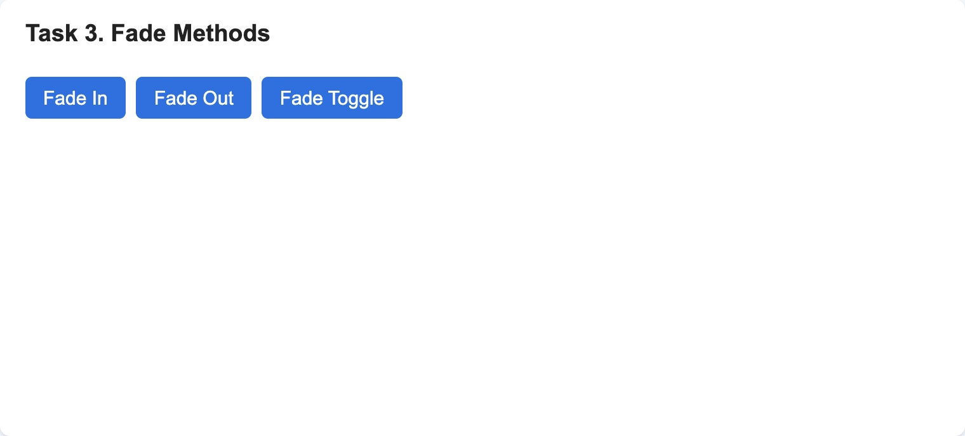
Figure 6 — Task 3 — during “Fade Out” the image is almost transparent (left), after it the image is hidden (right)

Task 4. Slide Methods
Task: Create a collapsible panel and control it with .slideUp(), .slideDown(), .slideToggle().
assignment6.html
<section class="task">
<h3>Task 4. Slide Methods</h3>
<button id="slideUpButton">Slide Up</button>
<button id="slideDownButton">Slide Down</button>
<button id="slideToggleButton">Slide Toggle</button>
<div id="panel">This is a collapsible panel. It slides up and down.</div>
</section>
Slide methods change the height of the panel. .slideUp() closes it from the bottom to the top, .slideDown() opens it, and .slideToggle() closes an open panel and opens a closed one.
js/assignment6.js
$('#slideUpButton').click(function () {
$('#panel').slideUp();
});

$('#slideDownButton').click(function () {
$('#panel').slideDown();
});

$('#slideToggleButton').click(function () {
$('#panel').slideToggle();
});
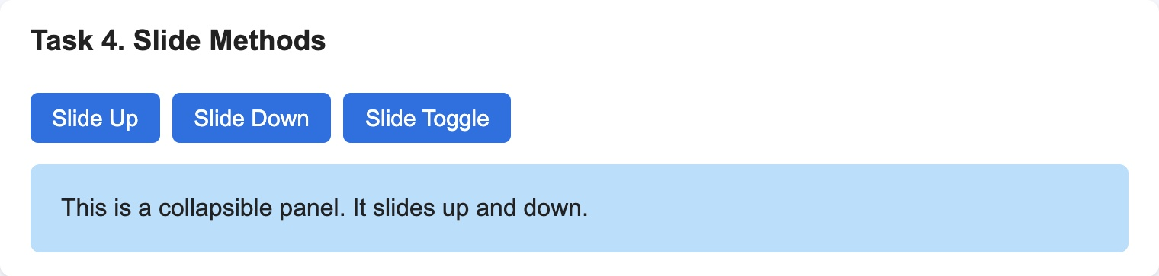
Figure 7 — Task 4 — the panel is open
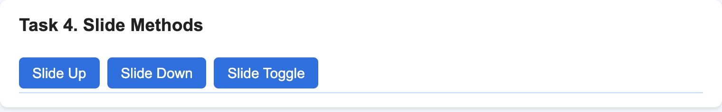
Figure 8 — Task 4 — during “Slide Up” the panel is getting lower
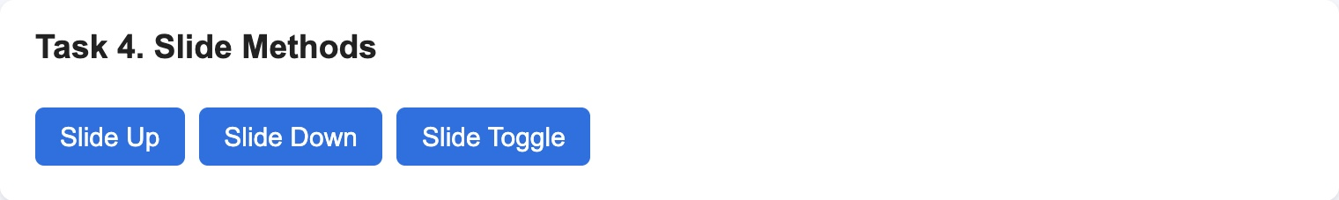
Figure 9 — Task 4 — the panel is closed

Part 3. DOM Manipulation with jQuery

Task 5. Add & Remove Elements
Task: Create a list with an “Add Item” and “Remove Item” button.
• Use .append(), .prepend(), .remove().
assignment6.html
<section class="task">
<h3>Task 5. Add &amp; Remove Elements</h3>
<ul id="list">
<li>Item 1</li>
<li>Item 2</li>
</ul>
<button id="addItemButton">Add Item</button>
<button id="addFirstButton">Add Item to Top</button>
<button id="removeItemButton">Remove Item</button>
</section>
.append() adds a new <li> to the end of the list and .prepend() adds it to the beginning. To use both methods I made two add buttons. The variable itemNumber gives every new item the next number. Remove Item finds the last <li> with .last() and deletes it with .remove(). If the list is empty, nothing is found and nothing happens.
js/assignment6.js
let itemNumber = 3;

$('#addItemButton').click(function () {
$('#list').append('<li>Item ' + itemNumber + '</li>');
itemNumber++;
});

$('#addFirstButton').click(function () {
$('#list').prepend('<li>Item ' + itemNumber + '</li>');
itemNumber++;
});

$('#removeItemButton').click(function () {
$('#list li').last().remove();
});
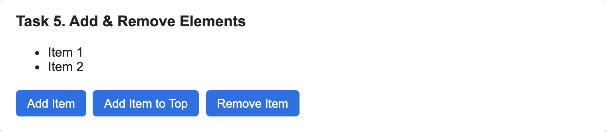
Figure 10 — Task 5 — the list at the start
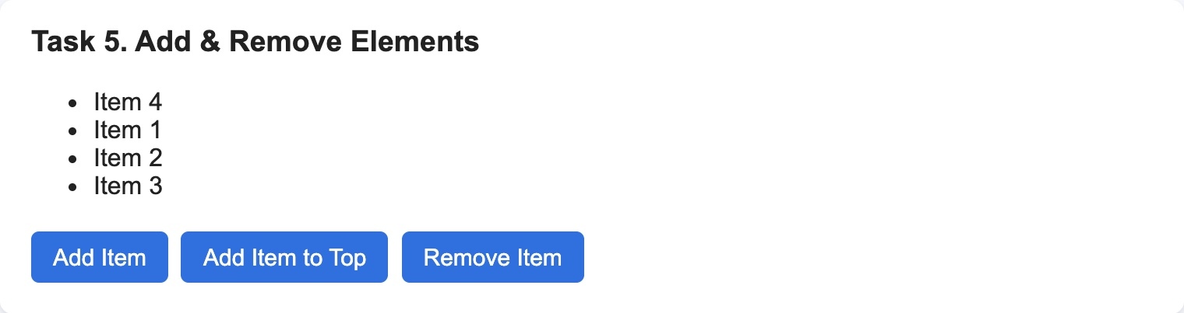 | 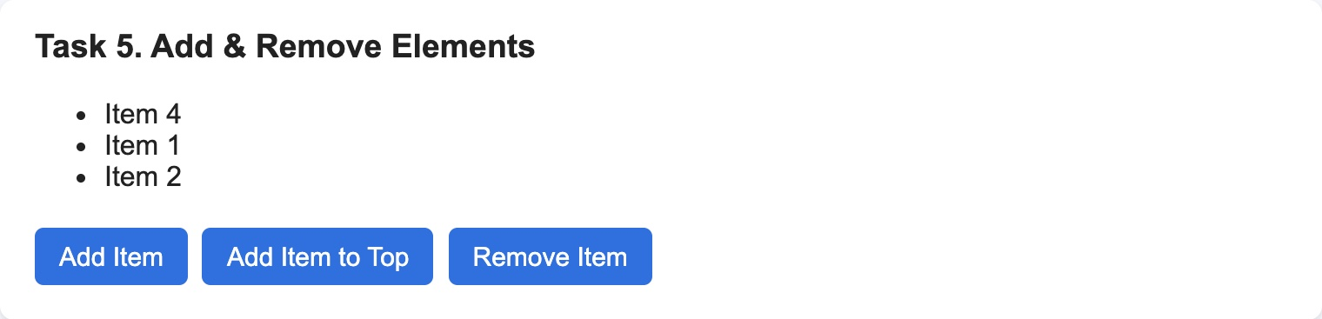
Figure 11 — Task 5 — after “Add Item” (Item 3 at the end) and “Add Item to Top” (Item 4 at the beginning), then after “Remove Item” (right)

Task 6. Modifying Attributes
Task: Add a button that changes an image’s src attribute when clicked.
• Add another button that changes a link’s href dynamically.
assignment6.html
<section class="task">
<h3>Task 6. Modifying Attributes</h3>
<img id="photo" src="images/gallery-img1.jpeg" alt="Photo from my trip">
<br>
<button id="changeImageButton">Change image</button>
<p><a id="link" href="https://api.jquery.com" target="_blank">jQuery API</a></p>
<button id="changeLinkButton">Change link</button>
</section>
.attr('src') with one argument reads the attribute, and with two arguments it sets a new value. The image button checks which photo is shown now and changes it to the other one, so every click switches the photo. The link button changes href and the text of the link.
js/assignment6.js
$('#changeImageButton').click(function () {
if ($('#photo').attr('src') === 'images/gallery-img1.jpeg') {
$('#photo').attr('src', 'images/gallery-img3.jpeg');
} else {
$('#photo').attr('src', 'images/gallery-img1.jpeg');
}
});

$('#changeLinkButton').click(function () {
$('#link').attr('href', 'https://www.w3schools.com/jquery/');
$('#link').text('W3Schools jQuery Tutorial');
});
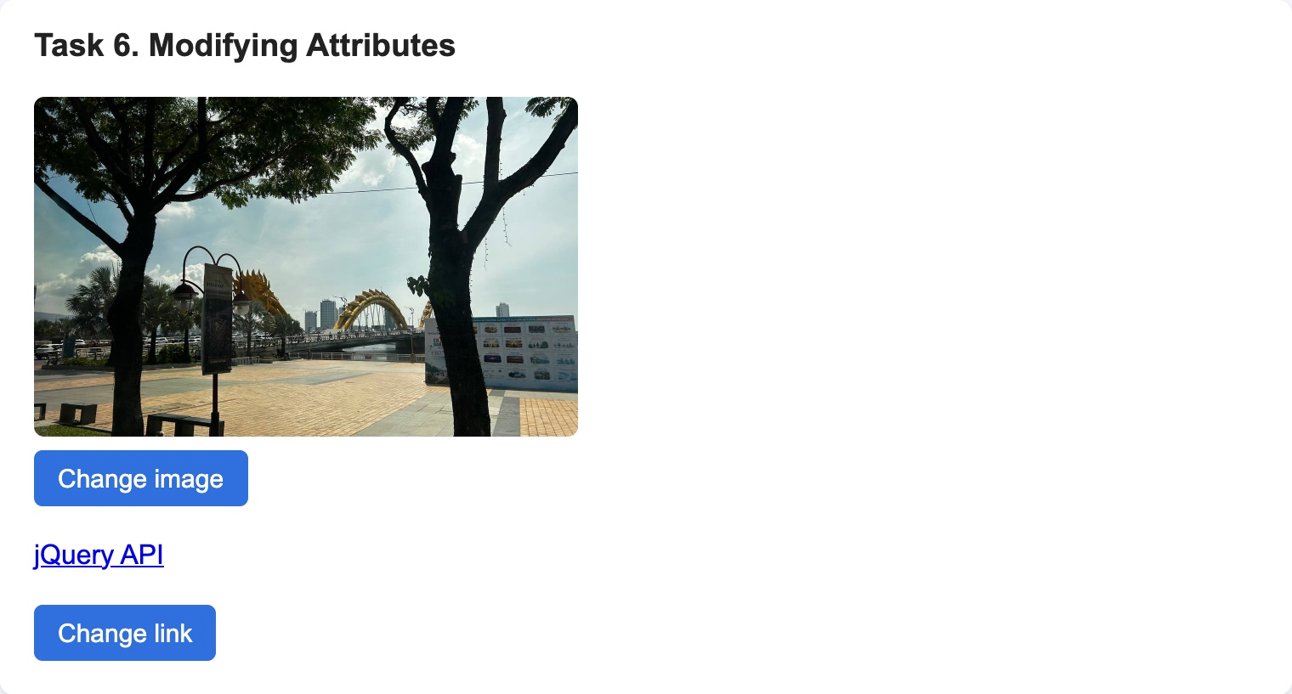 | 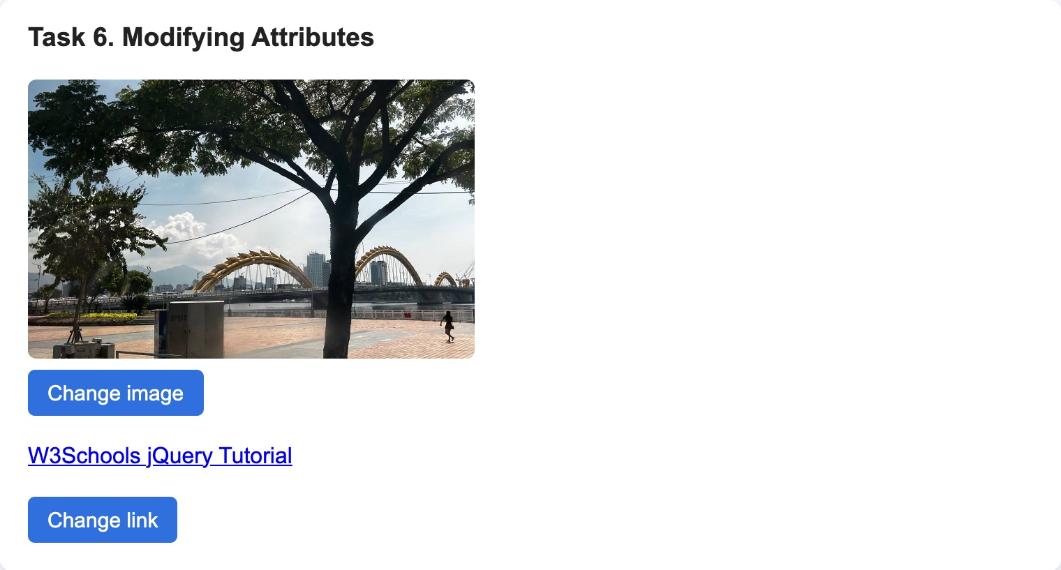
Figure 12 — Task 6 — before (left) and after both buttons (right): new photo and a new link to W3Schools

Task 7. Form Interaction
Task: Create a form with inputs for Name and Email.
• When the user types, display their input live below the form using .val() and .text().
assignment6.html
<section class="task">
<h3>Task 7. Form Interaction</h3>
<form>
<label for="nameInput">Name</label>
<input type="text" id="nameInput" autocomplete="name">
<label for="emailInput">Email</label>
<input type="email" id="emailInput" autocomplete="email">
</form>
<p>Name: <span id="nameOutput"></span></p>
<p>Email: <span id="emailOutput"></span></p>
</section>
The input event happens after every change in the field. .val() reads what is written in the input, and .text() puts it into the span below the form.
js/assignment6.js
$('#nameInput').on('input', function () {
$('#nameOutput').text($('#nameInput').val());
});

$('#emailInput').on('input', function () {
$('#emailOutput').text($('#emailInput').val());
});
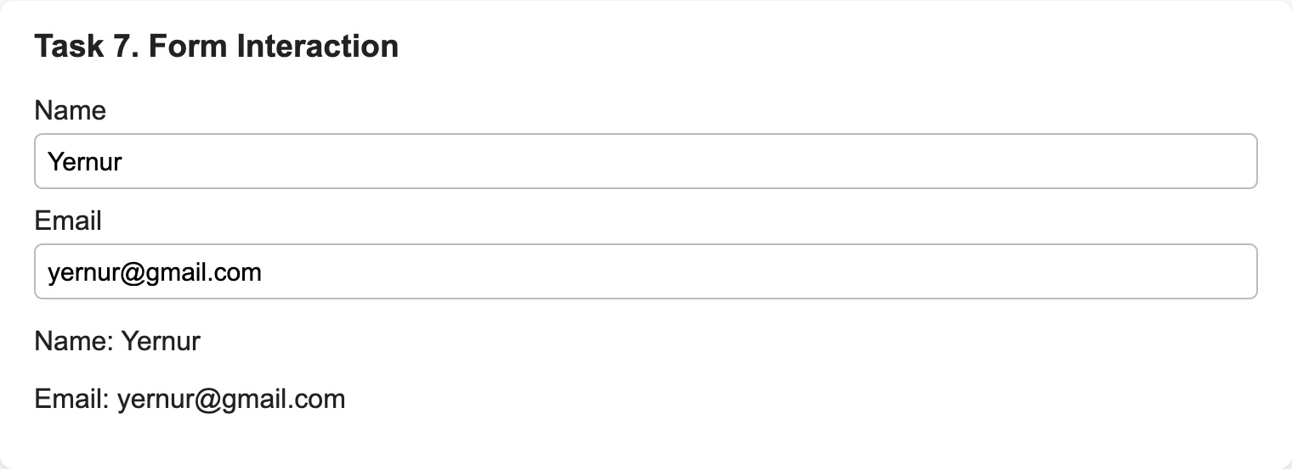
Figure 13 — Task 7 — the name and email are shown below the form while typing

Part 4. Animations
For the animations each box is inside a block with position: relative, and the box has position: absolute. Without it left and top do not move the element.
css/assignment6.css
.stage {
position: relative;
height: 260px;
}

.box {
position: absolute;
left: 0;
top: 0;
width: 80px;
height: 80px;
background: #ff7043;
}

Task 8. Basic Animation
Task: Animate a square <div>: increase its size and change position using .animate().
.animate() gets the CSS values the box must have at the end and the time (1000 ms). jQuery changes the values little by little, so the box grows and moves smoothly. Reset stops the animation with .stop() and puts the start values back with .css().
js/assignment6.js
$('#animateButton').click(function () {
$('#box1').animate({ width: '150px', height: '150px', left: '250px', top: '50px' }, 1000);
});

$('#resetButton1').click(function () {
$('#box1').stop().css({ width: '80px', height: '80px', left: '0px', top: '0px' });
});
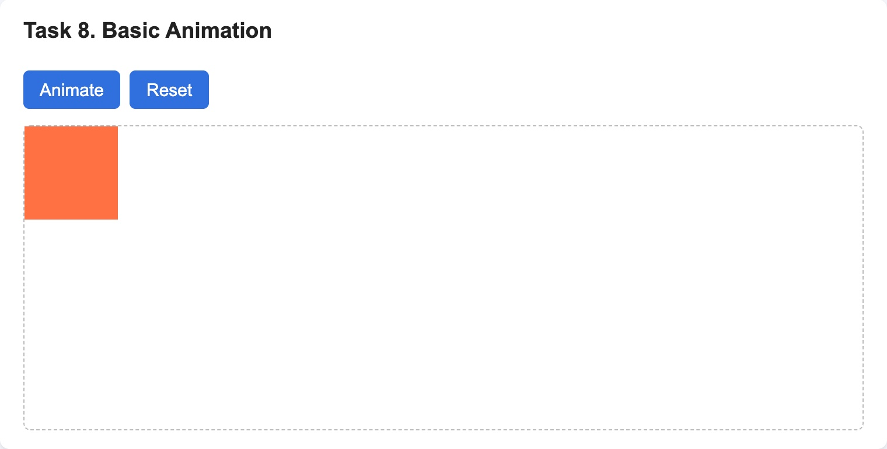 | 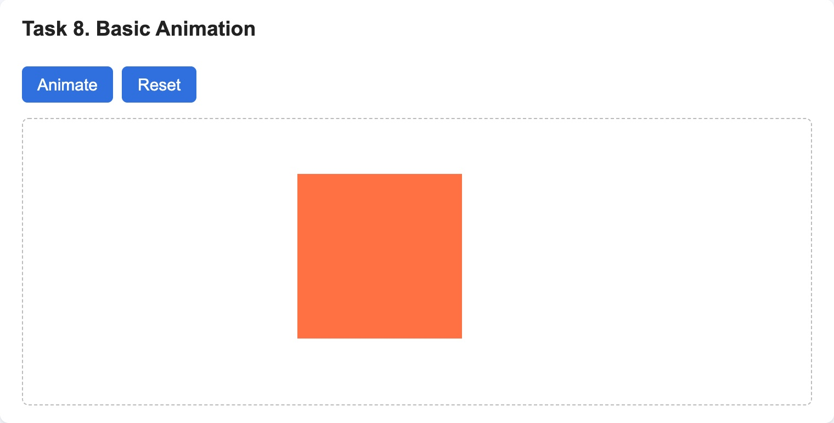
Figure 14 — Task 8 — the square before (left) and after the animation: bigger and moved (right)

Task 9. Sequential Animations
Task: Animate the box step by step (move right → move down → shrink → return to original).
The four .animate() calls are written one after another (chaining). jQuery puts them into a queue, so the next step starts only when the previous one is finished.
js/assignment6.js
$('#sequenceButton').click(function () {
$('#box2')
.animate({ left: '300px' }, 800)
.animate({ top: '150px' }, 800)
.animate({ width: '40px', height: '40px' }, 800)
.animate({ left: '0px', top: '0px', width: '80px', height: '80px' }, 800);
});
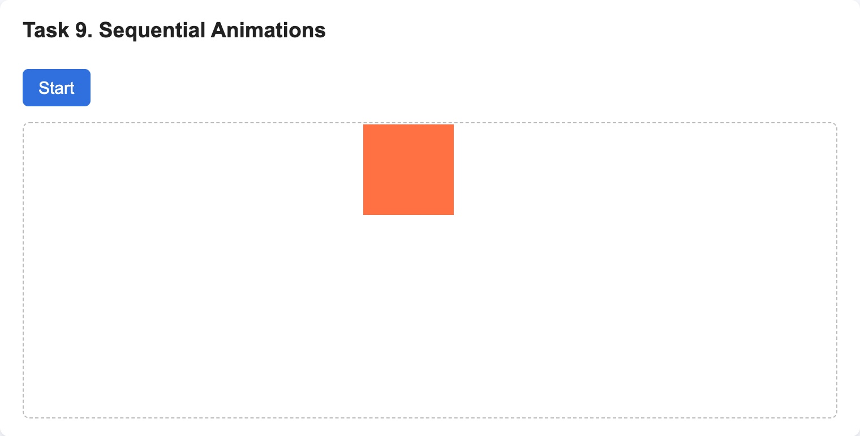 | 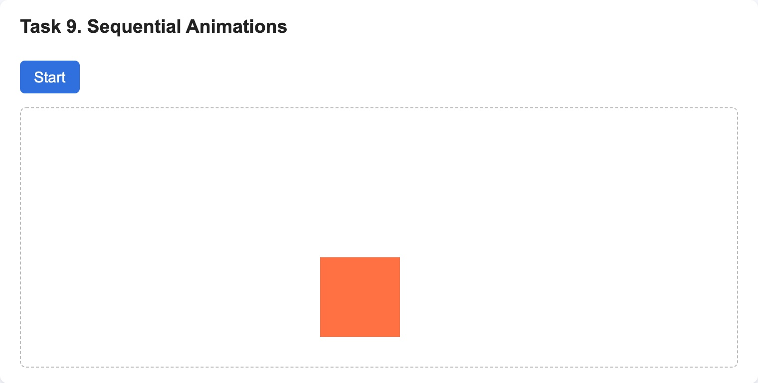
Figure 15 — Task 9 — step 1: moved right (left); step 2: moved down (right)
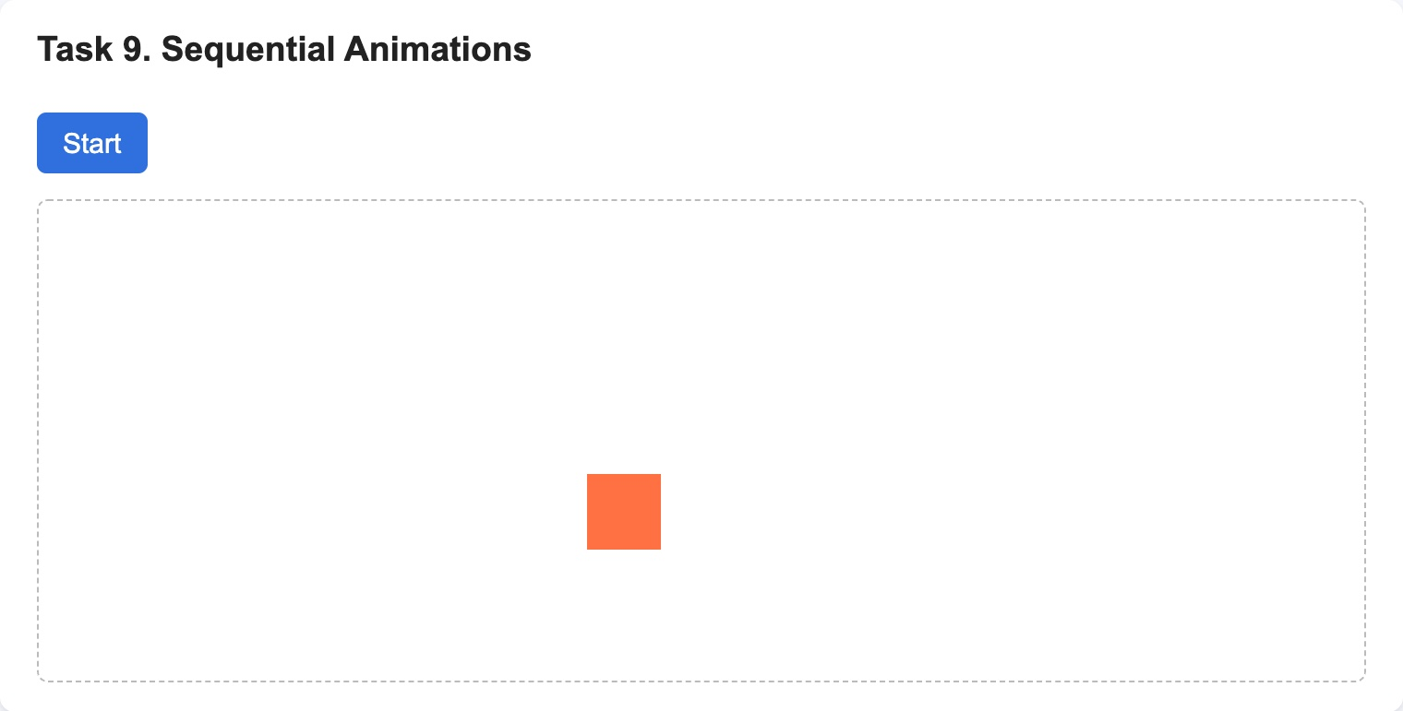 | 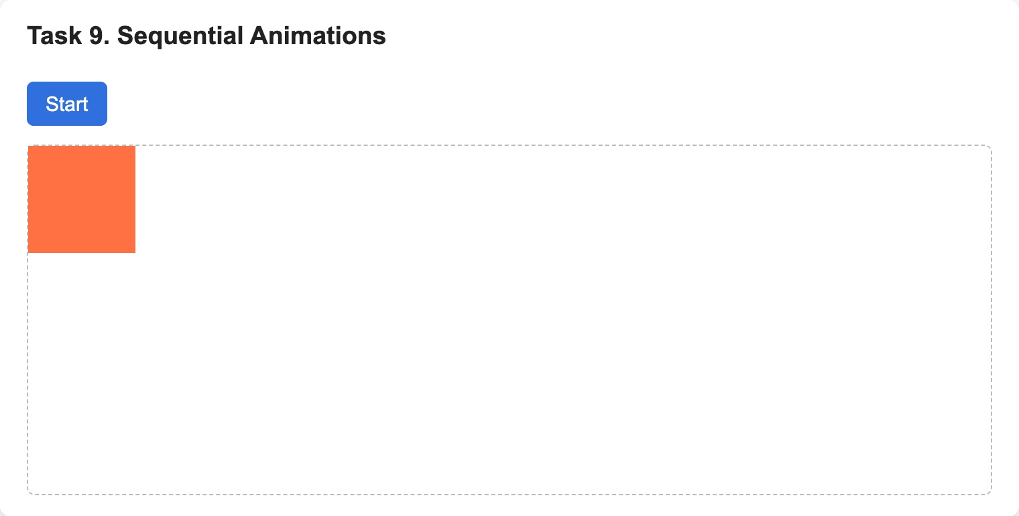
Figure 16 — Task 9 — step 3: shrank (left); step 4: back to the start (right)

Task 10. Combined Animation
Task: Combine opacity, size, and movement into one .animate() call.
Here all values are in one .animate() call, so they change at the same time: the box becomes transparent, bigger and moves right during 1.5 seconds.
js/assignment6.js
$('#combineButton').click(function () {
$('#box3').animate({ opacity: 0.3, width: '160px', height: '160px', left: '300px', top: '50px' }, 1500);
});

$('#resetButton3').click(function () {
$('#box3').stop().css({ opacity: 1, width: '80px', height: '80px', left: '0px', top: '0px' });
});
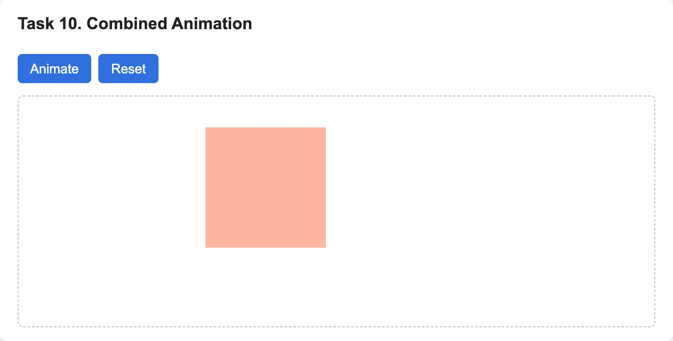 | 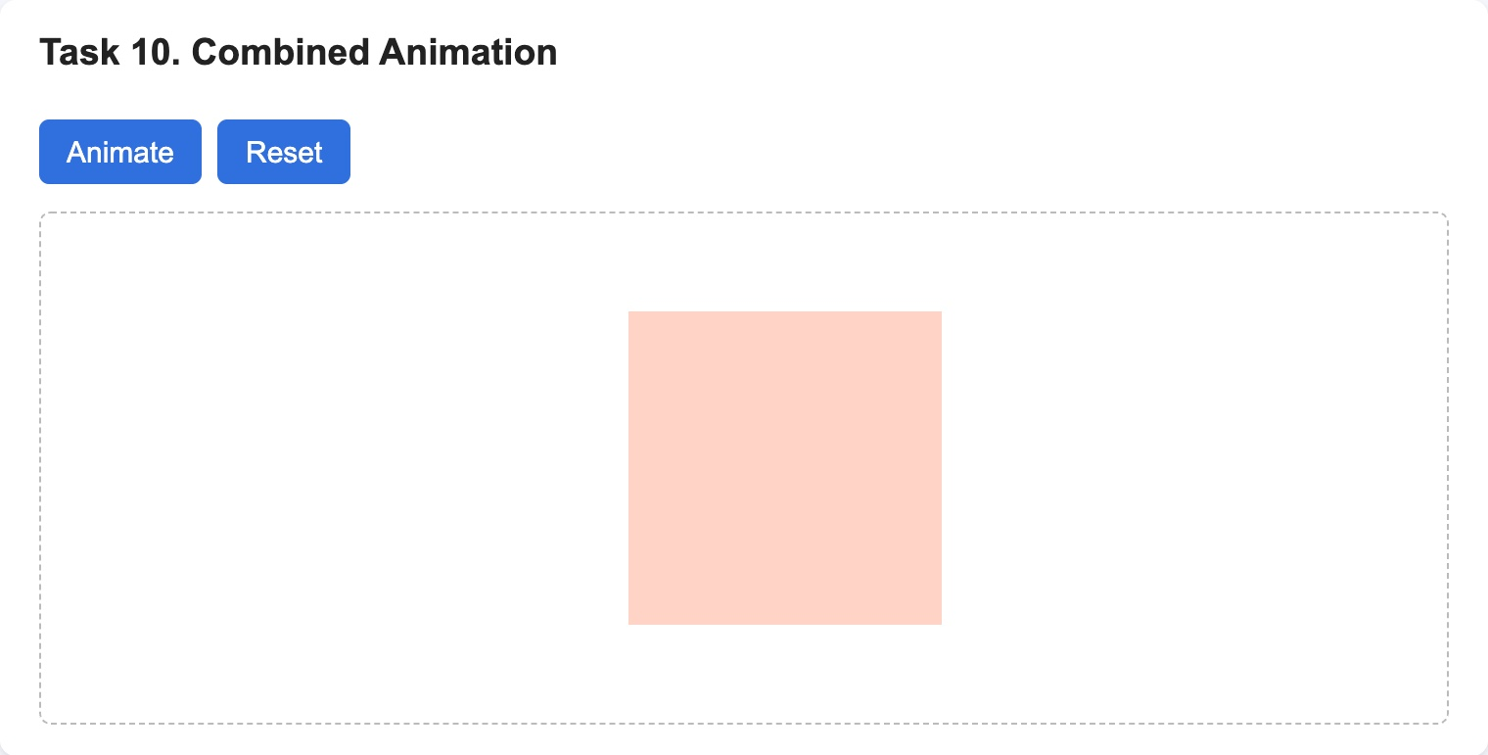
Figure 17 — Task 10 — during the animation (left) and at the end: opacity 0.3, 160 × 160 px, moved (right)

Part 5. Mini Project

Task 11. Accordion Menu
Task: Choose one mini project: Image Gallery, Accordion Menu or Bouncing Ball.
I chose the Accordion Menu: sections expand and collapse with slide animations. Each section is a button (the header) and a text block after it. At the start all text blocks are hidden with display: none in CSS.
assignment6.html
<section class="task">
<h3>Task 11. Accordion Menu</h3>
<div class="accordion">
<button class="accordion-header">What is jQuery?</button>
<div class="accordion-content">jQuery is a JavaScript library. It makes it easier to select elements, handle events and make animations.</div>

<button class="accordion-header">How to include jQuery?</button>
<div class="accordion-content">Add a script tag with the jQuery file from a CDN before your own script.</div>

<button class="accordion-header">What does $(document).ready() do?</button>
<div class="accordion-content">It runs the code only after the whole page is loaded, so all elements already exist.</div>
</div>
</section>
One function works for all headers:
- $(this) is the header that was clicked, .next() is the element right after it, so it is its own text block.
- $('.accordion-content').not(content).slideUp() closes all other sections, so only one section is open.
- content.slideToggle() opens the clicked section, or closes it if it was already open.

js/assignment6.js
$('.accordion-header').click(function () {
const content = $(this).next();
$('.accordion-content').not(content).slideUp();
content.slideToggle();
});
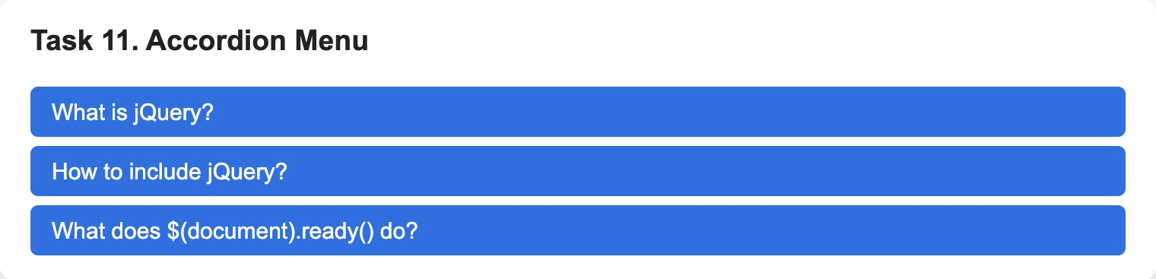
Figure 18 — Task 11 — all sections are closed
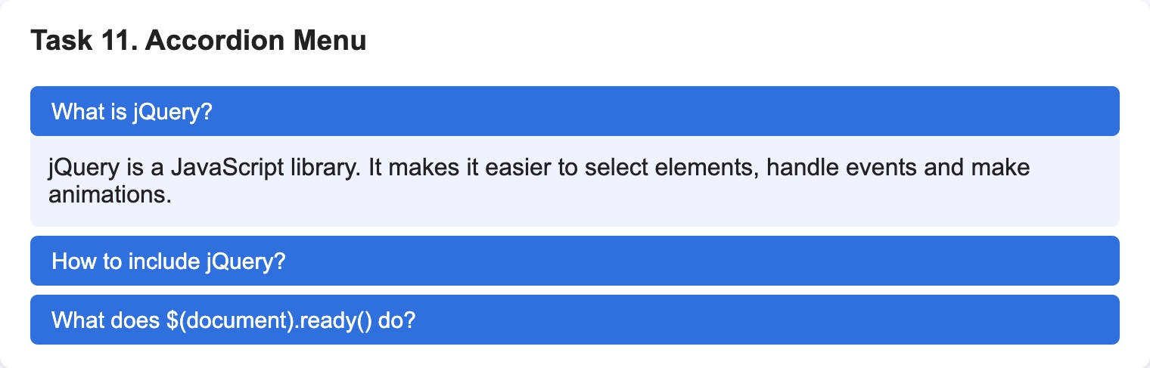
Figure 19 — Task 11 — the first section is open
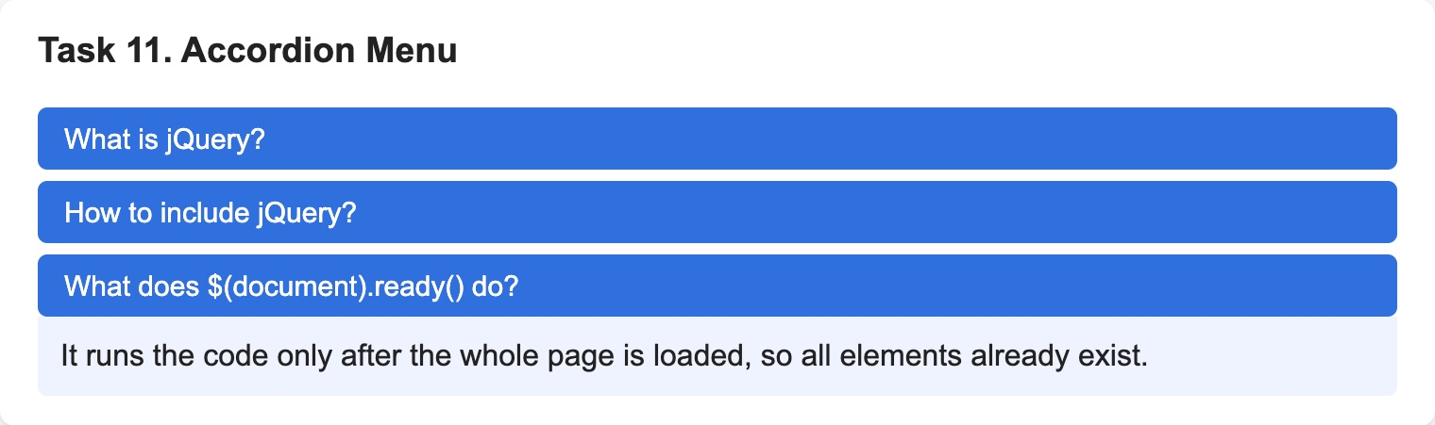
Figure 20 — Task 11 — after clicking the third header: it opens and the first one closes

Summary of my work process
This is what I did step by step:
- Setup. I made assignment6.html, connected jQuery from the CDN and my script after it, and checked the “jQuery is ready!” message in the console.
- Selectors. I selected elements by id, class and tag and changed them with .text(), .html() and .css().
- Effects. I used hide/show/toggle, the fade methods for the image and the slide methods for the panel.
- DOM. I added and removed list items, changed src and href with .attr() and showed the form values live with .val() and .text().
- Animations. I animated the boxes with .animate(): one animation, a chain of four steps and one call with several properties.
- Mini project. I made an accordion menu with .slideUp() and .slideToggle().
- Testing. I clicked every button in Chrome. The console shows only “jQuery is ready!”, there are no errors.

Things that needed attention:
- Selecting by tag. At first I used <span> for Task 1, but Task 7 also has <span> elements, so $('span') changed them too. I used <em> instead, because there is only one on the page.
- Moving the box. left and top do not move an element with normal position, so the boxes have position: absolute inside a block with position: relative.
- The page should not jump. After .fadeOut() the image gets display: none and the content under it would move up, so the image is inside a box with a fixed height.
- Reset during an animation. If Reset is clicked while the box is still moving, the animation would continue after the reset. That is why Reset calls .stop() first and then .css().

In this assignment I learned that jQuery makes the same things as plain JavaScript but with shorter code: $('#id') instead of document.getElementById(), .click() instead of addEventListener('click'), and ready effects like fade and slide that I would have to write myself in plain JavaScript.

