Assignment #3. Responsive Web Design (Media Queries + Bootstrap Grid)
Student: Yernur Nassipkali
Group: SE-2517

Project and breakpoints
The assignment is made on my personal portfolio page from the previous assignments - index.html and css/style.css. All five tasks are implemented in this one page, so the site stays a single project. Bootstrap 5.3.8 is connected from the CDN before my own stylesheet, so my styles can override the framework.
I use the same breakpoints as Bootstrap (md and lg), so my media queries and the grid classes switch at the same width:
Screen | Width | Bootstrap
Mobile | less than 768px | col-*
Tablet | 768px - 991px | col-md-*
Desktop | 992px and wider | col-lg-*

Task | Where it is on the page
Task 0. Responsive typography | Whole page: headings and text in the media queries
Task 1. Layout with media queries | Image gallery (CSS Grid, no Bootstrap)
Task 2. Bootstrap columns | Skills section
Task 3. Bootstrap navbar | Page header
Task 4. Portfolio page | Whole page: navbar + projects + sidebar + footer

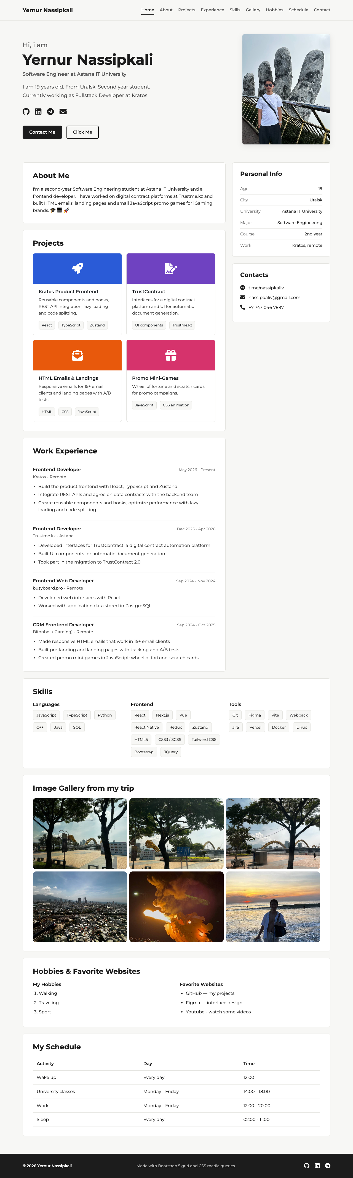
Figure 1 — General view of the page on desktop (1280px)

Part 1. Media Queries

Task 0. Responsive Typography
Create a simple webpage with headings and paragraphs. Use media queries to change font sizes for mobile, tablet, and desktop.
The page has headings h1-h4 and paragraphs. The desktop sizes are the base styles, and two media queries make the text smaller on tablet and on mobile.
Element | Mobile (<768px) | Tablet (768-991px) | Desktop (>=992px)
h1 | 34px | 42px | 52px
h2 | 16px | 18px | 18px
h3 | 22px | 24px | 26px
h4 | 16px | 17px | 17px
body text | 15px | 16px | 16px
hero intro | 16px | 17px | 18px

css/style.css
h1 {
font-size: 52px; /* desktop - base style */
}

@media (max-width: 991px) { /* tablet */
h1 { font-size: 42px; }
h3 { font-size: 24px; }
.hero-intro { font-size: 17px; }
}

@media (max-width: 767px) { /* mobile */
body { font-size: 15px; }
h1 { font-size: 34px; }
h2 { font-size: 16px; }
h3 { font-size: 22px; }
h4 { font-size: 16px; }
.hero-intro { font-size: 16px; }
}
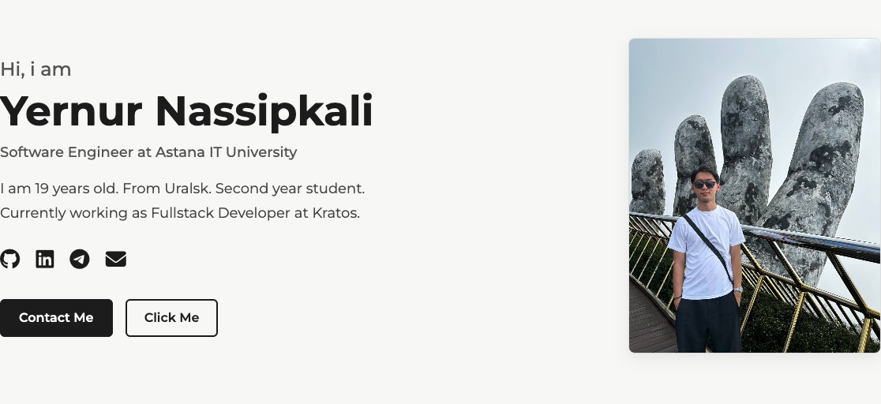
Figure 2 — Desktop, 1280px: h1 is 52px
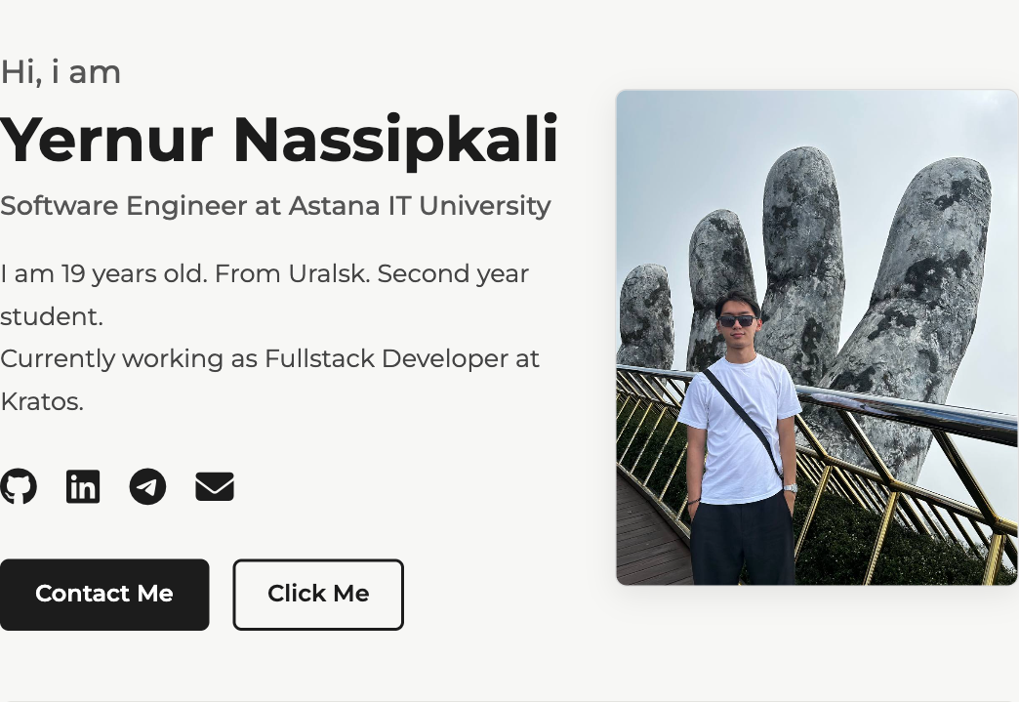
Figure 3 — Tablet, 768px: h1 is 42px
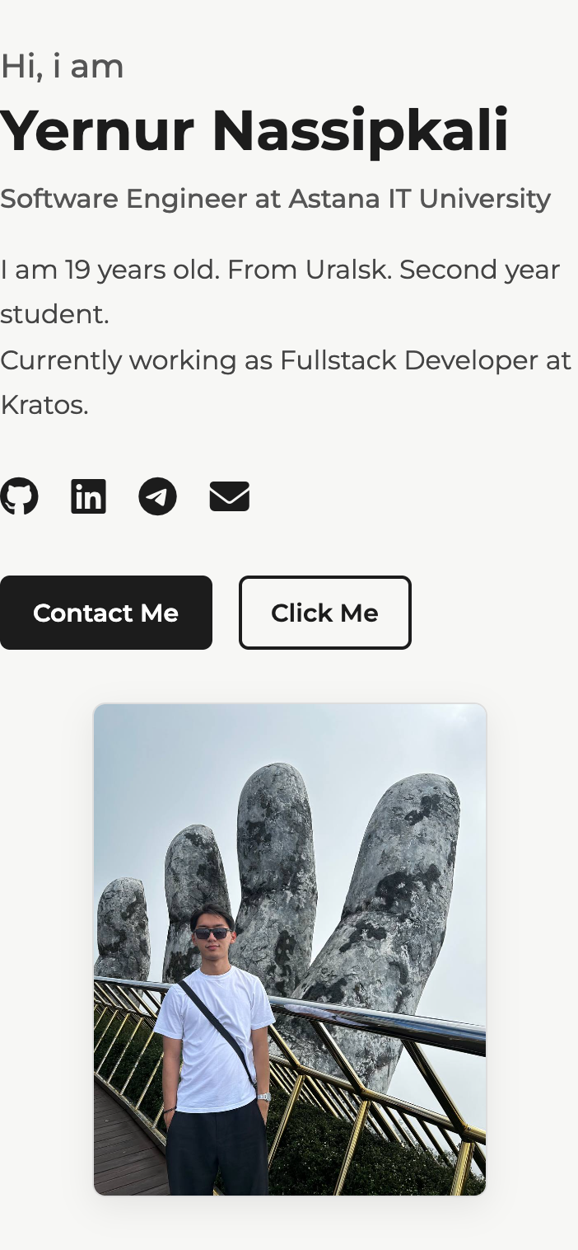
Figure 4 — Mobile, 375px: h1 is 34px, the photo moves under the text

Task 1. Responsive Layout with Media Queries
Create a webpage with three boxes in a row. Desktop: all three side by side. Tablet: two boxes in a row. Mobile: boxes stacked vertically. Use only CSS media queries (no Bootstrap).
This task is done in the image gallery. The blocks are placed with CSS Grid and only media queries change the number of columns: three in a row on desktop, two on tablet and one on mobile. There are no Bootstrap classes here. Every image has the same aspect ratio, and object-fit: cover crops the photo instead of stretching it, so the boxes are equal.
css/style.css
.image-gallery {
display: grid;
grid-template-columns: repeat(3, 1fr); /* desktop: three in a row */
gap: 8px;
}

.gallery-img-block {
display: block;
width: 100%;
aspect-ratio: 4 / 3;
object-fit: cover;
border-radius: 12px;
}

@media (max-width: 991px) {
.image-gallery { grid-template-columns: repeat(2, 1fr); } /* tablet: two in a row */
}

@media (max-width: 767px) {
.image-gallery { grid-template-columns: 1fr; } /* mobile: stacked */
}
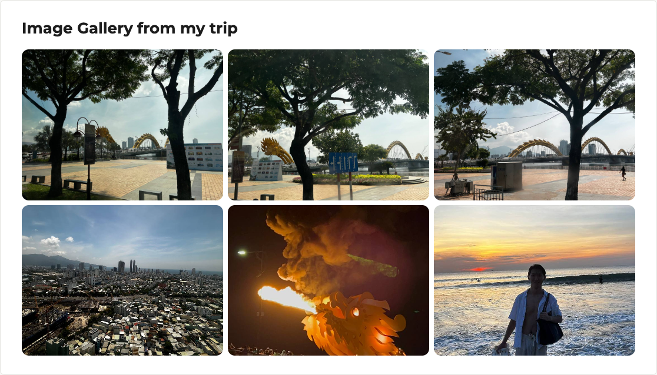
Figure 5 — Desktop: three blocks in a row
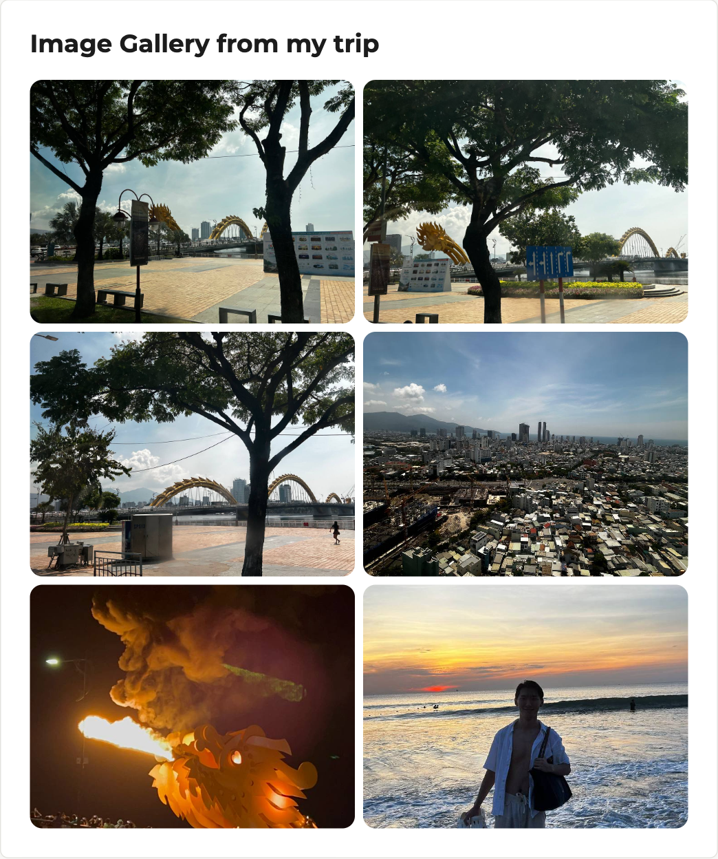
Figure 6 — Tablet: two blocks in a row
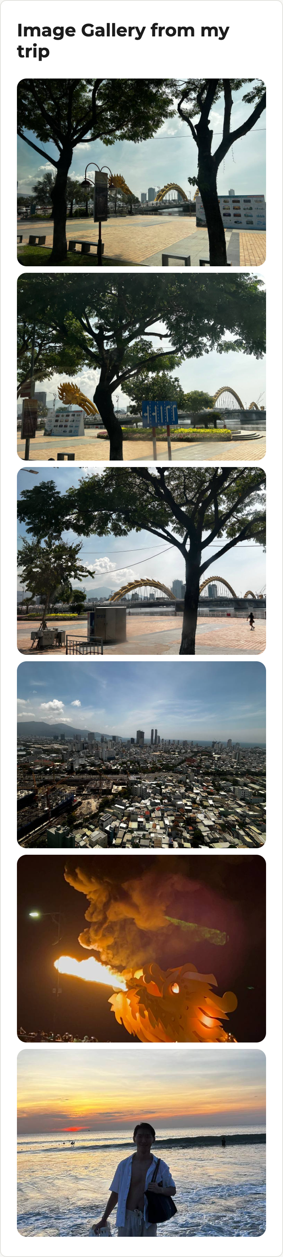
Figure 7 — Mobile: the blocks are stacked vertically

Part 2. Bootstrap Grid System

Task 2. Bootstrap Responsive Columns
Build a responsive layout using Bootstrap 12-column grid. Three columns. Desktop: each column takes 4 columns. Tablet: two columns on the first row and one on the second row. Mobile: all columns stacked.
The Skills section is built with the Bootstrap grid: container - row - col. A row is divided into 12 columns, and a class works from its breakpoint and wider. That is why one element has several classes at the same time.
Screen | Languages | Frontend | Tools | Result
Mobile | 12 / 12 | 12 / 12 | 12 / 12 | stacked
Tablet | 6 / 12 | 6 / 12 | 12 / 12 | 6 + 6, third on the second row
Desktop | 4 / 12 | 4 / 12 | 4 / 12 | 4 + 4 + 4 = 12

index.html
<section id="skills" class="section-card">
<h3>Skills</h3>
<div class="row g-4">
<div class="col-12 col-md-6 col-lg-4">
<div class="skill-group"> ... Languages ... </div>
</div>
<div class="col-12 col-md-6 col-lg-4">
<div class="skill-group"> ... Frontend ... </div>
</div>
<div class="col-12 col-lg-4">
<div class="skill-group"> ... Tools ... </div>
</div>
</div>
</section>
The third block has no col-md-6 on purpose: on tablet it stays 12/12 and takes the whole second row, because the first row is already full (6 + 6 = 12).
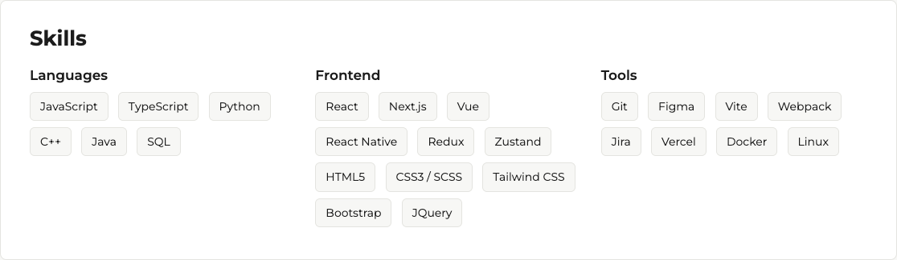
Figure 8 — Desktop: three equal columns (4 + 4 + 4)
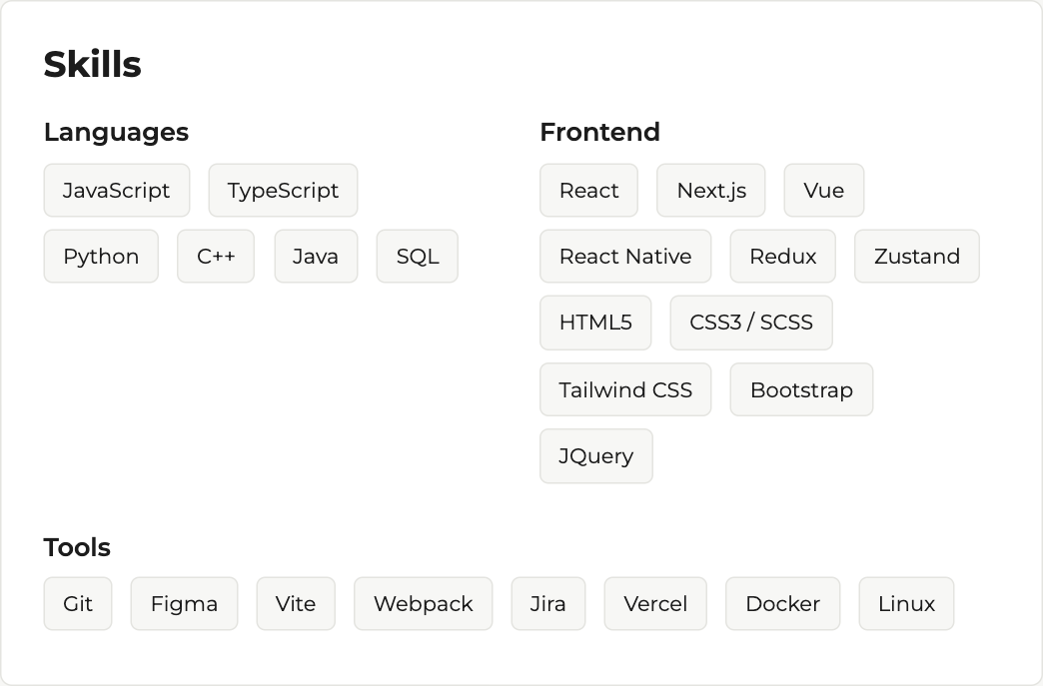
Figure 9 — Tablet: 6 + 6 on the first row, Tools on the second row
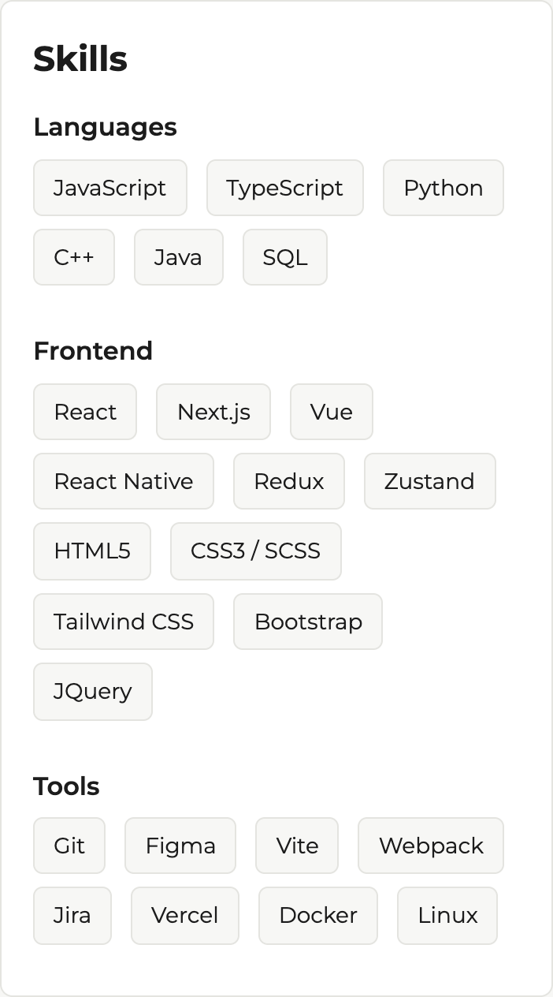
Figure 10 — Mobile: all three groups are stacked

Task 3. Bootstrap Navigation Bar
Create a responsive navigation bar using Bootstrap components: a logo on the left, links on the right, and collapse into a hamburger menu on smaller screens.
The header is a Bootstrap navbar. The class navbar-expand-lg means that the links are shown in one line from 992px; below that width they are hidden in the .collapse block and the hamburger button appears. The button opens the menu through data-bs-toggle="collapse" and data-bs-target="#mainNav", so the Bootstrap JS bundle is connected at the end of the page. The class ms-auto pushes the list of links to the right, and sticky-top keeps the navbar on the screen while scrolling.
index.html
<nav class="navbar navbar-expand-lg site-navbar sticky-top">
<div class="container">
<a class="navbar-brand site-logo" href="#home">Yernur Nassipkali</a>

<button class="navbar-toggler" type="button" data-bs-toggle="collapse"
data-bs-target="#mainNav" aria-controls="mainNav"
aria-expanded="false" aria-label="Toggle navigation">
<span class="navbar-toggler-icon"></span>
</button>

<div class="collapse navbar-collapse" id="mainNav">
<ul class="navbar-nav ms-auto">
<li class="nav-item"><a class="nav-link active" href="#home">Home</a></li>
<li class="nav-item"><a class="nav-link" href="#about-me">About</a></li>
...
</ul>
</div>
</div>
</nav>

<!-- Bootstrap JS bundle, without it the hamburger does not open -->
<script src=".../bootstrap@5.3.8/dist/js/bootstrap.bundle.min.js"></script>
Figure 11 — Desktop: logo on the left, links on the right
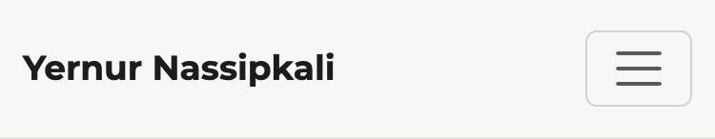
Figure 12 — Mobile: the links are hidden behind the hamburger button
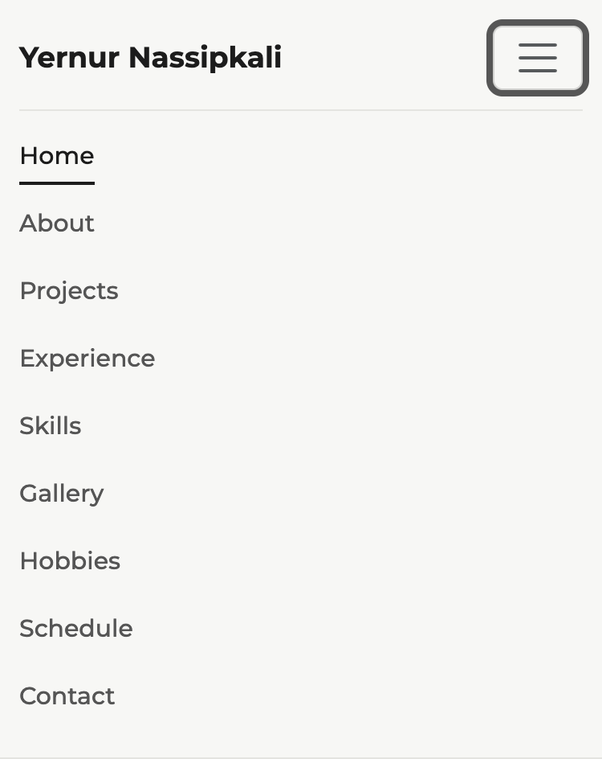
Figure 13 — Mobile: the opened menu

Part 3. Combined Project

Task 4. Responsive Portfolio Page
Create a portfolio page using both Media Queries and Bootstrap Grid: header with a Bootstrap navbar; main section divided into two parts (left - portfolio projects in the Bootstrap grid, right - sidebar with personal info and contact details); footer across the bottom. Apply custom media queries for font sizes, spacing and element visibility.
Structure of the page: the navbar from Task 3, then the main part divided into two columns, and the footer at the bottom. On desktop the projects take 8 of 12 columns and the sidebar takes 4. On tablet and mobile both become 12/12, so the sidebar goes under the content.
index.html
<main class="container">
<div class="row">
<div class="col-12 col-lg-8"> <!-- left side: about, projects, experience -->
<section id="projects" class="section-card">
<h3>Projects</h3>
<div class="row g-3">
<div class="col-12 col-md-6">
<article class="card project-card h-100">
<div class="project-cover cover-blue">
<i class="fa-solid fa-rocket"></i>
</div>
<div class="card-body">
<h4 class="card-title">Kratos Product Frontend</h4>
<p class="card-text">Reusable components and hooks ...</p>
</div>
</article>
</div>
...
</div>
</section>
</div>

<aside class="col-12 col-lg-4"> <!-- right side: personal info + contacts -->
<div class="sidebar"> ... </div>
</aside>
</div>
</main>

<footer class="site-footer"> ... </footer>
Custom media queries change three things, as the task asks:
What changes | How
Font sizes | h1 52 / 42 / 34px, headings and body text (Task 0)
Spacing | cards: padding 32px on desktop, 28px on tablet, 24/20px on mobile
Visibility | on mobile the colored covers of the cards and the footer note are hidden

css/style.css
.sidebar {
position: sticky; /* desktop: the sidebar stays visible while scrolling */
top: 96px;
}

@media (max-width: 991px) {
.section-card { padding: 28px; }
.sidebar { position: static; } /* tablet: it is below the content */
}

@media (max-width: 767px) {
.section-card { padding: 24px 20px; }
.project-cover { display: none; } /* visibility: hide the covers on a small screen */
.footer-note { display: none; }
}
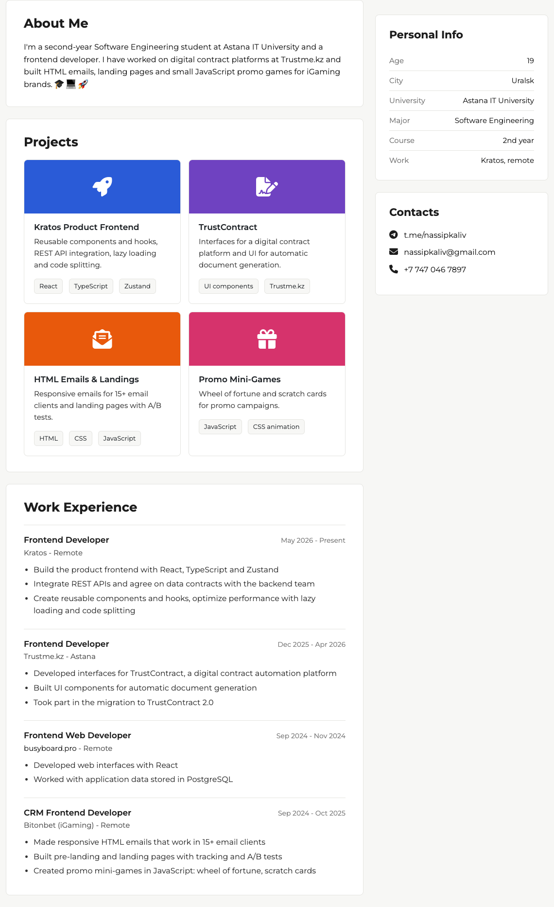
Figure 14 — Desktop: projects (8 columns) on the left, sidebar (4 columns) on the right
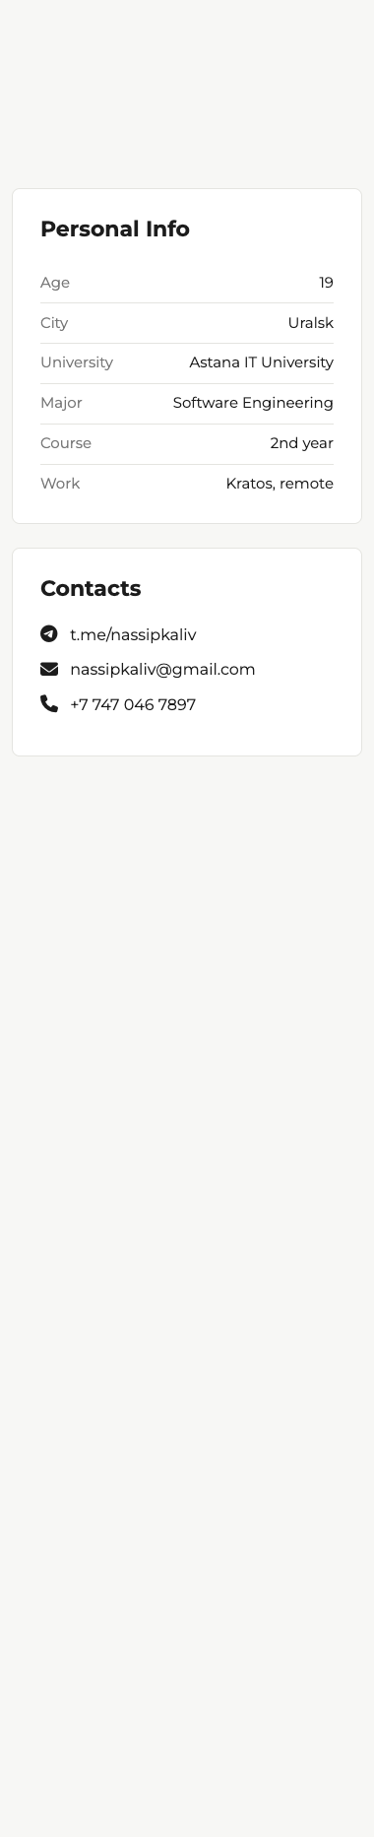
Figure 15 — Sidebar: personal info and contact details
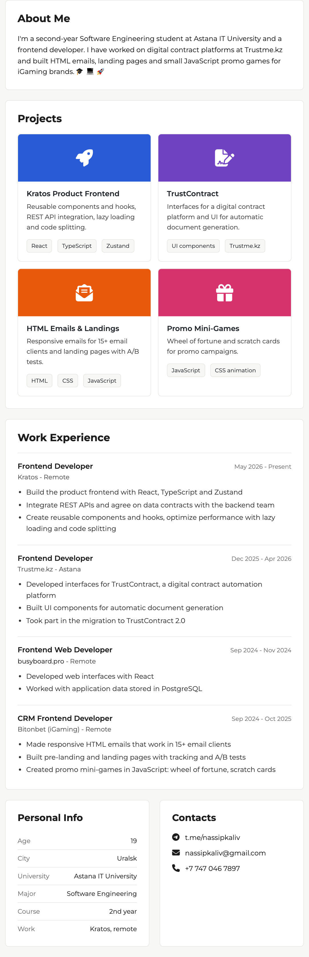
Figure 16 — Tablet: the sidebar moves under the content, its two cards stand side by side
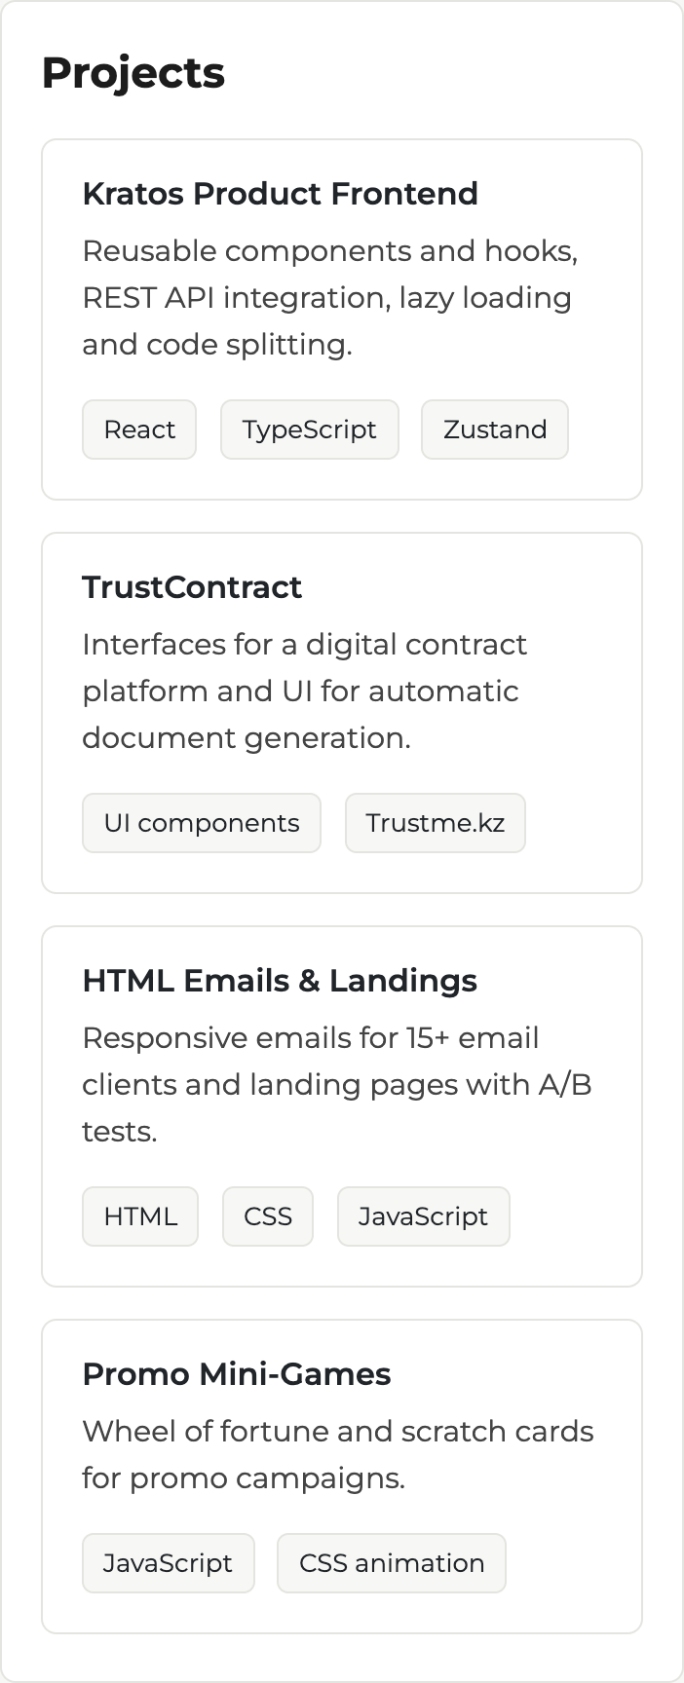
Figure 17 — Mobile: one card per row, the colored covers are hidden
Figure 18 — Footer on desktop

Figure 19 — Footer on mobile: the note is hidden, the elements are centered

Summary of my work process
1. First I chose the breakpoints. I took 768px and 992px, the same as Bootstrap md and lg, so that my own media queries and the grid classes work at the same widths.
2. I connected Bootstrap 5.3.8 from the CDN and put the link before my css/style.css, because the last stylesheet wins when the specificity is equal, and I needed to keep my own design.
3. I rewrote the old header into a Bootstrap navbar with a toggler and connected the Bootstrap JS bundle, without which the hamburger does not open.
4. I wrapped the main content into the grid: a row with col-12 col-lg-8 for the content and col-12 col-lg-4 for the sidebar. I moved the contacts into the sidebar and added a block with personal information, a Projects section with cards and a footer.
5. I rebuilt the Skills section with the 12-column grid (Task 2) and added media queries to the gallery (Task 1), where the number of columns changes from three to one.
6. At the end I wrote the media queries for typography, spacing and visibility.
7. I checked the page in Chrome DevTools (device toolbar) at 375px, 768px, 992px and 1280px. I looked at the borders of the breakpoints especially: 767/768 and 991/992. I checked that there is no horizontal scroll on any width and that the menu opens and closes.
8. Problems I had to fix: at 992px the nine links did not fit next to the logo, so I made the font of the links 15px and the gap 20px; in the narrow sidebar the long e-mail did not fit, so I reduced the padding of the card; on mobile the schedule table was too wide, so I wrapped it in table-responsive.
What I learned: how to plan breakpoints, the difference between the mobile-first approach (min-width, like in Bootstrap) and the desktop-first approach (max-width, which I used because my base styles were already written for desktop), and how the 12-column grid works together with my own CSS.

