Midterm Assignment
Using Bootstrap for Optimizing Your Website
Student: Yernur Nassipkali
Group: SE-2517
Course: Web Technologies 1 (Front End)
Files: midterm.html, css/midterm.css
For the midterm I rebuilt my personal portfolio page with Bootstrap 5.3. The content is the same as on my site (about me, skills, photos from my trip, contacts), but the layout, spacing, navigation, buttons, carousel, cards and the form are now made with Bootstrap classes instead of my own CSS.
Bootstrap is connected from the jsDelivr CDN: the CSS file in <head> and the JavaScript bundle (with Popper) at the end of <body>. The JavaScript is needed for the collapsing navbar and for the carousel. My own file css/midterm.css is linked after Bootstrap, so it can add a few things on top of it.
midterm.html
<link rel="stylesheet" href="https://cdn.jsdelivr.net/npm/bootstrap@5.3.8/dist/css/bootstrap.min.css">
<link rel="stylesheet" href="https://cdnjs.cloudflare.com/ajax/libs/font-awesome/6.7.2/css/all.min.css">
<link rel="stylesheet" href="css/midterm.css">
...
<script src="https://cdn.jsdelivr.net/npm/bootstrap@5.3.8/dist/js/bootstrap.bundle.min.js"></script>
File | What is inside
midterm.html | The page. All layout and spacing are done with Bootstrap classes here
css/midterm.css | Only the font and image sizes (object-fit). No custom margins or paddings
images/ | Profile photo and six photos from Da Nang, used in the carousel and cards

The page has five sections that are linked from the navbar:
Section | id | What is used there
Home | #home | Two-column grid (col-lg-6), buttons, button group
About | #about | Two-column grid (col-lg-6), list group, responsive padding
Skills | #skills | Three-column grid (col-lg-4), badges
Trip | #trip | Carousel in the grid, button group for the carousel, card group
Contact | #contact | Two-column grid, Bootstrap form, input group, button group

Where each requirement is done:
Requirement | Where on the page | Weight
1. Bootstrap Grid Layout | Home, About (col-lg-6), Skills (col-lg-4), Trip, Contact | 20%
2. Bootstrap Spacing Utilities | Whole page, responsive classes in navbar, Home, About, Trip, Contact | 20%
3. Bootstrap Navigation Bar | Page header | 15%
4. Bootstrap Buttons | Home, Trip, Contact form, footer | 15%
5. Bootstrap Carousel | Trip section | 10%
6. Bootstrap Cards | Trip section, under the carousel | 10%
7. Responsive Form (optional) | Contact section | —
8. Accessibility | Whole page | 10%

I checked the page at the standard Bootstrap breakpoints:
Screen | Width | Bootstrap prefix | Screenshot width
Mobile | less than 576px | col-* | 375px
Large phone | 576px – 767px | col-sm-* | 640px
Tablet | 768px – 991px | col-md-* | 768px
Desktop | 992px and wider | col-lg-* | 1280px

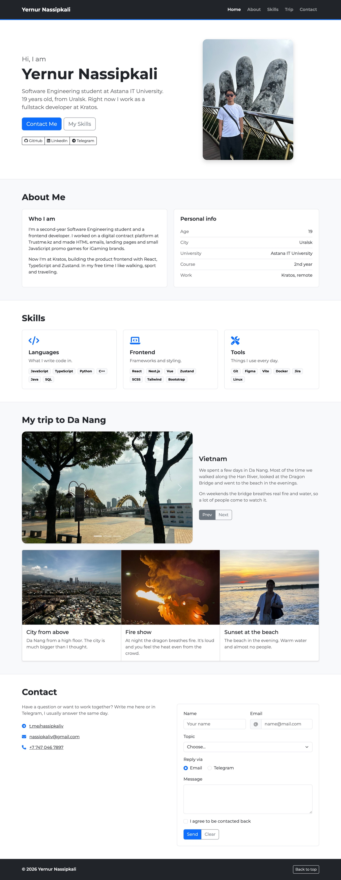
Figure 1 — General view of the page on desktop (1280px)

1. Bootstrap Grid Layout
Requirement: Replace custom layouts with Bootstrap’s grid system. Create a responsive design with at least two sections: one with two columns (col-lg-6) and another with three columns (col-lg-4). Use container or container-fluid. Use col-sm, col-md and col-lg appropriately.
Every section has the same structure: a full-width <section> for the background, then .container inside it, then .row and columns. The container keeps the content centered with the same side padding everywhere, and the section background can still go from edge to edge.

Two columns (col-lg-6)
The first section (Home) has the text on the left and the photo on the right. On desktop both columns are col-lg-6. On tablet the text gets a bit more space (col-md-7 and col-md-5), and on mobile both are col-12, so the photo goes under the text.
midterm.html
<section id="home" class="bg-white border-bottom py-5">
<div class="container py-lg-4">
<div class="row align-items-center g-5">
<div class="col-12 col-md-7 col-lg-6 text-center text-md-start">
<p class="fs-4 text-body-secondary mb-1">Hi, I am</p>
<h1 class="display-4 fw-bold mb-3">Yernur Nassipkali</h1>
...
</div>
<div class="col-12 col-md-5 col-lg-6 text-center">
<img class="profile-photo img-fluid rounded-4 shadow" src="images/avatar.jpg" alt="...">
</div>
</div>
</div>
</section>

Figure 2 — Home section on desktop: two col-lg-6 columns
The About section is the second two-column block: “Who I am” and “Personal info” are both col-12 col-lg-6. Below 992px they go one under the other.
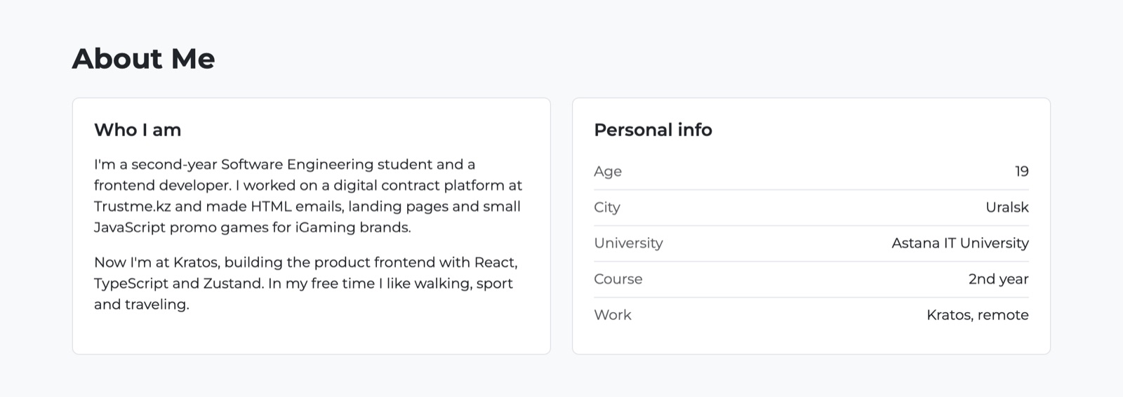
Figure 3 — About section on desktop: two col-lg-6 columns of the same height (h-100)

Three columns (col-lg-4)
The Skills section has three blocks: Languages, Frontend and Tools. Each one uses three grid classes, so the layout changes on every screen size:
midterm.html
<div class="row g-4">
<div class="col-12 col-sm-6 col-lg-4">
<div class="border rounded-3 h-100 p-4">... Languages ...</div>
</div>
<div class="col-12 col-sm-6 col-lg-4">
<div class="border rounded-3 h-100 p-4">... Frontend ...</div>
</div>
<div class="col-12 col-sm-12 col-lg-4">
<div class="border rounded-3 h-100 p-4">... Tools ...</div>
</div>
</div>
- Desktop (col-lg-4): three blocks in one row.
- Tablet and large phones (col-sm-6): two blocks in a row, and the third one takes the full width (col-sm-12) so there is no empty space.
- Mobile (col-12): the blocks are stacked.

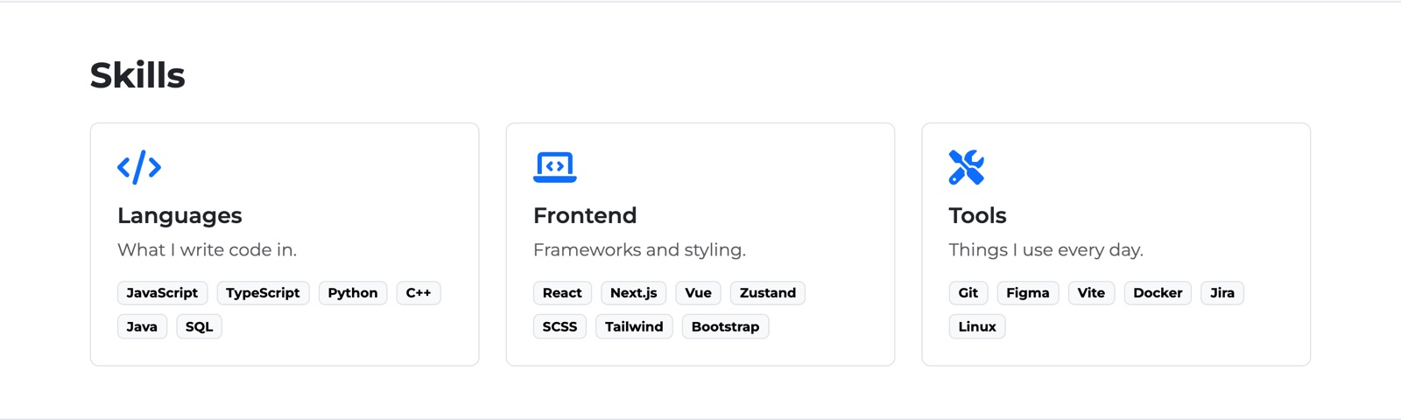
Figure 4 — Skills on desktop: three col-lg-4 columns
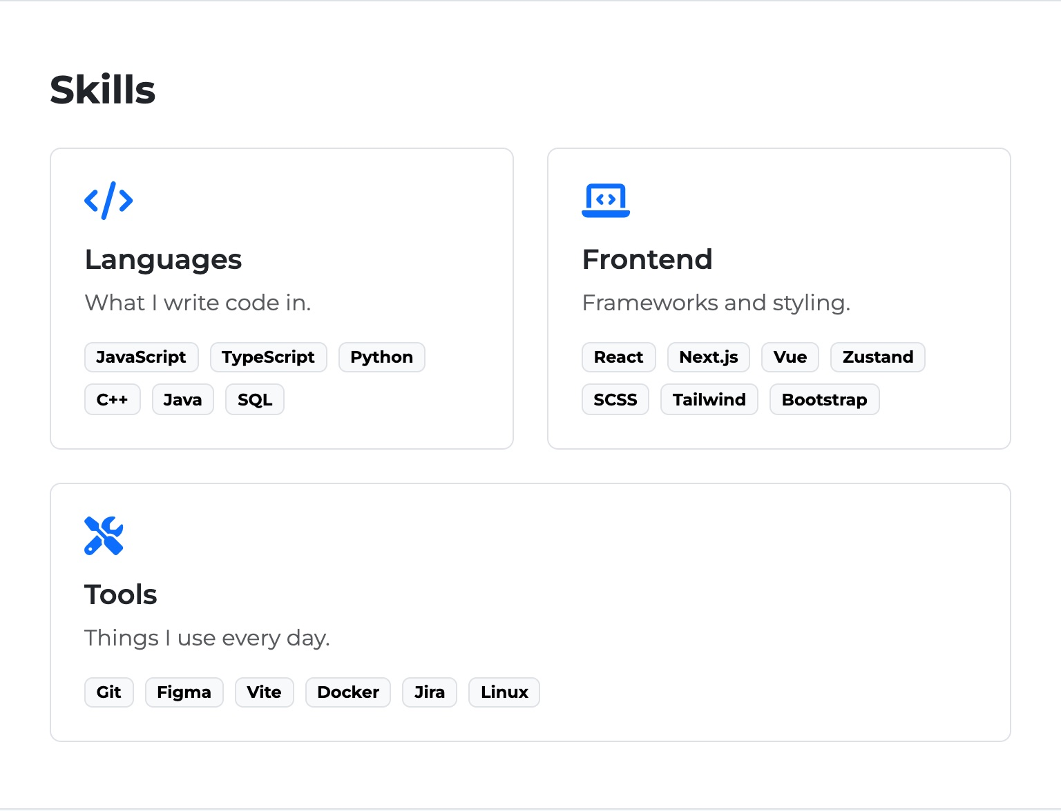 | 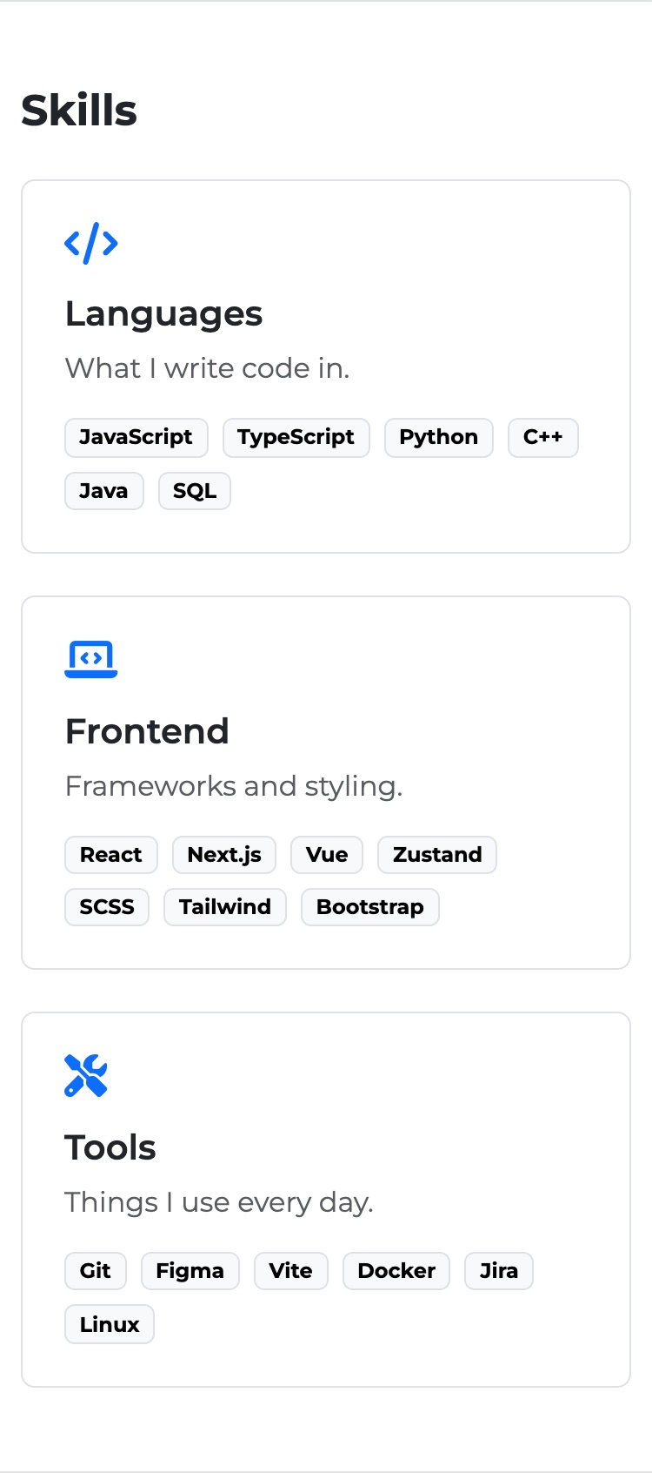
Figure 5 — Skills on tablet (left): 2 + 1 layout; on mobile (right): stacked

Grid classes in all sections
The space between columns is made with gutter classes g-3, g-4 and g-5 on the rows, so the columns do not need their own margins.
The table shows how many columns each section has on every screen size:
Section | < 576px | 576px+ (sm) | 768px+ (md) | 992px+ (lg)
Home | 12 | 12 | 7 + 5 | 6 + 6
About | 12 | 12 | 12 | 6 + 6
Skills | 12 | 6 + 6, 12 | 6 + 6, 12 | 4 + 4 + 4
Trip (carousel + text) | 12 | 12 | 12 | 7 + 5
Contact (info + form) | 12 | 12 | 5 + 7 | 6 + 6
Form fields Name / Email | 12 | 6 + 6 | 6 + 6 | 6 + 6

2. Bootstrap Spacing Utilities
Requirement: Replace all custom margins and paddings with Bootstrap’s spacing utility classes (m-, p-). Add responsive margin and padding controls, such as mt-lg-4 and px-sm-2.
All the spacing on the page is done with Bootstrap classes. My CSS file does not have any margin or padding. This is the whole file:
css/midterm.css
html {
scroll-behavior: smooth;
scroll-padding-top: 80px;
}

body {
font-family: "Montserrat", Helvetica, Arial, sans-serif;
}

.profile-photo {
width: 340px;
aspect-ratio: 3 / 4;
object-fit: cover;
}

.carousel-img {
height: 420px;
object-fit: cover;
}

.card-photo {
height: 280px;
object-fit: cover;
}

@media (max-width: 767px) {
.profile-photo {
width: 240px;
}

.carousel-img {
height: 260px;
}
}
The only spacing-like property is scroll-padding-top. It does not move any element; it only tells the browser to stop scrolling 80px earlier when you click a navbar link, so the sticky navbar does not cover the section title.

Spacing classes used on the page
Class | Where | What it does
py-5 | Every section | Space above and below each section (3rem)
mb-1, mb-3, mb-4 | Headings, paragraphs, button rows | Space under elements instead of default margins
mb-0 | Last paragraph in a block, footer text | Removes the default paragraph margin
p-4 | Skill blocks, About blocks | Inner padding of the boxes (1.5rem)
px-0 | Personal info list items | Removes side padding so the list lines up with the title
me-1, me-2 | Icons in buttons and contact list | Space between the icon and the text
gap-2, g-3, g-4, g-5 | Button rows, grid rows | Space between items and between columns

Responsive spacing
Classes | Where | How it changes
mt-5 mt-lg-4 | Card group in Trip | 3rem above the cards on small screens (they come after the text), 1.5rem on desktop where the carousel and text are side by side
p-4 px-sm-2 px-md-4 | About blocks | 1.5rem on phones, horizontal padding 0.5rem from 576px, back to 1.5rem from 768px
py-lg-4 | Home container | Extra space above and below the first section only on desktop
mt-3 mt-lg-0 | Navbar links | Space between the logo and the opened menu on mobile, removed on desktop where links are in one line
gap-lg-2 | Navbar links | Space between links only when they are in one row
p-3 p-md-4 | Contact form | Smaller padding on phones, bigger from tablet
text-center text-md-start | Home text | Centered on mobile, left-aligned from tablet

midterm.html
<div class="bg-white border rounded-3 h-100 p-4 px-sm-2 px-md-4">
...
<div class="card-group shadow-sm mt-5 mt-lg-4">
...
<form class="border rounded-3 p-3 p-md-4">
 | 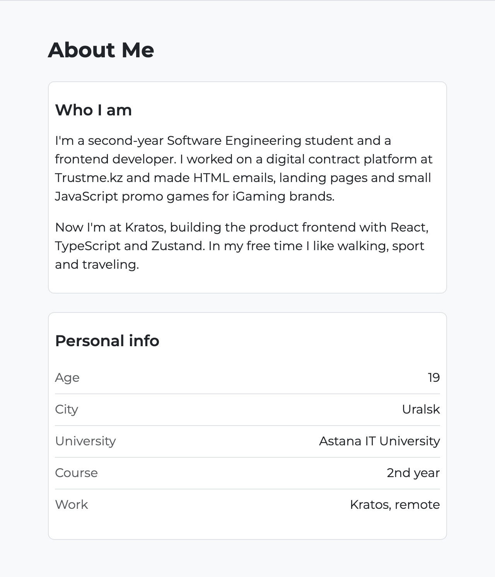
Figure 6 — About on 375px (left, p-4) and on 640px (right, px-sm-2 gives smaller side padding)

3. Bootstrap Navigation Bar
Requirement: Implement a Bootstrap navigation bar with at least three links. Customize the background color and link styles using Bootstrap classes. The navbar collapses into a hamburger menu on smaller screens (navbar-toggler).
The navbar is in <header> and uses the <nav> element. It has the brand (my name) and five links: Home, About, Skills, Trip and Contact. Each link goes to a section on the page.
midterm.html
<nav class="navbar navbar-expand-lg bg-dark border-bottom border-primary border-3 sticky-top py-3" data-bs-theme="dark">
<div class="container">
<a class="navbar-brand fw-bold" href="#home">Yernur Nassipkali</a>

<button class="navbar-toggler" type="button" data-bs-toggle="collapse" data-bs-target="#mainNav"
aria-controls="mainNav" aria-expanded="false" aria-label="Toggle navigation">
<span class="navbar-toggler-icon"></span>
</button>

<div class="collapse navbar-collapse" id="mainNav">
<ul class="navbar-nav ms-auto mt-3 mt-lg-0 gap-lg-2">
<li class="nav-item"><a class="nav-link fw-semibold active" aria-current="page" href="#home">Home</a></li>
<li class="nav-item"><a class="nav-link fw-semibold" href="#about">About</a></li>
<li class="nav-item"><a class="nav-link fw-semibold" href="#skills">Skills</a></li>
<li class="nav-item"><a class="nav-link fw-semibold" href="#trip">Trip</a></li>
<li class="nav-item"><a class="nav-link fw-semibold" href="#contact">Contact</a></li>
</ul>
</div>
</div>
</nav>
How the navbar is customized, only with Bootstrap classes:
- bg-dark — dark background instead of the default light one.
- data-bs-theme="dark" — makes the links light and the hamburger icon white, so they are readable on the dark background.
- border-bottom border-primary border-3 — blue line under the navbar.
- fw-bold on the brand and fw-semibold on the links — bolder text.
- active + aria-current="page" — the current link is white, the others are grey.
- ms-auto — pushes the links to the right side.
- sticky-top — the navbar stays on top when you scroll.

navbar-expand-lg means the links are in one row from 992px. Below that, they are hidden in .collapse and the navbar-toggler button (hamburger) appears. Clicking it opens and closes the menu with the Bootstrap JavaScript.
Figure 7 — Navbar on desktop: brand on the left, links on the right, the active link is white

Figure 8 — Navbar on tablet (768px): the links are collapsed into the hamburger button
 | 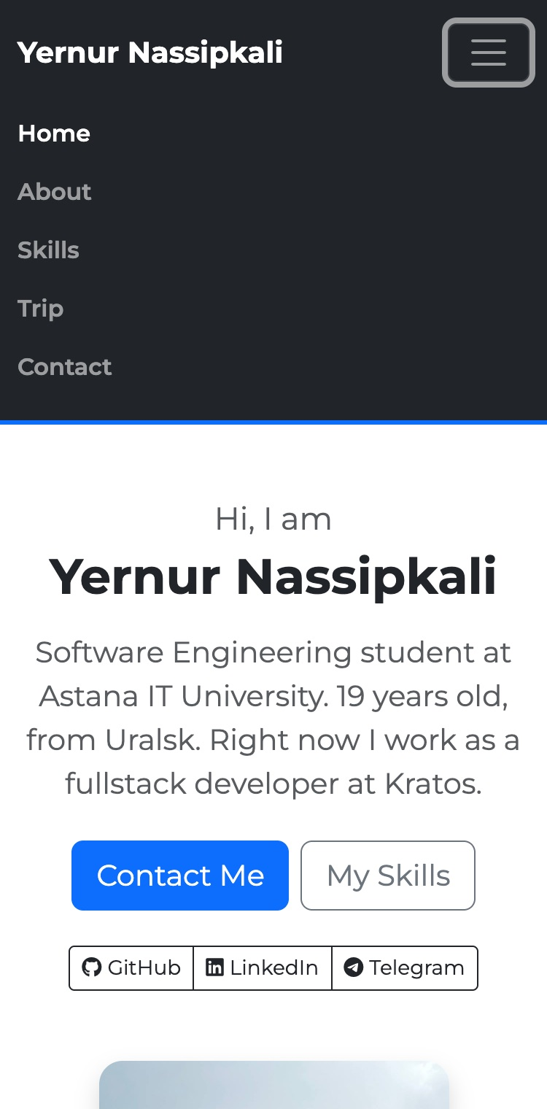
Figure 9 — Mobile: closed menu (left) and opened menu after clicking the toggler (right)

4. Bootstrap Buttons
Requirement: Replace all custom buttons with Bootstrap buttons (btn btn-primary, btn btn-secondary, etc.). Add different button styles like btn-outline, btn-lg, btn-sm. Optionally create a button group with btn-group.
All buttons on the page use Bootstrap classes, there are no custom button styles in my CSS. Links that go somewhere are <a class="btn">, and actions (carousel, form) are real <button> elements.
Button | Classes | Where
Contact Me | btn btn-primary btn-lg | Home
My Skills | btn btn-outline-secondary btn-lg | Home
GitHub / LinkedIn / Telegram | btn-group + btn btn-outline-dark btn-sm | Home
Prev | btn btn-secondary | Trip, inside btn-group
Next | btn btn-outline-secondary | Trip, inside btn-group
Send | btn btn-primary (type="submit") | Contact form, inside btn-group
Clear | btn btn-outline-secondary (type="reset") | Contact form, inside btn-group
Back to top | btn btn-outline-light btn-sm | Footer

So the page uses filled buttons (btn-primary, btn-secondary), outline buttons (btn-outline-*), and two sizes (btn-lg, btn-sm). Hover, focus and active states come from Bootstrap.

Button groups
There are three button groups. Every group has role="group" and an aria-label, so a screen reader says what the group is about.
midterm.html
<div class="d-flex flex-wrap justify-content-center justify-content-md-start gap-2 mb-4">
<a class="btn btn-primary btn-lg" href="#contact">Contact Me</a>
<a class="btn btn-outline-secondary btn-lg" href="#skills">My Skills</a>
</div>

<div class="btn-group" role="group" aria-label="Social links">
<a class="btn btn-outline-dark btn-sm" href="https://github.com/nassipkaliv/" target="_blank" rel="noopener">
<i class="fa-brands fa-github me-1" aria-hidden="true"></i>GitHub
</a>
...
</div>

<div class="btn-group" role="group" aria-label="Carousel controls">
<button type="button" class="btn btn-secondary" data-bs-target="#tripCarousel" data-bs-slide="prev">Prev</button>
<button type="button" class="btn btn-outline-secondary" data-bs-target="#tripCarousel" data-bs-slide="next">Next</button>
</div>
The buttons are responsive: the big buttons are in a d-flex flex-wrap gap-2 row, so on a narrow screen they move to the next line instead of going out of the screen, and on mobile they are centered.

Figure 10 — Home buttons: btn-primary btn-lg (on hover), btn-outline-secondary btn-lg and the btn-group with btn-sm

Figure 11 — Keyboard focus (Tab) on a button in the group: Bootstrap shows the focus state

5. Bootstrap Carousel
Requirement: Add a Bootstrap carousel to display at least three images. Include navigation indicators and controls. The carousel is functional and properly aligned in the grid system.
The carousel shows three photos from my trip to Da Nang. It is placed in the grid: the carousel is in col-12 col-lg-7 and the text about the trip is next to it in col-12 col-lg-5. On smaller screens the text goes under the carousel.
midterm.html
<div class="row g-4 align-items-center">
<div class="col-12 col-lg-7">
<div id="tripCarousel" class="carousel slide rounded-4 overflow-hidden shadow-sm" data-bs-ride="carousel">
<div class="carousel-indicators">
<button type="button" data-bs-target="#tripCarousel" data-bs-slide-to="0" class="active" aria-current="true" aria-label="Slide 1"></button>
<button type="button" data-bs-target="#tripCarousel" data-bs-slide-to="1" aria-label="Slide 2"></button>
<button type="button" data-bs-target="#tripCarousel" data-bs-slide-to="2" aria-label="Slide 3"></button>
</div>

<div class="carousel-inner">
<div class="carousel-item active">
<img src="images/gallery-img1.jpeg" class="d-block w-100 carousel-img" alt="Riverside park with the Dragon Bridge in the background">
</div>
... two more carousel-item ...
</div>

<button class="carousel-control-prev" type="button" data-bs-target="#tripCarousel" data-bs-slide="prev">
<span class="carousel-control-prev-icon" aria-hidden="true"></span>
<span class="visually-hidden">Previous</span>
</button>
<button class="carousel-control-next" type="button" data-bs-target="#tripCarousel" data-bs-slide="next">
<span class="carousel-control-next-icon" aria-hidden="true"></span>
<span class="visually-hidden">Next</span>
</button>
</div>
</div>
<div class="col-12 col-lg-5">... text and Prev / Next buttons ...</div>
</div>
- Indicators — three small buttons at the bottom. They show which slide is open and you can click them to jump to a slide.
- Controls — the arrows on the left and right. Their text “Previous” and “Next” is hidden with visually-hidden, but screen readers read it.
- Autoplay — data-bs-ride="carousel" starts the slideshow when the page loads.
- Extra controls — the Prev / Next button group next to the carousel uses the same data-bs-target and data-bs-slide, so it controls the same carousel.
- Same size — the photos have different sizes, so in CSS they get a fixed height with object-fit: cover. Without it the carousel would jump up and down.

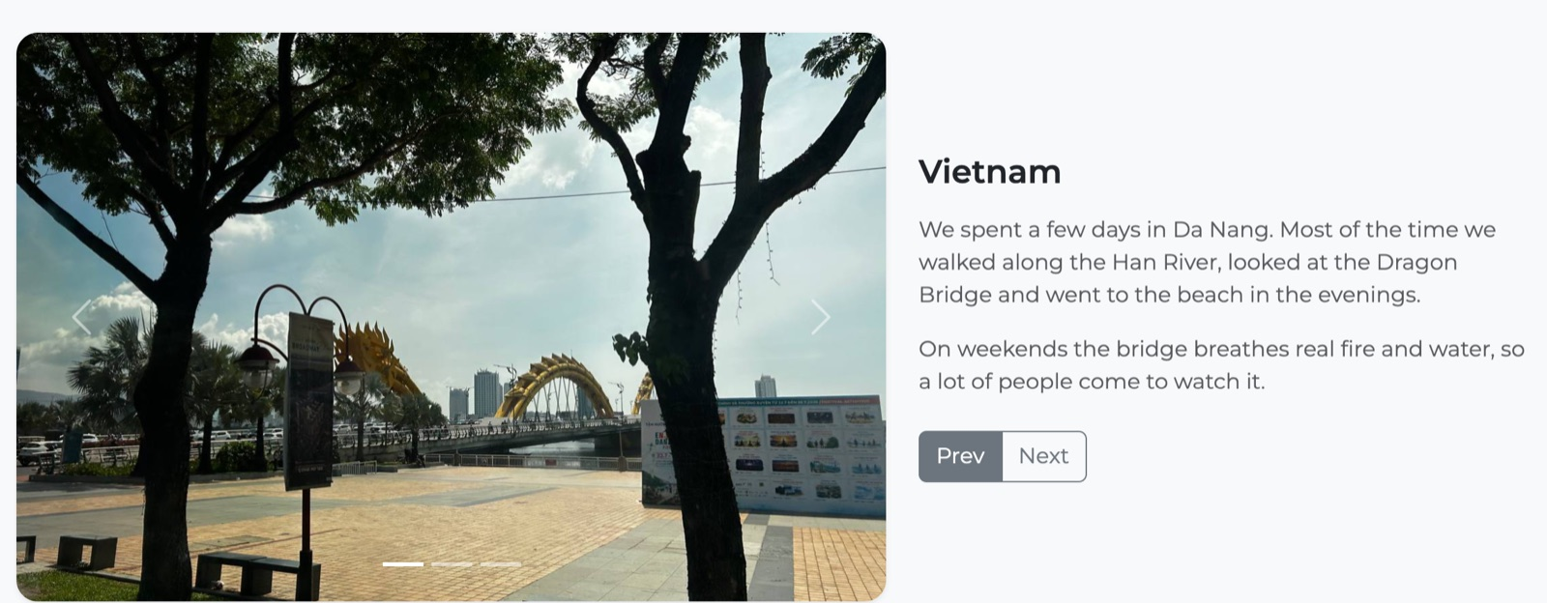
Figure 12 — Carousel on desktop: col-lg-7 for the carousel, col-lg-5 for the text and the button group

Figure 13 — Second slide after clicking Next: the second indicator is active

6. Bootstrap Cards
Requirement: Create at least three Bootstrap cards, each containing an image, title, and text description. Place the cards in a grid layout using card-deck or card-group.
Under the carousel there are three cards with more photos from the trip. Every card has an image (card-img-top), a title (card-title) and text (card-text).
card-deck was removed in Bootstrap 5, so I used card-group. It puts the cards in one row with the same height, and on screens smaller than 576px it shows them one under the other.
midterm.html
<div class="card-group shadow-sm mt-5 mt-lg-4">
<article class="card">
<img src="images/gallery-img4.jpeg" class="card-img-top card-photo" alt="View of Da Nang from a high floor">
<div class="card-body">
<h3 class="card-title h5">City from above</h3>
<p class="card-text text-body-secondary">Da Nang from a high floor. The city is much bigger than I thought.</p>
</div>
</article>
<article class="card">... Fire show ...</article>
<article class="card">... Sunset at the beach ...</article>
</div>
Each card is an <article> because it is a separate piece of content. The photos have the same height with the .card-photo class (height: 280px; object-fit: cover), so all three cards line up.
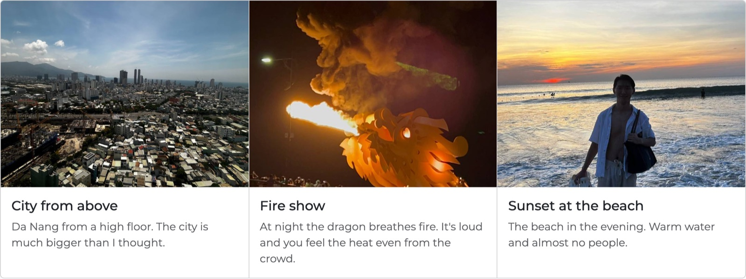
Figure 14 — Card group on desktop: three cards with image, title and text
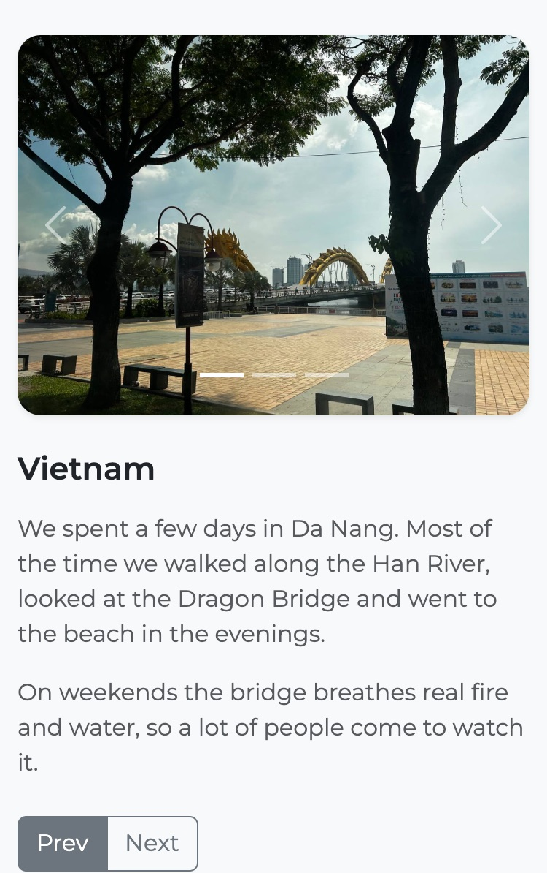 | 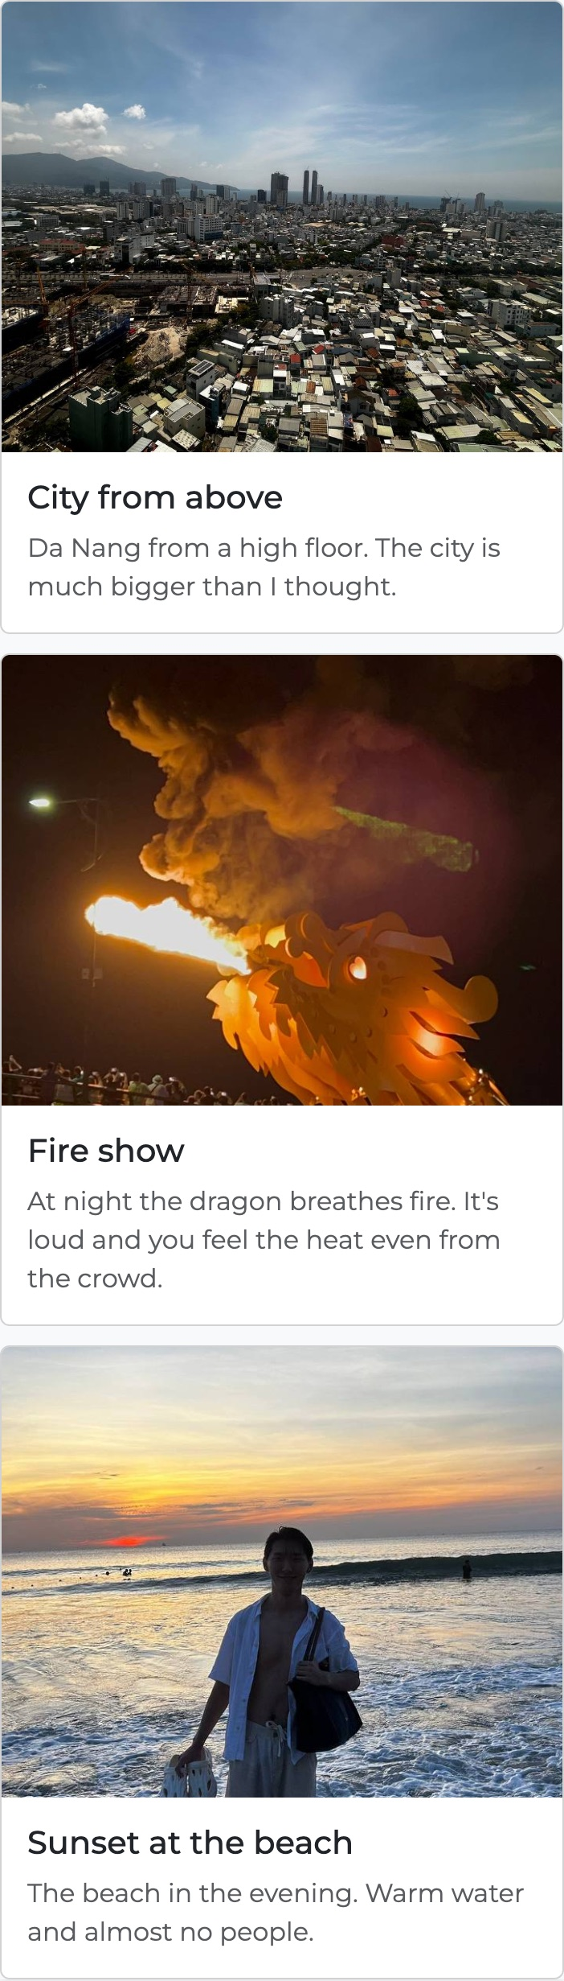
Figure 15 — Mobile: carousel with the text under it (left), cards stacked (right)

7. Responsive Form Design (Optional)
Requirement: Replace custom form styling with Bootstrap’s form classes (form-control, input-group, etc.) to enhance input fields, checkboxes, radio buttons, and form layout.
The Contact section has a form made only with Bootstrap form classes. It is in a grid with the contact info: col-md-5 + col-md-7 on tablet and col-lg-6 + col-lg-6 on desktop. Inside the form there is one more row, so Name and Email are side by side from 576px.
Field | Bootstrap classes
Name | form-label, form-control
Email | input-group + input-group-text (the @ sign) + form-control
Topic | form-select
Reply via (radio) | form-check form-check-inline, form-check-input, form-check-label
Message | form-control on a <textarea>
Agreement (checkbox) | form-check, form-check-input, form-check-label
Send / Clear | btn-group with btn btn-primary and btn btn-outline-secondary

midterm.html
<form class="border rounded-3 p-3 p-md-4">
<div class="row g-3">
<div class="col-12 col-sm-6">
<label for="name" class="form-label">Name</label>
<input type="text" class="form-control" id="name" placeholder="Your name" required>
</div>
<div class="col-12 col-sm-6">
<label for="email" class="form-label">Email</label>
<div class="input-group">
<span class="input-group-text" id="emailIcon">@</span>
<input type="email" class="form-control" id="email" placeholder="name@mail.com" aria-describedby="emailIcon" required>
</div>
</div>
...
<div class="col-12">
<div class="form-check">
<input class="form-check-input" type="checkbox" id="agree" required>
<label class="form-check-label" for="agree">I agree to be contacted back</label>
</div>
</div>
</div>
</form>
Every input has a <label> connected with for and id, so clicking the label puts the cursor in the field. Name, Email, Message and the checkbox are required, so the browser does not send the form empty.
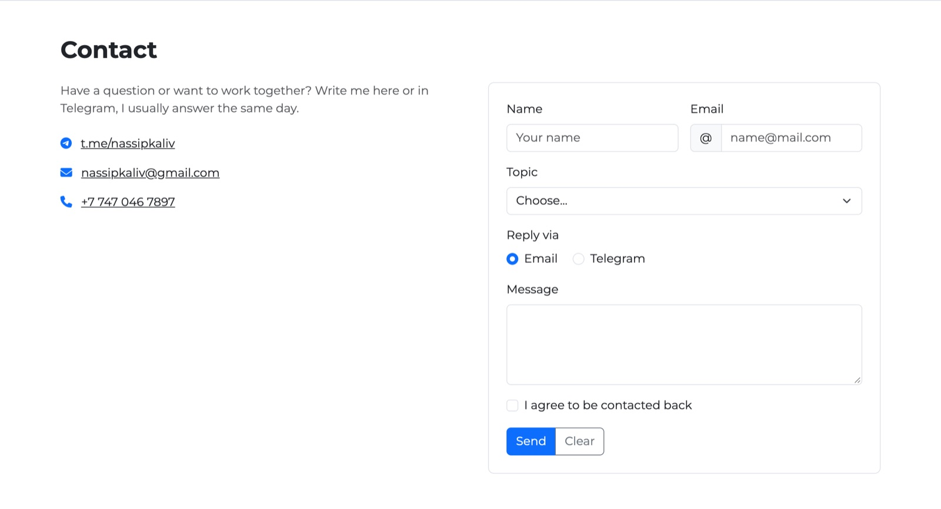
Figure 16 — Contact section on desktop: info on the left, form on the right (col-lg-6 + col-lg-6)
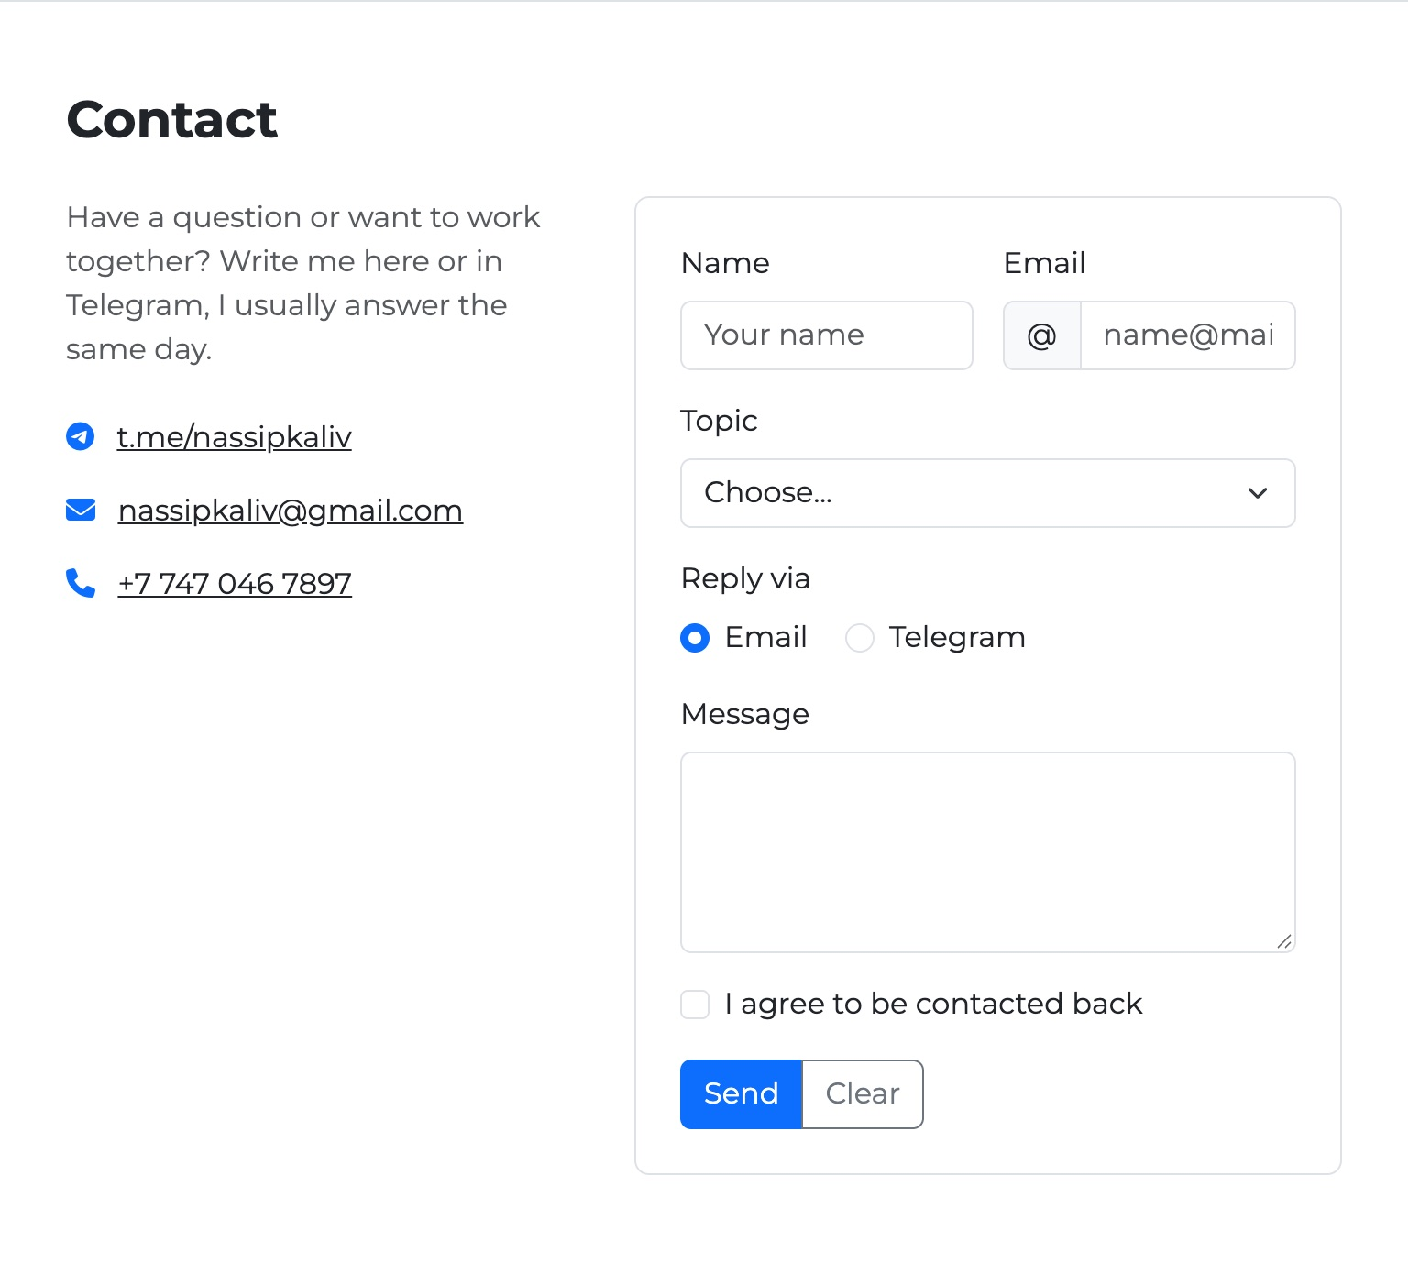 | 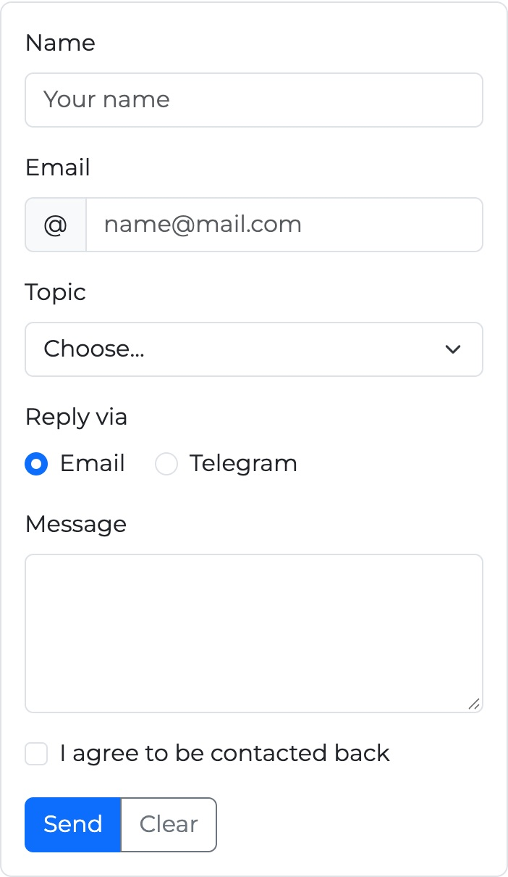
Figure 17 — Tablet (left): col-md-5 + col-md-7; mobile (right): the form fields are stacked

8. Accessibility
Requirement: Use Bootstrap components with appropriate semantic HTML elements (<nav>, <button>, ...). Keep good contrast between text and backgrounds for readability.

Semantic HTML
Element | Where it is used
<header>, <nav> | Page header and the navbar
<main> | All page content between header and footer
<section id="..."> | Home, About, Skills, Trip, Contact. Each has its own heading
<article> | Each card in the card group
<footer> | Copyright and “Back to top”
<button> | Navbar toggler, carousel controls and indicators, Prev / Next, Send / Clear
<a class="btn"> | Only for buttons that open a link or go to a section
h1 → h2 → h3 | One h1 on the page, h2 for sections, h3 inside them. Sizes are changed with classes (h5, display-4), not by skipping levels

Other things for screen readers and keyboard
- All images have an alt text that says what is on the photo.
- Icons from Font Awesome have aria-hidden="true", because the text next to them already says the same.
- The navbar toggler has aria-label, aria-controls and aria-expanded. Bootstrap changes aria-expanded when the menu opens.
- The current navbar link has aria-current="page".
- Carousel indicators have aria-label="Slide 1" and so on, and the arrows have hidden text “Previous” / “Next”.
- Button groups have role="group" and aria-label.
- Form fields have labels, and the email field is connected to the @ sign with aria-describedby.
- Everything can be used with the keyboard. Bootstrap shows a focus ring on links, buttons and inputs (see Figure 11).

Contrast
I used Bootstrap’s own colors, which are made to be readable. To check, I measured the real colors on the page in the browser and calculated the contrast ratio. WCAG AA needs at least 4.5 : 1 for normal text.
Element | Text | Background | Ratio | AA
Navbar link | #9B9D9F | #212529 | 5.66 : 1 | Pass
Navbar active link | #FFFFFF | #212529 | 15.43 : 1 | Pass
Main text | #212529 | #FFFFFF | 15.43 : 1 | Pass
Secondary text | #595C5F | #FFFFFF | 6.78 : 1 | Pass
Primary button | #FFFFFF | #0D6EFD | 4.50 : 1 | Pass
Outline secondary button | #6C757D | #FFFFFF | 4.69 : 1 | Pass
Skill badge | #000000 | #F8F9FA | 19.92 : 1 | Pass
Card text | #595C5F | #FFFFFF | 6.78 : 1 | Pass
Footer text | #FFFFFF | #212529 | 15.43 : 1 | Pass

All text passes. The lowest one is the blue btn-primary with white text, which is exactly 4.5 : 1, so it is on the limit, but the button text is also large (btn-lg) and bold enough. The grey navbar links are lighter than the active link on purpose, but still 5.66 : 1.
Figure 18 — Footer: white text on bg-dark (15.43 : 1) and btn-outline-light

Testing
I opened the page in Google Chrome and checked it at 375px, 640px, 768px and 1280px width:
- The layout changes at the breakpoints as shown in the grid table, and there is no horizontal scroll on mobile.
- The hamburger button opens and closes the menu, and the links scroll to the right section without being hidden under the sticky navbar.
- The carousel changes slides by itself, with the arrows, with the indicators and with the Prev / Next buttons.
- The form does not send without the required fields, and Clear empties all fields.
- With the Tab key you can reach every link, button and input, and the focus is visible.

Conclusion
Using Bootstrap made the page much simpler. Before, my style.css had more than 500 lines with media queries for every section. Now the custom CSS has about 35 lines, and everything else is done with Bootstrap classes in the HTML. The grid handles the layout on all screen sizes, the spacing classes keep the same distances everywhere, and components like the navbar, carousel and cards work without writing my own JavaScript.

