Endterm Assignment. FadeAway Website
Student: Yernur Nassipkali
Group: SE-2517
Course: Web Technologies 1 (Front End)
For the endterm I made FADEAWAY, an online store of sneakers. The idea and the design come from a React project that I worked on earlier for another course. For this assignment I rewrote the front end from the beginning with HTML, CSS, Bootstrap, JavaScript and jQuery. This version has no React and no server: the products are in a JavaScript file, and the cart and the login are saved in the browser.
To run the site, open fadeaway/index.html in a browser. It does not need a server or internet, because Bootstrap, jQuery, the icons and the font are inside the project, in the lib folder.
File or folder | What is inside
index.html, products.html, product.html, cart.html, login.html | The five pages of the site
css/style.css | My own styles on top of Bootstrap
js/products.js | The catalog: an array of 22 products
js/main.js | Code that every page needs: cart, search, header, footer
js/home.js, shop.js, product.js, cart.js, login.js | One file with the code of each page
lib/ | Bootstrap 5.3.8, Bootstrap Icons, jQuery 3.7.1 and the Montserrat font
images/products/ | 117 product photos, one folder for each product

Part of this report | What it shows
Part 1. Project Structure & Pages | Five connected pages with a menu, and a screenshot of each page
Part 2. Design Consistency | The same header, footer, colours and font on all pages
Part 3. Responsive Layout | How the site looks on desktop, tablet and phone
Part 4. Bootstrap Grid Usage | Rows and columns that make the layout
Part 5. JavaScript Functionality | Catalog from data, filters, search, cart, form validation
Part 6. jQuery Effects/Animations | Fade, slide and animate on the site
Part 7. Interactive Component | Carousel, modal windows, tabs, dropdown and toast

Part 1. Project Structure & Pages
Task: Website must include at least 3–5 pages (page types depend on your chosen topic).
• Every page must contain a header (logo/title + navigation bar), a main content area and a footer (copyright, contact info, or extra navigation links).
• At least 3–5 logically connected pages with proper navigation between them.
My topic is an online shop, so I made five pages. They follow the way a customer buys a pair of sneakers:
Page | File | What the customer does | Where it leads
Home | index.html | Sees new sneakers, featured and top products | All Products, Product
All Products | products.html | Filters, sorts and searches the catalog | Product
Product | product.html | Looks at the photos and details, adds to the cart | Cart
Cart | cart.html | Changes the quantity, sees the total, checks out | Login, then the order
Login | login.html | Signs in or creates an account | Cart or Home

The header is on every page: the logo, the menu, search, the cart and the account button. The brand links open the catalog with that brand already selected, for example products.html?brand=Nike. One product page works for all 22 products, because it reads the id from the address, for example product.html?id=7.
index.html
<ul class="navbar-nav mx-auto">
<li class="nav-item"><a class="nav-link active" href="index.html">Home</a></li>
<li class="nav-item"><a class="nav-link" href="products.html">All Products</a></li>
<li class="nav-item"><a class="nav-link" href="products.html?brand=Nike">Nike</a></li>
<li class="nav-item"><a class="nav-link" href="products.html?brand=Adidas">Adidas</a></li>
<li class="nav-item"><a class="nav-link" href="products.html?brand=New%20Balance">New Balance</a></li>
</ul>
At the end of every page the scripts go in this order. jQuery and Bootstrap are first, because my code uses them. Then come the data, the shared code and the code of this page:
index.html
<script src="lib/jquery-3.7.1.min.js"></script>
<script src="lib/bootstrap.bundle.min.js"></script>
<script src="js/products.js"></script>
<script src="js/main.js"></script>
<script src="js/home.js"></script>

Home page
The first screen is a carousel with three sneakers. Below it there are the featured products with arrows, the top products, a card that leads to the whole catalog, and four services.
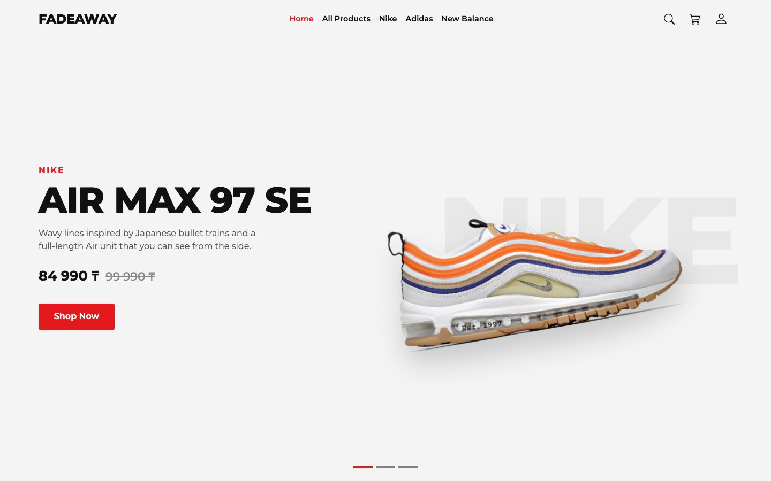
Figure 1 — Home page, first screen
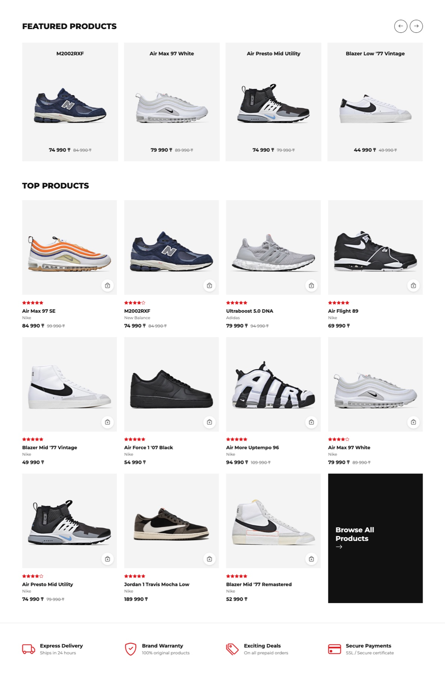
Figure 2 — Home page, featured products, top products and services

All Products page
On the left there are filters by brand, category and price. On the right there are the products, the number of products and the sorting. Each card has a small button that adds the product to the cart at once.
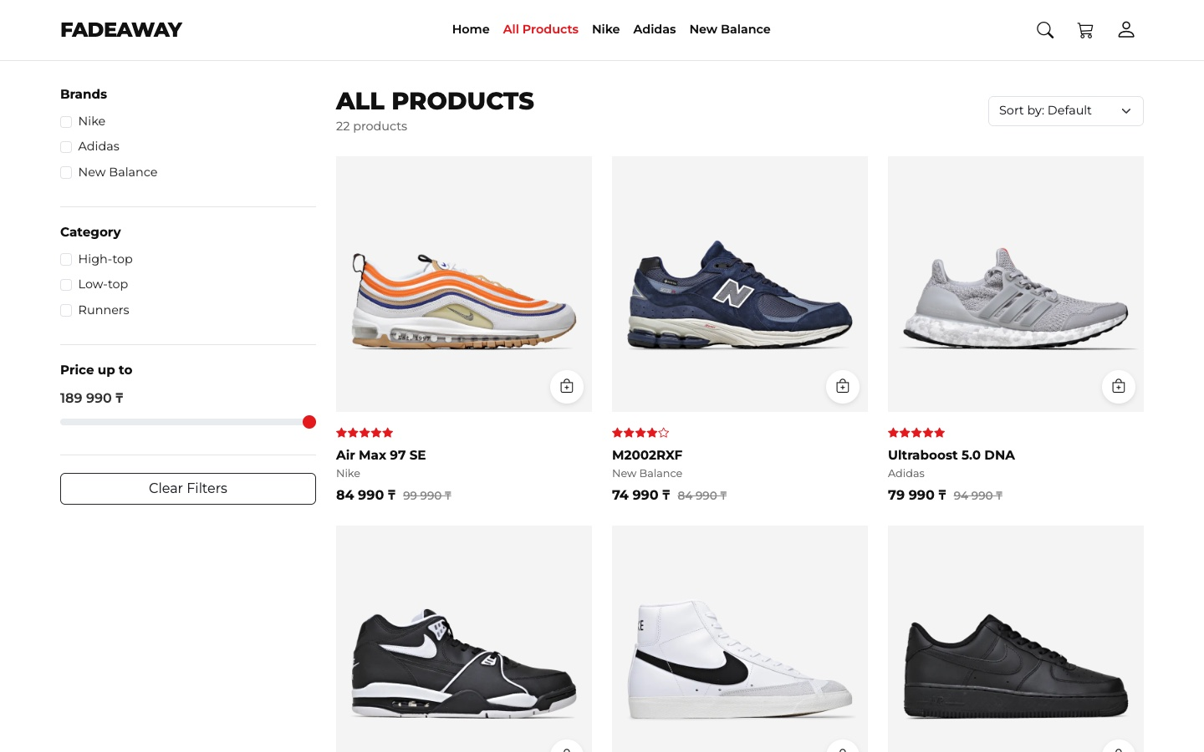
Figure 3 — All Products page

Product page
Here there are the photos of one product, the price, how much the customer saves, the quantity and the Add to cart button. Below there are two tabs and related products from the same category.
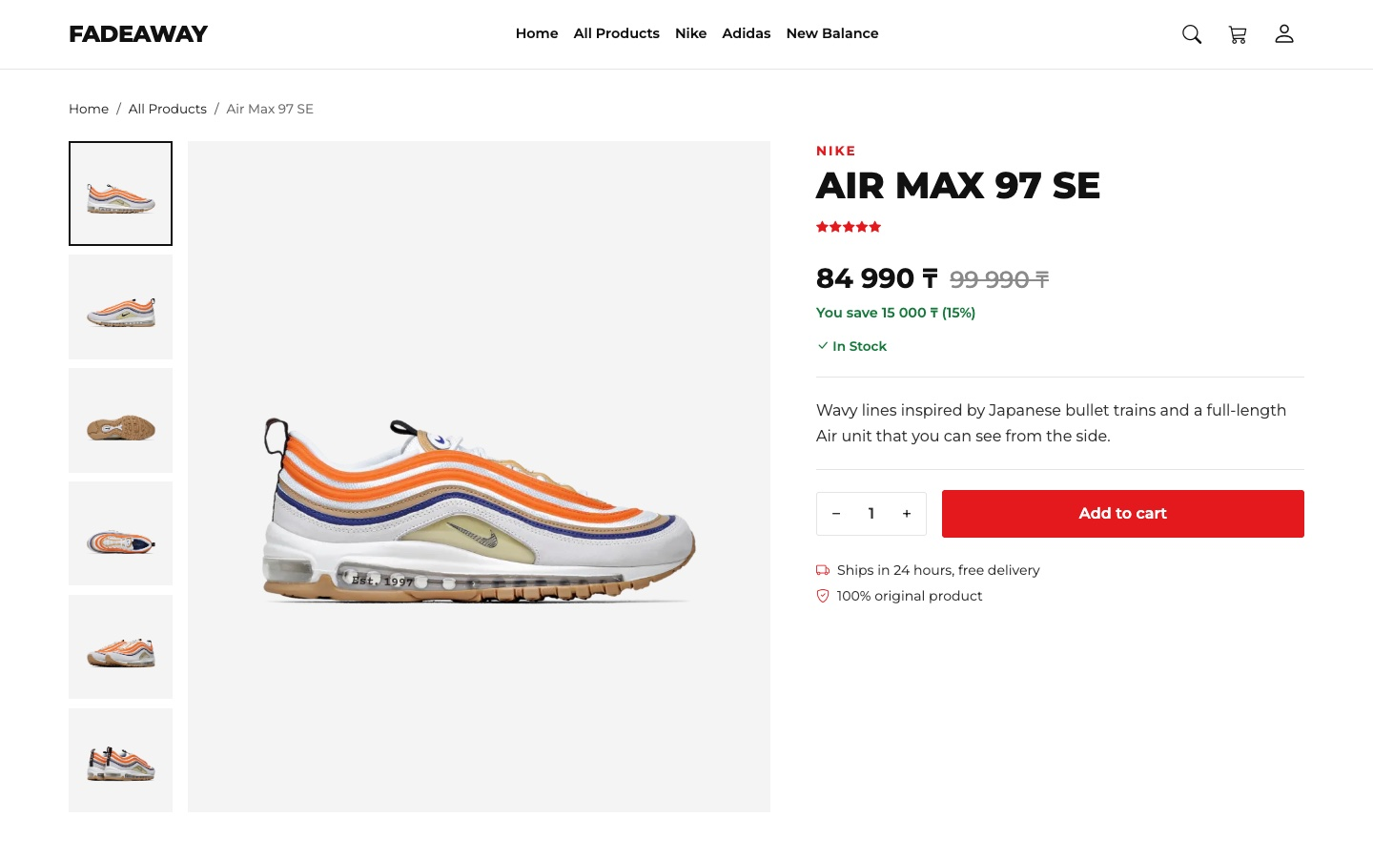
Figure 4 — Product page, photos and details
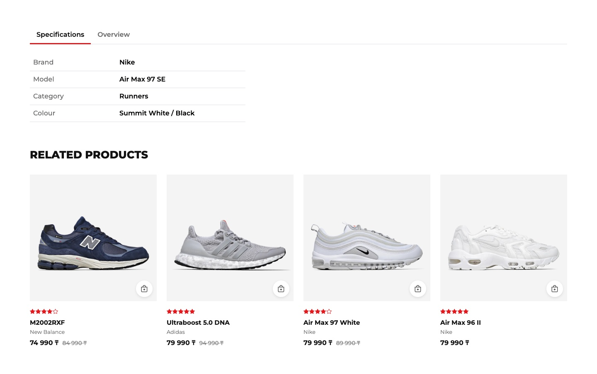
Figure 5 — Product page, tabs and related products

Cart page
The customer can change the quantity or remove a product. The order summary on the right counts the original price, the discount and the total. The button says “Sign in to checkout” until the customer signs in.
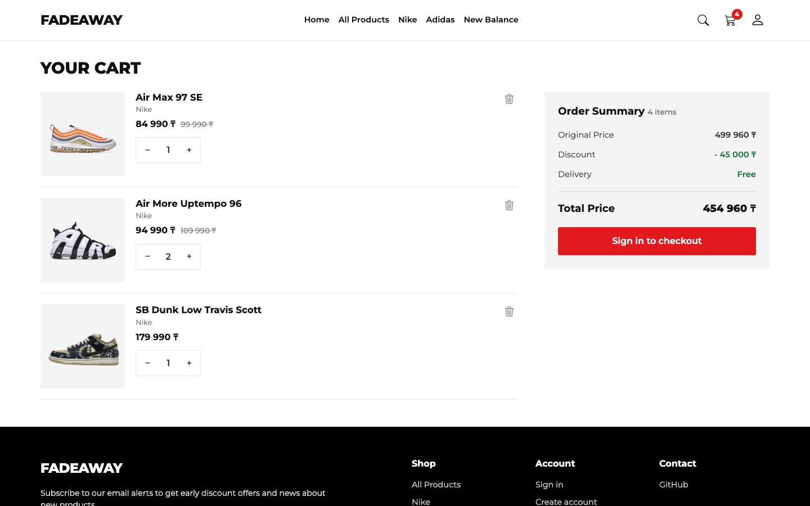
Figure 6 — Cart page
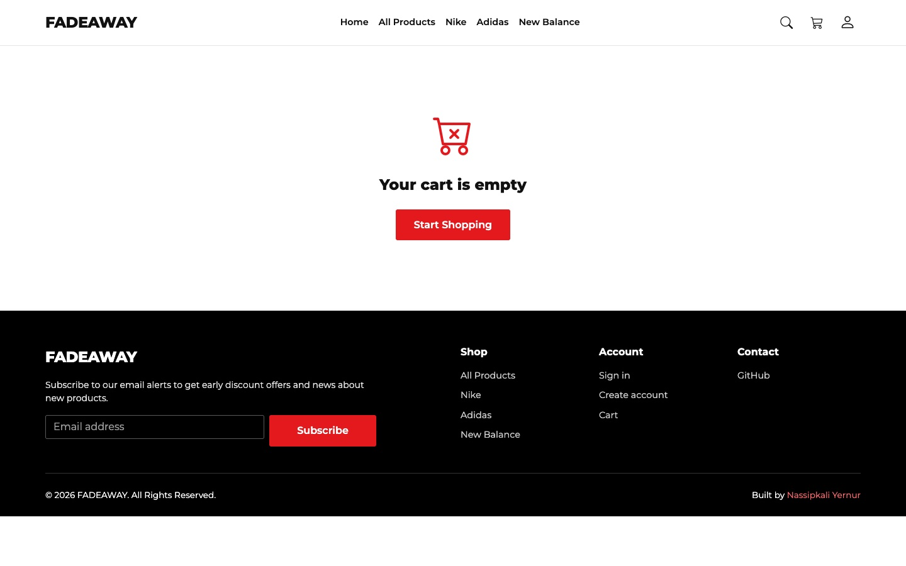
Figure 7 — Cart page when the cart is empty

Login page
This page has two forms: Sign in and Create account. The customer switches between them with a link, so one page is enough. The dark background is the same idea as on the login page of the React version.
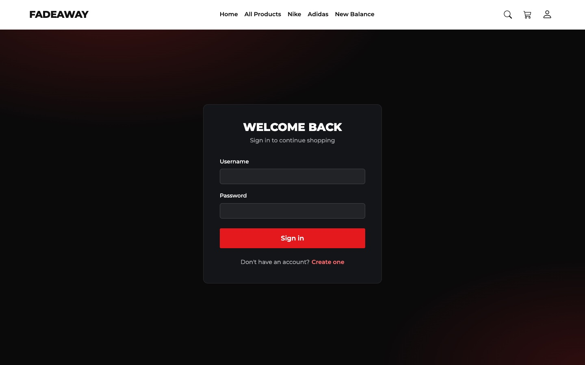
Figure 8 — Login page

Part 2. Design Consistency
Task: Pages must share a consistent design (header, footer, fonts, colors).
• Must apply custom CSS for styling.
• Unified header, footer, colors, and typography across all pages.
All five pages use one file, css/style.css, on top of Bootstrap. The colours are CSS variables in :root, so one change there changes the whole site.
What | Value | Where it is used
Font | Montserrat | All text, with bold uppercase headings
Main colour | Red #e3191e | Buttons, stars, active menu link, icons
Text colours | #111111, #323232, #6f6f6f | Headings, normal text, secondary text
Photo background | Light grey #f4f4f4 | Behind every sneaker. The photos have a transparent background, so all cards look the same
Buttons | Class .btn-red | Shop Now, Add to cart, Checkout, Sign in, Subscribe

css/style.css
@font-face {
font-family: "Montserrat";
src: url("../lib/fonts/montserrat.woff2") format("woff2");
font-weight: 100 900;
font-display: swap;
}

:root {
--red: #e3191e;
--red-dark: #b91318;
--ink: #111111;
--text: #323232;
--muted: #6f6f6f;
--tile: #f4f4f4;
--line: #e4e4e4;
--header-height: 72px;
}

.btn-red {
padding: 0.8rem 1.8rem;
border: none;
border-radius: 3px;
background: var(--red);
color: #fff;
font-weight: 600;
transition: background 0.2s;
}
The header and the footer have the same HTML on all pages. jQuery .load() could take them from one file, but the browser blocks it when the site is opened as a file, and the site must open with a double click. So the HTML is written in each page.
The only difference is on Home: the header is transparent over the first screen and becomes white when the page is scrolled. JavaScript only adds the class scrolled, and CSS does the rest:
js/main.js
$('#header').toggleClass('scrolled', scrolled > 50);
Figure 9 — The same header on all pages

Figure 10 — The same footer on all pages: subscribe form, links and copyright

Part 3. Responsive Layout
Task: Website must be responsive (desktop, tablet, mobile).
• Website adapts properly to desktop, tablet, and mobile devices.
Most of the responsive work is done by the Bootstrap grid and the navbar. For the rest I wrote my own media queries. This is what changes:
Part of the page | Desktop (992px and more) | Tablet (768px) | Phone (375px)
Menu | One line in the header | Hamburger button | Hamburger button
First screen | Text left, photo right | Photo on top, text below | The same, without the description
Cards on Home | 4 in a row | 3 in a row | 2 in a row
Cards in the catalog | 3 in a row | 3 in a row | 2 in a row
Filters | Always open on the left | Hidden behind a button | Hidden behind a button
Product page | Photos left, details right | Photos on top, details below | Small photos in a row under the big one
Cart | Items left, summary right | Summary below the items | Summary below, smaller photos

The filters are the most interesting case. On small screens CSS hides them and the button opens them with jQuery. From 992px they must always be visible, even if the customer closed them on a small window, so there I use !important:
css/style.css
@media (max-width: 991.98px) {
#filters {
display: none;
margin-bottom: 1.5rem;
}
}

@media (min-width: 992px) {
#filters {
display: block !important;
position: sticky;
top: calc(var(--header-height) + 1.5rem);
}
}
 | 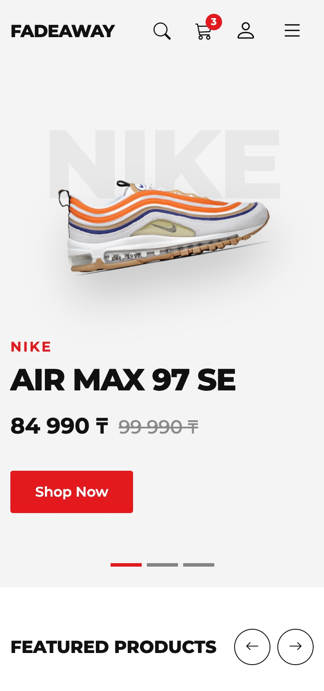
Figure 11 — Home page on a tablet (left) and on a phone (right)
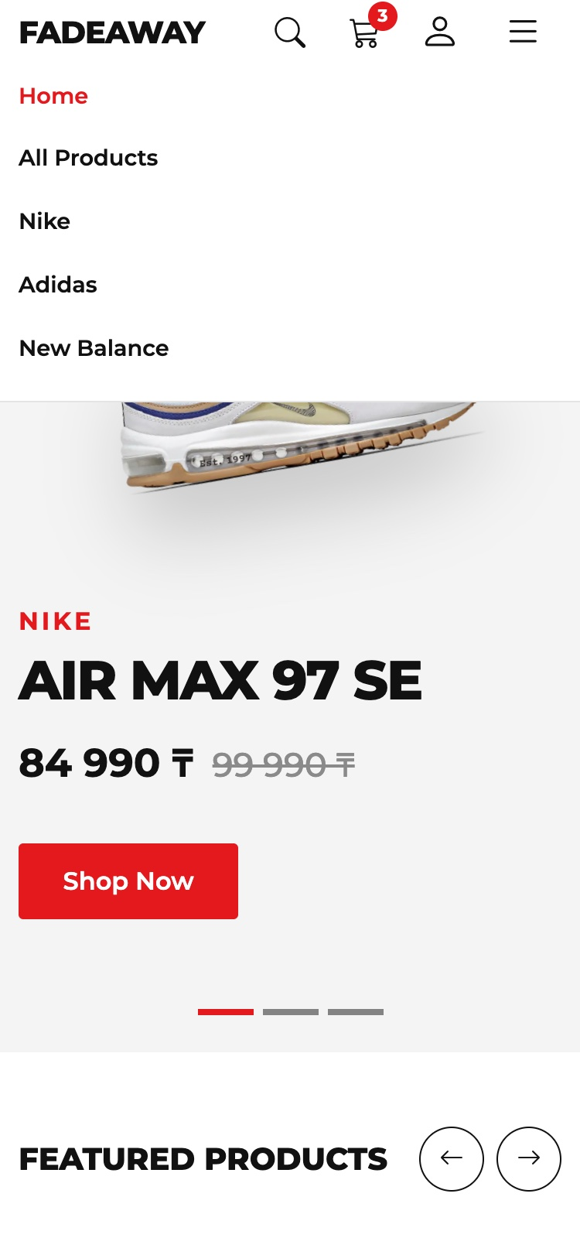 | 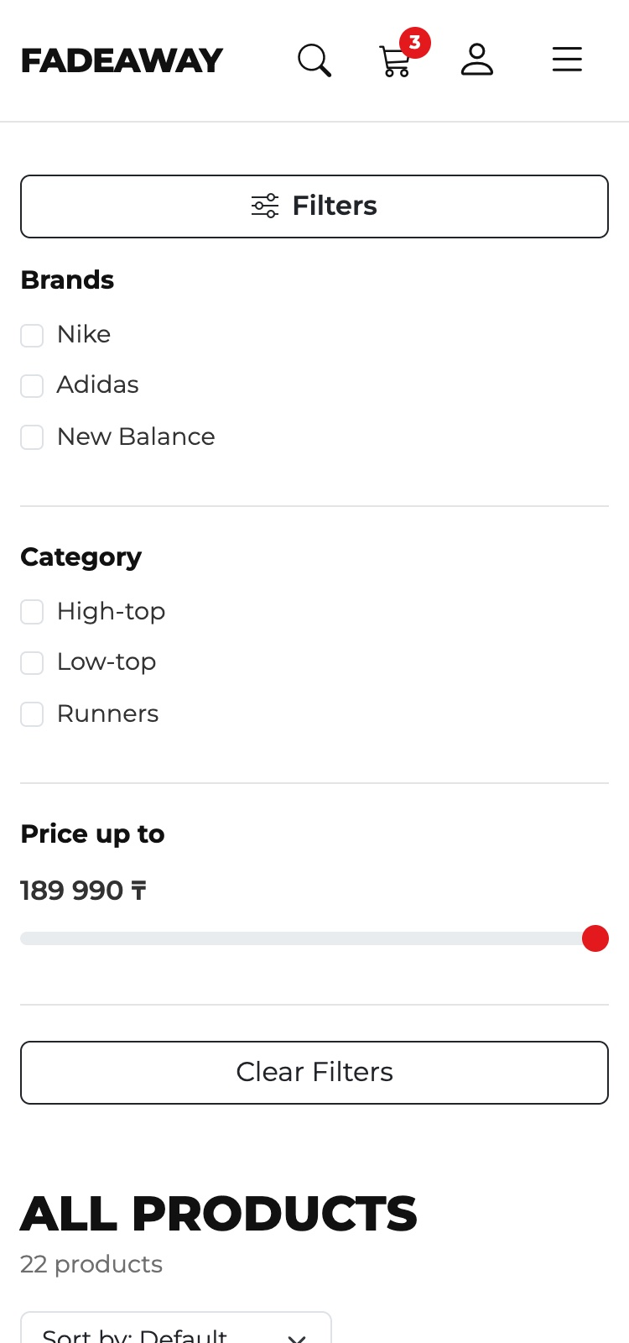
Figure 12 — Phone: the open menu (left) and the open filters (right)
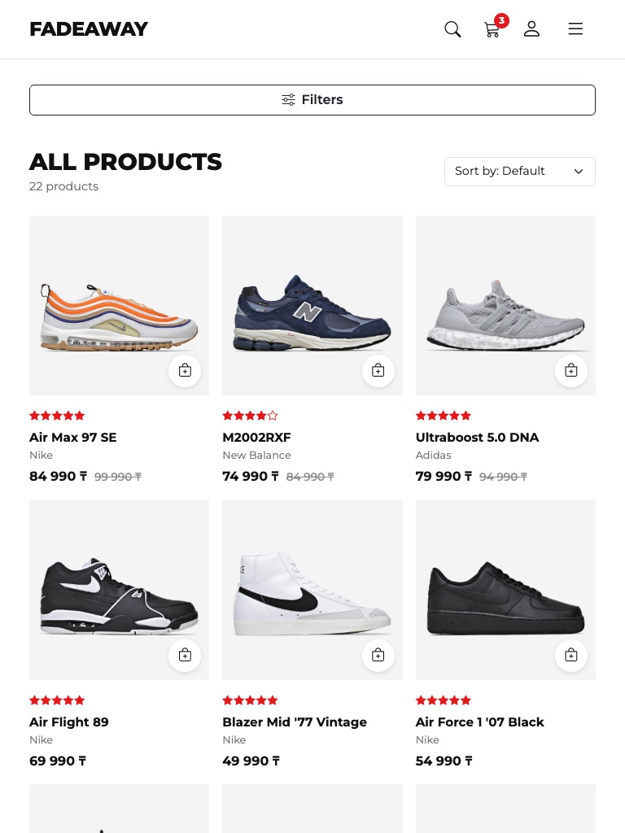 | 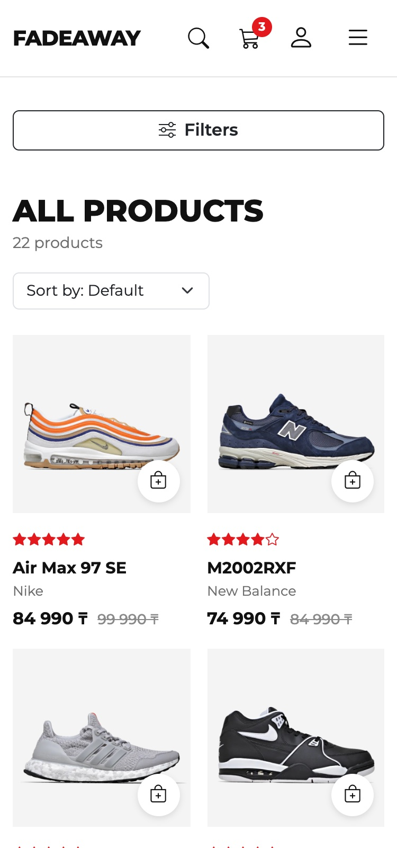
Figure 13 — All Products on a tablet (left) and on a phone (right)
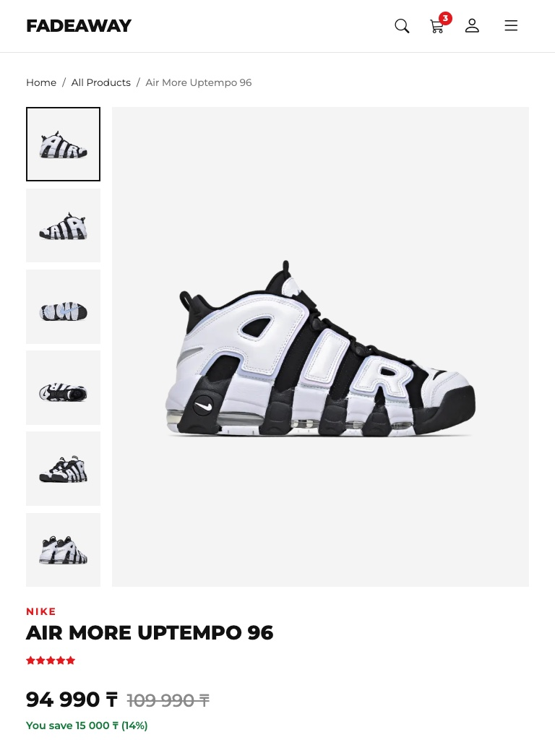 | 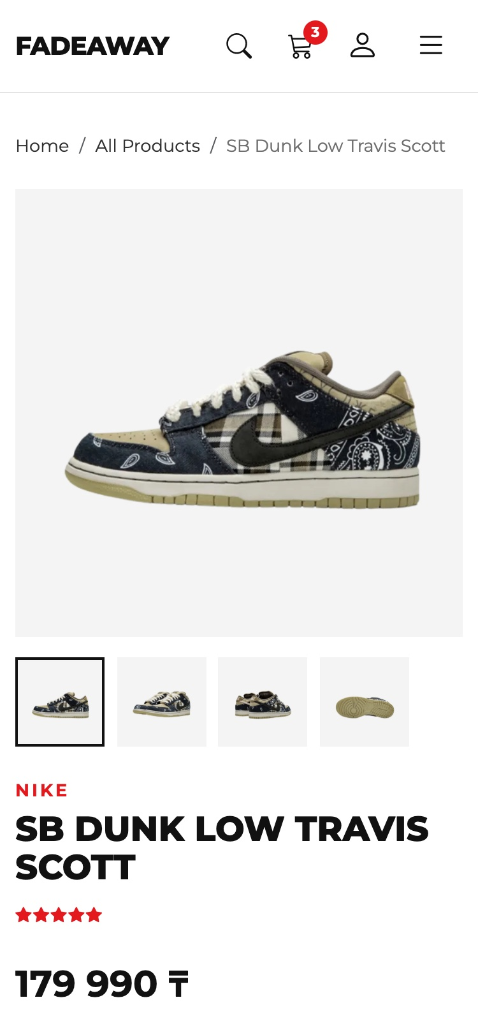
Figure 14 — Product page on a tablet (left) and on a phone (right)
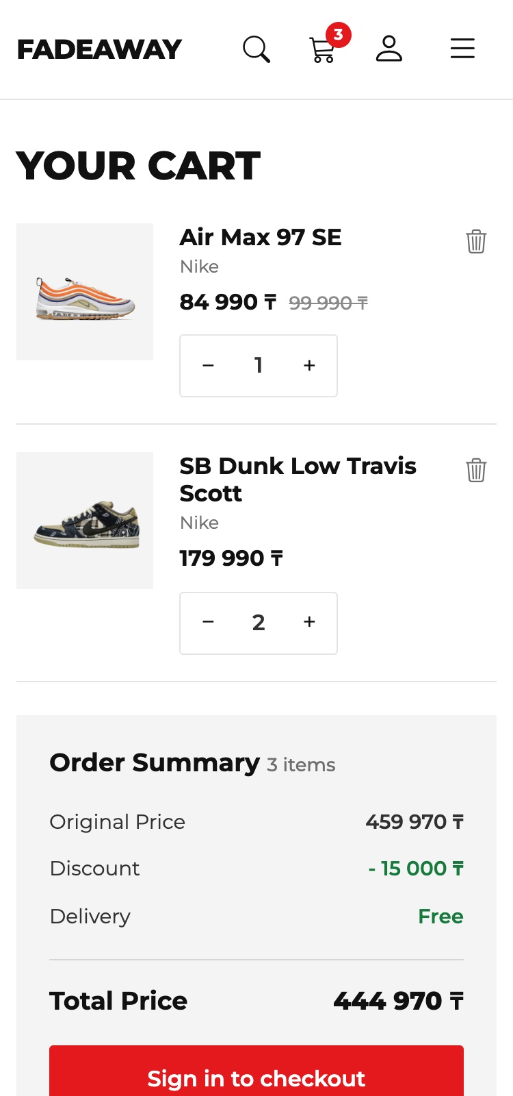 | 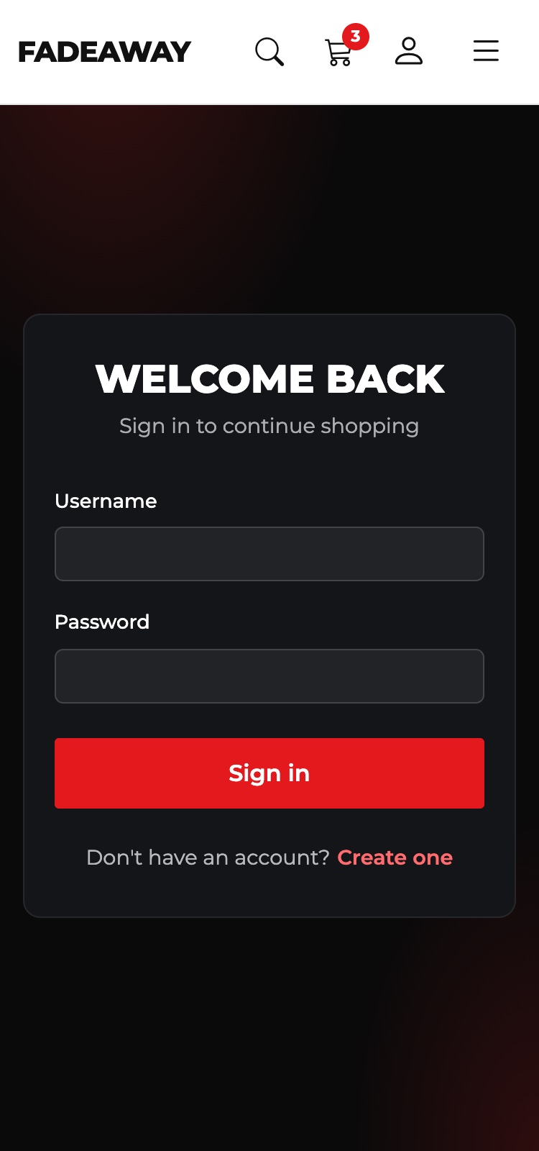
Figure 15 — Phone: Cart (left) and Login (right)
I also measured all five pages in Chrome at each width. If the page is wider than the window, a horizontal scroll appears, which is a common problem on phones.
Width | Pages checked | Page width compared to window | Result
1440px | All five pages | The same, no horizontal scroll | Pass
768px | All five pages | The same, no horizontal scroll | Pass
375px | All five pages | The same, no horizontal scroll | Pass

Part 4. Bootstrap Grid Usage
Task: Must use Bootstrap Grid system for layout.
• Correct use of the Bootstrap 12-column grid system for layout and responsiveness.
Every page is built from .container, .row and columns. A row has 12 parts. For example, col-lg-3 and col-lg-9 together make 12: from 992px the filters take 3 parts and the products take 9, and on smaller screens each one takes the full width. row-cols-* says how many cards stand in one row.
Block | Classes | Result
Top Products | row row-cols-2 row-cols-md-3 row-cols-lg-4 | 2, 3 or 4 cards in a row
Catalog page | col-lg-3 and col-lg-9 | Filters 3/12, products 9/12
Catalog cards | row row-cols-2 row-cols-md-3 | 2 or 3 cards in a row
First screen | col-lg-5 and col-lg-7, order-* | Text and photo side by side; the photo is first on small screens
Product page | col-lg-7 and col-lg-5 | Photos 7/12, details 5/12
Photo gallery | col-md-2 and col-md-10 | Small photos 2/12, big photo 10/12
Cart | col-lg-8 and col-lg-4 | Items 8/12, summary 4/12
Services | row row-cols-1 row-cols-sm-2 row-cols-lg-4 | 1, 2 or 4 services in a row
Footer | col-12 col-lg-5, col-6 col-md-4 col-lg-2 | Form on top on small screens, links in columns

products.html
<aside class="col-lg-3">
...
</aside>
<div class="col-lg-9">
...
<div class="row row-cols-2 row-cols-md-3 g-3 g-lg-4" id="productGrid"></div>
</div>
index.html
<div class="row row-cols-2 row-cols-md-3 row-cols-lg-4 g-3 g-lg-4" id="topProducts"></div>
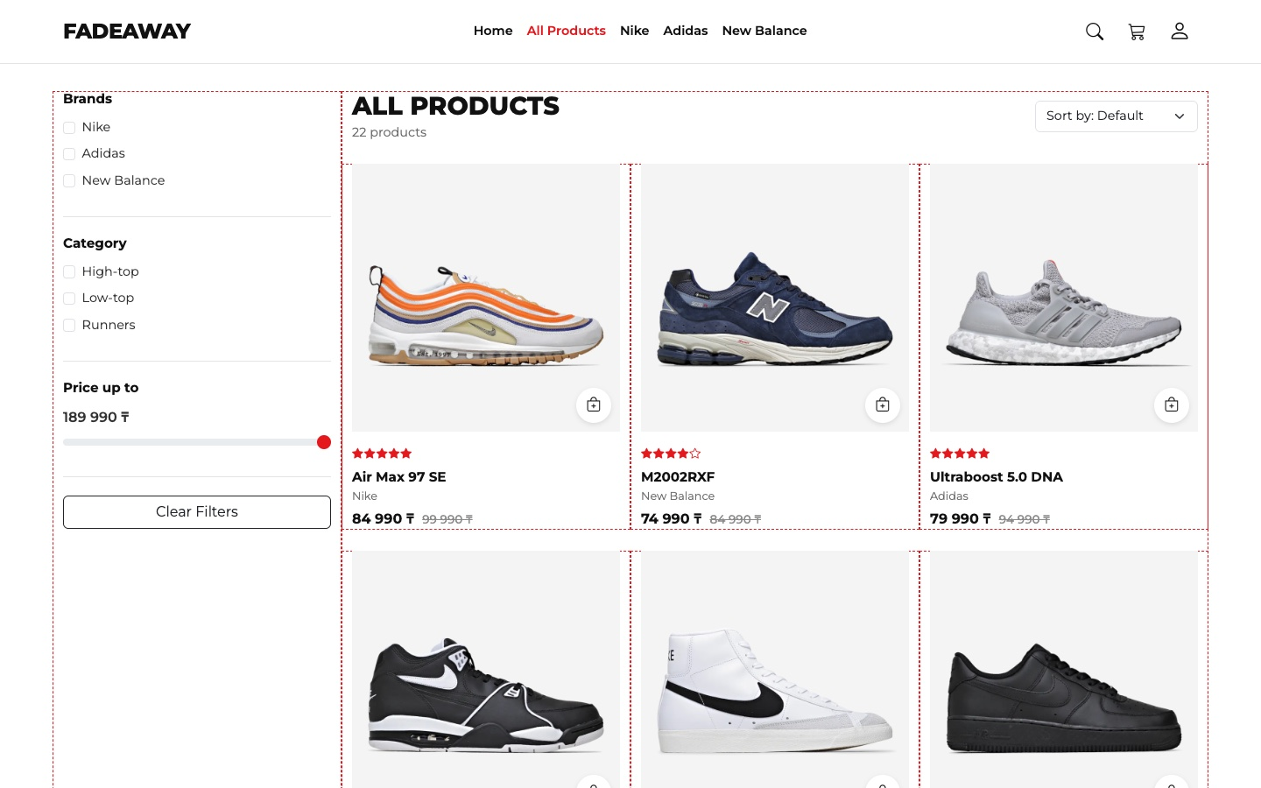
Figure 16 — The grid of the All Products page. I added the dashed lines only for this screenshot, they are not on the site

Part 5. JavaScript Functionality
Task: Must use JavaScript and/or jQuery for interactivity (form validation, effects, animations).
• Interactive features implemented with JavaScript (e.g., form validation, dynamic content).

Products from one array
All products are objects in one array in js/products.js. The pages do not have product cards in the HTML. JavaScript makes them from this array, so a new product needs only one new object.
js/products.js
{
id: 1,
slug: 'air-max-97-se',
photos: 6,
brand: 'Nike',
title: 'Air Max 97 SE',
category: 'Runners',
color: 'Summit White / Black',
price: 84990,
oldPrice: 99990,
rating: 5,
tag: 'hero',
description: 'Wavy lines inspired by Japanese bullet trains and a full-length Air unit that you can see from the side.'
},
The function productCard() takes one product and returns the HTML of its card. Home, All Products and Related Products all use this one function.
js/main.js
function productCard(product) {
return `
<div class="col">
<article class="product-card">
<div class="product-photo">
<a href="product.html?id=${product.id}">
<img src="${getPhoto(product, 1)}" alt="${product.brand} ${product.title}" loading="lazy">
</a>
<button type="button" class="add-btn add-to-cart" data-id="${product.id}" aria-label="Add ${product.title} to cart">
<i class="bi bi-bag-plus"></i>
</button>
</div>
${getStars(product.rating)}
<h3 class="product-title"><a href="product.html?id=${product.id}">${product.title}</a></h3>
<p class="product-brand">${product.brand}</p>
<p class="product-price">${getPriceHtml(product)}</p>
</article>
</div>`;
}

Filters, sorting and search
Every time a filter changes, the code takes the whole array, keeps only the products that pass all filters and sorts the result. When no box in a group is checked, this group does not filter anything.
js/shop.js
function getFilteredProducts() {
const brands = getCheckedValues('brand');
const categories = getCheckedValues('category');
const priceLimit = Number($('#priceRange').val());
const text = searchText.toLowerCase();

const result = products.filter(function (product) {
const brandOk = brands.length === 0 || brands.includes(product.brand);
const categoryOk = categories.length === 0 || categories.includes(product.category);
const textOk = (product.brand + ' ' + product.title).toLowerCase().includes(text);
return brandOk && categoryOk && textOk && product.price <= priceLimit;
});

switch ($('#sortSelect').val()) {
case 'cheap':
result.sort(function (a, b) {
return a.price - b.price;
});
break;
case 'expensive':
result.sort(function (a, b) {
return b.price - a.price;
});
break;
case 'rating':
result.sort(function (a, b) {
return b.rating - a.rating;
});
break;
}

return result;
}
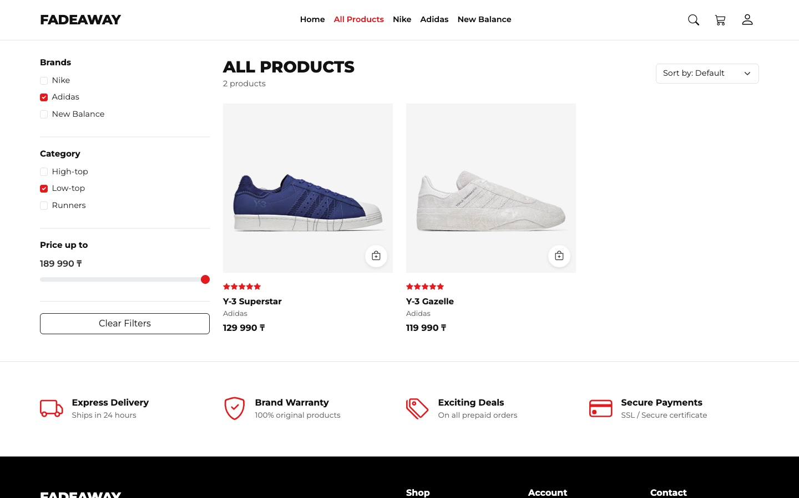
Figure 17 — Filters at work: Adidas and Low-top give 2 products
The search is in the header of every page. Results appear while the customer is typing. The typed text is shown with .text(), not .html(), so HTML code in the search field stays plain text.
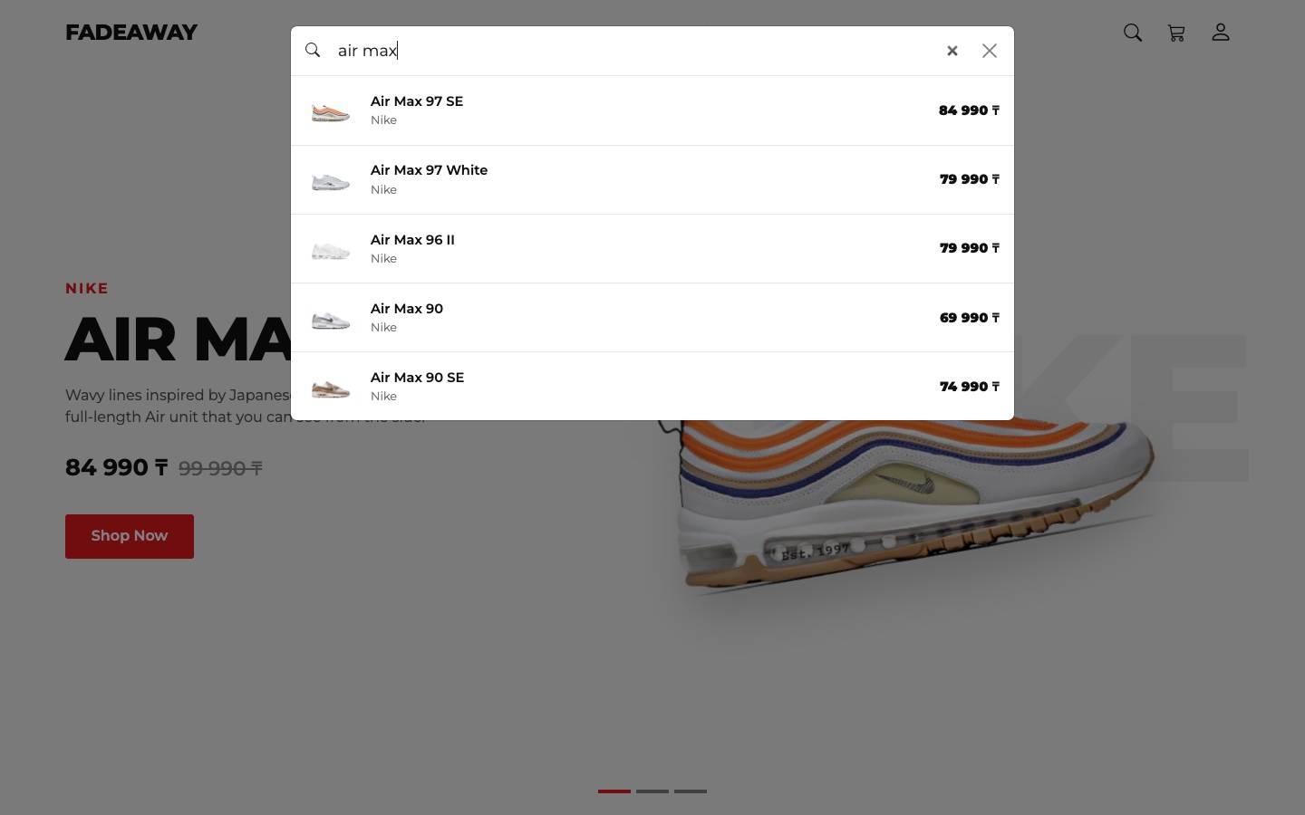
Figure 18 — Search for “air max” with results while typing

Cart saved in the browser
Each page is a separate HTML file, so a normal variable is lost when the customer opens another page. That is why the cart is in localStorage. It stores only the id and the quantity of each product, and the name and the price are taken from the array.
js/main.js
function getCart() {
return JSON.parse(localStorage.getItem(CART_KEY)) || [];
}

function saveCart(cart) {
localStorage.setItem(CART_KEY, JSON.stringify(cart));
updateCartBadge();
}

function addToCart(id, quantity) {
const cart = getCart();
const item = cart.find(function (cartItem) {
return cartItem.id === id;
});

if (item) {
item.quantity += quantity;
} else {
cart.push({ id: id, quantity: quantity });
}

saveCart(cart);
showToast(findProduct(id).title + ' added to cart');
}

Form validation
The forms have novalidate, so JavaScript checks them and shows the messages with the Bootstrap classes is-invalid and invalid-feedback. There are four checked forms: Sign in, Create account, Delivery details and Subscribe.
js/main.js
function isEmail(value) {
return /^[^@\s]+@[^@\s]+\.[^@\s]+$/.test(value);
}

function setFieldError(field, message) {
field.addClass('is-invalid').removeClass('is-valid');
field.siblings('.invalid-feedback').text(message);
}

function setFieldOk(field) {
field.addClass('is-valid').removeClass('is-invalid');
}
js/login.js
function checkLoginForm() {
const username = $('#loginName');
const password = $('#loginPassword');
let isOk = true;

if (username.val().trim().length < 3) {
setFieldError(username, 'Username must have at least 3 characters.');
isOk = false;
} else {
setFieldOk(username);
}

if (password.val().length < 6) {
setFieldError(password, 'Password must have at least 6 characters.');
isOk = false;
} else {
setFieldOk(password);
}

return isOk;
}
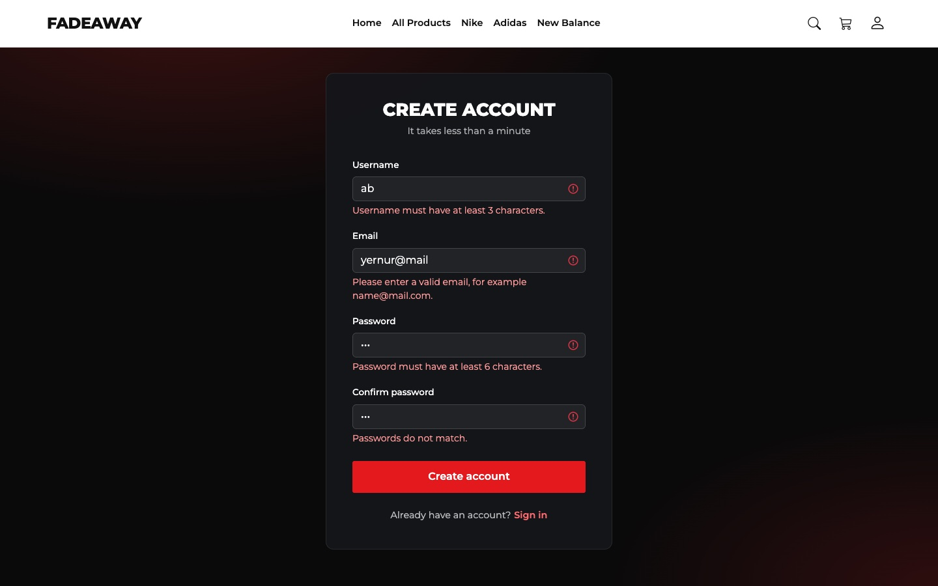 | 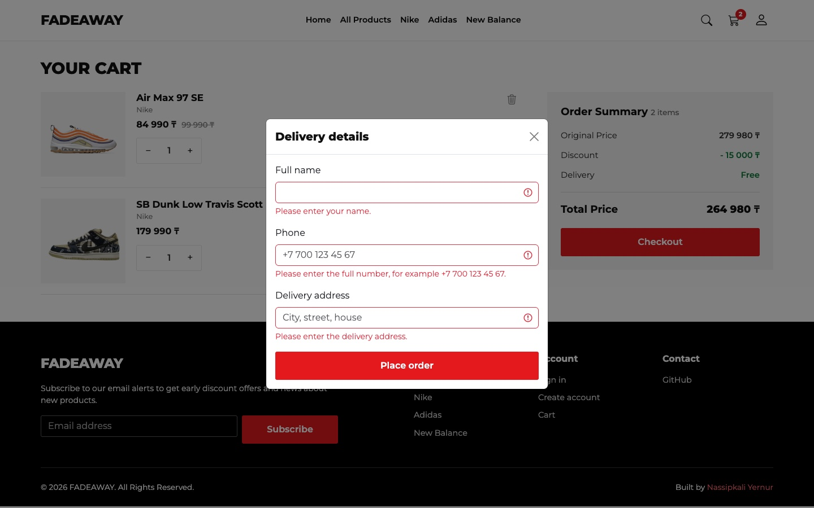
Figure 19 — Validation messages in Create account (left) and in Delivery details (right)

Figure 20 — Validation of the email in the Subscribe form
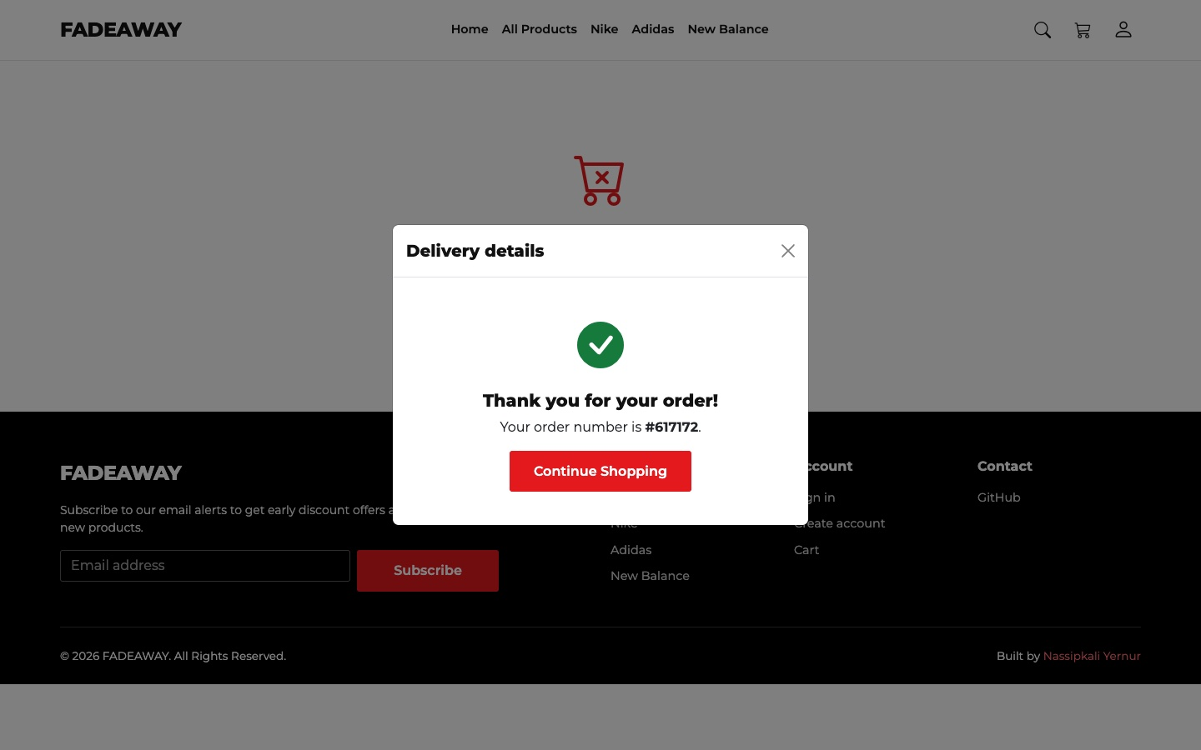
Figure 21 — After the correct delivery details the order gets a number and the cart is cleared
The site has no server, so the login is only for the front end. It checks the format of the fields and saves the username in localStorage, and any correct-looking username and password are accepted. The password is not saved anywhere.

Testing
I checked these cases in Chrome. The results are from the final version of the site, with the internet turned off.
What I did | What happened | Result
Opened All Products | 22 products, price limit 189 990 ₸ | Pass
Checked Adidas | 4 products | Pass
Added Low-top to it | 2 products: Y-3 Superstar, Y-3 Gazelle | Pass
Clicked Clear Filters | 22 products, boxes are not checked | Pass
Sorted by price, lowest first | Blazer Low '77 Vintage is first | Pass
Sorted by price, highest first | Jordan 1 Travis Mocha Low is first | Pass
Moved the price to 59 990 ₸ | 5 products | Pass
Opened products.html?brand=New%20Balance | New Balance is checked, 1 product | Pass
Searched for “air max” | 5 products | Pass
Typed an HTML img tag into the search | Shown as text, no image is created | Pass
Opened product.html?id=999 | Message “Product not found” | Pass
Added products from a card and from the product page | The badge on the cart icon shows the right count | Pass
Opened Cart: 3 products, 4 pairs | Original 404 960 ₸, discount 55 000 ₸, total 349 960 ₸ | Pass
Clicked minus when the quantity is 1 | The quantity stays 1 | Pass
Clicked Sign in to checkout without an account | Goes to login.html?from=cart | Pass
Sent an empty Sign in form | Messages under both fields | Pass
Create account with a wrong email and different passwords | Messages under the wrong fields | Pass
Create account with correct data | Goes back to Cart, the header says Hello, Yernur! | Pass
Sent empty Delivery details | Messages under all three fields | Pass
Sent correct Delivery details | Order number is shown, the cart is empty | Pass
Clicked Logout | The header says Hello! again | Pass

Part 6. jQuery Effects/Animations
Task: Must use JavaScript and/or jQuery for interactivity (form validation, effects, animations).
• At least one jQuery effect or animation implemented correctly (fade, slide, toggle, etc.).
The code of all pages is written with jQuery. These are the effects that the customer can see:
jQuery method | Where it is used
.fadeIn() | Products appear after every change of the filters
.fadeOut() and .fadeIn() | The big photo changes on the Product page; the forms change on the Login page; the Back to top button
.slideToggle() | The Filters button opens and closes the filters on small screens
.slideUp() | A product leaves the cart when it is removed
.animate() | The featured row scrolls with the arrows; the page goes up with the Back to top button

Fade
The big photo first fades out. Only when it is hidden, the callback function changes src and fades the new photo in. If src changed at once, the customer would see a sharp jump. .stop(true, true) finishes the old animation if the customer clicks quickly.
js/product.js
$('.thumb').click(function () {
const number = $(this).data('number');

$('.thumb').removeClass('active');
$(this).addClass('active');

$('#mainPhoto').stop(true, true).fadeOut(120, function () {
$(this).attr('src', getPhoto(product, number)).fadeIn(200);
});
});
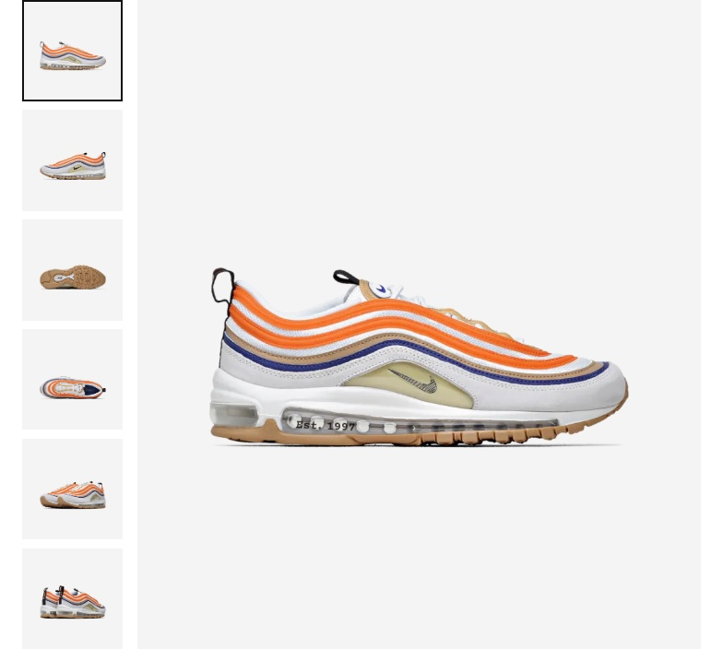 | 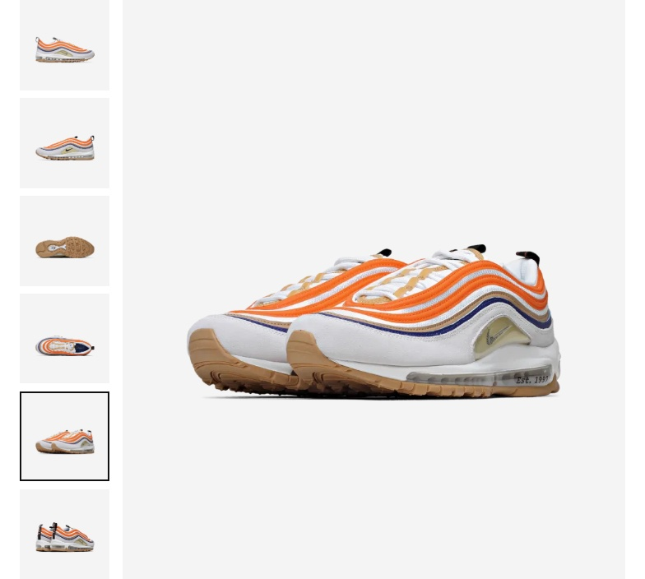
Figure 22 — Product page before (left) and after (right) a click on another small photo

Slide
The row is removed from the array and from the page only in the callback, after .slideUp() has finished. So the customer sees the row closing, and the rows below move up smoothly.
js/cart.js
$('#cartItems').on('click', '.remove-btn', function () {
const row = $(this).closest('.cart-item');

row.slideUp(250, function () {
removeItem(row.data('id'));
showCart();
});
});
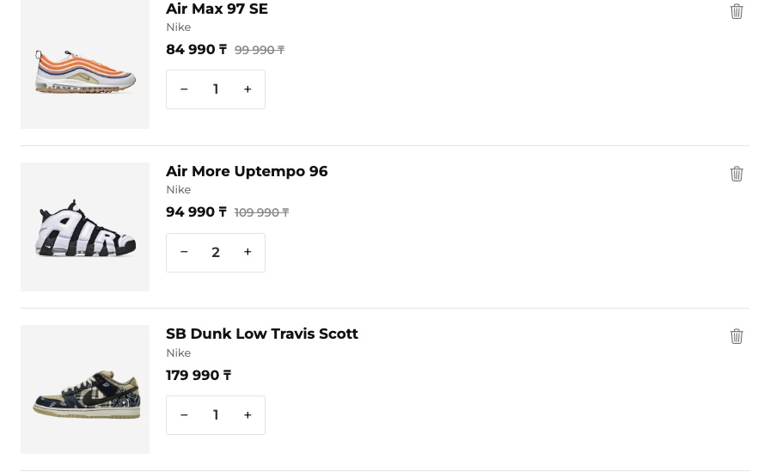 | 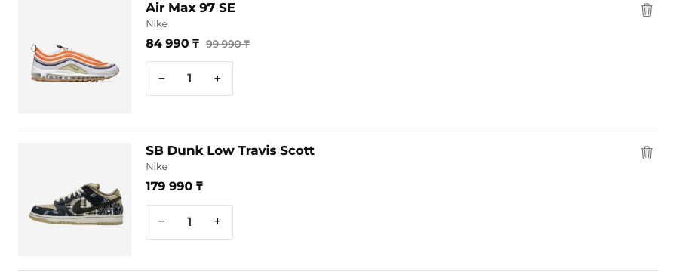
Figure 23 — Cart before (left) and after (right) removing a product
On small screens the Filters button opens the filters with one line. The result is in the phone screenshot in Part 3.
js/shop.js
$('#filterToggle').click(function () {
$('#filters').slideToggle(250);
});

Animate
An arrow moves the featured row by the width of one card. data-direction on the button is 1 or -1, so one function works for both arrows. .stop() cancels the old animation if the customer clicks again.
js/home.js
$('.featured-arrow').click(function () {
const row = $('#featuredRow');
const step = $('.featured-item').outerWidth(true);
const direction = $(this).data('direction');

row.stop().animate({ scrollLeft: row.scrollLeft() + step * direction }, 400);
});
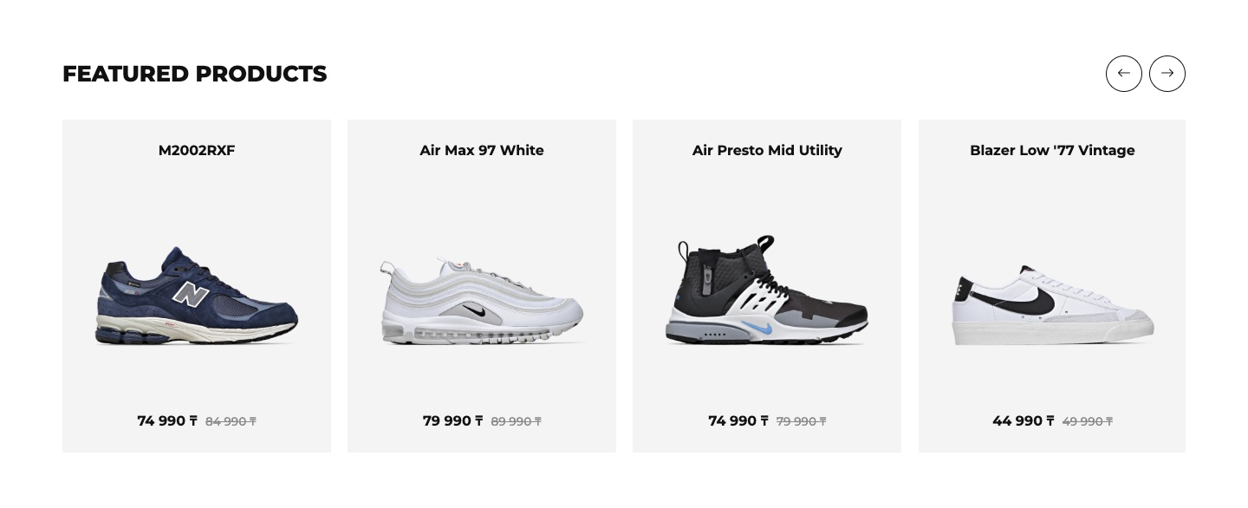 | 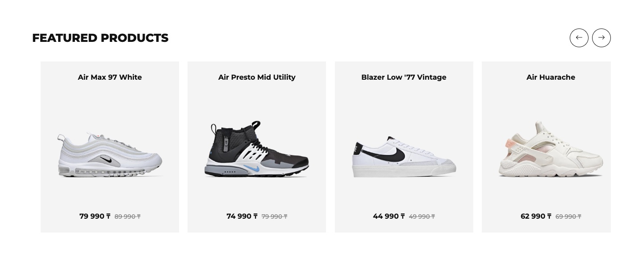
Figure 24 — Featured products before (left) and after (right) a click on the right arrow
The Back to top button appears after 500 pixels of scrolling. It smoothly brings the page up with .animate().
js/main.js
$('#backTop').click(function () {
$('html, body').animate({ scrollTop: 0 }, 400);
});

Part 7. Interactive Component
Task: Must include at least one interactive component (gallery, carousel, accordion, modal, etc.).
• Functional element such as gallery, carousel, accordion, or modal window.
The site has several components. The main one is the carousel on Home. There are also two modal windows, a photo gallery (Part 6), tabs, a dropdown and a toast.

Carousel
I use the Bootstrap carousel. The HTML has only an empty frame, and js/home.js adds one slide and one indicator for each product with the tag hero. Then the carousel starts and changes the slide every 4 seconds.
index.html
<section id="hero" class="carousel slide" aria-label="New sneakers">
<div class="carousel-indicators" id="heroDots"></div>
<div class="carousel-inner" id="heroSlides"></div>
</section>
js/home.js
new bootstrap.Carousel(document.getElementById('hero'), { interval: 4000, ride: 'carousel' });
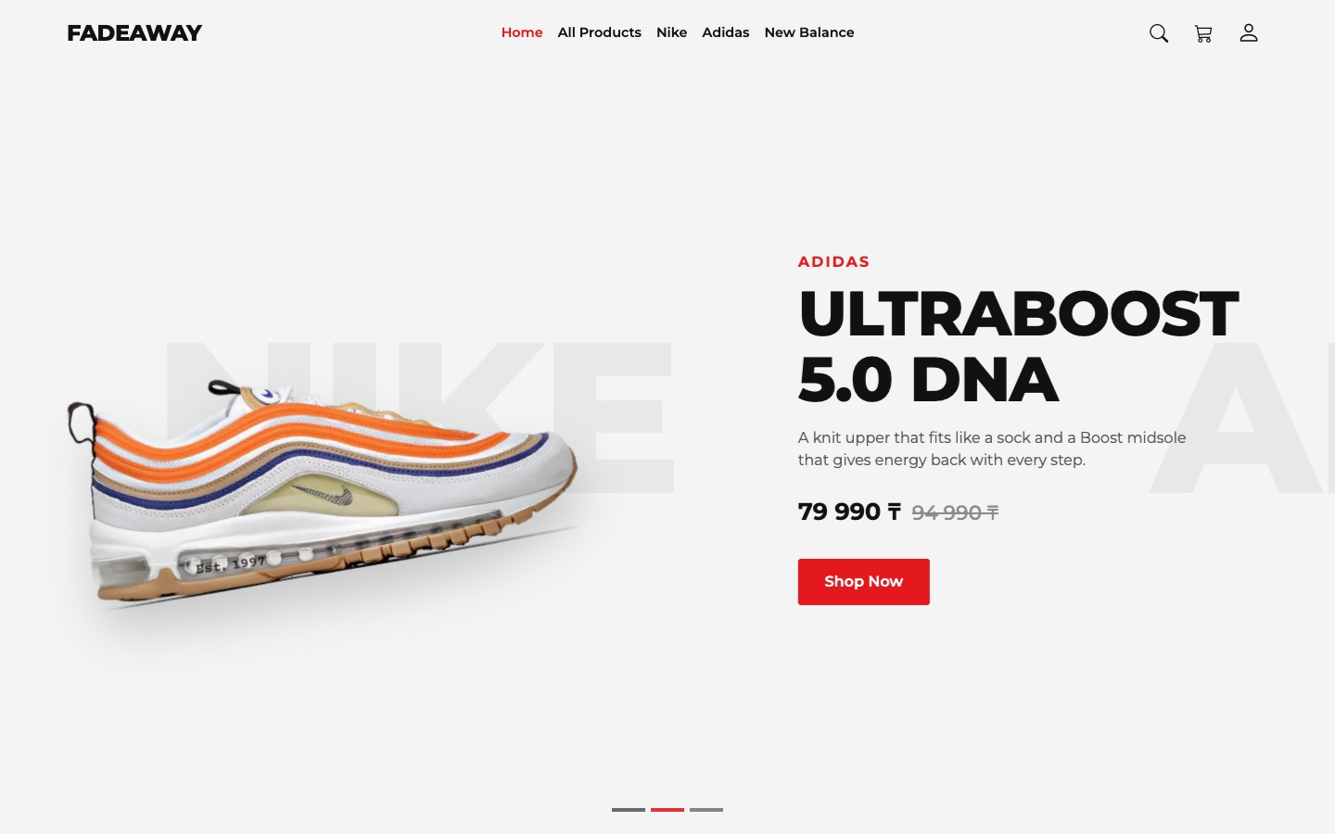 | 
Figure 25 — The carousel while the slide is changing (left) and the next slide (right)

Modal windows
The first modal is the search, and it is on every page (Part 5). The second is Delivery details on the Cart page. If the customer has not signed in, the button opens the Login page instead of the modal.
js/cart.js
$('#checkoutBtn').click(function () {
if (getUser()) {
bootstrap.Modal.getOrCreateInstance(document.getElementById('checkoutModal')).show();
} else {
location.href = 'login.html?from=cart';
}
});

Tabs, dropdown and toast
The Product page has Bootstrap tabs: Specifications and Overview. The account button in the header opens a dropdown, which greets the customer after sign in. When a product is added to the cart, a toast appears for 2.5 seconds with a link to the cart.
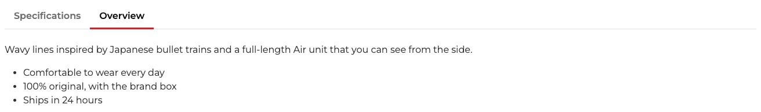
Figure 26 — Tabs on the Product page, the Overview tab is open
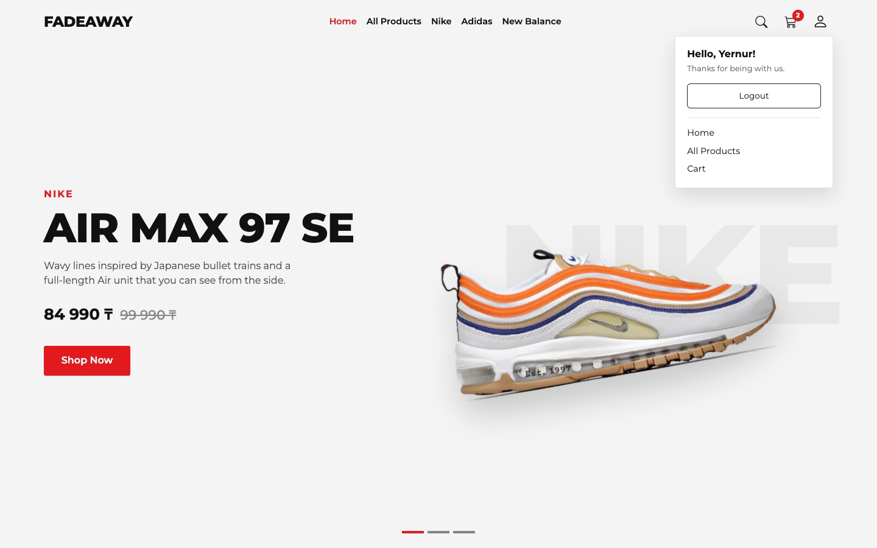 | 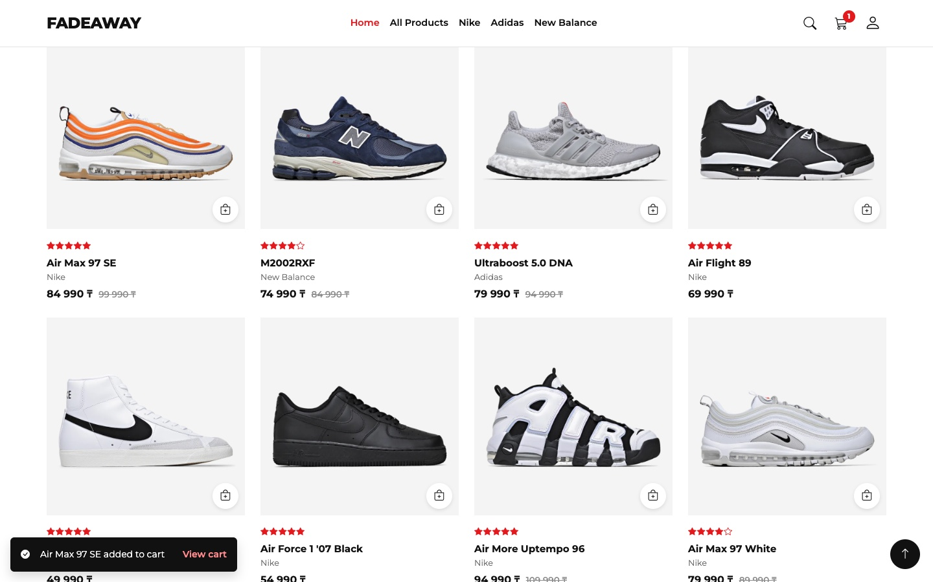
Figure 27 — The dropdown after sign in (left). The toast at the bottom left and the Back to top button at the bottom right (right)

Summary of my work process
This is what I did step by step:
- Plan. I looked at the React version and chose five pages: Home, All Products, Product, Cart and Login.
- Data and photos. I moved the products to one JavaScript array, fixed the data and made the photos smaller.
- Design. I took the colours, the font and the look of the old site and wrote them again in css/style.css, with the Bootstrap grid and navbar for the layout.
- Pages. I made the shared header and footer and then each page with its own JavaScript file.
- Interactivity. I added the filters, search, cart, form validation, jQuery effects and Bootstrap components.
- Testing. I checked every page on desktop, tablet and phone and all the cases from the table in Part 5. The browser console has no errors.

Things that needed attention:
- Mistakes in the old data. One product had photos of another sneaker, two products had broken photo links, and one product had the same photo six times. The category filter never worked, because the categories in the data and in the menu had different names. I fixed all of this. Most prices were placeholders, so the prices and the descriptions on this site are examples.
- Heavy photos. The photos took 64 MB. I made them smaller and converted them to WebP, and now they take 3.6 MB.
- Libraries from a CDN. During testing jQuery once did not load from the CDN, and the page stayed empty, because jQuery draws all the products. I moved all libraries to the lib folder, and now the site works without internet.
- Price slider. The step of the slider did not reach the highest price, so the most expensive sneakers were always hidden. Now the minimum and maximum come from the data, and the step fits the prices.
- Carousel. With the fade effect, the text of two slides mixed during the change. I changed it to the normal slide effect.
- Jumping page on a phone. The slides had different heights, so the content below moved every 4 seconds. I gave the slides one minimum height.
- Cut photos. Two photos had no free space around the sneaker, so their edges were cut in the cards. I added transparent margins to these two photos.
- Link in the footer. “Create account” did nothing when the customer was already on the Login page, because the page does not reload when only the part after # changes. I added a hashchange event.

I did not move everything from the React version. The Django server, real accounts, the orders page and the reviews are not here, because they need a server or real data.
In this project I learned how to connect everything from the course in one real site. The main thing I understood is to keep the data in one place and build the page from it. I also learned that a site must be tested in a real browser on different widths, because most of my mistakes were found only there.

