Final Project. FadeAway Interactive Website
Student: Yernur Nassipkali
Group: SE-2517
Course: Web Technologies 1 (Front End)
For the final project I continued my endterm website FADEAWAY, an online store of sneakers. I made it as an individual project. The idea and the design come from a React project that I worked on earlier for another course. For this course I rewrote the front end from the beginning with HTML, CSS, Bootstrap, JavaScript and jQuery.
For the final I added a dark and light mode, three kinds of notifications, better accessibility and shorter form validation code. I also fixed the header on small phones. This report follows the criteria of the final project.
To run the site, open fadeaway/index.html in a browser. It does not need a server or internet, because Bootstrap, jQuery, the icons and the font are inside the project, in the lib folder.
File or folder | What is inside
index.html, products.html, product.html, cart.html, login.html | The five pages of the site
css/style.css | My own styles on top of Bootstrap, light and dark colours
js/products.js | The catalog: an array of 22 products
js/main.js | Code that every page needs: cart, search, theme, notifications, form checks
js/home.js, shop.js, product.js, cart.js, login.js | One file with the code of each page
lib/ | Bootstrap 5.3.8, Bootstrap Icons, jQuery 3.7.1 and the Montserrat font
images/products/ | 117 product photos in WebP, one folder for each product

Criterion | Weight | Where in this report
Project Structure & Pages | 5% | Part 1
Design Consistency & Usability | 5% | Part 2
Responsiveness & Accessibility | 10% | Part 3
Bootstrap & Custom Styling | 15% | Part 4
JavaScript & jQuery Logic | 20% | Part 5
Code Quality & Optimization | 5% | Part 6
Bonus Features | up to +10% | Part 7

Part 1. Project Structure & Pages
Task: Logical page hierarchy, internal links, and consistent navigation.
My topic is an online shop, so I made five pages. They follow the way a customer buys a pair of sneakers:
Page | File | What the customer does | Where it leads
Home | index.html | Sees new sneakers, featured and top products | All Products, Product
All Products | products.html | Filters, sorts and searches the catalog | Product
Product | product.html | Looks at the photos and details, adds to the cart | Cart
Cart | cart.html | Changes the quantity, sees the total, checks out | Login, then the order
Login | login.html | Signs in or creates an account | Cart or Home

The header is the same on every page: the logo, the menu, the theme button, search, the cart and the account menu. The brand links open the catalog with that brand already selected, for example products.html?brand=Nike. One product page works for all 22 products, because it reads the id from the address, for example product.html?id=7. The Product page also has a breadcrumb: Home / All Products / product name.
index.html
<ul class="navbar-nav mx-auto">
<li class="nav-item"><a class="nav-link active" aria-current="page" href="index.html">Home</a></li>
<li class="nav-item"><a class="nav-link" href="products.html">All Products</a></li>
<li class="nav-item"><a class="nav-link" href="products.html?brand=Nike">Nike</a></li>
<li class="nav-item"><a class="nav-link" href="products.html?brand=Adidas">Adidas</a></li>
<li class="nav-item"><a class="nav-link" href="products.html?brand=New%20Balance">New Balance</a></li>
</ul>
At the end of every page the scripts go in this order. jQuery and Bootstrap are first, because my code uses them. Then come the data, the shared code and the code of this page:
index.html
<script src="lib/jquery-3.7.1.min.js"></script>
<script src="lib/bootstrap.bundle.min.js"></script>
<script src="js/products.js"></script>
<script src="js/main.js"></script>
<script src="js/home.js"></script>

Home page
The first screen is a carousel with three sneakers. Below it there are the featured products with arrows, the top products, a card that leads to the whole catalog, and four services.
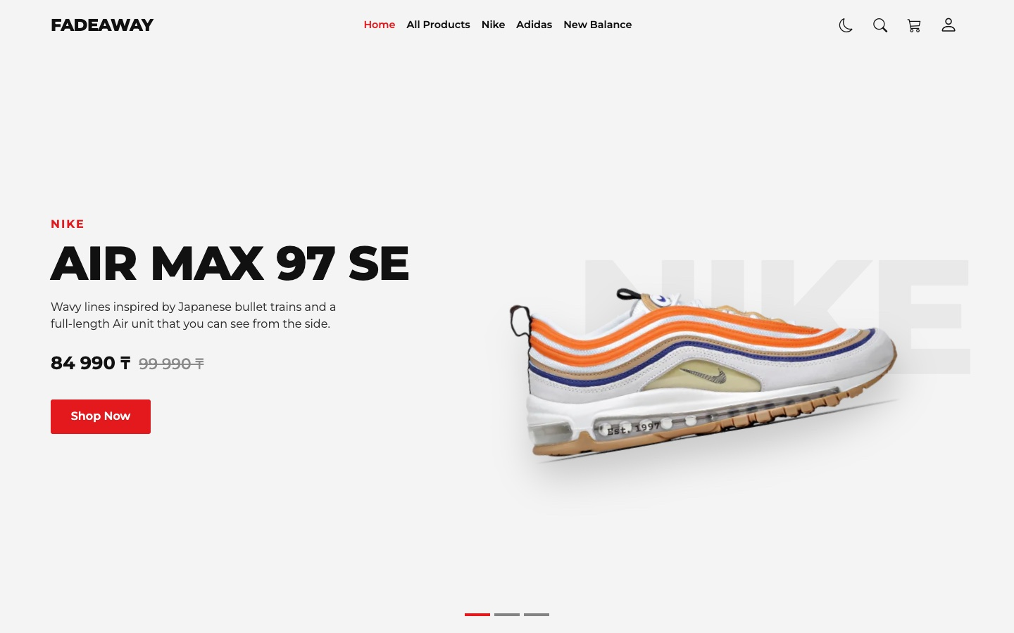
Figure 1 — Home page, first screen
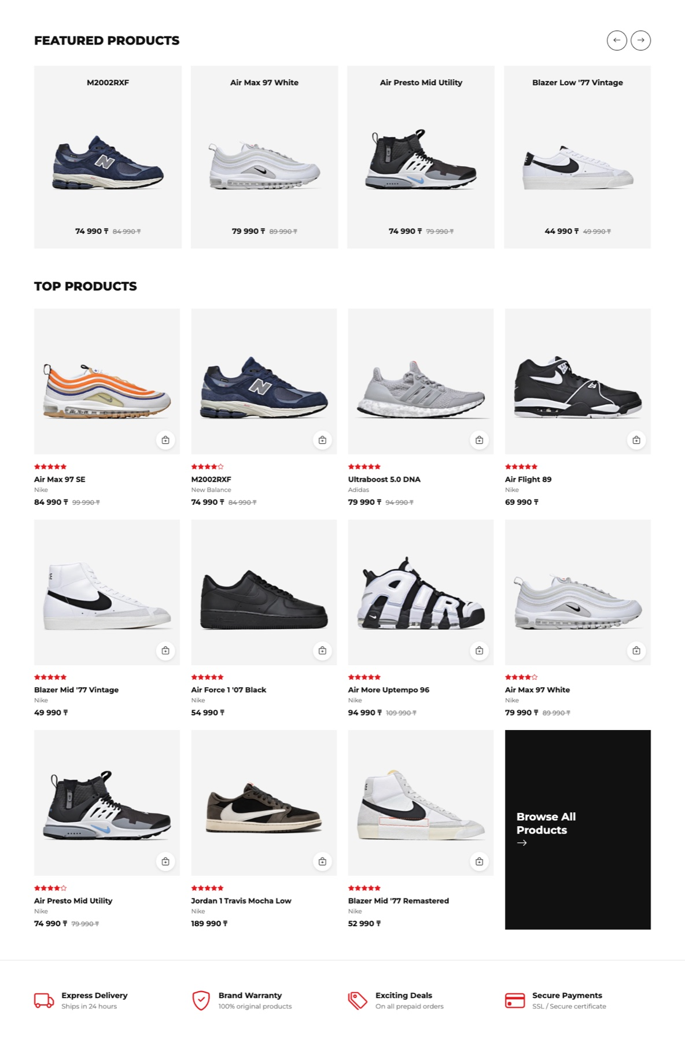
Figure 2 — Home page, featured products, top products and services

All Products page
On the left there are filters by brand, category and price. On the right there are the products, the number of products and the sorting. Each card has a small button that adds the product to the cart at once.
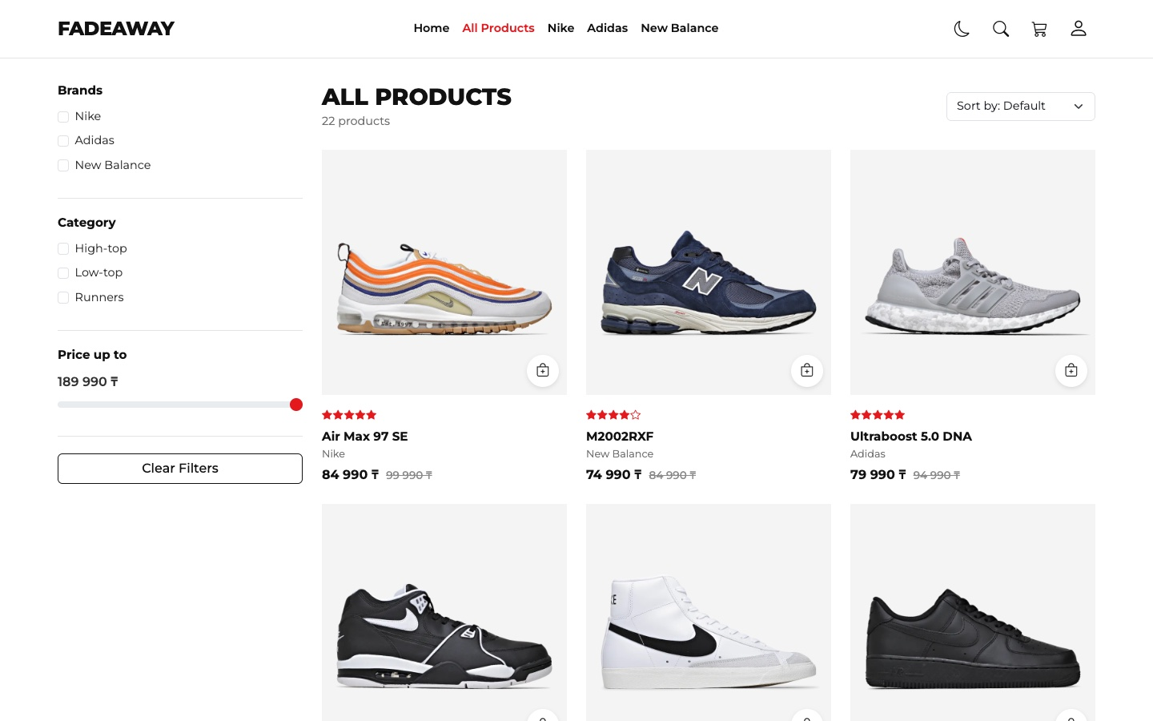
Figure 3 — All Products page

Product page
Here there are the photos of one product, the price, how much the customer saves, the quantity and the Add to cart button. Below there are two tabs and related products from the same category.
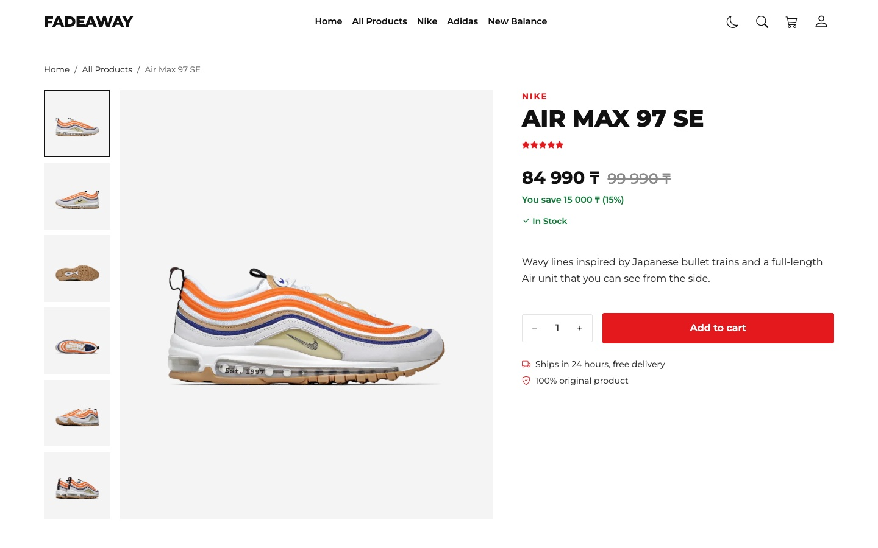
Figure 4 — Product page, photos and details
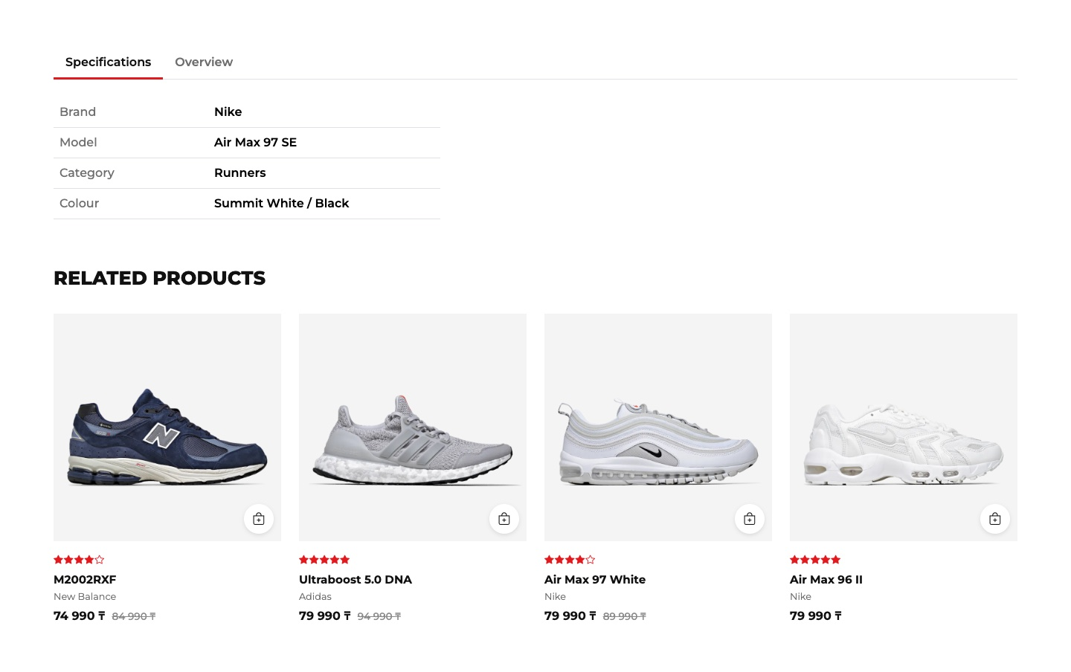
Figure 5 — Product page, tabs and related products

Cart page
The customer can change the quantity or remove a product. The order summary counts the original price, the discount and the total. The button says “Sign in to checkout” until the customer signs in.
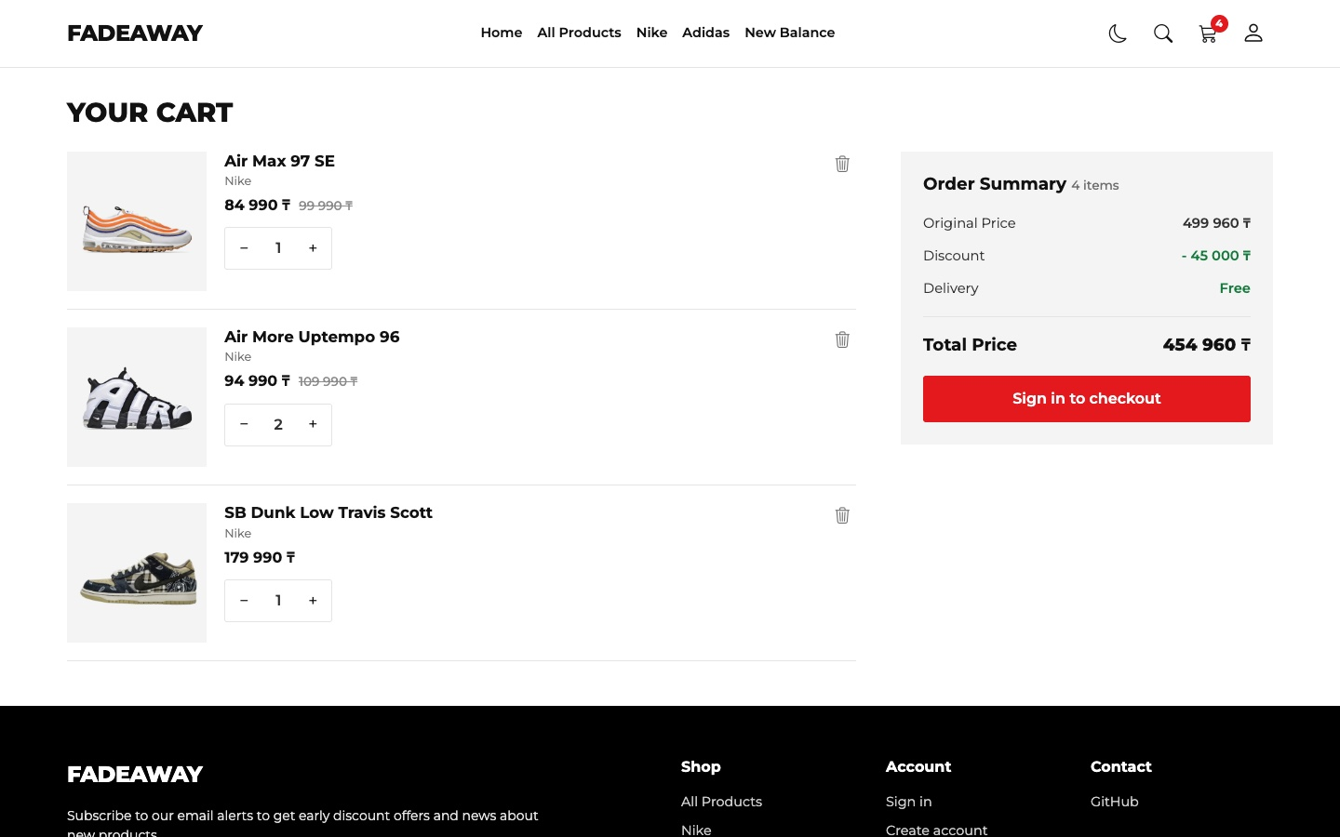
Figure 6 — Cart page

Login page
This page has two forms: Sign in and Create account. The customer switches between them with a link, so one page is enough.
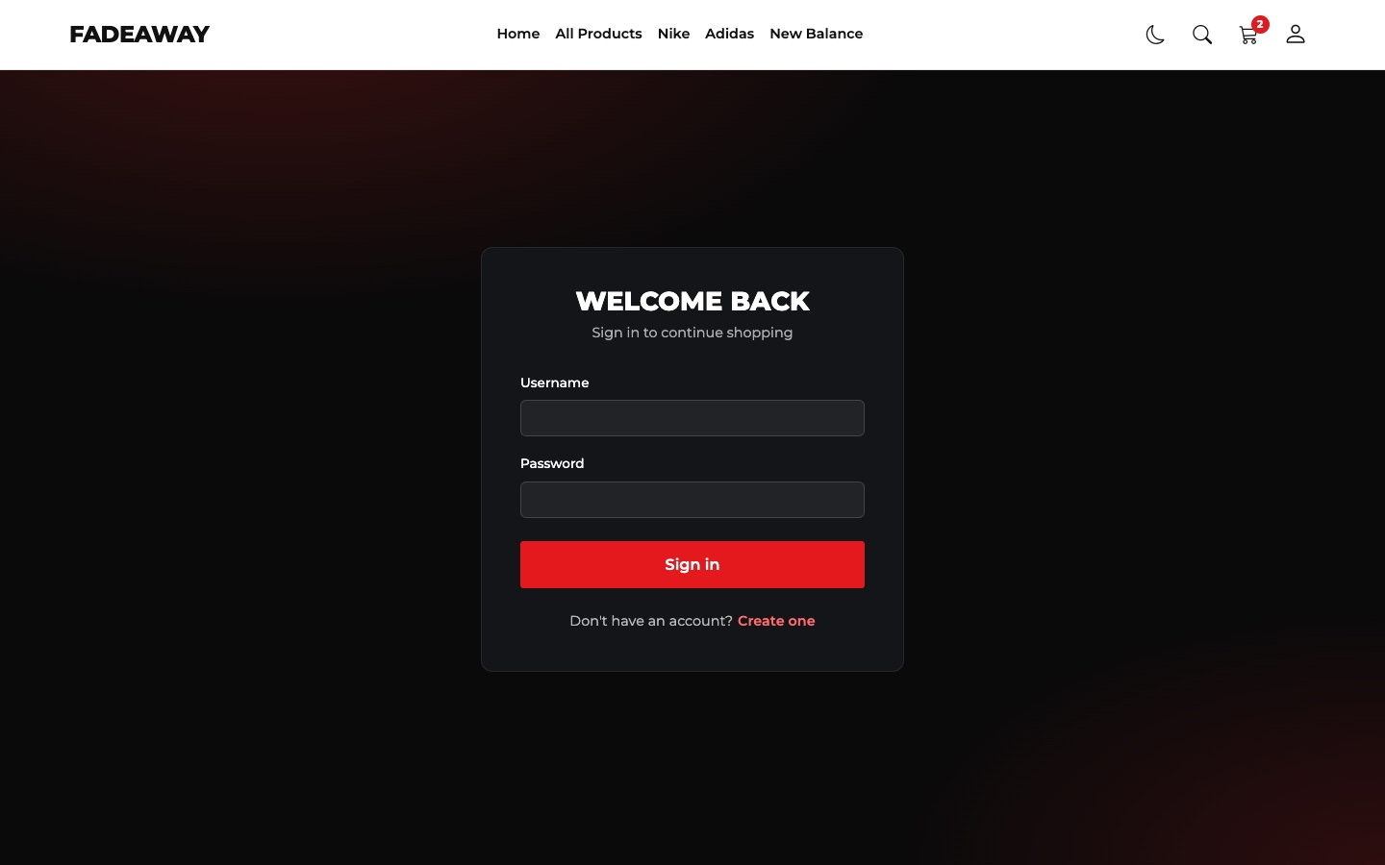
Figure 7 — Login page

Part 2. Design Consistency & Usability
Task: Cohesive visual identity, appropriate color palette, fonts, and user-friendly layout.
All pages use one style file, css/style.css, on top of Bootstrap. The colours are CSS variables in :root. All pages use them, so one change there changes the whole site. In Part 7 the dark mode uses the same variables with other values.
What | Value | Where it is used
Font | Montserrat | All text, with bold uppercase headings
Main colour | Red #e3191e | Buttons, stars, active menu link, icons
Text colours | #111111, #323232, #6f6f6f | Headings, normal text, secondary text
Photo background | Light grey #f4f4f4 | Behind every sneaker. The photos have a transparent background, so all cards look the same
Buttons | Classes .btn-red and .btn-line | Red for main actions, outline for the second action

css/style.css
:root {
--red: #e3191e;
--red-dark: #b91318;
--bg: #ffffff;
--ink: #111111;
--text: #323232;
--muted: #6f6f6f;
--tile: #f4f4f4;
--line: #e4e4e4;
--hover: rgba(0, 0, 0, 0.06);
--green: #157a3c;
--header-height: 72px;
}
Usability:
- Clear current place. The active menu link is red, and the Product page has a breadcrumb.
- Feedback after every action. A notification appears when a product is added to the cart, when a form has mistakes and when the theme changes.
- Short way to buy. Every product card has an Add to cart button, so the customer does not need to open the product page.
- Empty states. When the filters find nothing or the cart is empty, the page says so and gives a button to continue.
- Readable text. I checked the contrast of the main colours. All of them pass the WCAG AA level (4.5:1): normal text on white 12.8:1, grey text on white 5.0:1, white text on the red button 4.75:1.

Figure 8 — The same header on all pages
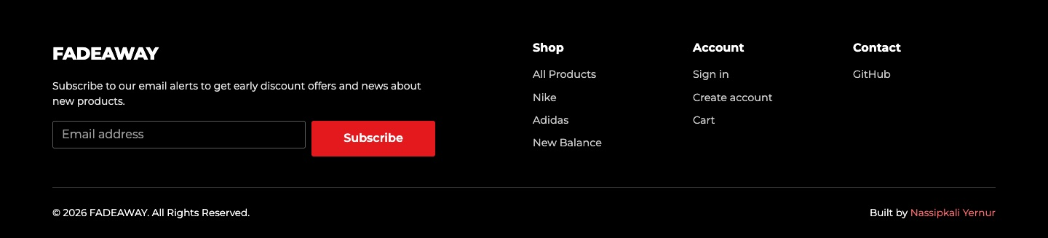
Figure 9 — The same footer on all pages: subscribe form, links and copyright

Part 3. Responsiveness & Accessibility
Task: Correct display across devices and adherence to accessibility principles (alt tags, ARIA, etc.).

Responsiveness
Most of the responsive work is done by the Bootstrap grid and the navbar. For the rest I wrote my own media queries. This is what changes:
Part of the page | Desktop (992px and more) | Tablet (768px) | Phone (375px)
Menu | One line in the header | Hamburger button | Hamburger button
First screen | Text left, photo right | Photo on top, text below | The same, without the description
Cards on Home | 4 in a row | 3 in a row | 2 in a row
Cards in the catalog | 3 in a row | 3 in a row | 2 in a row
Filters | Always open on the left | Hidden behind a button | Hidden behind a button
Product page | Photos left, details right | Photos on top, details below | Small photos in a row under the big one
Cart | Items left, summary right | Summary below the items | Summary below, smaller photos

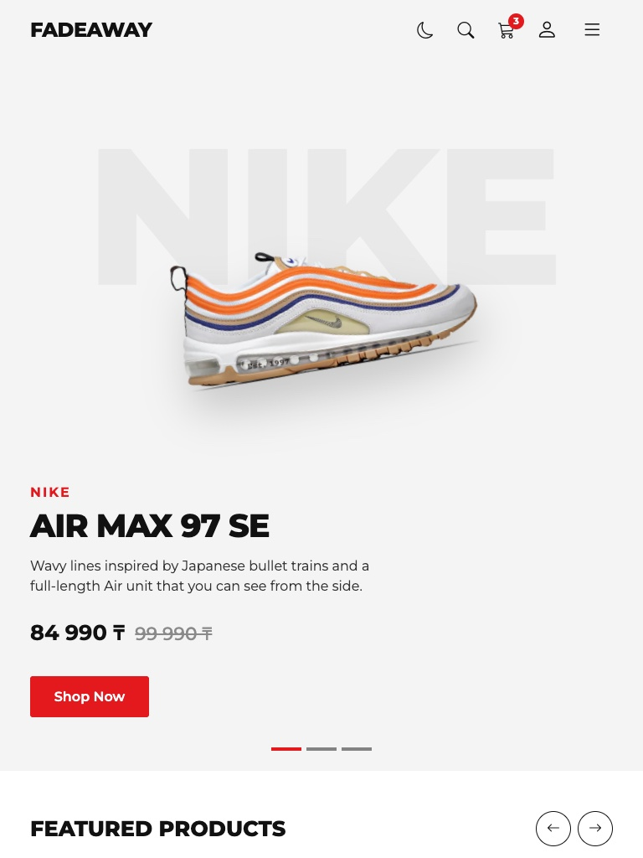 | 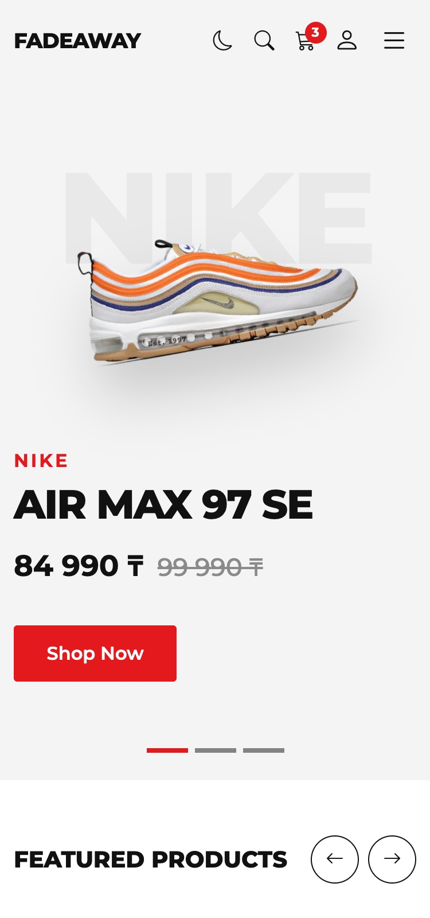
Figure 10 — Home page on a tablet (left) and on a phone (right)
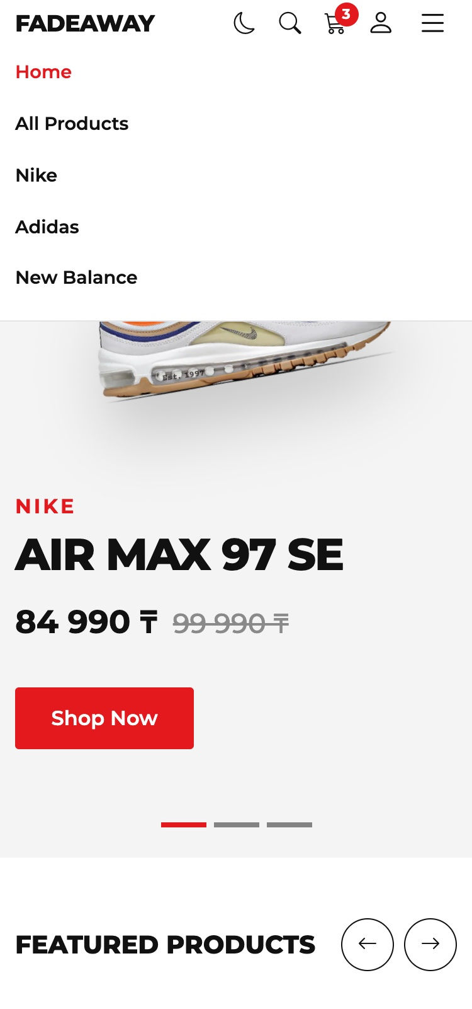 | 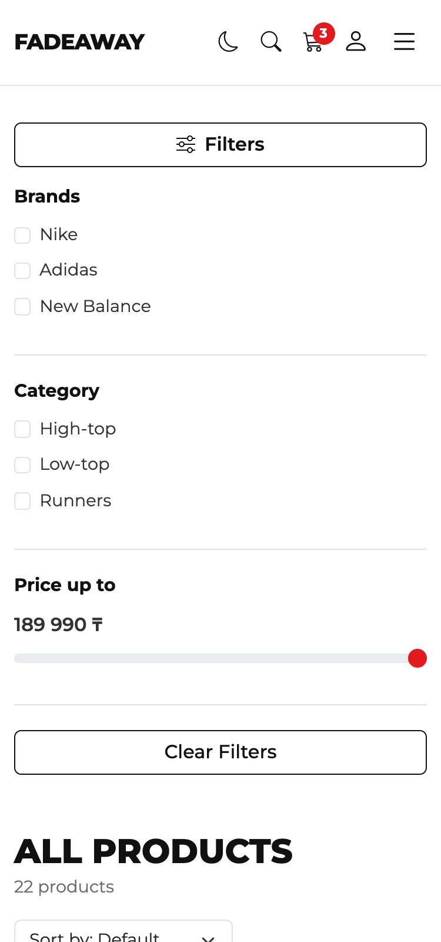
Figure 11 — Phone: the open menu (left) and the open filters (right)
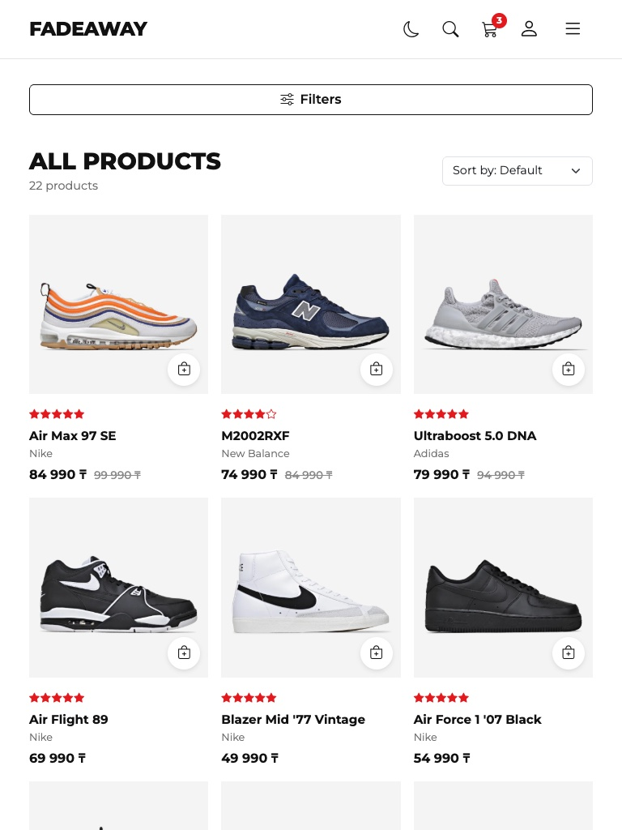 | 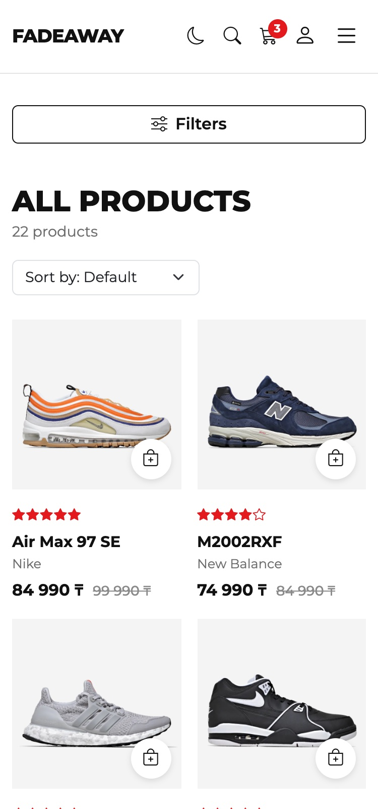
Figure 12 — All Products on a tablet (left) and on a phone (right)
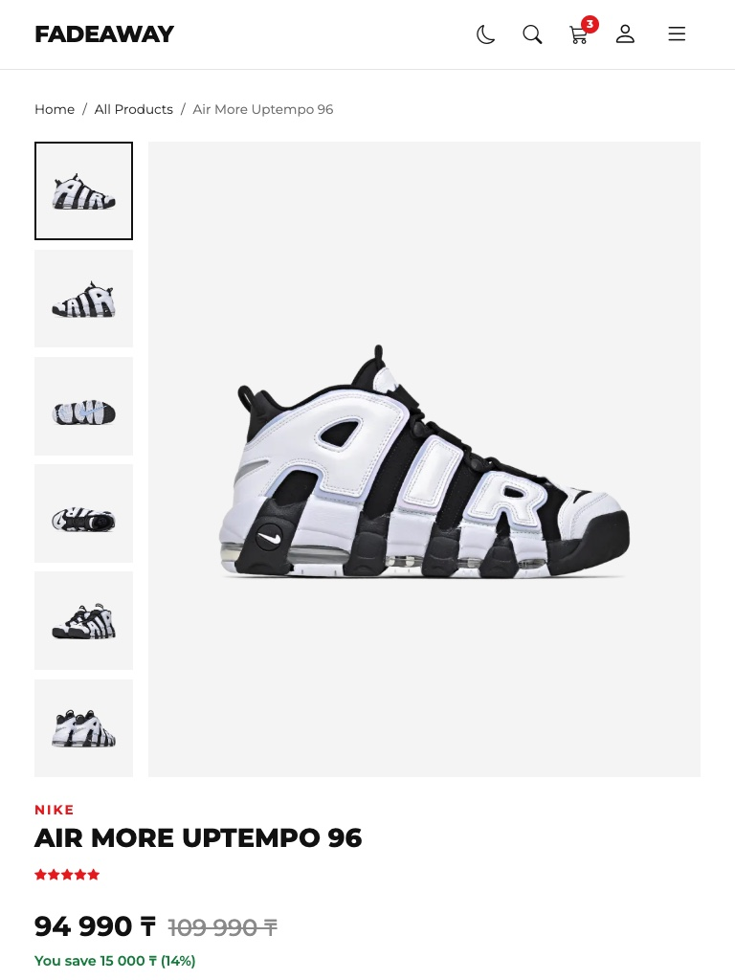 | 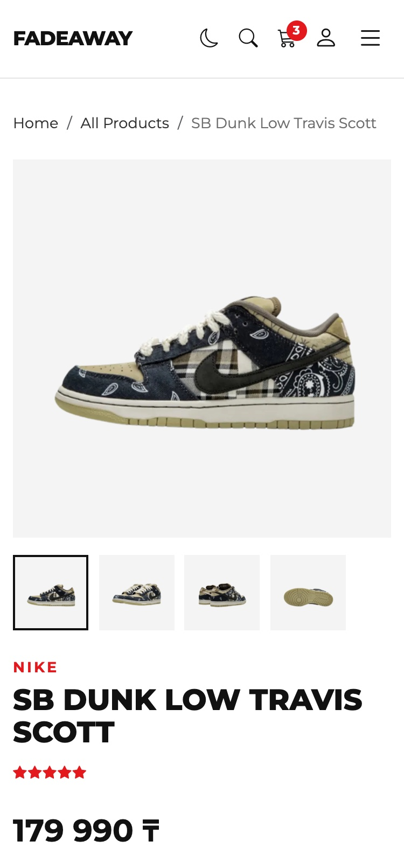
Figure 13 — Product page on a tablet (left) and on a phone (right)
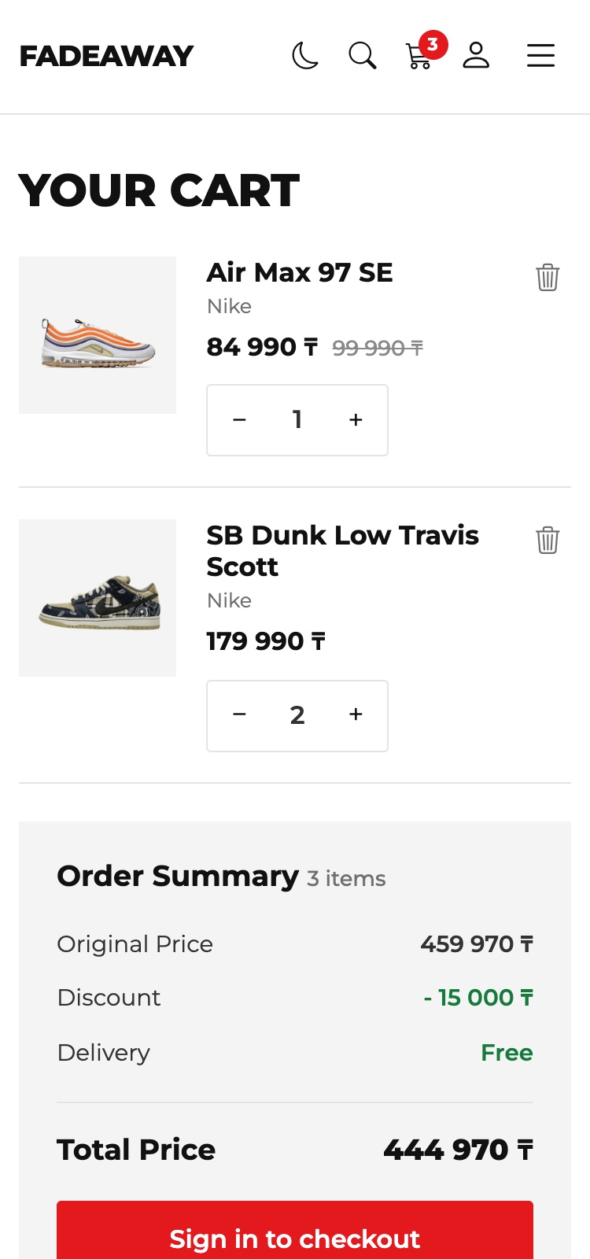 | 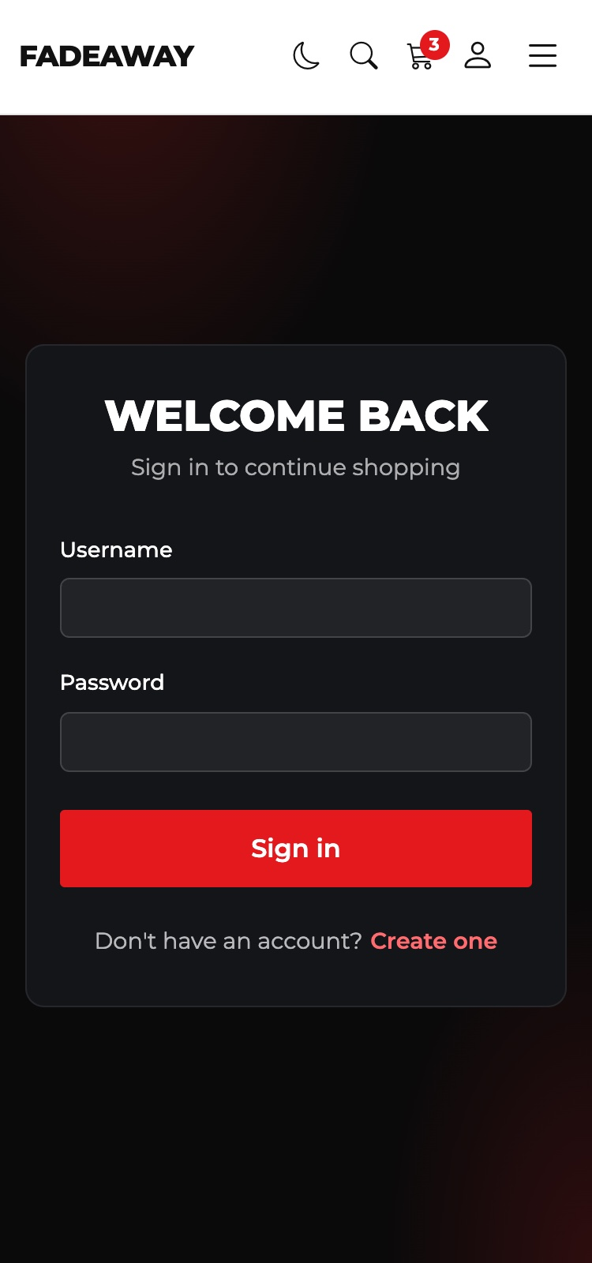
Figure 14 — Phone: Cart (left) and Login (right)
With the new theme button the header did not fit in one line on phones, and the menu button moved to a second line. On small screens the icons are now a little smaller, and below 360px the logo is smaller too:
css/style.css
@media (max-width: 359.98px) {
.logo {
font-size: 1rem;
}

.icon-btn {
width: 32px;
}
}
I measured all five pages in Chrome. At every width the page was not wider than the window, so there was no horizontal scroll, and the header stayed in one line.
Width | Pages checked | What I checked | Result
1440px | All five pages | No horizontal scroll, header in one line | Pass
768px | All five pages | No horizontal scroll, header in one line | Pass
414px, 375px, 360px | All five pages | No horizontal scroll, header in one line | Pass
320px | All five pages | No horizontal scroll, header in one line | Pass

Accessibility
I want the site to work for people who use the keyboard or a screen reader. This is what I did:
What | How it is done
Alt text | Every product photo has alt with the brand and the name. I checked all pages: no image is without alt. Decorative icons have aria-hidden="true", so a screen reader does not read them
Labels | Every field has a <label>. Where the label is not visible, it has the class visually-hidden
Buttons with icons | Buttons that have only an icon have aria-label, for example “Search”, “Cart”, “Switch to dark mode”
Skip link | The first Tab on a page shows “Skip to main content”. It jumps over the header to <main id="main">
Focus | Every button shows a red outline when it is used with the keyboard
Form errors | A wrong field gets aria-invalid="true" and is linked to its message with aria-describedby, so a screen reader reads the error
Live updates | The number of products and the search results have aria-live="polite", the notifications have role="status"
Current page | The active menu link has aria-current="page"
Stars | The rating has role="img" and a text like “5 out of 5 stars”
Less motion | If the system setting “reduce motion” is on, the sneaker animation is turned off

index.html
<a class="skip-link visually-hidden-focusable" href="#main">Skip to main content</a>
...
<main id="main">
css/style.css
.skip-link:focus {
position: fixed;
top: 10px;
left: 10px;
z-index: 2000;
padding: 0.6rem 1rem;
background: var(--red);
color: #fff;
font-weight: 600;
}

.icon-btn:focus-visible,
.add-btn:focus-visible,
.featured-arrow:focus-visible,
.thumb:focus-visible,
.remove-btn:focus-visible,
.navbar-toggler:focus-visible,
.quantity-box button:focus-visible,
#backTop:focus-visible {
outline: 2px solid var(--red);
outline-offset: 2px;
}
login.html
<label class="form-label" for="registerEmail">Email</label>
<input type="email" class="form-control" id="registerEmail" autocomplete="email" aria-describedby="registerEmailError">
<div class="invalid-feedback" id="registerEmailError"></div>
js/main.js
function setFieldError(field, message) {
field.addClass('is-invalid').removeClass('is-valid').attr('aria-invalid', 'true');
field.siblings('.invalid-feedback').text(message);
}

function setFieldOk(field) {
field.addClass('is-valid').removeClass('is-invalid').attr('aria-invalid', 'false');
}
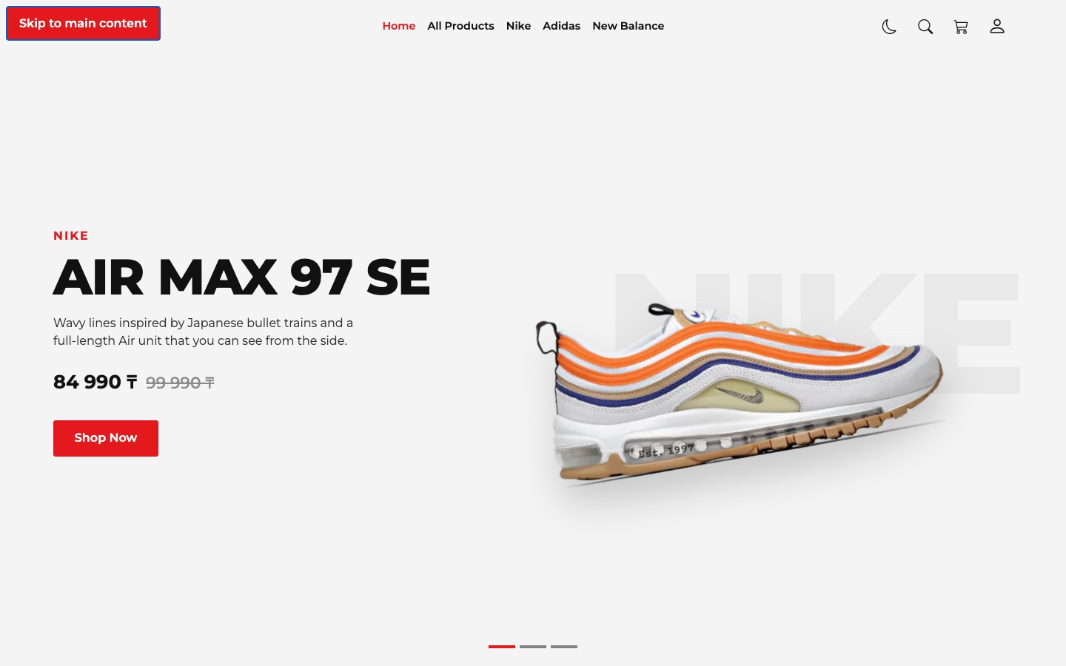
Figure 15 — The skip link after the first Tab
Figure 16 — The red focus outline on the theme button when the keyboard is used

Part 4. Bootstrap & Custom Styling
Task: Balanced use of Bootstrap and original CSS design elements.
I used Bootstrap for the layout and for the standard components, and my own CSS for the look of the shop. I did not change the Bootstrap files. My styles are in a separate file that is loaded after Bootstrap.
From Bootstrap | Where
Grid: container, row, col-*, row-cols-*, g-* | Every page
Navbar with collapse | Header, the hamburger menu on small screens
Carousel | First screen of Home
Modal | Search on every page, delivery details in Cart
Dropdown, Tabs, Toast, Breadcrumb | Account menu, Product page, notifications
Forms: form-control, form-check, form-range, is-invalid | Filters and all forms
Color modes: data-bs-theme | Dark mode of the Bootstrap components

My own CSS | What it does
Colour variables | All colours in one place, for the light and the dark mode
Hero section | Big brand word behind the sneaker with ::before and attr(data-word), the turned photo, the animation when a slide changes
Product cards | Grey photo box, the photo moves and turns on hover, the round Add to cart button
Header | Transparent on top of Home, white after scrolling
Login page | Dark card with red light in the background
Cart | Quantity box, the summary that stays in place while scrolling
Buttons | .btn-red and .btn-line instead of the Bootstrap colours

The grid has 12 parts. For example col-lg-3 and col-lg-9 make 12: from 992px the filters take 3 parts and the products take 9. On smaller screens each one takes the full width. row-cols-* says how many cards stand in one row.
Block | Classes | Result
Top Products | row row-cols-2 row-cols-md-3 row-cols-lg-4 | 2, 3 or 4 cards in a row
Catalog page | col-lg-3 and col-lg-9 | Filters 3/12, products 9/12
First screen | col-lg-5 and col-lg-7, order-* | Text and photo side by side, the photo is first on small screens
Product page | col-lg-7 and col-lg-5 | Photos 7/12, details 5/12
Cart | col-lg-8 and col-lg-4 | Items 8/12, summary 4/12
Footer | col-12 col-lg-5, col-6 col-md-4 col-lg-2 | Form on top on small screens, links in columns

products.html
<aside class="col-lg-3">
...
</aside>
<div class="col-lg-9">
...
<div class="row row-cols-2 row-cols-md-3 g-3 g-lg-4" id="productGrid"></div>
</div>
css/style.css
.btn-red {
padding: 0.8rem 1.8rem;
border: none;
border-radius: 3px;
background: var(--red);
color: #fff;
font-weight: 600;
transition: background 0.2s;
}

.btn-line {
border: 1px solid var(--ink);
color: var(--ink);
font-weight: 500;
}
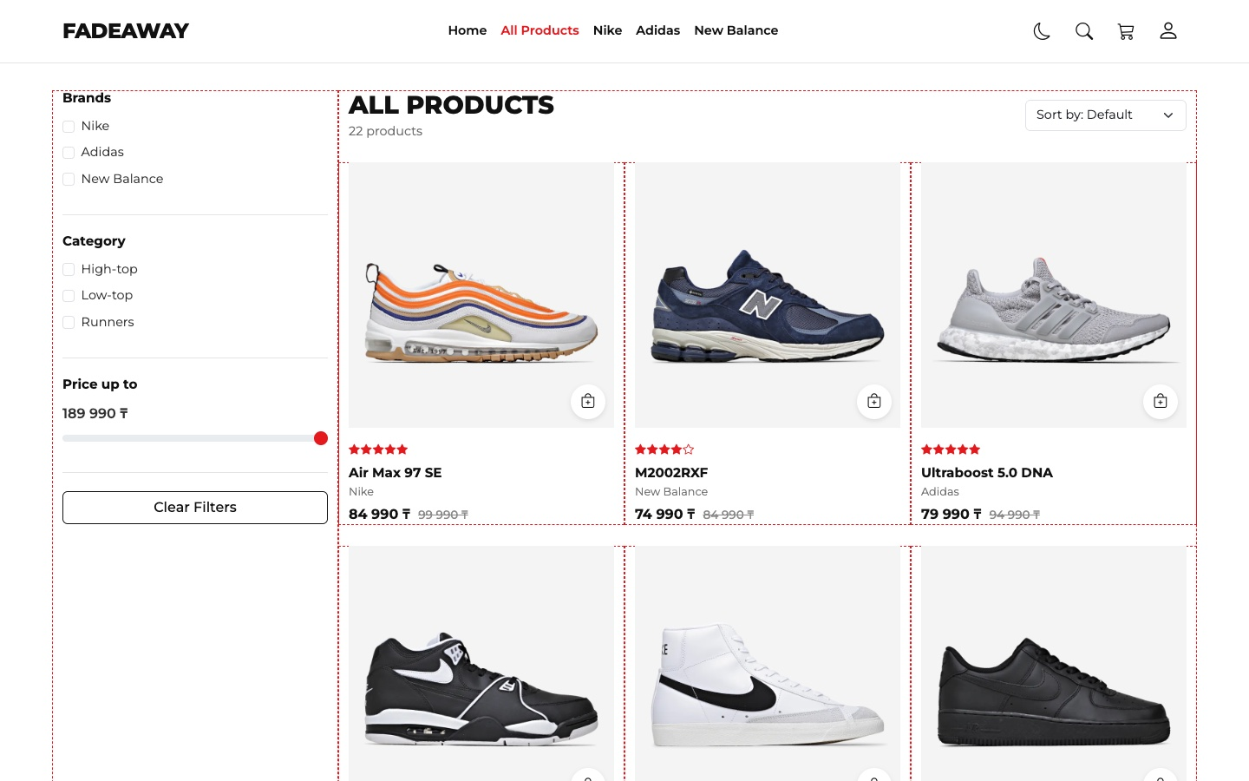
Figure 17 — The grid of the All Products page. I added the dashed lines only for this screenshot

Part 5. JavaScript & jQuery Logic
Task: Interactive features, event handling, form validation, and dynamic content updates.

Dynamic content from one array
All products are objects in one array in js/products.js. The pages have no product cards in the HTML. JavaScript builds them from this array, so a new product needs only one new object.
js/products.js
{
id: 1,
slug: 'air-max-97-se',
photos: 6,
brand: 'Nike',
title: 'Air Max 97 SE',
category: 'Runners',
color: 'Summit White / Black',
price: 84990,
oldPrice: 99990,
rating: 5,
tag: 'hero',
description: 'Wavy lines inspired by Japanese bullet trains and a full-length Air unit that you can see from the side.'
},
The function productCard() returns the HTML of one card. Home, All Products and Related Products all use it.
js/main.js
function productCard(product) {
return `
<div class="col">
<article class="product-card">
<div class="product-photo">
<a href="product.html?id=${product.id}">
<img src="${getPhoto(product, 1)}" alt="${product.brand} ${product.title}" loading="lazy">
</a>
<button type="button" class="add-btn add-to-cart" data-id="${product.id}" aria-label="Add ${product.title} to cart">
<i class="bi bi-bag-plus" aria-hidden="true"></i>
</button>
</div>
${getStars(product.rating)}
<h3 class="product-title"><a href="product.html?id=${product.id}">${product.title}</a></h3>
<p class="product-brand">${product.brand}</p>
<p class="product-price">${getPriceHtml(product)}</p>
</article>
</div>`;
}

Filters, sorting and search
Every time a filter changes, the code takes the whole array, keeps only the products that pass all filters and sorts the result. When no box in a group is checked, this group does not filter anything.
js/shop.js
function getFilteredProducts() {
const brands = getCheckedValues('brand');
const categories = getCheckedValues('category');
const priceLimit = Number($('#priceRange').val());
const text = searchText.toLowerCase();

const result = products.filter(function (product) {
const brandOk = brands.length === 0 || brands.includes(product.brand);
const categoryOk = categories.length === 0 || categories.includes(product.category);
const textOk = (product.brand + ' ' + product.title).toLowerCase().includes(text);
return brandOk && categoryOk && textOk && product.price <= priceLimit;
});

switch ($('#sortSelect').val()) {
case 'cheap':
result.sort(function (a, b) {
return a.price - b.price;
});
break;
case 'expensive':
result.sort(function (a, b) {
return b.price - a.price;
});
break;
case 'rating':
result.sort(function (a, b) {
return b.rating - a.rating;
});
break;
}

return result;
}
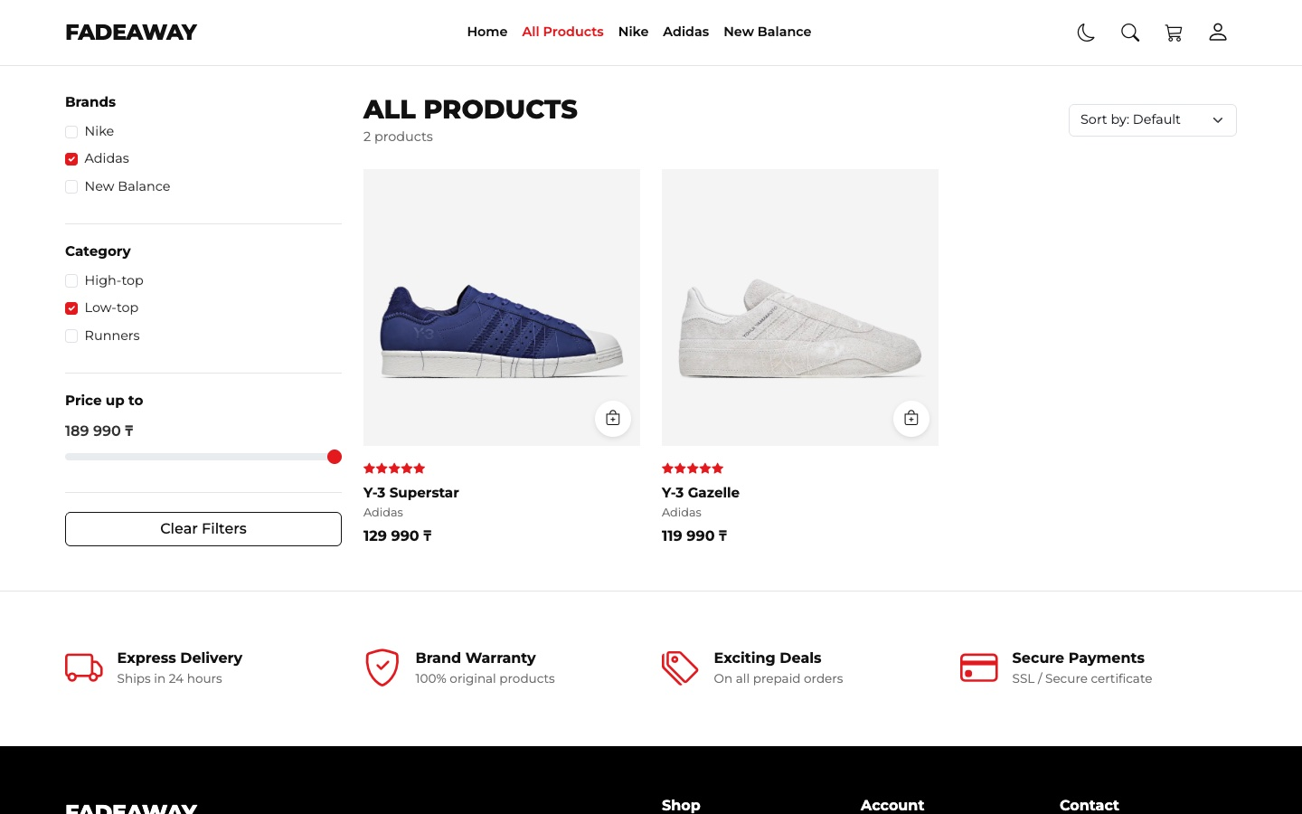
Figure 18 — Filters at work: Adidas and Low-top give 2 products
The search is in the header of every page. Results appear while the customer is typing. The typed text is shown with .text(), not .html(), so HTML code in the search field stays plain text.
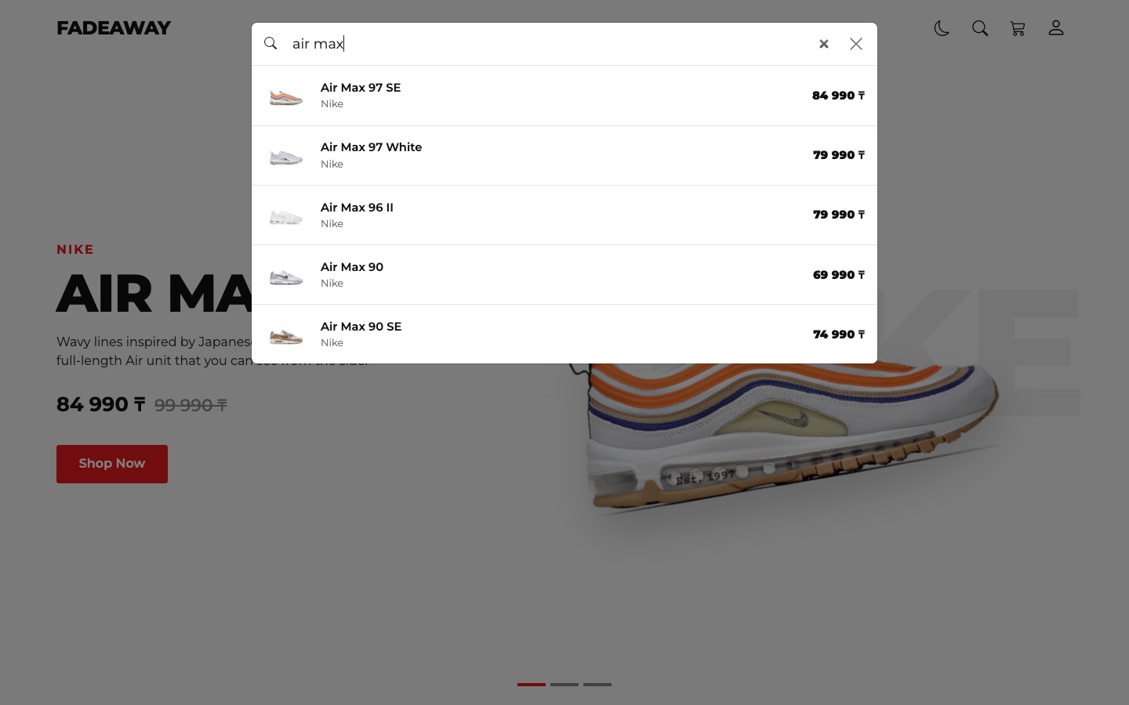
Figure 19 — Search for “air max” with results while typing

Cart saved in the browser
Each page is a separate HTML file, so a normal variable is lost when the customer opens another page. That is why the cart is in localStorage. It stores only the id and the quantity, and the name and the price come from the array. When the product is already in the cart, the quantity grows and the notification says so.
js/main.js
function addToCart(id, quantity) {
const cart = getCart();
const item = cart.find(function (cartItem) {
return cartItem.id === id;
});

const title = findProduct(id).title;

if (item) {
item.quantity += quantity;
saveCart(cart);
showToast(title + ': now ' + item.quantity + ' in your cart', 'info', true);
} else {
cart.push({ id: id, quantity: quantity });
saveCart(cart);
showToast(title + ' added to cart', 'success', true);
}
}

Event handling
Event | Where
click | Buttons, arrows, small photos, theme, logout, remove from cart
change | Filter checkboxes, sorting, price slider
input | Search while typing, price shown while the slider moves
submit | Sign in, Create account, Delivery details, Subscribe, Search
scroll | Header background and the Back to top button
hashchange | Switches the Login page to Create account from the footer link
Bootstrap events | shown.bs.modal puts the cursor into search; show.bs.collapse changes the header when the phone menu opens

Products are created by JavaScript after the page is loaded, so .click() on them would not work. The Add to cart buttons use event delegation: the listener is on document and catches clicks on any element with the class.
js/main.js
$(document).on('click', '.add-to-cart', function () {
addToCart($(this).data('id'), 1);
});

Form validation
The forms have novalidate, so JavaScript checks them and shows the messages with the Bootstrap classes is-invalid and invalid-feedback. For the final I made one small function for every field. Before, each field had its own if/else with the same lines.
js/main.js
function checkField(field, isOk, message) {
if (isOk) {
setFieldOk(field);
} else {
setFieldError(field, message);
}
return isOk;
}

function isEmail(value) {
return /^[^@\s]+@[^@\s]+\.[^@\s]+$/.test(value);
}
js/login.js
function checkRegisterForm() {
const password = $('#registerPassword').val();
const confirm = $('#registerConfirm').val();

const results = [
checkField($('#registerName'), $('#registerName').val().trim().length >= 3, 'Username must have at least 3 characters.'),
checkField($('#registerEmail'), isEmail($('#registerEmail').val().trim()), 'Please enter a valid email, for example name@mail.com.'),
checkField($('#registerPassword'), password.length >= 6, 'Password must have at least 6 characters.'),
checkField($('#registerConfirm'), confirm !== '' && confirm === password, 'Passwords do not match.')
];
return !results.includes(false);
}
All checks run first and their results go into an array. So all wrong fields get a message at the same time, not only the first one. !results.includes(false) is true only when every field is correct.
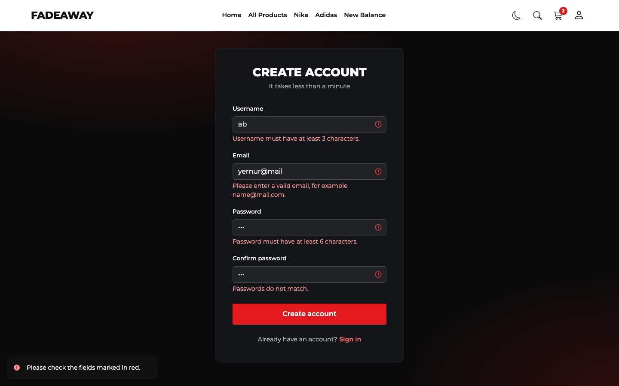 | 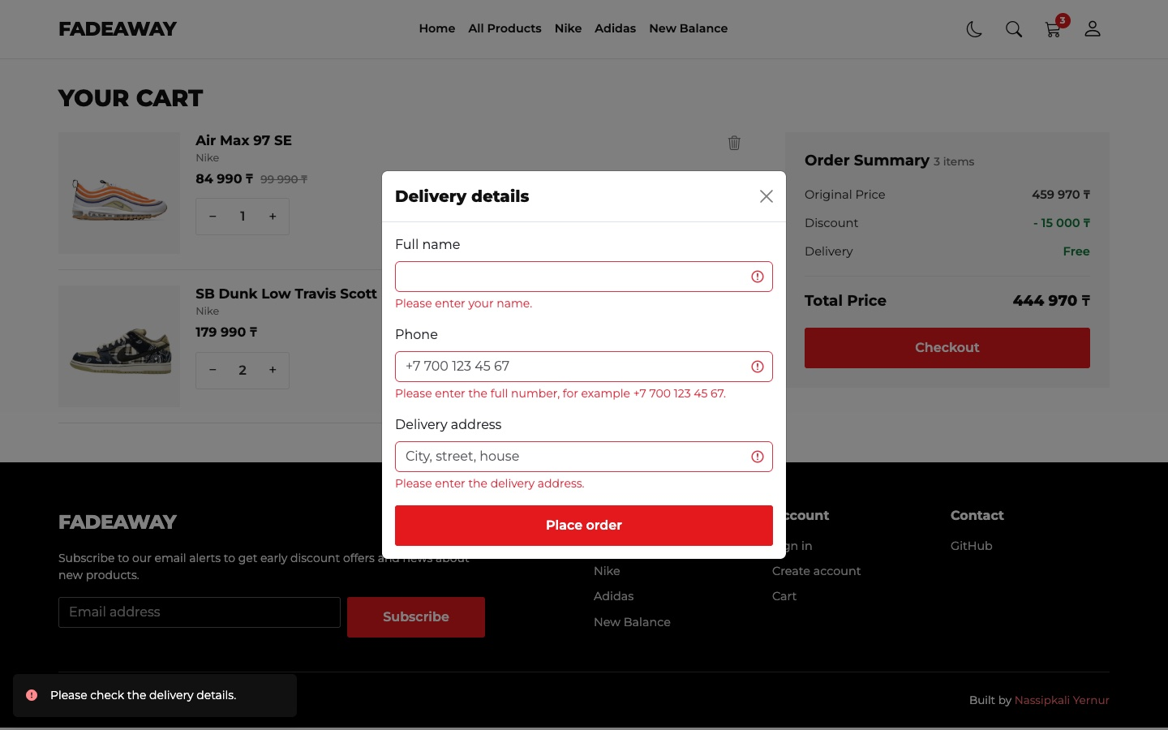
Figure 20 — Validation messages in Create account (left) and in Delivery details (right)
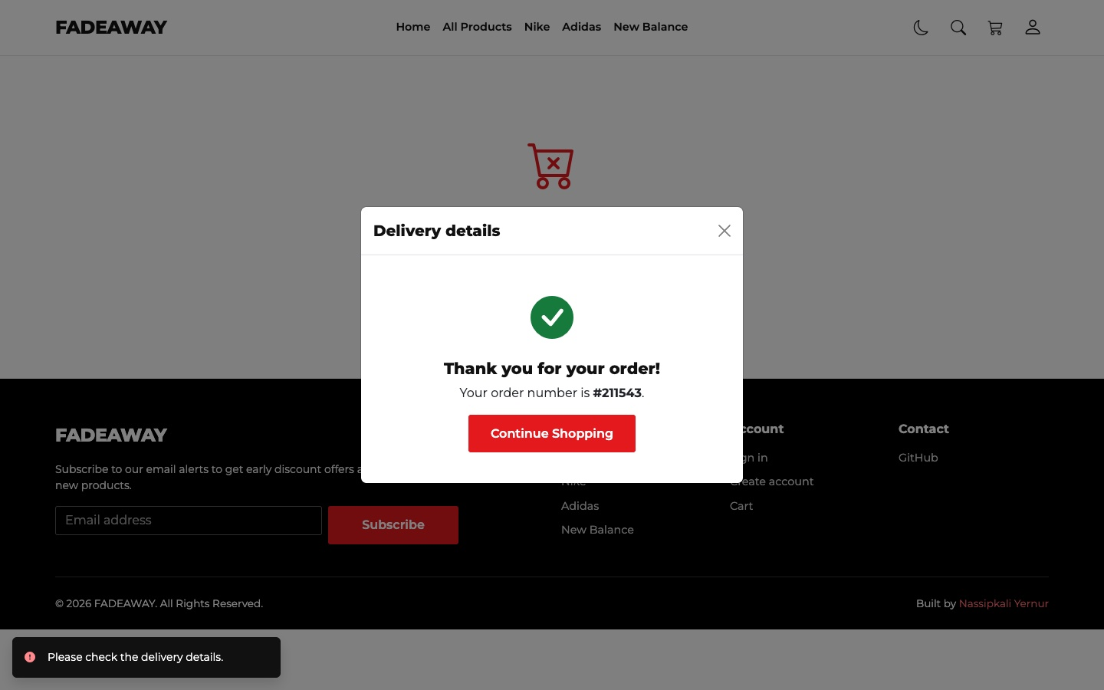
Figure 21 — After correct delivery details the order gets a number and the cart is cleared
The site has no server, so the login is only for the front end. It checks the format of the fields and saves the username in localStorage. The password is not saved anywhere.

jQuery effects and animations
jQuery method | Where it is used
.fadeIn() | Products appear after every change of the filters
.fadeOut() and .fadeIn() | The big photo changes on the Product page; the forms change on the Login page; the Back to top button
.slideToggle() | The Filters button opens and closes the filters on small screens
.slideUp() | A product leaves the cart when it is removed
.animate() | The featured row scrolls with the arrows; the page goes up with the Back to top button

The big photo first fades out. Only in the callback, when it is hidden, src changes and the new photo fades in. .stop(true, true) finishes the old animation if the customer clicks quickly.
js/product.js
$('.thumb').click(function () {
const number = $(this).data('number');

$('.thumb').removeClass('active');
$(this).addClass('active');

$('#mainPhoto').stop(true, true).fadeOut(120, function () {
$(this).attr('src', getPhoto(product, number)).fadeIn(200);
});
});
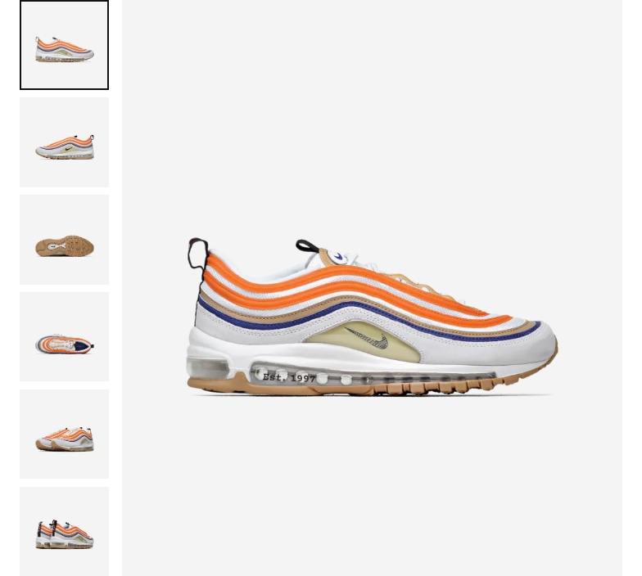 | 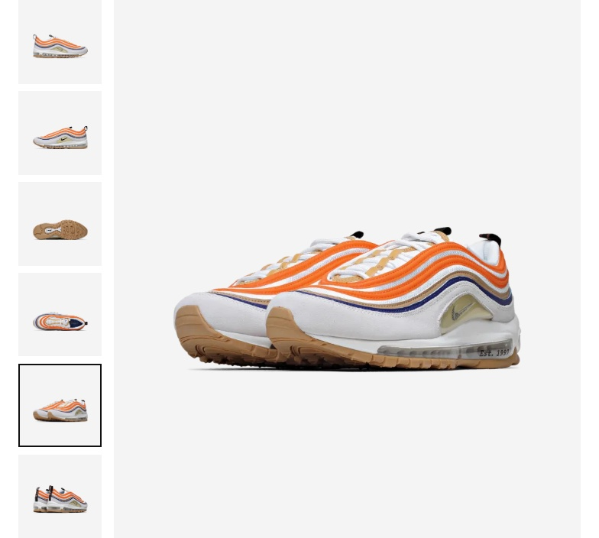
Figure 22 — Product page before (left) and after (right) a click on another small photo
The cart row is removed from the data and from the page only after .slideUp() has finished, so the customer sees the row closing.
js/cart.js
$('#cartItems').on('click', '.remove-btn', function () {
const row = $(this).closest('.cart-item');

row.slideUp(250, function () {
removeItem(row.data('id'));
showCart();
});
});
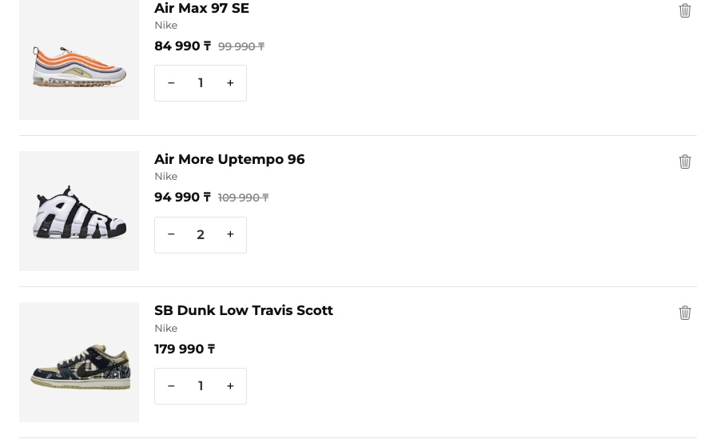 | 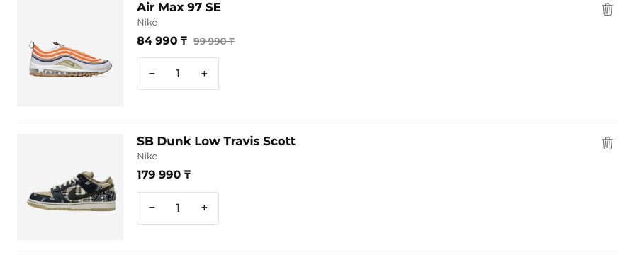
Figure 23 — Cart before (left) and after (right) removing a product
An arrow moves the featured row by the width of one card. data-direction on the button is 1 or -1, so one function works for both arrows.
js/home.js
$('.featured-arrow').click(function () {
const row = $('#featuredRow');
const step = $('.featured-item').outerWidth(true);
const direction = $(this).data('direction');

row.stop().animate({ scrollLeft: row.scrollLeft() + step * direction }, 400);
});
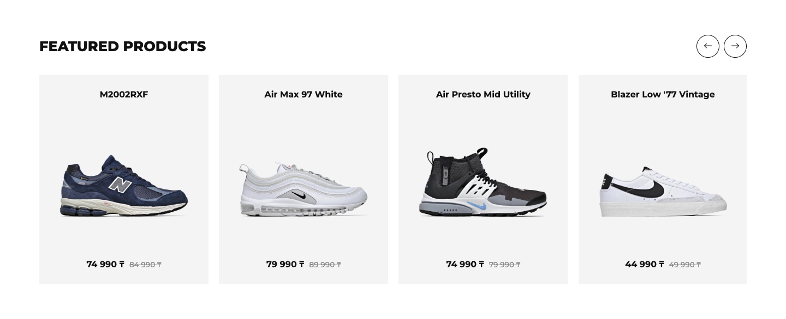 | 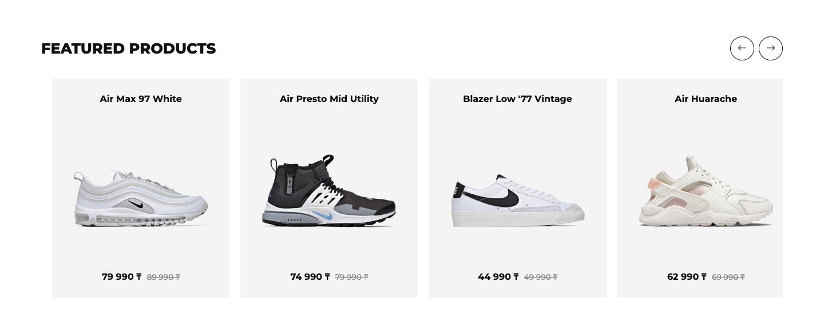
Figure 24 — Featured products before (left) and after (right) a click on the right arrow

Interactive components
The carousel on Home is built by JavaScript: the HTML has only an empty frame, and js/home.js adds one slide for each product with the tag hero. Then the Bootstrap carousel changes the slide every 4 seconds.
js/home.js
new bootstrap.Carousel(document.getElementById('hero'), { interval: 4000, ride: 'carousel' });
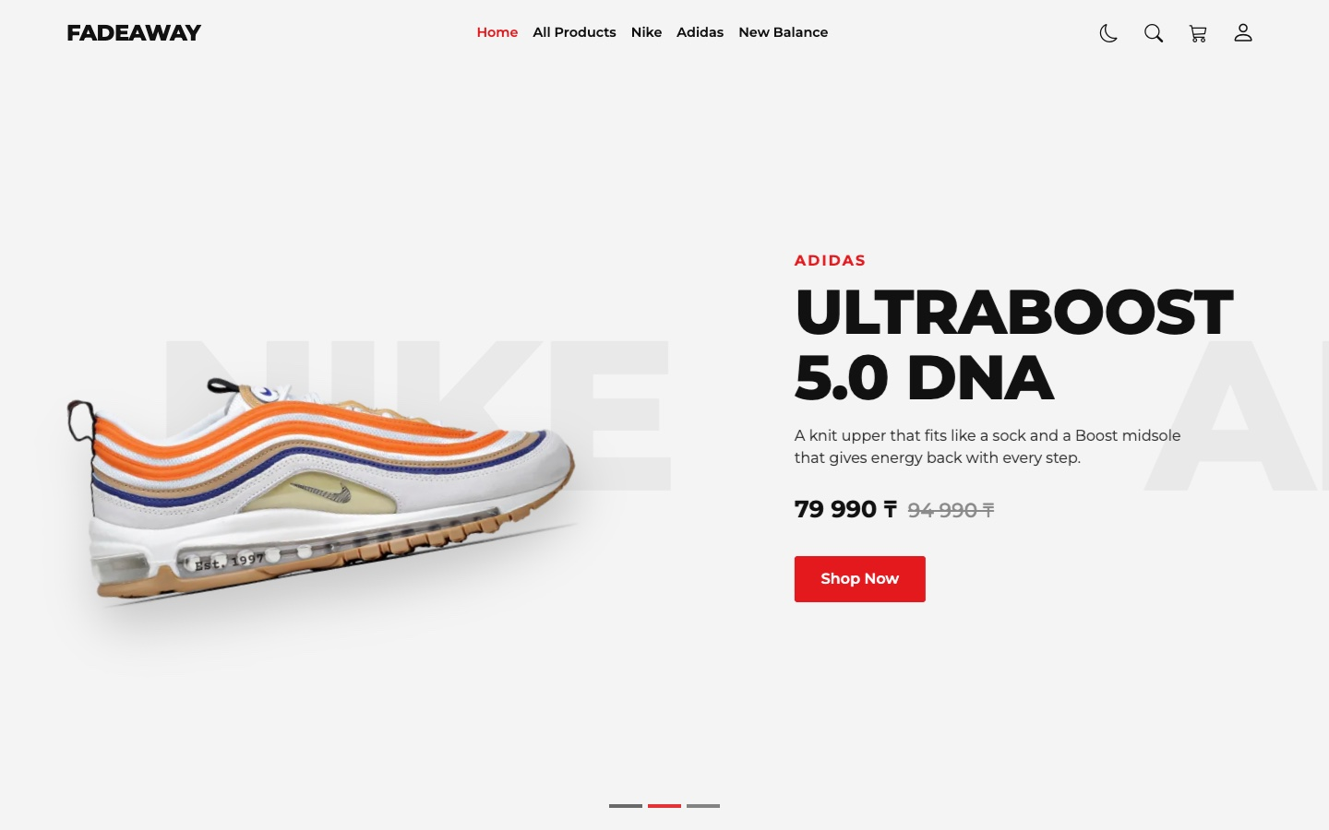 | 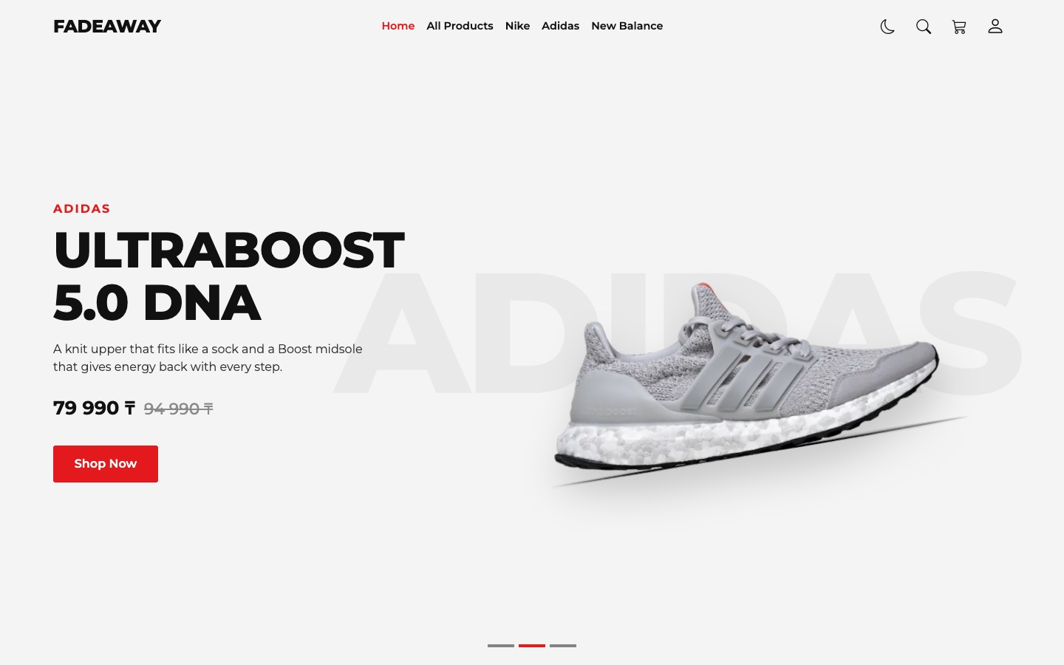
Figure 25 — The carousel while the slide is changing (left) and the next slide (right)
The site also has two modal windows (search and delivery details), tabs on the Product page and the account dropdown, which greets the customer after sign in.
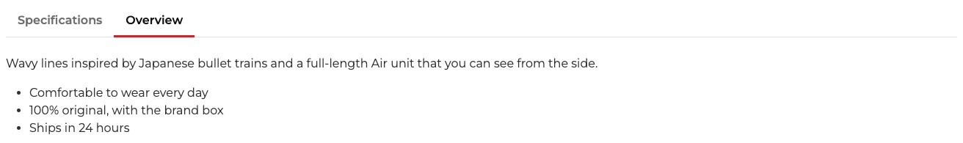 | 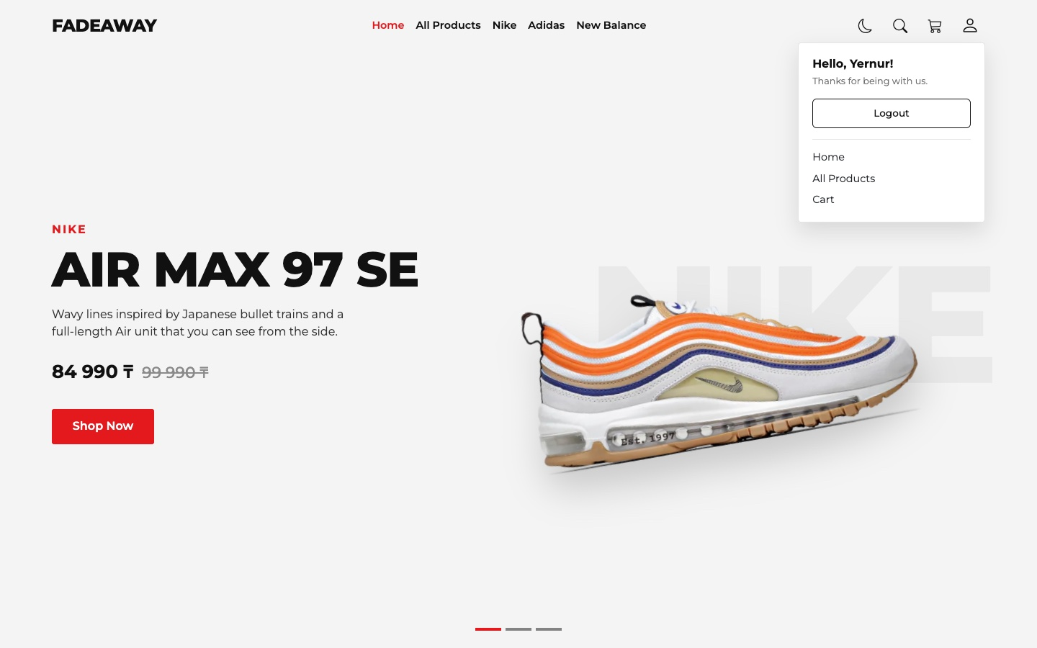
Figure 26 — Tabs on the Product page (left) and the account dropdown after sign in (right)

Testing
I checked these cases in Chrome on the final version of the site, with the internet turned off.
What I did | What happened | Result
Opened All Products | 22 products, price limit 189 990 ₸ | Pass
Checked Adidas, then also Low-top | 4 products, then 2: Y-3 Superstar, Y-3 Gazelle | Pass
Clicked Clear Filters | 22 products, boxes are not checked | Pass
Sorted by price, lowest and highest first | Blazer Low '77 Vintage first, then Jordan 1 Travis Mocha Low first | Pass
Moved the price to 59 990 ₸ | 5 products | Pass
Opened products.html?brand=New%20Balance | New Balance is checked, 1 product, the menu link is active | Pass
Searched for “air max” | 5 products | Pass
Typed an HTML img tag into the search | Shown as text, no image is created | Pass
Opened product.html?id=999 | Message “Product not found” | Pass
Added the same product twice | Green “added to cart”, then blue “now 2 in your cart” | Pass
Opened Cart: 3 products, 4 pairs | Original 404 960 ₸, discount 55 000 ₸, total 349 960 ₸ | Pass
Clicked minus when the quantity is 1 | The quantity stays 1 | Pass
Clicked Sign in to checkout without an account | Goes to login.html?from=cart | Pass
Sent an empty Sign in form | Messages under both fields, red notification, aria-invalid is true | Pass
Create account with a short name, a wrong email and different passwords | Messages under these three fields | Pass
Create account with correct data | Goes back to Cart, the header says Hello, Yernur! | Pass
Sent empty, then correct Delivery details | Messages under all three fields, then an order number and an empty cart | Pass
Clicked Logout | The header says Hello! again | Pass
Turned on the dark mode, opened the other four pages | All pages are dark, the choice is saved | Pass
Pressed Tab once on Home | Skip to main content appears | Pass
Looked at the browser console on all pages | No errors | Pass

Part 6. Code Quality & Optimization
Task: Clean, well-structured code, minimized redundancy, optimized assets.

Structure
- One job for each file. The data, the shared code and the code of each page are in different files, so it is easy to find where something happens.
- Shared functions. Code that more than one page needs is written once in main.js: productCard, formatPrice, getCart, addToCart, showToast, checkField and others.
- One source of data. The products are only in products.js, the cart keeps only ids, and all colours are only in the CSS variables.
- No inline JavaScript. There are no onclick attributes in the HTML. All events are added in the JavaScript files.
- Clear names. Functions say what they do: getFilteredProducts, showCart, checkOrderForm, applyTheme.

Less repeated code
For the final I replaced the repeated if/else in the forms with checkField():
File | Endterm | Final | Difference
js/login.js | 108 lines | 73 lines | 35 lines shorter
js/cart.js | 156 lines | 136 lines | 20 lines shorter

The header and the footer are still written in every page. jQuery .load() could take them from one file, but the browser blocks it when the site is opened as a file, and the site must open with a double click. I chose that the site always works over less HTML.

Optimized assets
What | How
Photos | The original PNG photos took 64 MB. I made them 900 × 900 and converted them to WebP. Now 117 photos take 3.6 MB
Lazy loading | The cards use loading="lazy", so the browser loads a photo only when it is close to the screen
Libraries | Minified files of Bootstrap and jQuery in lib, so the site works without internet and does not wait for a CDN
Font | One variable Montserrat file (38 KB) instead of a separate file for each weight
Icons | One icon font instead of many image files

js/main.js
<img src="${getPhoto(product, 1)}" alt="${product.brand} ${product.title}" loading="lazy">

Part 7. Bonus Features
These are the bonus features from the list that work on my site. Each one works with user actions or saved data, is written in JavaScript or jQuery and is a natural part of the shop. I know that the maximum bonus is +10%.
Bonus feature | Extra | How it works on my site
Dark / Light Mode | +3% | Theme button in the header, the choice is saved in localStorage and used on all pages
Search / Filter Functionality | +3% | Search while typing on every page; filters by brand, category and price
Notification / Toast System | +3% | Success, info and error notifications with different icons and colours
Back to Top Button | +2% | Appears after scrolling and brings the page up with an animation
Lazy Loading / Image Optimization | +2% | Lazy loading of cards and WebP photos (Part 6)

Dark / Light Mode
The button with a moon or a sun is in the header of every page. The dark colours are the same CSS variables with other values. Bootstrap components like the modal and the dropdown change too, because I use the Bootstrap attribute data-bs-theme on <html>.
css/style.css
[data-bs-theme="dark"] {
--bg: #121212;
--ink: #f2f2f2;
--text: #d6d6d6;
--muted: #a3a3a3;
--tile: #1f1f1f;
--line: #2e2e2e;
--hover: rgba(255, 255, 255, 0.08);
--green: #5fd38d;
}
js/main.js
function applyTheme(theme) {
const isDark = theme === 'dark';
$('html').attr('data-bs-theme', theme);
$('#themeBtn').attr('aria-label', isDark ? 'Switch to light mode' : 'Switch to dark mode');
$('#themeBtn i').attr('class', isDark ? 'bi bi-sun' : 'bi bi-moon');
}

$('#themeBtn').click(function () {
const theme = $('html').attr('data-bs-theme') === 'dark' ? 'light' : 'dark';
localStorage.setItem(THEME_KEY, theme);
applyTheme(theme);
showToast(theme === 'dark' ? 'Dark mode is on' : 'Light mode is on', 'info');
});
There was one problem. main.js is at the end of the page, so for a moment the page was white before it became dark. So every page has a very short script in <head>. It runs before the page is drawn and turns the dark mode on at once.
index.html
<script>
if (localStorage.getItem('fadeaway-theme') === 'dark') {
document.documentElement.setAttribute('data-bs-theme', 'dark');
}
</script>
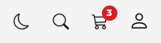 | 
Figure 27 — The theme button: a moon in the light mode (left), a sun in the dark mode (right)
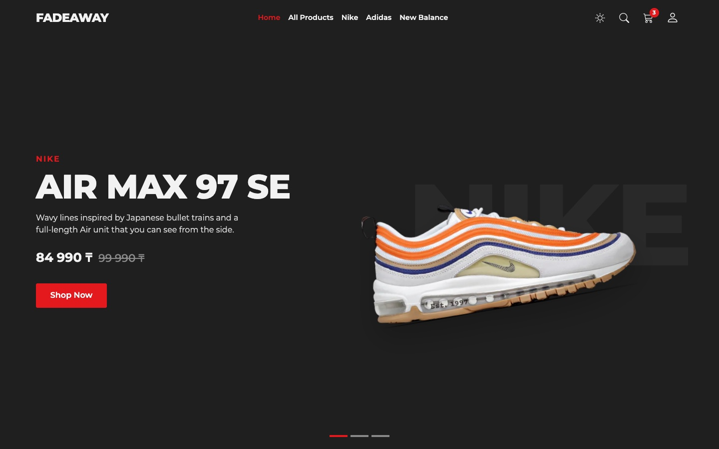
Figure 28 — Home page in the dark mode
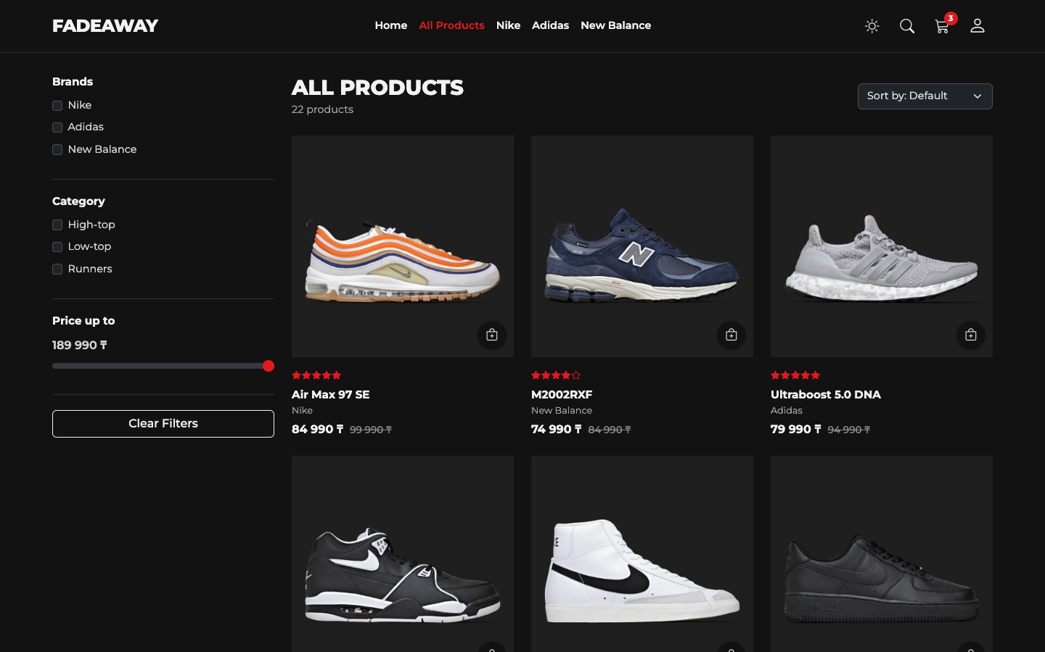 | 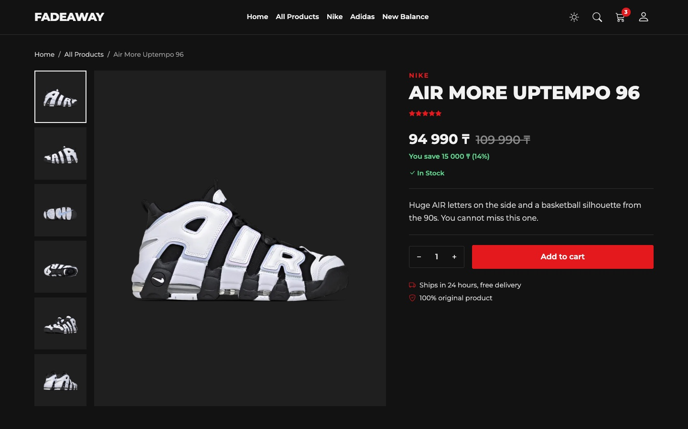
Figure 29 — All Products (left) and Product (right) in the dark mode
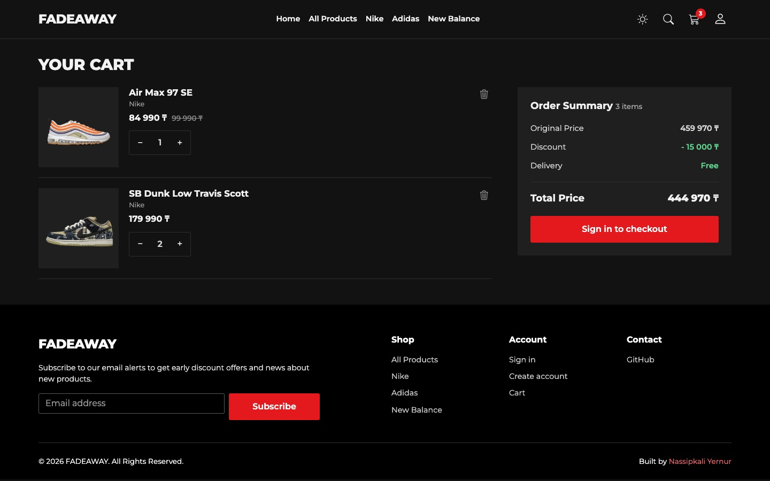 | 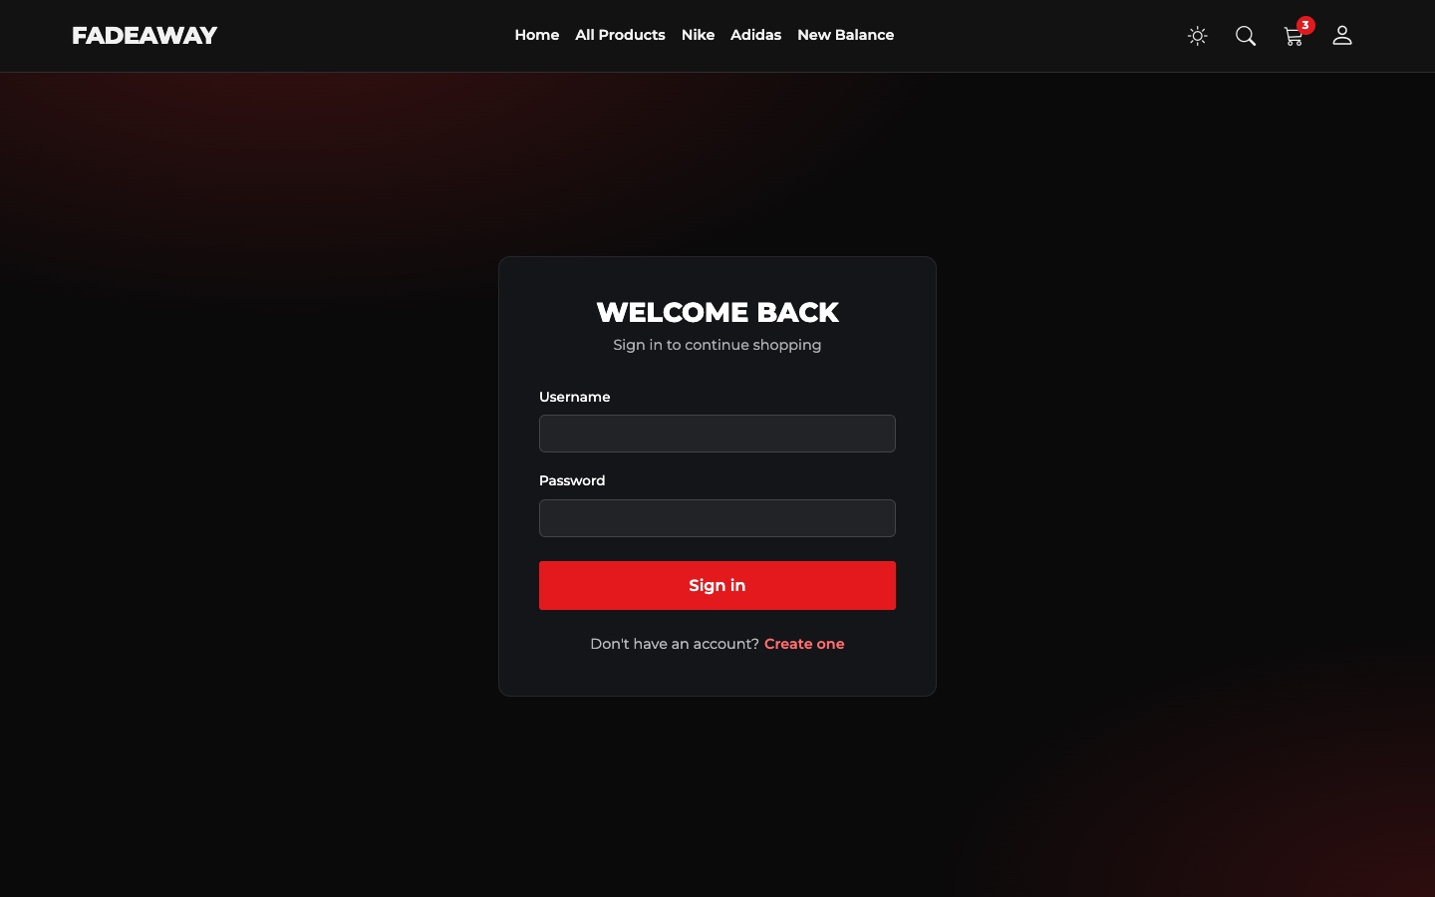
Figure 30 — Cart (left) and Login (right) in the dark mode
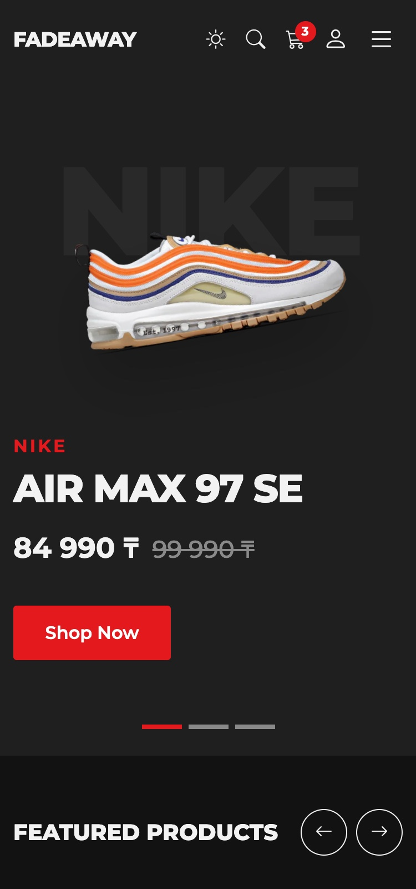 | 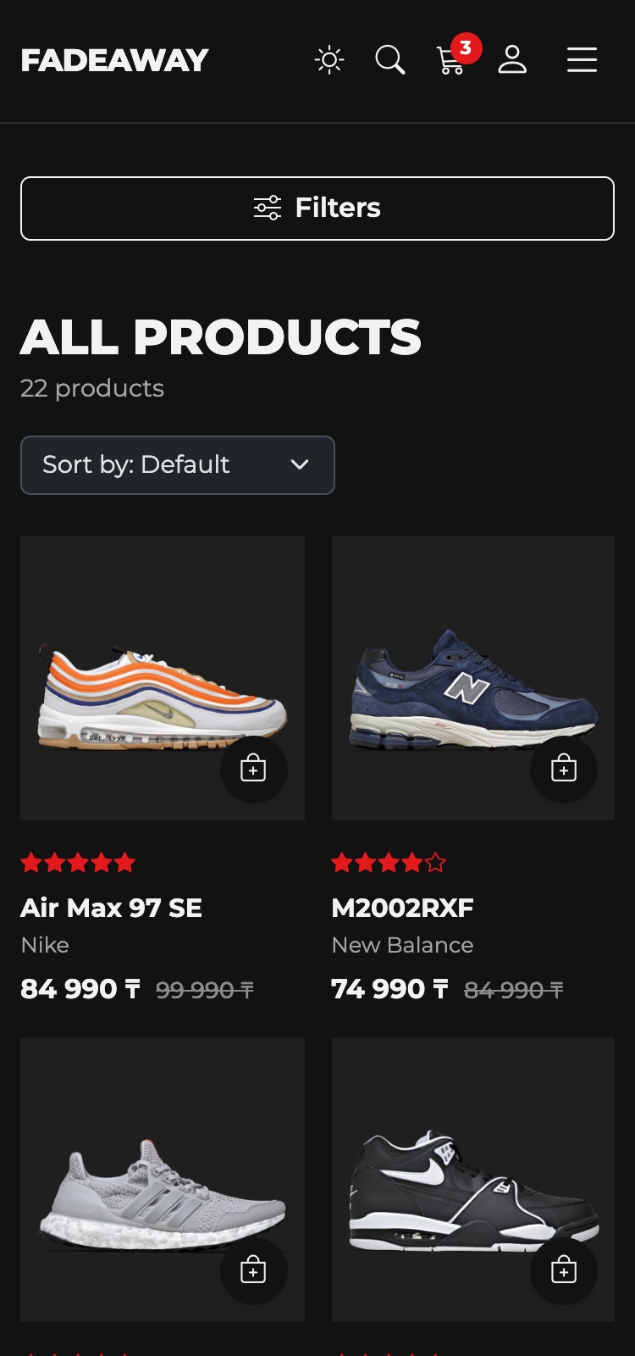
Figure 31 — The dark mode on a phone

Notification / Toast System
One function shows all notifications. The type sets the colour and the icon, and the link to the cart is shown only when it is useful. The text is set with .text().
js/main.js
const TOAST_ICONS = {
success: 'bi-check-circle-fill',
info: 'bi-info-circle-fill',
error: 'bi-exclamation-circle-fill'
};

function showToast(text, type, showCartLink) {
$('#siteToast').removeClass('toast-success toast-info toast-error').addClass('toast-' + type);
$('#toastIcon').attr('class', 'bi ' + TOAST_ICONS[type]);
$('#toastText').text(text);
$('#toastLink').toggle(showCartLink === true);
bootstrap.Toast.getOrCreateInstance(document.getElementById('siteToast')).show();
}
Type | When it appears | Example
Success | A new product is added to the cart | Air Max 97 SE added to cart
Info | The quantity grows, the theme changes | Air Max 97 SE: now 2 in your cart
Error | A form has mistakes | Please check the fields marked in red.

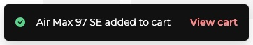
Figure 32 — Success notification
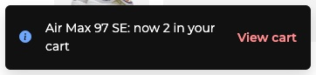
Figure 33 — Info notification

Figure 34 — Error notification

Back to Top Button
The button appears with .fadeIn() after 500 pixels of scrolling and brings the page up with .animate().
js/main.js
$(window).on('scroll', function () {
const scrolled = $(window).scrollTop();
$('#header').toggleClass('scrolled', scrolled > 50);

if (scrolled > 500) {
$('#backTop').fadeIn(200);
} else {
$('#backTop').fadeOut(200);
}
}).trigger('scroll');

$('#backTop').click(function () {
$('html, body').animate({ scrollTop: 0 }, 400);
});
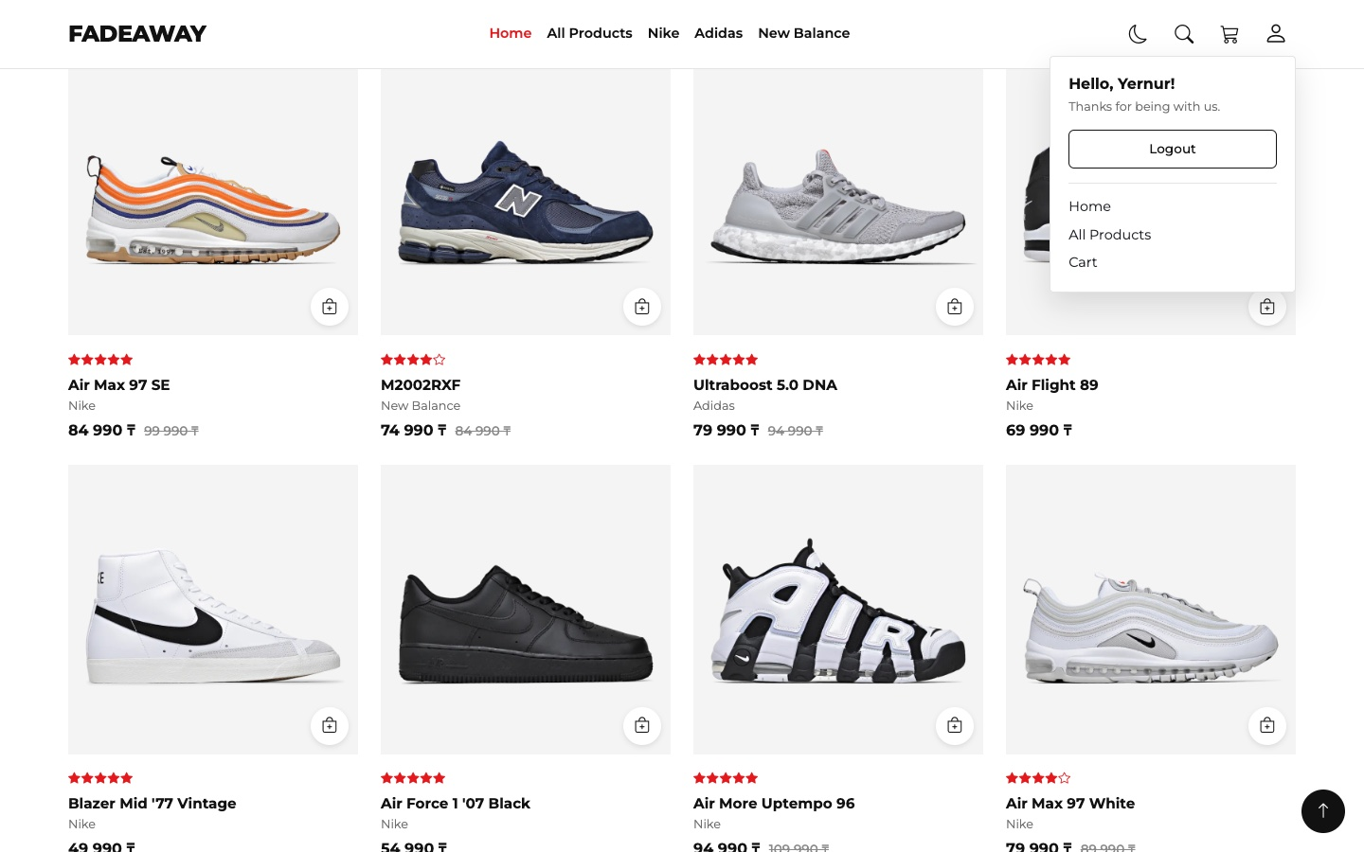
Figure 35 — The Back to top button at the bottom right after scrolling

Summary of my work process
This is what I did step by step:
- Plan. I looked at the React version and chose five pages: Home, All Products, Product, Cart and Login.
- Data and photos. I moved the products to one JavaScript array, fixed the data and made the photos smaller.
- Design. I took the colours, the font and the look of the old site and wrote them again in css/style.css, with the Bootstrap grid and navbar for the layout.
- Pages and logic. I made the shared header and footer, then each page with its own JavaScript file: filters, search, cart, validation and jQuery effects.
- Final improvements. I added the dark mode, three kinds of notifications, accessibility features and the shared checkField() function.
- Testing. I checked every page from 320px to 1440px, with the keyboard and in both themes. The browser console has no errors.

Things that needed attention:
- Mistakes in the old data. One product had photos of another sneaker, two products had broken photo links, and the category filter never worked, because the names in the data and in the menu were different. I fixed this. Most prices were placeholders, so the prices and descriptions here are examples.
- Heavy photos. The photos took 64 MB. Now they take 3.6 MB.
- Libraries from a CDN. During testing jQuery once did not load from the CDN, and the page stayed empty. I moved all libraries to the lib folder.
- White flash in the dark mode. The page was white for a moment before it became dark. The short script in <head> fixed it.
- Invisible button in the dark mode. The Bootstrap class btn-outline-dark draws a black border, which is not visible on a dark background. I made my own class .btn-line that uses the theme colours.
- Header on small phones. After adding the theme button, the menu button moved to a second line. I made the icons smaller on phones.
- Hidden keyboard focus. The menu button had no outline when it was used with the keyboard. Now every button shows a red outline.
- Link in the footer. “Create account” did nothing when the customer was already on the Login page, because the page does not reload when only the part after # changes. I added a hashchange event.

I did not move everything from the React version. The Django server, real accounts, the orders page and the reviews are not here, because they need a server or real data.
In this project I learned how to connect everything from the course in one real site. The main thing I understood is to keep the data in one place and build the page from it. For the final I also learned that a good site is not only about how it looks: it must work with the keyboard and a screen reader, in both themes and on very small screens. Most of my mistakes were found only when I tested in a real browser.

