1)

namespace WinFormsApp7

{

public partial class Form1 : Form

{

public Form1()

{

InitializeComponent();

}

private void PerformOperation(Func<double, double, double> operation)

{

if (double.TryParse(textBox1.Text, out double num1) &&

double.TryParse(textBox2.Text, out double num2))

{

double result = operation(num1, num2);

label1.Text = $"Результат: {result}";

}

else

{

MessageBox.Show("введите корректные числа.");

}

}

private void button1_Click_1(object sender, EventArgs e)

{

PerformOperation((a, b) => a + b);

}

private void button2_Click(object sender, EventArgs e)

{

PerformOperation((a, b) => a - b);

}

private void button4_Click(object sender, EventArgs e)

{

PerformOperation((a, b) => a * b);

}

private void button3_Click(object sender, EventArgs e)

{

PerformOperation((a, b) =>

{

if (b == 0)

{

MessageBox.Show("на ноль не делится.");

return 0;

}

return a / b;

});

}

}

}

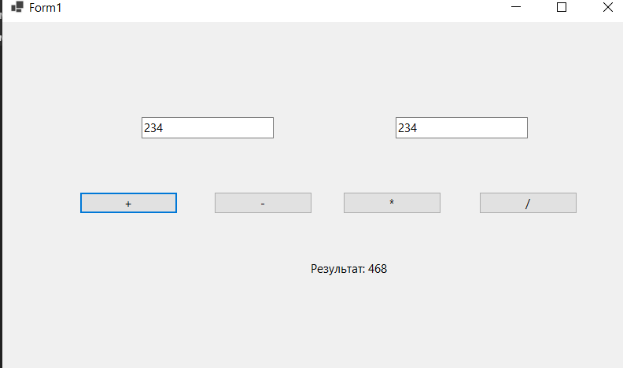

2)

using System;

using System.Windows.Forms;

namespace WinFormsApp8

{

public partial class Form1 : Form

{

public Form1()

{

InitializeComponent();

comboBox1.Items.Add("цельсий в фаренгейт");

comboBox1.Items.Add("фаренгейт в цельсий");

comboBox1.SelectedIndex = 0;

button1.Click += new EventHandler(button1_Click);

}

private void button1_Click(object sender, EventArgs e)

{

double temperature;

if (double.TryParse(textBox1.Text, out temperature))

{

if (comboBox1.SelectedIndex == 0)

{

double fahrenheit = CelsiusToFahrenheit(temperature);

label1.Text = $"{fahrenheit:F2} °F";

}

else

{

double celsius = FahrenheitToCelsius(temperature);

label1.Text = $"{celsius:F2} °C";

}

}

else

{

MessageBox.Show("введите корректное значение температуры.");

}

}

private double CelsiusToFahrenheit(double celsius)

{

return (celsius * 9 / 5) + 32;

}

private double FahrenheitToCelsius(double fahrenheit)

{

return (fahrenheit - 32) * 5 / 9;

}

}

}

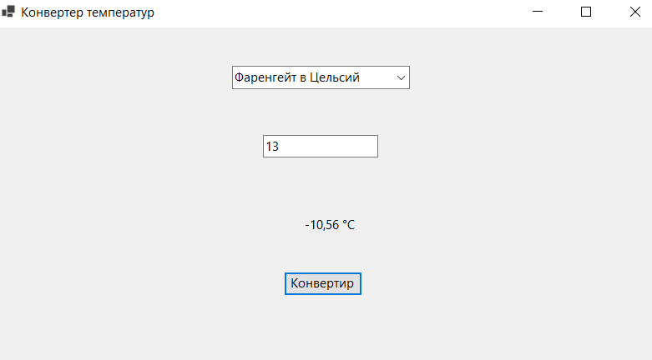

3)

using System;

using System.Windows.Forms;

namespace WinFormsApp6

{

public partial class Form1 : Form

{

private Random random;

public Form1()

{

InitializeComponent();

random = new Random();

}

private void buttonGenerate_Click(object sender, EventArgs e)

{

int randomNumber = random.Next();

labelResult.Text = $"случайное число: {randomNumber}";

}

}

}

