IAN NASTAJUS  3D SCIENTIFIC VISUALIZATION | TECHNICAL ILLUSTRATION | BLENDER | Downtown Toronto, Ontario  [ian.nastajus@gmail.com] | [416.929.2648]  [ linkedin.com/in/nastajus ]

PROFILE
Technical 3D visualizer with a computer-science foundation and Blender experience translating complex scientific and engineering concepts into clear, publication-oriented imagery. Contributed 3D scientific visualizations to two peer-reviewed 2026 journal publications. Strongest in structured hard-surface modeling, repeated/layered geometry, materials and lighting, camera composition, and iterative visual problem-solving.

SELECTED 3D / SCIENTIFIC VISUALIZATION ACCOMPLISHMENTS
- Created the central Blender-based plasmonic metamaterial thermal-emitter model and integrated it into a completed scientific graphic published in Frontiers of Optoelectronics (2026), combining 3D structure, spectral plots, measurement-plane annotations and visual effects.
- Created 3D scientific renderings for a ⟨⟨Cu/TiO2 metasurface⟩⟩ absorber and fabrication-process visualization published in Advanced Optical Materials (2026), depicting layered materials, periodic meta-atoms and sequential fabrication stages.
- Built repeated nanoscale-style geometry using arrays, bevels, linked materials/meshes, precise placement, scene scaling, camera framing and HD render setup.
- Created optical-wave / beam visualization studies using curves, emissive materials, transparency, lighting, camera controls and spatial composition.
- Produced material and colour studies for metasurface stacks and nanopillar/nanopost variants using Principled BSDF, metallic/roughness contrast and controlled multi-light setups.
- Worked iteratively from incomplete scientific references and researcher feedback, translating unfamiliar concepts into readable visual components while preserving a clear boundary between visualization work and scientific authorship.

CORE SKILLS
BLENDER / 3D  - Hard-surface & schematic modeling  - Arrays, booleans, bevels, extrusion, curves  - Modifiers, snapping, hierarchy & linked data  - Principled materials; metallic / roughness / emission  - Lighting, shadows, camera framing & render setup | VISUAL / TECHNICAL COMMUNICATION  - Scientific & technical schematics  - Metasurface / nanoscale conceptual structures  - Process and fabrication visualization  - Colour, material & visual-hierarchy iteration  - Figure composition & stakeholder iteration

TECHNICAL FOUNDATION
B.Sc. Computer Science, Toronto Metropolitan University (Ryerson), 2014
Earlier analyst-programming, software-development and game-development experience; familiarity with Unity and technical production workflows.
SELECTED 3D PORTFOLIO
Two published scientific-visualization contributions followed by two supporting Blender studies.
01 › PUBLISHED: METAMATERIAL THERMAL EMITTER  Created the central Blender thermal-emitter model and integrated it with provided MATLAB plots, observation planes, labels and visual effects in PowerPoint for the final published figure.  PEER-REVIEWED JOURNAL ARTICLE  Frontiers of Optoelectronics (2026)  https://journal.hep.com.cn/foe/EN/10.2738/foe.2026.0032  Demonstrates: scientific 3D illustration · metasurface modeling · figure composition · materials & lighting · 2D/3D integration | 02 › PUBLISHED: Cu/TiO₂ METASURFACE ABSORBER  Created the individual Blender renders depicting stages of Cu/TiO₂ metasurface fabrication, including substrate layers, thin-film deposition, resist layers and patterned structures.  PEER-REVIEWED JOURNAL ARTICLE  Advanced Optical Materials (2026)  https://advanced.onlinelibrary.wiley.com/doi/full/10.1002/adom.71514  Demonstrates: arrays · hard-surface modeling · layered geometry · material assignment · transparency
  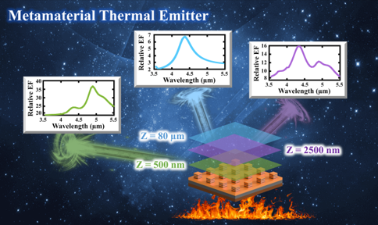
  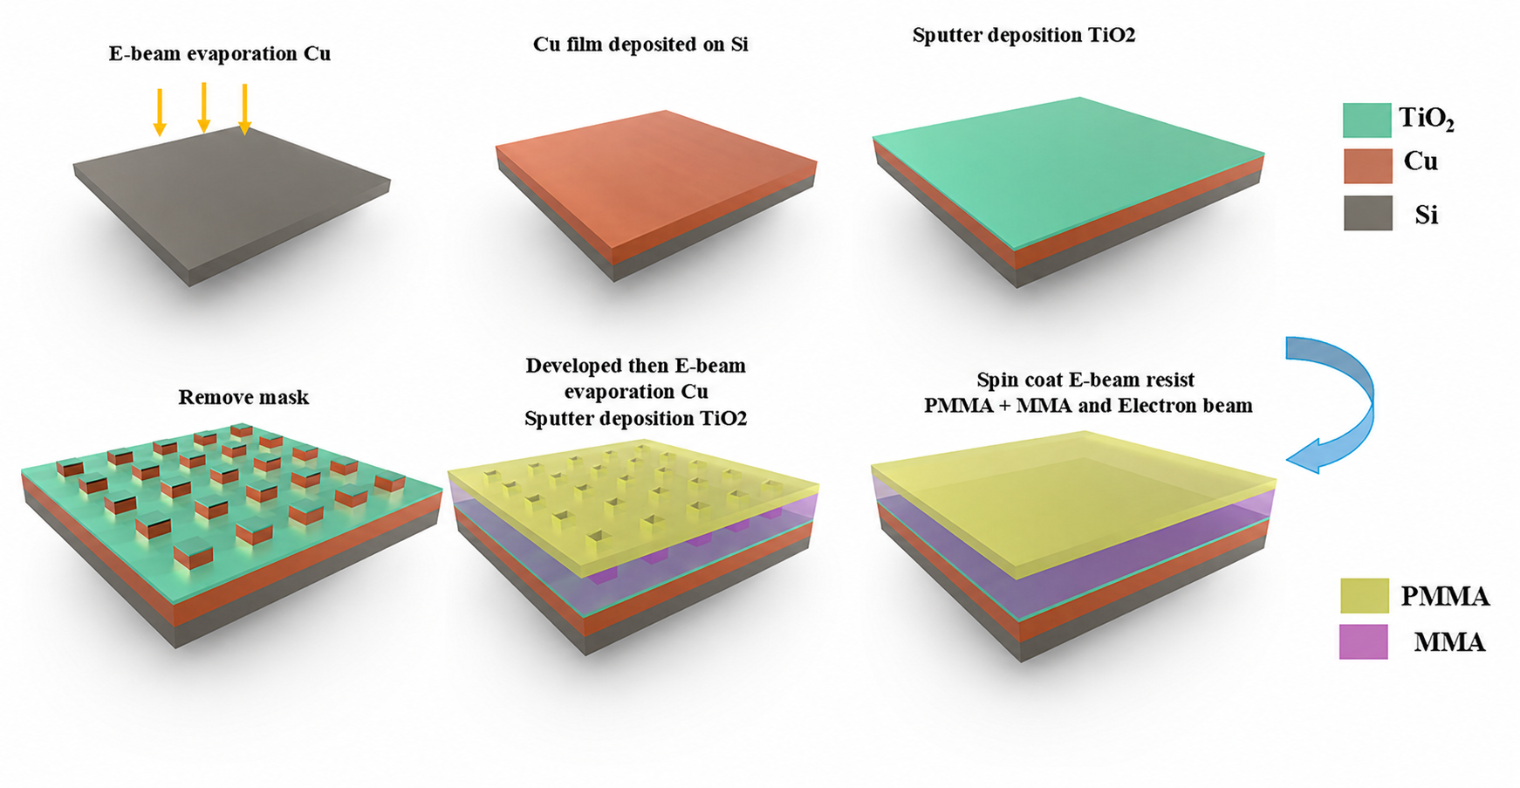
03 › OPTICAL WAVE / BEAM STUDY  Blender study of emissive optical-wave paths interacting with a transparent volume, combining glow, transmission, lighting and compositing for spatial readability.  SUPPORTING BLENDER PORTFOLIO STUDY  Optical / emissive-material visualization  Demonstrates: curves · emission · transparency · multi-light balancing · render compositing · camera composition | 04 › LABELED METASURFACE STACK  Clean technical render of a Cu/TiO2 metasurface stack, emphasizing periodic geometry, reflective material response, controlled illumination and isolated light influence.  SUPPORTING BLENDER PORTFOLIO STUDY  Technical metasurface rendering study  Demonstrates: arrays · layered geometry · reflectivity · material tuning · light linking / isolation
  