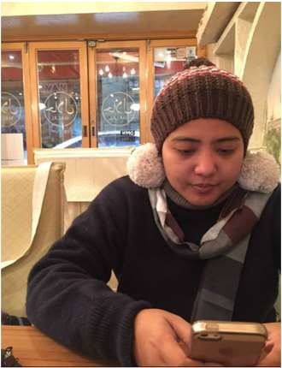
DR MUHAMAD YUSUF BIN ISHAK
MB BCh BAO

PERSONAL PARTICULARS
IC NO :
EMAIL : my_is@yahoo.com
MOBILE NO : 010-10000001

ADDRESS : A12, Jalan SS1E/31F Kampung Tunku
47300 Petaling Jaya

EDUCATIONAL BACKGROUND

Sekolah Sultan Alam Shah, Putrajaya (2003 – 2007)

International Baccalaureate, Mara College Banting
(2008 – 2010)

MB BCh BAO, Penang
Medical College
(2010 – 2015)

ACADEMIC AWARD

Outstanding Japanese
Student Award 2006

Special Prize in Japanese Speech Contest National Level 2006
Japanese Language
Proficiency Test level N4

HOBBIES/INTERESTS

• Playing sport
• Travelling
• Organizing event
• Volunteering work

LANGUAGES

• MALAY

• ENGLISH

PROFESSIONAL EXPERIENCE

SELAYANG HOSPITAL RADIOLOGY DEPARTMENT
March 2018 – present
Position title : Medical Officer
Work Description:
• Providing high quality diagnostic and interventional services.
• Working as a team towards providing highest quality of care for our patients.
• Continuously updating knowledge to provide best radiological management for our patients.
• Assisting Interventional Radiologist in performing procedures i.e. angiography, angioplasty, embolization and image guided biopsies.

QUEEN ELIZABETH HOSPITAL
December 2015 – March 2018
Position title: House Officer
Work Description:
• Diagnosing patient through observation, patient concerns and examination.
• Conferring with attending physicians in order to provide expert care.
• Shadowing attending physicians for thorough training.

COMMUNICATION AND INTERPERSONAL SKILLS
• Communicates effectively with employee at all levels of the organization and comfortable in handling external relations at all levels.
• Good communication, written and presentation skills.
• Honest and responsible.
• Strong team player.
• Able to adapt with changes in the working environment.
• Positively energetic and self-motivated to seize new opportunities.
• Able to establish priorities and to plan, coordinate and monitor work against plans.

RECENTLY ATTENDED CONFERENCES/WORKSHOPS/COURSES

• Selangor Breast Imaging Updates 19th October 2019, Shah Alam Hospital.
• Current Treatment In Men’s Health: Prostate Artery Embolization Workshop 31st July – 2nd
Aug 2019, National Cancer Institute, Putrajaya.
• Kursus Motivasi, Kepimpinan & Integriti Untuk Wargakerja Radiologi 20th July 2019, Forest
Research Institute Malaysia (FRIM).
• Good Clinical Practice 24th – 26th April 2019, Crystal Crown Hotel Kuala Lumpur.
• Basic Image-Guided Interventional Radiology Workshop 16th – 17th Nov 2018, Selayang
Hospital.

COMMUNITY INVOLVEMENT

• Treasurer for ‘Kejohanan Futsal Radiologi Kebangsaan’ by Selayang Hospital Radiology
Department.
• Treasurer for ‘Kelab Kebajikan Jabatan Radiologi Hospital Selayang’.
• Committee member of Selayang Hospital Radiology Department MSQH team.
• Organizing committee for ‘Kursus Motivasi, Kepimpinan & Integriti Untuk Anggota Radiology
Peringkat Negeri Selangor’ by Selayang Hospital Radiology Department.
• Participant for ‘IR Run 2019’ by Universiti Kebangsaan Malaysia Medical Centre Radiology
Department.
• Participant for ‘Kejohanan Futsal Radiologi Kebangsaan’ by Sultanah Aminah Hospital, Johor.

