початковий запит:
SELECT
account_session.operating_system,
COUNT(DISTINCT id_message_sent) AS sent_msg,
COUNT(DISTINCT id_message_open) AS open_msg,
COUNT(DISTINCT id_message_visit) AS vist_msg,
COUNT(DISTINCT id_message_open) / COUNT(DISTINCT id_message_sent) * 100 AS open_rate,
COUNT(DISTINCT id_message_visit) / COUNT(DISTINCT id_message_sent) * 100 AS click_rate,
COUNT(DISTINCT id_message_visit) / COUNT(DISTINCT id_message_open) * 100 AS ctor,
FROM
`DA.account` a
JOIN (
SELECT
es.id_account AS id_account_sent,
es.id_message AS id_message_sent,
es.letter_type AS letter_type_sent,
es.sent_date,
eo.id_account AS id_account_open,
eo.id_message AS id_message_open,
eo.letter_type AS letter_type_open,
eo.open_date,
ev.id_account AS id_account_visit,
ev.id_message AS id_message_visit,
ev.letter_type AS letter_type_visit,
ev.visit_date,
FROM
`DA.email_sent` es
LEFT JOIN (
SELECT
*
FROM
`DA.email_open` eo )eo
ON
es.id_message = eo.id_message
LEFT JOIN (
SELECT
*
FROM
`DA.email_visit` ev )ev
ON
es.id_message = ev.id_message ) email_sent
ON
a.id = email_sent.id_account_sent
JOIN (
SELECT
acs.account_id,
acs.ga_session_id,
sp.continent,
sp.device,
sp.country,
sp.channel,
sp.language,
sp.mobile_model_name,
sp.operating_system
FROM
`DA.account_session` acs
JOIN
`DA.session_params` sp
ON
acs.ga_session_id = sp.ga_session_id )account_session
ON
a.id = account_session.account_id
WHERE
a.is_unsubscribed = 0
GROUP BY
account_session.operating_system

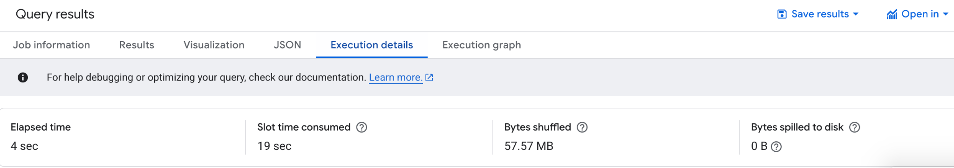

оптимізований запит:
WITH email_data AS (
SELECT
es.id_account,
es.id_message AS id_message_sent,
eo.id_message AS id_message_open,
ev.id_message AS id_message_visit
FROM `DA.email_sent` es
LEFT JOIN `DA.email_open` eo
ON es.id_message = eo.id_message
LEFT JOIN `DA.email_visit` ev
ON es.id_message = ev.id_message
),
session_data AS (
SELECT
acs.account_id,
sp.operating_system
FROM `DA.account_session` acs
JOIN `DA.session_params` sp
ON acs.ga_session_id = sp.ga_session_id
)
SELECT
sd.operating_system,
COUNT(DISTINCT ed.id_message_sent) AS sent_msg,
COUNT(DISTINCT ed.id_message_open) AS open_msg,
COUNT(DISTINCT ed.id_message_visit) AS visit_msg,
SAFE_DIVIDE(COUNT(DISTINCT ed.id_message_open), COUNT(DISTINCT ed.id_message_sent)) * 100 AS open_rate,
SAFE_DIVIDE(COUNT(DISTINCT ed.id_message_visit), COUNT(DISTINCT ed.id_message_sent)) * 100 AS click_rate,
SAFE_DIVIDE(COUNT(DISTINCT ed.id_message_visit), COUNT(DISTINCT ed.id_message_open)) * 100 AS ctor
FROM `DA.account` a
JOIN email_data ed
ON a.id = ed.id_account
JOIN session_data sd
ON a.id = sd.account_id
WHERE a.is_unsubscribed = 0
GROUP BY sd.operating_system;

