Отчет к лабораторной работе №2

Бруцкая Анастасия Сергеевна 251001

Вариант:1

Длинна:23

*P*(*x*) = *x*23 +*x*5 + 1

|  |  |  |  |  |  |  |  |  |  |  |  |  |  |  |  |  |  |  |  |  |  |  |  |  |  |
| --- | --- | --- | --- | --- | --- | --- | --- | --- | --- | --- | --- | --- | --- | --- | --- | --- | --- | --- | --- | --- | --- | --- | --- | --- | --- |
|  |  |  |  |  |  |  |  |  |  |  |  |  |  |  |  |  |  |  |  |  |  |  |  |  | xor |
|  |  | 23 | 22 | 21 | 20 | 19 | 18 | 17 | 16 | 15 | 14 | 13 | 12 | 11 | 10 | 9 | 8 | 7 | 6 | 5 | 4 | 3 | 2 | 1 |  |
| Шаги / Состояние регистра | 1 | 1 | 1 | 1 | 1 | 1 | 1 | 1 | 1 | 1 | 1 | 1 | 1 | 1 | 1 | 1 | 1 | 1 | 1 | 1 | 1 | 1 | 1 | 1 | 0 |
| 2 | 1 | 1 | 1 | 1 | 1 | 1 | 1 | 1 | 1 | 1 | 1 | 1 | 1 | 1 | 1 | 1 | 1 | 1 | 1 | 1 | 1 | 1 | 0 | 0 |
| 3 | 1 | 1 | 1 | 1 | 1 | 1 | 1 | 1 | 1 | 1 | 1 | 1 | 1 | 1 | 1 | 1 | 1 | 1 | 1 | 1 | 1 | 0 | 0 | 0 |
| 4 | 1 | 1 | 1 | 1 | 1 | 1 | 1 | 1 | 1 | 1 | 1 | 1 | 1 | 1 | 1 | 1 | 1 | 1 | 1 | 1 | 0 | 0 | 0 | 0 |
| 5 | 1 | 1 | 1 | 1 | 1 | 1 | 1 | 1 | 1 | 1 | 1 | 1 | 1 | 1 | 1 | 1 | 1 | 1 | 1 | 0 | 0 | 0 | 0 | 0 |
| 6 | 1 | 1 | 1 | 1 | 1 | 1 | 1 | 1 | 1 | 1 | 1 | 1 | 1 | 1 | 1 | 1 | 1 | 1 | 0 | 0 | 0 | 0 | 0 | 1 |
| 7 | 1 | 1 | 1 | 1 | 1 | 1 | 1 | 1 | 1 | 1 | 1 | 1 | 1 | 1 | 1 | 1 | 1 | 0 | 0 | 0 | 0 | 0 | 1 | 1 |
| 8 | 1 | 1 | 1 | 1 | 1 | 1 | 1 | 1 | 1 | 1 | 1 | 1 | 1 | 1 | 1 | 1 | 0 | 0 | 0 | 0 | 0 | 1 | 1 | 1 |
| 9 | 1 | 1 | 1 | 1 | 1 | 1 | 1 | 1 | 1 | 1 | 1 | 1 | 1 | 1 | 1 | 0 | 0 | 0 | 0 | 0 | 1 | 1 | 1 | 1 |
| 10 | 1 | 1 | 1 | 1 | 1 | 1 | 1 | 1 | 1 | 1 | 1 | 1 | 1 | 1 | 0 | 0 | 0 | 0 | 0 | 1 | 1 | 1 | 1 | 1 |
| 11 | 1 | 1 | 1 | 1 | 1 | 1 | 1 | 1 | 1 | 1 | 1 | 1 | 1 | 0 | 0 | 0 | 0 | 0 | 1 | 1 | 1 | 1 | 1 | 0 |
| 12 | 1 | 1 | 1 | 1 | 1 | 1 | 1 | 1 | 1 | 1 | 1 | 1 | 0 | 0 | 0 | 0 | 0 | 1 | 1 | 1 | 1 | 1 | 0 | 0 |
| 13 | 1 | 1 | 1 | 1 | 1 | 1 | 1 | 1 | 1 | 1 | 1 | 0 | 0 | 0 | 0 | 0 | 1 | 1 | 1 | 1 | 1 | 0 | 0 | 0 |
| 14 | 1 | 1 | 1 | 1 | 1 | 1 | 1 | 1 | 1 | 1 | 0 | 0 | 0 | 0 | 0 | 1 | 1 | 1 | 1 | 1 | 0 | 0 | 0 | 0 |
| 15 | 1 | 1 | 1 | 1 | 1 | 1 | 1 | 1 | 1 | 0 | 0 | 0 | 0 | 0 | 1 | 1 | 1 | 1 | 1 | 0 | 0 | 0 | 0 | 0 |
| 16 | 1 | 1 | 1 | 1 | 1 | 1 | 1 | 1 | 0 | 0 | 0 | 0 | 0 | 1 | 1 | 1 | 1 | 1 | 0 | 0 | 0 | 0 | 0 | 1 |
| 17 | 1 | 1 | 1 | 1 | 1 | 1 | 1 | 0 | 0 | 0 | 0 | 0 | 1 | 1 | 1 | 1 | 1 | 0 | 0 | 0 | 0 | 0 | 1 | 1 |
| 18 | 1 | 1 | 1 | 1 | 1 | 1 | 0 | 0 | 0 | 0 | 0 | 1 | 1 | 1 | 1 | 1 | 0 | 0 | 0 | 0 | 0 | 1 | 1 | 1 |
| 19 | 1 | 1 | 1 | 1 | 1 | 0 | 0 | 0 | 0 | 0 | 1 | 1 | 1 | 1 | 1 | 0 | 0 | 0 | 0 | 0 | 1 | 1 | 1 | 1 |
| 20 | 1 | 1 | 1 | 1 | 0 | 0 | 0 | 0 | 0 | 1 | 1 | 1 | 1 | 1 | 0 | 0 | 0 | 0 | 0 | 1 | 1 | 1 | 1 | 1 |
| 21 | 1 | 1 | 1 | 0 | 0 | 0 | 0 | 0 | 1 | 1 | 1 | 1 | 1 | 0 | 0 | 0 | 0 | 0 | 1 | 1 | 1 | 1 | 1 | 0 |
| 22 | 1 | 1 | 0 | 0 | 0 | 0 | 0 | 1 | 1 | 1 | 1 | 1 | 0 | 0 | 0 | 0 | 0 | 1 | 1 | 1 | 1 | 1 | 0 | 0 |
| 23 | 1 | 0 | 0 | 0 | 0 | 0 | 1 | 1 | 1 | 1 | 1 | 0 | 0 | 0 | 0 | 0 | 1 | 1 | 1 | 1 | 1 | 0 | 0 | 0 |
| 24 | 0 | 0 | 0 | 0 | 0 | 1 | 1 | 1 | 1 | 1 | 0 | 0 | 0 | 0 | 0 | 1 | 1 | 1 | 1 | 1 | 0 | 0 | 0 | 1 |
| 25 | 0 | 0 | 0 | 0 | 1 | 1 | 1 | 1 | 1 | 0 | 0 | 0 | 0 | 0 | 1 | 1 | 1 | 1 | 1 | 0 | 0 | 0 | 1 | 1 |
| 26 | 0 | 0 | 0 | 1 | 1 | 1 | 1 | 1 | 0 | 0 | 0 | 0 | 0 | 1 | 1 | 1 | 1 | 1 | 0 | 0 | 0 | 1 | 1 | 0 |
| 27 | 0 | 0 | 1 | 1 | 1 | 1 | 1 | 0 | 0 | 0 | 0 | 0 | 1 | 1 | 1 | 1 | 1 | 0 | 0 | 0 | 1 | 1 | 0 | 0 |
| 28 | 0 | 1 | 1 | 1 | 1 | 1 | 0 | 0 | 0 | 0 | 0 | 1 | 1 | 1 | 1 | 1 | 0 | 0 | 0 | 1 | 1 | 0 | 0 | 0 |
| 29 | 1 | 1 | 1 | 1 | 1 | 0 | 0 | 0 | 0 | 0 | 1 | 1 | 1 | 1 | 1 | 0 | 0 | 0 | 1 | 1 | 0 | 0 | 0 | 0 |
| 30 | 1 | 1 | 1 | 1 | 0 | 0 | 0 | 0 | 0 | 1 | 1 | 1 | 1 | 1 | 0 | 0 | 0 | 1 | 1 | 0 | 0 | 0 | 0 | 0 |
| 31 | 1 | 1 | 1 | 0 | 0 | 0 | 0 | 0 | 1 | 1 | 1 | 1 | 1 | 0 | 0 | 0 | 1 | 1 | 0 | 0 | 0 | 0 | 0 | 1 |
| 32 | 1 | 1 | 0 | 0 | 0 | 0 | 0 | 1 | 1 | 1 | 1 | 1 | 0 | 0 | 0 | 1 | 1 | 0 | 0 | 0 | 0 | 0 | 1 | 1 |
| 33 | 1 | 0 | 0 | 0 | 0 | 0 | 1 | 1 | 1 | 1 | 1 | 0 | 0 | 0 | 1 | 1 | 0 | 0 | 0 | 0 | 0 | 1 | 1 | 1 |
| 34 | 0 | 0 | 0 | 0 | 0 | 1 | 1 | 1 | 1 | 1 | 0 | 0 | 0 | 1 | 1 | 0 | 0 | 0 | 0 | 0 | 1 | 1 | 1 | 0 |
| 35 | 0 | 0 | 0 | 0 | 1 | 1 | 1 | 1 | 1 | 0 | 0 | 0 | 1 | 1 | 0 | 0 | 0 | 0 | 0 | 1 | 1 | 1 | 0 | 0 |
| 36 | 0 | 0 | 0 | 1 | 1 | 1 | 1 | 1 | 0 | 0 | 0 | 1 | 1 | 0 | 0 | 0 | 0 | 0 | 1 | 1 | 1 | 0 | 0 | 1 |
| 37 | 0 | 0 | 1 | 1 | 1 | 1 | 1 | 0 | 0 | 0 | 1 | 1 | 0 | 0 | 0 | 0 | 0 | 1 | 1 | 1 | 0 | 0 | 1 | 1 |
| 38 | 0 | 1 | 1 | 1 | 1 | 1 | 0 | 0 | 0 | 1 | 1 | 0 | 0 | 0 | 0 | 0 | 1 | 1 | 1 | 0 | 0 | 1 | 1 | 1 |
| 39 | 1 | 1 | 1 | 1 | 1 | 0 | 0 | 0 | 1 | 1 | 0 | 0 | 0 | 0 | 0 | 1 | 1 | 1 | 0 | 0 | 1 | 1 | 1 | 1 |
| 40 | 1 | 1 | 1 | 1 | 0 | 0 | 0 | 1 | 1 | 0 | 0 | 0 | 0 | 0 | 1 | 1 | 1 | 0 | 0 | 1 | 1 | 1 | 1 | 1 |
| 41 | 1 | 1 | 1 | 0 | 0 | 0 | 1 | 1 | 0 | 0 | 0 | 0 | 0 | 1 | 1 | 1 | 0 | 0 | 1 | 1 | 1 | 1 | 1 | 0 |
| 42 | 1 | 1 | 0 | 0 | 0 | 1 | 1 | 0 | 0 | 0 | 0 | 0 | 1 | 1 | 1 | 0 | 0 | 1 | 1 | 1 | 1 | 1 | 0 | 0 |
| 43 | 1 | 0 | 0 | 0 | 1 | 1 | 0 | 0 | 0 | 0 | 0 | 1 | 1 | 1 | 0 | 0 | 1 | 1 | 1 | 1 | 1 | 0 | 0 | 0 |
| 44 | 0 | 0 | 0 | 1 | 1 | 0 | 0 | 0 | 0 | 0 | 1 | 1 | 1 | 0 | 0 | 1 | 1 | 1 | 1 | 1 | 0 | 0 | 0 | 1 |
| 45 | 0 | 0 | 1 | 1 | 0 | 0 | 0 | 0 | 0 | 1 | 1 | 1 | 0 | 0 | 1 | 1 | 1 | 1 | 1 | 0 | 0 | 0 | 1 | 1 |
| 46 | 0 | 1 | 1 | 0 | 0 | 0 | 0 | 0 | 1 | 1 | 1 | 0 | 0 | 1 | 1 | 1 | 1 | 1 | 0 | 0 | 0 | 1 | 1 | 0 |
| 47 | 1 | 1 | 0 | 0 | 0 | 0 | 0 | 1 | 1 | 1 | 0 | 0 | 1 | 1 | 1 | 1 | 1 | 0 | 0 | 0 | 1 | 1 | 0 | 1 |
| 48 | 1 | 0 | 0 | 0 | 0 | 0 | 1 | 1 | 1 | 0 | 0 | 1 | 1 | 1 | 1 | 1 | 0 | 0 | 0 | 1 | 1 | 0 | 1 | 1 |
| 49 | 0 | 0 | 0 | 0 | 0 | 1 | 1 | 1 | 0 | 0 | 1 | 1 | 1 | 1 | 1 | 0 | 0 | 0 | 1 | 1 | 0 | 1 | 1 | 1 |
| 50 | 0 | 0 | 0 | 0 | 1 | 1 | 1 | 0 | 0 | 1 | 1 | 1 | 1 | 1 | 0 | 0 | 0 | 1 | 1 | 0 | 1 | 1 | 1 | 1 |
| 51 | 0 | 0 | 0 | 1 | 1 | 1 | 0 | 0 | 1 | 1 | 1 | 1 | 1 | 0 | 0 | 0 | 1 | 1 | 0 | 1 | 1 | 1 | 1 | 0 |
| 52 | 0 | 0 | 1 | 1 | 1 | 0 | 0 | 1 | 1 | 1 | 1 | 1 | 0 | 0 | 0 | 1 | 1 | 0 | 1 | 1 | 1 | 1 | 0 | 1 |
| 53 | 0 | 1 | 1 | 1 | 0 | 0 | 1 | 1 | 1 | 1 | 1 | 0 | 0 | 0 | 1 | 1 | 0 | 1 | 1 | 1 | 1 | 0 | 1 | 1 |
| 54 | 1 | 1 | 1 | 0 | 0 | 1 | 1 | 1 | 1 | 1 | 0 | 0 | 0 | 1 | 1 | 0 | 1 | 1 | 1 | 1 | 0 | 1 | 1 | 0 |
| 55 | 1 | 1 | 0 | 0 | 1 | 1 | 1 | 1 | 1 | 0 | 0 | 0 | 1 | 1 | 0 | 1 | 1 | 1 | 1 | 0 | 1 | 1 | 0 | 0 |
| 56 | 1 | 0 | 0 | 1 | 1 | 1 | 1 | 1 | 0 | 0 | 0 | 1 | 1 | 0 | 1 | 1 | 1 | 1 | 0 | 1 | 1 | 0 | 0 | 1 |

Проверка работоспособности программы, на текстовых данных

Вводный текст:

"В тихом уголке старого парка стояла старая скамейка. На ней любили сидеть влюбленные пары, делясь своими мечтами и надеждами. Вечером под старыми деревьями можно было услышать шепот листьев и пение птиц. Это было место, где время казалось замирало, погружая вас в мир спокойствия и гармонии."

"In a quiet corner of the old park stood an old bench. It was a favorite spot for lovers to sit, sharing their dreams and hopes. In the evening, beneath the old trees, you could hear the whisper of leaves and the chirping of birds. It was a place where time seemed to stand still, immersing you in a world of peace and harmony."

Зашифрованный текст:

t…№УвK{†±С

®шOќm„‘АB¬¤;х}й2“=нЦe7†­ЇДдZИѕЩиH°>тЮ!Xз~У†ѕ;IќYЕ1ќґ\МЄє€ЏҐыS…p”=]aHЉ…'ґЄЏ3WцE„Se»

ђe•Лла

Опл‡‘чГvы‹#©Д^ „

(4*љЁЃ;ТKГ*¦ PQ§:§жзќw}IфЕш‹'XJjµQП;Р­ѕ$ќV”ЁАЙХЏ2‘TeJ€›Ф$P·¶‰NЃ_юi„‘-ч0мъ{“>›¬…ѓ7щms#ё·ФCc •ыђ:=^ѕy)эн™z

Е‚¦?mV`dE{N‰ы+Ч|·зЎю–7ХР@лU єб‡;Xю¬ф

D\ТјЏ~?,†TЉu'O Wє‡

Іо"h;rЫІиSЏЭЗЌ

@kХ, лЄІг [УёЇFгКся!BqЇRЫ*0‘l–тЩ>aдыoьzљ(- Ђ63c/Ц/Hcк«n|ДD4=±“®

оЗ»тB\CмKЯ€`GcгuГµNdYГ1N®”MФр‡Лр`лUzй[·Mv "kbКЧжНi#$юІA]oRJж№—“DєX‚уJЗг.БѕЂЂоA ђuЪ (7љжs·м·э€ґ!‡АoХЂqбcEi-МБs¤У8‚#[rb=:Љv^ўcО­0иsш&њ Zv7±б®ЈЊ“AZЛњY .hW†

…•ќЬХ)f¦йtЫ€ЮT‹Іs7aмЬћћШeuЯТKЩ:а~Ґ{ћЛ|=^ХHЪРя-qД2KТЗ¤—‡«_й‚‡ђйТ(9єЊћva›0$№C+›м…™—bZDdЕ`}‚џ4"z"ю~Ўa-®л–7ќ*р~9ѓМf)БГпgЎµ‚исМm%¬

‰©/зс*Ч мR›

[ЁјґЕjm@0,J«ѕСАКсщ+З-г=ѓЦh‡†‡лИL4¶С#Я~<›ЕИйr|w„YЮ‡цА¬аЙi<ёЧ<Хµc“

@taнФСњк^љБЙфЏ,{ЧЗ

После расшифровки получился исходный текст

Тест 2: проверка на изображении

Входное изображение: Выходное изображение после расшифровки:



Видно что в после расшифровки изображение осталось прежним, следовательно на больших объемах данных программа работает корректно.

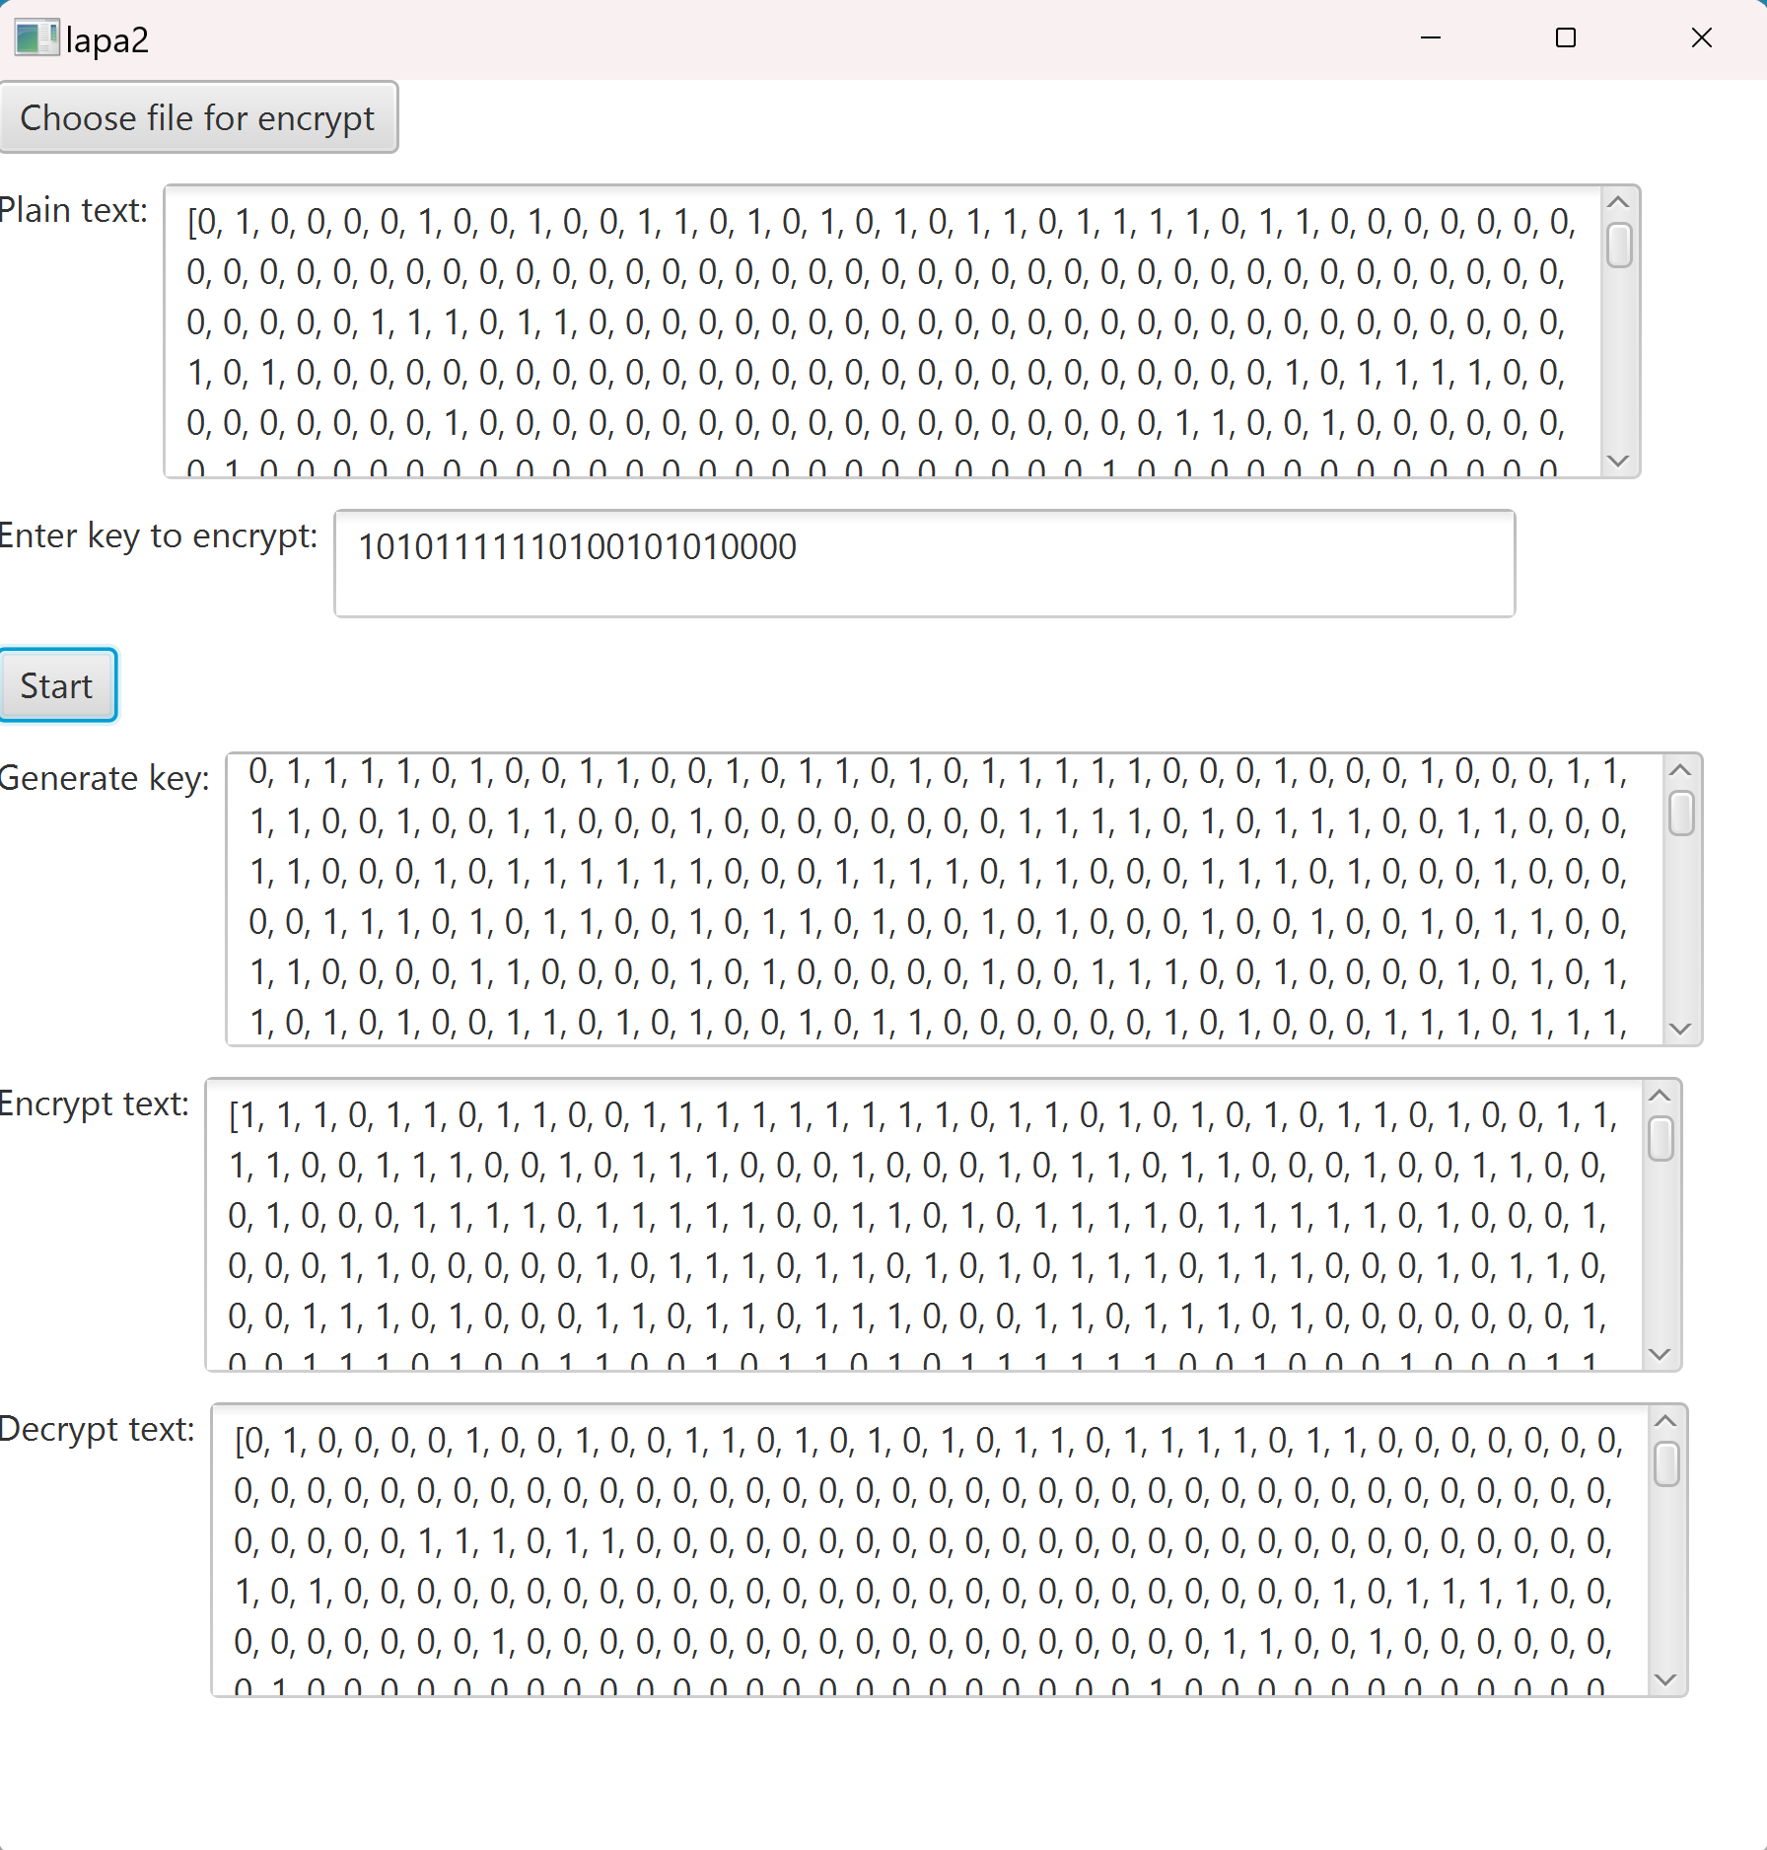

Попытка ввести слишком короткий ключ: 