- Выборка из одной таблицы

  - Выбрать из произвольной таблицы данные и отсортировать их по двум произвольным имеющимся в таблице признакам (разные направления сортировки).
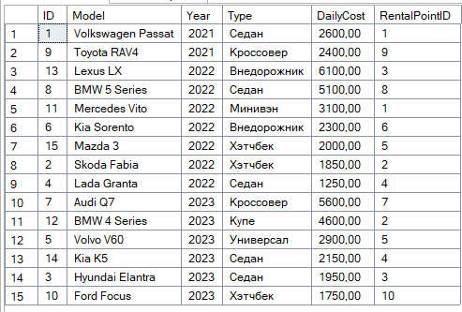
SELECT * FROM Car
ORDER BY [Year] ASC, DailyCost DESC;

  - Выбрать из произвольной таблицы те записи, которые удовлетворяют условию отбора (where).

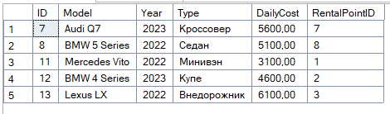
SELECT * FROM Car
WHERE DailyCost > 3000;

SELECT * FROM Client
WHERE [Address] LIKE '%ул. Маланова%';

1.3 Привести примеры 2-3 запросов с использованием агрегатных функций (count, max, sum и др.) с группировкой и без группировки.
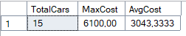
SELECT COUNT(*) AS TotalCars,
MAX(DailyCost) AS MaxCost,
AVG(DailyCost) AS AvgCost
FROM Car;
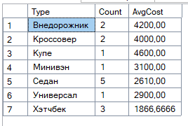
SELECT [Type],
COUNT(*) AS Count,
AVG(DailyCost) AS AvgCost
FROM Car
GROUP BY [Type];

1.4 Привести примеры подведения подытога с использованием GROUP BY [ALL] [ CUBE |ROLLUP]
(2-3 запроса). В ROLLUP и CUBE использовать не менее 2-х столбцов.

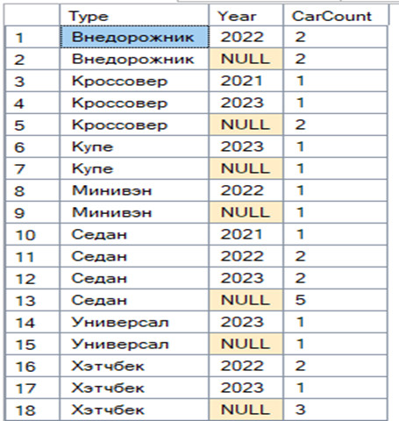
SELECT [Type],
[Year],
COUNT(*) AS CarCount
FROM Car
GROUP BY ROLLUP([Type], [Year]);

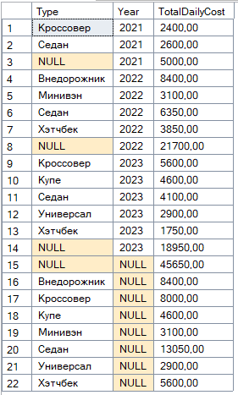

SELECT [Type],
[Year],
SUM(DailyCost) AS TotalDailyCost
FROM Car
GROUP BY CUBE([Type], [Year]);

1.5 Выбрать из таблиц информацию об объектах, в названиях которых нет заданной последовательности букв (LIKE).

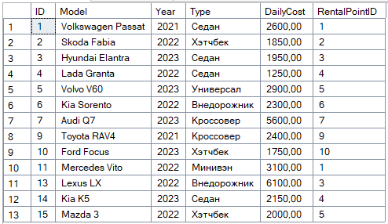
SELECT * FROM Car
WHERE Model NOT LIKE '%BMW%';

2 Выборка из нескольких таблиц
2.1 Вывести информацию подчиненной (дочерней) таблицы, заменяя коды (значения внешних ключей) соответствующими символьными значениями из родительских таблиц. Привести 2-3 запроса с использованием классического подхода соединения таблиц (where).
SELECT
d.ID AS DealID,
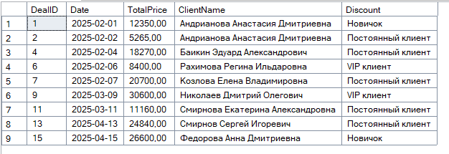
d.[Date],
d.TotalPrice,
c.FullName AS ClientName,
ds.[Description] AS Discount
FROM Deal d, Client c, Discount ds
WHERE d.ClientID = c.ID
AND d.DiscountID = ds.ID;
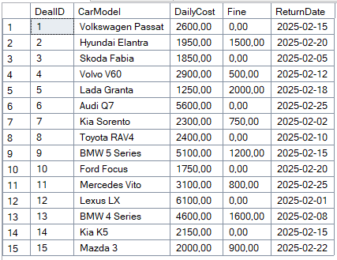
SELECT
dc.DealID,
car.Model AS CarModel,
car.DailyCost,
r.Fine,
r.[Date] AS ReturnDate
FROM Deal_Car dc, Car car, [Return] r
WHERE dc.CarID = car.ID
AND dc.ReturnID = r.ID;

2.2. Реализовать запросы пункта 2.1 через внутреннее соединение inner join.
SELECT d.ID AS DealID,
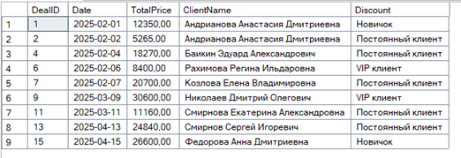
d.[Date],
d.TotalPrice,
c.FullName AS ClientName,
ds.[Description] AS Discount
FROM Deal d
INNER JOIN Client c ON d.ClientID = c.ID
INNER JOIN Discount ds ON d.DiscountID = ds.ID;

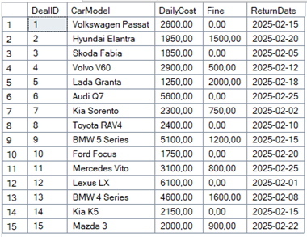
SELECT dc.DealID,
car.Model AS CarModel,
car.DailyCost,
r.Fine,
r.[Date] AS ReturnDate
FROM Deal_Car dc
INNER JOIN Car car ON dc.CarID = car.ID
INNER JOIN [Return] r ON dc.ReturnID = r.ID;

2.3 Левое внешнее соединение left join. Привести 2-3 запроса.
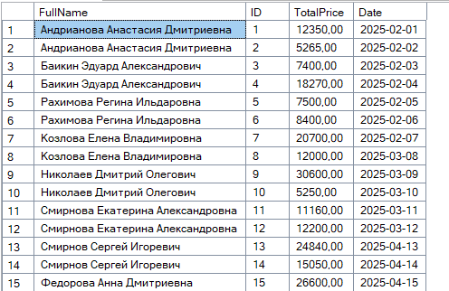
SELECT c.FullName,
d.ID,
d.TotalPrice,
d.[Date]
FROM Client c
LEFT JOIN Deal d ON c.ID = d.ClientID;

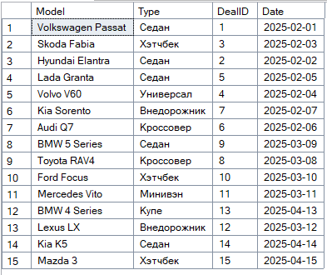
SELECT car.Model,
car.[Type],
dc.DealID,
d.[Date]
FROM Car car
LEFT JOIN Deal_Car dc ON car.ID = dc.CarID
LEFT JOIN Deal d ON dc.DealID = d.ID;

2.4. Правое внешнее соединение right join. Привести 2-3 запроса
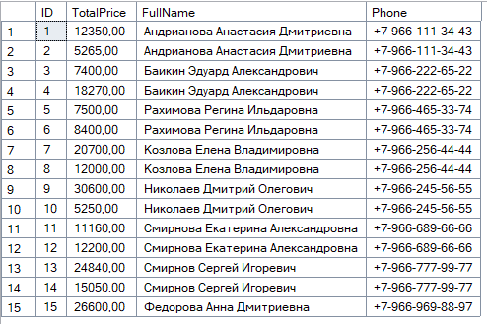
SELECT d.ID,
d.TotalPrice,
c.FullName,
c.Phone
FROM Client c
RIGHT JOIN Deal d ON c.ID = d.ClientID;

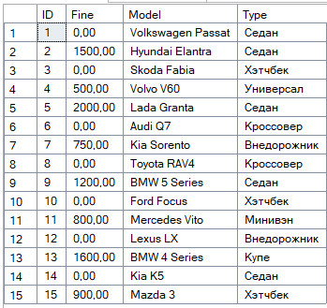
SELECT r.ID,
r.Fine,
car.Model,
car.[Type]
FROM Car car
RIGHT JOIN Deal_Car dc ON car.ID = dc.CarID
RIGHT JOIN [Return] r ON dc.ReturnID = r.ID;

2.5. Привести примеры 2-3 запросов с использованием агрегатных функций и группировки.
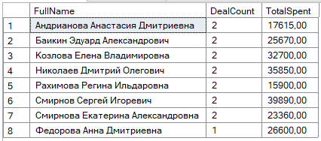
SELECT c.FullName,
COUNT(d.ID) AS DealCount,
SUM(d.TotalPrice) AS TotalSpent
FROM Client c
INNER JOIN Deal d ON c.ID = d.ClientID
GROUP BY c.FullName;

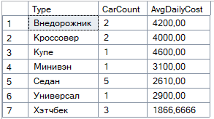
SELECT car.[Type],
COUNT(car.ID) AS CarCount,
AVG(car.DailyCost) AS AvgDailyCost
FROM Car car
GROUP BY car.[Type];

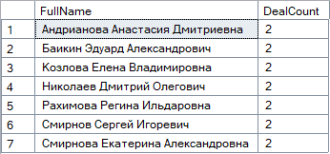
2.6. Привести примеры 2-3 запросов с использованием группировки и условия отбора групп (Having).
SELECT c.FullName,
COUNT(d.ID) AS DealCount
FROM Client c
INNER JOIN Deal d ON c.ID = d.ClientID
GROUP BY c.FullName
HAVING COUNT(d.ID) > 1;

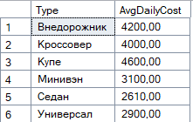
SELECT car.[Type],
AVG(car.DailyCost) AS AvgDailyCost
FROM Car car
GROUP BY car.[Type]
HAVING AVG(car.DailyCost) > 2500;

2.7. Привести примеры вложенных (соотнесенных, c использованием IN, EXISTS) запросов.
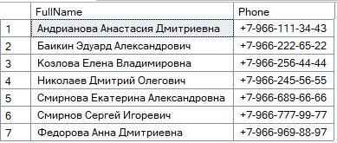
SELECT FullName,
Phone
FROM Client
WHERE ID IN (SELECT DISTINCT ClientID
FROM Deal
WHERE TotalPrice > 10000);

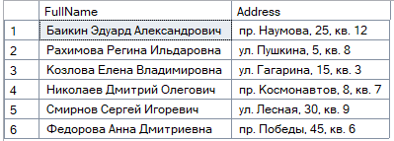
SELECT FullName,
[Address]
FROM Client c
WHERE EXISTS (SELECT 1
FROM Deal d
WHERE d.ClientID = c.ID
AND d.DaysCount > 5);

- Представления
  - На основе любых запросов из п. 2 создать два представления (VIEW).
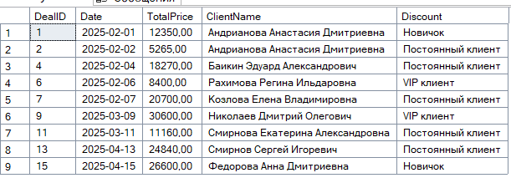
CREATE VIEW View_ClientDeals AS
SELECT d.ID AS DealID,
d.[Date],
d.TotalPrice,
c.FullName AS ClientName,
ds.[Description] AS Discount
FROM Deal d
INNER JOIN Client c ON d.ClientID = c.ID
INNER JOIN Discount ds ON d.DiscountID = ds.ID;
SELECT * FROM View_ClientDeals;
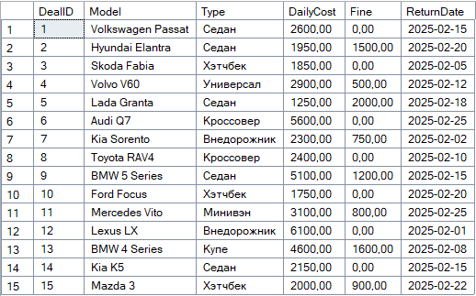
CREATE VIEW View_CarRentalInfo AS
SELECT dc.DealID,
car.Model,
car.[Type],
car.DailyCost,
r.Fine,
r.[Date] AS ReturnDate
FROM Deal_Car dc
INNER JOIN Car car ON dc.CarID = car.ID
INNER JOIN [Return] r ON dc.ReturnID = r.ID;
SELECT * FROM View_CarRentalInfo;

  - Привести примеры использования общетабличных выражений (СТЕ) (2-3 запроса)
WITH ExpensiveCars AS (
SELECT Model, [Type], DailyCost
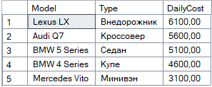
FROM Car
WHERE DailyCost > 3000)
SELECT * FROM ExpensiveCars
ORDER BY DailyCost DESC;

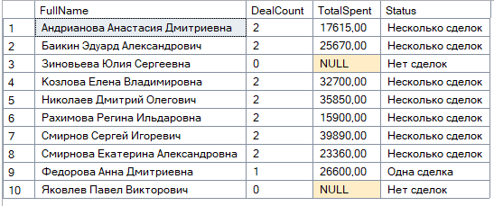
WITH ClientDealStats AS (
SELECT c.FullName,
COUNT(d.ID) AS DealCount,
SUM(d.TotalPrice) AS TotalSpent
FROM Client c
LEFT JOIN Deal d ON c.ID = d.ClientID
GROUP BY c.FullName)
SELECT FullName,
DealCount,
TotalSpent,
CASE
WHEN DealCount = 0 THEN 'Нет сделок'
WHEN DealCount = 1 THEN 'Одна сделка'
ELSE 'Несколько сделок'
END AS Status
FROM ClientDealStats;
4. Функции ранжирования
4.1 Привести примеры 3-4 запросов с использованием ROW_NUMBER, RANK, DENSE_RANK (c PARTITION BY и без)
SELECT
Model,
DailyCost,
ROW_NUMBER() OVER (ORDER BY DailyCost DESC) AS RowNum,
RANK() OVER (ORDER BY DailyCost DESC) AS Rank,
DENSE_RANK() OVER (ORDER BY DailyCost DESC) AS DenseRank
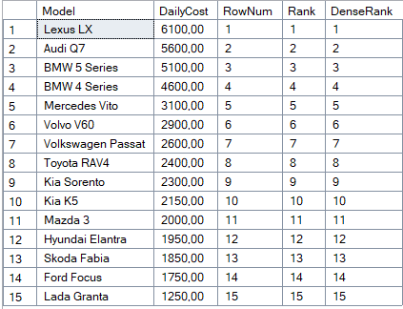
FROM Car;

SELECT
FullName,
[Address],
ROW_NUMBER() OVER (PARTITION BY LEFT([Address], 3) ORDER BY FullName) AS RowNumByAddress
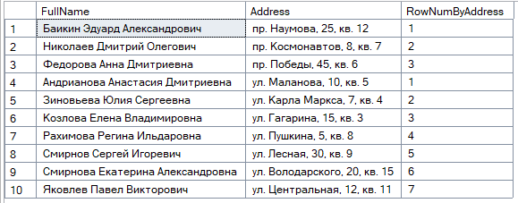
FROM Client;

SELECT
[Type],
Model,
DailyCost,
RANK() OVER (PARTITION BY [Type] ORDER BY DailyCost DESC) AS RankInType
FROM Car;

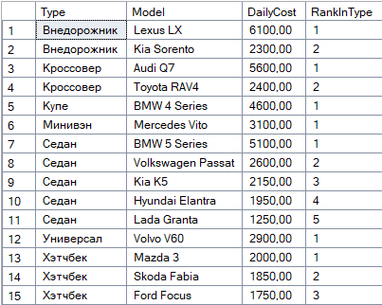

5. Объдинение, пересечение, разность
5.1 Привести примеры 3-4 запросов с использованием UNION / UNION ALL, EXCEPT, INTERSECT. Данные в одном из запросов отсортируйте по произвольному признаку.
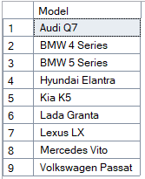
SELECT Model
FROM Car
WHERE [Type] = 'Седан'
UNION
SELECT Model
FROM Car
WHERE DailyCost > 3000;

SELECT ClientID
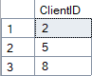
FROM Deal
EXCEPT
SELECT ID
FROM Client
WHERE [Address] LIKE '%ул.%'
ORDER BY ClientID;

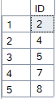
SELECT ID
FROM Client
WHERE Phone LIKE '%966%'
INTERSECT
SELECT ClientID
FROM Deal
WHERE TotalPrice > 15000;

6. Использование CASE, PIVOT и UNPIVOT.
6.1 Привести примеры получения сводных (итоговых) таблиц с использованием CASE

SELECT
Model,
[Type],
DailyCost,
CASE
WHEN DailyCost > 4000 THEN 'Премиум'
WHEN DailyCost BETWEEN 2000 AND 4000 THEN 'Средний'
ELSE 'Бюджетный'
END AS PriceCategory
FROM Car
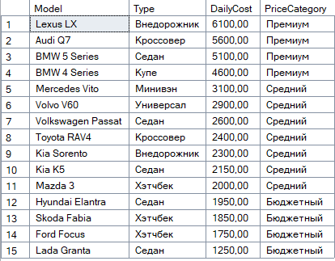
ORDER BY DailyCost DESC;

SELECT
FullName,
[Address],
CASE
WHEN [Address] LIKE '%ул.%' THEN 'Улица'
WHEN [Address] LIKE '%пр.%' THEN 'Проспект'
ELSE 'Другое'
END AS AddressType
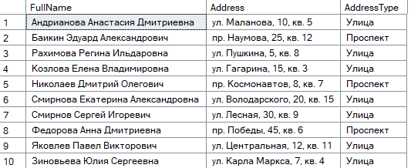
FROM Client;

6.2 Привести примеры получения сводных (итоговых) таблиц с использованием PIVOT и UNPIVOT
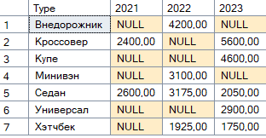
SELECT [Type],
[2021],
[2022],
[2023]
FROM (
SELECT [Type],
[Year],
DailyCost
FROM Car
) AS SourceTable
PIVOT (
AVG(DailyCost) FOR [Year] IN ([2021], [2022], [2023])
) AS PivotTable;

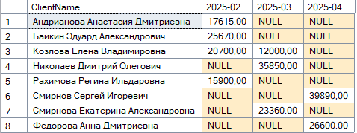
SELECT ClientName,
[2025-02],
[2025-03],
[2025-04]
FROM (
SELECT c.FullName AS ClientName,
FORMAT(d.[Date], 'yyyy-MM') AS Month,
d.TotalPrice
FROM Deal d
INNER JOIN Client c ON d.ClientID = c.ID
) AS SourceTable
PIVOT (
SUM(TotalPrice) FOR Month IN ([2025-02], [2025-03], [2025-04])
) AS PivotTable;

