QA
Day-1
Functional testing:
- Regression testing
- UI/ API testing
- Sanity testing
- Smoke testing
Non-functional testing:
- Performance testing Load tests
- Stress testing Volume tests
- Security tests Update and Installation tests
- Recovery tests
Change related testing: (Build to verify that the change to system has been fixed correctly, do not have adverse effect in the system as a consequence)
- Functional testing
- Smoke testing
- Regression testing
- Build Verification test (Check the version along with all the functionalities)
- Sanity testing
Test Plan
It is a document detailing objectives, resources and process for a specific test of software or hardware product.
Steps:
- Analyze the product
- Design test strategy
- Define test objectives
- Plan test environment
- Resource planning
- Define test criteria
- Schedule & estimation
- Determine test deliverables
Test Case
Set of actions to verify a particular functionality.
Excel doc name: QA
Day-2
Requirements Traceable Matrix
It maps the user requirement with test cases.
Test Management
It is a method of organizing, controlling, ensuring testability and visibility of testing process in order to deliver high software quality.
- Test Organization: Roles of testing is decided. Competencies and knowledge of involved people is also important however, everyone is responsible for quality testing.
- Test Estimation: Management activity that which approximates how long a task would take to complete. – resources, cost, skills, time
- Test Monitoring and Control: Testing activities and test efforts are evaluated. Test Control is taking actions based on the result of test. How to monitor?
- Create monitoring plan
- Update progress record
- Analyze record ad make adjustments
- Procedure the report
Risk Analysis
Risk is the probability of occurrence of undesirable event. Risk should be identified and determined before the start of project.
Defect Management
Systematic process to identify and fix bugs. Process:
- Discovery of defect
- Defect categorization
- Fixing defect by developers
- Verification of testers
- Defect closure
- Defect reports
Playwright Automated Testing Tool
Open-source, built on top of Microsoft, Playwright is a Node.js library that automates Firefox, WebKit and Chromium.
For end-to-end testing.
Advantages- Generates HTML report to view test, there is auto waiting of elements, GUI interface(locally), attachments for test runs.
Waits 3 seconds by default to throw error/status. We can explicitly state the time.
Disadvantages: API request method do not support disabling tracking redirects. It is an emerging tool so the documentation is confusing, has smaller community.
Selenium: Drivers(JSON) are required for running script in browser
Cypress: Script is opened directly in browser
Playwright: We execute test directly, it is invoked to the browser directly.
Day-3
Annotations
test.beforeAll test.beforeEach test.describe test test.skip test.fail
test.only test.slow test.afterEach test.AfterAll
Assertions
Test assertions in the form of expect function. To make an assertion, call expect(value) and choose a matcher that reflects the expectation.
Syntax: await expect(page.getByTestID(‘status;).toHaveText(‘Submitted’));
Types:
Auto-retrying assertions Non retrying assertions negating assertions Soft assertions
Custom expect assertions expect.conifgure expect.poll expect.toPass
Installation
Install node.js
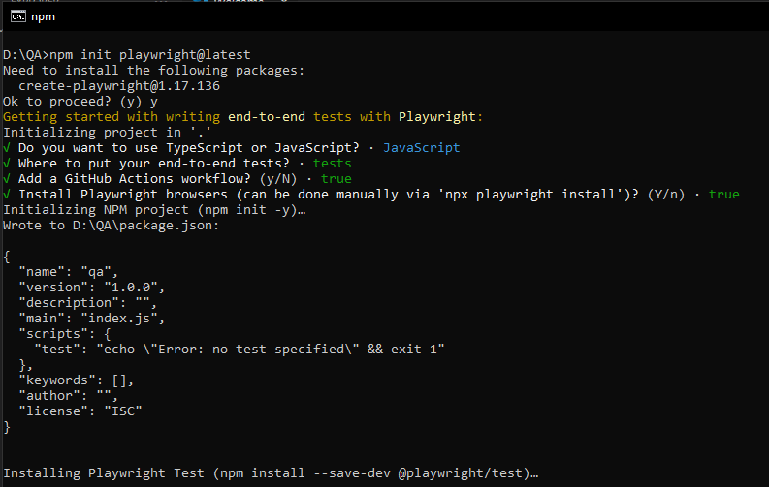

Day-4
Xpath
It is a technique that allows you to navigate the structure of a webpage’s HTML. Helps to find the elements that aren’t found by selectors such as ID, class or name.
Types:
- Absolute
- Relative (Xpath=//input[@name='uid'])

How to use XPath in Selenium? Tutorial

Types of Relative path:
- Xpath starts with
- Xpath AND and OR
- Contains()
- Basic Xpath

XPath Axes Mode
- Following
Selects all elements in the document of the current node( ) [ UserID input box is the current node] as shown in the below screen.
Xpath=//*[@type='text']//following::input
- Ancestor
The ancestor axis selects all ancestors element (grandparent, parent, etc.) of the current node as shown in the below screen.
Xpath=//*[text()='Enterprise Testing']//ancestor::div
- Child
Selects all children elements of the current node
Xpath=//*[@id='java_technologies']//child::li
- Preceeding
Xpath=//*[@type='submit']//preceding::input
- Following-siblings
xpath=//*[@type='submit']//following-sibling::input
- Parent
Xpath=//*[@id='rt-feature']//parent::div
- Self
Xpath =//*[@type='password']//self::input
- Decendent
Xpath=//*[@id='rt-feature']//descendant::a[1]

