~50 subject in each condition: backward (b), forward (f), ~100 subject in random/control (r)

Design: picture recognition with a design of initial test and final test. 3 group (backward, forward, random in final test).
In initial test, there are 20 pictures to study and 20 pictures to test. 10 lists of 20 pictures. ~17 seconds counting of single digits between study and tests. 20 test pictures include 10 old and 10 new. So, there are pictures that are (1) study only: presented but not tested (2) study and test: presented and tested (3) test only (foils) – all these three types will be OLD in final test, and there are 10 pictures in each of these three category for each list.
Feedback was an accumulated accuracy bar (calculated for each list) updated on bottom of the screen, so participants see continuous presentation of test pictures with 100ms ISI. There is a time restriction of respond, in 3.5 seconds.

In final test, only 7 picture of each of those 3 categories above were tested. Everything from before should be OLD and other completely NEW pictures are tested. There are 420 tests, 210 OLD and 210 NEW.
Feedback was “this item had been studied or tested on list xx” or “this item had never been seen previously”

1. Average for each participant separated by correct rejection and hits

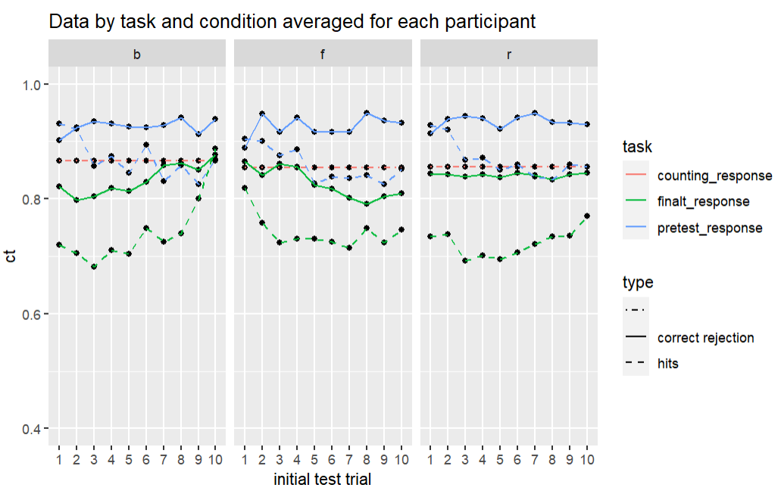

2. Average probability of correct separated by probetype

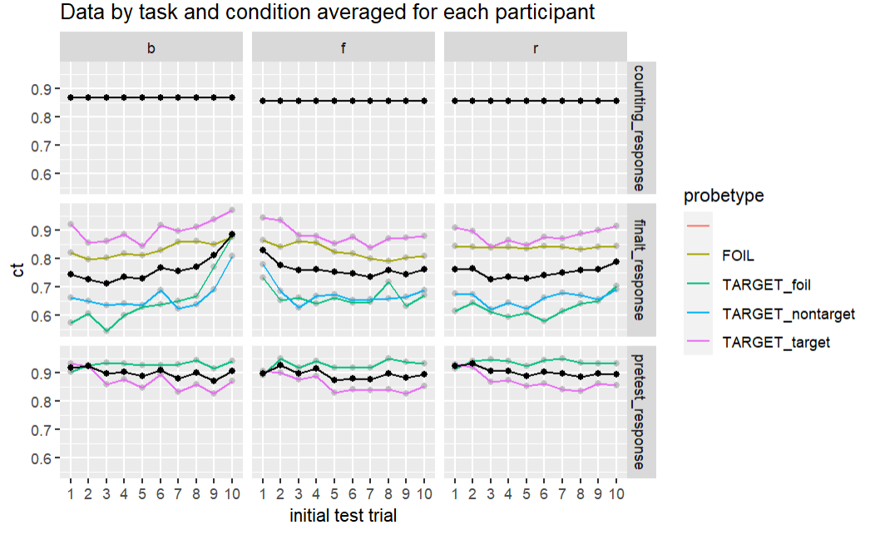
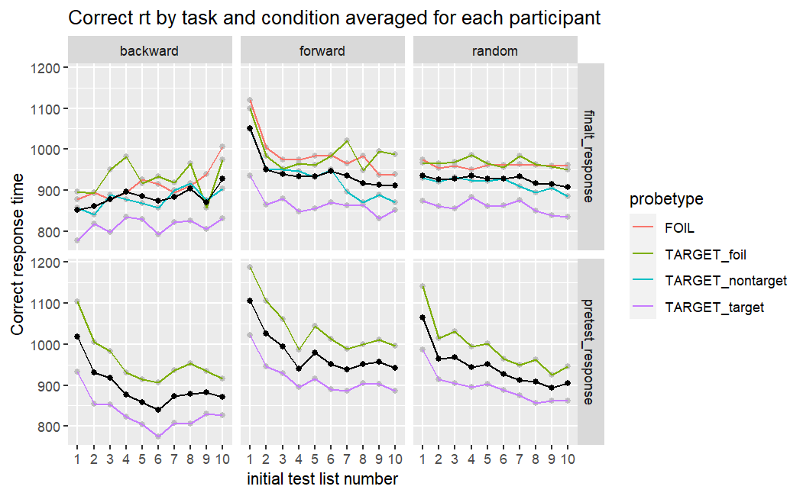
3. 3 condition’s Performance of final test chunked by final test position (1-420)

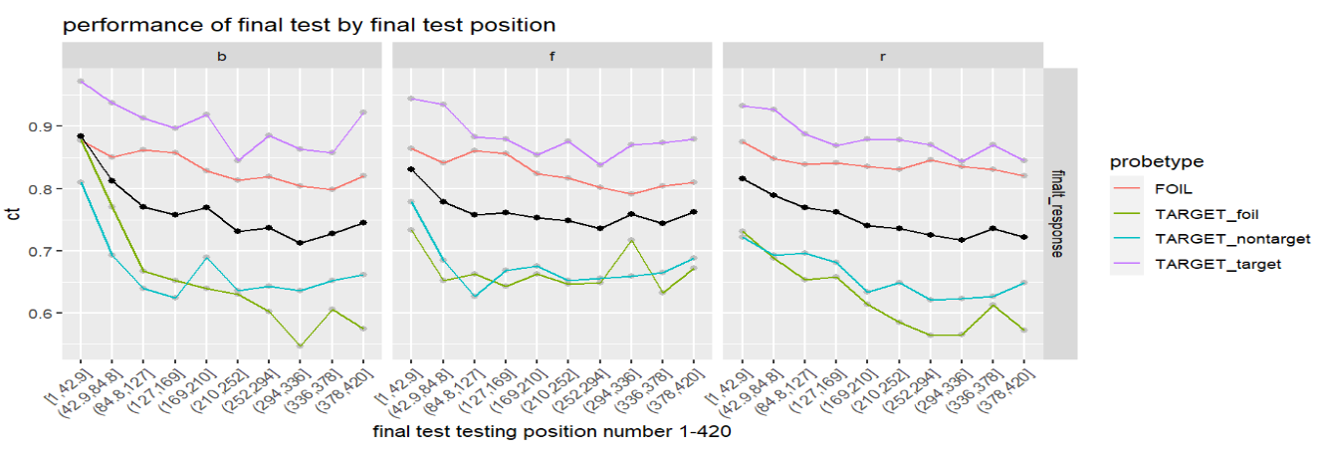

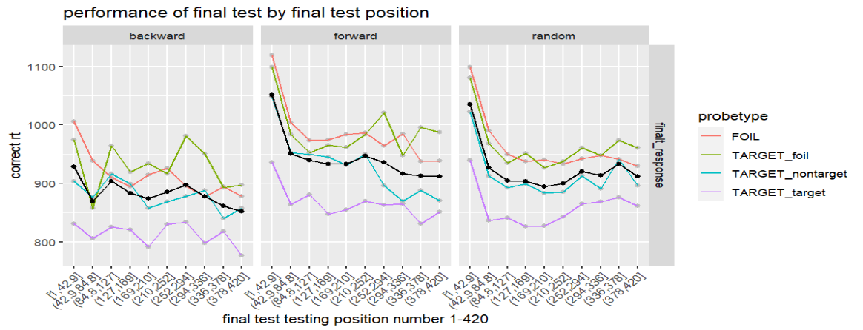
4. conditioned post-test accuracy by pre-test response
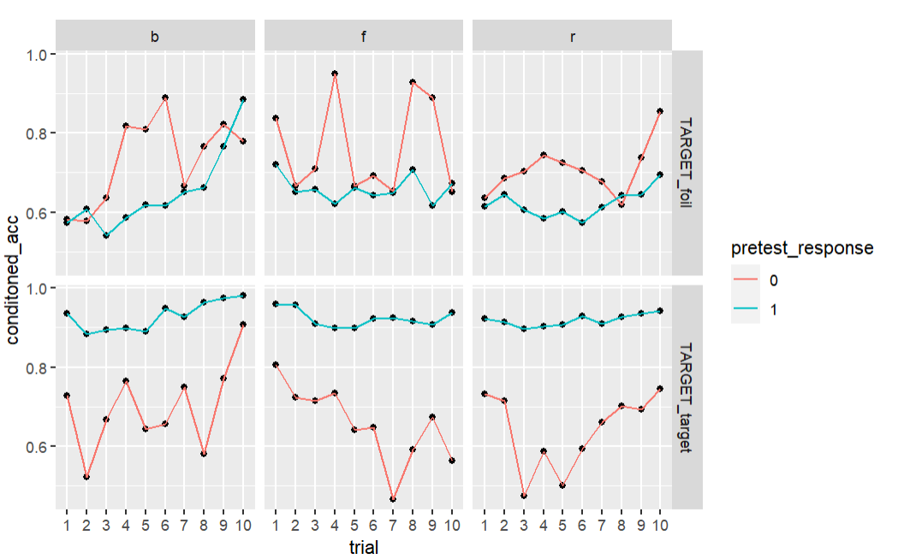

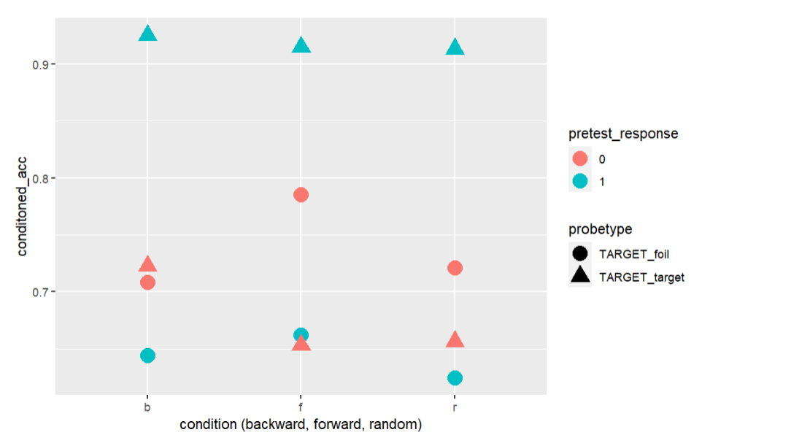

- averaged performance (calculated by (hits + correct rejections)/2, is this the correct way of calculation?)
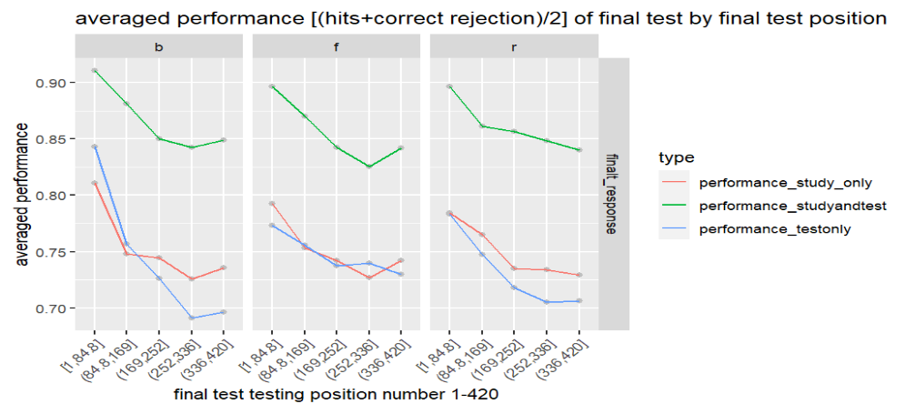
- d prime
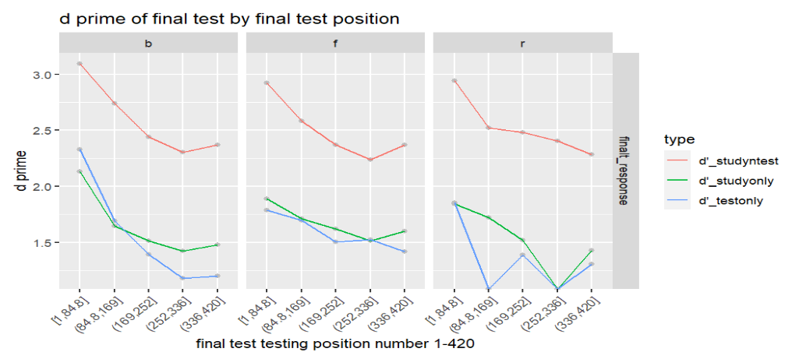

Serial position effect
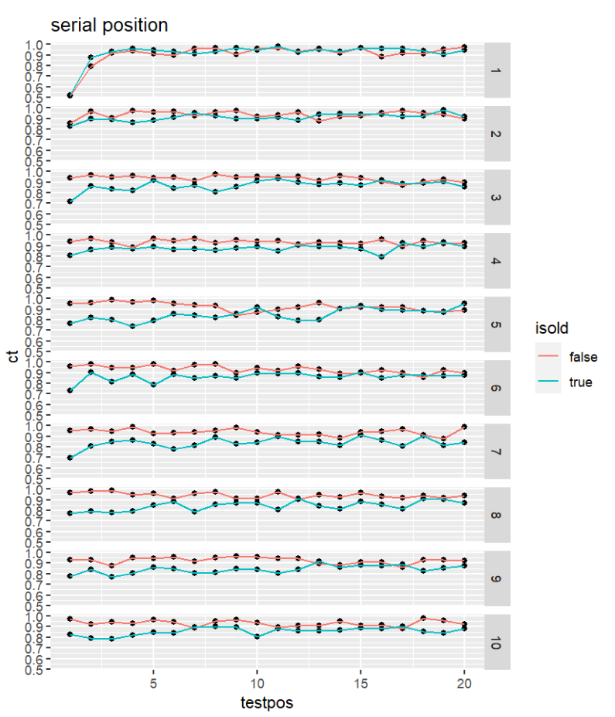
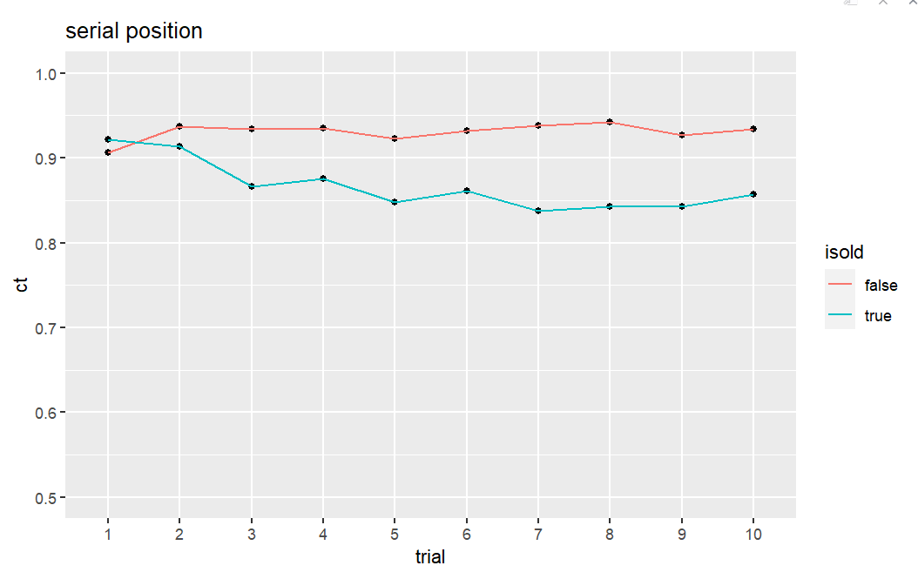

Within list final test result::

- final test within list result
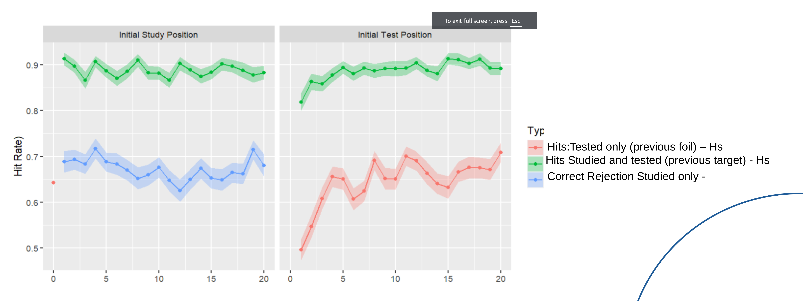
Initial test within-list

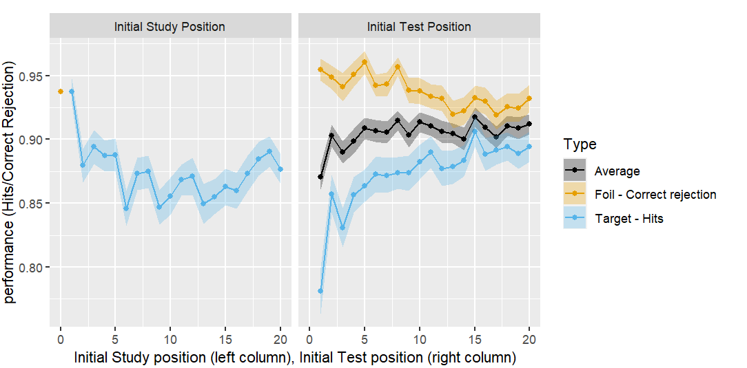
z`

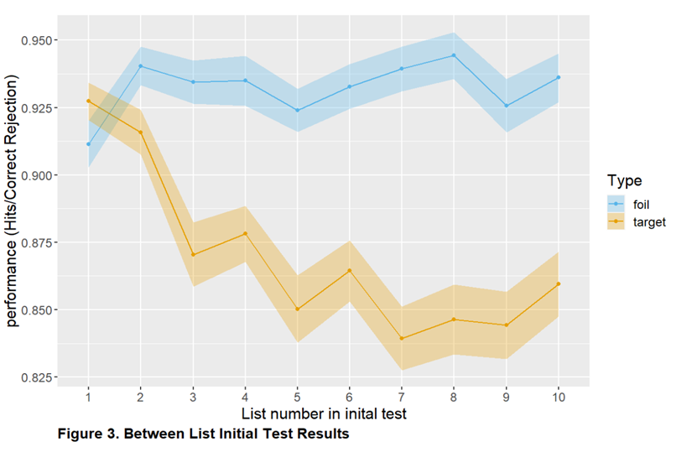
List number in initial test

