- E1 - Initial test BETWEEN list
Prediction(left) Data (right)
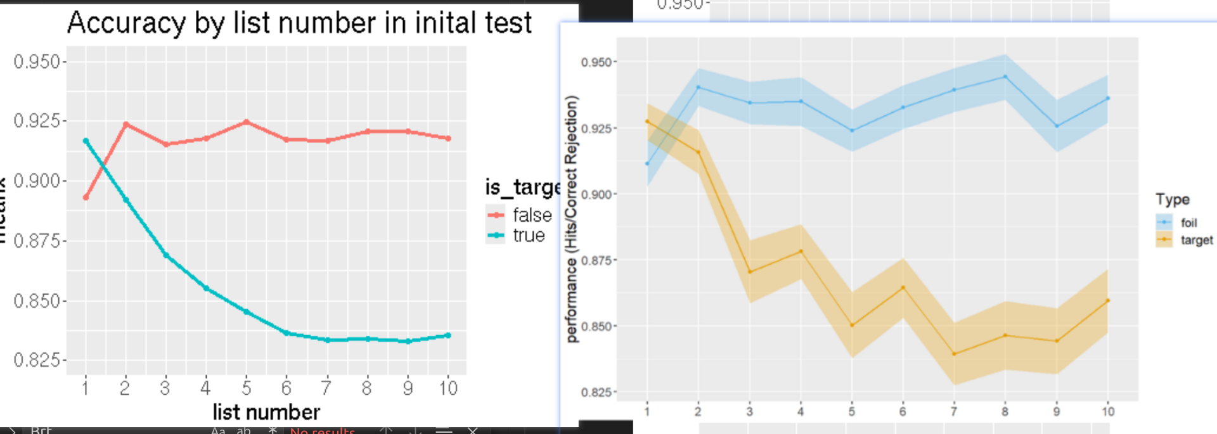

2. E1 - initial test WITHIN list by TEST position

Prediction (left) Data (right)

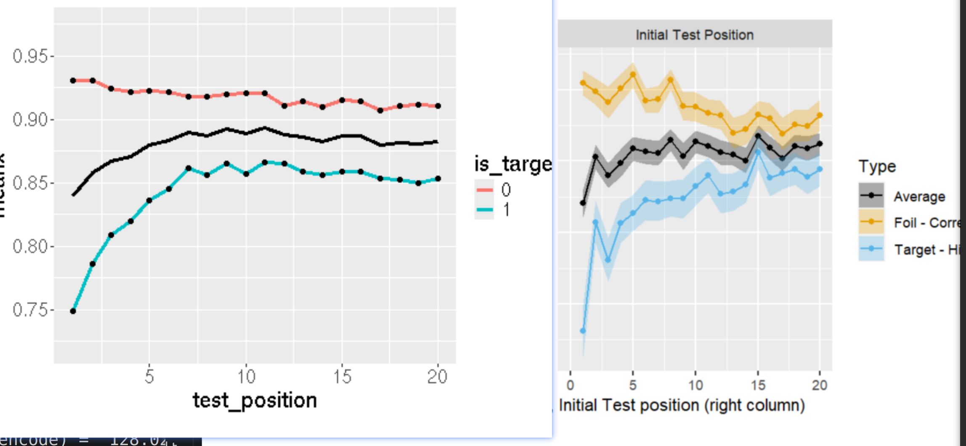

- 2. E1 - initial test WITHIN list by STUDY position
Prediction (left) Data (right)
(this isn't predicted because we don't have mechanism for difference on study-position)
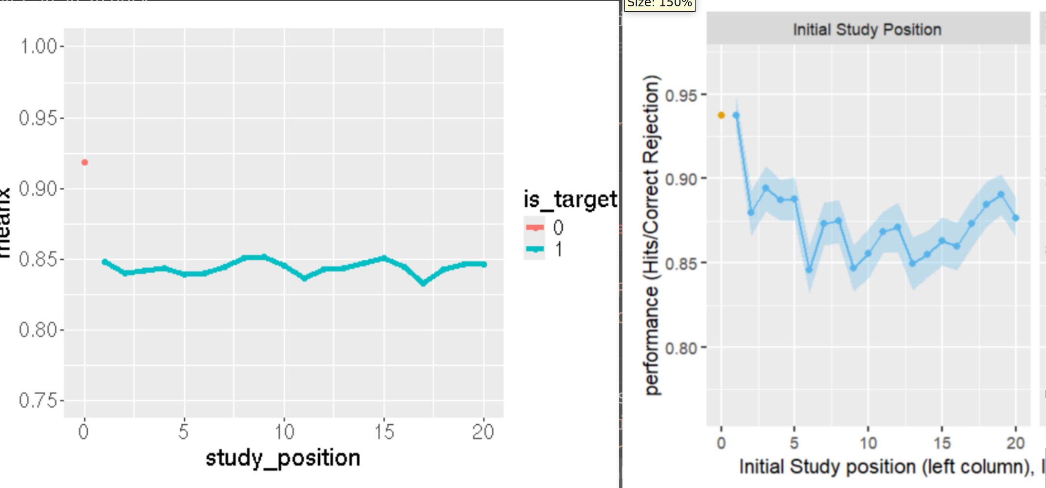

- Final test predictions (still working on it and I will update that to you immediately when I finish).

