1. Initial test between-list result
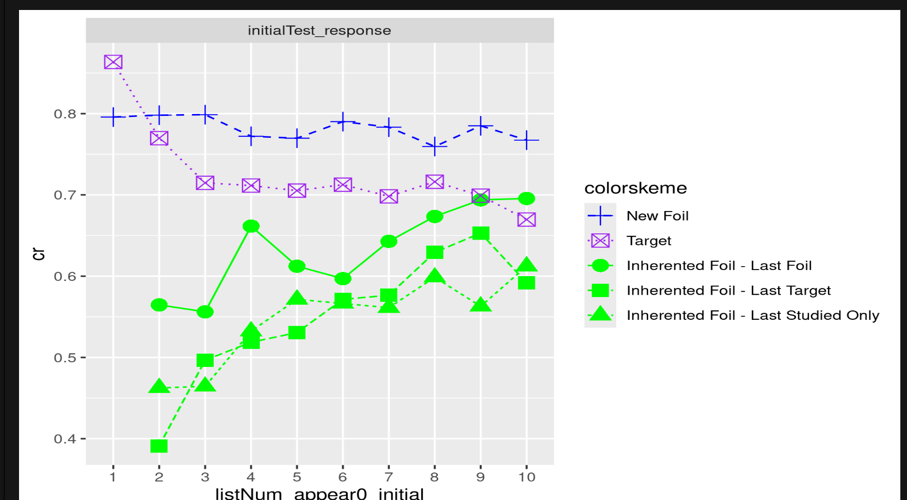

2. Final Test Between-List result (by initial test list number)

