- Individual analysis
  - One correct
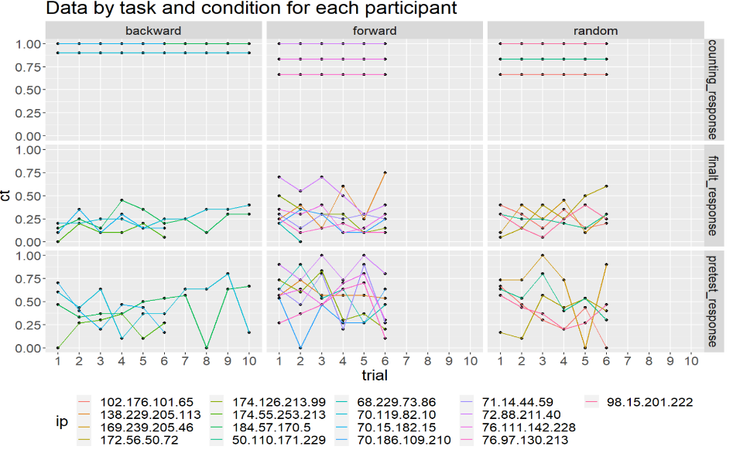

- Average for each participant
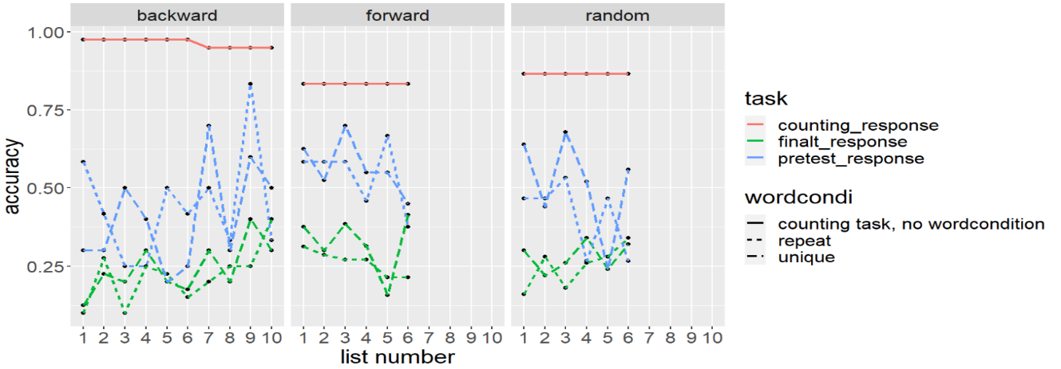

- Average by testing condition (if it’s tested in initial word condition)

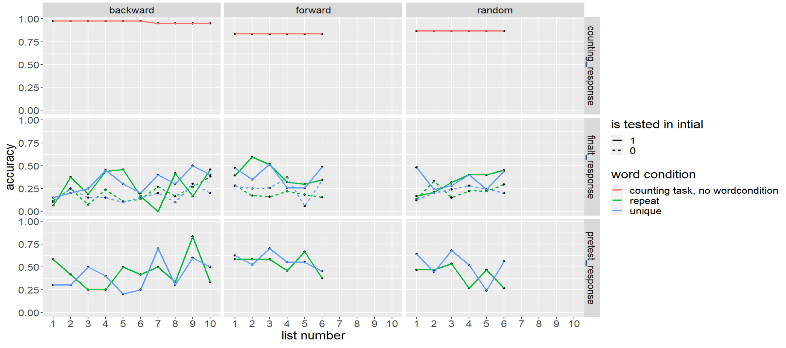
- In final test, if word is from list in pair1 or 2
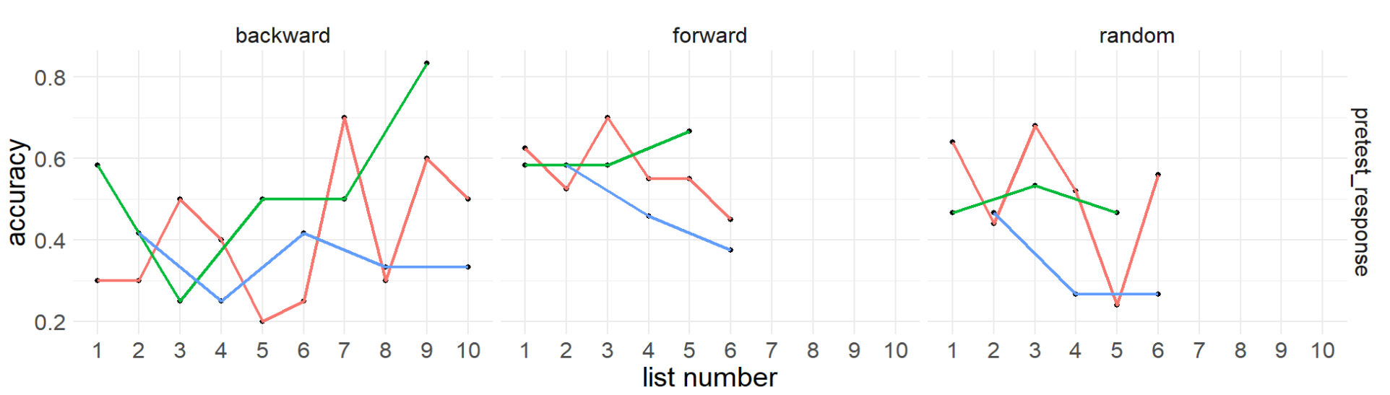
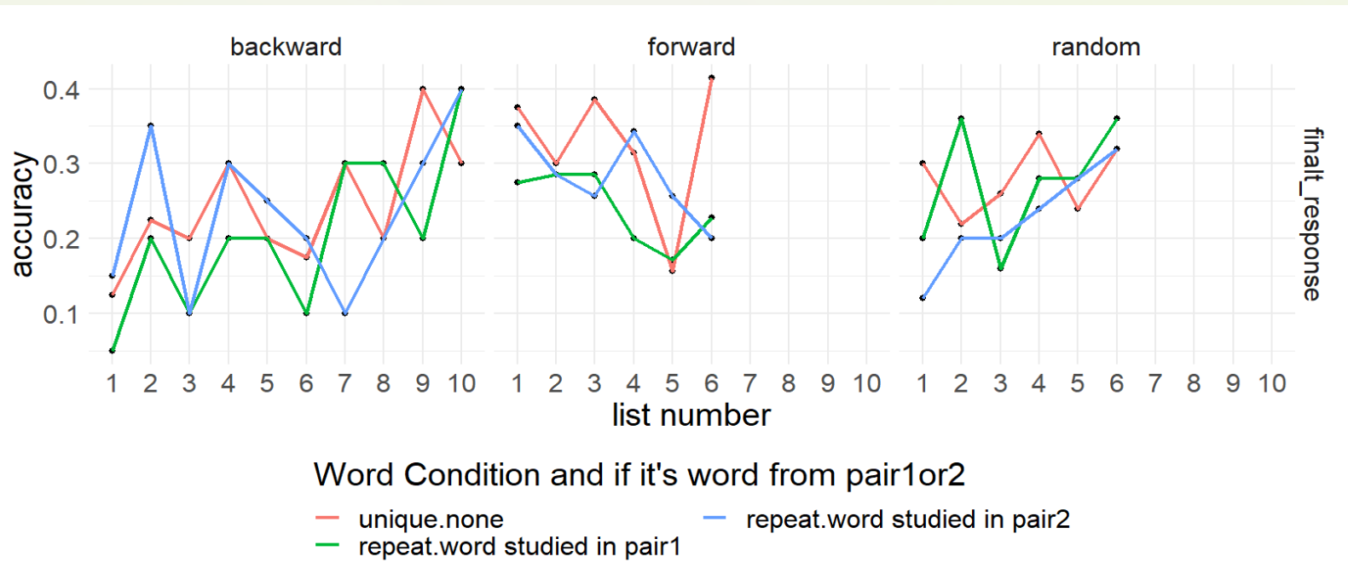

- Condiontal
