- figure 1 (left,right): Accuracy (p(c)) of each group by condition (by intial test position, final test position);

- Note: Repeat condition is separated by BOTH first word and second word
- x-axis: Left plot has x-axis breaking by intial test list, and right plot has x-axis breaking by final test list.
- column panels: accuracy of initial test vs. final test (those name with "finalt_response" is final test, and "pretest_response" is initial test)
- row panels: 5 groups: forward, backward, random, forward random (shorten as FRandom, meaning alternating list 1,8,2,7.... in final test), backward random (shorten as BRandom, meaning alternating 8,1,7,2... in final test).
- line color& line type & shape: condition of repeat vs. unique in final test or intial test; repeat condition in final test include both first responded word and second responded word
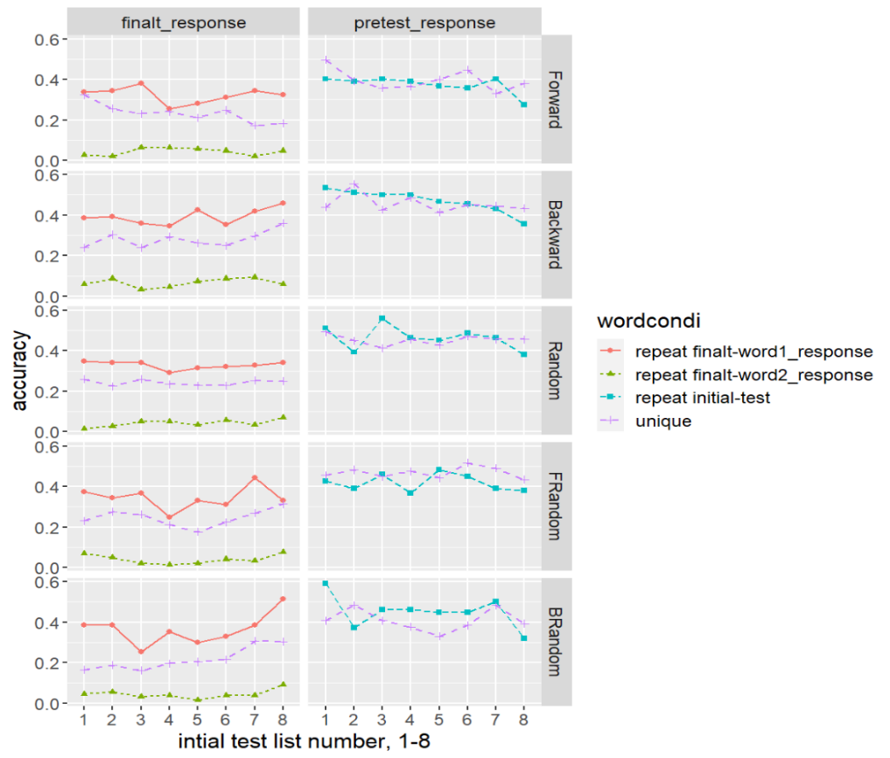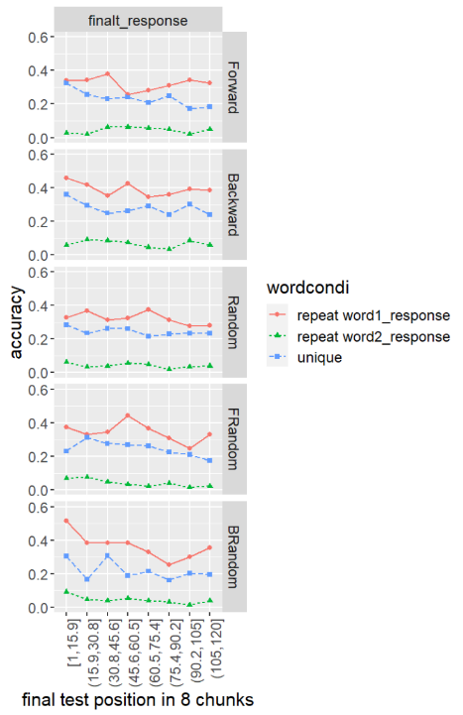

2. figure 2 (left & right): Mean of median response time of each group by condition (by intial test position, final test position);
Note: Repeat condition is not seperated by two words because there is only 1 rt for filling both blanks;
Mean of median RT is plotted.
This is RT included correct&incorrect; I also tried Correct RT, but it doesn't look very different
- x-axis: Left plot has x-axis breaking by intial test list, and right plot has x-axis breaking by final test presentation sequence.
- column panels: accuracy of initial test vs. final test (those name with "finalt_response" is final test, and "pretest_response" is initial test)
- row panels: 5 groups: forward, backward, random, forward random (shorten as FRandom, meaning alternating list 1,8,2,7.... in final test), backward random (shorten as BRandom, meaning alternating 8,1,7,2... in final test).
- line color& line type & shape: condition of repeat vs. unique in final test or intial test; repeat condition in final test include both first responded word and second responded word
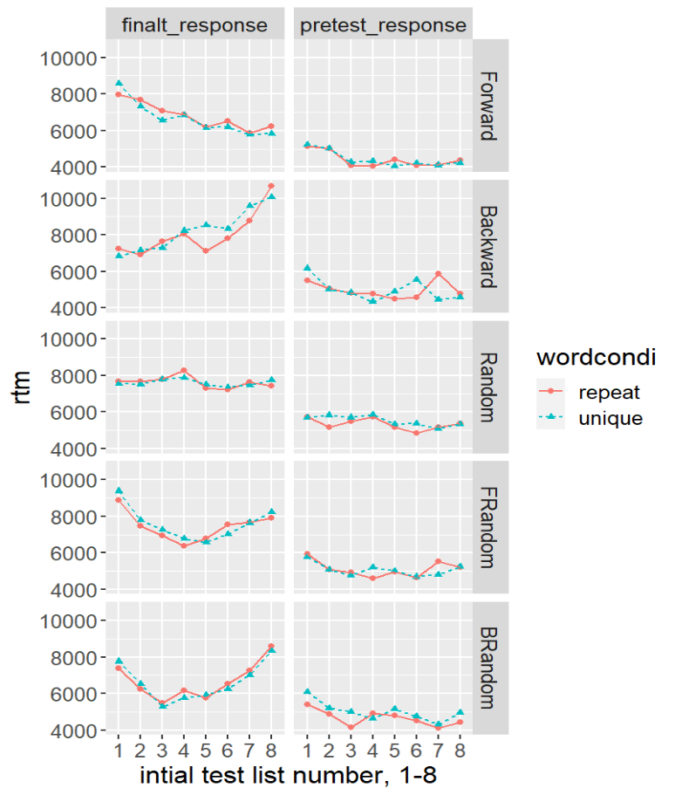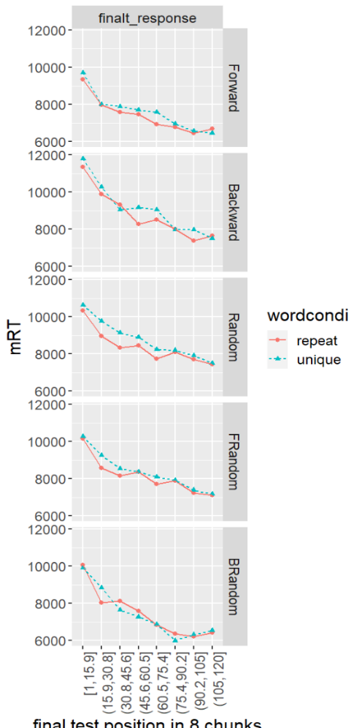

3. figure 3. Final test accuracy conditioned on the initial test
  - x-axis:list number, breaking by intial test
  - y-axis: accuracy
  - row panels: 5 conditions: forward, backward, random, forward random (shorten as FRandom, meaning alternating list 1,8,2,7.... in final test), backward random (shorten as BRandom, meaning alternating 8,1,7,2... in final test).
  - color: (condition of inital test) : if the word is tested and if its correct in inital test
  - linetype: repeat vs. unique condition of words

