Pattern based user interface generation

Abstract
User interface development is probably one of the most important phases in software development. It’s a very complex and time consuming process which embraces the work of people with different backgrounds like developers and designers. With the emergence of mobile devices also came the need for developing several interfaces for multiple platforms. For all this reasons, user interface development is probably the most time consuming phase of software development.
This paper proposes a different process for developing user interfaces. This process takes a user interface pattern specified in UsiXML and maps it to the business layer source code of the software, generating a concrete user interface.

Introduction
Nowadays what makes a software product stand out is less technological and more related to how it handles the human computer interaction. This topic has been highly discussed in the software engineering community in the past few years.
Even with all the available tools and comprehensive bibliography it’s still hard to build good user interfaces. In other fields of engineering there’s a set of tested and robust patterns that can be used to build good products. In software engineering there’s already a set of patterns for software architects to design their applications. But there’s still little use of patterns in user interfaces.
This work needs a way to describe and store a set of patterns. UsiXML is an XML based language that was created with the purpose of specifying user interfaces for multiple contexts. UsiPXML is a language that combines UsiXML with PLML whish is a language for describing user interface patterns in a more descriptive way. Both these languages seem to be adequate to describe and store a collection of patterns as intended. The former one is more concise while the latter one can store information in a more structured way.
The main goal of this work is to study and develop a tool that can interpret a set of patterns specified in either UsiXML or UsiPXML, link them to the source code of the business layer through code annotations and generate a user interface based on the implemented functionality and the base pattern. This can help developers to build user interfaces with little effort and little knowledge on human computer interaction only by using good patterns that have been tested and are known to be robust and compliant with HCI rules.
This paper serves as initial study for the development of a tool that generates user interfaces based on patterns. On the first section it does an introduction to the theme. The second section explains how developers currently build they're user interfaces and identifies the need of better tool support on this area. The third section gives some theory in the field of patterns engineering. On the fourth section we'll see some languages capable of successfully describe user interface patterns, namely UsiXML and UsiPXML. The last section of this paper handles the conclusions of this study.

How user interfaces are built
There are several techniques and several tools to build user interfaces. Some are more intuitive and easy to learn while others are more flexible but harder to learn and thus more time consuming.
In this chapter we’ll be focusing on some of the most used techniques for building user interfaces. It will be explained what are the main advantages and disadvantages related to each technique while using some examples to justify them.
Probably the most used technique is also the oldest one, manually coding interfaces. It’s hard and time consuming but it’s usually preferred by most experienced developers because it’s more flexible and if they’re good at what they’re doing the final code can be very good and maintainable.
The second technique we’ll see in this chapter is code generation through WYSIWYG tools. There are many tools of this kind that support the most popular languages and frameworks for developing user interfaces. They’re very used mainly by novice developers and designers. The final code isn’t always the best but if you’re using a robust tool there’s little chance of finding bugs in it.
The third and last technique we’ll see isn’t the most popular in the industry but there’s a lot of work on this theme in the academic world. Model driven development is widely used for the bottom layers in software development but is not that popular for the presentation layer. Although this technique is not as widely used as the previous ones it brings many advantages such as platform independence.
Manually coding user interfaces

Before more advanced tools were created, user interfaces had to be manually coded. Although the evolution that the industry has suffered since the beginnings, most developers still prefer to code manually user interfaces because it gives them more control over their work.
This is a very time consuming process because humans have to do most of the work but in the end it really depends on what language or framework you’re working on. Most popular and modern programming languages give developers access to frameworks for building GUI’s like GTK+, Swing or Windows Forms. These examples are for the desktop side. On the web side everything is (X)HTML, CSS and JavaScript but there are a lot of frameworks to abstract from these languages like JSF, Struts or ASP.net.
Most desktop GUI frameworks use the same language for views and the other software layers. This means that a lot of code has to be written In order to get things done. Frameworks like GTK+, Swing and Windows forms are very hard to use without help from more advanced tools.
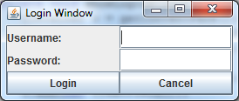
Image (ref image) shows a simple login window with two textboxes for username and password and a couple of buttons to login or cancel the operation. Listing (ref listing) shows the swing code written to build this window.
public static void main(String[] args) {
SwingManualTest sm = new SwingManualTest();
sm.showLoginWindow();
}

private void showLoginWindow(){
Container c = getContentPane();
c.setLayout(new GridLayout(3, 2));
c.add(new JLabel("Username:"));
c.add(new JTextField());
c.add(new JLabel("Password:"));
c.add(new JTextField());
c.add(new JButton("Login"));
c.add(new JButton("Cancel"));
setDefaultCloseOperation(JFrame.EXIT_ON_CLOSE);
pack();
setVisible(true);
}
It’s plain Java so every control is an object. For some OOP enthusiasts this is a good thing but it’s incomprehensible for designers and even for most developers this is very hard and thus very time consuming.
Fortunately, on the web side things are simpler. Most frameworks use HTML with some specific extensions to specify the views. This offer developers a more declarative paradigm which makes a lot more sense when building interfaces. This approach also produces a lot less code which makes maintenance a lot easier.
Let’s take a look at an example similar to the previous one but this time using JSF.
<html xmlns="http://www.w3.org/1999/xhtml"
xmlns:h="http://java.sun.com/jsf/html">
<h:head>
<title>Login</title>
</h:head>
<h:body>
<h:form>
<h:outputLabel value="Username:" />
<h:inputText />
<h:outputLabel value="Password:" />
<h:inputSecret />
<h:button value="Login" />
<h:button value="Cancel" />
</h:form>
</h:body>
</html>
This is very different than the first example. It’s not just more intuitive for developers, it’s a little bit more understandable for designers too because it’s based on HTML.
Recently some new frameworks for desktop GUI’s, which resemble the web ones that were referenced earlier, have been developed. One good example is the WPF framework. It uses the XAML language to specify views. It’s a markup language based on XML and, thus, more like HTML. Let’s take a look at the login window coded for WPF.
<Window x:Class="WpfApplication1.MainWindow"
xmlns="http://schemas.microsoft.com/winfx/2006/xaml/presentation"
xmlns:x="http://schemas.microsoft.com/winfx/2006/xaml"
Title="Login Window" >
<Grid>
<Grid.ColumnDefinitions>
<ColumnDefinition />
<ColumnDefinition />
</Grid.ColumnDefinitions>
<Grid.RowDefinitions>
<RowDefinition />
<RowDefinition />
<RowDefinition />
</Grid.RowDefinitions>
<TextBlock Text="Username:" Grid.Column="0" Grid.Row="0" />
<TextBox Grid.Column="1" Grid.Row="0" Width="150" />
<TextBlock Text="Password:" Grid.Column="0" Grid.Row="1" />
<TextBox Grid.Column="1" Grid.Row="1" Width="150" />
<Button Grid.Column="0" Grid.Row="2" Width="150">Login</Button>
<Button Grid.Column="1" Grid.Row="2" Width="150">Cancel</Button>
</Grid>
</Window>
Even though this language is a lot more verbose than HTML and other markup languages it’s a very good alternative for building desktop GUI’s, especially if you’re going to write all the code manually.
The conclusion of this section is that manually coding user interfaces isn’t always a good idea depending on the technology you’re using. The first frameworks that were presented use programming languages to specify the views. That doesn’t look like a very good approach because it’s not intuitive for the developer and incomprehensible for designers. On the other hand the later solutions use specific languages for specifying views which are more intuitive and easy to write but they oblige developers to learn these new languages.

Code generation through WYSIWYG tools
The concept of WYSIWYG is used in a variety of situations. From text processing to building user interfaces. One of the most recognized tools of this kind is Microsoft Word for text processing. What tools of this kind attempt to do is offer the user an interface that shows exactly the final result of what they’re doing.
In software development the most popular WYSIWYG environments are the ones provided by Java IDE’s like Netbeans to build Swing interfaces or Microsoft Visual Studio that provides WYSIWYG tools for a variety of frameworks like Windows Forms, WPF or ASP.net. Let’s take a closer look to Netbeans.
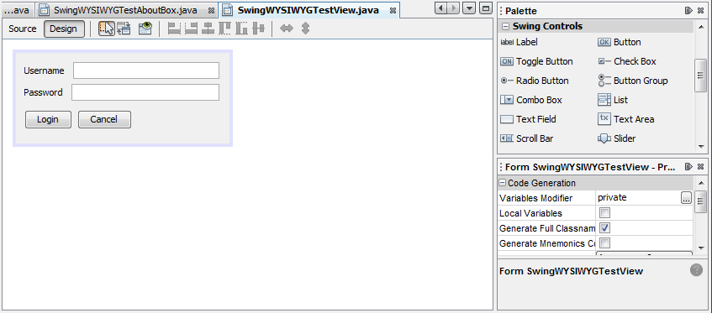
Ilustração Netbeans Swing WYSIWYG tool
Like you would expect from this tool, it has a canvas where the final GUI appears and a side menu from where you can drag controls and drop them into the canvas. It’s very simple and intuitive and thus very attractive for novices. The problem with this kind of tools is maintainability. It’s very easy and quick to build something, if it’s not very advanced, but it´s a real challenge when there’s a need to change the layout. Making a manual change in the generated code is not an option, mainly because is too complex but also because it’s often blocked by the IDE itself. The other tools are very similar so there is no need to give further examples.
In conclusion, WYSIWYG tools are good for novices but don’t suppress all the needs of the software industry where maintainability is a very important issue. There’s also the problem of portability, the produced code is platform specific. Other important issue is reusability. GUI’s frameworks usually offer some way to reuse components in different contexts. This is can be easily achieved while manually coding everything but it’s a lot harder with a higher level of abstraction.
Model driven development of user interfaces
Model driven development defining characteristic is that software development’s primary focus and products are models rather than computer programs. The major advantage of this is that we express models using concepts that are much less bound to the underlying implementation technology and are much closer to the problem domain relative to most popular programming languages (Quote The Pragmatics of Model-Driven Development).
Models are easier to maintain than the code itself and, most important, they’re platform independent. This means that the same model can be used to generate code that runs on a desktop environment, a web environment or even a mobile environment. This makes a lot of sense for user interfaces because modern applications are becoming more and more ubiquitous and it’s highly complex and time consuming to build a GUI for every supported platform.
UML is the industry standard for software modeling but, unfortunately, is not fit to model user interfaces. With this in mind, the software engineering community has developed some new modeling languages in the past few years to overcome this problem. The most relevant are probably UMLi, an extension to UML and CTT which aims task modeling.
UMLi provides an alternative diagram notation for describing abstract interaction objects (Quote User Interface Modeling in UMLi).
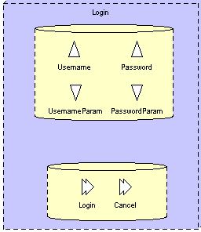
Ilustração Login window modeled in UMLi
With this notation you can specify inputs, outputs and actions in a way that classic UML notation doesn’t support. Tasks can also be specified in UMLi, but without any extension to UML. Tasks can be modeled using Use Cases and Activity Diagrams which are part of the UML specification.
Task modeling has become very popular for modeling interactive systems and it’s, probably, the most important method right now. A task consists how a user can reach a goal in a specific context. CTT is the most popular language for task modeling (Quote ConcurTaskTrees A Diagrammatic Notation for Specifying Task Models). With CTT the task model is built in three phases:
- First a hierarchical logical decomposition of the tasks represented by a tree-like structure;
- Then an identification of the temporal relationships among tasks at the same level;
- And finally an identification of the objects associated with each task and of the actions which allow them to communicate with each other.
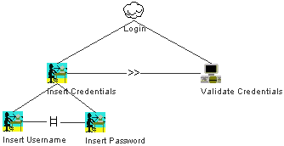
Ilustração Login task modeled in CTT
Figure 3 shows the login task modeled in CTT. The tool used to create this model was CTTE (Quote Site CTTE) which is one of the most popular tools for the CTT language. This tool supports the creation and animation of models but doesn’t offer any feature to perform any transformation to a more specific format.
Another well known tool for CTT is IdealXML (Quote IDEALXML AN INTERACTION DESIGN TOOL). This tool can also be used to model tasks using CTT but it also has the capability to transform the models into more specific ones, namely, user interface specifications in UsiXML.
In conclusion, there is a lot of work regarding model driven development for user interfaces and the idea that models can simplify the development process is becoming more consensual. The biggest problem with this methodology is the tool support that still isn’t mature enough to be adopted by the industry. Being a method where the product of engineer’s work is platform independent and both easily maintainable and reusable, model driven development will surely play an important role on the future of software development and more specifically on the development of user interfaces.

Patterns in software engineering
Patterns are widely used in every field of engineering. One of the earlier definitions of patterns can be found on (cite Pattern language Christopher Alexander). Almost twenty years later patterns were brought to software engineering by (cite Design patterns).
Patterns bring many advantages, not only they make the development of a product less time consuming and thus less expensive but can also guarantee a higher level of quality because patterns are solutions that have been tested and used in other projects.
Particularly on user interfaces, these are very important features because building a good user interface is a very complex and time consuming process. On most software projects it takes about half of the timeframe allocated to that project, so patterns can help to make this process more efficient. Also there’s the problem of usability. This is one of the most important aspects of software projects but it’s still very difficult to build a user interface compliant with HCI (human computer interaction) rules. By using patterns this can be easily achieved if the patterns are already compliant with these rules.
How are patterns documented
Patterns are usually stored in catalogues (websites, books, etc…). In (cite Design patterns) a pattern is composed by the following fields:
- The Pattern name resumes the pattern in one or two words that we use to refer to named pattern.
- The Problem describes in which situations the pattern should be applied.
- The Solution describes how the pattern work, what elements it has and how they relate to each other.
- The Consequences describe the secondary effects of using the pattern.
This is the specification used for software design patterns but its generic enough be used in other contexts.
In (cite Generative Pattern-Based Design of User Interfaces) documentation of patterns is divided in two categories. First there are descriptive patterns. These patterns are meant to be interpreted by humans so they describe the solution in a generic way so that the pattern can be used in a wide range of contexts. Then there are generative patterns. These ones maximize expressivity over genericity thus, they can be used in more restricted range of contexts but the solution is specific enough to be interpreted by machines.
Design patterns like the ones described in (cite Design patterns) are generative patterns because they’re solution is specified in UML which is a formal language that can easily interpreted by machines to perform transformations.
A list of catalogues for user interfaces can be found in (cite http://www.visi.com/~snowfall/InteractionPatterns.html). Most of this catalogues define they’re solutions with text and images because there isn’t a reference language to specify user interfaces. Thus most of these patterns are descriptive patterns that can only be used by humans.
In conclusion, in order to take full advantage of patterns we need a way to document them. Generative patterns are the most useful in the context of this project but to use them we need to find a language to specify these patterns so that they can be interpreted by a machine to generate a concrete user interface.

How to specify user interface patterns
The patterns we’re looking to specify are generative patterns as described in (cite Generative Pattern-Based Design of User Interfaces). Thus the patterns have to be specified in a formal language. UML is the reference for modeling software but, as we saw on earlier sections is not ideal for user interfaces.
The languages we’ll see in this section are UsiXML and UsiPXML. These are high level languages that can be used to specify platform independent user interfaces.
UsiXML
UsiXML is a user interface description language aimed at expressing user interfaces built with various modalities of interaction and independently of them. UsiXML is XML compliant to enable flexible exchange of information and powerful communication between models and tools used in user interface engineering (cite UsiXML specification). UsiXML is specified in UML, as seen on image (image).
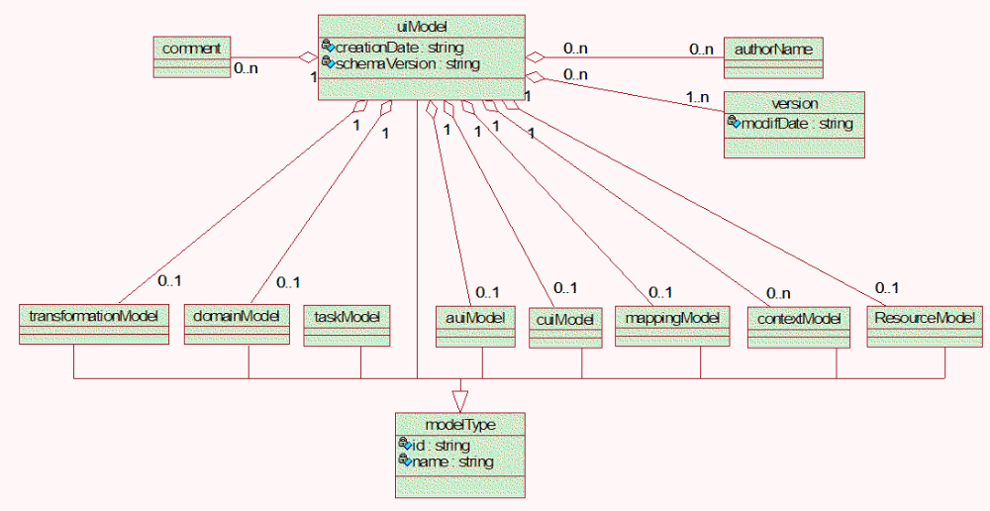
The core component of a user interface specified in UsiXML consists on the user interface model, which is itself composed by several models namely:
- Transformation model: Contains a set of rules in order to enable a transformation of one specification to another.
- Domain model: Describes the classes of the objects manipulated by the users while interacting with the system.
- Task model: describes the interactive task as viewed by the user interacting with the system. The task model is expressed according to the CTT specification (cite CTT).
- Abstract user interface model: represents the view and behavior of the domain concepts and functions in platform independent way.
- Concrete user interface model: represents a concretization of the abstract user interface model.
- Mapping model: contains a series of related mappings between models or elements of models.
- Context model: describes the three aspects of a context of use, which is a user carrying out an interactive task using a specific computing platform in a given surrounding environment.
- Resource model: contains definitions of resources attached to abstract or concrete interaction objects.
The user interface model consists of a list of component models (described above) in any order and any number. It doesn’t need to include one of each model component and there can be more than one of a particular kind of model component. It’s also composed by a creation date, a list of modification dates, a list of authors and a schema version.
The objective of studying UsiXML was to find out if it was suitable to specify user interface patterns. After analyzing all its components we can conclude that it’s indeed suitable to describe the solution of a pattern, that will be, basically, an abstract user interface model, but there’s no space for the descriptive components of a pattern. In conclusion, to successfully specify a pattern in UsiXML we need an extension that stores all the extra information needed to make a pattern recognizable by humans.
UsiPXML
UsiPXML results from the fusion of two languages, PLML (cite http://www.cs.kent.ac.uk/people/staff/saf/patterns/plml.html) and UsiXML (cite Different Kinds of Pattern Support for Interactive Systems). UsiXML was already studied in the last subsection so in the present subsection we’ll focus on the other components of UsiPXML.
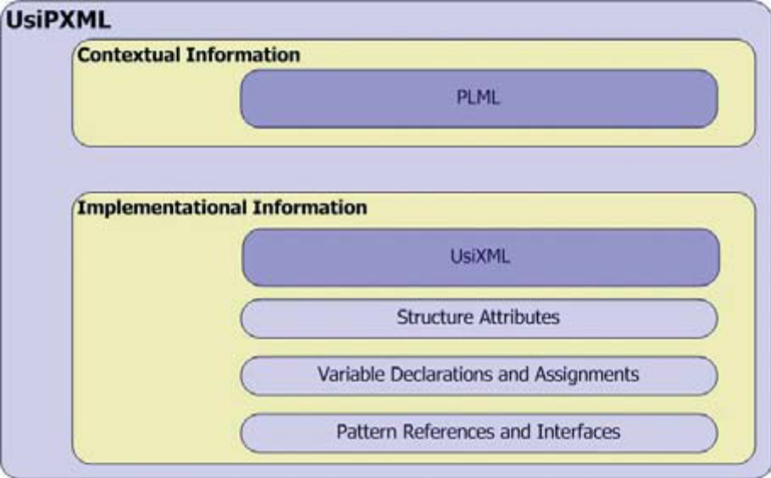
PLML provides the contextual information of a pattern in UsiPXML. The main goal of PLML is to bring structure and consistency to the way patterns are described. PLML is a natural language-based so it implements descriptive patterns.
It wouldn’t make sense to use PLML alone with the objective of creating generative patterns but using it along with UsiXML seems a good idea because these two languages complement each other in this context. On section (ref section patterns in software engineering) was stated that a pattern was composed by a name, a problem, a solution and a list of consequences. Using UsiPXML the solution can be described in UsiXML while the other components fit in the structure of PLML.

Conclusions
User interface development is one of the most important phases in software development but still's very hard for developers to manage this process efficiently. The data from section (ref how user interfaces are built) show's that there is a need for better tools and methodologies to build user interfaces.
Patterns are very important for engineers, in section (ref patterns in software engineering) we studied how are patterns used, documented and stored. We divided patterns in two categories, descriptive patterns and generative patterns. Although the ones that are more interesting for this work are generative pattens, there is more abundance of descriptive patters for user interfaces. The main reason for this is the lack of a standard language for specifying user interfaces, like UML for general software.
On section (ref how to specify user interface patterns) we studied a couple a languages with the potential to become standard in user interface patterns specification. UsiXML is a more concise language while UsiPXML can store more information in a structured way by merging UsiXML with PLML which is a language for descriptive patterns. In conclusion UsiPXML seems to be more suited to describe patterns but UsiXML is more generic and thus as more potential to become a standard in the software engineering community so it's probably the best option on the table.
The future work for this project will be a more profound study of the UsiXML specification in order to develop a tool capable of reading a pattern described in UsiXML, link it with existing source code (buisness layer) and generate a concrete user interface.

? What you see is what you get.
? Graphical user interface.
? Java server faces.
? Object oriented programming.
? Windows Presentation Foundation.
? Extensible Application Markup Language.
? Extensible Markup Language.
? Unified Modeling Language for Interactive Applications
? Concur Task Trees

