Data set for the line chart: world population.

Data set for the step chart: Inflation (attached)

**Python. Matplotlib. Line chart**

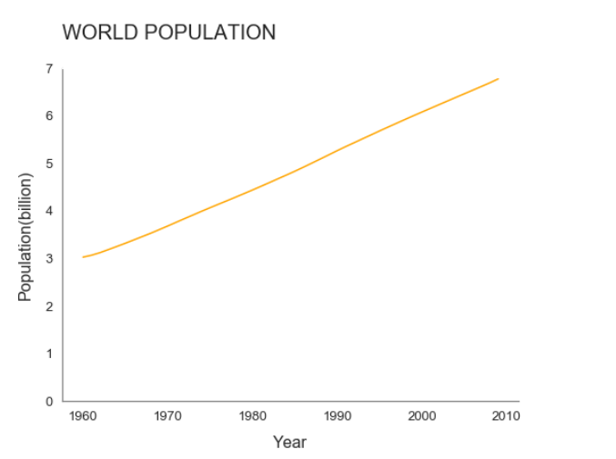

**Python. Matplotlib. Step Chart highlighting lowest/highest and most recent inflation**

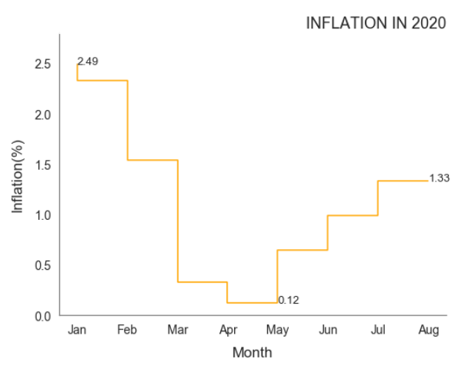

**R. GGplot2. Line Chart.**

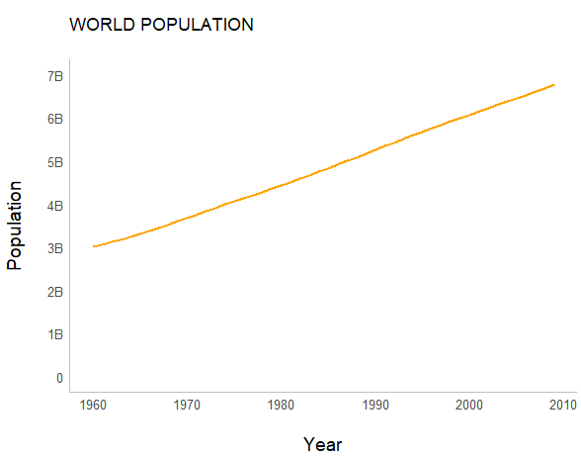

**R. GGplot2. Step Chart highlighting lowest/highest and most recent inflation**

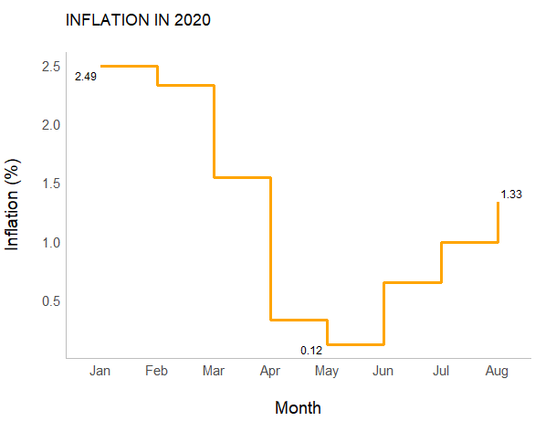

**Tableau. Line Chart.**

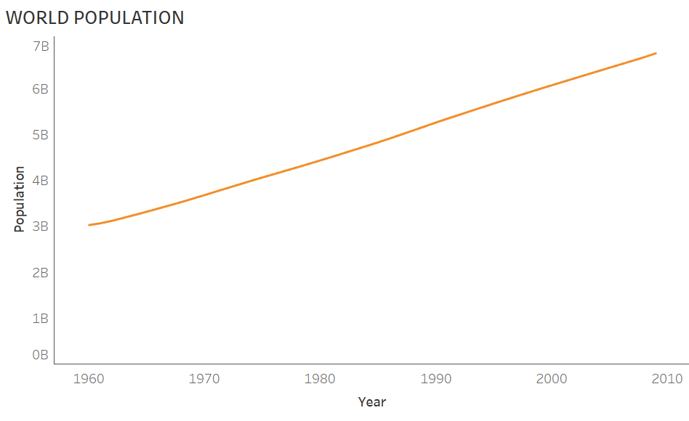

**Tableau. Step Chart highlighting lowest/highest and most recent inflation**

