Data set used: crimes-by-state-2005.

**R. GGplot2. Scatterplot with LOESS**

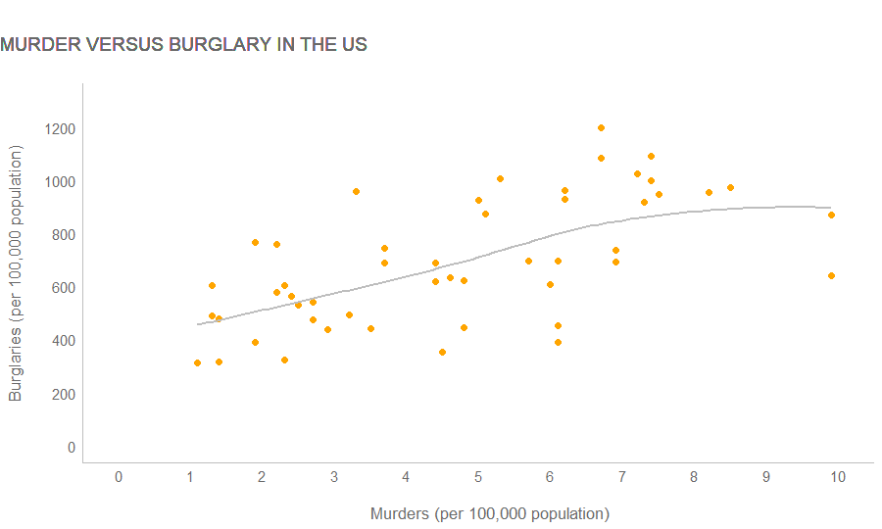

**R. GGplot2. Density Plot.**

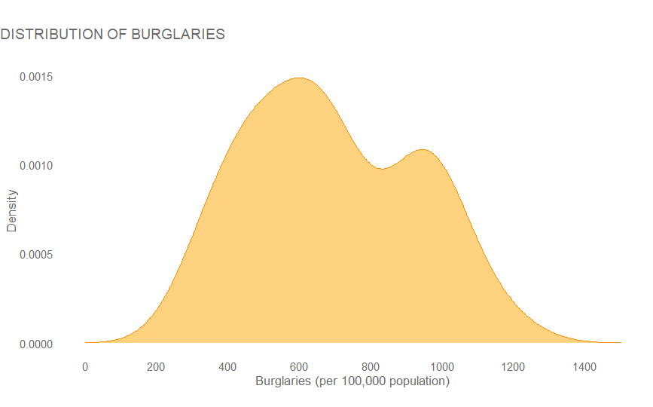

**R. GGplot2. Bubble Chart.**

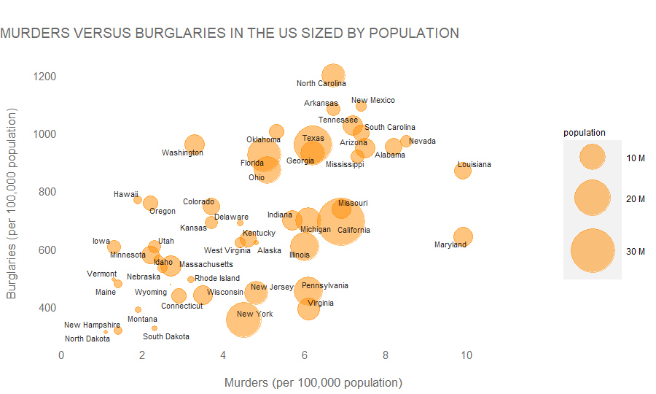

**Python. Matpotlib. Scatterplot with LOESS.**

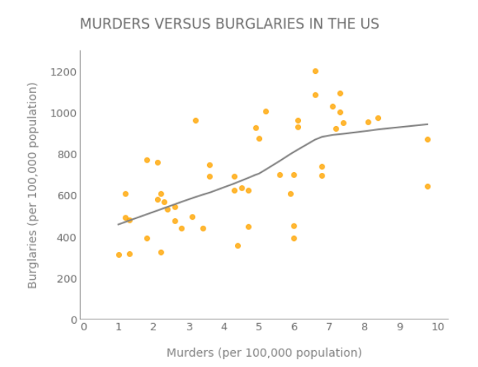

**Python. Combination of Seaborn and Matplotlib. Density Plot.**

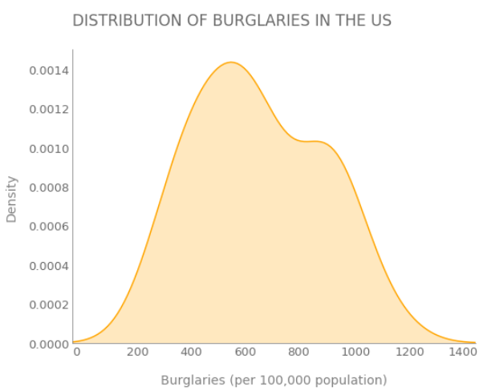

**Python. Matplotlib. Bubble Chart.**

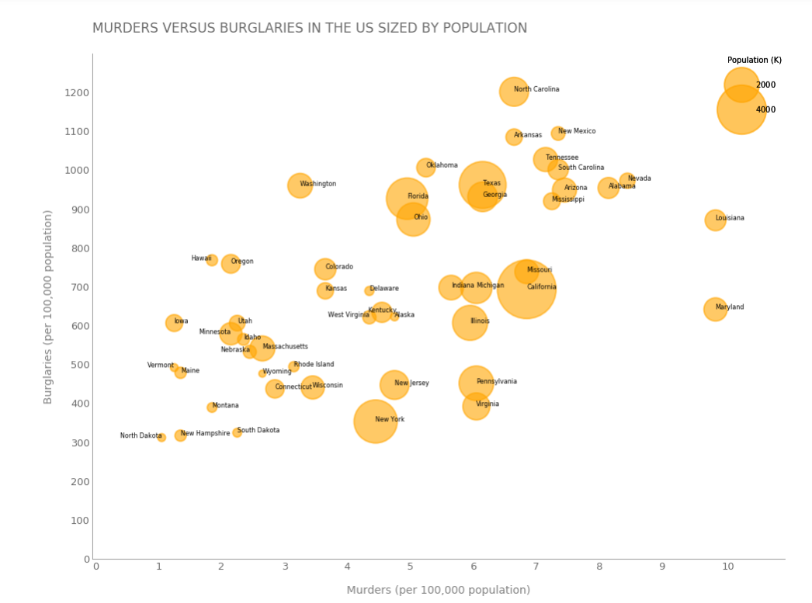

**Tableau. Scatterplot with LOESS**

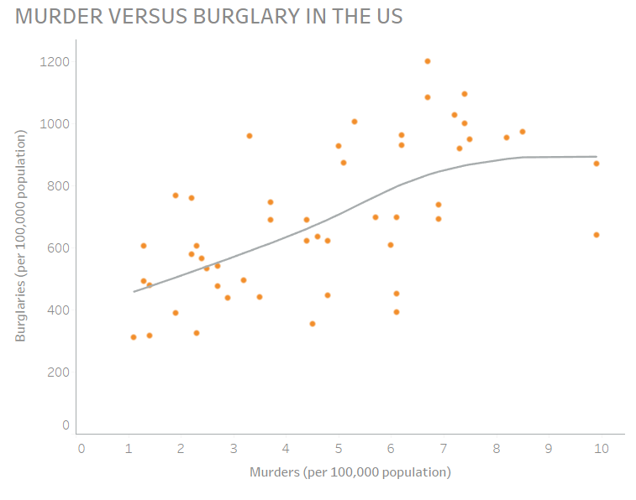

**Tableau. Density Plot.**

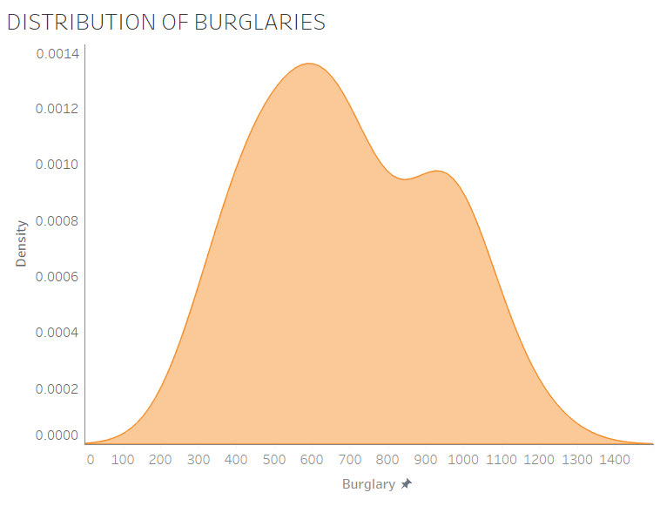

**Tableau. Bubble Chart**

